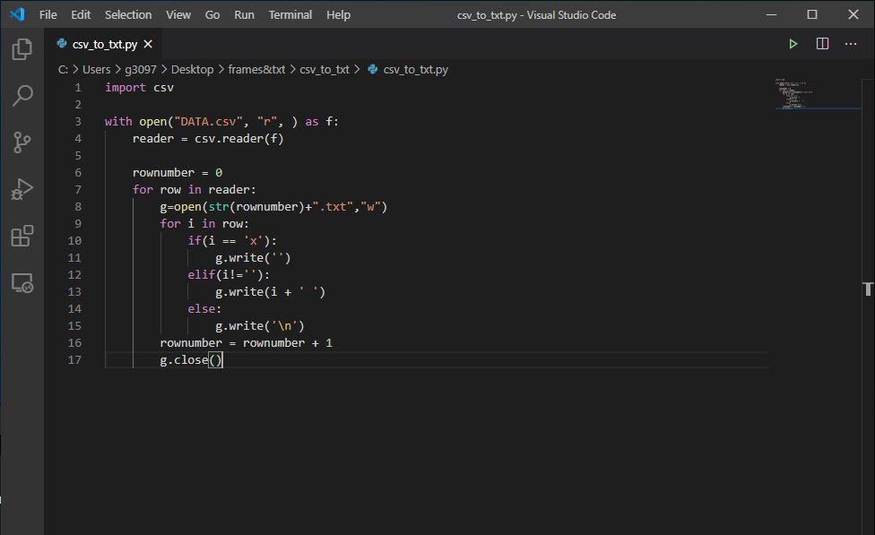

Simple python program, read each row from the csv file.

Every extracted row is an array, we can spilt the array the write into the csv file.