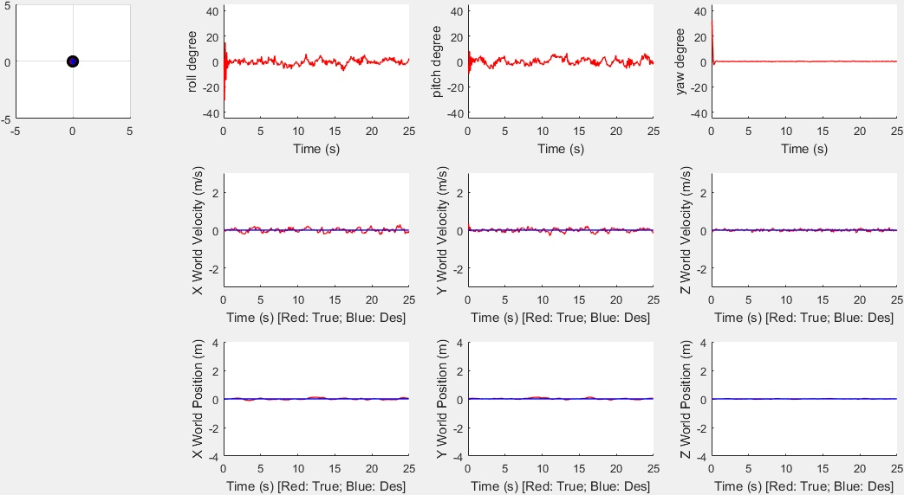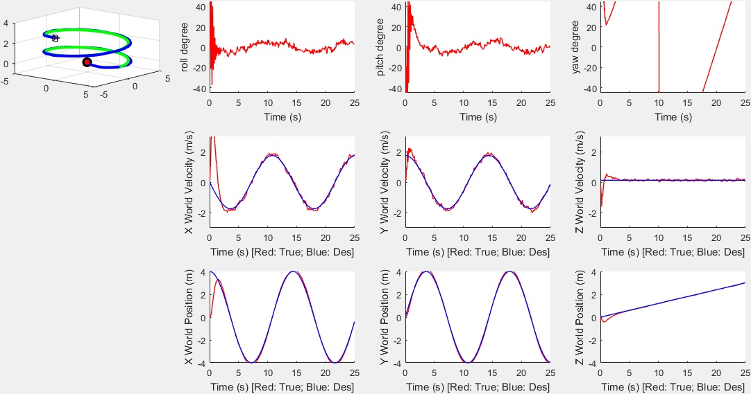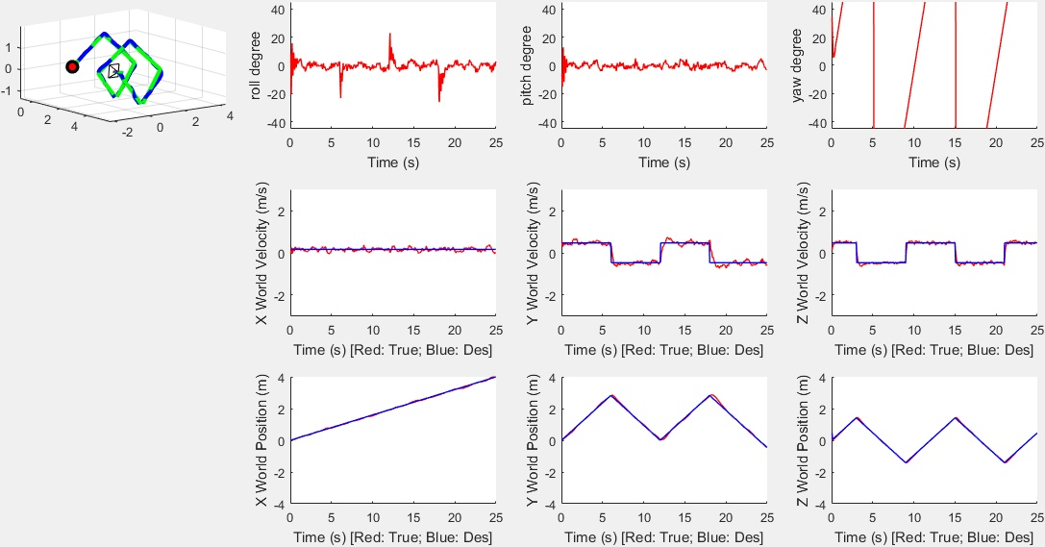

B)

For the hover trajectory, this controller has Root Mean Square error around **0.0383** for **X** position, **0.0848** for **Vx**, **0.0350** for **Y** position, **0.0987** for **Vy** and **0.0131** for **Z** position, **0.0484** for **Vz**;

For the circle trajectory, this controller has Root Mean Square error around **0.5871** for **X** position, **0.7705** for **Vx**, **0.1169** for **Y** position, **0.1791** for **Vy** and 0.**1094** for **Z** position, **0.1713** for the **Vz**;

For the diamond trajectory, this controller has Root Mean Square error around **0.0302** for **X** position, for **Vx**, **0.0639** for **Y** position, **0.1564** for **Vy** and **0.0315** for **Z** position, **0.1078** for **Vz**.