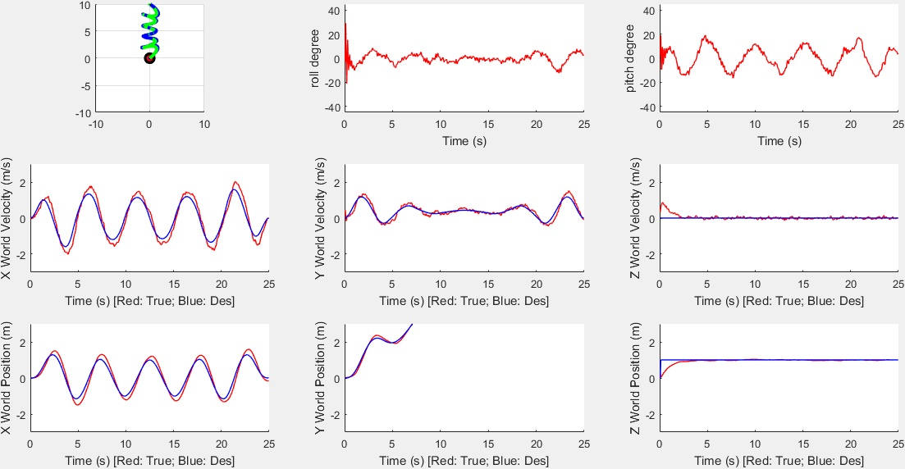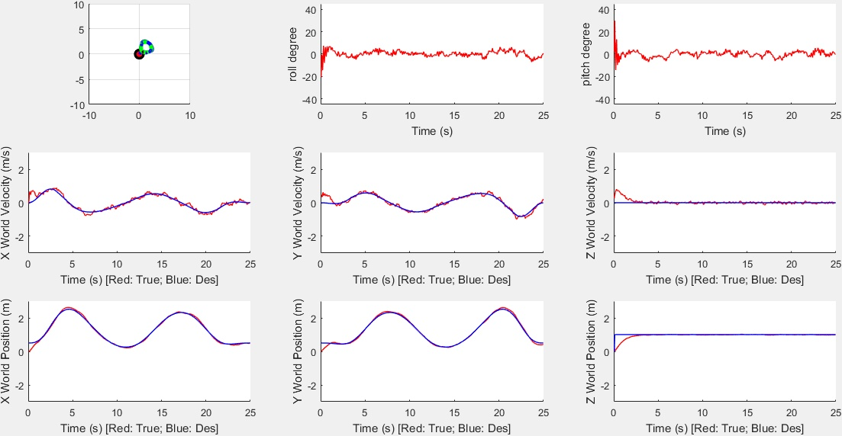

The RMS of velocity **x** in path1 is **0.2973**, of position **x** is **0.2152**;

The RMS of velocity **y** in path1 is **0.1552**, of position **y** is **0.0979**;

The RMS of velocity **z** in path1 is **0.1446**, of position **z** is **0.1546**;

The RMS of velocity **x** in path2 is **0.1175**, of position **x** is **0.0894**;

The RMS of velocity **y** in path2 is **0.1547**, of position **y** is **0.0799**;

The RMS of velocity **z** in path2 is **0.1456**, of position **z** is **0.1554**;