**Conflict of Interest Statement**  
  
The author declares no conflict of interest related to this work. Specifically:  
  
1. **Funding Sources**   
 This research received no external funding, grants, or financial support from any organization. All data acquisition and analysis were self-funded.  
  
2. **Commercial Ties**   
 There are no commercial or financial relationships with entities producing materials mentioned in this study (including Pt, Ni, Fe suppliers).  
  
3. **Academic Integrity**   
 I have used AI to assist writing. Specific purposes: 1. Language polishing 2. Inquiring about the information of cited papers 3. Inquiring about the specific data published by NIST. See GitHub for detailed records.  
  
4. **Data Transparency**   
 Raw data were obtained exclusively from public databases (NIST, CRC, Materials Project). Processed datasets and codes are available at:   
 https://github.com/LIUbingqian727/resistivity-study-2025.git  
  
5. **Guardian Certification**   
 As a 15-year-old researcher, this declaration is co-verified by my legal guardian:   
 Guardian Name: ______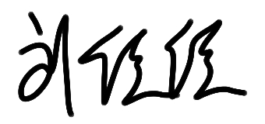_________   
 Signature: _______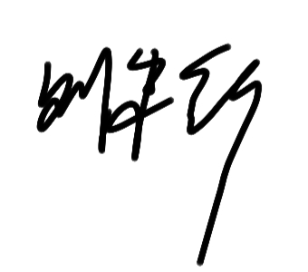___________   
 Date: 2023.07.15