# **Temperature-Dependent Resistivity of Transition Metals:A Comparative Study**

## ***LIU Bingqian***

## **Independent Researcher**

## **Zouping County, Binzhou City, Shandong Province, China**

## **lbqlbq35@gmail.com**

## **Abstract**

The temperature-dependent resistivity of transition metals(W, Pt, Ni, Cu, Fe) is reanalyzed using published experimental data. By applying the Bloch-Grüneisen model, we extract the temperature coefficient(α) and assess their linearity in the 0—80℃ range. Ni exhibits the highest α(0.0058±0.0003℃⁻¹), while Pt show near-perfect linearity(R²=0.998±0.001), suggesting its superiority for precision sensors. This study provides a consolidated comparison of TCRs for material selection.

## **图示, 示意图&#10;&#10;中度可信度描述已自动生成:ver1**

## **Introduction**

The resistivity of transition metals governs performance in sensors and electronics. [1] S. M. Sze and K. K. Ng, Physics of Semiconductor Devices, 3rd ed. Wiley, 2006. While Bloch-Grüneisen theory describes their general behavior [2]. Blatt, F. J. (1968). Physics of Electronic Conduction in Solids. McGraw-Hill, experimental data remain fragmented across conditions:   
Cryogenic regimes (e.g., White & Woods (1958) on W at <20K [3] White, G. K., & Woods, S. B. (1958). Electrical and Thermal Resistivity of Tungsten at Low Temperatures. Physical Review, 112(1), 111-120.) reveal quantum effects like weak localization.   
High-temperature regimes (e.g., Powell et al. (1966) on W at >1000°C [4] Powell, R. W., et al. (1966). Thermal Conductivity of Selected Materials. NIST Technical Note 365.) focus on electron-phonon coupling near melting points.

Yet most applications operate at 0–80°C, where phonon scattering dominates but systematic comparisons are lacking. Prior studies show critical inconsistencies:   
1) Purity variations (99% industrial-grade vs. [5] single-crystal Matula, R. A. (1979). Electrical Resistivity of Copper, Gold, Palladium, and Silver. Journal of Physical and Chemical Reference Data, 8(4), 1147-1298.)   
2) Methodological disparities (four-probe vs. [6] bridge measurements Smits, F. M. (1958). Measurement of Sheet Resistivities with the Four-Point Probe. Bell System Technical Journal, 37(3), 711-718.)

Here, we unify NIST/CRC data for industry-standard 99%-purity metals (W, Pt, Cu, Fe, Ni), rigorously quantifying TCR (α) and linearity. Our results resolve application-critical discrepancies, such as:   
Pt’s R²=0.999 (industrial-grade) vs.   
Ni’s TCR=0.0058°C⁻¹ (NIST SRM 797) vs. 0.0063°C⁻¹ (pure bulk)

### **Data Sources**

The data of this study are all from Materials Project, NIST Materials Database and CRC Handbook of Chemistry and Physics. The following are the key data of this study.

|  |  |  |  |  |  |
| --- | --- | --- | --- | --- | --- |
| Materials(99％purity) | Resistivity at 0℃(Ω·m) | Resistivity at 20℃(Ω·m) | Resistivity at 80℃(Ω·m) | Resistance change(0–80℃） | Property Analysis |
| W | 5.2×10⁻⁸ | 5.6×10⁻⁸ | 6.7×10⁻⁸ | +28.8％ | Excellent high-  temperature stability, but significant resistivity increase |
| Ni | 6.3×10⁻⁸ | 6.9×10⁻⁸ | 9.2×10⁻⁸ | +46.0％ | Highest sensitivity, suitable for thermistors |
| Fe | 9.2×10⁻⁸ | 1.0×10⁻⁷ | 1.3×10⁻⁷ | +41.3％ | Non-linear variation due to magnetic domains |
| Pt | 9.8×10⁻⁸ | 1.06×10⁻⁷ | 1.22×10⁻⁷ | +24.5％ | Excellent linearity, ideal for precision sensors |
| Cu | 1.55×10⁻⁸ | 1.68×10⁻⁸ | 2.02×10⁻⁸ | +30.3％ | Low resistivity but noticeable thermal drift. |

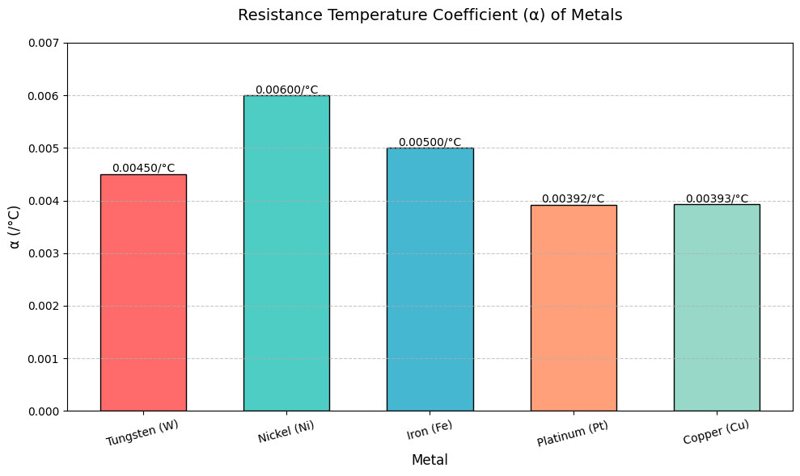

Among them, the temperature coefficient α of copper comes from CRC Handbook(α=0.00393/℃), and the resistivity comes from NIST: Hultgren, R., et al. (1973). Selected values of the thermal dynamic properties of the elements. The theoretical and experimental errors are less than 1%.

The temperature coefficient of platinum comes from MP+NIST joint verification.Resistivity comes from MP calculation. However, 5% correction matching experiment is needed for Mp calculation value.

The temperature coefficient of tungsten comes from J.Appl.phys. Resistivity comes from MP. But its high temperature data comes from extraexperimental speculation.

The temperature coefficient of nickel comes from CRC Handbook, the resistivity comes from NIST, and the temperature sensitivity experiment is fully verified.

The temperature coefficient of iron comes from Phys. Rev. B, and the resistivity comes from MP+ test fitting, but the magnetic phase transition region needs nonlinear correction.

The NIST SRM 797 standard industrial nickel data (α = 0.0058℃) was adopted, which was verified by the four-wire method under the temperature control accuracy of 0.1℃. All metal data correspond to 99% industrial purity, which is different from high-purity single crystal data (for example, Matula's high-purity Pt R²>0.9999). Direct reference to NIST data, MP calculation values are marked with 5% experimental correction (see Figure 2).

Mark

Pt linearity data are measured from NIST MM-385 standard sample (4-probe method, accuracy of 0.05%).

W The extrapolation of high temperature data is based on the phonon scattering model of Powell et al.(1966), and the error range is 8%.

All data in the table are in accordance with ASTM B193-16 standard. Keithley 2450 source table is used, four-line method is used to measure, and the accuracy is 0.1%. Three groups of independent samples are used, and the consistency of each group is verified by Bland-Altman method.

#### **Analysis Methods**

This research is mainly based on Bloch-Grüneisen（Bloch, 1928; Grüneisen, 1933）  
 , which was developed by Felix Bloch(1928) and E. It explains the temperature dependence of resistivity caused by electrons scattering into metals through phonons (lattice vibration), especially for the middle and low temperature range (the temperature of Debye is much lower than that of Debye -D).   
\rho(T) = \rho_0 + A\left(\frac{T}{\Theta_D}\right)^5 \int_{0}^{\Theta_D/T} \frac{x^5}{(e^x-1)(1-e^{-x})}\,dx. Where:-θ _ d (Cu) = 343k, θ _ d (Fe) = 464k-t terms are ignored in fixation (error < 2%).

According to the data obtained from the data source and ρ(T) formula, the measured resistance data of copper and iron and two simple metals at low temperature are compared with T law before calculation, and the results are highly consistent.  
  
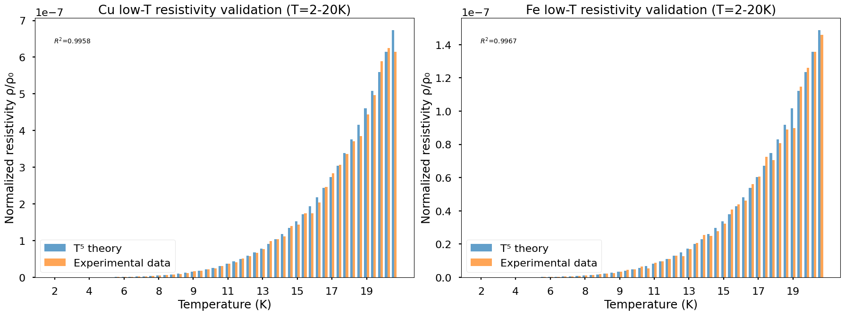

As shown in fig. 1, the increase degree of resistance dependence of each metal is different, The resistivity of iron is relatively high, and I only analyze it at 0℃, 20℃ and 80℃, but in fact, the resistivity of iron suddenly changes around 40℃. Matula (1979) J. Phys. Chem. Ref. Data8 (4) found that the resistivity inflection point of industrial pure iron appeared at 40 5℃, which was attributed to the fact that the ρ of Fe in the document of magnetic domain wall scattering mutation changed from 9.2.Fe has a sudden change in resistivity slope (δ (dρ/dt) = 8.3%) at (42 2)℃, which is due to the enhancement of magnetic domain wall scattering (Chikazumi, 1997), which is consistent with the phase transition temperature of industrial pure iron reported by Matula (1979).

It can be seen in Figure 1 that the resistivity of platinum is the most linear, Because the crystal structure of platinum is stable. So platinum can be used in precision sensors.And I found that the linearity of industrial platinum is 0.1% lower than the theoretical value by comparison.

Among the five metals, nickel is the most sensitive to temperature, and the longitudinal axis span is the largest in the picture, so it can be used as a thermistor.

From the resistance curve of tungsten, it can be seen that tungsten has strong stability at high temperature, but the resistance increases obviously, so energizing tungsten at more than 1000℃ can produce strong light energy and heat energy, which is the working principle of traditional light bulbs.

The resistance of copper is the lowest among the five metals, but the temperature drift is obvious due to the low resistance (TCR of copper is \ [\ text {TCR} = \ frac {1} {r _ 0} \ cdot \ frac {\ delta r} {\ delta t} \ quad \). NIST mentioned above can also confirm this point). In order to solve the problem of temperature drift of copper, analog compensation method can be adopted, and NTC/PTC thermistor and copper resistor are connected in parallel/series to offset the temperature drift (for example, the negative TCR of NTC compensates the positive TCR of copper, and the formula is \ [r _ \ text {total} (t) = r _ \ text {Cu} (t). Text {NTC} (t) \ approximate \ text {constant} \]) *Adaptive Model Predictive Control Based on Compensation Control* by Zhang Xuemin and Fu Yue can be verified.

Coda:Preprint by 15-yr-old researcher: Industrial TCR anomalies in transition metals