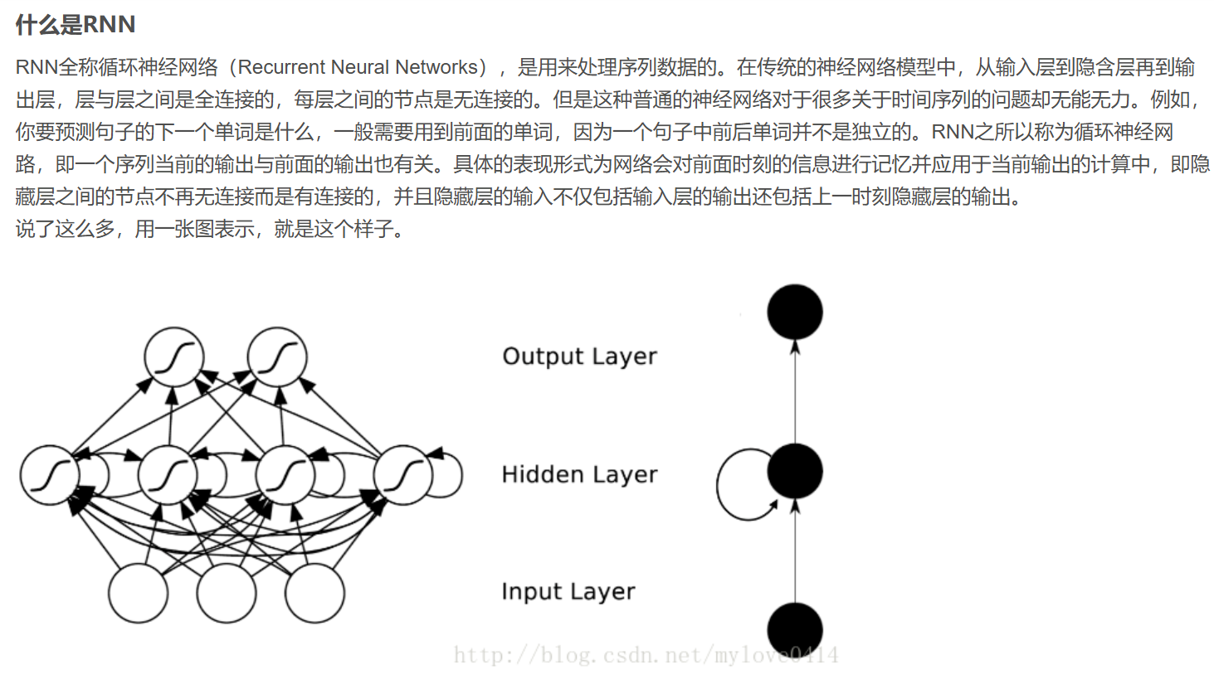
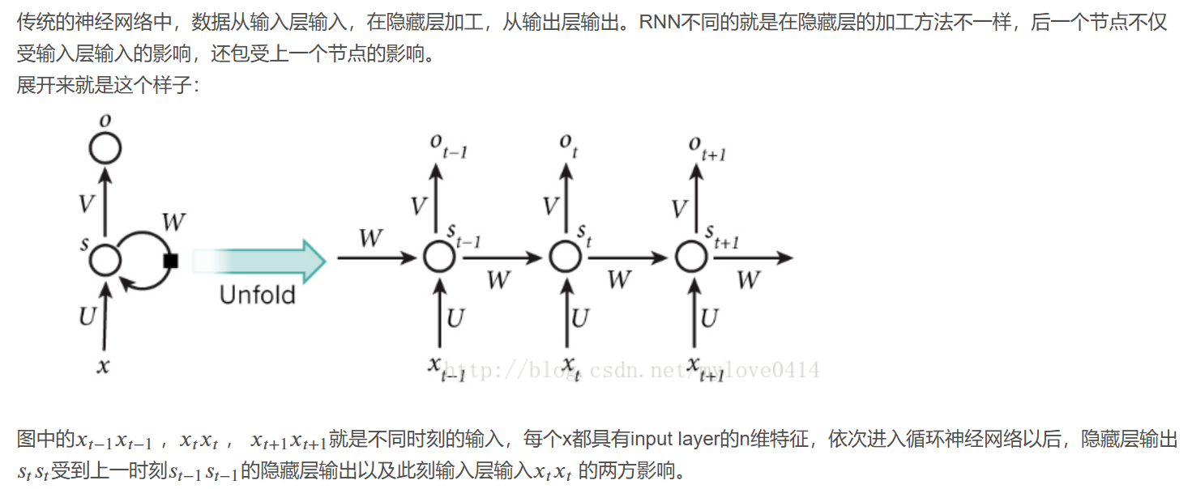

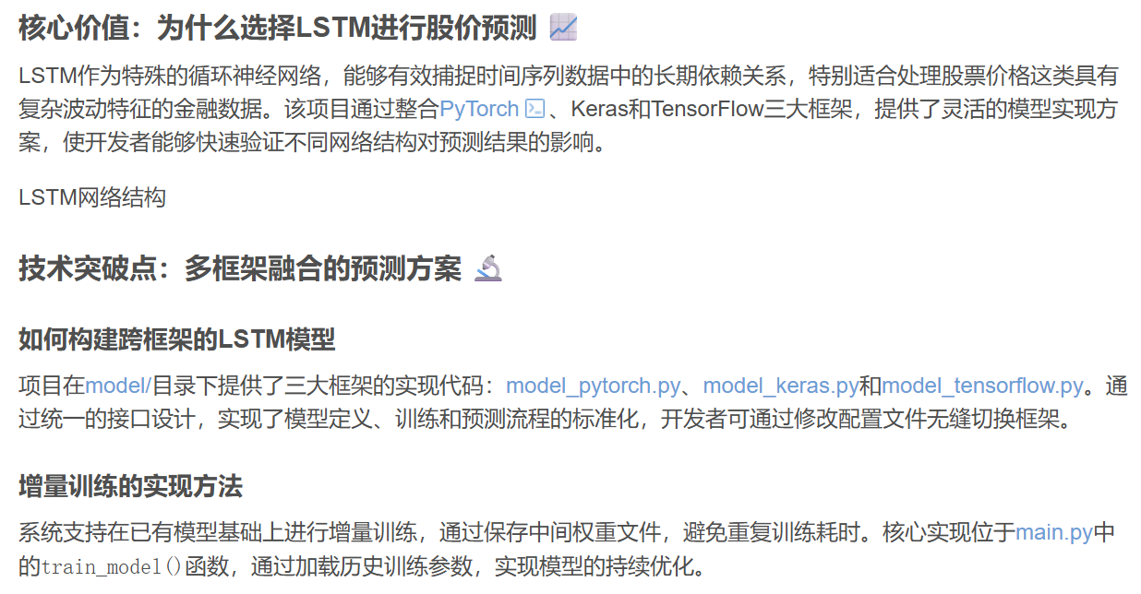

更详细的说明：https://blog.csdn.net/2501_91025807/article/details/159605254?fromshare=blogdetail&sharetype=blogdetail&sharerId=159605254&sharerefer=PC&sharesource=2301_80159094&sharefrom=from_link

