Fundamentals

Overview
Table of Contents
Overview 1
Structure of Enbios 2
Configuration 2
Validation 3
Initializing an experiment 3
Running an experiment 4
Running a scenario 4
A first simple example 4
Configuration details 10
How to configure Adapters and Aggregators 11
Builtin adapters and aggregators 13
Splitting the config file 13
Hierarchy 13
Exporting the results 13
Exporting the results to json 13
Exporting the results to csv 14
Storing the experiment as a pickle 16
Aggregating the results into alternative hierarchies 16
Creating Adapters and Aggregators 17
Adapter 19
Aggregator 20
Environmental variables 21
Plotting results 21
Full Experiment API 24

This version is based on a very simple assumption. Calculating arbitrary (structural/terminal nodes) and aggregated values (functional nodes) in a MuSIASEM hierarchy for any type of scenarios (functional outputs).
The following diagram explains the main components and their interaction. The main class is the Experiment. It requires a configuration object, which can come directly from a json file (or a python dict object).
The behaviour of the MuSIASEM hierarchy elements (here called nodes) is not defined by fixed core implementation of enbios, but through adapters and aggregators, which can dynamically be added. We differentiate two types of nodes. Structural nodes (those at the bottom of the hierarchy) and functional nodes (all nodes not on the bottom). An experiment can specify any number of scenarios. Each scenario can specify different outputs for the nodes defined in the hierarchy.
Structural nodes are each assigned an adapter, which calculates their result values based on their given output in a scenario. Both outputs and resultvalues are passed up in the hierarchy until the root node (which is a functional node).
Functional nodes are each assigned an aggregator, which aggregates outputs and results and pass those up the hierarchy ( if there is a level up in the hierarchy for any given node).

Structure of Enbios
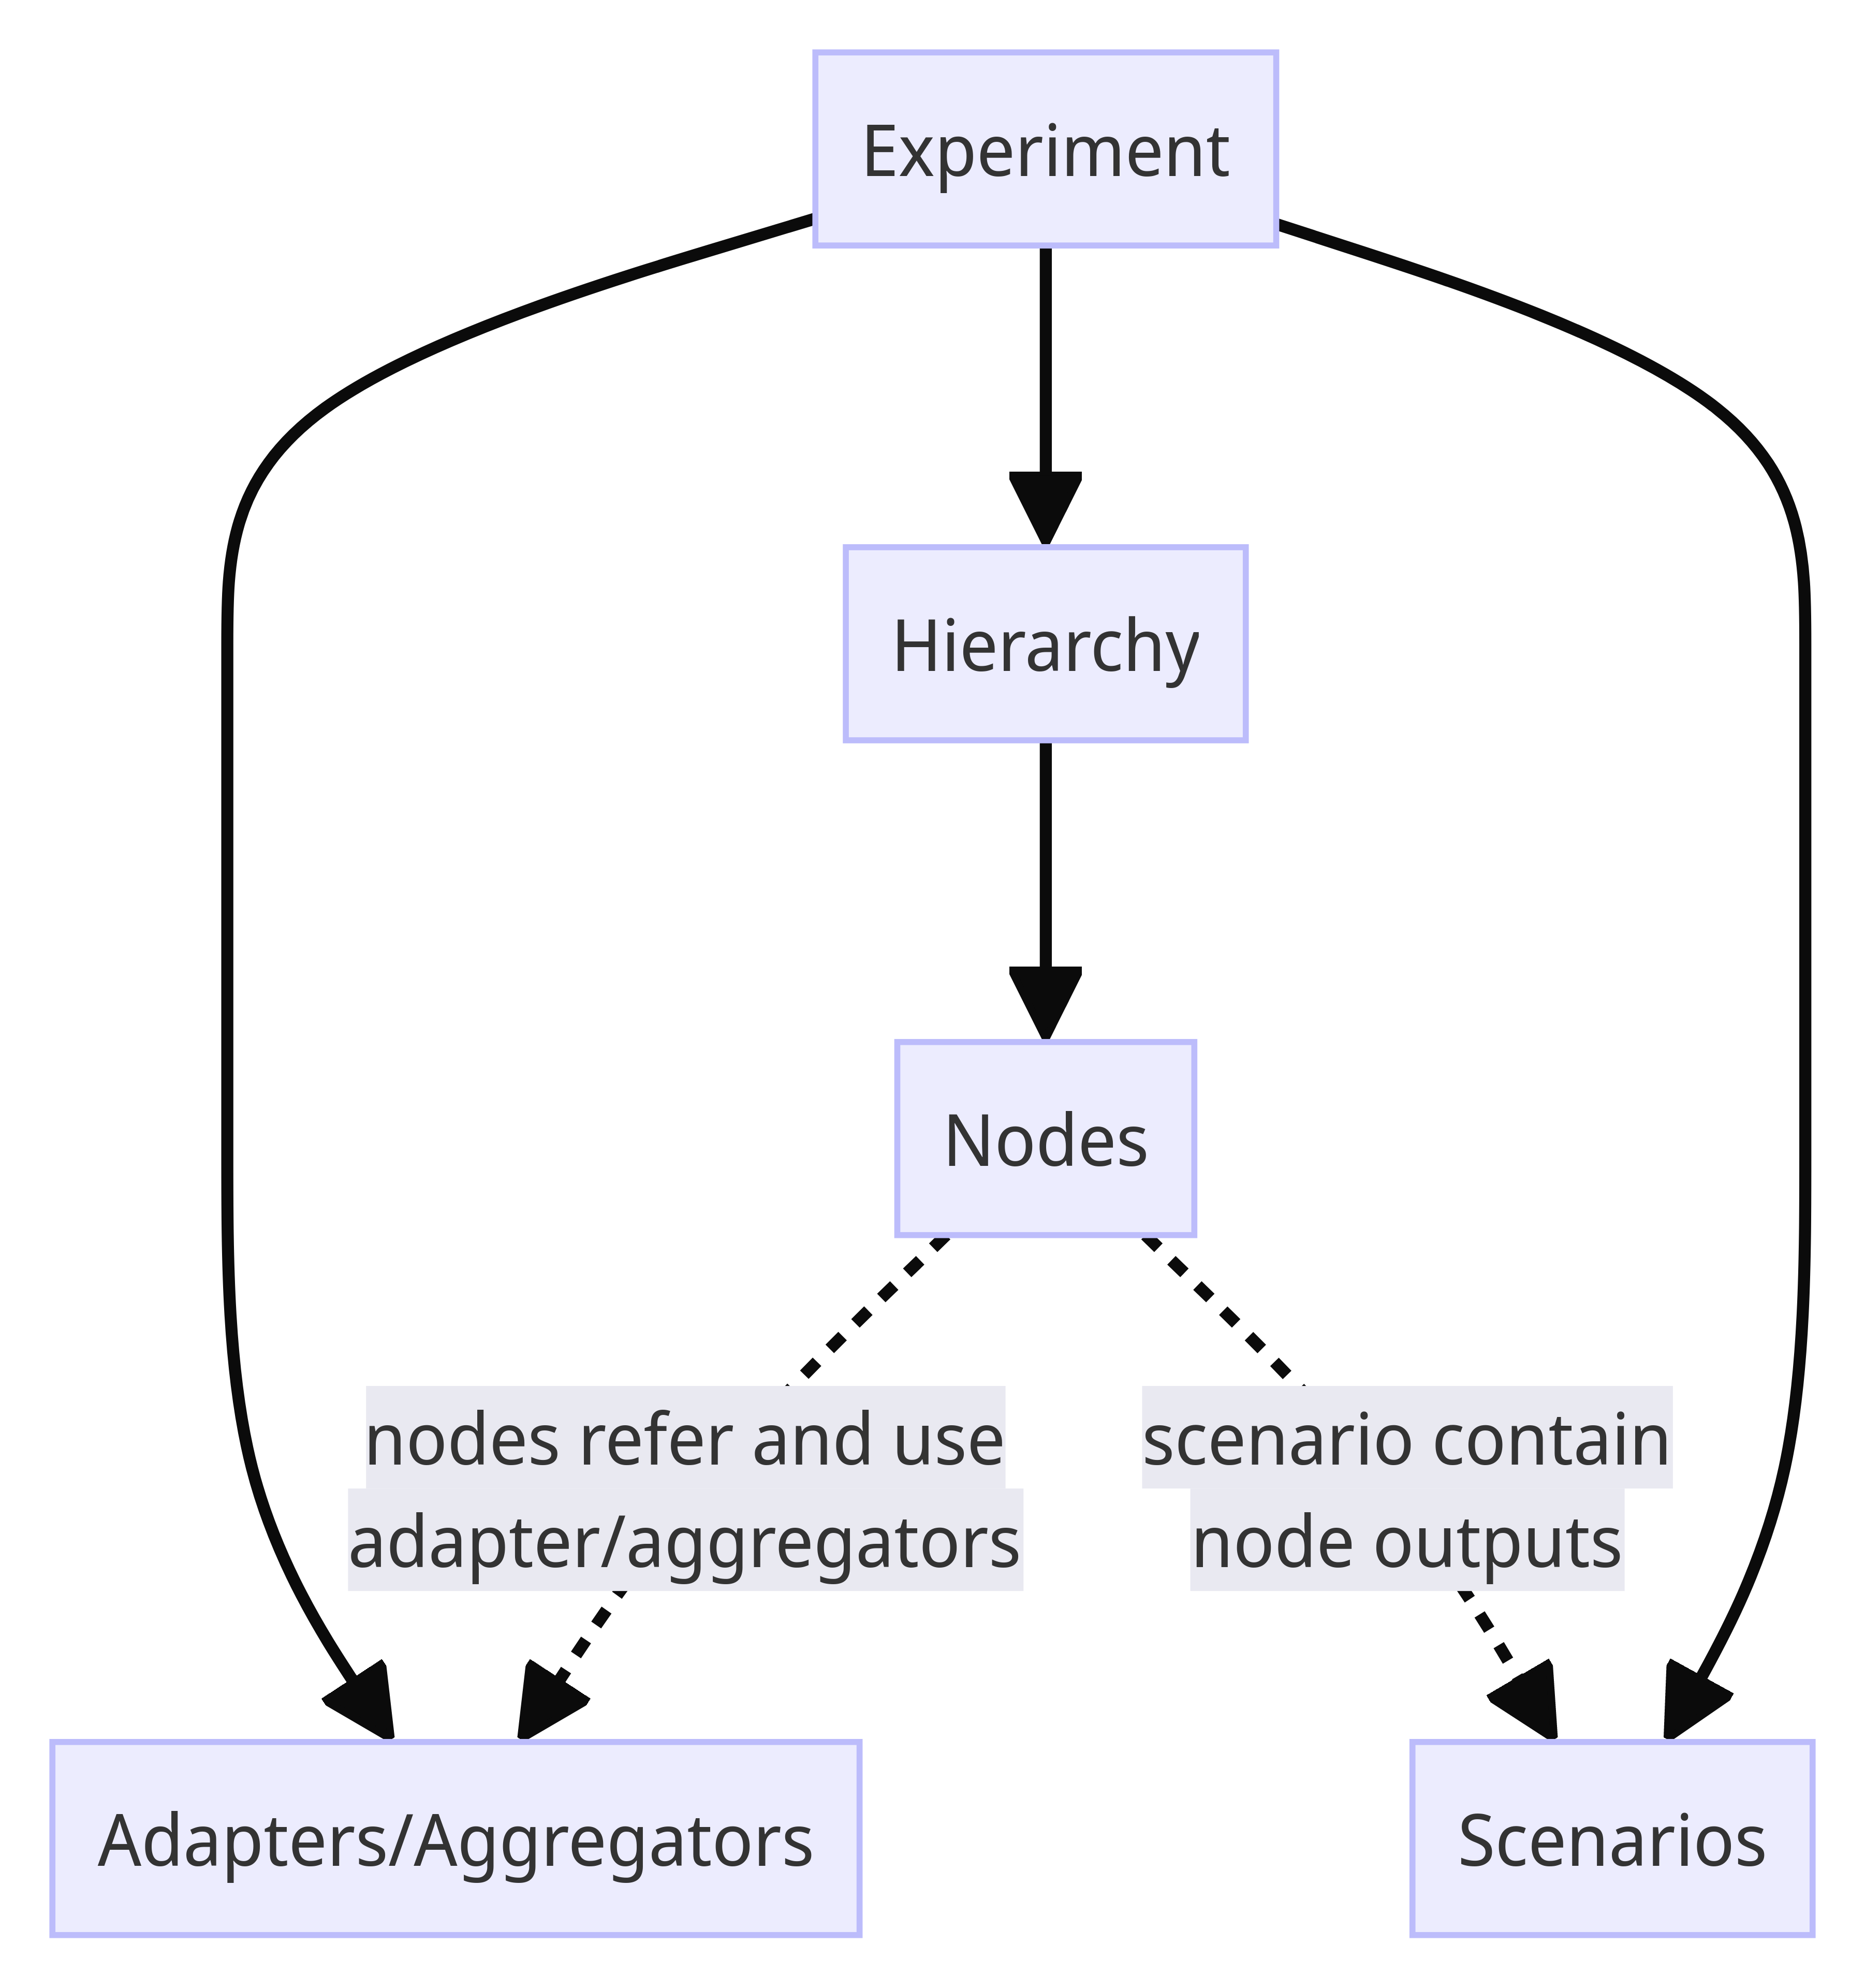
In creation of an enbios experiment. its configuration, is on strictly validated. Afterward any scenario or all scenarios, defined in the config object can be executed.
The full experiment API can be found here.
This version of enbios, is built with flexibility in mind. That means, the value calculation for structural nodes and aggregation calculations for functional nodes is done in external python modules. Through this approach, users can develop new arbitrary calculation (Adapter) and aggregation (Aggregator) modules and use them in Enbios.

Configuration
As seen above these are the main parts of an enbios config
- adapters: a list of adapter configurations, that should be used in this experiment
- aggregators: a list of aggregator configurations, that should be used in this experiment
- hierarchy: a tree-like structure, where each node in the tree needs a name, depending on its position (structural or functional) an association with an adapter or aggregator, and some specific configuration for that (e.g. how to identify the node in the adapter/aggregator, default outputs)
- scenarios: a list of scenario configuration, containing in particular the outputs of the structural units
- config: Some generic configurations

Validation
Enbios uses pydantic (https://docs.pydantic.dev/latest/), as data validation library for the structural validation of the configuration. The complete structural definitions of the data, is also given as a JSON Schema (https://json-schema.org/) file https://github.com/LIVENlab/enbios/blob/main/data/schema/experiment.schema.gen.json Therefor the config data can also be validated with any JSON Schema validator ( e.g. https://www.jsonschemavalidator.net/)

Initializing an experiment
An Experiment can be initialized in the 3 following ways.
- Passing a python dictionary object, which contains the configuration
- Passing a string to a JSON file, which contains the configuration
- Not passing anything to the experiment, which will make enbios look for a JSON file at the path given for the environmental variable CONFIG_FILE.
This starts off the following steps of validation and preparation:
- check environment variables for link to experiment config file
- register additional units
- validate experiment data (structural validation)
- resolve experiment data links (eventual links to hierarchy and scenario files)
- validate full experiment data (structural validation)
- validate adapters
  - For each defined adapter: *️⃣
    - load adapter module
    - adapter.validate_definition *️⃣
    - adapter.validate_config *️⃣
    - adapter.validate_methods *️⃣
  - load builtin adapters
- validate aggregators
  - For each defined aggregator: ⏏️
    - load aggregator module
    - aggregator.validate_definition ⏏️
    - aggregator.validate_config ⏏️
  - load builtin aggregators
- validate hierarchy
  - basic structural validation
  - validate hierarchy nodes against their adapters, aggregators (adapter.validate_node *️⃣ / aggregator.validate_node ⏏️)
- create template result-tree
- validate scenarios
  - create default scenario, if no scenario is defined
  - for each defined scenario (or the default scenario):
    - validate scenario
      - for each node that the scenario specifies:
        - Validate the nodes scenario data against their adapter/aggregator: adapter.validate_scenario_node *️⃣ / aggregator.validate_scenario_node ⏏️)
    - prepare scenario result-tree
      - for all structural nodes of the result-tree:
        - Get the nodes output from its adapter: adapter.get_node_output *️⃣
      - eventually remove exclude defaults (nodes with no output for a scenario) from the result-tree
      - from top to bottom aggregate the outputs within the result-tree ( aggregator.aggregate_node_output ⏏️)
- validate scenario settings: Check if the environmental settings, specify which scenarios to run

Running an experiment
The function Experiment.run will run either
- all scenarios defined in the experiment config or
- run all scenarios specified in the config (a subset specifief in the experiment config or in through environmental variables )
Scenarios can also be run individually with: Experiment.run_scenario

Running a scenario
For all adapters specified for the experiment:
- adapter.run_scenario *️⃣
- add the results from the adapters to the result-tree
Propagate the results up in the result-tree:
From top to bottom aggregate the results within the result-tree (aggregator.aggregate_node_result ⏏️)

A first simple example
This example uses the brightway adapter and 4 activities of ecoinvent 3.9.1. The hierarchy contains 2 wind farms and 2 solar plants, which are in 2 functional nodes ('wind' and 'solar'). Additionally, the configuration contains 2 scenarios.
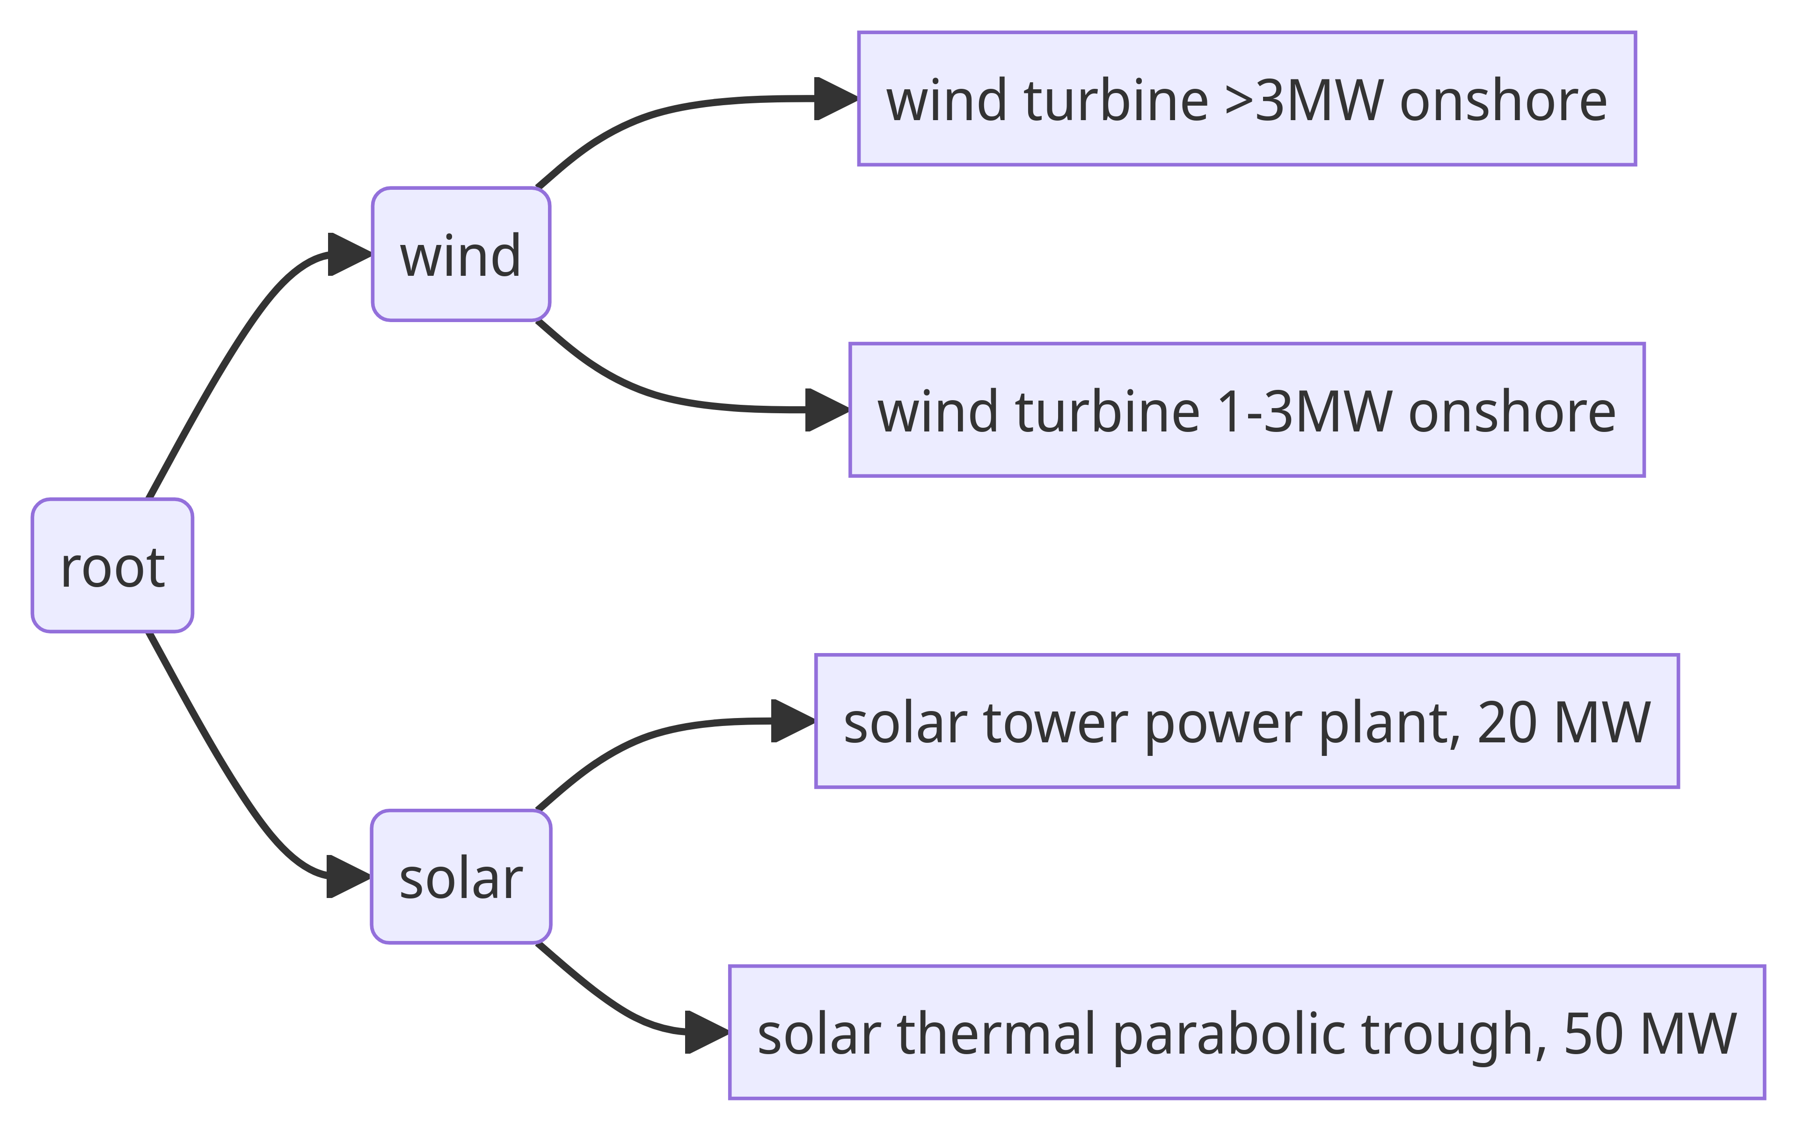
(structural nodes are rectangles and functional nodes are rounded rectangles)
This demo notebook shows how to build the configuration step by step.
Full details are below the configuration
{
"adapters": [
{
"adapter_name": "brightway-adapter",
"config": {
"bw_project": "ecoinvent_391"
},
"methods": {
"GWP1000": [
"ReCiPe 2016 v1.03, midpoint (H)",
"climate change",
"global warming potential (GWP1000)"
],
"FETP": [
"ReCiPe 2016 v1.03, midpoint (H)",
"ecotoxicity: freshwater",
"freshwater ecotoxicity potential (FETP)"
]
}
}
],
"hierarchy": {
"name": "root",
"aggregator": "sum",
"children": [
{
"name": "wind",
"aggregator": "sum",
"children": [
{
"name": "wind turbine >3MW onshore",
"adapter": "bw",
"config": {
"code": "0d48975a3766c13e68cedeb6c24f6f74",
"default_output": {
"unit": "kilowatt_hour",
"magnitude": 3
}
}
},
{
"name": "wind turbine 1-3MW onshore",
"adapter": "bw",
"config": {
"code": "ed3da88fc23311ee183e9ffd376de89b"
}
}
]
},
{
"name": "solar",
"aggregator": "sum",
"children": [
{
"name": "solar tower power plant, 20 MW",
"adapter": "bw",
"config": {
"code": "f2700b2ffcb6b32143a6f95d9cca1721"
}
},
{
"name": "solar thermal parabolic trough, 50 MW",
"adapter": "bw",
"config": {
"code": "19040cdacdbf038e2f6ad59814f7a9ed"
}
}
]
}
]
},
"scenarios": [
{
"name": "normal scenario",
"nodes": {
"wind turbine >3MW onshore": [
"kilowatt_hour",
1
],
"wind turbine 1-3MW onshore": [
"kilowatt_hour",
1
],
"solar tower power plant, 20 MW": [
"kilowatt_hour",
1
],
"solar thermal parabolic trough, 50 MW": [
"kilowatt_hour",
1
]
}
},
{
"name": "randomized outputs",
"nodes": {
"wind turbine >3MW onshore": [
"kilowatt_hour",
6
],
"wind turbine 1-3MW onshore": [
"kilowatt_hour",
1
],
"solar tower power plant, 20 MW": [
"kilowatt_hour",
8
],
"solar thermal parabolic trough, 50 MW": [
"kilowatt_hour",
6
]
}
}
]
}
Upon running the experiment with the fiven configuration we get this result (if converted into a dict):
{
"normal scenario": {
"name": "root",
"results": {
"GWP1000": {
"unit": "kg CO2-Eq",
"magnitude": 0.142615182893779
},
"FETP": {
"unit": "kg 1,4-DCB-Eq",
"magnitude": 0.06303329465759974
}
},
"output": [
{
"unit": "kilowatt_hour",
"magnitude": 4.0,
"label": null
}
],
"children": [
{
"name": "wind",
"results": {
"GWP1000": {
"unit": "kg CO2-Eq",
"magnitude": 0.04021441221464619
},
"FETP": {
"unit": "kg 1,4-DCB-Eq",
"magnitude": 0.0566978988042604
}
},
"output": [
{
"unit": "kilowatt_hour",
"magnitude": 2.0,
"label": null
}
],
"children": [
{
"name": "wind turbine >3MW onshore",
"results": {
"GWP1000": {
"unit": "kg CO2-Eq",
"magnitude": 0.024970800870991273
},
"FETP": {
"unit": "kg 1,4-DCB-Eq",
"magnitude": 0.050272290729750875
}
},
"output": [
{
"unit": "kilowatt_hour",
"magnitude": 1.0,
"label": null
}
],
"bw_activity_code": "0d48975a3766c13e68cedeb6c24f6f74"
},
{
"name": "wind turbine 1-3MW onshore",
"results": {
"GWP1000": {
"unit": "kg CO2-Eq",
"magnitude": 0.015243611343654916
},
"FETP": {
"unit": "kg 1,4-DCB-Eq",
"magnitude": 0.006425608074509521
}
},
"output": [
{
"unit": "kilowatt_hour",
"magnitude": 1.0,
"label": null
}
],
"bw_activity_code": "ed3da88fc23311ee183e9ffd376de89b"
}
]
},
{
"name": "solar",
"results": {
"GWP1000": {
"unit": "kg CO2-Eq",
"magnitude": 0.10240077067913281
},
"FETP": {
"unit": "kg 1,4-DCB-Eq",
"magnitude": 0.006335395853339337
}
},
"output": [
{
"unit": "kilowatt_hour",
"magnitude": 2.0,
"label": null
}
],
"children": [
{
"name": "solar tower power plant, 20 MW",
"results": {
"GWP1000": {
"unit": "kg CO2-Eq",
"magnitude": 0.04820458190235993
},
"FETP": {
"unit": "kg 1,4-DCB-Eq",
"magnitude": 0.0032423199619428613
}
},
"output": [
{
"unit": "kilowatt_hour",
"magnitude": 1.0,
"label": null
}
],
"bw_activity_code": "f2700b2ffcb6b32143a6f95d9cca1721"
},
{
"name": "solar thermal parabolic trough, 50 MW",
"results": {
"GWP1000": {
"unit": "kg CO2-Eq",
"magnitude": 0.05419618877677287
},
"FETP": {
"unit": "kg 1,4-DCB-Eq",
"magnitude": 0.0030930758913964764
}
},
"output": [
{
"unit": "kilowatt_hour",
"magnitude": 1.0,
"label": null
}
],
"bw_activity_code": "19040cdacdbf038e2f6ad59814f7a9ed"
}
]
}
]
},
"randomized outputs": {
"name": "root",
"results": {
"GWP1000": {
"unit": "kg CO2-Eq",
"magnitude": 0.8758822044490706
},
"FETP": {
"unit": "kg 1,4-DCB-Eq",
"magnitude": 0.35255636749694047
}
},
"output": [
{
"unit": "kilowatt_hour",
"magnitude": 21.0,
"label": null
}
],
"children": [
{
"name": "wind",
"results": {
"GWP1000": {
"unit": "kg CO2-Eq",
"magnitude": 0.1650684165695875
},
"FETP": {
"unit": "kg 1,4-DCB-Eq",
"magnitude": 0.30805935245300914
}
},
"output": [
{
"unit": "kilowatt_hour",
"magnitude": 7.0,
"label": null
}
],
"children": [
{
"name": "wind turbine >3MW onshore",
"results": {
"GWP1000": {
"unit": "kg CO2-Eq",
"magnitude": 0.14982480522593258
},
"FETP": {
"unit": "kg 1,4-DCB-Eq",
"magnitude": 0.3016337443784996
}
},
"output": [
{
"unit": "kilowatt_hour",
"magnitude": 6.0,
"label": null
}
],
"bw_activity_code": "0d48975a3766c13e68cedeb6c24f6f74"
},
{
"name": "wind turbine 1-3MW onshore",
"results": {
"GWP1000": {
"unit": "kg CO2-Eq",
"magnitude": 0.015243611343654916
},
"FETP": {
"unit": "kg 1,4-DCB-Eq",
"magnitude": 0.006425608074509521
}
},
"output": [
{
"unit": "kilowatt_hour",
"magnitude": 1.0,
"label": null
}
],
"bw_activity_code": "ed3da88fc23311ee183e9ffd376de89b"
}
]
},
{
"name": "solar",
"results": {
"GWP1000": {
"unit": "kg CO2-Eq",
"magnitude": 0.7108137878794831
},
"FETP": {
"unit": "kg 1,4-DCB-Eq",
"magnitude": 0.04449701504393135
}
},
"output": [
{
"unit": "kilowatt_hour",
"magnitude": 14.0,
"label": null
}
],
"children": [
{
"name": "solar tower power plant, 20 MW",
"results": {
"GWP1000": {
"unit": "kg CO2-Eq",
"magnitude": 0.38563665521887946
},
"FETP": {
"unit": "kg 1,4-DCB-Eq",
"magnitude": 0.02593855969554289
}
},
"output": [
{
"unit": "kilowatt_hour",
"magnitude": 8.0,
"label": null
}
],
"bw_activity_code": "f2700b2ffcb6b32143a6f95d9cca1721"
},
{
"name": "solar thermal parabolic trough, 50 MW",
"results": {
"GWP1000": {
"unit": "kg CO2-Eq",
"magnitude": 0.3251771326606037
},
"FETP": {
"unit": "kg 1,4-DCB-Eq",
"magnitude": 0.018558455348388462
}
},
"output": [
{
"unit": "kilowatt_hour",
"magnitude": 6.0,
"label": null
}
],
"bw_activity_code": "19040cdacdbf038e2f6ad59814f7a9ed"
}
]
}
]
}
}

Configuration details
adapters: This list contains only the configuration for brightway-adapter. For each adapter, one of the given fields must be given:
module_path: The absolute path of the module that contains the adapter.
adapter_name: The name of the builtin adapter.
Respectively for an aggregator (module_path, aggregator_name)
Besides the identification the adapter should have the fields config and methods. For the config of the brightway-adapter it is crucial to include the field bw_project, so that enbios know which brightway project to use.
For methods we need to pass a dictionary, where the keys are arbitrary names that we give to the method and the tuple of strings, which are the names/identifiers of methods in brightway.
aggregators:
Since we only make use of the builtin sum-aggregator which does not require any configuration, we can omit, this field in the experiment configuration.
hierarchy:
Each node in the hierarchy has the following fields
name: An arbitrary name for that node (all names must be unique in the hierarchy)
adapter | aggregator : All structural nodes require an adapter field and all functional nodes require an aggregator field. The values correspond to the name of the module, or it's specific node_indicator, which are 'sum' for sum-aggregators and 'bw' for the brightway-adapter. (More details on that later)
children: A list of all the nodes children. This field is only required for functional nodes and must be omitted for structural nodes.
config: A node specific config, that will be passed on to the Adapter ore Aggregator. The required fields depend on the module at hand. In the case of brightway, we need some fields that help brightway to identify the activity.
scenarios:
A list of scenario configurations. Generally, we want to run multiple scenarios with different outputs for the structural nodes. Each configuration can have the following fields:
name: An arbitrary name for the scenario
activities: A dictionary where the keys are (structural) node names, as defined in the hierarchy and the values their outputs. The outputs can have the form of a dictionary with the keys: unit, magnitude or list of 2 elements, where the first one defines the unit and the 2nd the amount. E.g. these two definitions are equivalent: {'unit':'kilowatt_hour','magnitude':5} and ['kilowatt_hour', 5].
config: A dictionary with scenario specific configuration. A dictionary with 2 keys: name: Name of the scenario nodes: A dictionary of scenario specific configuration of each node. Keys are the node names, and values are adapter/aggregator specific.

How to configure Adapters and Aggregators
Before we look at how adapter and aggregator are created and work, we look at how users can look up how to specify them, when making use of them.
There are 2 parts in the experiment file, where adapter/aggregator specific data has to be used. In the configuration of the module (adapters/aggregators) in the experiment configuration and for each node, in the config field.
As seen in the example the adapter data for the brightway-adapter looks like this:
{
"adapter_name": "brightway-adapter",
"config": {
"bw_project": "ecoinvent_391"
},
"methods": {
"GWP1000": [
"ReCiPe 2016 v1.03, midpoint (H)",
"climate change",
"global warming potential (GWP1000)"
],
"FETP": [
"ReCiPe 2016 v1.03, midpoint (H)",
"ecotoxicity: freshwater",
"freshwater ecotoxicity potential (FETP)"
]
}
}
And the structural nodes in the example, have a config specific for the brightway_adapter

{
"name": "electricity production, wind, >3MW turbine, onshore",
"adapter": "bw",
"config": {
"code": "0d48975a3766c13e68cedeb6c24f6f74",
"default_output": {
"unit": "kilowatt_hour",
"magnitude": 3
}
}
}
All adapters/aggregators have the static function get_config_schemas, which gives us the corresponding json-schemas for configuration. Adapters return 3 schemas which are (by convention) called: adapter, activity and method, while aggregators contain the schemas aggregator, activity.
Since the method get_config_schemas is static, we can call it directly on the class and do not need to initiate any object before. So we can call BrightwayAdapter.get_config_schemas() to get its config schemas.
However, there are some functions in Experiment for convenience of getting all configurations. get_builtin_adapters(details: bool = True) get_builtin_aggregators(details: bool = True)
will return dictionaries, which include node_indicator (the indicator to use for nodes) and (if the parameter details is True (default:True)), config, which will have the 2 (or the 3 in the case of aggregators) fields.
E.g. get_builtin_adapters()['brightway-adapter']
On an experiment instance the following function can be called: get_all_configs(include_all_builtin_configs: bool = True), which will return all configs for all adapters and aggregators specified in the experiment config data and all builtin modules, when include_all_builtin_configs is set True (default).
The configs are in a dictionary in the fields adapters, aggregators
{
"adapters": {
"<adapter_name>": "<adapter_config>"
},
"aggregators": {
"...": "..."
}
}

Validation aspects of Adapters/Aggregators (summary)
In summary, adapter/aggregator specific validation happens at 3 locations of the configuration file:
- The adapter/aggregator definition itself
- Node configs against their corresponding adapter/aggregator
- Node scenario configs against their corresponding adapter/aggregator

Builtin adapters and aggregators
There are a some builtin adapters and aggregators:
Adapters:
- SimpleAssignmentAdapter: For this Adapter, the outputs and impacts can be defined in the adapter configuration
- BrightwayAdapter: This Adapter, uses brightway2 (https://docs.brightway.dev) in order to calculate impacts, based on the outputs of activities (structural nodes). See this notebook for all possible configs in one dictionary.
Aggregators
- SumAggregator: This Aggregator simply sums up the impact results of its children in the hierarchy.

Splitting the config file
The configuration of an experiment can also be split into multiple files. The hierarchy and scenarios can be separated in external files (and be provided in alternative formats).
See this notebook for details.

Hierarchy
Besides including the hierarchy in the configuration it is also possible to have a file location. Enbios is able to read hierarchies in 3 formats.
- as .json, which should be the same format as it would be in the experiment config.
- as .csv file The following jupyter notebook demonstrates how to use a csv file to specify the hierarchy:
- as .mermaid (or .mm) file As demonstrated in this notebook

Exporting the results
After running an experiment or individual scenarios, the results are stored in a tree structure.

Exporting the results to json
The result can be turned into a dictionary (and dumped into a json file) with the Experiment function:

results_to_dict
def results_to_dict(
scenarios: Optional[Union[str, list[str]]] = None,
include_method_units: bool = True,
include_output: bool = True,
include_extras: Optional[bool] = True,
alternative_hierarchy: Optional[dict] = None) -> list[dict[str, Any]]
Get the results of all scenarios as a list of dictionaries as dictionaries
Arguments:
- scenarios: A selection of scenarios to export. If None, all scenarios will be exported.
- alternative_hierarchy: If given, the results will be recalculated using the given alternative hierarchy. In this alternative hierarchy, tho, already defined nodeds need no config and no adapter/aggregator.
- include_method_units: Include the units of the methods in the header (default: True)
- include_output: Include the output of each node in the tree (default: True)
- include_extras: Include extras from adapters and aggregators in the results (default: True)
And for scenarios:

result_to_dict
def result_to_dict(
include_output: bool = True,
include_method_units: bool = True,
include_extras: bool = True,
warn_no_results: bool = True,
alternative_hierarchy: Optional[dict] = None) -> dict[str, Any]
Return the results as a dictionary
Arguments:
- include_method_units: (Include the units of the methods in the header)
- include_output: Include the output of all nodes (default: True)
- alternative_hierarchy: An alternative hierarchy to use for the results, which comes from Scenario.rearrange_results.
- warn_no_results: Write a warning, if the scenario has not run yet.

Exporting the results to csv
But can also be written to csv files with functions for Experiment (and scenarios respectively)

results_to_csv
def results_to_csv(file_path: PathLike,
scenarios: Optional[Union[str, list[str]]] = None,
level_names: Optional[list[str]] = None,
include_method_units: bool = True,
include_output: bool = True,
flat_hierarchy: Optional[bool] = False,
include_extras: Optional[bool] = True,
repeat_parent_name: bool = False,
alternative_hierarchy: Optional[dict] = None)
Turn the results into a csv file. If no scenario name is given,
it will export all scenarios to the same file,
Arguments:
- file_path: File path to export to
- scenarios: string or list of strings. If no scenario name is given, it will export all scenarios to the same file, with an additional column for the scenario alias
- level_names: (list of strings) If given, the results will be exported with the given level names. This is only effective when flat_hierarchy is False.
- include_method_units: (Include the units of the methods in the header)
- include_output: Include the output of all nodes (default: True)
- flat_hierarchy: If instead of representing each level of the hierarchy with its own column, we just indicate the node levels.
- include_extras: Include extras from adapters and aggregators in the results (default: True)
- repeat_parent_name: If True, the parent name will be repeated for each child node in the corresponding level column. This is only effective when flat_hierarchy is False. (default: False)
- alternative_hierarchy: If given, the results will be recalculated using the given alternative hierarchy. In this alternative hierarchy, tho, already defined nodeds need no config and no adapter/aggregator.

result_to_csv
def result_to_csv(file_path: PathLike,
level_names: Optional[list[str]] = None,
include_output: bool = True,
include_method_units: bool = True,
alternative_hierarchy: Optional[dict] = None,
flat_hierarchy: Optional[bool] = False,
repeat_parent_name: bool = False,
include_extras: bool = True,
warn_no_results: bool = True)
Save the results (as tree) to a csv file
:param file_path: path to save the results to :param level_names: names of the levels to include in the csv (must not match length of levels) :param include_method_units: (Include the units of the methods in the header)
Arguments:
- include_output: Include the output of all nodes (default: True)
- flat_hierarchy: If instead of representing each level of the hierarchy with its own column, we just indicate the node levels.
- include_extras: Include extras from adapters and aggregators in the results (default: True)
- repeat_parent_name: If True, the parent name will be repeated for each child node in the corresponding level column. This is only effective when flat_hierarchy is False. (default: False)
- alternative_hierarchy: If given, the results will be recalculated using the given alternative hierarchy. In this alternative hierarchy, tho, already defined nodeds need no config and no adapter/aggregator.
- warn_no_results: Write a warning, if the scenario has not run yet.
This notebook demonstrates to usage of the results_to_csv function.

Storing the experiment as a pickle
Sometimes it useful to keep the experiment object after an experiment has been run. The experiment object (or scenario objects) can be stored into files with the python module pickle (Read more about the pickle module here).
import pickle
from enbios.base.experiment import Experiment

config_file = "...some_config_path...json"
exp = Experiment(config_file)
exp.run()
with open("experiment.pickle", "wb") as fout:
pickle.dump(exp, fout)

## somewhere else (e.g. in another script)

exp: Experiment = pickle.load(open("experiment.pickle", "rb"))
This allows you to reopen the same experiment later, in order to
- run more scenarios
- recalculate the results with an alternative hierarchy (see the next section)
- do more plotting
- do alternative exports (omitting certain fields, or only selecting certain scenarios)
Caution
The pickle module is not secure. Only unpickle data you trust. That generally means, you should only use pickle to store experiments on one computer. It is well possible, that pickled experiments cannot be unpickled on other computers, when you are using custom adapters/aggregators.

Aggregating the results into alternative hierarchies
After running an experiment (or individual scenarios) it is also possible to restructure the results into alternative hierarchies. That means, that the results of the structural nodes, are not recalculated, but the functional nodes (which use adapters) recalculate their results. When this is done, configurations for adapter nodes do not need to be provided again. However, nodes with aggregators can redefine their config if wanted, or it might be needed, if the user introduces new functional nodes.
This notebook demonstrates how this can be done.

Creating Adapters and Aggregators
In order to create new adapters and aggregators, one has to create module which contain a class, which inherits from the abstract classes enbios.base.adapters_aggregators.adapter.EnbiosAdapter or enbios.base.adapters_aggregators.aggregator.EnbiosAggregator respectively.
The fact that these parent classes are abstract, means they both specify a set of abstract methods, which any subclass needs to implement.
The internals of these functions is mostly up to the developer, but they have to make sure, that they return data of the types that enbios requires (these return types are already included as return type hints in the abstract methods).
Since adapters and aggregators have several functions in common, there is a common parent class, which defines these functions. When creating a concrete adapter or aggregator, these functions have to be implemented as well.

EnbiosNodeModule Objects

validate_definition
@abstractmethod
def validate_definition(definition: T)
This is the first validator to be called. Validates the whole adapter/aggregator definition, which is the whole
dictionary (parse as enbios.models.models.AdapterModel)
Arguments:
- definition: the whole adapter/aggregator definition (containing 'config' and 'methods')

validate_config
@abstractmethod
def validate_config(config: Optional[dict[str, Any]])
Validate the config. The creator may store anything in the
adapter/aggregator object through this method.
Arguments:
- config: the configuration of the adapter/aggregator, which might have its own BaseModel. For understanding the structure, it makes sense to provide this model as a return value of "adapter/aggregator" in the get_config_schemas() method.

validate_node
@abstractmethod
def validate_node(node_name: str, node_config: Any)

validate_scenario_node
@abstractmethod
def validate_scenario_node(node_name: str, scenario_name: str,
scenario_node_data: Any)
Validates the output of a node within a scenario. Is called for each node within a scenario.
Arguments:
- node_name: Name of the node in the hierarchy.
- scenario_name: Name of scenario
- scenario_node_data: The output or config of the node in the scenario

node_indicator
@staticmethod
@abstractmethod
def node_indicator() -> str
This string can be used in order to indicate that a node in the hierarchy should use this adapter/aggregator.
Returns:
node-indicator string

get_config_schemas
@staticmethod
@abstractmethod
def get_config_schemas() -> dict[str, dict[str, Any]]
Get the Jsonschema for the adapter/aggregator. These can be derived, when there are pydantic based models
for validation (using the model_json_schema function). The structure of the return value should correspond to the three parts of validation, the adapter/aggregator-config, the node-configs in the hierarchy and the methods.
Returns:
dictionary, where each key corresponds to one part of validation (proposed keys: adapter/aggregator, activty and method.

name
@staticmethod
@abstractmethod
def name() -> str
Name of the adapter/aggregator (which can also used to indicate in the hierarchy that a node should use this
adapter/aggregator.
Returns:
string: name of the adapter/aggregator

get_logger
def get_logger() -> Logger
Logger of this adapter/aggregator. Use this inside the adapter/aggregator.
Returns:
Use this to make logs inside the adapter/aggregator

result_extras
def result_extras(node_name: str, scenario_name: str) -> dict[str, Any]
Extra data that are stored for a node in the adapter/aggregator. This is method is called for each scenario run
and stored in the result-tree. Therefore, the scenario_name is passed (but does not always need to be used). Adapters/Aggregators do not need to store node-extras over multiple scenarios.
Arguments:
- node_name: Name of the node in the hierarchy
- scenario_name: Name of the scenario
Returns:
A dictionary of string values pairs. The values should be primitives (like int, or string) since, they are generally serialized.
This demo notebook shows how to build and use a custom aggregator.

Adapter
First, there are several validation functions. These functions serve to check the correctness of the input, but also to store all configurations inside the adapter object as they are later needed for the execution. In case of invalid data, they should raise an Exception. In the case some validation is not required, it is ok, they just contain pass.

EnbiosAdapter Objects

validate_methods
@abstractmethod
def validate_methods(methods: Optional[dict[str, Any]]) -> list[str]
Validate the methods. The creator might store method specific data in the adapter through this method.
Arguments:
- methods: A dictionary of method names and their config (identifiers for the adapter).
Returns:
list of method names

get_node_output
@abstractmethod
def get_node_output(node_name: str, scenario: str) -> list[NodeOutput]
The output of a node for a scenario. A list of NodeOutput objects.
Arguments:
- node_name: Name of the node in the hierarchy
- scenario: Name of the scenario
Returns:
Multiple NodeOutput objects.

get_method_unit
@abstractmethod
def get_method_unit(method_name: str) -> str
Unit of a method
Arguments:
- method_name: The name of the method
Returns:
the unit (as string)

run_scenario
@abstractmethod
def run_scenario(scenario: Scenario) -> dict[str, dict[str, ResultValue]]
Run a specific scenario. The adapter should return a dictionary of the form:
{ node_name: { method_name: ResultValue (unit, magnitude) } }
Arguments:
- scenario: The scenario object
Returns:
Returns a dictionary node-name: (method-name: results)

Aggregator

EnbiosAggregator Objects

aggregate_node_output
@abstractmethod
def aggregate_node_output(
node: BasicTreeNode[ScenarioResultNodeData],
scenario_name: Optional[str] = "") -> output_merge_type

aggregate_node_result
@abstractmethod
def aggregate_node_result(node: BasicTreeNode[ScenarioResultNodeData],
scenario_name: str)

Environmental variables
In order to help executing enbios on remote systems it is also possible to make use of certain environmental variables, for the enbios experiments. Environment variables can be set before a python script is executed.
Enbios reads two environmental variables:
- CONFIG_FILE: In case an experiment file is created without a config object, nor without a filepath for the configuration file, it will check for the existence of this variable and interpret is as the location of the configuration file.
- RUN_SCENARIOS: This variable is read as a json object (in this case as a list) and defines, which scenarios should be run.
The following jupyter notebook demonstrates the usage.

Plotting results
Enbios allows creating plots directly from Experiment objects. For several plot types it allows to filter by scenarios, methods (and by levels of the hierarchy or even individual nodes).
Some plots need to apply some scaling (like a normalization) to the data before it can be plotted. This normalization is done per method and normalizes over all scenarios (or a selected subset).
For example this result with several scenarios and methods:
 | scenario | GWP1000 | WCP | LandUse
0 | scenario 1 | 0.424077 | 0.002763 | 0.051385
1 | scenario 2 | 0.422291 | 0.002823 | 0.050667
2 | scenario 3 | 0.460658 | 0.002933 | 0.055922
3 | scenario 4 | 0.254918 | 0.001718 | 0.030420
will be normalized like so:
 | scenario | GWP1000 | WCP | LandUse
0 | scenario 1 | 0.822196 | 0.860085 | 0.822084
1 | scenario 2 | 0.813515 | 0.909543 | 0.793935
2 | scenario 3 | 1.000000 | 1.000000 | 1.000000
3 | scenario 4 | 0.000000 | 0.000000 | 0.000000

Simple barplot
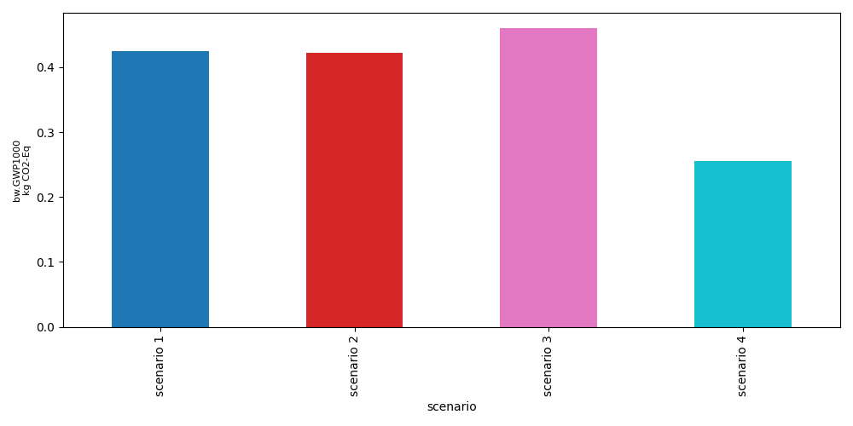

Stacked barplot
This type of plot, allows to select specific nodes, which will be stacked up for each scenario bar.
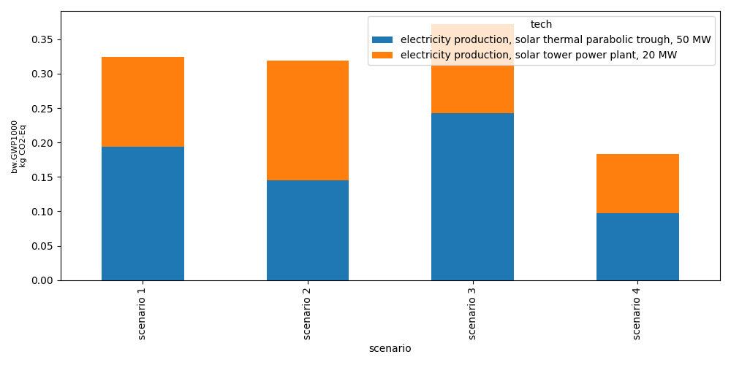

Starplot

star_plot
def star_plot(experiment: Union[Experiment, ResultsSelector],
scenarios: Optional[list[str]] = None,
methods: Optional[list[str]] = None,
*,
fill: bool = True,
r_ticks=(0.2, 0.4, 0.6, 0.8, 1.0),
show_r_ticks: bool = True,
show_grid: bool = True,
col: int = 4,
row: Optional[int] = None,
show_labels: bool = True,
image_file: Optional[PathLike] = None) -> Figure
Create a star plot (radar chart) to visualize the results across multiple scenarios.
The results are normalized across scenarios before plotting, so the values are relative. Each scenario is represented by a circle, with multiple axis for different angles, representing different methods. It is important to note, that in some cases, some circles
Arguments:
- experiment: experiment to plot
- scenarios: scenarios to plot
- methods: methods to plot
- fill: if the circles should be filled
- r_ticks: ticks for the radial axis
- show_r_ticks: if the radial axis should be shown
- show_grid: if the grid should be shown
- row: How many rows the figure should have
- col: How many columns the figure should have
- show_labels: if the method labels should be shown
- image_file: file to save the plot to
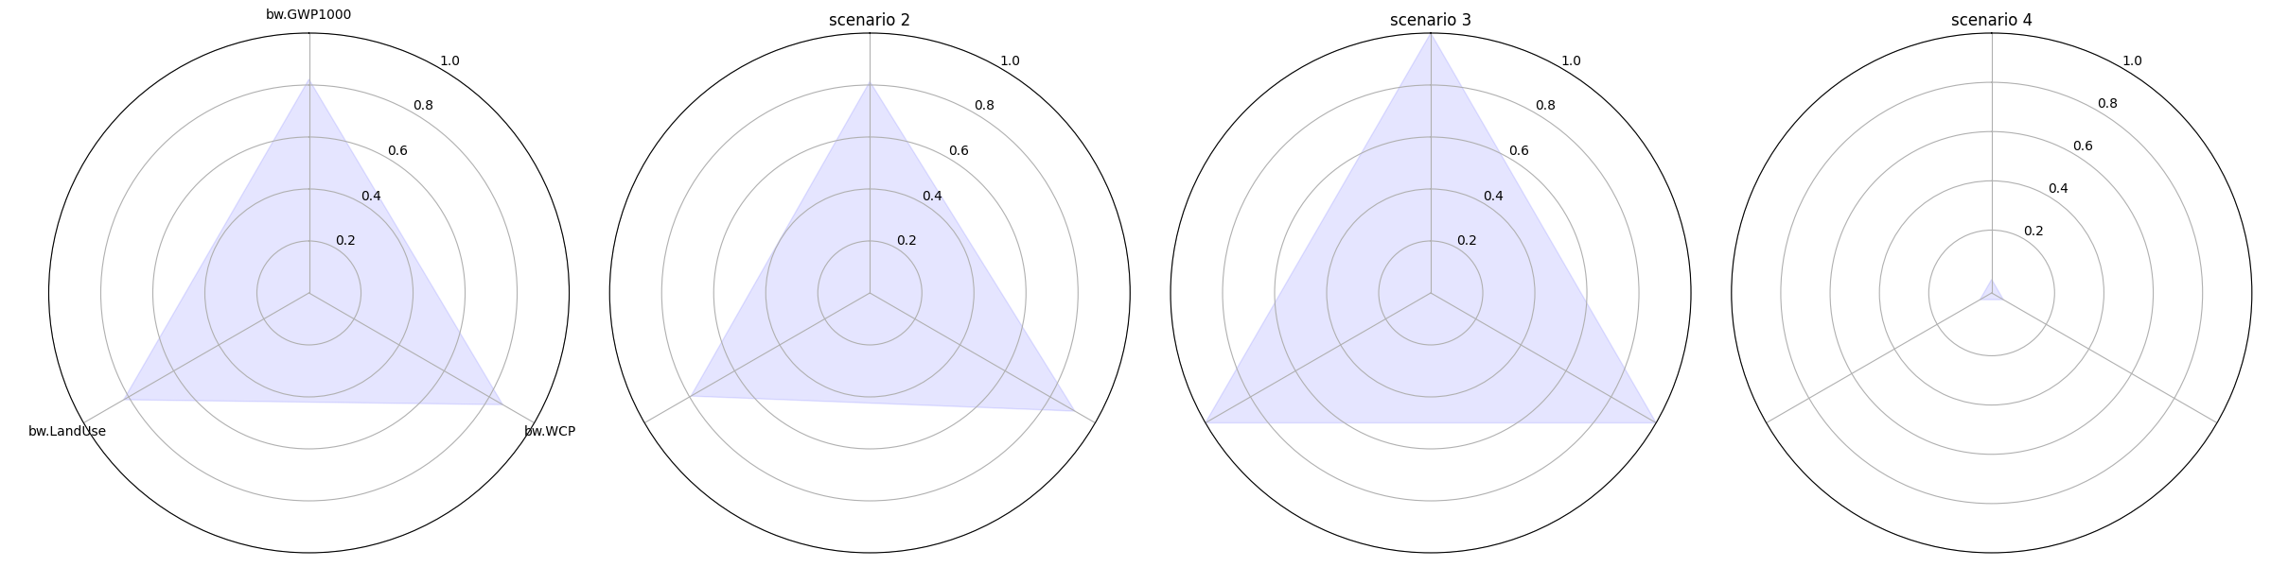

single_star_plot
def single_star_plot(experiment: Union[Experiment, ResultsSelector],
scenarios: Optional[list[str]] = None,
methods: Optional[list[str]] = None,
*,
r_ticks=(0.2, 0.4, 0.6, 0.8, 1.0),
show_r_ticks: bool = True,
show_grid: bool = True,
show_labels: bool = True,
image_file: Optional[PathLike] = None) -> Figure
plots multiple scenarios into a single star plot
Arguments:
- experiment: experiment to plot
- scenarios: scenarios to plot
- methods: methods to plot
- r_ticks: ticks for the radial axis
- show_r_ticks: if the radial axis should be shown
- show_grid: if the grid should be shown
- show_labels: if the method labels should be shown
- image_file: file to save the plot to
Returns:
A Figure object

plot_heatmap
def plot_heatmap(experiment: Union[Experiment, ResultsSelector],
scenarios: Optional[list[str]] = None,
methods: Optional[list[str]] = None,
special_df: Optional[DataFrame] = None,
image_file: Optional[PathLike] = None,
x_label_rotation: Optional[int] = 45) -> Figure

plot_sankey
def plot_sankey(exp: Experiment,
scenario_name: str,
method_: str,
default_bar_color: Optional[str] = "blue",
color_map: Optional[dict[str, str]] = None,
*,
image_file: Optional[PathLike] = None) -> Figure

one_axes_scatter_plot
def one_axes_scatter_plot(experiment: Union[Experiment, ResultsSelector],
selected_scenario: str,
methods: Optional[list[str]] = None,
image_file: Optional[PathLike] = None) -> Figure

plot_multivalue_results
def plot_multivalue_results(experiment: Union[Experiment, ResultsSelector],
scenarios: Optional[list[str]] = None,
level: int = 1,
methods: Optional[list[str]] = None,
nodes: Optional[list[str]] = None,
image_file: Optional[PathLike] = None,
err_method: Optional[Callable[[np.ndarray],
float]] = None)

Full Experiment API

Experiment Objects

get_node
def get_node(name: str) -> BasicTreeNode[TechTreeNodeData]
Get a node from the hierarchy by its name
Arguments:
- name: name of the node
Returns:
All node-data

get_node_module
def get_node_module(node: Union[str, BasicTreeNode[TechTreeNodeData]],
module_type: Optional[T] = EnbiosNodeModule) -> T
Get the module of a node in the experiment hierarchy

get_adapter_by_name
def get_adapter_by_name(name: str) -> EnbiosAdapter
Get an adapter by its name
Arguments:
- name: name of the adapter
Returns:
The adapter

get_module_by_name_or_node_indicator
def get_module_by_name_or_node_indicator(name_or_indicator: str,
module_type: Type[T]) -> T

get_scenario
def get_scenario(scenario_name: str) -> Scenario
Get a scenario by its name
Arguments:
- scenario_name: The name of the scenario as defined in the config or (Experiment.DEFAULT_SCENARIO_NAME)
Returns:
The scenario object

run_scenario
def run_scenario(
scenario_name: str,
results_as_dict: bool = True
) -> Union[BasicTreeNode[ScenarioResultNodeData], dict]
Run a specific scenario
Arguments:
- scenario_name: Name of the scenario to run
- results_as_dict: If the result should be returned as a dict instead of a tree object
Returns:
The result_tree (eventually converted into a dict)

run
def run(
results_as_dict: bool = True
) -> dict[str, Union[BasicTreeNode[ScenarioResultNodeData], dict]]
Run all scenarios. Returns a dict with the scenario name as key and the result_tree as value
Arguments:
- results_as_dict: If the result should be returned as a dict instead of a tree object
Returns:
dictionary scenario-name : result_tree (eventually converted into a dict)

execution_time
@property
def execution_time() -> str
Get the execution time of the experiment (or all its scenarios) in a readable format
Returns:
execution time in the format HH:MM:SS

results_to_csv
def results_to_csv(file_path: PathLike,
scenarios: Optional[Union[str, list[str]]] = None,
level_names: Optional[list[str]] = None,
include_method_units: bool = True,
include_output: bool = True,
flat_hierarchy: Optional[bool] = False,
include_extras: Optional[bool] = True,
repeat_parent_name: bool = False,
alternative_hierarchy: Optional[dict] = None)
Turn the results into a csv file. If no scenario name is given,
it will export all scenarios to the same file,
Arguments:
- file_path: File path to export to
- scenarios: string or list of strings. If no scenario name is given, it will export all scenarios to the same file, with an additional column for the scenario alias
- level_names: (list of strings) If given, the results will be exported with the given level names. This is only effective when flat_hierarchy is False.
- include_method_units: (Include the units of the methods in the header)
- include_output: Include the output of all nodes (default: True)
- flat_hierarchy: If instead of representing each level of the hierarchy with its own column, we just indicate the node levels.
- include_extras: Include extras from adapters and aggregators in the results (default: True)
- repeat_parent_name: If True, the parent name will be repeated for each child node in the corresponding level column. This is only effective when flat_hierarchy is False. (default: False)
- alternative_hierarchy: If given, the results will be recalculated using the given alternative hierarchy. In this alternative hierarchy, tho, already defined nodeds need no config and no adapter/aggregator.

results_to_dict
def results_to_dict(
scenarios: Optional[Union[str, list[str]]] = None,
include_method_units: bool = True,
include_output: bool = True,
include_extras: Optional[bool] = True,
alternative_hierarchy: Optional[dict] = None) -> list[dict[str, Any]]
Get the results of all scenarios as a list of dictionaries as dictionaries
Arguments:
- scenarios: A selection of scenarios to export. If None, all scenarios will be exported.
- alternative_hierarchy: If given, the results will be recalculated using the given alternative hierarchy. In this alternative hierarchy, tho, already defined nodeds need no config and no adapter/aggregator.
- include_method_units: Include the units of the methods in the header (default: True)
- include_output: Include the output of each node in the tree (default: True)
- include_extras: Include extras from adapters and aggregators in the results (default: True)

config
@property
def config() -> ExperimentConfig
get the config of the experiment

structural_nodes_names
@property
def structural_nodes_names() -> list[str]
Return the names of all structural nodes (bottom)
Returns:
names of all structural nodes

scenario_names
@property
def scenario_names() -> list[str]
Get all scenario names
Returns:
list of strings of the scenario names

adapters
@property
def adapters() -> list[EnbiosAdapter]
Get all adapters in a list
Returns:
A list of all adapters

run_scenario_config
def run_scenario_config(
scenario_config: dict,
result_as_dict: bool = True,
append_scenario: bool = True
) -> Union[BasicTreeNode[ScenarioResultNodeData], dict]
Run a scenario from a config dictionary. Scenario will be validated and run. An
Arguments:
- scenario_config: The scenario config as a dictionary (as it would be defined in the experiment config)
- result_as_dict: If True, the result will be returned as a dictionary. If False, the result will be returned as a BasicTreeNode.
- append_scenario: If True, the scenario will be appended to the experiment. If False, the scenario will not be appended.
Returns:
The scenario result as a dictionary or a BasicTreeNode

info
def info() -> str
Information about the experiment
Returns:
Generated information as a string

get_module_definition
@staticmethod
def get_module_definition(clazz: Union[Type[EnbiosAdapter], EnbiosAdapter,
Type[EnbiosAggregator],
EnbiosAggregator],
details: bool = True) -> dict[str, Any]
Get the 'node_indicator' and schema of a module (adapter or aggregator)
Arguments:
- clazz: The class of the module (adapter or aggregator)
- details: If the whole schema should be returned (True) or just the node_indicator (False) (default: True)
Returns:
returns a dictionary {node_indicator: <node_indicator>, config: }

get_builtin_adapters
@staticmethod
def get_builtin_adapters(details: bool = True) -> dict[str, dict[str, Any]]
Get the built-in adapters
Arguments:
- details: If the schema should be included or not (default: True)
Returns:
all built-in adapters as a dictionary name: {node_indicator: <node_indicator>, config: }

get_builtin_aggregators
@staticmethod
def get_builtin_aggregators(details: bool = True) -> dict[str, dict[str, Any]]
Get the built-in aggregators
Arguments:
- details: If the schema should be included or not (default: True)
Returns:
all built-in aggregators as a dictionary name: {node_indicator: <node_indicator>, config: }

get_all_configs
def get_all_configs(
include_all_builtin_configs: bool = True
) -> dict[str, dict[str, dict[str, Any]]]
Result structure:
{
"adapters": { <adapter_name>: <adapter_config>},
"aggregators": { ... }
}
```

**Arguments**:

- `include_all_builtin_configs`: Include the jsonschema configs of all adapters and aggregegators

**Returns**:

all configs

#### method\_names

```python
@property
def method_names() -> list[str]
Names of all methods
Returns:
a list of method names

hierarchy2mermaid
def hierarchy2mermaid() -> str
Convert the hierarchy to a mermaid graph diagram
Returns:
a string representing in mermaid syntax

get_simplified_hierarchy
def get_simplified_hierarchy(
print_it: bool = False) -> dict[str, Optional[dict[str, Any]]]
Get the hierarchy as a dictionary, but in a simplified form, i.e. only the nodes with children are included.
Arguments:
- print_it: Print it to the console
Returns:
A simplified dictionary of the hierarchy

delete_pint_and_logging_file
@staticmethod
def delete_pint_and_logging_file()

