12032924_李熹成

Problem1:

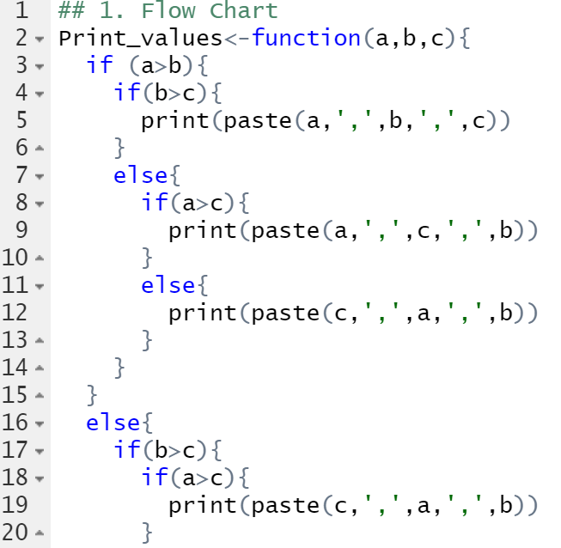

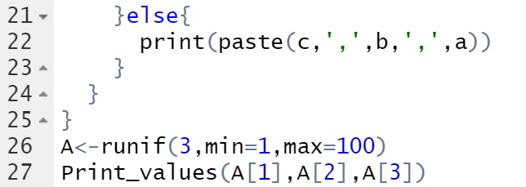

**Results are as followed:**



To verify the effectiveness of script, three numbers are randomly generated from 1 to 100 and be input into the function and the results are above.

Problem2:

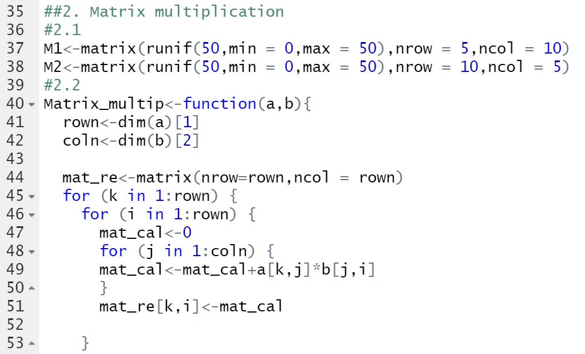

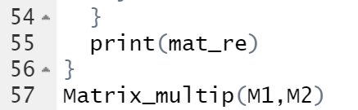\

M1:

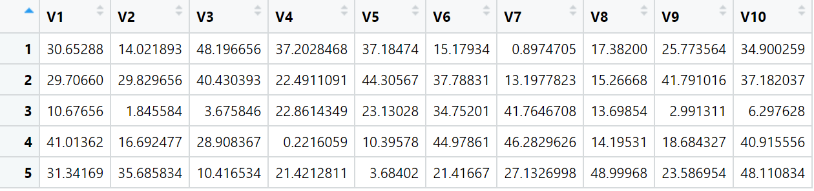

M2:

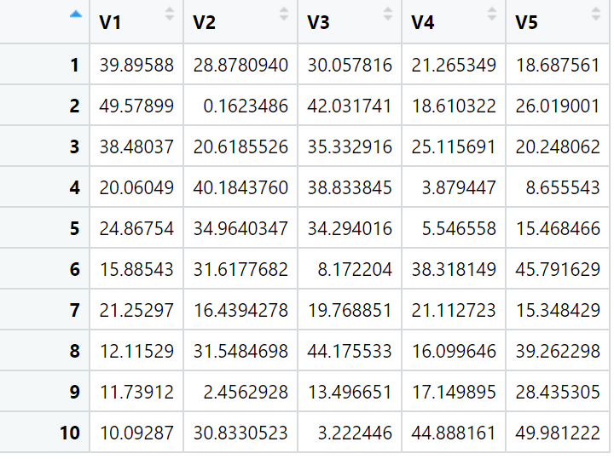

**The results are as below:**

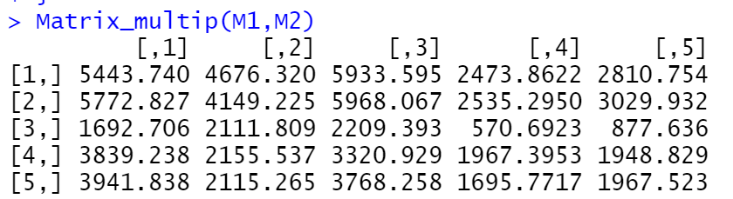

Problem3:

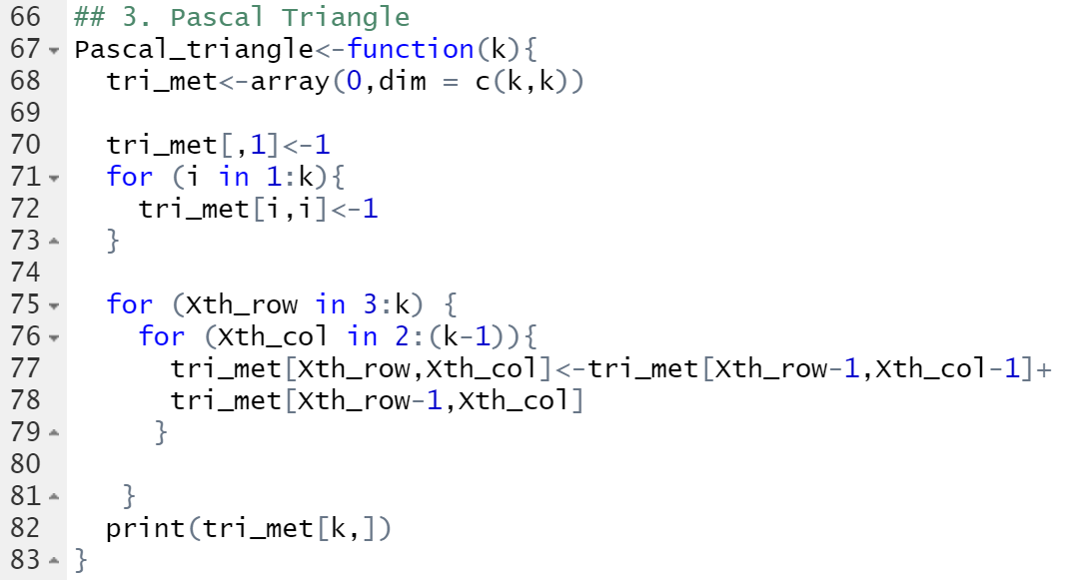

Firstly, create a k by k array with the outer side of the triangle equals to 1. Secondly, padding operations to the inner layers.

**The results are as below:**

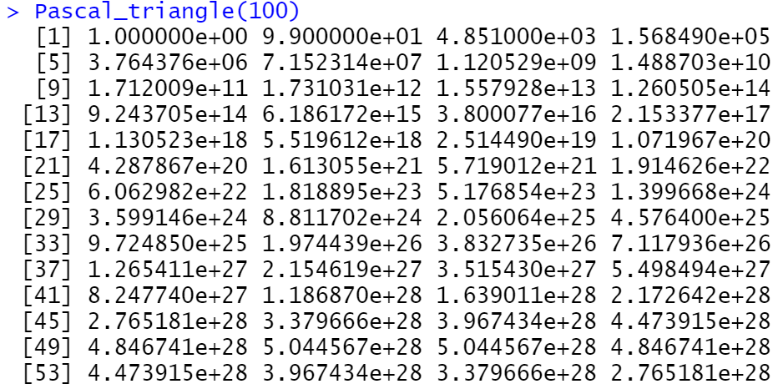

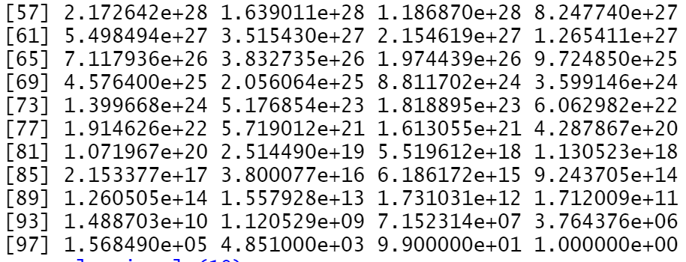

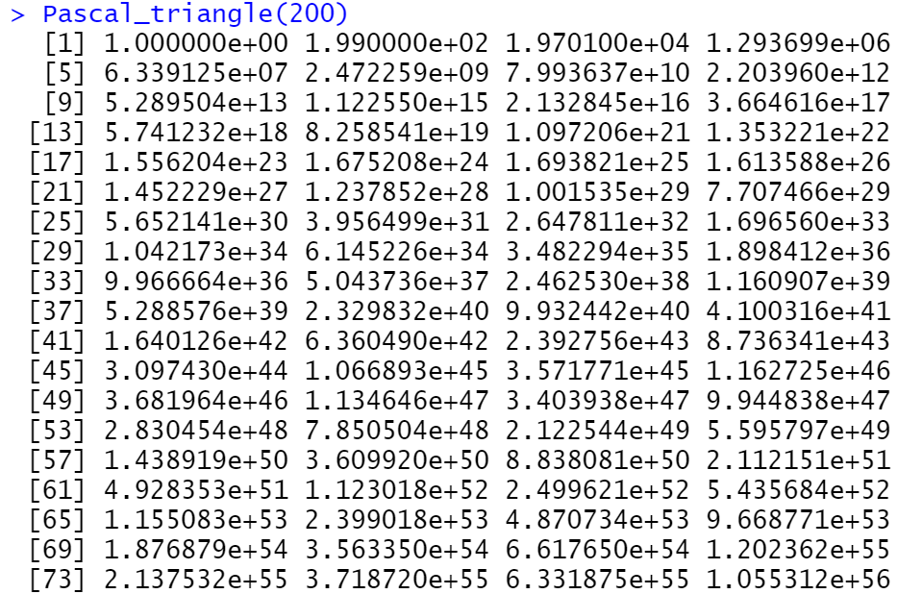

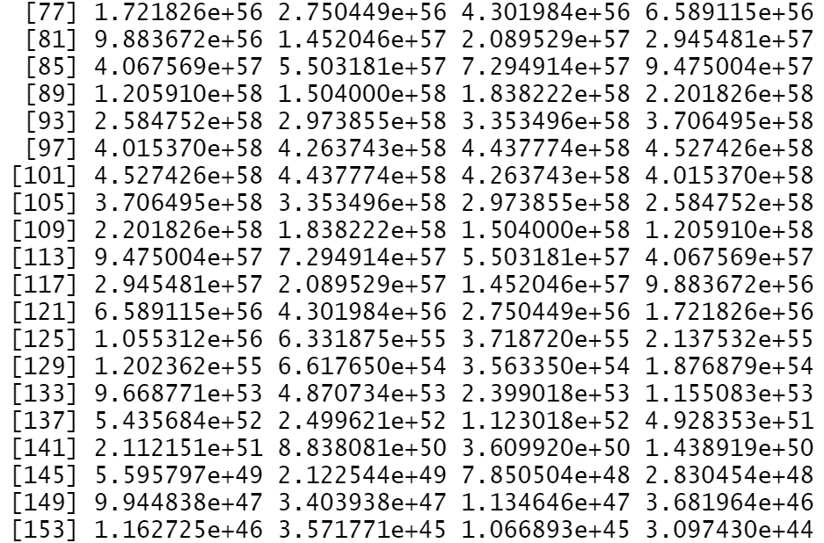

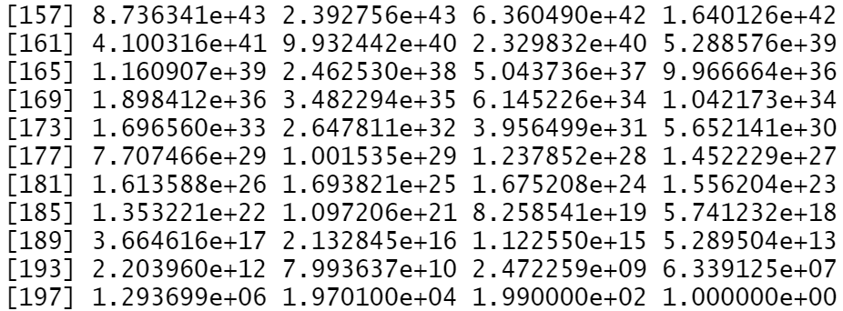

Problem4:

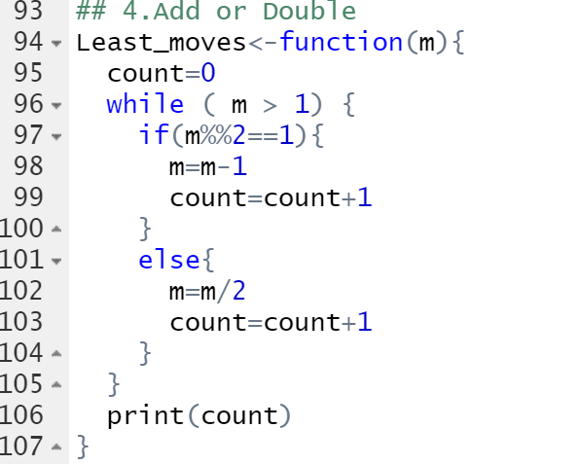

I tried inverse operations. If the number is save to be divide by 2, then do division. If not, do subtraction. Count the times of operation each time after the operations.

**The results are as below:**

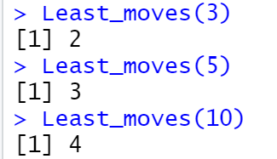

Problem5:

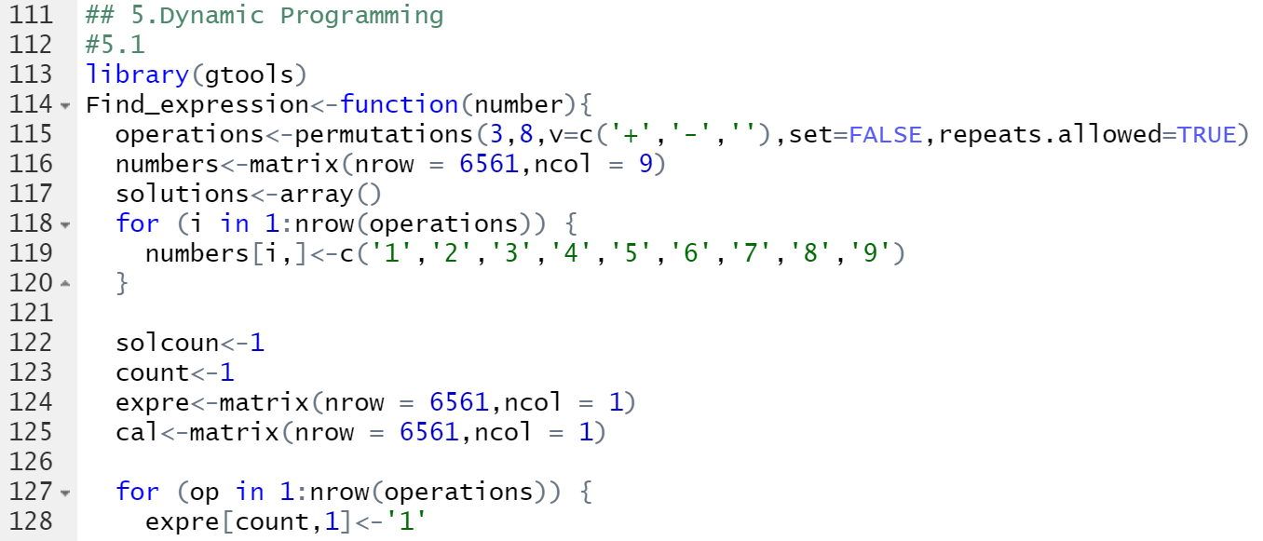

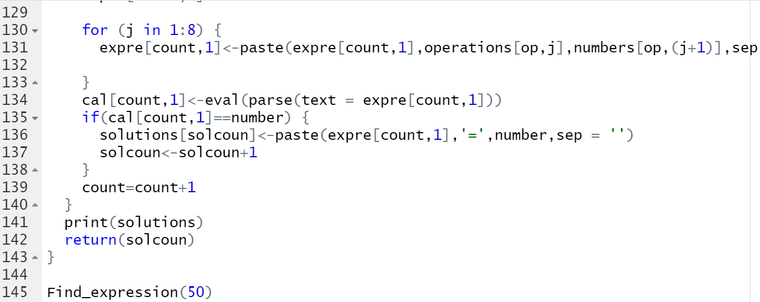

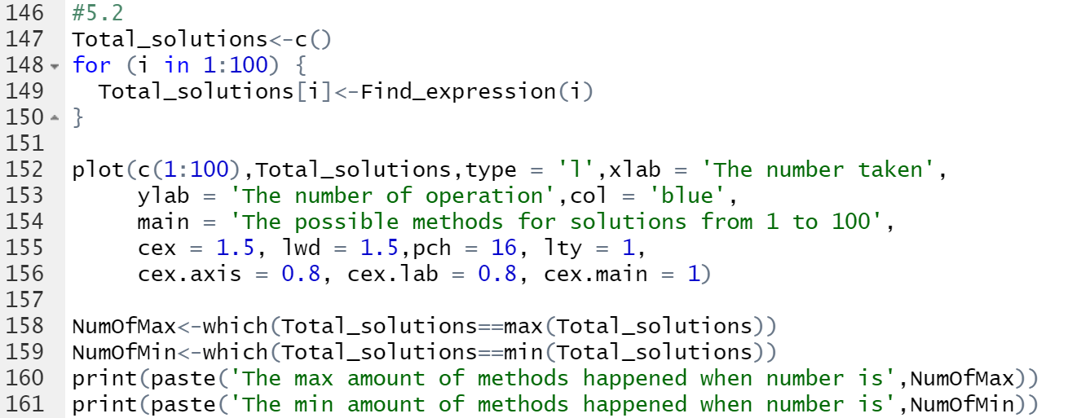

Thanks to CHEN Yuyang’s idea of changing characters to operations. I firstly using function Permutations() to do the permutations of 3 operations with replacement. Then built a matrix with 3^8 row of characters from 1 to 9. Finally, combine them correspondently. Then, use eval(parse(text = expre[count,1])) to change characters to operations.

**The results are as below:**

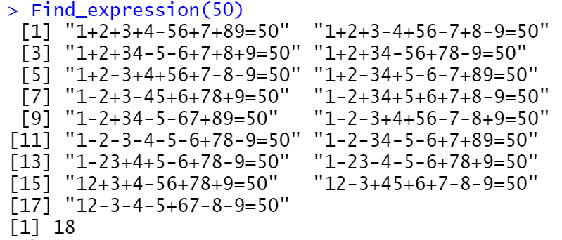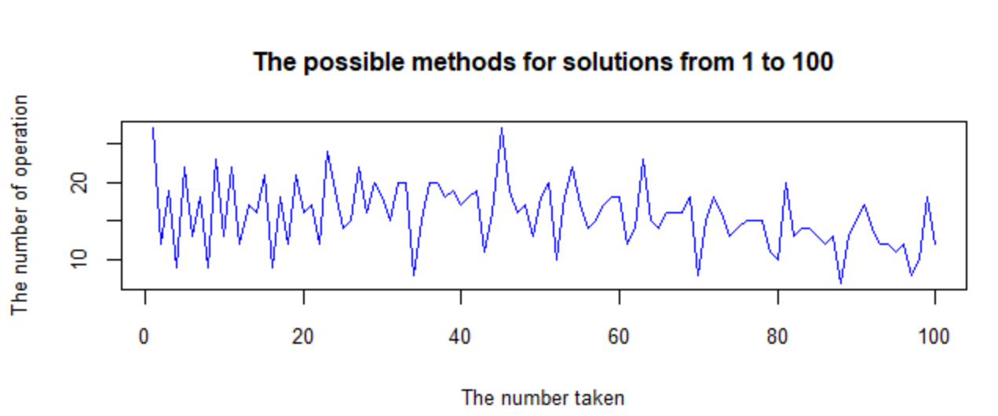

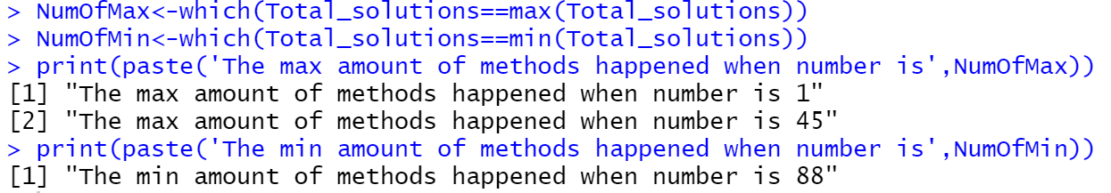

My previous thinking is as below:

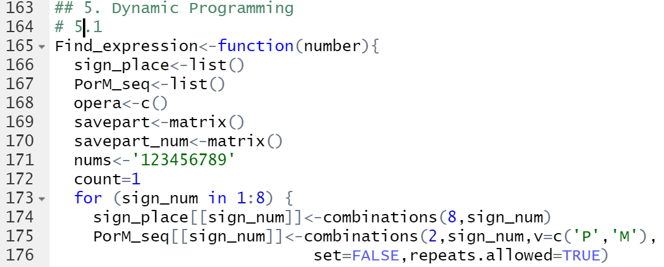

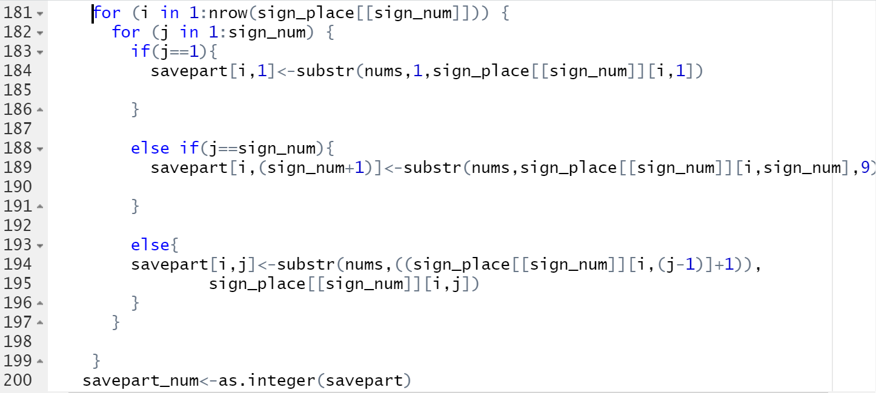

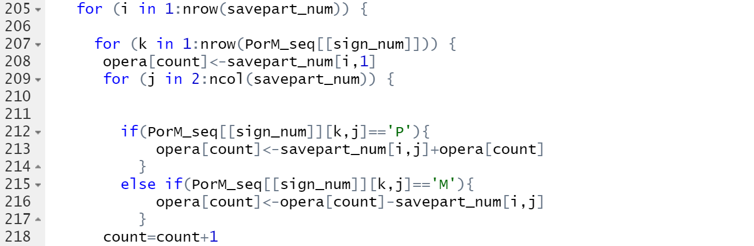

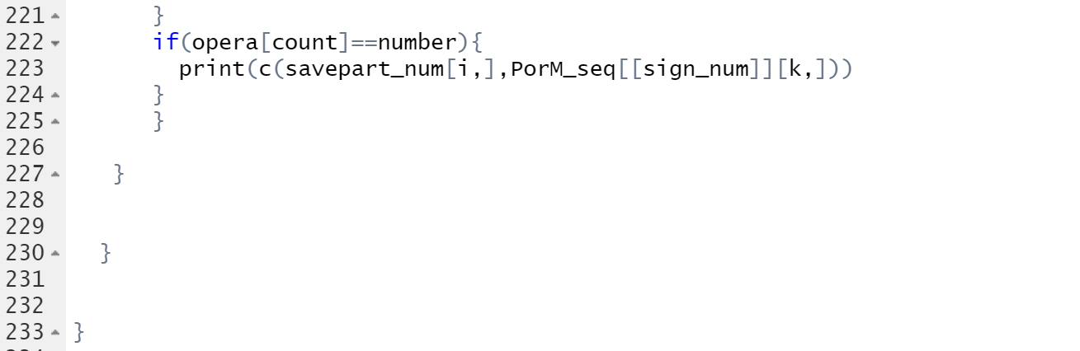

In this script, I tried to use Combinations() to lock the spacing between each or several numbers and then insert Plus or Subtract into each of them. While it seems quite redundant to do several layers of FOR loop and finally I abandoned this thinking.

Problem6:

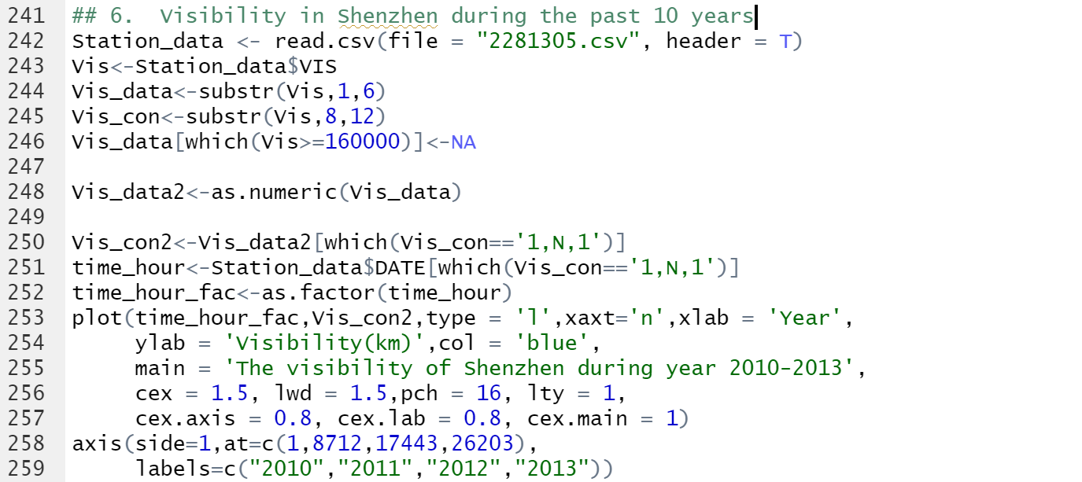

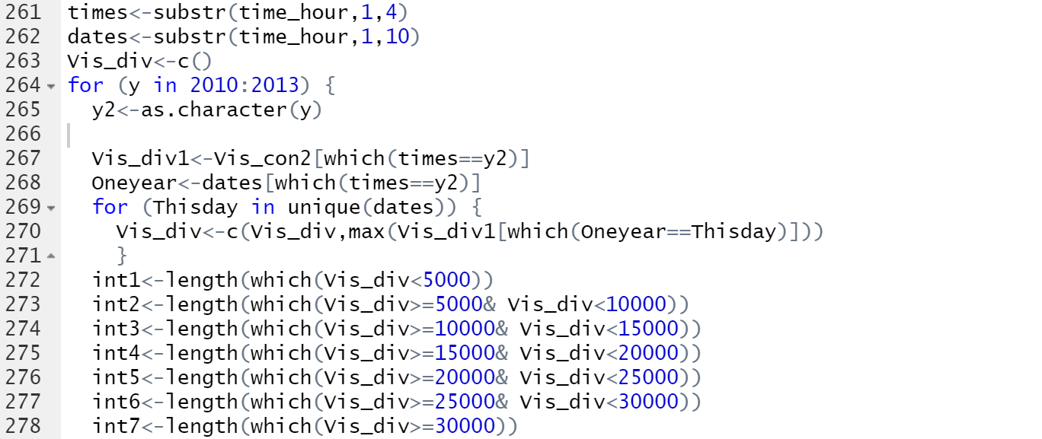

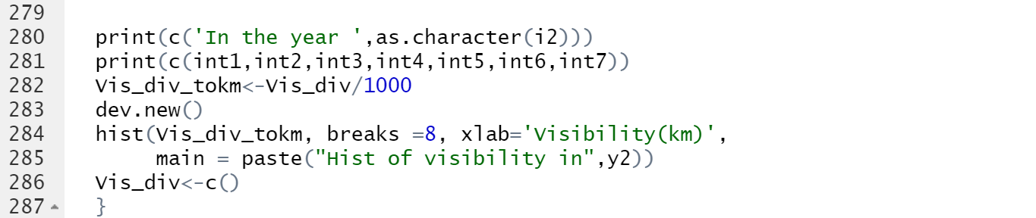

The function substr() is used to cut the VIS data and selection of data that passes quality check. Using max() to pick the maximum visibility from each day. Using hist() to draw hist graph of each year from 2010 to 2013.

**The results are as below:**

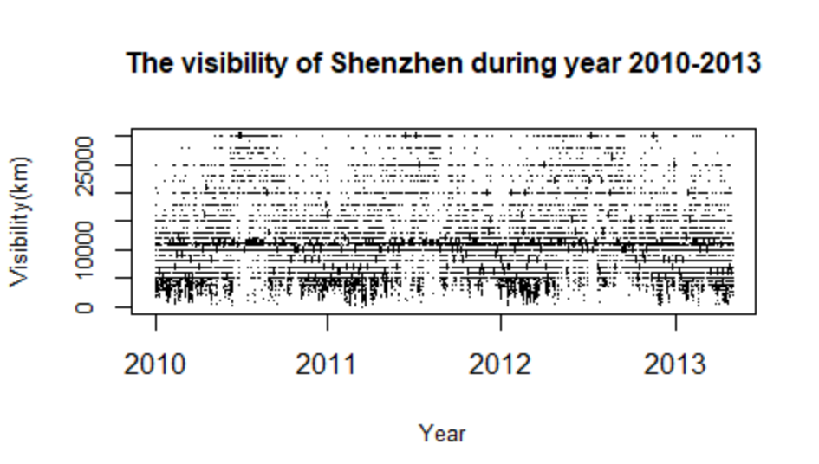

After all quality control checks which satisfied “1,N,1”, the remaining data contains only data from 2010 to 2013.

6.1: There is a trend over each year that in the summer months, probably during July and August, the visibility will come to a relatively high level. That is, the visibility will go up during from January to July and go down from August to December.

6.2:

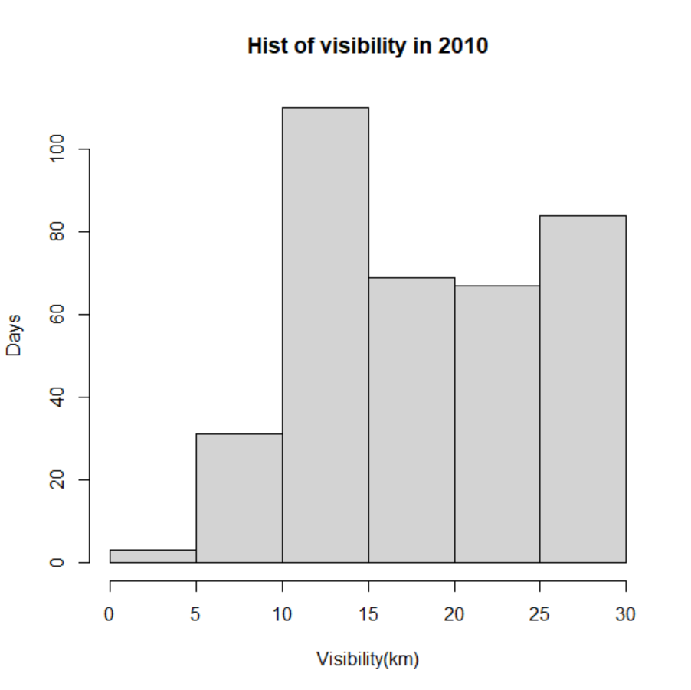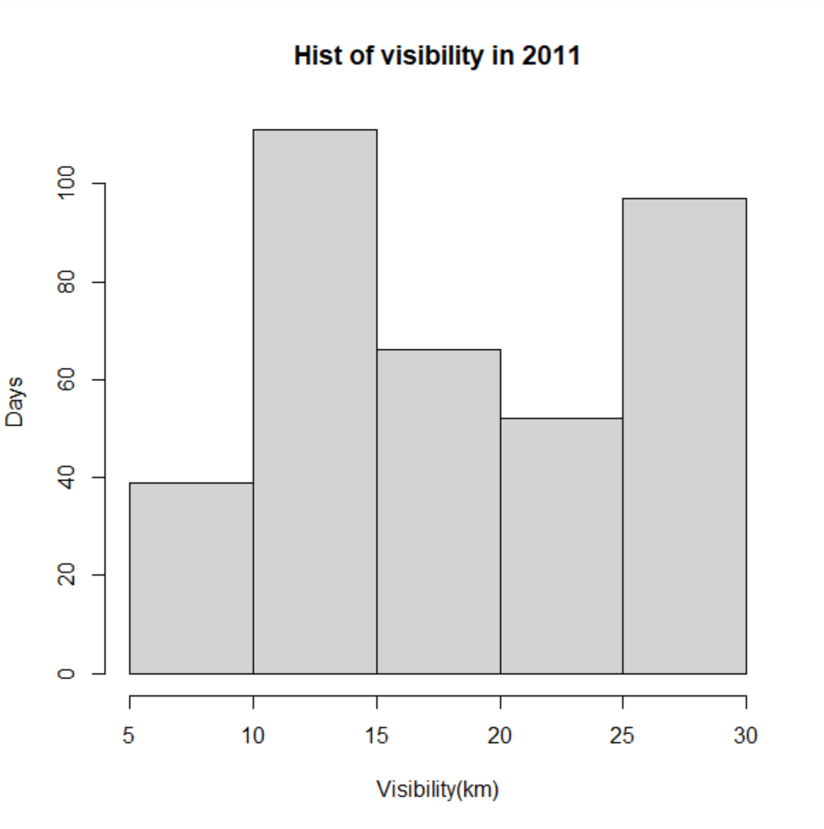

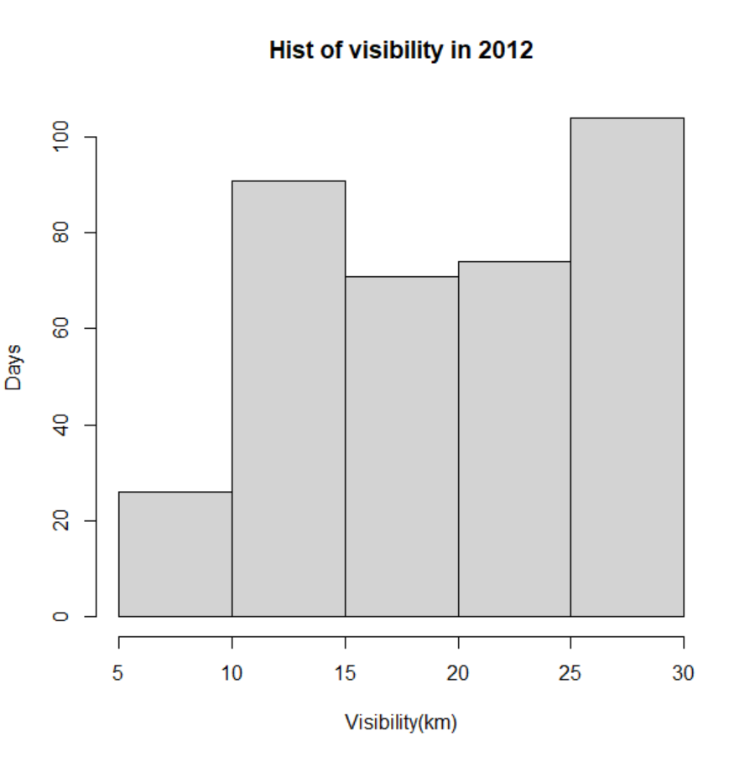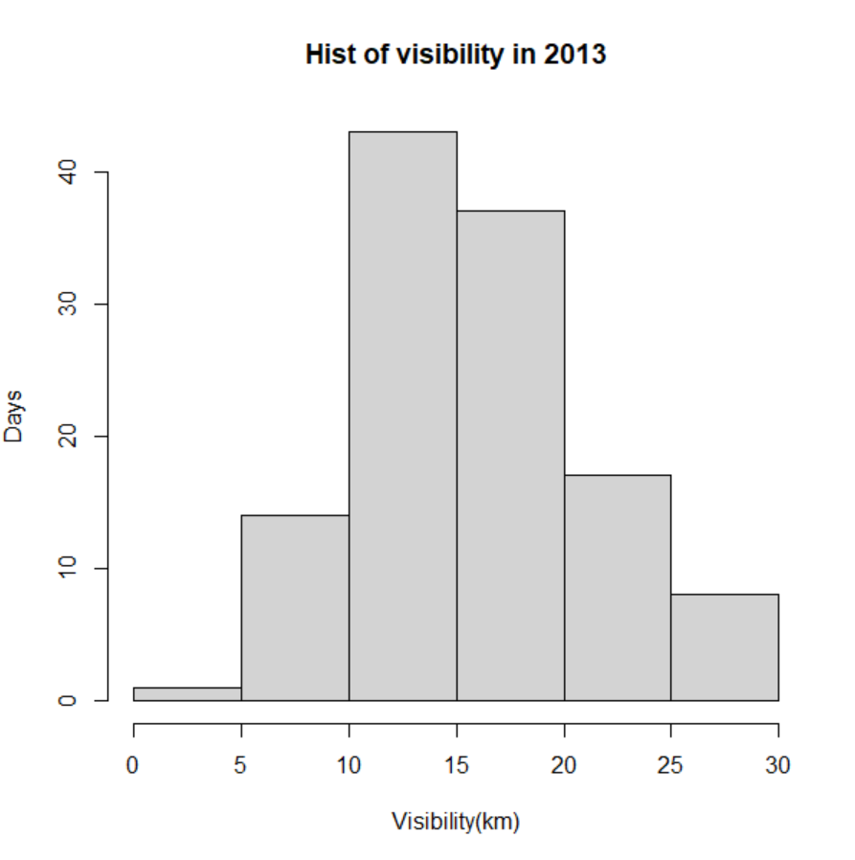

From the hist graphs, it seems the air quality is getting better over year 2010-2012, because the count of visibility range [10,15) decreases while in range [20,25) increases. Besides, it is not deniable that the [5,10) has a trend of decrease. So it could be positive that the air quality is getting better.

Problem7:

Downloaded sample data from <https://en.tutiempo.net/climate/download/info/>.

This data is a combined .xlsx dataset of multiple station data from 1991 to 1995, a station in Madrid/ Barajas. The descriptions of the data are as below.

I manually transform the document from .xlsx to .csv. And now that it is a cleaned dataset used as an example (Other datasets in this website is charging), I did not do further data clean work.

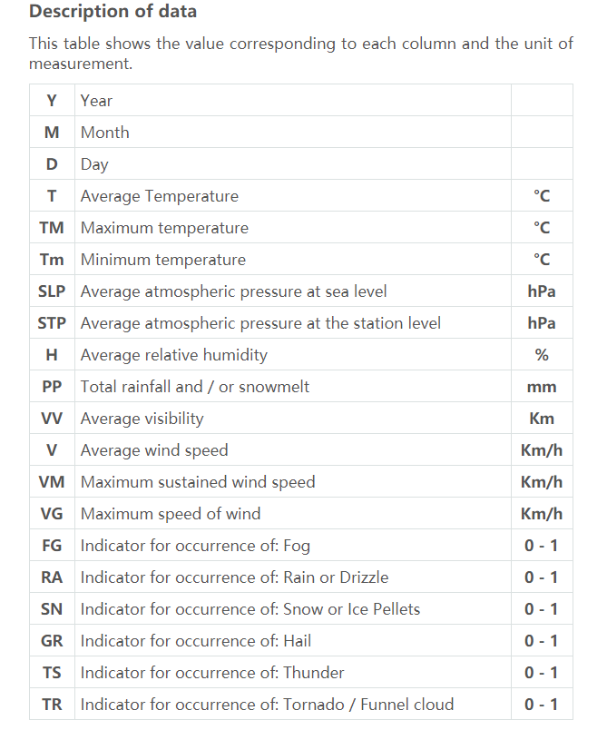

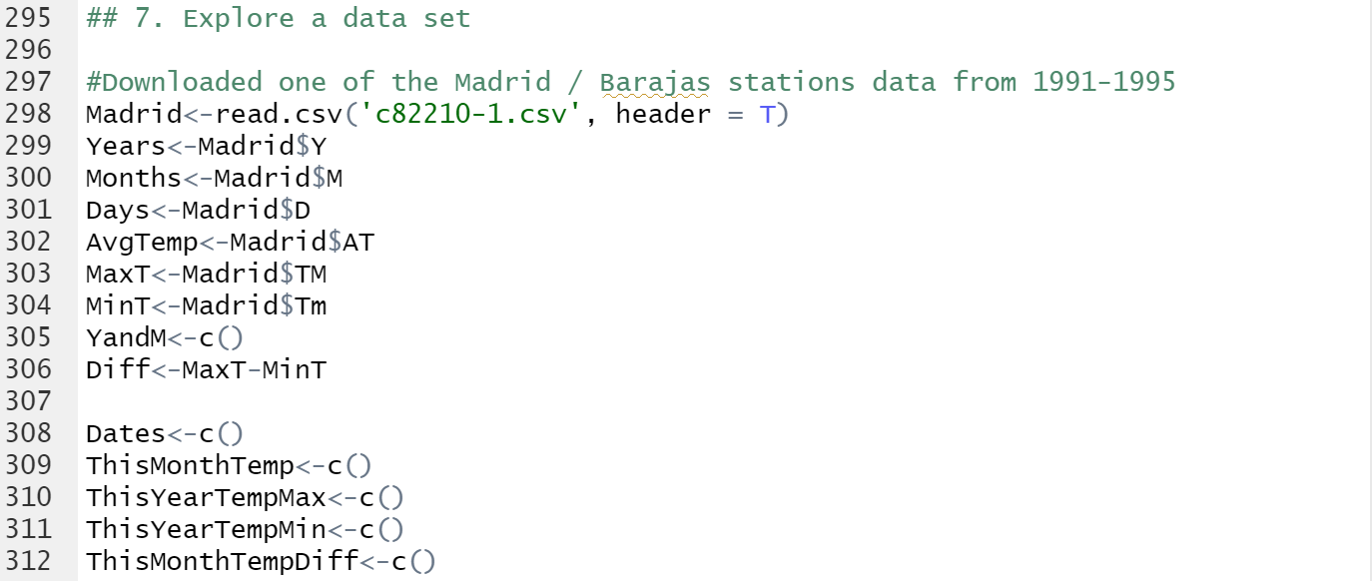

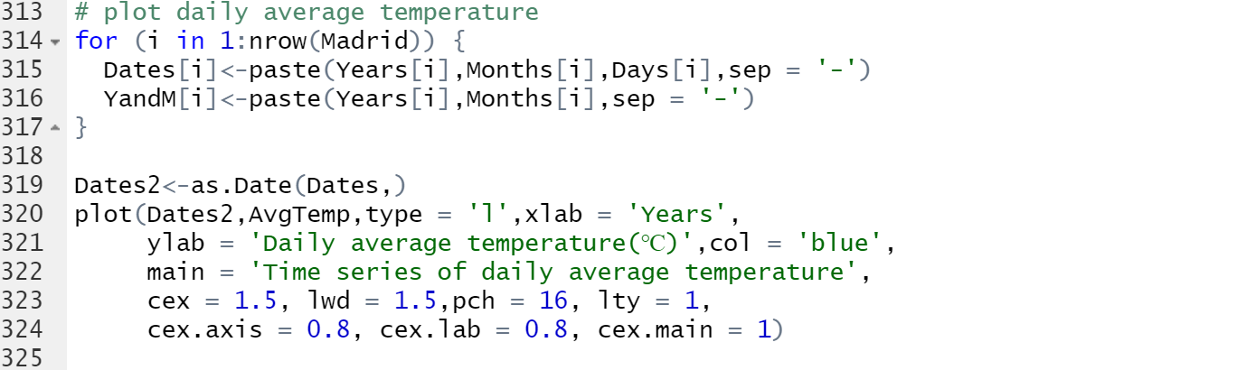

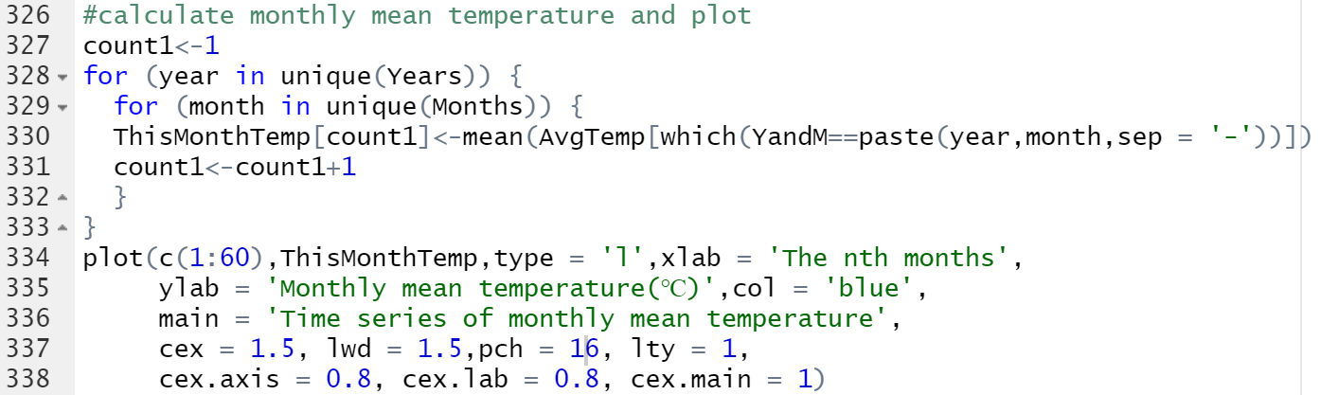

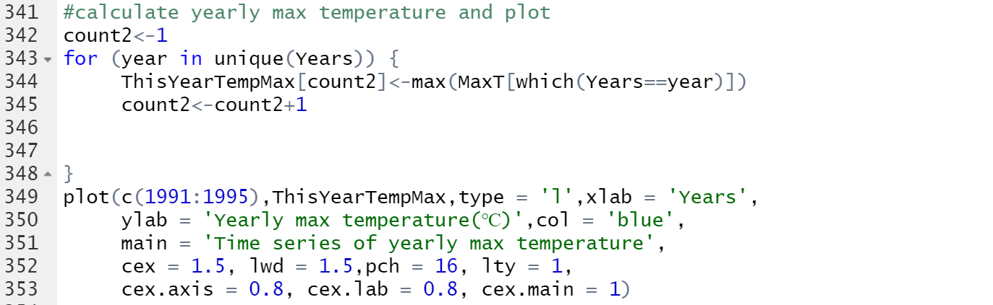

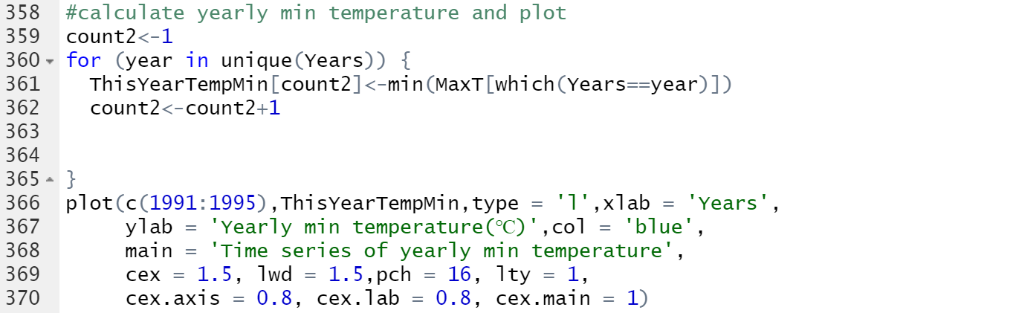

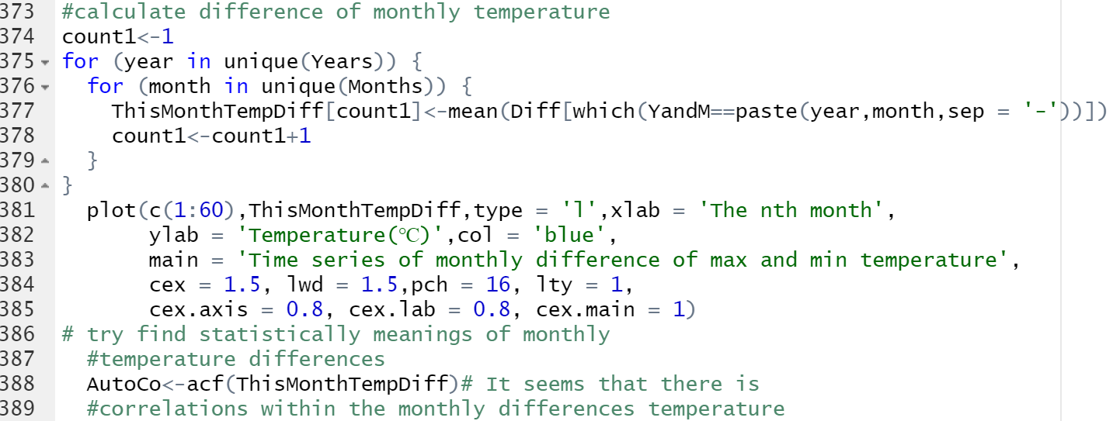

**The results are as below:**

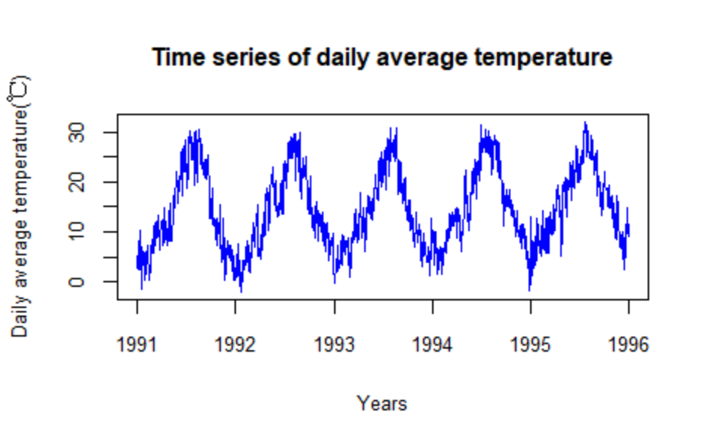

Graph.1

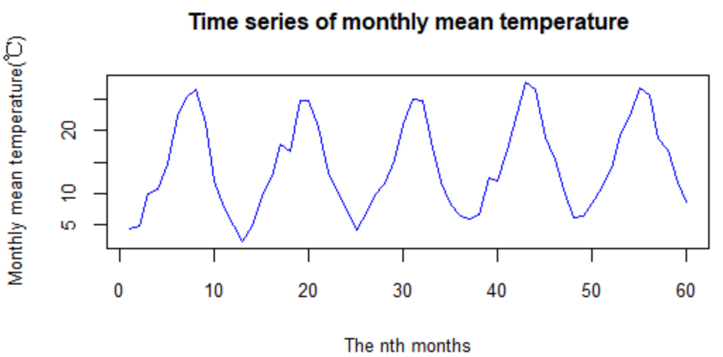

Graph.2

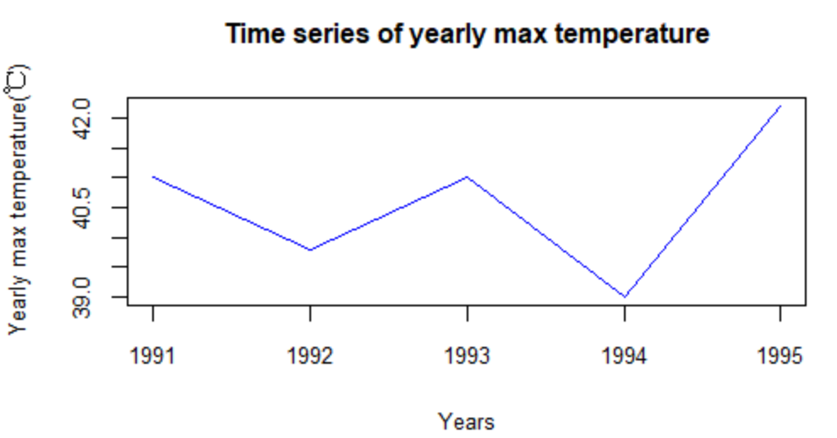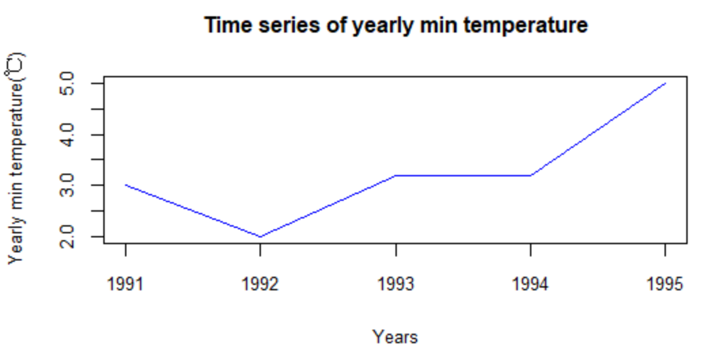

Graph.3 Graph.4

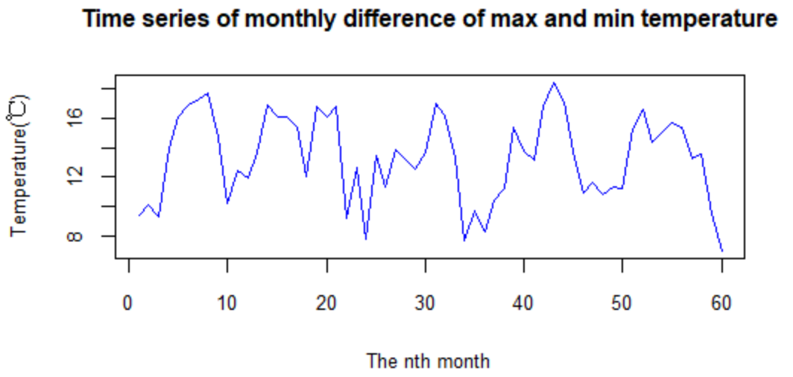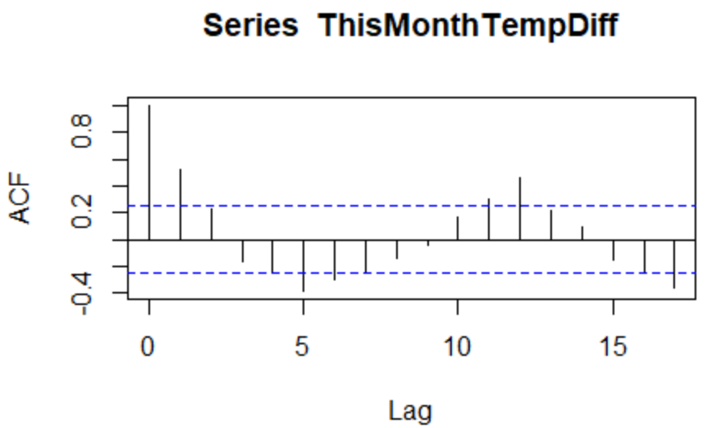

Graph.5 Graph.6

From the graph above (Graph.1-Graph.2), the temperatures in a year obey the rule that increase from January to July and decrease from September to December. The yearly maximum temperature and yearly minimum temperature has a trend of increasing, while the length time series is not enough to quantify the trend. (Graph.3-Graph.4) The monthly differences of max and min temperature (average daily differences as monthly differences) show little trends, but probably have autocorrelation on year-on-year basis. (Graph.5-Graph.6)