Report for homework#7

12032924 李熹成

Problem#1

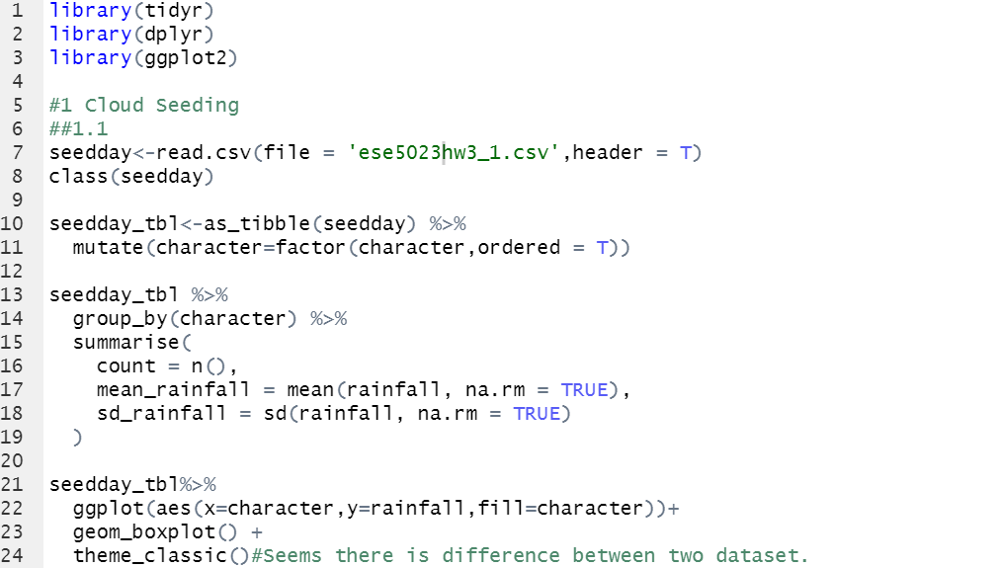

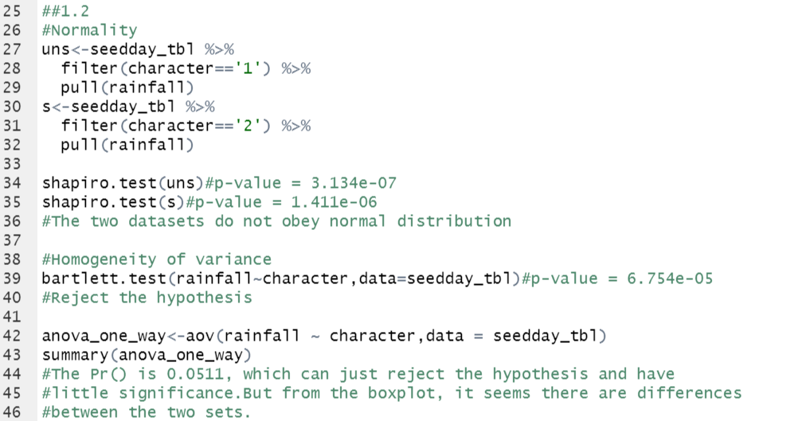

**The results are as below:**

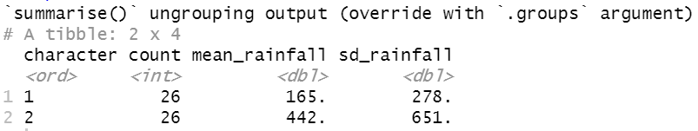

From the simple statistics, the mean and SD are distinct.

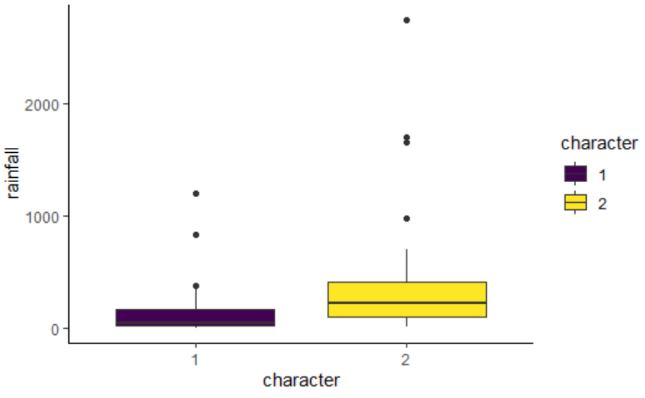

It seems to have differences from boxplot.

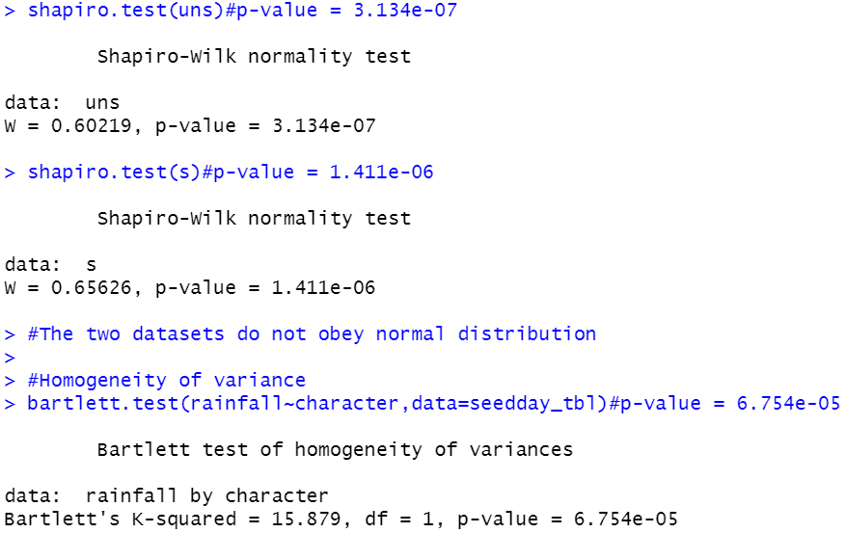

After doing normality and heterogeneity test the data seems not conform to the condition to do ANOVA.

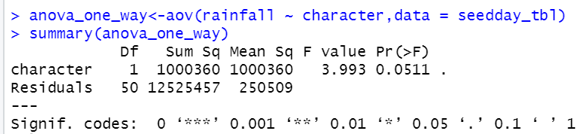

We can just reject the hypothesis, which is there is a difference between the variances while there is little significancy. However, from the simple statistics and boxplot, there seems to have differences. **This may be caused by the data itself is not fit the requirement to do ANOVA.**

Problem#2

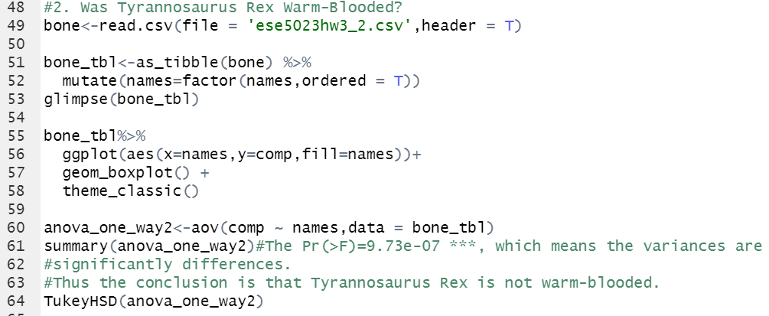

**The results are as below:**

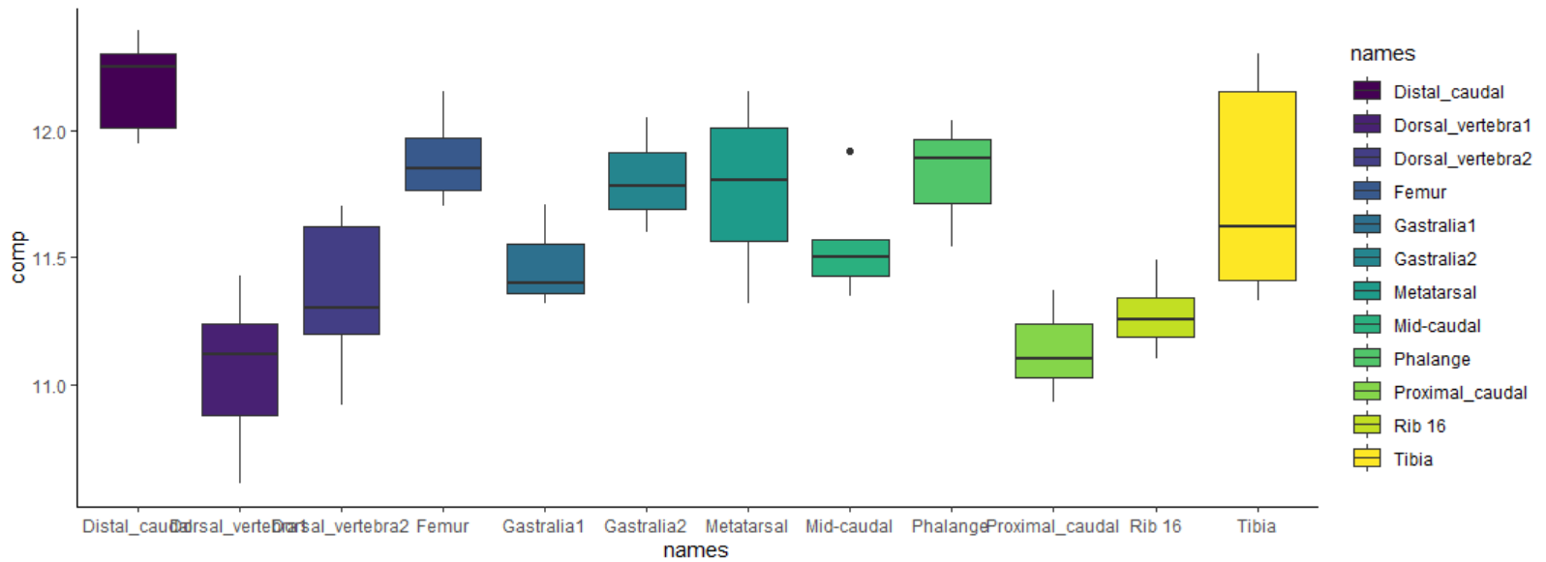

It seems there are distinct differences among the different bone groups.

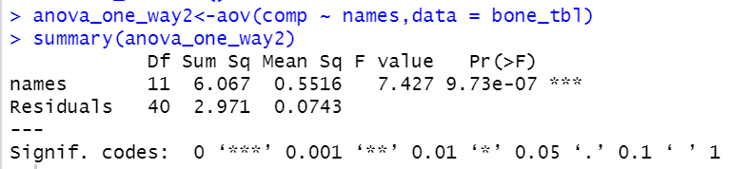

The P-value shows that the difference in variances are significant and thus the conclusion is that Tyrannosaurus Rex is not warm-blooded.

Problem#3

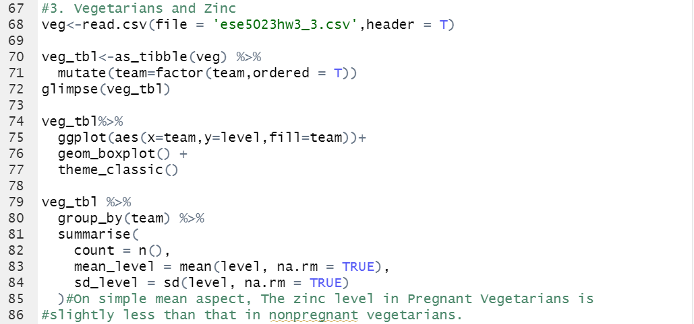

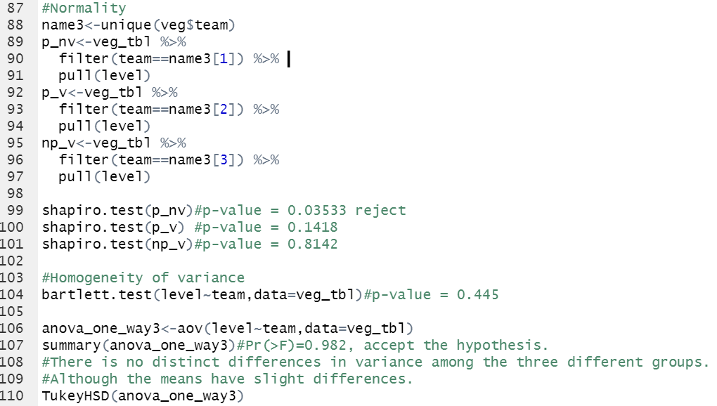**The results are as below:**

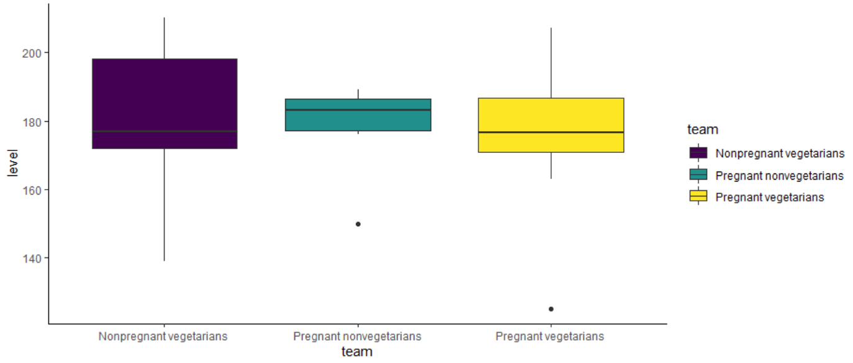

From the boxplot, it seems there is little difference among the three groups.

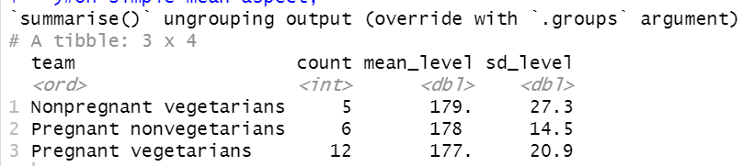

On simple mean aspect, the zinc level in Pregnant Vegetarians is slightly less than that in nonpregnant vegetarians.

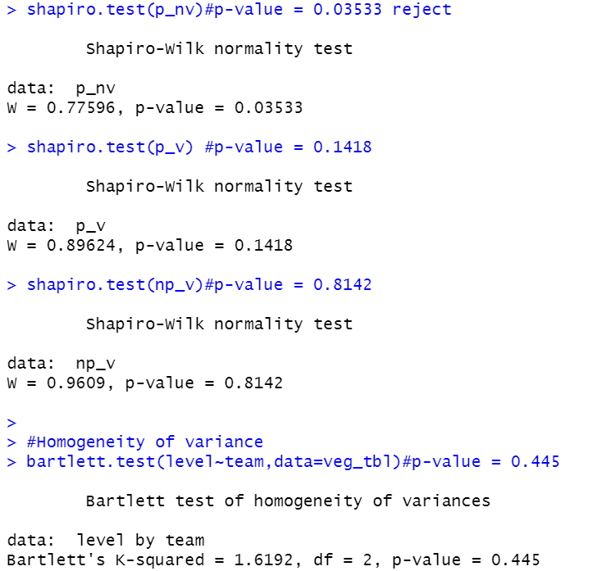

The data can pass the normality and heterogeneity test.

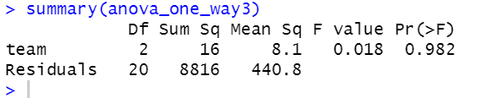

**However**, the P-value shows that, there is no distinct differences in variance among the three different groups. **Although the means have slight differences.**

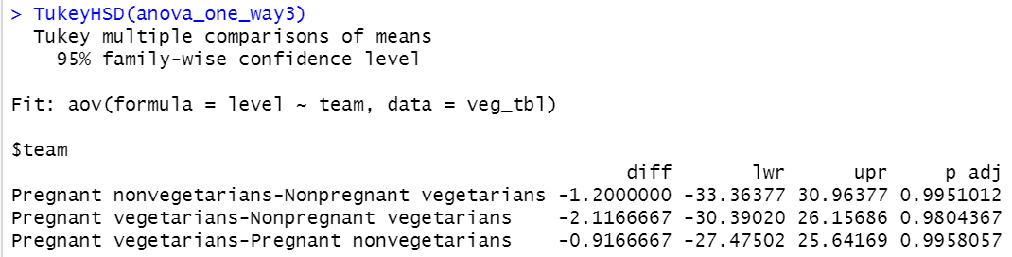

Problem#4

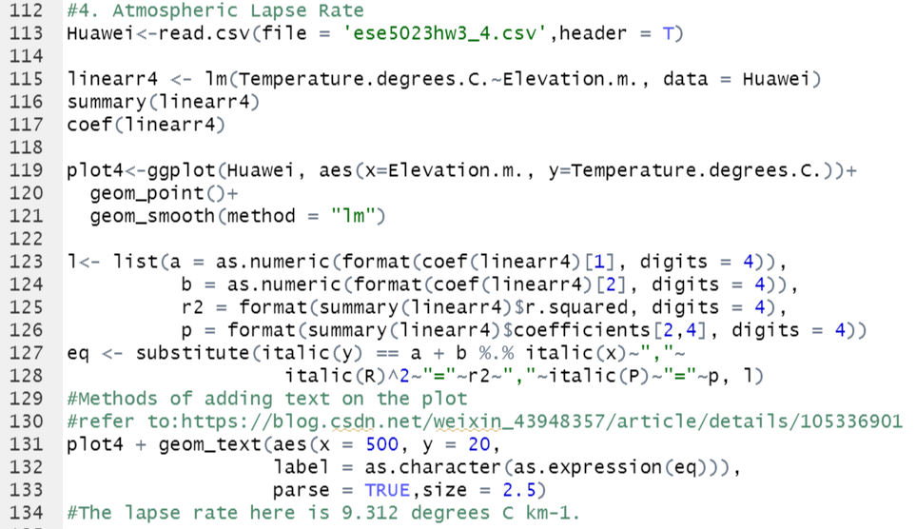

**The results are as below:**

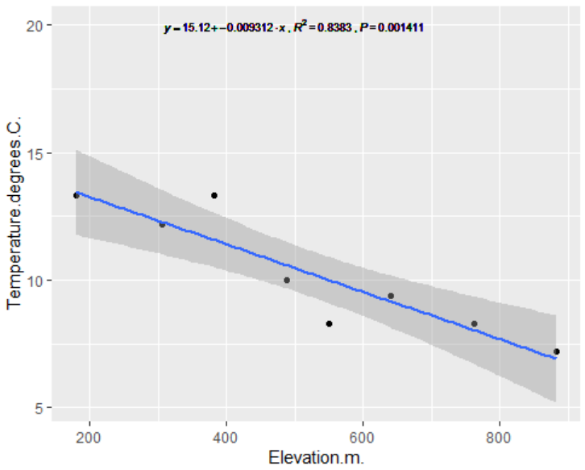

From the expression, the lapse rate here is **9.312 degrees C km-1.**

Problem#5

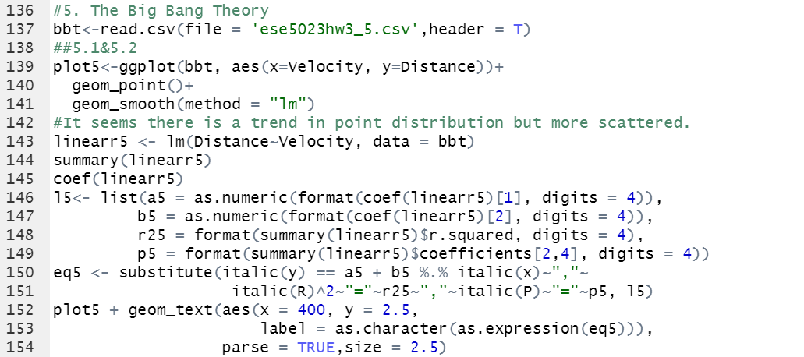

**The results and calculating processes are as below:**

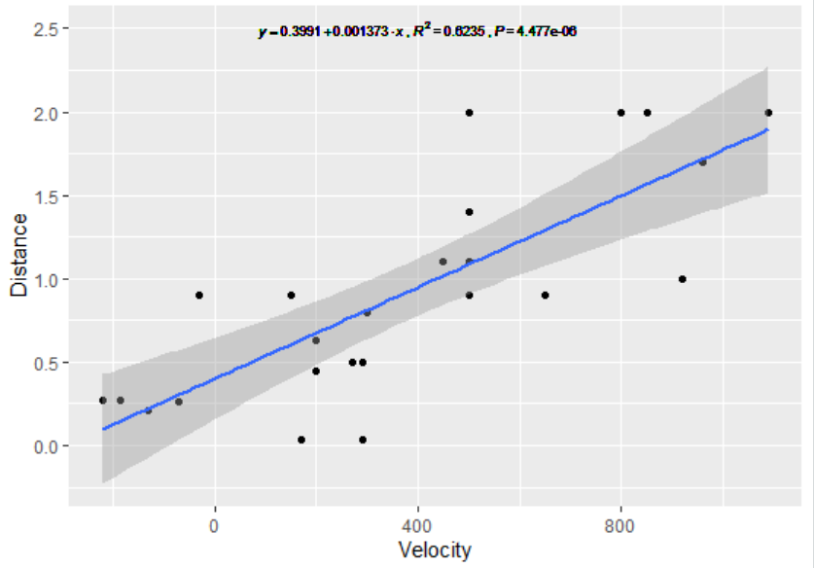

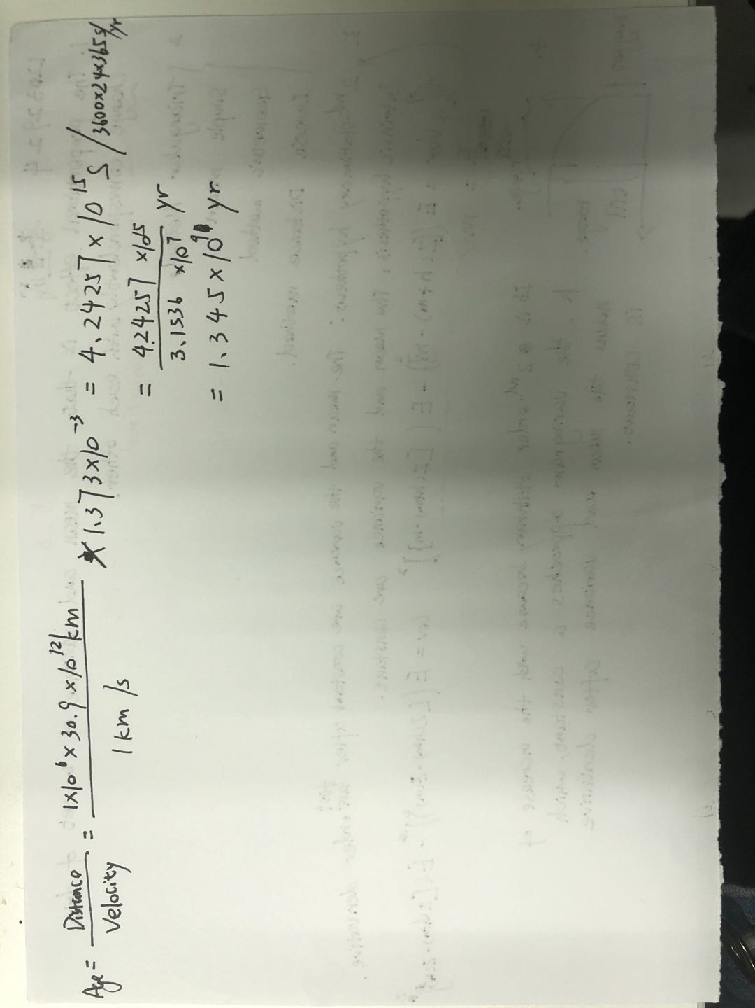

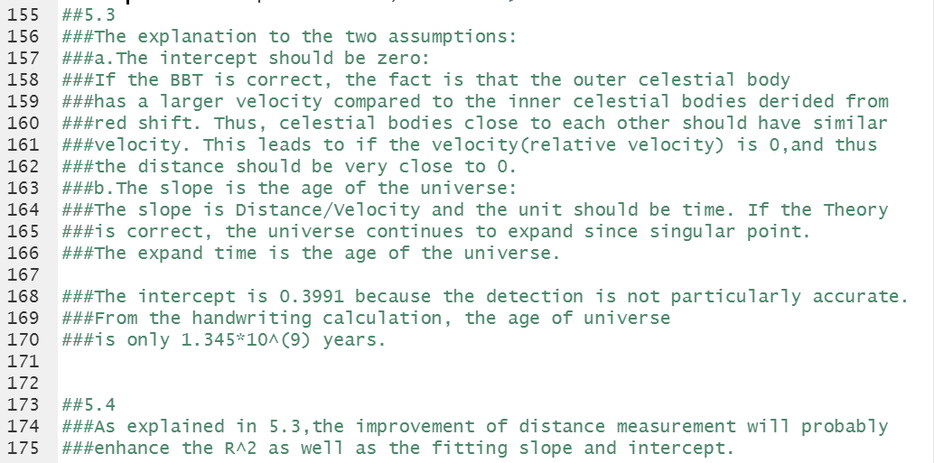

Problem#6

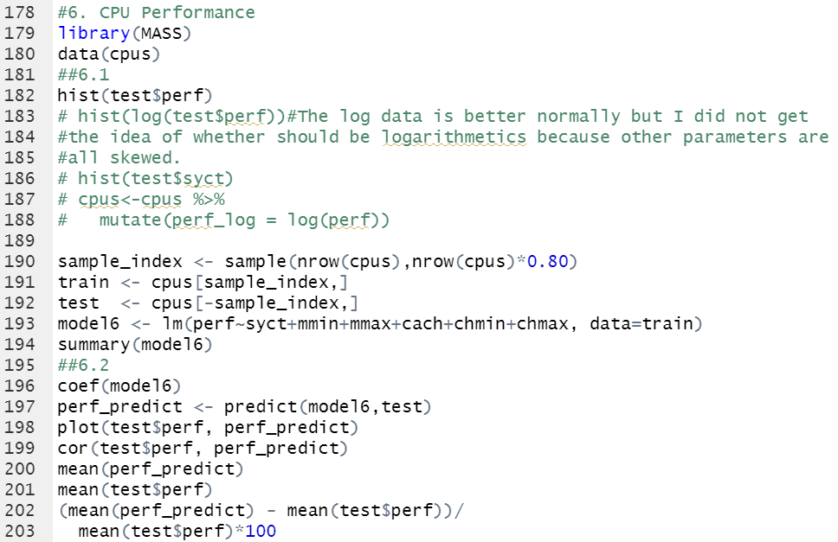

**The results are as below:**

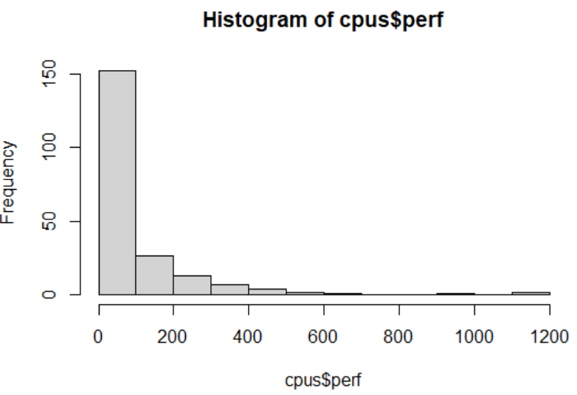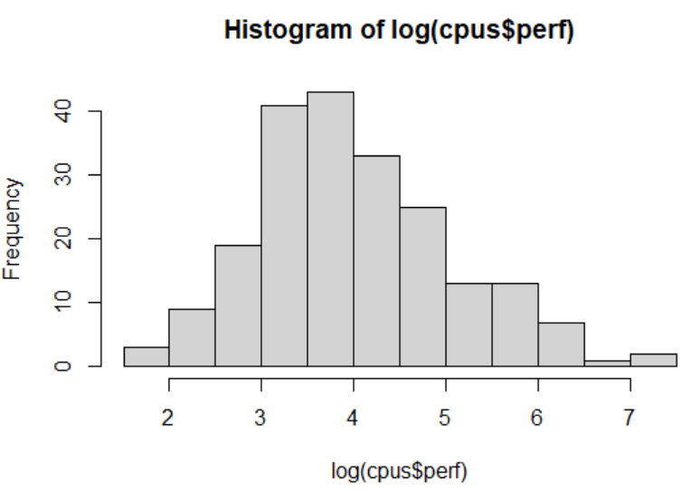

The log data is better normally but I did not get the idea of whether data should be logarithmetics because other parameters are all skewed.

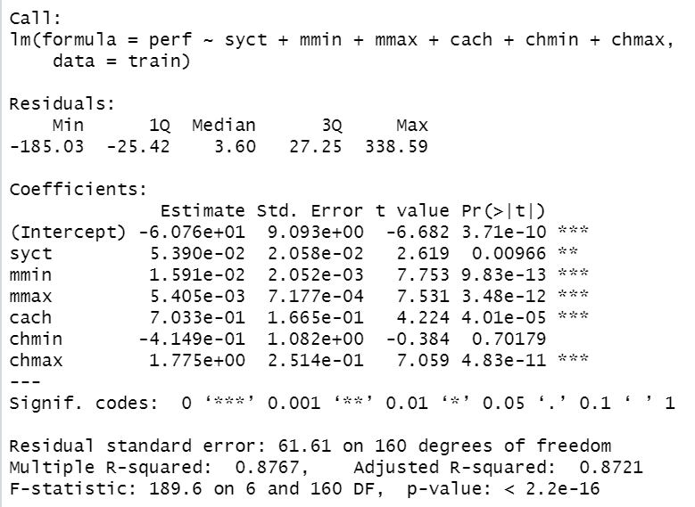

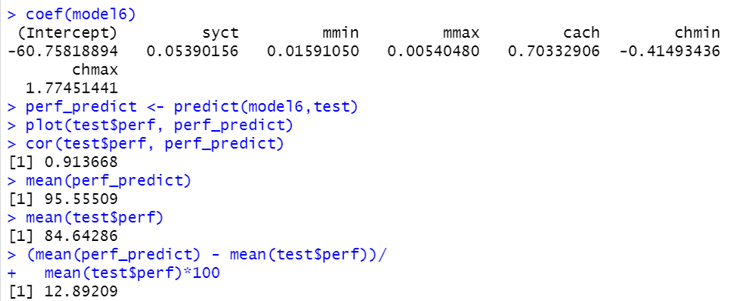

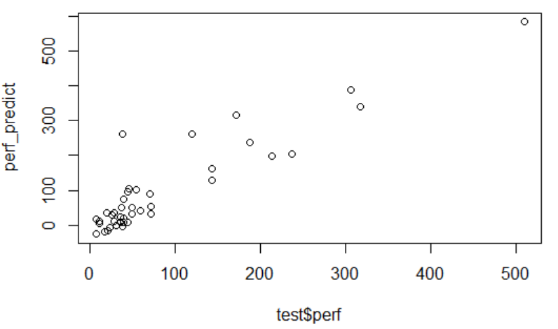

The mean bias is 12.89209.

Problem#7



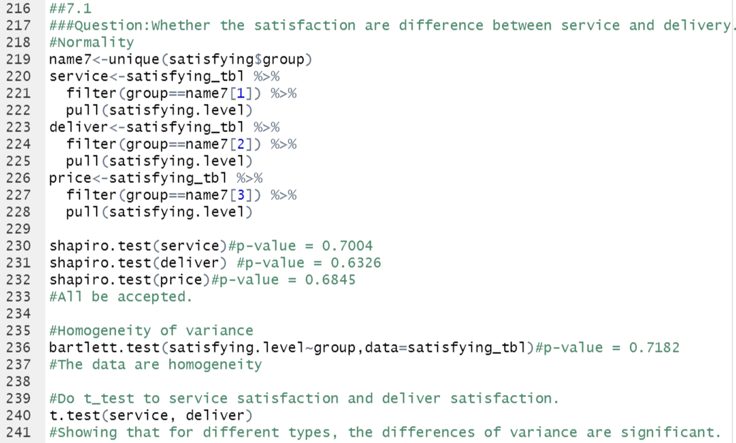

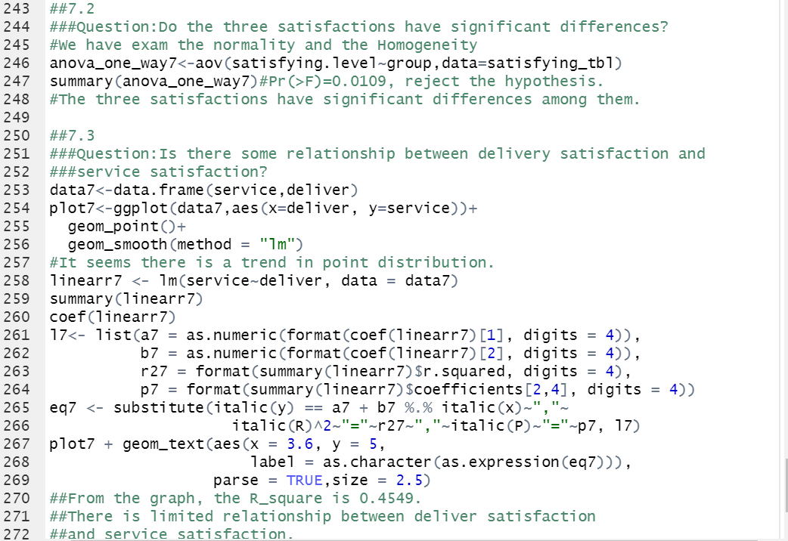

**The results are as below:**

I choose a dataset which is about the satisfaction rate to service(1), delivery(2), and price(3).

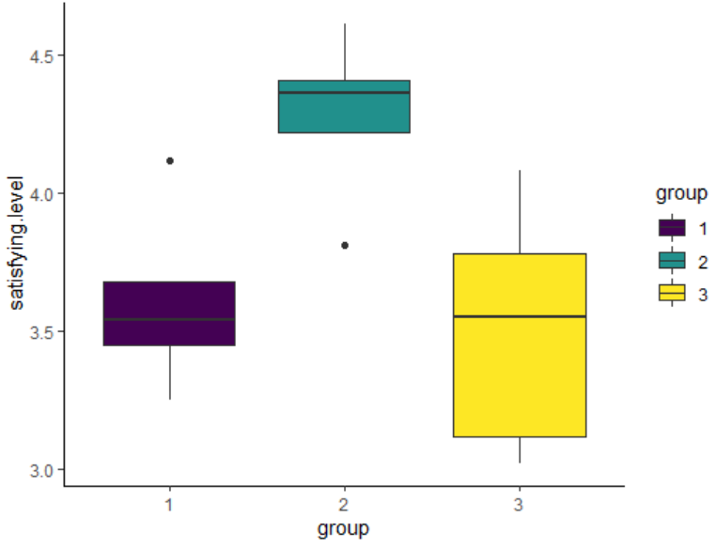

From the boxplot the difference seems distinct.

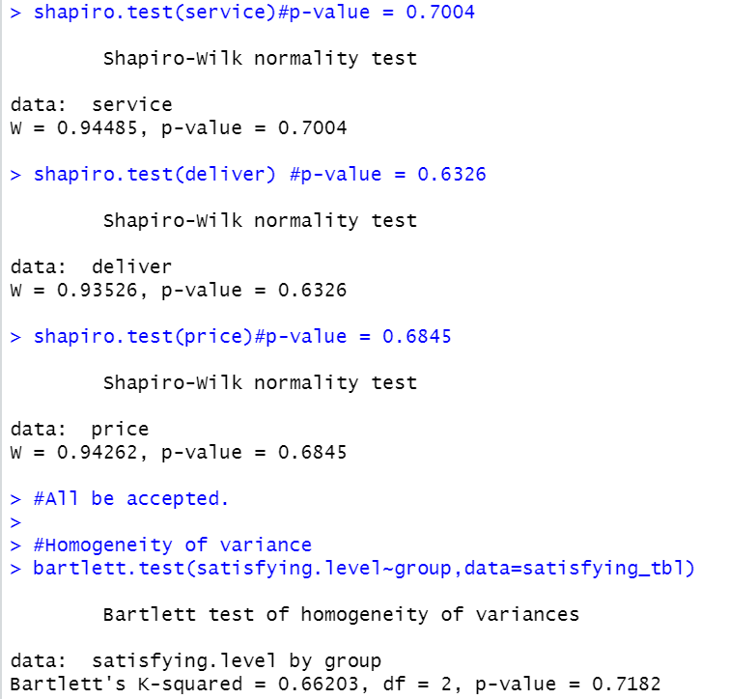

The data **pass** the normality and heterogeneity test.

**7.1 Question: Whether the satisfactions are difference between service and delivery?**

Do t-test to service satisfaction and deliver satisfaction.

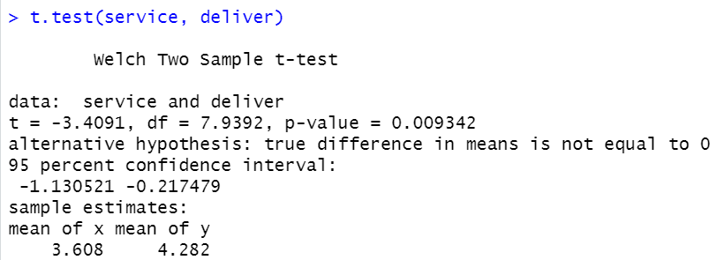

The results show that for different types, the differences of variance are significant.

**7.2 Question: Do the three satisfactions have significant differences?**

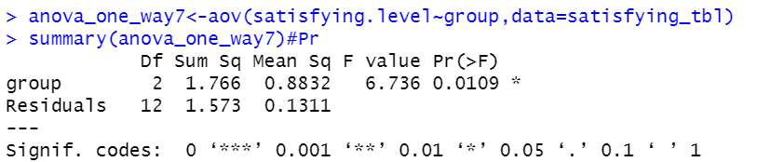

The three satisfactions have significant differences among them.

Pr(>F)=0.0109, reject the hypothesis.

**7.3 Question: Is there some relationship between delivery satisfaction and service satisfaction?**

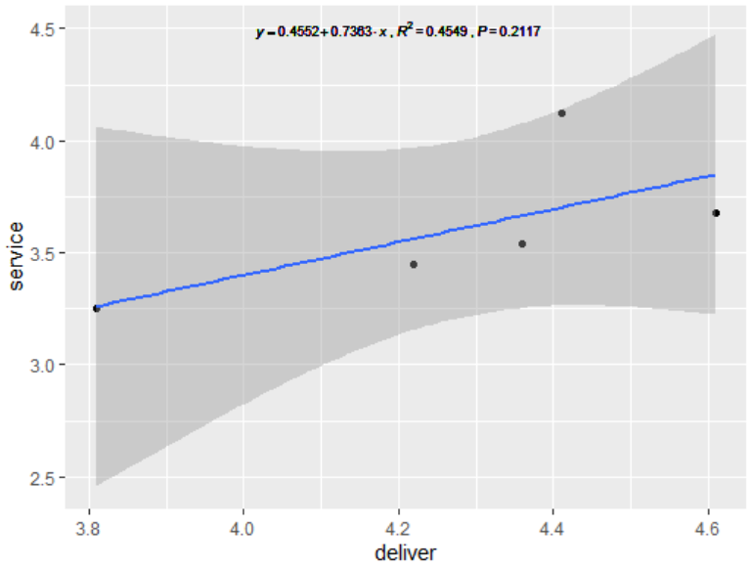

From the graph, the R_square is 0.4549. There is limited relationship between deliver satisfaction and service satisfaction. 