Dataset: ILSVRC2012 dataset(IMAGENET)

Images in one class: 50

Semantic Segmentation Models: FCN, DeepLabv3

表 1 类别层级的ISSC和ISDC得分

|  |  |  |  |  |  |  |
| --- | --- | --- | --- | --- | --- | --- |
| Class | ${ISSC}_{X^{k}}^{d}$, $d=5$ | | | ${ISDC}_{X^{k}}^{d}$, $d=5$ | | |
| FCN | DeepLabv3 | LR-ASPP | FCN | DeepLabv3 | LR-ASPP |
| Sorrel | **0.732** | **0.732** | 0.643 | 0.911 | **0.929** | 0.857 |
| Tabby | 0.536 | **0.750** | 0.589 | 0.643 | **0.929** | 0.857 |
| Bulbul | **0.798** | 0.750 | 0.655 | 0.958 | 0.857 | **0.964** |
| Siamese cat | 0.690 | **0.798** | 0.625 | 0.869 | **0.964** | 0.804 |
| Bison | 0.429 | 0.494 | **0.839** | 0.589 | 0.786 | **0.911** |
| Zebra | 0.946 | **1.000** | 0.875 | 0.929 | **0.982** | 0.929 |
| Average |  |  |  |  |  |  |

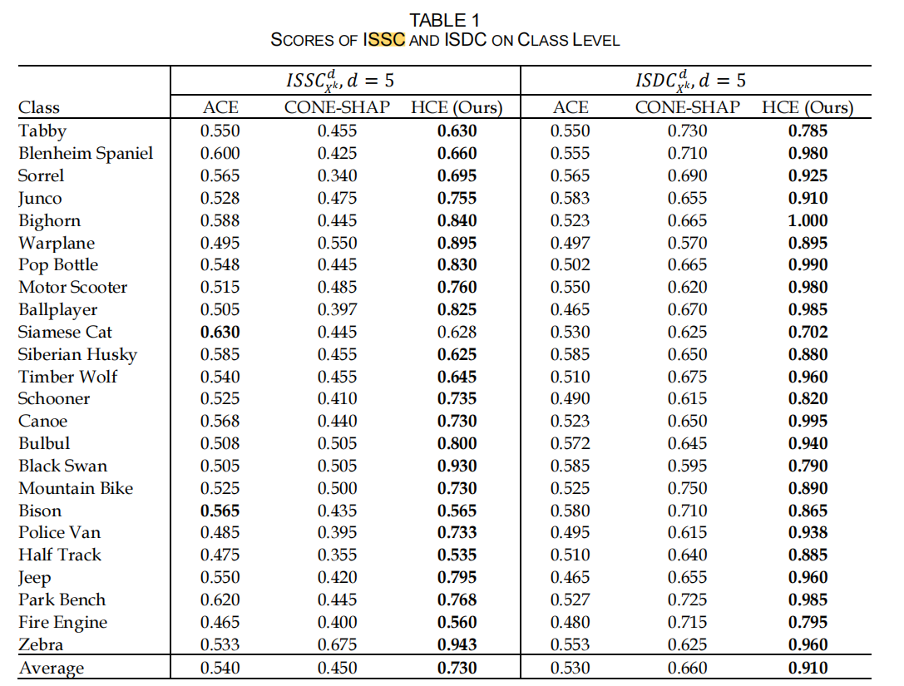

Note that row1 and row3 will be used.

表 2 SSC得分（越高越好）

|  |  |  |  |  |  |
| --- | --- | --- | --- | --- | --- |
|  | SSC(add top-d most important concept) | | | | |
|  | $$d=1$$ | $$d=2$$ | $$d=3$$ | $$d=4$$ | $$d=5$$ |
| FCN |  |  |  |  |  |
| LR-ASPP |  |  |  |  |  |
| DeepLabv3 |  |  |  |  |  |

表 3 SDC得分（越低越好）

|  |  |  |  |  |  |
| --- | --- | --- | --- | --- | --- |
|  | SDC(add top-d most important concept) | | | | |
|  | $$d=1$$ | $$d=2$$ | $$d=3$$ | $$d=4$$ | $$d=5$$ |
| FCN |  |  |  |  |  |
| LR-ASPP |  |  |  |  |  |
| DeepLabv3 |  |  |  |  |  |