NER：Bert-lstm-crf 环境：gxy

**输入：data_aug.csv（好像不是输入，只是用来训练的）**

需要**分过句**的文本即可

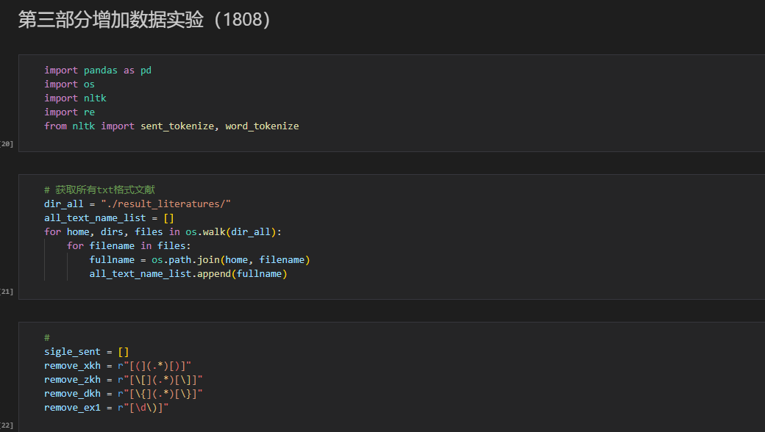

分句后这一步会去跑模型处理

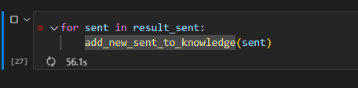

**输出：第二章-NER/add_knowledge_base_with_tag.csv**

|  |  |  |
| --- | --- | --- |
|  | 0 | 1 |
| 0 | K structure | 对应的句子 |
| 1 | Special atmosphere | 对应的句子 |

第三部分增加数据实验不太确定，是对txt全部进行处理，然后用NER去跑出得到结果？

**输出处理：数据：第二章-NER/add_knowledge_base.csv**

**代码：第二章-NER/NER-Result-Prepare.ipynb**

将同一句句子中的实体merge在一起，排列组合出所有的可能<e1, e2>

|  |  |
| --- | --- |
| Other | In each phosphate series , the а cell parameter increases slightly when the **<e1>M</e1>** + cations occupy vacant **<e2>sites</e2>** ( Fig . |
| Other | In each phosphate series , the а **<e1>cell parameter</e1>** increases slightly when the M + cations occupy vacant **<e2>sites</e2>** ( Fig . |
| Other | In each **<e1>phosphate</e1>** series , the а cell parameter increases slightly when the M + cations occupy vacant **<e2>sites</e2>** ( Fig . |
| Other | In each phosphate series , the а **<e1>cell parameter</e1>** increases slightly when the **<e2>M</e2>** + cations occupy vacant sites ( Fig . |
| Other | In each **<e1>phosphate</e1>** series , the а cell parameter increases slightly when the **<e2>M</e2>** + cations occupy vacant sites ( Fig . |
| Other | In each **<e1>phosphate</e1>** series , the а **<e2>cell parameter</e2>** increases slightly when the M + cations occupy vacant sites ( Fig . |

BERT：

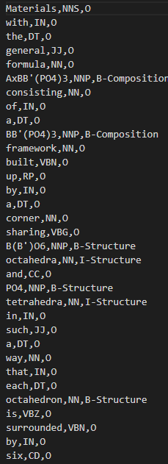

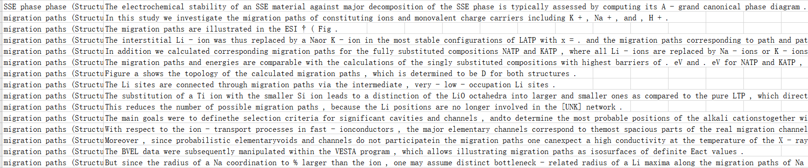

RE：

输入：nine relations/test.tsv

输出：Eval/proposed_answer

左边输入右边输出

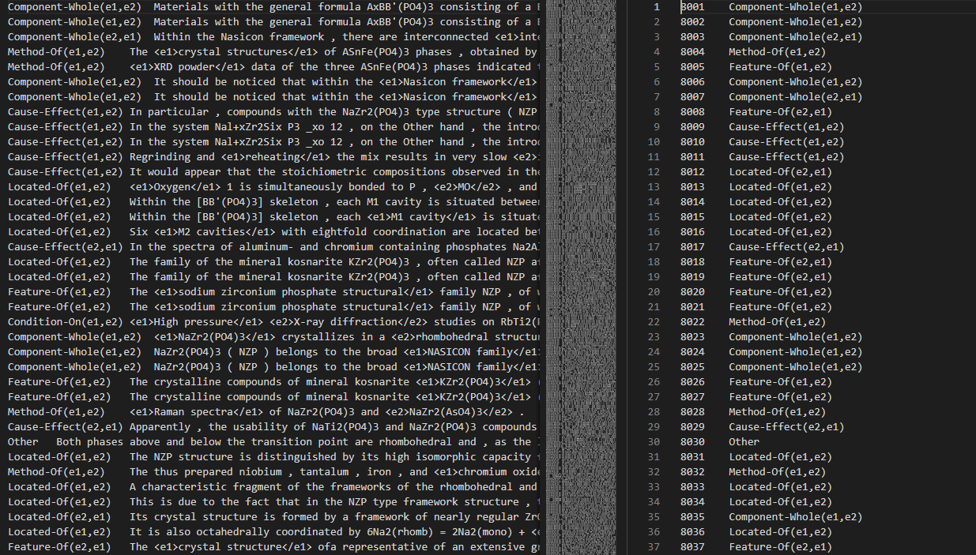

CNN & BiLSTM_Att

