# 2023.9.7

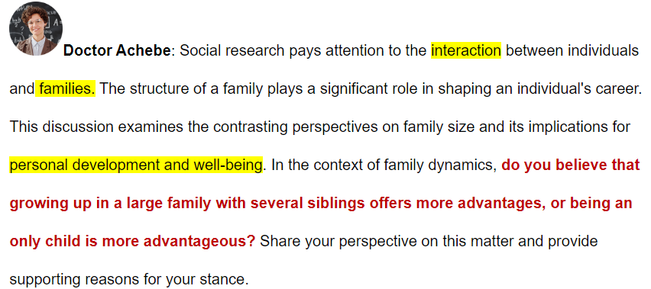

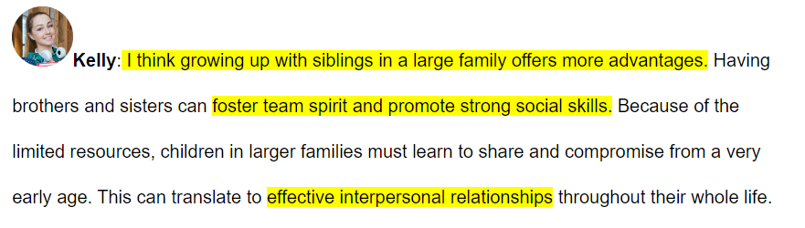

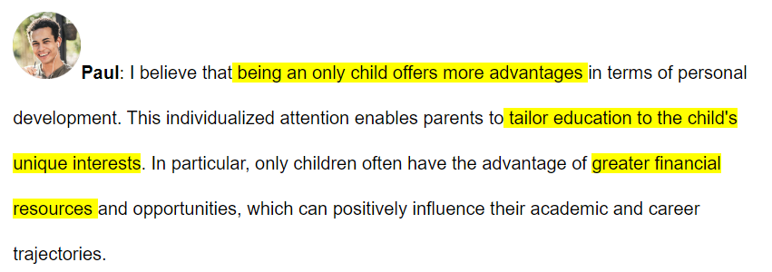

|  |  |
| --- | --- |
| 60s 审题  效率 方便  安全 环保  经济 耐用 Paul  乐趣 成就  健康 情绪  交流 经验 kelly | 直接选大纲，而不是想理由  【让步认可】Paul对独生子女家庭的好处论述有道理。  【让步理由】的确，独生子女可以享受更多的经济支持。  【转折观点】但是，兄弟姐妹的相互支持，更有利于每个家庭成员 。  挑理由：耐久 - 分担压力和责任 - 帮助个人成长  【给出理由】  当家庭面对长期挑战，家庭成员共同承担，个人压力减小，有助个人长期发展。  【解释陈述】特别是人口老龄化，父母养老是每个家庭都要妥善解决的。  【例证细节】  人物：我在新加坡留学的同学； 起因：父母年纪大了需要照顾；  发展：哥哥在国内帮照料父母；  结果：专心完成学业顺利毕业。  【总结观点】尽管独生子女有经济优势，但长期看大家庭对个人支持更大。 |

9’30’’

It makes sense that there are some advantages for being the only child.

**Paul's argument** about the advantages of being an only child **holds value / weight / merit.**

**Xx’s argument about xxxxx holds value/merit/weight.**

-----------------------

Indeed, the only child can enjoy more financial support.

Indeed, only children often **obtain** more **economic / financial / monetary** support from their families.

Indeed, xxxxxxx 让步理由

-----------------------

However, mutual support among several siblings ~~in a large family can do favor for each other, which do more~~

~~merits~~ can be more beneficial for every family member ‘s progress.

However, **mutual support** among siblings can be more **beneficial / advantageous / favorable** for everyone's **progress**.

However, 转折**观点**

------------------------

When the family ~~face~~ long-term challenges, family members can ~~shoulder~~ responsibilities collectively which is helpful for personal profound development, xxxxxxxx.

When a family **encounters** long-term challenges, all family members can **share** the responsibility, **reducing / lessening / alleviating** stress for each individual.

When xxxxx 给出**理由**

-------------------------

Especially for the reason of ~~population aging~~, taking care of our ~~elder~~ parents is a ~~problem~~ every family need to solve.

Especially **in an aging society**, taking care of **elderly parents** has become a **major / significant / paramount** **concern** for every family.

Especially for xxxxxxxx 解释理由**陈述**

-------------------------

For example, one of my friends [studied abroad in Singapore] had to xxx ~~whose~~ parents were getting older and need looking after【描述问题】. xxxx His brother lent his hands to do that, allowing him to ~~so he could~~ finish his education abroad.【解决办法】

For example, a friend of mine, who was studying in Singapore, had to take care his **aged parents**, **but fortunately**, his brother helped to look after them, **allowing / enabling / permitting** him to graduate successfully.

For example, xxxxxxx【描述问题】But fortunately, xxxxxxx, allowing xxxxxx【解决问题】

--------------------------

Therefore, the only child has the merit of finance though, the large family do more help for personal development in the long run.

Therefore, although being an only child has advantages in youth, having siblings in a larger family provides more **important / significant / substantial** support in the long run.

Therefore, although xxxx has advantages in xxxx, having xxxxx provides more xxxxx

# 2023.9.8

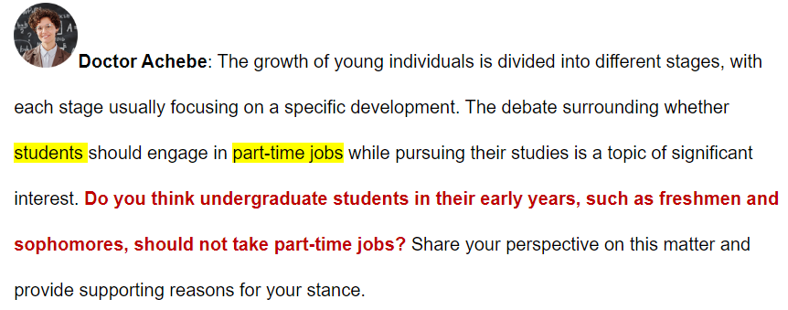

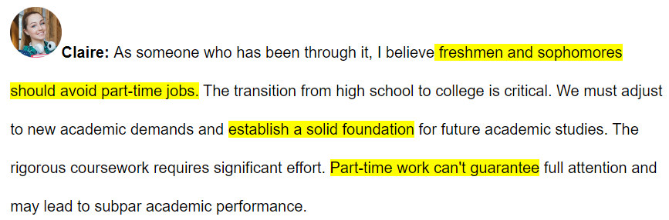

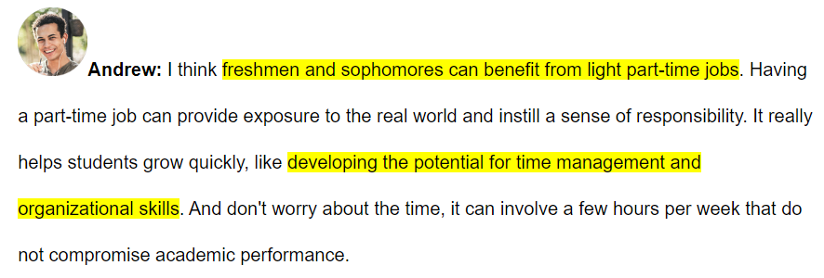

|  |  |
| --- | --- |
| 45s 审题  效率 方便  安全 环保  （学业安全 Claire  经济 耐用  乐趣 成就  （技能算成就Andrew  健康 情绪  交流 经验 | 直给型  【给出观点】Andrew的观点，从个人成长的角度看有道理  【补充理由】兼职经验有助于对**专业的理解**，并能提供**经济来源**。  【解释1】低年级大学生通过本专业兼职，理解是否适合学本专业  【例证细节】记叙文六要素：时间、地点、**人物**、**起因**、**发展**、**结果** 选四个  我的计算机专业学弟，因为大一暑假兼职厌恶天天写代码，大二转专业去了机械专业，热爱新专业并取得好成绩。  【解释2】很多美国大学生有学贷，兼职可以缓解经济负担  【例证细节】机构 统计 结果  美国大学统计，超过一般的大学生背负学贷，大一暑假就兼职为了还学贷  【总结观点】虽然以学业为重，但只要能平衡时间，兼职有助于事业发展并缓解经济压力。 |

10’47’’

Andrew's perspective is reasonable, which makes sense for personal development.

Andrew’s perspective is **valid** when **considering/evaluating/assessing** the development of social skills(总结Andrew的观点，归到12个理由中) through part-time work.

Xxxx’s perspective is valid when considering xxxxxxx through xxxxxx(直给观点）.

Taking a part-time job helps students to accumulate working experience in his arena and relieve financial burden.

Specifically, I believe that the **experience/knowledge/insight** **gained** from part-time job can improve **understanding** one’s major while providing **financial aid**.

Specifically, I believe that xxxxxx can improve xxxxxx （理由1）while xxxxxx（理由2）

Low-grade undergraduate students can figure out whether he is suitable for his major through doing a part-time job in this field.

First, lower-grade college students can determine their **suitability/compatibility/aptness** for their **field** through part-time work in their **specialty**.

First, xxxxxxxx

For example, one of my friends ~~used to~~ [study computer science] ~~in his freshman year.~~ He did a ~~part-time job~~ internship in that summer holiday and he coded all day, which frustrated him. So he ~~transferred~~ switched to mechanical engineering which he ~~really loved~~ in his sophomore year and he ~~made great achievements~~.

For example, a classmate of mine majoring in computer science **lost interest** during his first **summer internship** **involving daily coding** and thus **switched** to mechanical engineering in his second year, where he discovered his **passion** and excelled/**thrived**/prospered **academically**.

For example,xxxxxx

In addition, many students in America lent academic loan. Taking part-time can help alleviate this.

Furthermore, given the **burden of debts** on American college students, part-time work can lessen/**alleviate**/mitigate their **financial pressure(=financial aid)**.

Furthermore, given the xxxxxxx of xxxx (缺陷), xxx(理由2) can alleviate xxxx(缺陷的笼统说法)

According to an institute, over half undergraduate students have academic loans, they often do a part-time job in their freshman summer holiday to pay off this loan.

According to **statistics**, over half **of** US college students have **student loans**, **leading/causing/prompting** many to start part-time jobs during their first summer to **repay** their loans.

According to **statistics**, half of xxxx（存在Furthermore中的现象）, causing xxxxxx（观点） to xxxxx（解决上述现象）

In conclusion, though it's academic performance that really matters in university, if one can find a balance between part-time job and studying, it's better for one's future development and offer financial support.

Therefore, although academics are a **priority** for college students, **moderate** part-time work **benefits** **career progression** and **reduces** financial burden.

Therefore, although xxxxx, xxxxx can xxxxx