The reading passage states that .... However, the professor in the lecture articulates that ....

First of all,

Secondly,

Lastly,

陈述 / 反对reading观点

1. The professor refutes the argument in the reading passage that...
2. The professor questions the reading’s assertion that ...
3. Even though the professor recognizes that ..., as asserted in the reading passage.
4. The reading passage declares that ...

陈述教授观点；

1. In fact, he argues that ...
2. On the contrary, he claims that ....
3. Whereas the professor holds a contradictory view that ...

进一步解释：

1. He/She further emphasizes that ...
2. He/She points out that ...
3. In addition, ...
4. Also, ...
5. According to the professor, ...
6. He/She believes that ...
7. He/She implies that ...

**In conclusion, despite several positive reasons made in the reading,** **it can be said that the professor is against the idea that** early humans had control over the use of fire 1.6 million years ago **and have valid arguments to support his position.**

The dinosaurs, known as sauropods, were the largest animals ever to walk the Earth. One sauropod, the Brachiosaurus or "arm lizard," weighed over 50 tons and was very tall, the equivalent of a three-story building. Brachiosaurus adults measured over 80 feet. Brachiosaurus' necks took up a third of this length, extending 30 feet. Its tail was also very long, serving as a counterbalance for the neck. **Because the animal was limited by its huge size and shape, scientists believe it was probably confined to a water habitat.**

**For one thing, on land, the short legs of Brachiosaurus would have been unable to support such a large mass.** Its frame would have collapsed, the bones being crushed by the weight. In water, however, buoyancy would help support the bodies of these large animals, allowing them to stand and even move about, just as large crocodiles are supported by water in rivers and swamps.

**Second, it is unlikely that Brachiosaurus could have lifted its neck to reach tree leaves on land due to the weight of its head and long neck.**Because this giant dinosaur ate 400 pounds of food a day, it would  have needed a ready food supply. Thus, Brachiosaurus could only have survived by dipping its long neck under the water and feeding on aquatic plants in the many lakes and swamps that existed in the warm Jurassic Period.

**Finally, because its nostrils are located at the top of its head, the Brachiosaurus could have spent much of the time mostly submerged in deep lake waters.**In such habitats, the dinosaurs would have used their nostrils to breathe, like swimmers use snorkels.

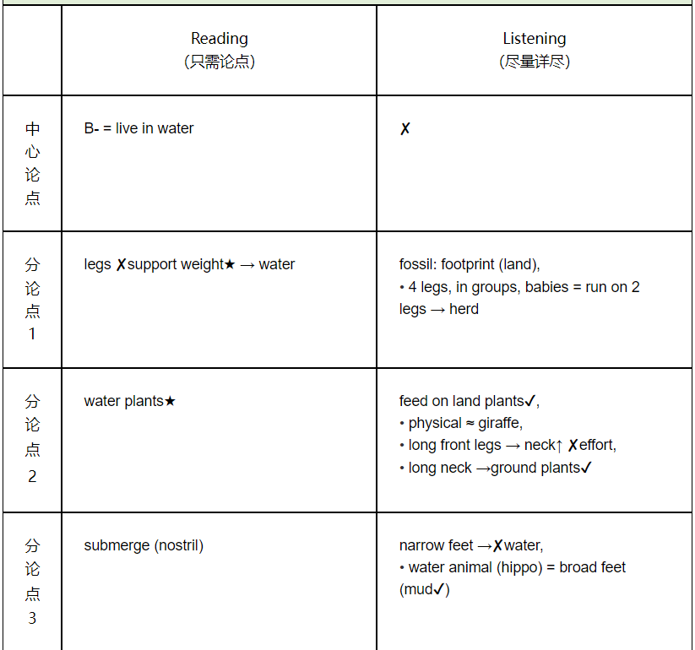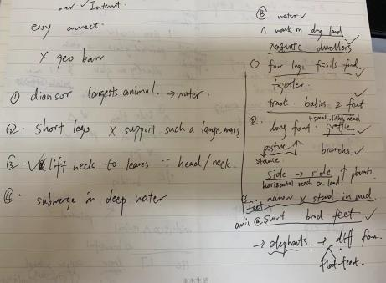

According to the reading, scientists believe that Brachiosaurus were restricted to a aquatic habitat.

Nevertheless, the professor talks about that Brachiosaurus were not confined to a water habitat.

First, the professor questions the short legs which cannot support their weight in the reading. She argues that they used all their four legs together to walk which ensured by evidence found in fossils. And the tracks got by researchers of Brachiosaurus babies could even use 2 legs to walk.

Second, the reading declares that they could not raise their heads to reach leaves because of the head weight and long neck. But the professor holds a contradictory view, believing that they could set a posture like a ~~graffie~~ giraffe with their long front legs and short hind legs to reach branches. Also, they might move their head from head to head to get enough amount of plants.

Last, the professor rejects the reading's claim of only sticking to feeding on deep lake water. She believes that they could hardly stand in mud with their short broad feet. She states that one type of elephants which was similar to them could do this, but their bodies were totally different from Brachiosaurus.

**The reading passage states that** the living habitat of Brachiosaurus would be water. **However, the professor declares that** it could walk on foot and thus live on land.

**First, the professor refutes the reading passage that** Brachiosaurus' legs could not support their massive weight and had to rely on water buoyancy. **She claims that** there were fossil records of Brachiosaurus' footprints on land. S**he further emphasizes that** it could walk in groups on land using four legs, and youngsters of sauropod could run on their two legs to keep up with adults.

**Second, the professor questions the reading's argument that** Brachiosaurus fed on water plants. **She articulates that** it could feed on land plants thanks to its long front legs, extending its neck upward with less effort, just like a giraffe. **She further asserts that** even if it could only reach its neck horizontally, there were plenty of plants at its body height. So, its long neck could cover a large ground area to take food.

**Finally, the professor dismisses the assertion in the passage that** Brachiosaurus submerged in water and used nostrils to breathe. She points out that it had narrow feet, given the structure of bone fossils, which were unfit for life in water. **The professor believes that** for a large animal to live in the lakes or swamps, it needed to have broad feet like a hippo to walk on the muddy bottom.

【应试技巧】考试如果听力的细节记不全，答题字数达不到要求，可以最后加个第5段：再总结一遍阅读和听力的关系，字数至少达到225词。结尾总结参考：

**In summary, the professor provides compelling counterarguments to the reading passage's claim that** the Brachiosaurus' natural habitat was water. **She highlights** the fossil evidence of footprints on land, the adaptability of feeding on land plants, and the unsuitability of its feet for an aquatic environment, all of which strongly suggest that the Brachiosaurus was well-equipped to thrive on land rather than in water.

There has been much discussion about when our early human ancestors were first able to control fire on a regular basis. Many archaeologists believe that some 1.6 million years ago, the early human ancestors referred to as Hominins had control over fire when they emerged from Africa. These predecessors of modern human beings could walk on two feet and were always on the move. They were hunters and gatherers who could use simple stone tools. We can logically assume that the Homo erectus species — the name we often give the first upright Hominins — had control of fire when they arrived in Europe. There are several reasons for this thinking.

First, because we know the Homo erectus species colonizing Europe had rapidly evolving bodies and relatively large brains, they would have required a steady source of energy. Heat greatly increases the nutritional quality of food. Cooked foods are more efficiently digested and boost metabolicenergy. In cold climates, the consumption of raw foods would have been an insufficient source of energy to fuel the growth and evolution of Homo erectus that took place.

Also, archaeologists have discovered traces of fireplaces and burned materials in many excavations in Europe. Although the nomadic Homo erectus did not take time to build formal hearths, the clusters of burnt materials that have been found indicate that heating took place. For example, there are reddened sediments (showing iron oxidation), charred bone fragments and small pieces of charcoal.

Moreover, we know that during this time the temperatures in Europe routinely dropped below freezing. It would have been impossible for Homo erectus to survive in the northern latitudes of Europe during the Ice Age without relying on fire to stay warm, especially during the coldest periods of winter.

-------------------------------------------------------------------------------------------------------

Of course, our early human ancestors made use of natural fires in Africa, but they were not able to control the technology. There is simply no evidence in Europe that the early Hominins had regular control of fire almost two million years ago. Research findings suggest that humans did not control fire until much later, about 400,000 years ago.

What about the claim that Homo erectus must have eaten cooked food to have enough energy to evolve? To be sure, cooked food is more energy efficient for human bodies. However, even in cold climates, Homo erectus would have had an excellent source of meat and fish. And archaeologists who have analyzed fossils of teeth have found that Homo erectus munched（用力咀嚼） on crunchy（硬脆的） and tough foods, such as raw meat and root vegetables. The size and shape of their teeth were well suited for tearing and chewing meat, a source of protein that supports brain development.

As for fireplaces, no charcoal or charred（烧焦的） bones have been found in European archaeological sites dating a million years back that can be linked to the controlled use of fire. The charcoal particles and burnt bones that have been found seem to be products of fires which occurred much later in geologic time. Furthermore, while our ancestors in Africa certainly made good domestic use of fire when lightning struck（闪电击中） or when volcanoes erupted（火山爆发）, they were unable to create fire on a habitual basis.

And third, whereas it's true that a million years ago, temperatures in Europe dipped below freezing as glaciers advanced and retreated, the Homo erectus who colonized these parts proved able to survive without fire. How? They were tenacious（顽强的） and resilient（坚韧的）. They followed herds of game（狩猎物） and took advantage of natural shelters such as caves. Adapting to the cold, they used primitive（原始的） tools to create warm clothing out of animal skins.

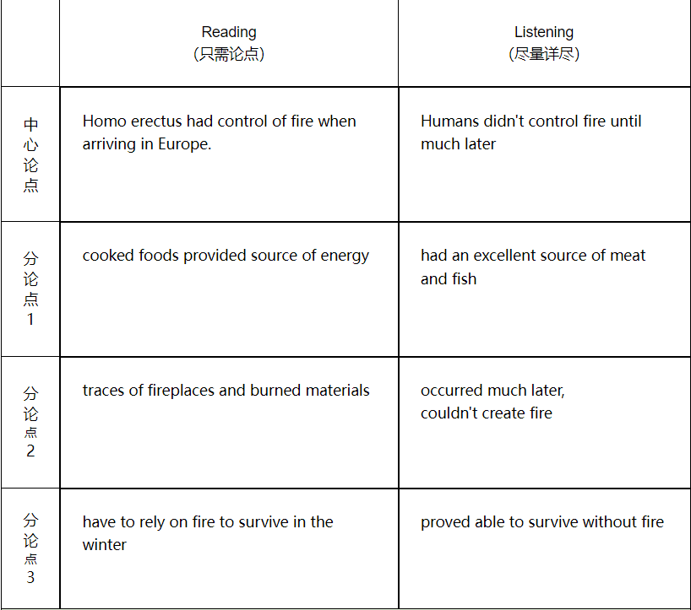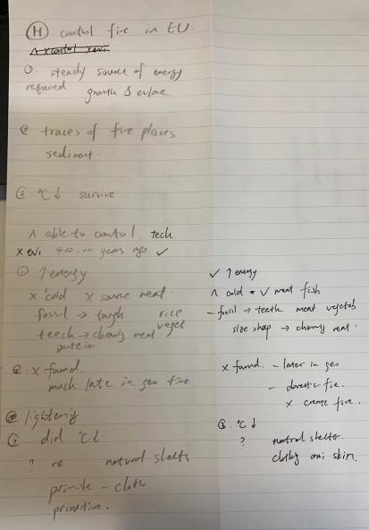

18’36’’ 224 words

The reading passage states that Homo erectus had the ability to control fire when arriving in Europe. However, the professor in the lecture articulates that they were not able to control fire until 400,000 years ago.

First of all, even though the professor recognizes that Homo erectus species needed a source of energy to evolve, as asserts in the reading passage, he claims that they got nutrition from various sources but not cooked food. Since the weather was cold, there were few sources of meat, rice and vegetables. But according to found fossils of them, tough teeth were indicated to chew meat to obtain protein.

Secondly, the reading passage declares that evidences of burned staff were found. Whereas the professor holds a contradictory view that the existing time of these stuff did not match the time when Homo erectus species existed. He points out that these fragments and pieces of charcoal were much later in geological time. Also, they were not used for cooking but lighting.

Lastly, the professor refutes the reading's argument that Homo erectus depended on fire to survive in freezing weather conditions. In fact, the professor argues that they exactly survive by other methods without fire. He implies that they relied on natural shelters like caves to live in. In addition, primitive clothes were made to keep themselves warm.

In conclusion, despite several positive reasons made in the reading, it can be said that the professor is against the idea that early humans had control over the use of fire 1.6 million years ago and have valid arguments to support his position.

The reading argues that early humans knew how to control the use of fire 1.6 million years ago. However, the professor articulates that it was much later, about 400,000 years ago.

First, the professor concurs with the reading's statement that cooking enhances the nutritional value of food; however, he asserts that early Hominins got enough nutrition through raw foods like meat and fish during cold climates. The professor cites that fossil records of teeth are well-suited for tearing tough foods, which could support enough proteins for the brain's development. And he implies that they would not have had this kind of teeth if they had not consumed raw food.

Second, the professor disputes the dating of the charcoal and burnt bones. He explains that the burnt materials were from a much later time. He also states that there is no archeological evidence of the controlled use of fire in Europe that goes back a million years. In addition, Homo erectus in Africa may have taken advantage of natural fires, but that does not mean they could create fire.

Finally, the reading claims that fire played a role in the Homo erectus kept warm in the frigid temperatures of the times. In contrast, the professor declares that Homo erectus was persistent and adaptable. Their hunting lifestyle kept them moving with herds of animals, and they could use furs for clothing. He also says that they could stay in natural shelters to keep warm.

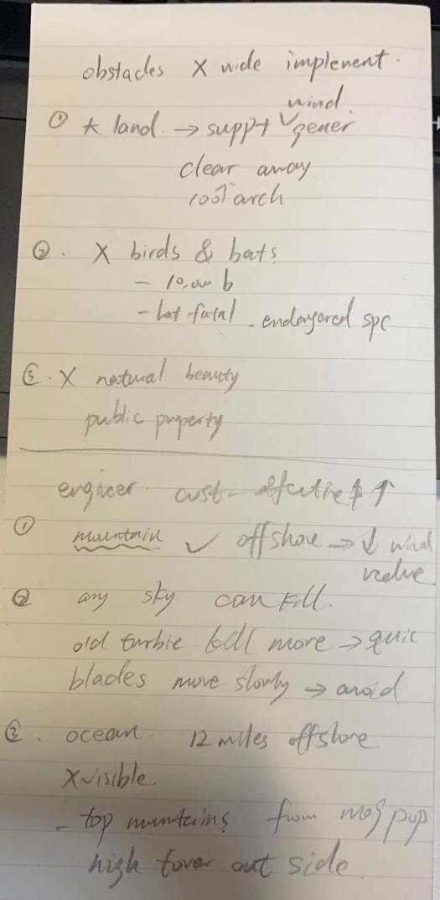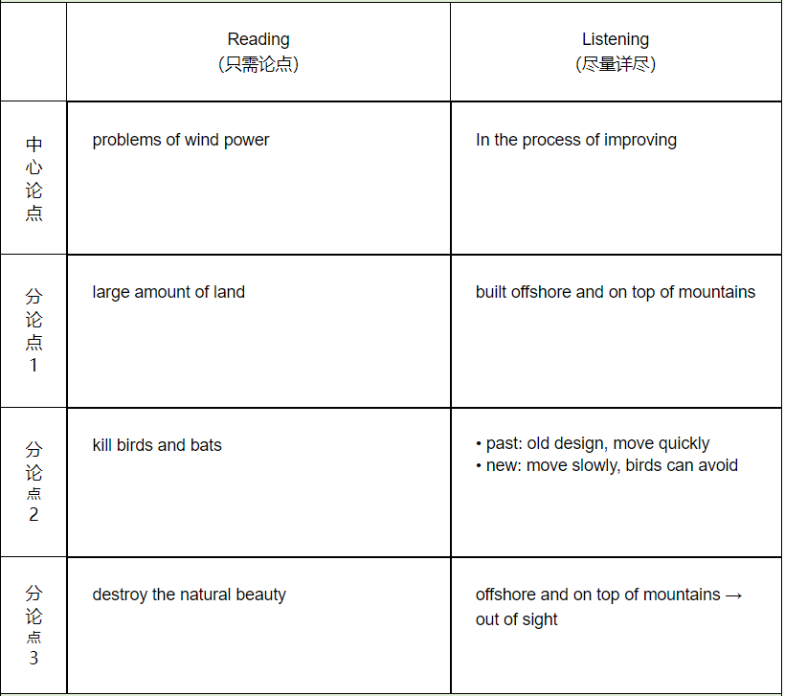

The reading passage states that there are many problems to widely utilize wind power in the future. However, the professor in the lecture articulates that more money will be invested to this project since they are cost-effect.

To begin with, the professor refutes the argument in the reading passage that wind generators necessitate mass land to place. On the contrary, she argues that most of them are now built on the mountains instead of lands.

Secondly, the reading passage declares that many birds and bats species are under great risk due to the development of turbines. Whereas the professor holds a contradictory view that any structures such as skyscrapers will kill flying birds. In fact, she cites that old turbines kill more birds than the one nowadays. The blade today moves so slowly that makes it easier for birds and bats to avoid.

Lastly, the professor questions the reading's assertion that landscape are destroyed by wind farms. She claims that wind turbines which can be controlled 12 miles off shore are now on the ocean, making it invisible on the land. Also, mountain tops are utilized to build them, removing exactly out from human's sight.

In conclusion, despite several positive reasons proposed in the reading passage, it can be said that the professor is against the idea that too much challenges will be encountered to use wind resources and she has valid arguments to back her position.

**The reading passage states that**the problems associated with wind power might hinder the widespread adoption of this renewable energy technology. **However, the professor argues that** there are feasible solutions to these challenges.

**First, the reading claims that**a wind power system requires substantial land. **By contrast, the professor points out that** there are effective strategies to address the land-use issue. **She suggests that**situating wind power systems offshore or on mountaintops can significantly mitigate land-use restrictions, freeing up much land.

**Second, the reading contends that**wind power facilities threaten the lives of birds and bats. **Nonetheless, the professor asserts that**tall structures, not just wind turbines, can threaten flying animals. **She notes that**the primary cause of many bird fatalities in California's wind farms is the outdated designs featuring fast-spinning blades and the placement of some farms in major flyways or close to nesting sites. **She also maintains that**newer designs with slow-moving blades will reduce the number of bird and bat   fatalities.

**Finally, the reading reveals that there are** aesthetic issues with wind   farms. **Nevertheless, the professor declares that**this problem can be solved by situating the facilities beyond the visual range of residents. **She emphasizes that**current technologies allow for the offshore installation of power systems, remaining out of sight for most locals and alleviating concerns over property values. **Additionally, she underscores that**building wind turbines on mountaintops can avoid negative impacts on residential areas.