**데이터 통신**

Term Project #2

2020.11.06 제출

2015112525 이준병

1. Checksum 계산과 검산을 위한 루틴에 대한 Flow Chart를 구성하여라.

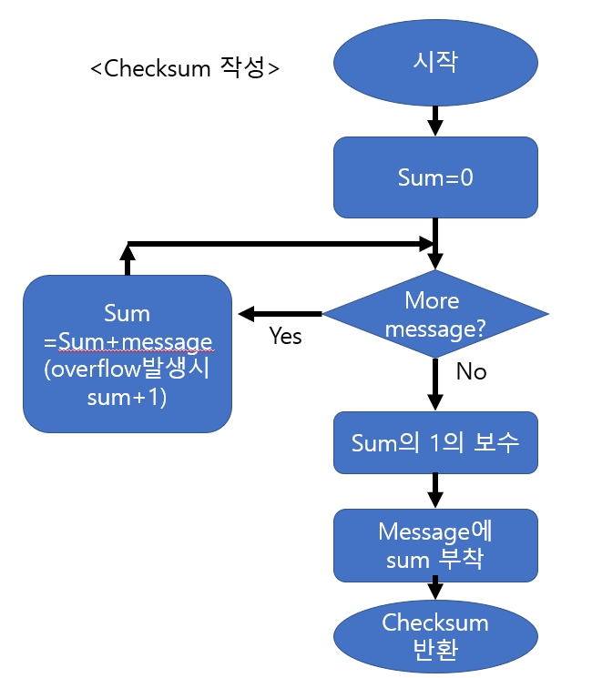

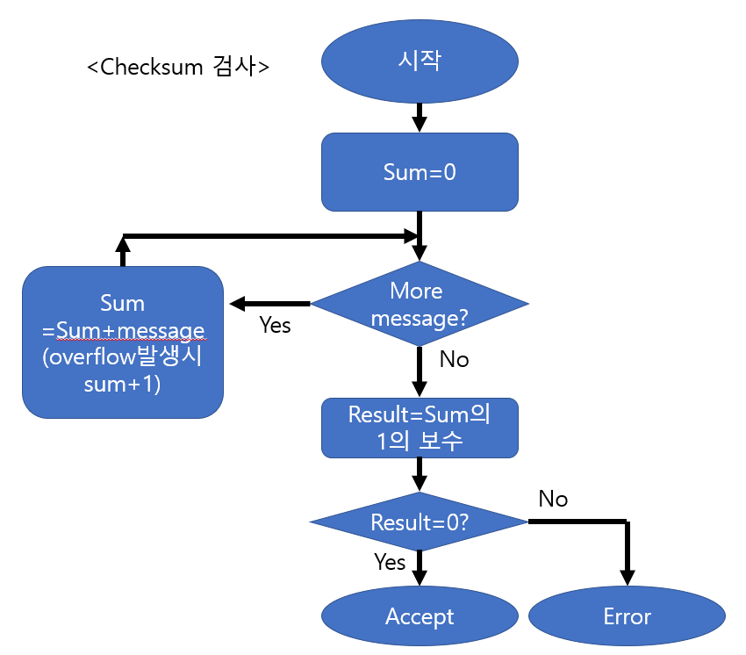

1. 아래 함수를 완성하여라

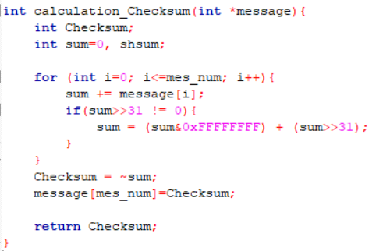

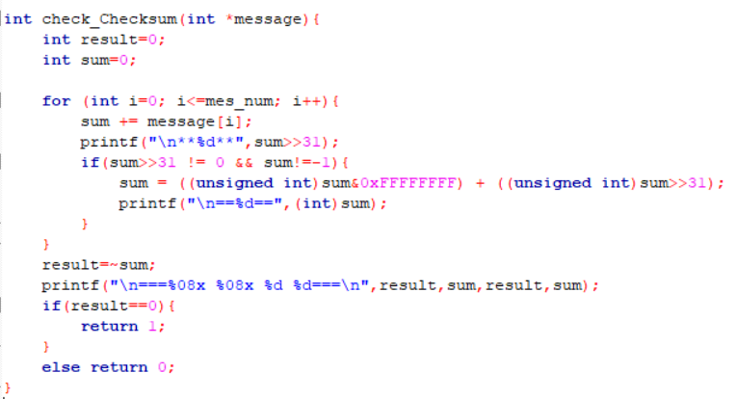

1. 테스트 프로그램

#include <stdio.h>

int mes_num;

int calculation_Checksum(int *message){

int Checksum;

int sum=0, shsum;

for (int i=0; i<=mes_num; i++){

sum += message[i];

if(sum>>31 != 0){

sum = (sum&0xFFFFFFFF) + (sum>>31);

}

}

Checksum = ~sum;

message[mes_num]=Checksum;

return Checksum;

}

int check_Checksum(int *message){

int result=0;

int sum=0;

for (int i=0; i<=mes_num; i++){

sum += message[i];

if(sum>>31 != 0 && sum!=-1){

sum = ((unsigned int)sum&0xFFFFFFFF) + ((unsigned int)sum>>31);

}

}

result=~sum;

if(result==0){

return 1;

}

else return 0;

}

int main(){

int mes[100];

int checksum;

printf("How many characters your input?: ");

scanf("%d", &mes_num);

printf("Please input message: ");

for(int i=0;i<mes_num;i++){

scanf("%d",&mes[i]);

}

mes[mes_num]=0;

printf("\nchecksum=%d \n",calculation_Checksum(mes));

if(check_Checksum(mes)==0){

printf("Error!");

}

else{

printf("message accepted. \n");

for(int i=0;i<=mes_num;i++){

printf("%d ",mes[i]);

}

}

}

<실행결과>

