1. 探究类的继承中，构造函数和析构函数的调用顺序
2. #include "stdafx.h"
3. class Grandpa
4. {
5. public:
6. Grandpa()
7. {
8. printf("Grandpa constreated\n");
9. }
10. ~Grandpa()
11. {
12. printf("Grandpa destoryed\n");
13. }
14. };
15. class Father:public Grandpa
16. {
17. public:
18. Father()
19. {
20. printf("Father constreated\n");
21. }
22. ~Father()
23. {
24. printf("Father destoryed\n");
25. }
26. };
27. class Son:public Father
28. {
29. public:
30. Son()
31. {
32. printf("Son constreated\n");
33. }
34. ~Son()
35. {
36. printf("son destoryed\n");
37. }
38. };
39. int main()
40. {
41. Son a;
42. return 0;
43. }

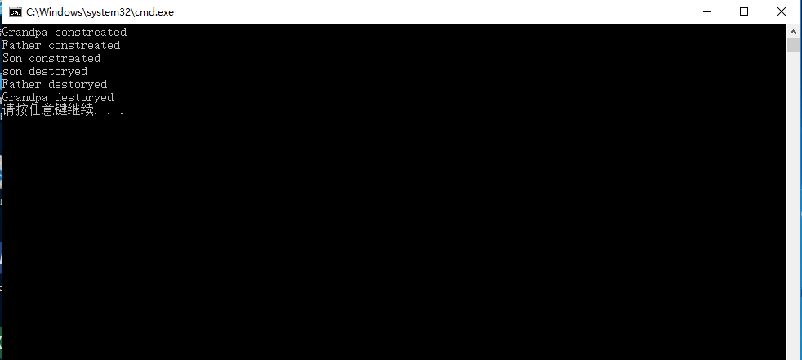

1. 利用xml做一张学生信息表

<?xml version="1.0" encoding="UTF-8"?>

<class>

<![CDATA[学生信息]]>

<student>

<student1>

<![CDATA[姓名]]>

<name>小明</name>

<![CDATA[序号]]>

<number>1</number>

<![CDATA[性别]]>

<gender>男</gender>

<![CDATA[年龄]]>

<age>19</age>

</student1>

<student2>

<![CDATA[姓名]]>

<name>小红</name>

<![CDATA[序号]]>

<number>2</number>

<![CDATA[性别]]>

<gender>女</gender>

<![CDATA[年龄]]>

<age>18</age>

</student2>

<student3>

<![CDATA[姓名]]>

<name>小军</name>

<![CDATA[序号]]>

<number>3</number>

<![CDATA[性别]]>

<gender>男</gender>

<![CDATA[年龄]]>

<age>20</age>

</student3>

<student4>

<![CDATA[姓名]]>

<name>小华</name>

<![CDATA[序号]]>

<number>4</number>

<![CDATA[性别]]>

<gender>男</gender>

<![CDATA[年龄]]>

<age>19</age>

</student4>

<student5>

<![CDATA[姓名]]>

<name>小林</name>

<![CDATA[序号]]>

<number>8</number>

<![CDATA[性别]]>

<gender>男</gender>

<![CDATA[年龄]]>

<age>20</age>

</student5>

<student6>

<![CDATA[姓名]]>

<name>小青</name>

<![CDATA[序号]]>

<number>9</number>

<![CDATA[性别]]>

<gender>女</gender>

<![CDATA[年龄]]>

<age>19</age>

</student6>

</student>

</class>

