DEVELOPMENT OF TRACKR

By:
Longjie Chao
Sophia Patrice Manalo Mendoza

A Thesis Submitted in Partial Fulfillment of the Requirements for the degree of Web Application Development

Approved by:
Mr. Josep Queralt
Mr. Jordi Bosom

Ciclo de Grado Superior
Institut Nicolau Còpernic
May, 2021
ABSTRACT
Self-tracking has become a part of today’s digitized world. Smartphones and wearable devices allows us to capture quantitative self-representation in tables, graphs and numbers. Along with written and visual self-representations, they have come to shape an extension of one’s self.
The objective of this research is to show and organize our day-to-day basis to a more compact and accessible self-tracking application. The main research question answered is “how is self-quantification helping and improving our daily lives?”. To answer this, an application was built to help us define our lives and to show us that with the help of self-trackers, we could make our lives a little bit easier, more organize, and collected. A primary overarching theme that were found in this research was a reflexive self-analysis, which shows us the practice of self-tracking is grounded in a culture idealization of self-improvement, but can lead to self-destruction.
This research connects to the modern perspective of the self as a direct reflection of our moral decision making, behavior and actions.

Table of Contents
1. INTRODUCTION 3
2. PROJECT PLANNING 4
3. MARKET 6
1. Executive summary 6
2. Products and services 6
3. Mission 6
4. Vision 6
5. Competition 6
6. Competitive advantage 7
7. SWOT analysis 7
A. Strengths 7
B. Weaknesses 7
C. Opportunities 7
D. Threats 7
8. Buyer persona 7
9. Marketing objectives 8
10. Marketing Budget 8
A. Development Schedule 8
B. Marketing Mix 8
C. Social media 9
4. ANALYSIS PHASES 10
No functional requirements 10
Technologies 10
Functional requirements 11
Use Case Actor Census 11
Use Case Census 11
Analysis Class Diagram 13
Use Case Diagram 14
Use Case Specification 15
5. DESIGN 21
Database design 21
Sketch 22
Mockup 30
Login 30
Registry 31
Main page 32
Mood 33
Expenses 34
Old Transactions 35
To Do List 36
Task Folder 37
Edit Task 38
Contact 39
Calendar 40
Edit Contact 41
Scheduler 42
Edit Scheduler 43
Menu 44
Style Guide 45
6. USER MANUAL 46
Login 46
Register 46
Menu 47
Mood 48
Expenses 48
Old transactions 50
To do list (folder) 50
Add/Update To do List 51
Task and Challenge List 51
Add/Update Task/Challenge 52
Schedule 52
Schedule update 53
Schedule task 54
Contacts 55
Calendar 56
Main 57
7. INSTALLATION MANUAL 58
8. BIBLIOGRAPHY 59

Table of figures
Figure 1: Gantt 1 4
Figure 2: Gantt 2 5
Figure 3: Analysis Class Diagram 14
Figure 4: Use Case Diagram 15
Figure 5: Database design 22
Figure 6: Sketch: Login and Register 23
Figure 7: Sketch: Main and Menu 24
Figure 8: Sketch: Mood and Financial 25
Figure 9: Sketch: Old Transactions and To Do List 26
Figure 10: Sketch: Task/Challenge List and Edit/Add 27
Figure 11: Sketch: Contact 28
Figure 12: Sketch: Scheduler 29
Figure 13: Sketch: Calendar 30
Figure 14: MockUp: Login 31
Figure 15: MockUp: Register 32
Figure 16: MockUp: Main 33
Figure 17: MockUp: Mood 34
Figure 18: MockUp: Expenses 35
Figure 19: MockUp: Old Transaction 36
Figure 20: MockUp: To Do List 37
Figure 21: MockUp: Task Folder 38
Figure 22: MockUp: Edit Task 39
Figure 23: MockUp: Contact 40
Figure 24: MockUp: Calendar 41
Figure 25: MockUp: Edit Contact 42
Figure 26: MockUp: Scheduler 43
Figure 27: MockUp: Edit Schedule 44
Figure 28: MockUp: Menu 45
Figure 29: Style Guide 46
Figure 30: Final: Login 47
Figure 31: Final: Register 47
Figure 32: Final: Menu button 48
Figure 33: Menu 48
Figure 34: Final: mood 49
Figure 35: Final: Transaction 49
Figure 36: Financial 50
Figure 37: Final: Old Transaction Button 50
Figure 38: Final: Old Transaction 51
Figure 39: Final: No data to show 51
Figure 40: Final: To Do List 52
Figure 41: Final: Add Folder/To Do List 53
Figure 42: Final: To Do/Folder List 53
Figure 43: Final: Add Challenge 54
Figure 44: Final: Add Task 54
Figure 45: Final: Scheduler 54
Figure 46: Final: Schedule List 55
Figure 47: Final: Schedule Add/Update 55
Figure 48: Final: Schedule Task 56
Figure 49: Final: Schedule Task Add/Update 56
Figure 50: Final: Contact List 57
Figure 51: Final: Contact Add/Update 57
Figure 52: Final: Calendar 58
Figure 53: Final: Main 59

1. INTRODUCTION
In our current era of non-stop technological innovation, fuzzy wishful thinking has yielded to the very core of our mind. It is no longer enough to imagine our way to a better state of mind and body. We must now chart our progress, count our steps log our sleep rhythms, tweak our diets, record our negative thoughts – then analyze the data, calibrate and repeat.

2. PROJECT PLANNING
At the start we had everything planned, thinking it was simple, by doing something everyday and it kinda was, but not really as it planned. As you can see the red squares, means we used extra time, for doing something that we expected to finish earlier. Also some of them we started earlier because we needed to start some task before so we could continue.
Planning it’s easy, but doing everything will go as planned not
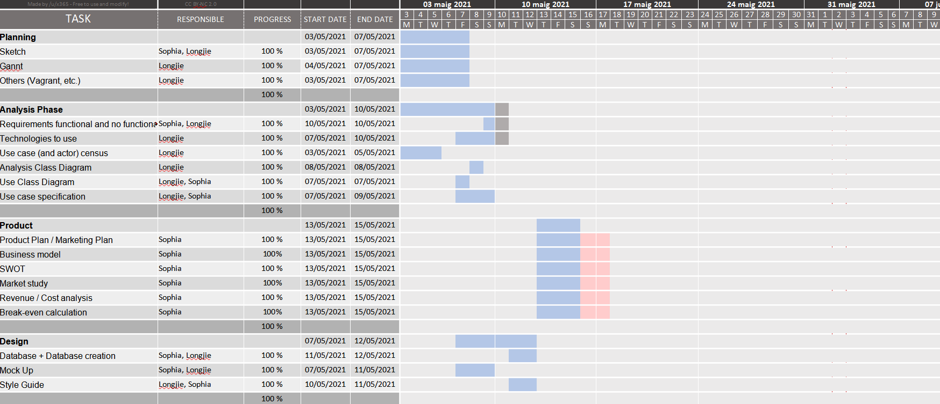Figure 1: Gantt 1
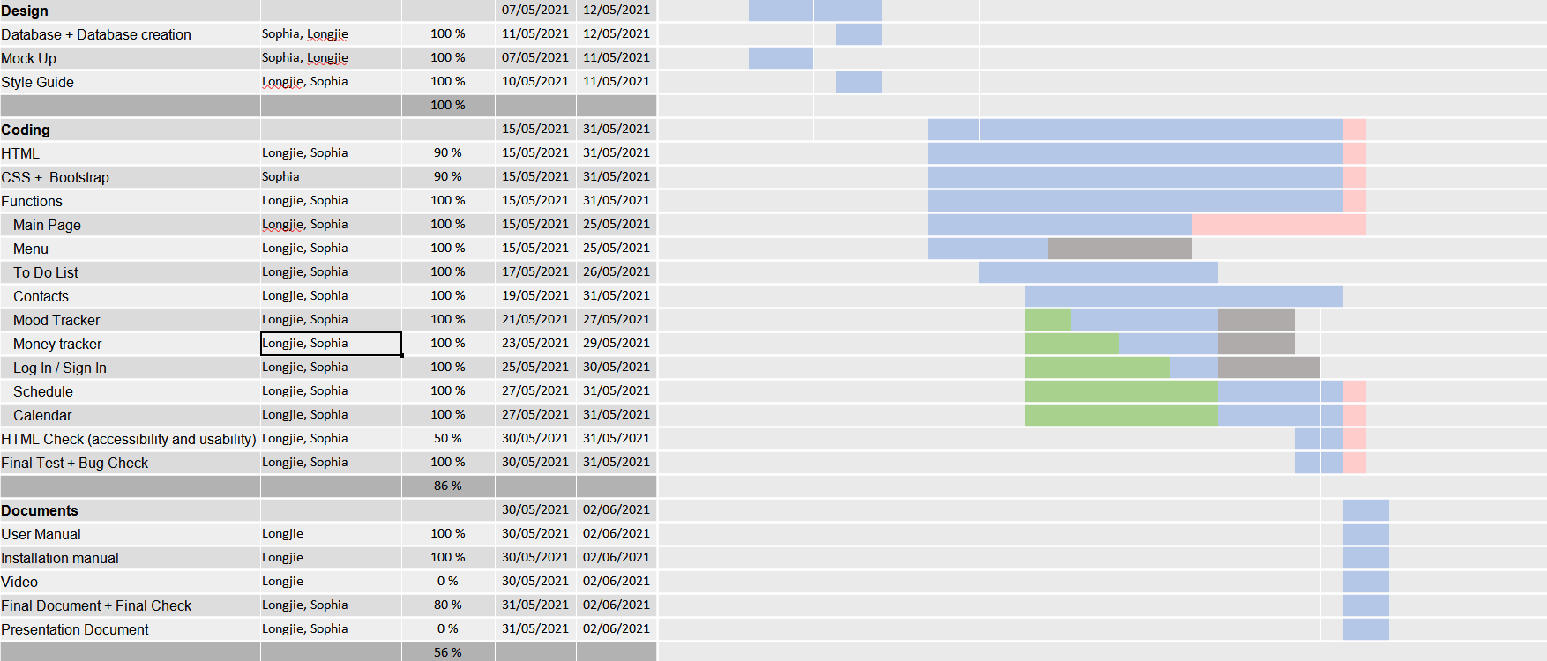Figure 2: Gantt 2

3. MARKET

1. Executive summary
We live in a technology world of technology that is both a curse and blessing. Sadly enough, people are connected than ever, but feel less connected at the same time.
Trackr is a unique freemium tracker that provides an effective way on how to manage your time wisely.
Trackr is not your typical tracker where you can only use it as a self-tracking device. It is an extension of one’s life to effectively manage our time to our own rhythm.

2. Products and services
- Mood tracker with integrated diary
- Financial tracker
- To-do list
- Scheduler

3. Mission
Trackr’s mission is to provide a rather friendly and useful application that people can use to manage their lives more efficiently and effectively, to not lose time and rather spend it wisely.

4. Vision
We want the world to be more social. We live in a busy world that loses the personal touch of human connection, so we thrive to create a tool to help people manage their time and spend it wisely with the things and people they love. Life is too short to be too busy.

5. Competition
- Our biggest competitors are the paper based mood trackers and agendas.
- Single functional applications

6. Competitive advantage
We live in a technological world where a mobile phone is an essential and an extension of our lives. Comparing to our biggest competitors which are mostly paper based, our application has a lot of potential to integrate in our daily lives. Not only it is easily portable, you can always use it knowing it is on your phone.

7. SWOT analysis

A. Strengths
Trackr is an application which offers a lot of utilities and functionalities that are needed for our daily necessities.

B. Weaknesses
There are a lot of well known application that only focuses on one thing.

C. Opportunities
Having the application means that no more managing too many applications.

D. Threats
A lot of different competitors on different fields of the application are prevalent. While having a lot of functionalities, the application is a jack of all trades, master of none.

8. Buyer persona
Trackr’s customer can be broken down into two groups, busy professionals and students and your every day consumers. The former are smaller than the latter by the fact that the former can and will utilize the application to its maximum potential while the latter can use the application base on their own needs.
The larger group of everyday consumers consists of:
- Age: 16-60. People tends to be the busiest.
- Marital Status: Single to Widowed
- Area of living: Anywhere in the world
- Women tend to use the application more than men due to their motherly nature.

9. Marketing objectives
- Develop strong brand awareness: Invite a friend promotion. Local news feature.
- Create brand loyalty: Be a go to application in which people use on their daily lives.
- Increase in sales and decrease in marketing expenses: Holiday promotions, Student / enterprise promotion

10. Marketing Budget
I calculated that the business will need to make at least 50.000€ a month in revenue to reach the break-even point. The first two months will be used to set up the physical location, hire personnel, rent servers and obtain a patented license. Business during the second month will be understandably slow as a steady customer base takes time to build. This is the stage where the majority of our marketing budget will go.

A. Development Schedule
What: Marketing campaign and Social Media campaign
Who: Longjie
Objectives: Marketing, Socials
Budget: 20.000€

What: Sales research
Who: Sophia
Objectives: Sales
Budget: 10.000€

B. Marketing Mix
Product: Mood tracker with integrated diary, Financial tracker, To-do list, Scheduler
Price: Free, single purchase: 9.99€, promotional prices: 4.99€
Distribution: App Store, Play Store and Official Website
Promotion: Social media

C. Social media
Instagram: Purchase of sponsored ads targeting our specified list of interests. Influencer posts. Heavy use of hashtag promotion.
Facebook ads: Purchase of sponsored ads targeting our specified list of interests. Influencer posts. Heavy use of hashtag promotion.
Google ads: Purchase of sponsored ads targeting our specified list of interests.
When it came to collaborations with schools and enterprises, it can be cross-promotional discounts! When looking for influencers we wanted to work with we would hyper-focus on ones with at least 20K followings, and topics that are of interest to us.

4. ANALYSIS PHASES

No functional requirements
- Compatibility – It needs
- Conformance
- Dependability
- Installability
- Maintainability
- Performance
- Portability
- Reliability
- Usability
- Security

Technologies
- Web Server Software
  - Apache2: One of the most popular web server software. It allow us to save the files and be able to connect to the server.
- Database Engine
  - MariaDB: Used to create all the database and used to save all the data of the users and their tasks.
- Programming Language
  - PHP: One of the most popular back-end language for web. It allow us to keep users session, connect to the database, create interaction, encrypt data, etc.
- Client-Side Coding
  - HTML: the basic language to create a website.
  - JavaScript: front-end programming language used to make the website more interactive and for example, to make the user create more rows.
  - Bootstrap/CSS: all the visuals of the web site are made with Bootstrap and CSS.

Functional requirements

Use Case Actor Census
Actor | Responsibility | Requirement | Guide
User | -A person who wants to use the application and wants to have a better life. | -Any user that has email. | -The users can see their calendar  -The users can modify their schedules, to do list, mood tracker, financial tracker...

Use Case Census
- Sign up / Sign In
- Manage Contact list
  - Add, Modify and Delete Contacts
- Manage To Do List
  - Add and Modify To Do List
    - Set / Change Tag name
      - Manage Tasks
      - Check / Uncheck Important tasks
      - Set Contact
    - Set / Change Description
    - Set type of the To do list
      - Normal
      - Challenge
  - Delete To Do List
- Manage Mood Tracker
  - Select daily mood
  - Show Mood Calendar
  - Set daily mood
- Manage Financial Tracker
  - Enable and Disable function
  - Set Total and Income
  - Set Daily Expenses
    - Set Expenses name and quantity
  - Show Money Stats and Graphic
- Manage Scheduler
  - Add / Change daily entries
  - Delete entries
- Show current schedule
- Show current Schedule
- Show current To do list
- Show Calendar
  - Show Schedule
  - Show To Do List
  - Show Exposes and Income
  - Show mood

Analysis Class Diagram
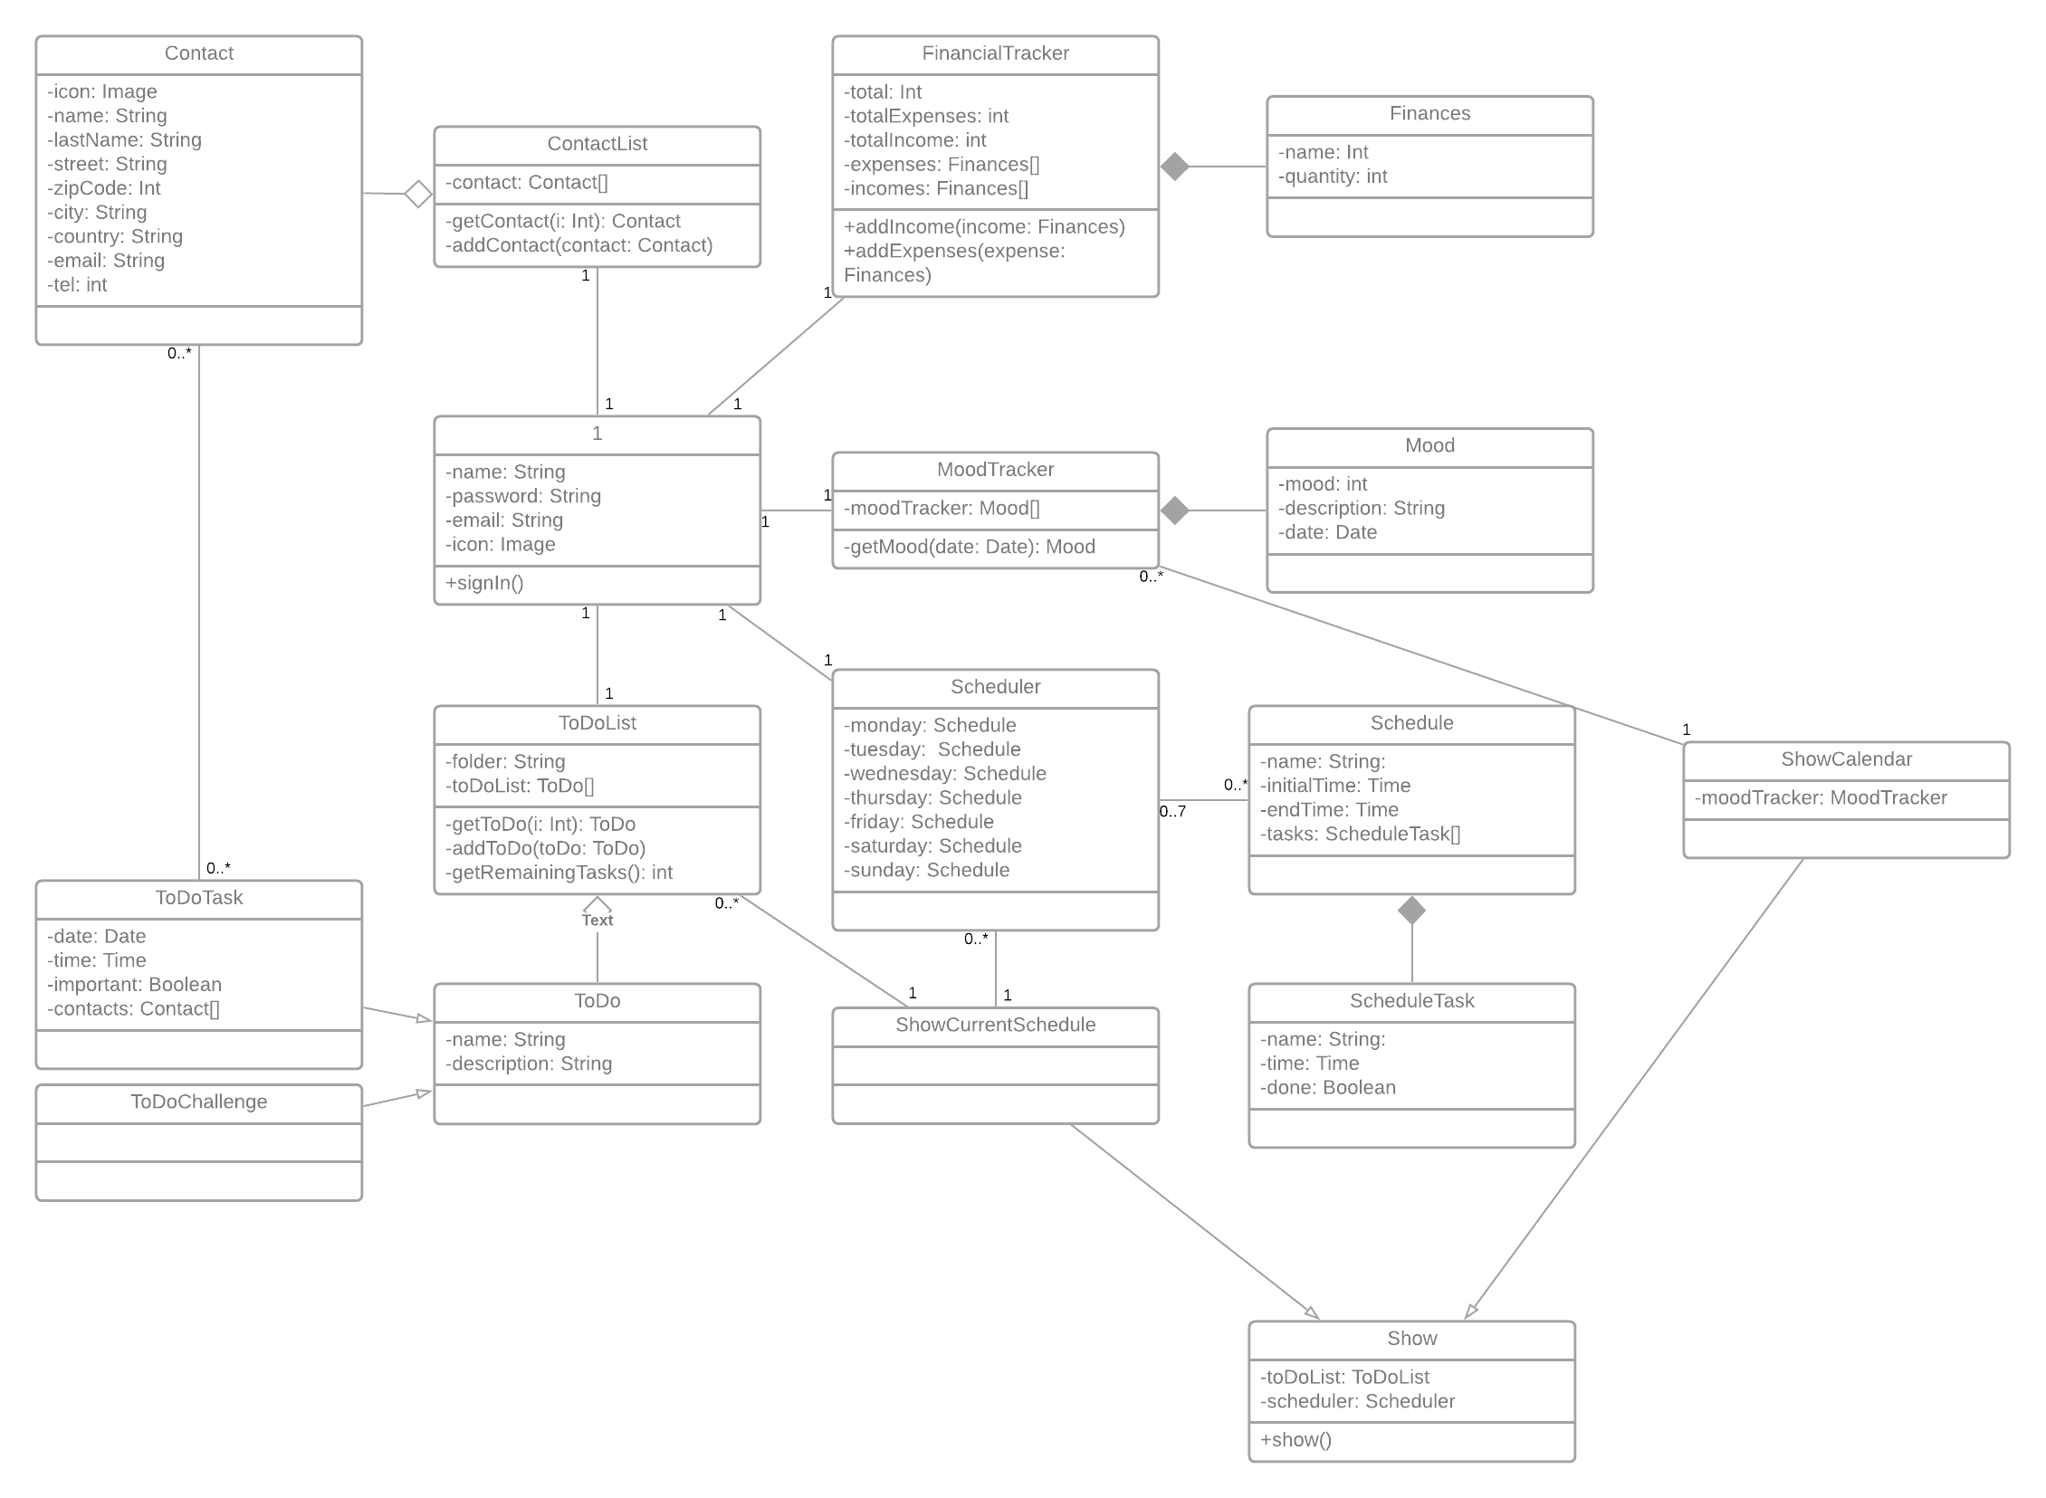Figure 3: Analysis Class Diagram

Use Case Diagram
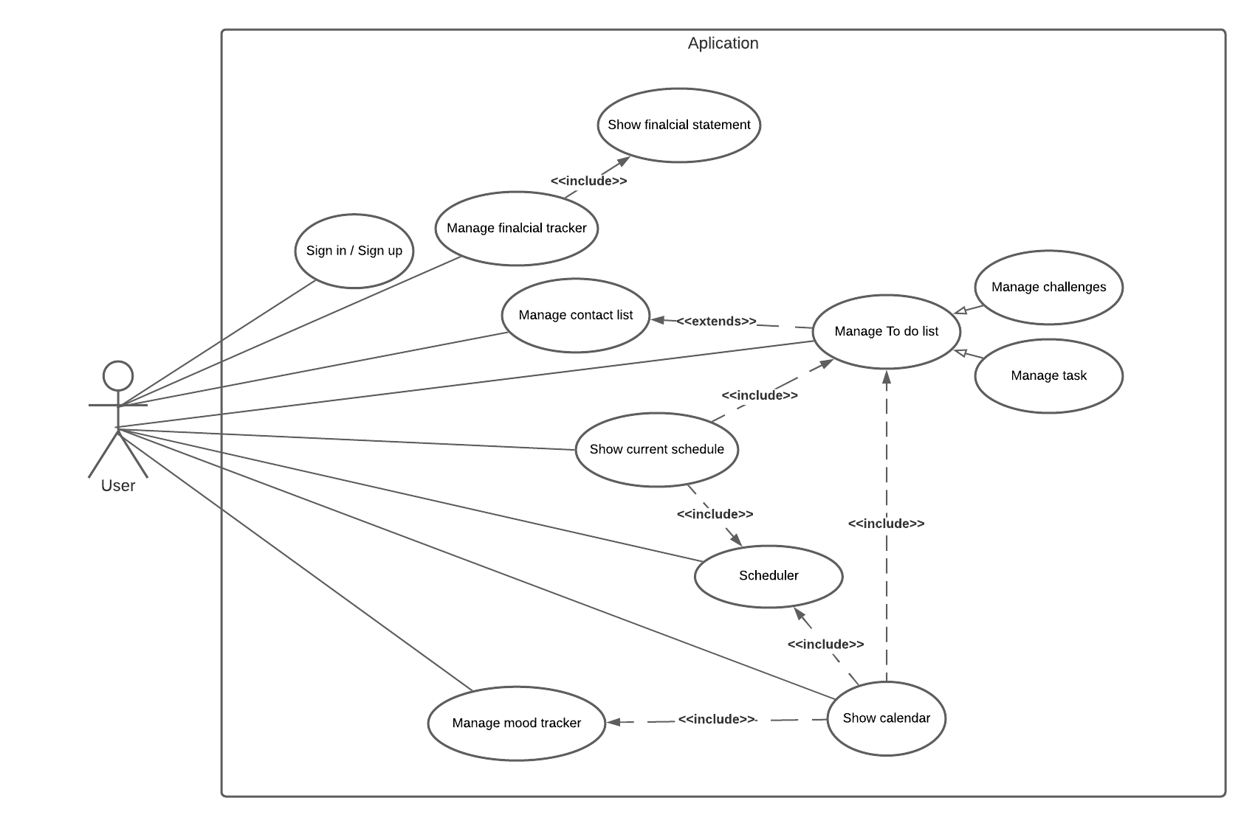Figure 4: Use Case Diagram

Use Case Specification
Use Case | Sign up
Pre-condition | - The user doesn’t have an account to access to the application.  - The user must have an email to register to the application  - The web side is online properly
Post-condition | - Account created for the user to access to the application
Basic Path | - The user puts its email, password and password verification to create an account.  - The system checks if both password coincide.  - The system saves the data to its database
Alternative paths | 2a The passwords don’t coincide.  2b Email already in use  2c Invalid email format
Exception paths | - Cannot create the account  - Cannot create new account  - The application cannot connect to the database

Use Case | Sign in
Pre-condition | - The user must have an account to access to the application  - The web side is online properly
Post-condition | - The user acceded to the application and its functionalities.
Basic Path | - The user enters his email and password.  - The system verifies his email and password, comparing to the database’s.  - The email and password are correct
Alternative paths | 3a. The email or account doesn’t exist.  3b. The password is incorrect
Exception paths | - Cannot access to the application  - The application cannot connect to the database

Use Case | Manage contact list
Pre-condition | - The user already signed in  - The web side is online properly
Post-condition | - The user added a new contact  - The user modified a contact  - The user deleted the contacts  - The database changed / updated the data  - The user sees the information
Basic Path | - The user go to the Contact List page  - The system gets the information of the users contact  - The user manages the contact list:  - The user want to add a new contact  - The user clicks the button to add a new contact  - The system shows to the user a screen to add a new contact.  - The user enters the new contact’s information (Name, Last name, Phone, Email, etc) and confirms  - The system adds the new contact with the information given by the user to the database  - The user wants to edit a contact  - The user clicks the edit button of the interested contact  - The system shows to the user a screen to edit the selected contact.  - The user changes the information of the contact and confirms  - The system updates the information changed by the user to the database  - The user wants to delete a contact  - The user clicks the delete button of the interested contact  - The system asks if the user wants to delete the contact or not  - The user chooses “yes”  - The system deletes the contact from the database  - The system updates and now shows the contact page without the deleted contact
Alternative paths | 2a. The application shows no information of the users contact, because there’s none  3.1.3a The user denies on adding a new contact  3.2.3a The user denies on modifying the contact  3.3.3a The user chooses “no”  3.3.4b The system doesn’t delete the contact
Exception paths | - The application cannot connect to the database

Use Case | Manage To Do list (folders)
Pre-condition | - The web side is online properly  - The user already signed in
Post-condition | - The user added a new folder  - The user modified a folder  - The user deleted a folder  - The user enters to a folder  - The database changed / updated the data  - The user sees the information
Basic Path | - The user go to the To do list page  - The system loads the “folders” and shows to the user  - The user manages the folders:  - The user enters to a folder  - The user click to the interested folder and enters  - The application shows the tasks within the folder  - The user adds a new folder  - The user click on add new folder  - The system gives to the user a form to set a name  - The user puts a names for the new folder and confirms  - The system creates a new folder and inserts into the database  - The user renames a folder  - The user clicks edit on the interested folder  - The system leads the user to another page  - The system loads the old name of the folder  - The user changes the old name of the folder and confirms  - The system updates the folder’s name and updates into the database  - The user deletes a folder  - The user click delete on the interested folder  - The system asks the user to delete the folder  - The user accepts  - The system deletes the folder from the database and reloads the page
Alternative paths | 2a There’s no folders  3.2.3a The user denies on adding a new folder  3.2.4a The system doesn’t add a new folder  3.3.4a The user denies on modifying the folder  3.3.5a The system doesn’t modify the folder  3.4.3a The user denies on deleting the folder  3.4.4a The system doesn’t delete the folder
Exception paths | - The application cannot connect to the database

Use Case | Manage To Do list (tasks and challenges)
Pre-condition | - The web side is online properly  - The user already signed in  - There must be folders created first  - The user must have selected the folder first
Post-condition | - The user added a new task/challenge  - The user modified a task/challenge  - The user deleted a task/challenge  - The database changed / updated the data  - The user sees the information
Basic Path | - The user chooses the folder  - The system shows to the user the tasks or challenges created  - The user manages the tasks:  - The user adds a new task  - The user clicks on add new task  - The system gives to the user a form about the task  - The users enters all the information (name, important check, date, time and contact).  - The system gets the information and inserts in to the database  - The user modifies a task  - The user clicks on the interested to edit  - The system loads the task information to edit  - The user changes the information about the task and confirms  - The System updates the information to the database  - The user deletes a task  - The user clicks on the interested task to delete  - The system asks the user to delete  - The user confirm it.  - The system delete the task from the database
Alternative paths | 2a There’s no task or challenge  3.1.3a The user changes the type of the task to “challenge” and enters the information (only name)  3.1.4a The system didn’t add a new task  3.2.3a The user changes task to normal or to challenge type, and the system changes the form  3.2.4a The system didn’t update the tasks  3.3.3a The user denies the confirmation  3.3.4a The system didn’t delete the task
Exception paths | - The application cannot connect to the database

Use Case | Manage mood tracker
Pre-condition | - The web side is online properly  - The user already signed in
Post-condition | - The user set his mood of the day  - The user set a description of his day  - The database updated the data
Basic Path | - The user goes to the mood tracker page  - The system shows the page to the user  - The user selects his mood and writes a description of the day  - The user clicks on the confirm button  - The system adds a new entry to the database
Alternative paths | 2a The system loads the mood and the description wrote previously  5a The system updates the entry if it already exists
Exception paths | - The application cannot connect to the database

Use Case | Manage Financial tracker
Pre-condition | - The web side is online properly  - The user already signed in  - The Financial tracker is enabled
Post-condition | - The user sees his information about the expenses, income and total  - The user sees his information about all the different expenses and incomes
Basic Path | - The user goes to the financial page  - The system shows all his financial information  - The user adds/modifies/deletes and expense or income  - The system inserts/updates/deletes the entry from the database
Alternative paths | 5. The user click on the old transaction button  6. The system shows to the user the transactions of the everyday
Exception paths | - The application cannot connect to the database

Use Case | Manage Scheduler
Pre-condition | - The web side is online properly  - The user already signed in
Post-condition | - The user set his schedule  - The database updated the data
Basic Path | - The user goes to the scheduler page  - The system shows the scheduler  - The user chooses which day of the week will he modify  - The system shows the information about that day  - The user adds, modifies or deletes entries and confirms  - The system makes the changes on the database
Alternative paths | 5a The user doesn’t want to make the changes
Exception paths | - The application cannot connect to the database

Use Case | Show Current schedule (Main page)
Pre-condition | - The web side is online properly  - The user already signed in
Post-condition | - The user sees his data  - The user sees his daily Schedule and its information (Schedule and To do)
Basic Path | - The user goes to the main page  - The system loads from the database the information about the schedule and to do list  - The system uses those information to make a list and shows to the user
Alternative paths
Exception paths | - The application cannot connect to the database

Use Case | Show Calendar
Pre-condition | - The web side is online properly  - The user already signed in
Post-condition | - The user sees his data  - The user sees his monthly calendar and its information (To do, mood, financial, etc).
Basic Path | - The user goes to the calendar page  - The system loads from the database the information about the schedule, to do list, financial tracker and mood tracker  - The system put those information in a calendar and shows to the user  - The user click on a certain date  - The system shows to the user a summary of that day
Alternative paths
Exception paths | - The application cannot connect to the database

5. DESIGN

Database design
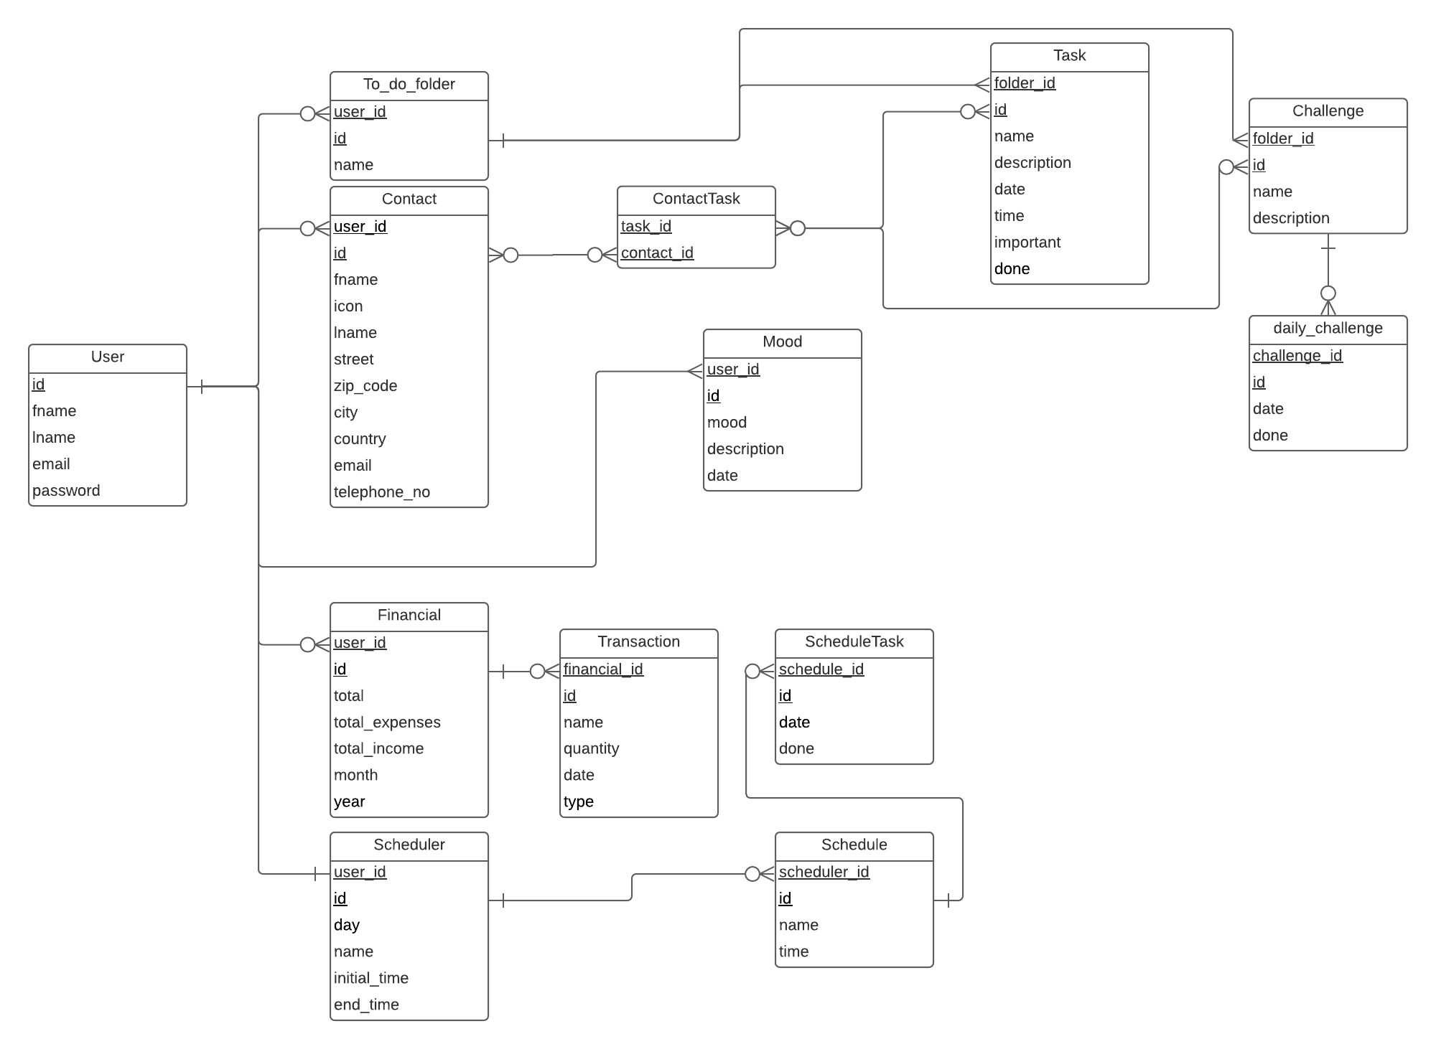Figure 5: Database design

Sketch
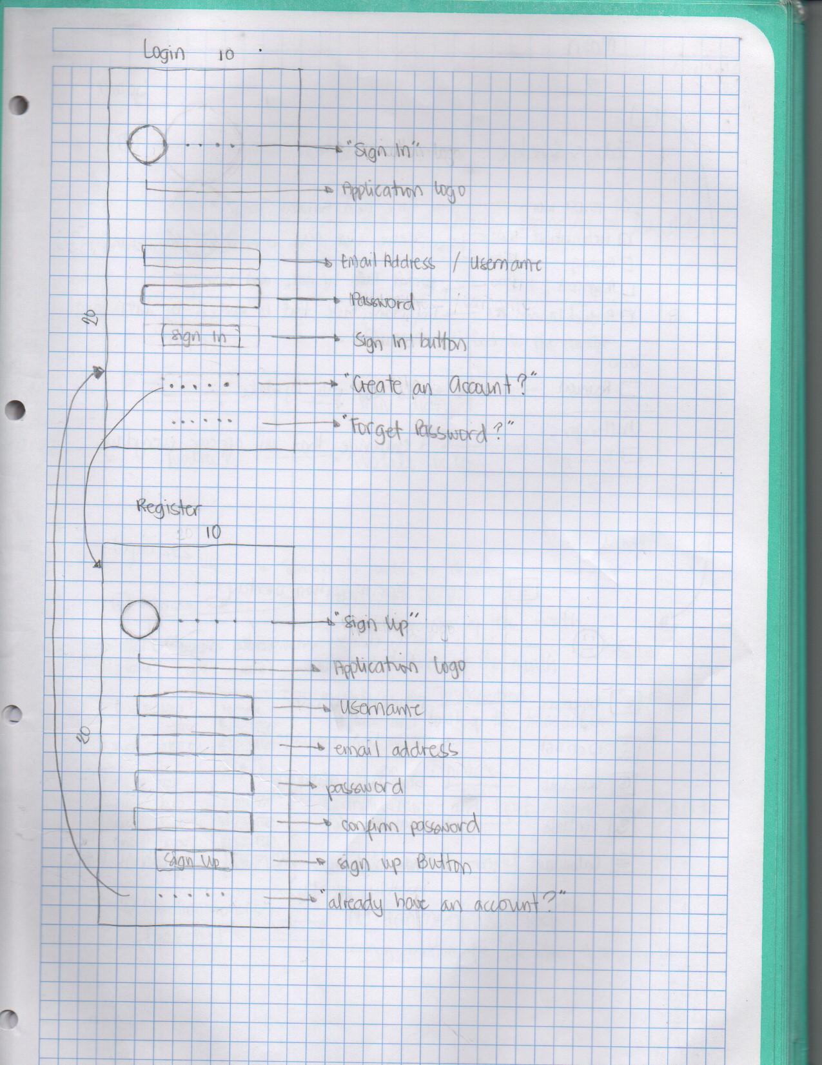Figure 6: Sketch: Login and Register

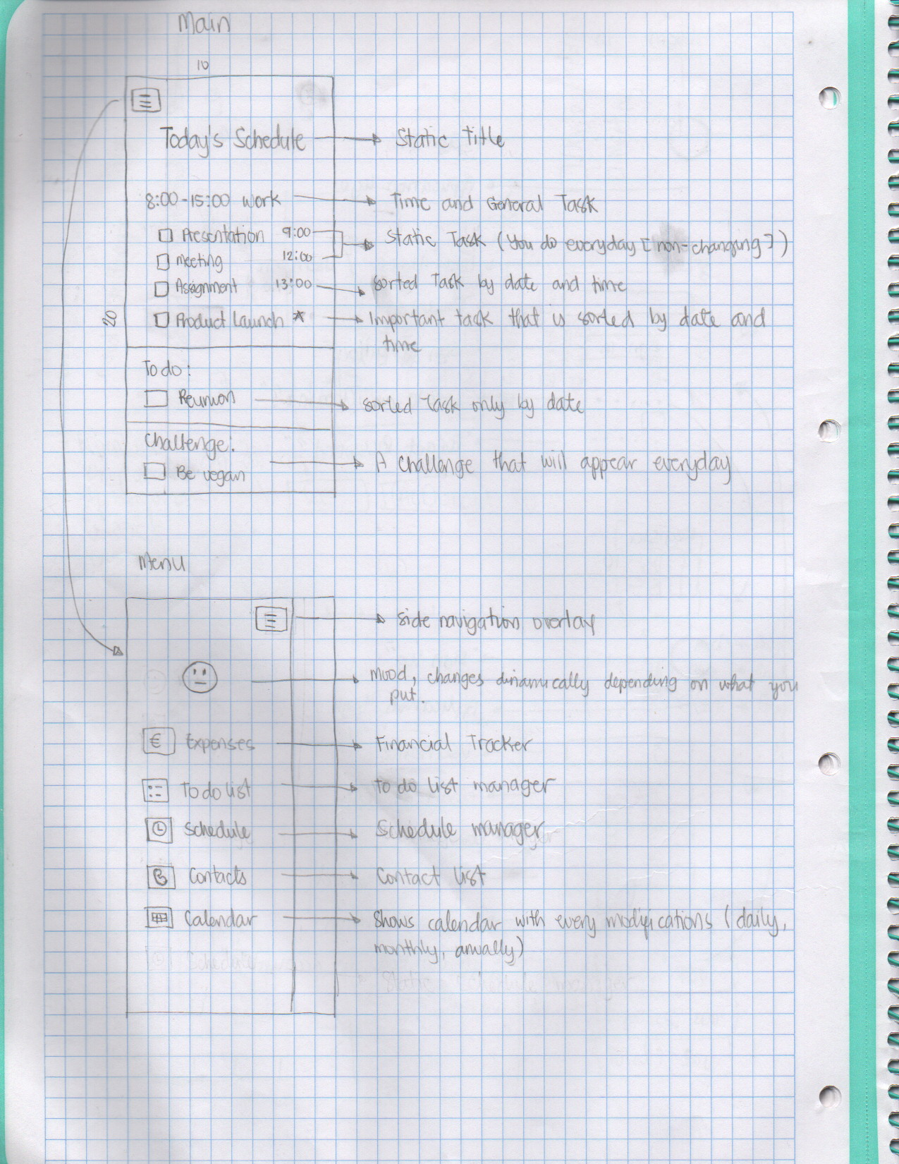Figure 7: Sketch: Main and Menu
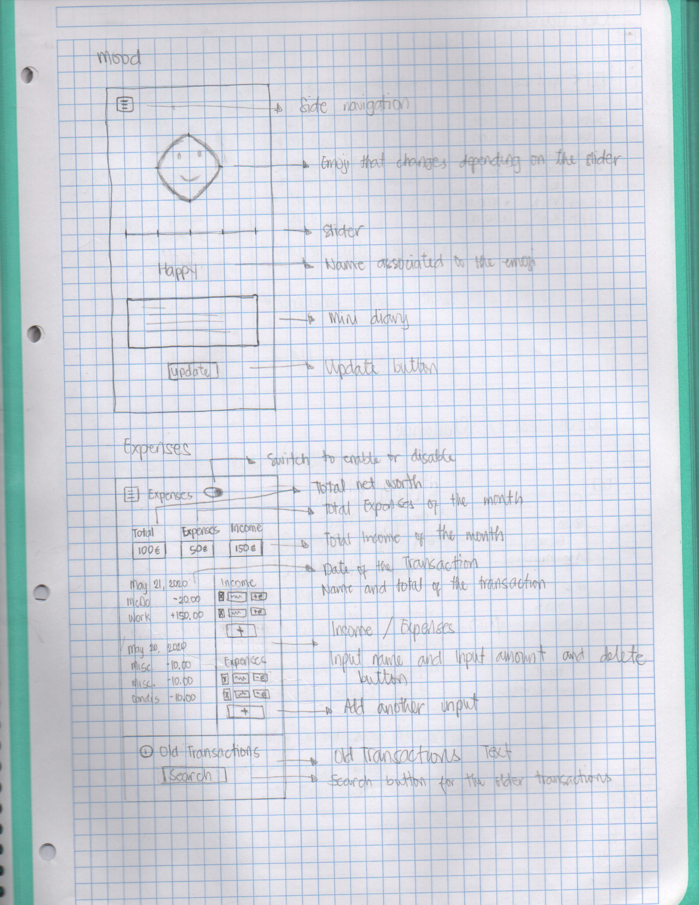Figure 8: Sketch: Mood and Financial
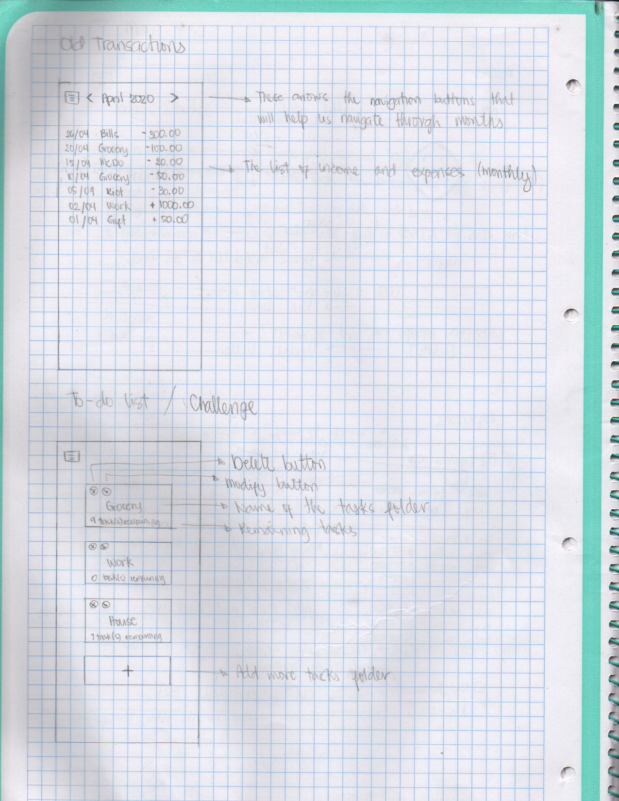Figure 9: Sketch: Old Transactions and To Do List
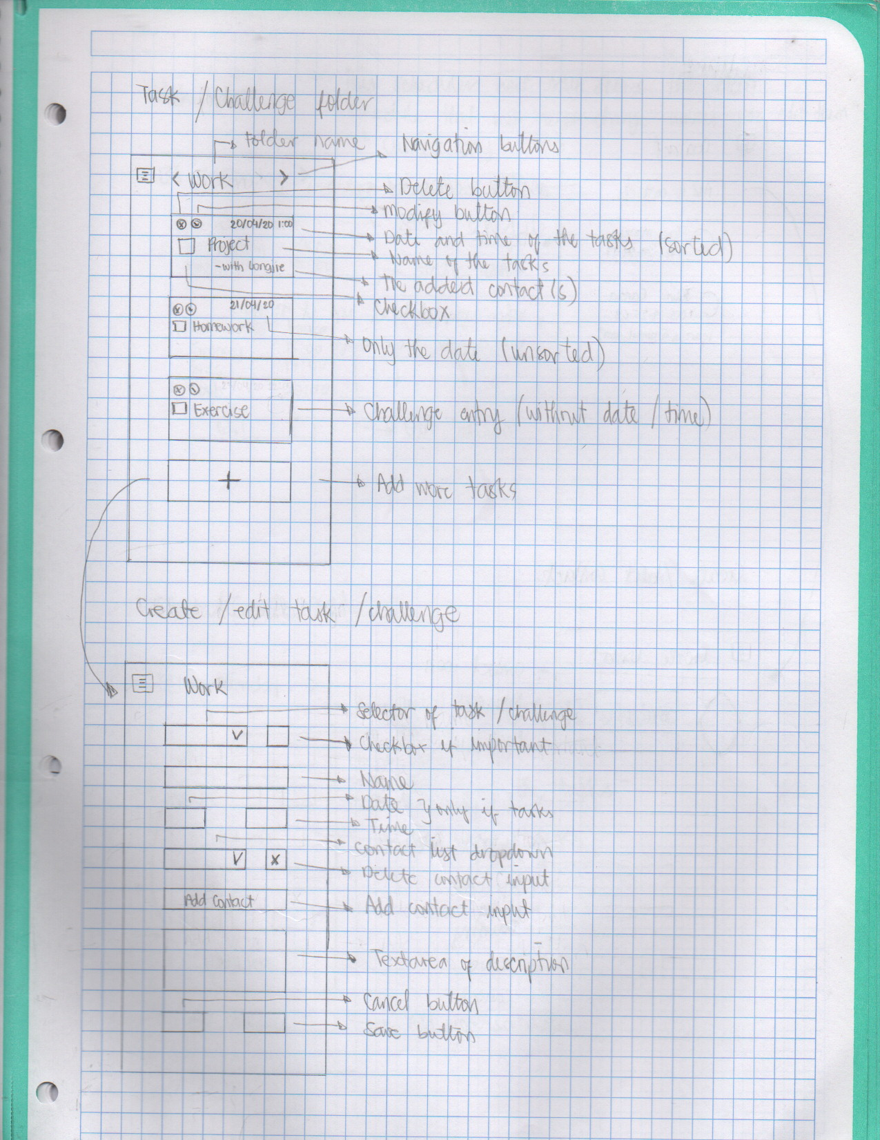Figure 10: Sketch: Task/Challenge List and Edit/Add
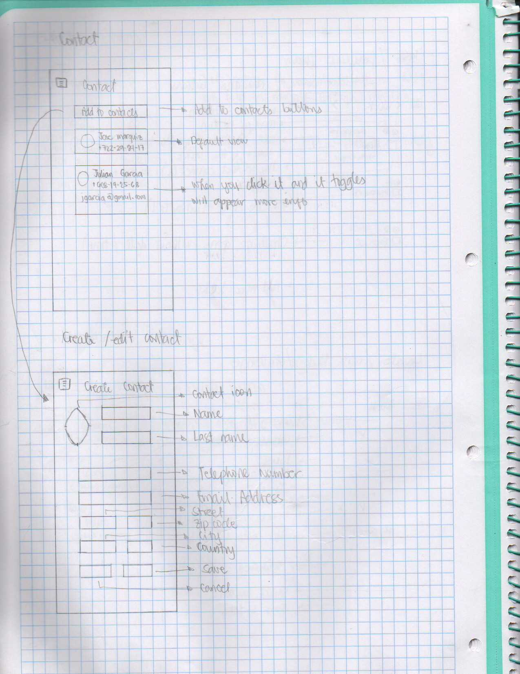Figure 11: Sketch: Contact
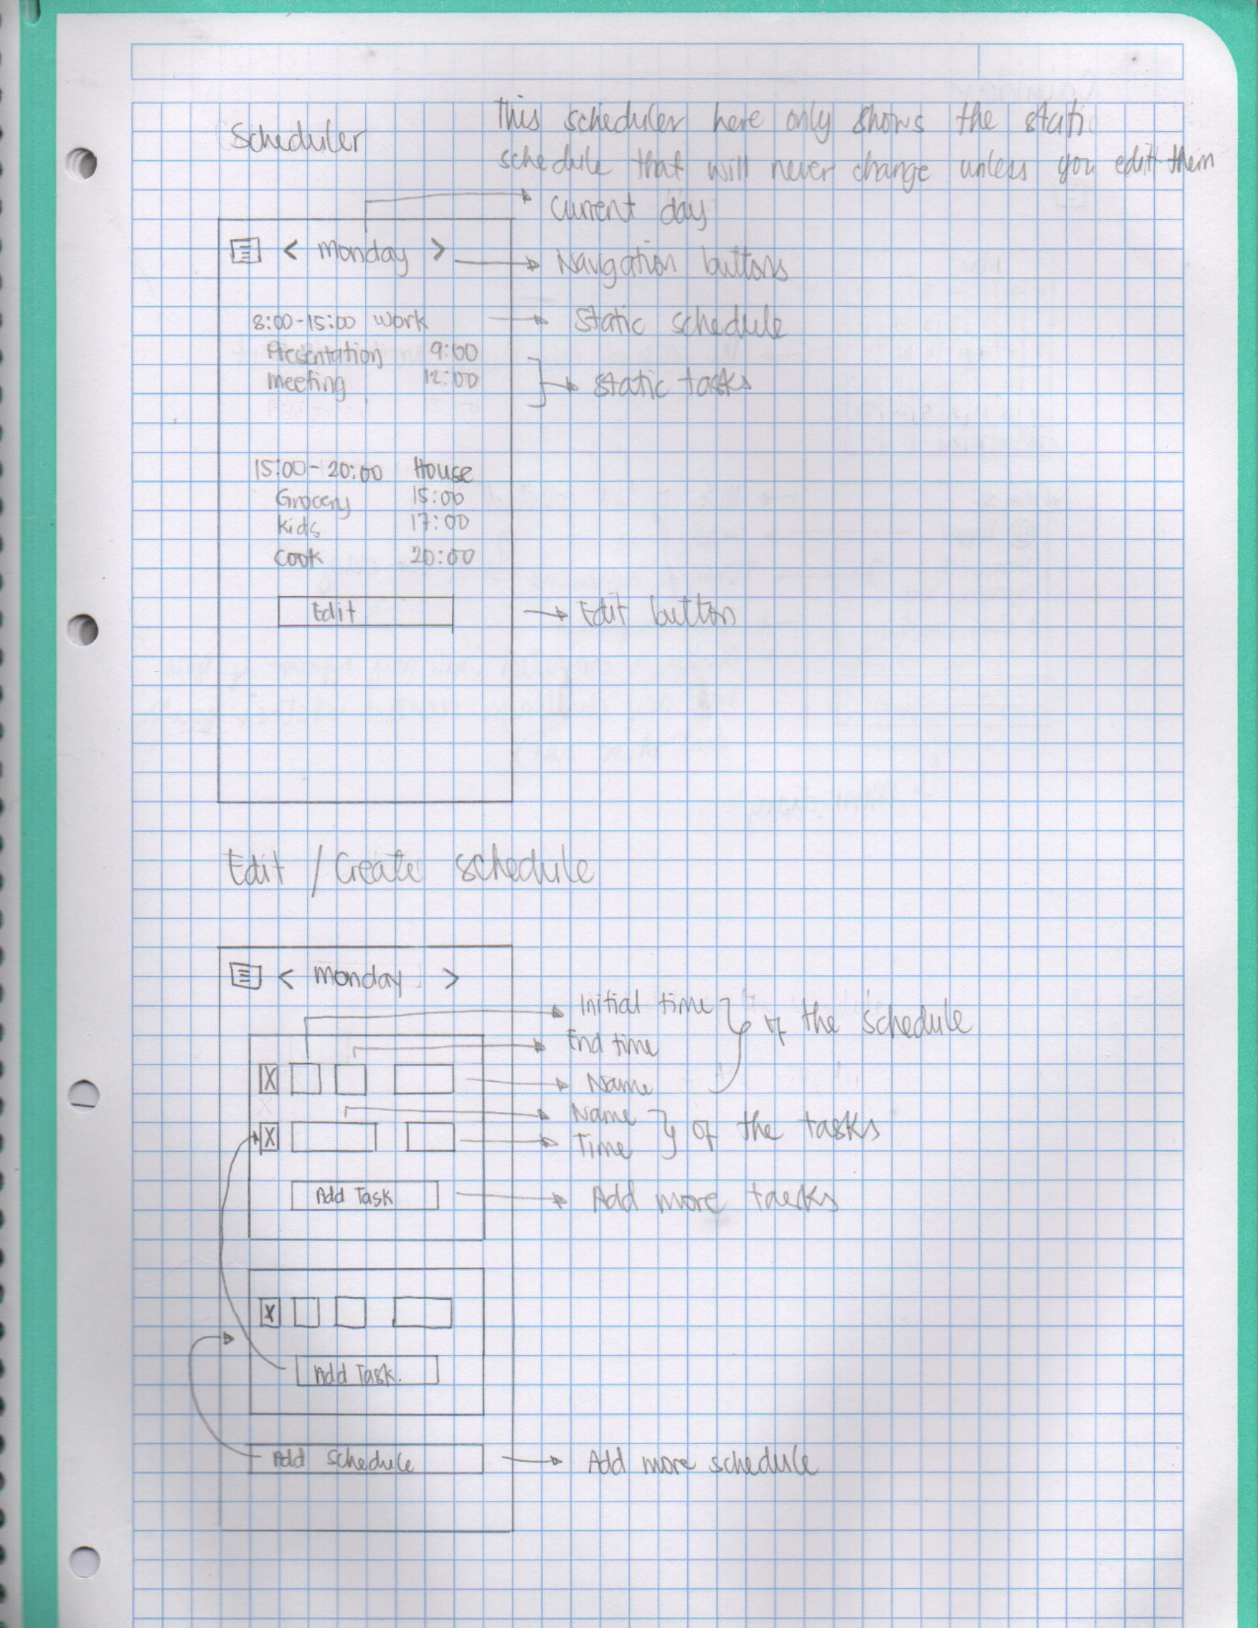Figure 12: Sketch: Scheduler
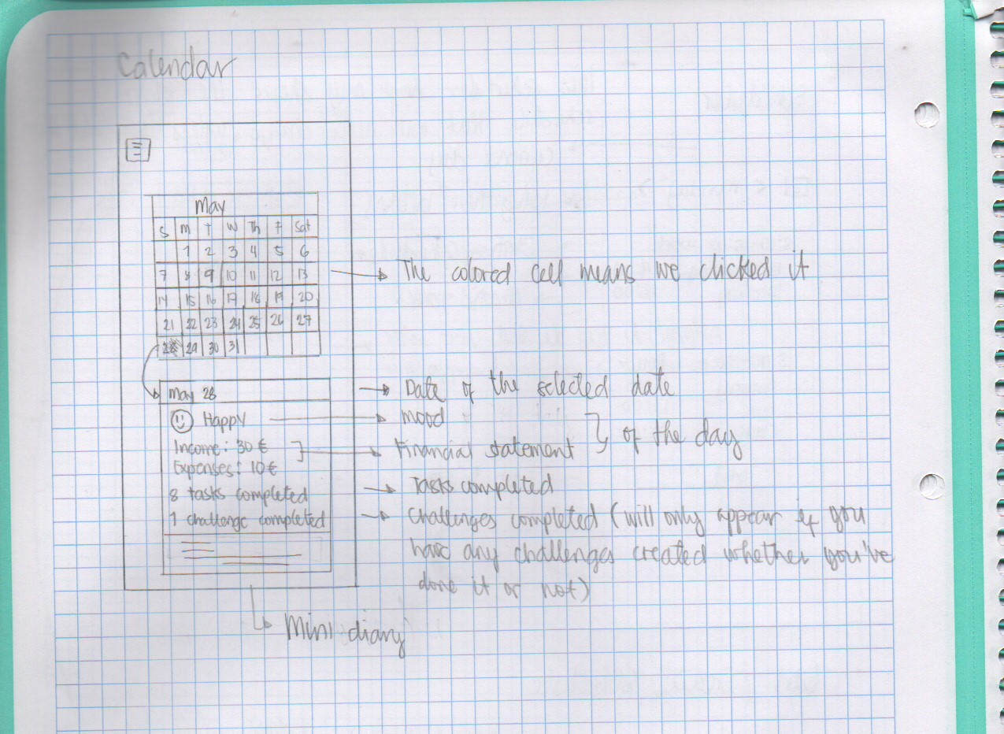Figure 13: Sketch: Calendar

Mockup

Login
Clicking here will redirect you to another page which is the registry.
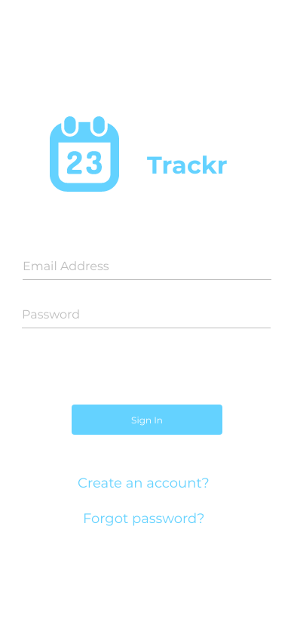Figure 14: MockUp: Login

Registry
Clicking here will redirect you back to login screen.
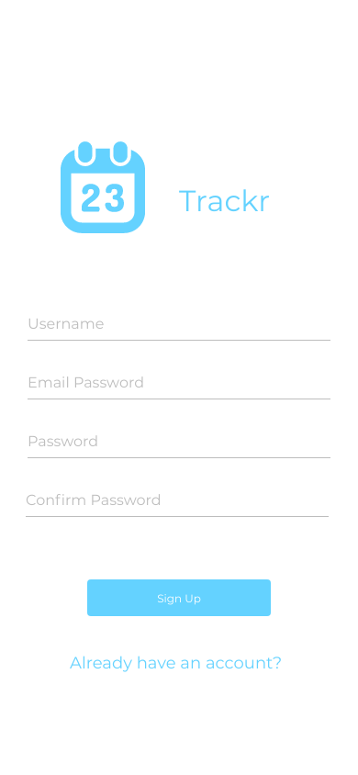Figure 15: MockUp: Register

Main page
Sliding navigation menu
Static daily schedule
Static daily task.
Red if important
Tasks you manually created
Daily challenges
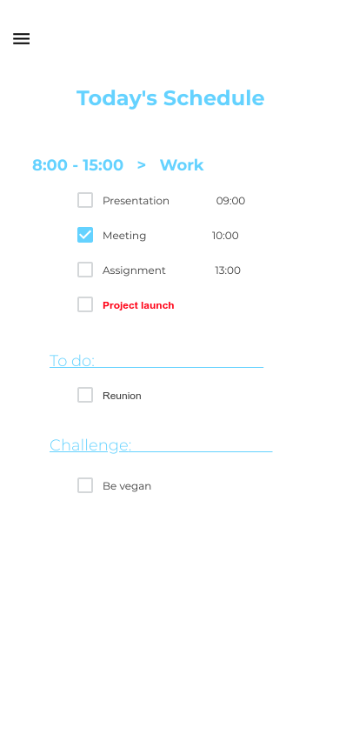Figure 16: MockUp: Main

Mood
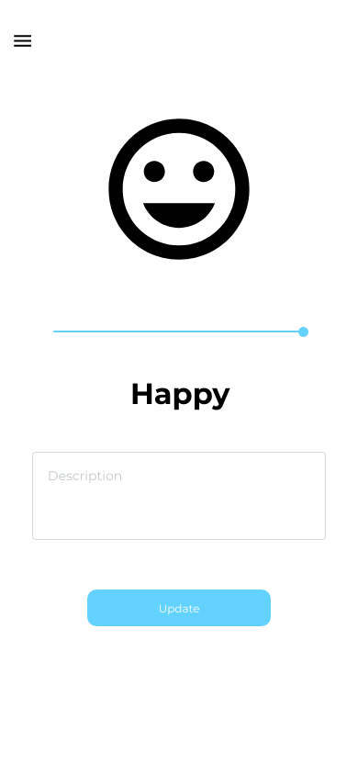Figure 17: MockUp: Mood

Expenses
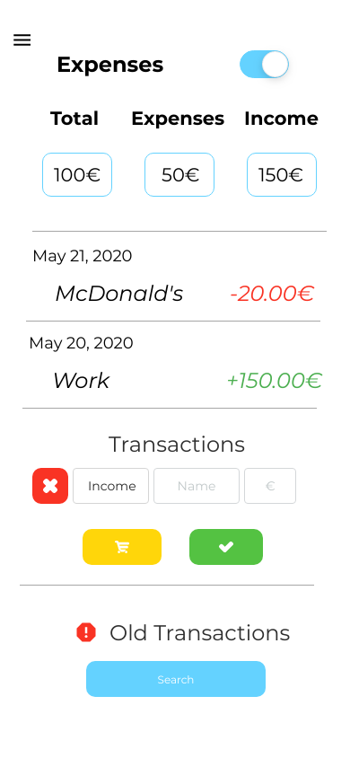Figure 18: MockUp: Expenses

Old Transactions
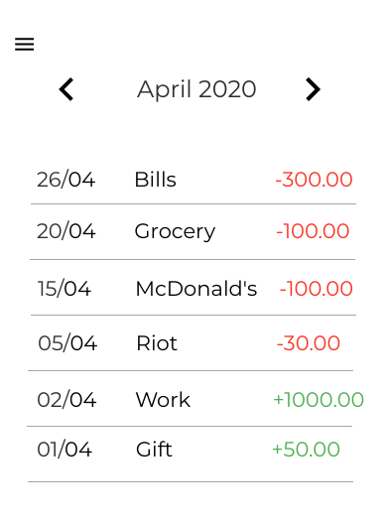Figure 19: MockUp: Old Transaction

To Do List
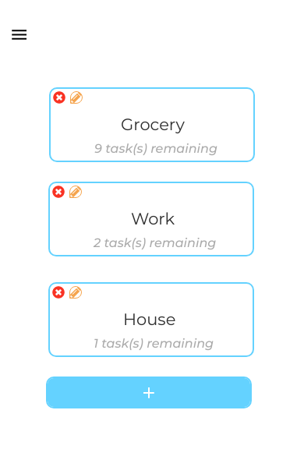Figure 20: MockUp: To Do List

Task Folder
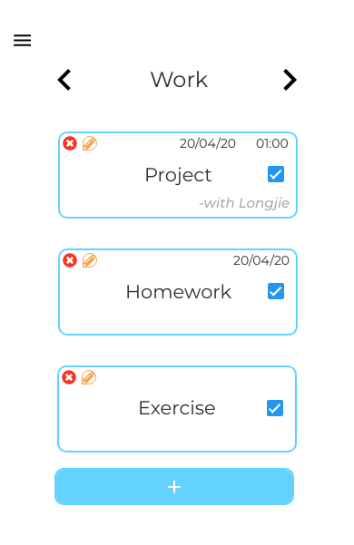Figure 21: MockUp: Task Folder

Edit Task
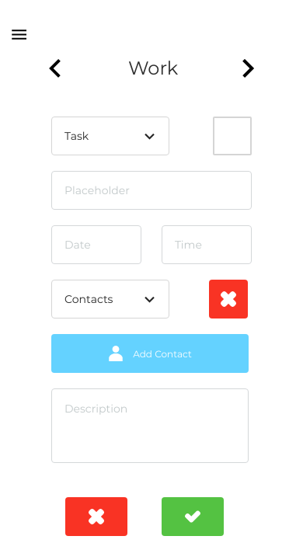Figure 22: MockUp: Edit Task

Contact
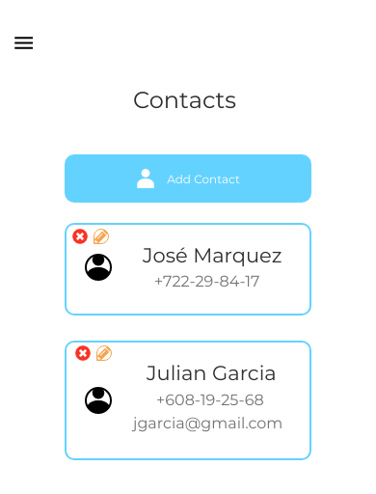Figure 23: MockUp: Contact

Calendar
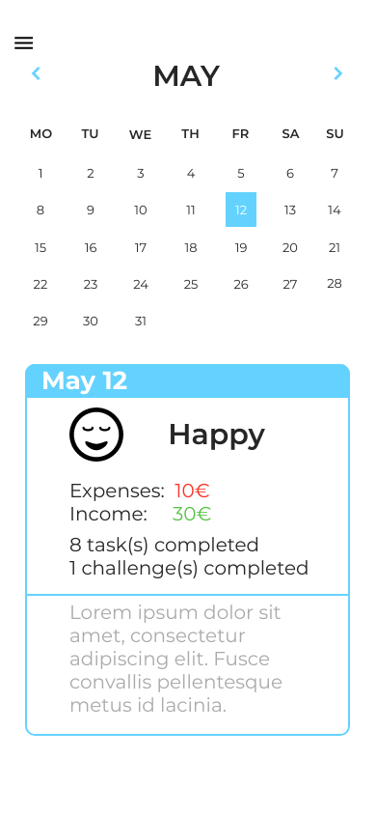Figure 24: MockUp: Calendar

Edit Contact
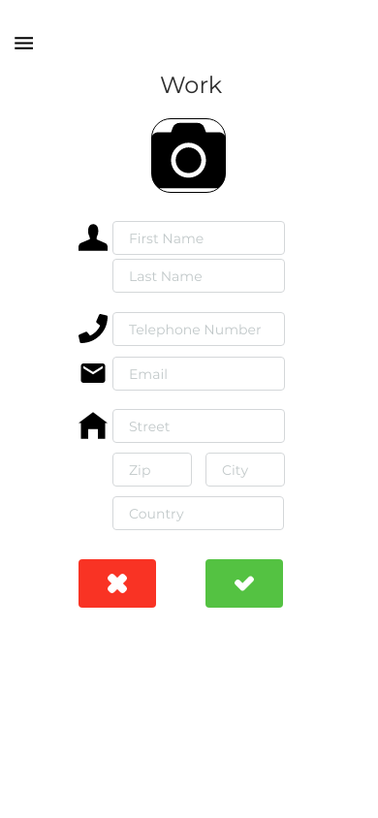Figure 25: MockUp: Edit Contact

Scheduler
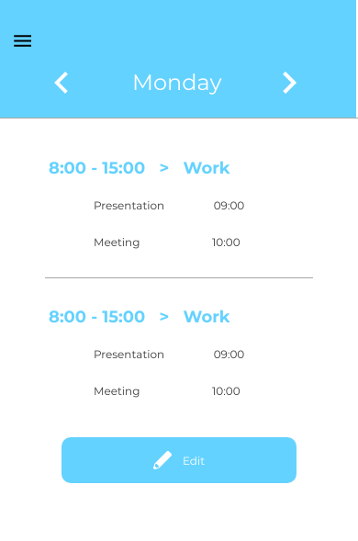Figure 26: MockUp: Scheduler

Edit Scheduler
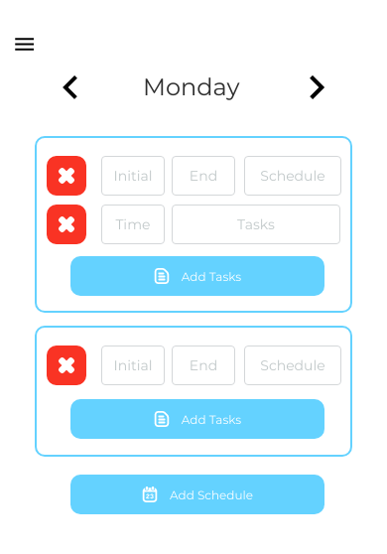Figure 27: MockUp: Edit Schedule

Menu
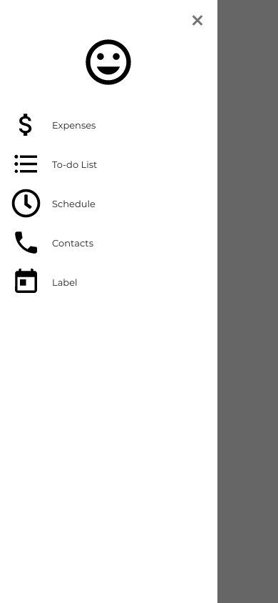Figure 28: MockUp: Menu

Style Guide
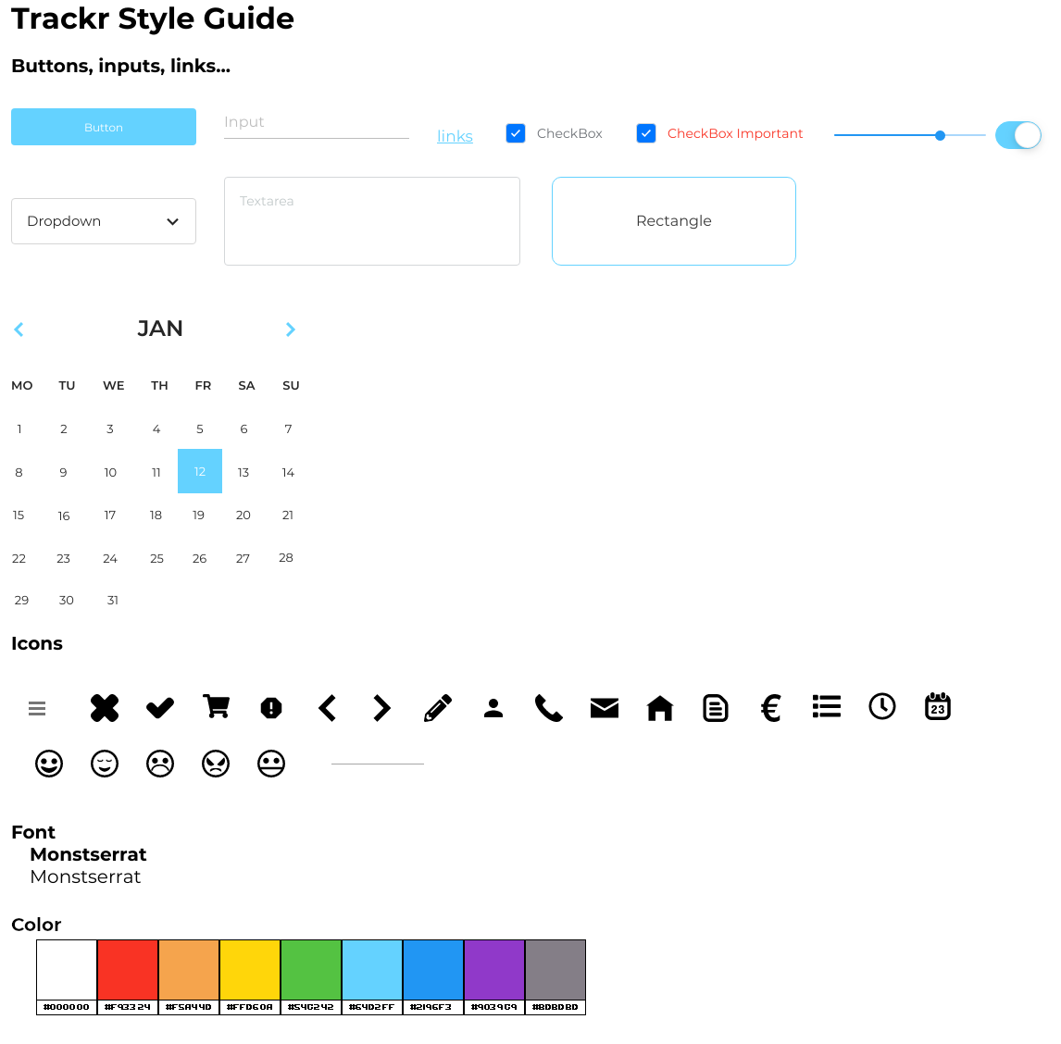Figure 29: Style Guide

6. USER MANUAL

Login
In this page is where the users log in. Apart from logging in we are given the option to register as a new user.
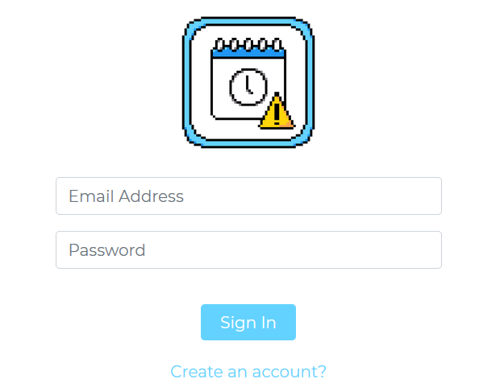Figure 30: Final: Login

Register
In this page the users can register as a new user by assigning them their first name, last name, email and password.
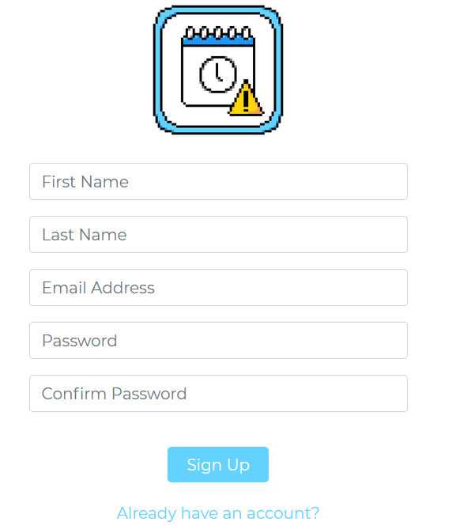Figure 31: Final: Register

Menu
In every page has a button, which opens a menu where the users can browse the pages.
Figure 32: Final: Menu button
On the menu, it shows the users first and last name, an “emoji” which shows their emotion, the pages button and a button to log out.
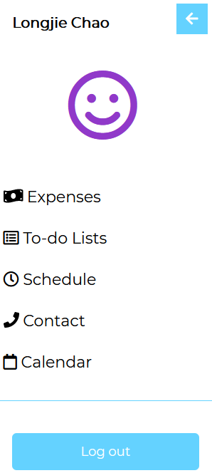Figure 33: Menu

Mood
When the user clicks on the “emoji”, it will lead them to the mood page. In this page has a slider to set their mood and a box where they can express how they feel or write how is the user’s day.
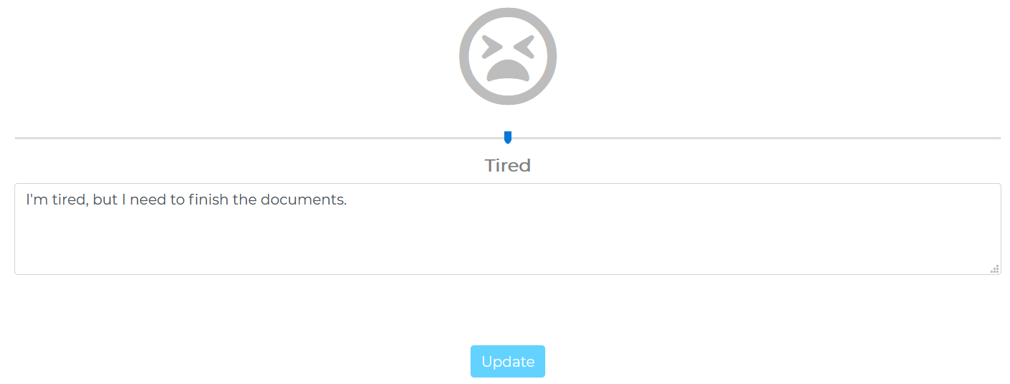Figure 34: Final: mood

Expenses
In this page the users can set their income and expenses by assigning a name and quantity.
Figure 35: Final: Transaction
To add a new transaction, the user needs to click the add button first and when they finish setting the data, they need to click on submit button.

After submitting, the page will refresh and update the data, and show what the user added. Only the data of the current month will be shown. After the month ends the data of the previous month won’t show.
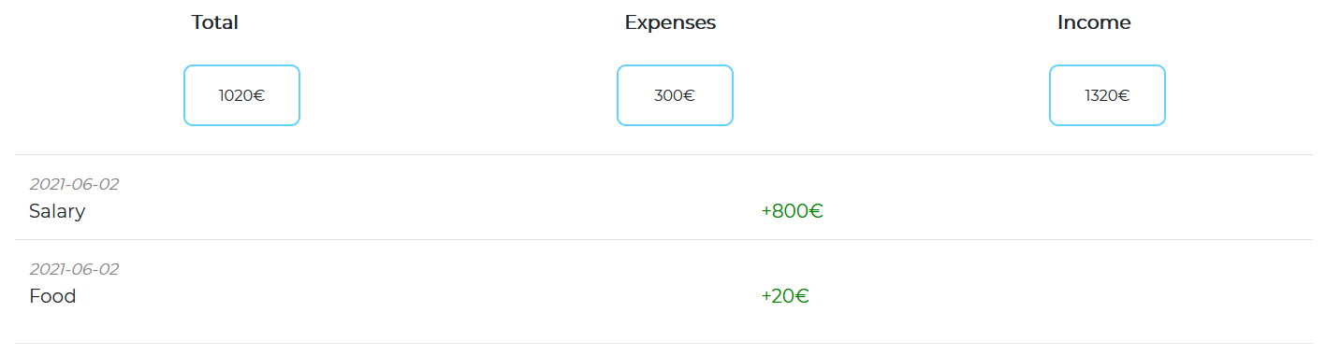Figure 36: Financial
If the user wants to see the previous months transaction, they can click on the oldTransaction button.
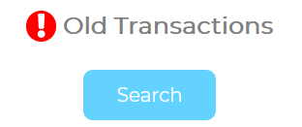Figure 37: Final: Old Transaction Button

Old transactions
In this page the users can see their previous transactions. They can change the month with the arrows.
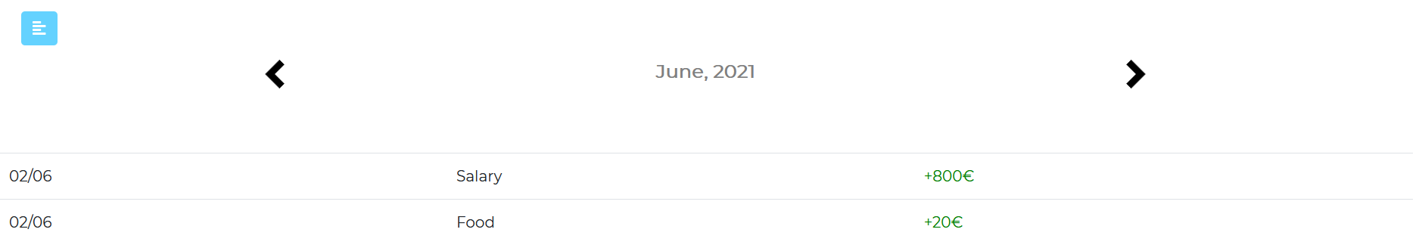Figure 38: Final: Old Transaction

If there’s no data, it will only show a text saying “No data no show”.
Figure 39: Final: No data to show

To do list (folder)
To do list, it’s a folder to organize the tasks that the user will add.
In this page, the users can see the to do lists and they can delete, edit or add a new to do list. The button “x” is to delete, “pencil” to edit and “+” to add a new to do list.
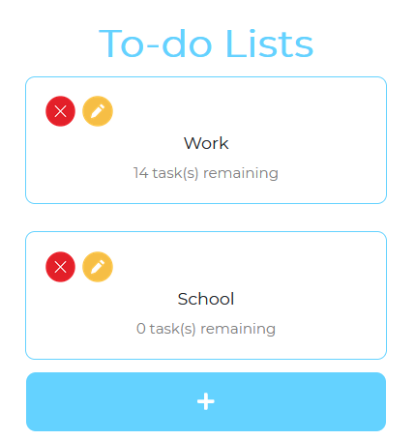Figure 40: Final: To Do List

Add/Update To do List
When the user click neither the add button or edit button, it will appear a modal where the user can change the name of the to do list. And click the check button to confirm.
If the user are updating the to do list, the folder name will appear.
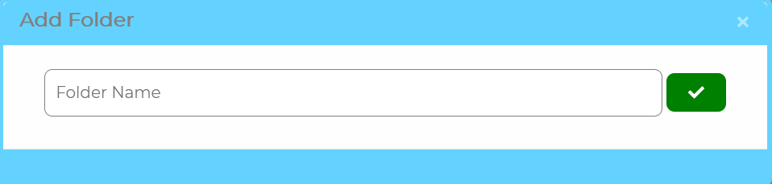Figure 41: Final: Add Folder/To Do List

Task and Challenge List
In this page, the users can see the to do list’s task or challenge and they can delete, edit or add a new to do list. The button “x” is to delete, “pencil” to edit and “+” to add a new to do list.
Each task will show the name and a button to check as done or not, and if the user will do the task with someone, a contact, it will show too.
Each challenge will just show the name.
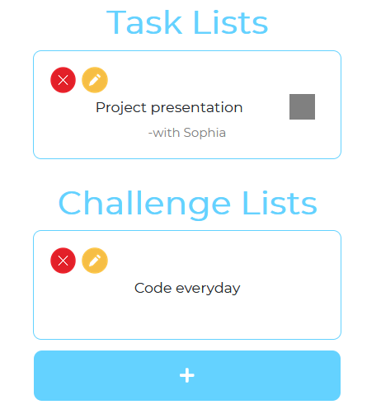Figure 42: Final: To Do/Folder List

Add/Update Task/Challenge
When editing or adding, the user can choose if they want a task or a challenge.
Task: The user need to put a name, the date, a time and a description. Also they can add contacts, by clicking “Add Contact”, if they’re going to do the task with someone. And if the user checks on the check mark, it will be considered as important task.
Challenge: The user just need to add a name and description. Unlike the task, the challenge doesn’t need to set a date, because everyday the users will do the challenge. It’s a daily challenge.
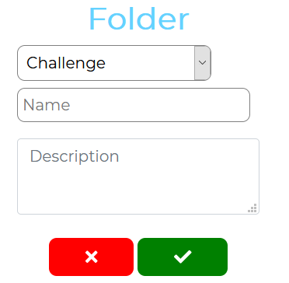Figure 43: Final: Add Challenge
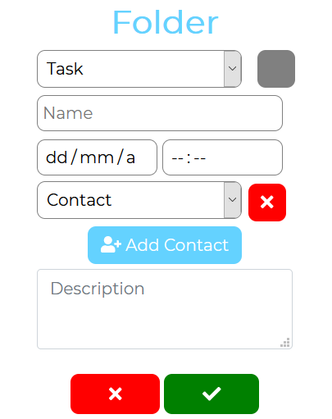Figure 44: Final: Add Task

Schedule
In this page the users will see what will he going to do everyday of the week.
The users can change which day of the week they want to see. To edit they just need to click on edit.
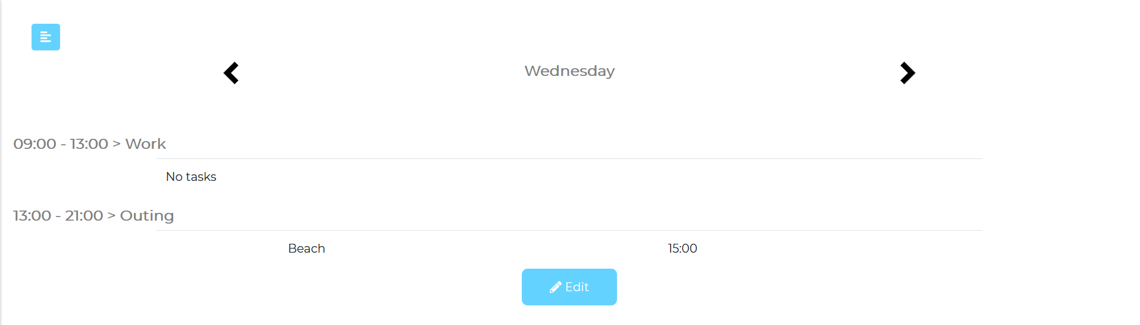Figure 45: Final: Scheduler

Schedule update
To edit the schedule, the users will see the tags. The first thing they need to do is go on what day of the week they want to make a schedule and by clicking the button “+”, they can add a new schedule by setting a name, initial time and end time.
After that they can edit, by clicking on the pencil button or delete, by clicking on the “X” button.
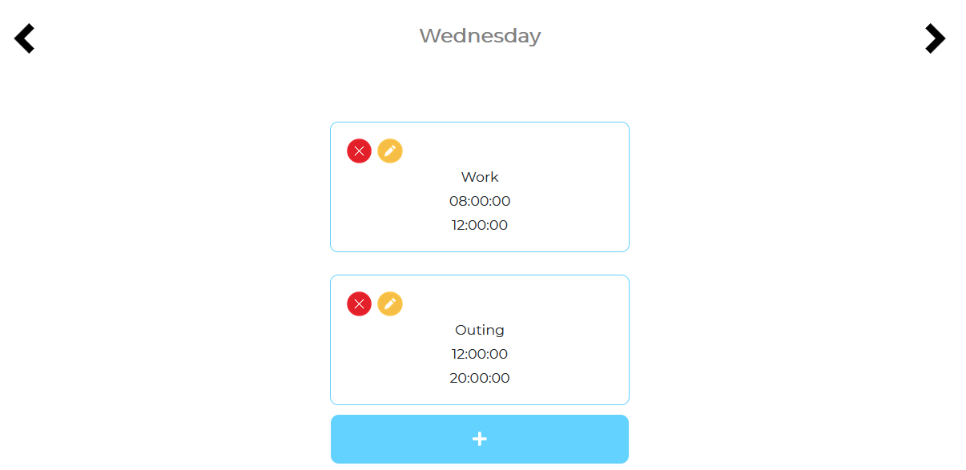Figure 46: Final: Schedule List
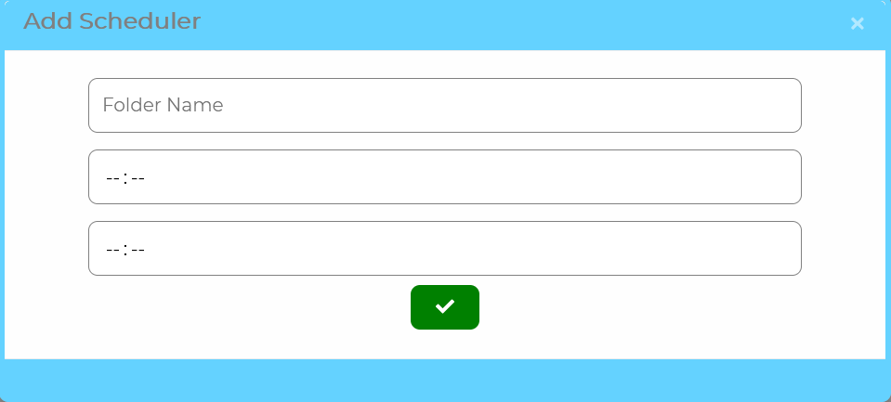Figure 47: Final: Schedule Add/Update

Schedule task
Now that the users added a schedule, they can now add a specific task to do within the times.
To do that they first need to click on schedule name and then the application will lead them to this page.
Here they can do the same: delete by clicking on “x”, edit and add new task by clicking on pencil by clicking the button “+”.
And everything they need to set are the name and a time.
And the application will show them the name and the time.
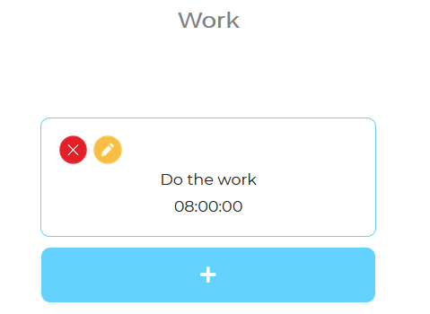Figure 48: Final: Schedule Task
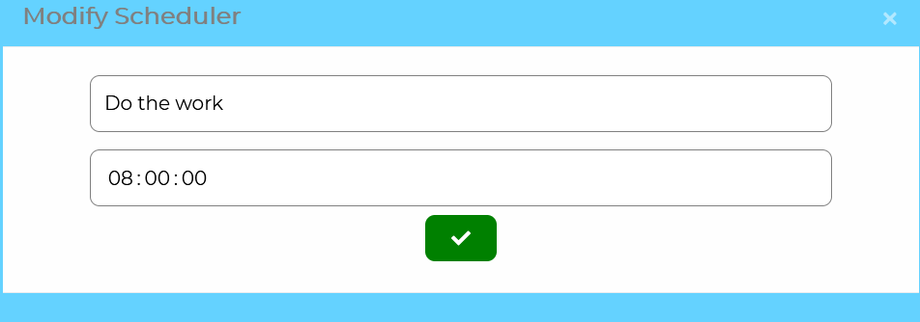Figure 49: Final: Schedule Task Add/Update

Contacts
In this page the users can delete, edit and add a contact. The contact are used to add into the to do tasks, to see with who are they going to do the tasks or they can just add a contact to remember them.
To add a contact the user need to click on the add contact button and it will lead them to the page.
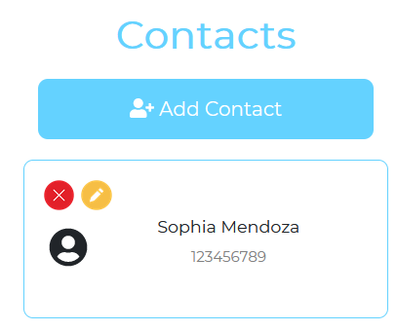Figure 50: Final: Contact List
Now they need to set the first name, last name, telephone, mail, street, zip, city and country in order to add a new contact. And to update the contact, by clicking on the pencil button, they just need to change those data.
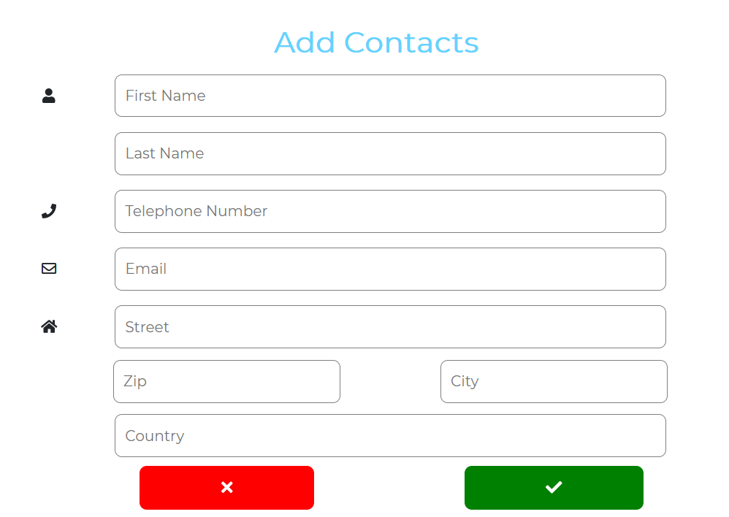Figure 51: Final: Contact Add/Update

Calendar
In this page, the user can see what they did everyday. They can chose a specific day and see it, the application will show them their mood and the description of the day, also will show the number of tasks they did.
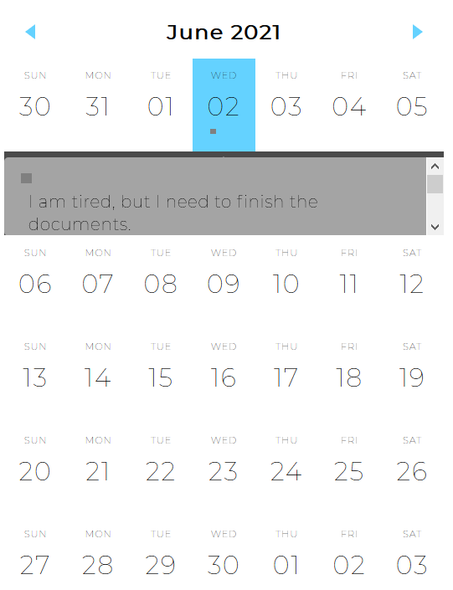Figure 52: Final: Calendar

Main
This is the main page, here the application shows what tasks they have on the current day. They can check as done by clicking on the button or uncheck.
The first row shows the schedule that the user set on every day of the week.
The to-do row, shows the to do task and shows the time.
The pending, is the same as to-do row, but it shows when the to-do task doesn’t have a specific date on it. Meaning that it will appear everyday until the user marks them as done.
And the last one, the challenge row. The application will give the challenge everyday, until the user deletes them.
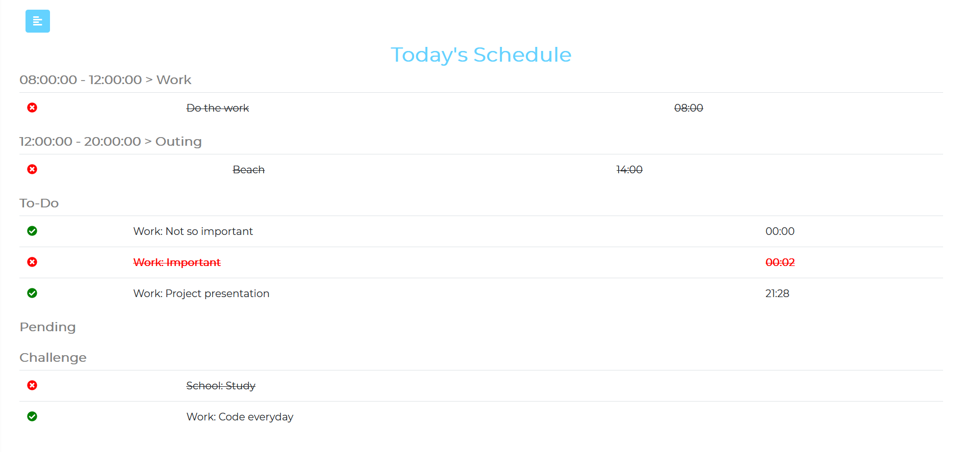Figure 53: Final: Main

7. INSTALLATION MANUAL
To install the application, first need a server with Apache, PHP and mariaDB. Set up all the server, drop all the files, set up the database and make the php be able to connect to the database.

Or we can register a domain, find a web hosting company, transfer all the files to the web hosting, create and set up the database and connect the files to the database.

After we installed the web application in the hosting or a private server, the users can use a browser and connect to the server and use the application.

8. BIBLIOGRAPHY
Visual Paradigm: “What is Use Case Specification?”, https://www.visual-paradigm.com/guide/use-case/what-is-use-case-specification/
r/x365: “Simple Gantt Template”, https://www.reddit.com/r/excel/comments/axedht/simple_gantt_template/
Stack Exchange Inc.: Stack Overflow, https://stackoverflow.com/
HashiCorp: Vagrant, https://www.vagrantup.com/
The Apache Software Foundation: Apache NetBeans, https://netbeans.apache.org/
Refsnes Data: W3Schools, https://www.w3schools.com/
Fonticons, Inc.: Font Awesome; https://fontawesome.com/
MIT: Bootstrap, https://getbootstrap.com/
The PHP Group: PHP, https://www.php.net/
MariaDB Foundation: MariaDB Server, https://mariadb.org/
The Apache Software Foundation: Apache, https://httpd.apache.org/
Software Freedom Conservancy: Git, https://git-scm.com/
CodePen: CodePen, https://codepen.io/
Lucid Software Inc.: Lucid, https://lucid.app/
Navasard Paul: “Event Calendar Widget”, https://codepen.io/peanav/pen/CfFjl

