DEVELOPMENT OF TRACKR
by:
Longjie Chao
Sophia Patrice Manalo Mendoza

A Thesis Submitted in Partial Fulfillment of the Requirements for the degree of Web Application Development

Approved by:
Mr. Josep Queralt
Mr. Jordi Bosom

Ciclo de Grado Superior
Institut Nicolau Còpernic
May, 2021
Table of Contents
1 Introduction 1
2 Project Planning 2
3 Marketing 3
3.1 Executive Summary 3
3.2 Products and services 3
3.3 Mission 3
3.4 Vision 3
3.5 Competition 3
3.6 Competitive advantage 4
3.7 SWOT Analysis 4
3.7.1 Strengths 4
3.7.2 Weaknesses 4
3.7.3 Opportunities 4
3.7.4 Threats 4
3.8 Buyer persona 4
3.9 Marketing objectives 5
3.10 Marketing budget 5
3.10.1 Development Schedule 5
3.10.2 Marketing Mix 5
3.10.3 Social media 6
4 Analysis Phase 7
4.1 Non functional requirements 7
4.1.1 Technologies 7
4.2 Functional requirements 8
4.2.1 Use Case Actor Census 8
4.2.2 Use Case Census 8
4.2.3 Analysis Class Diagram 10
4.2.4 Use Case Diagram 10
4.2.5 Use Case Specification 11
5 Design 20
5.1 Database design 20
5.2 Sketch 21
5.3 Mockup 29
5.3.1 Login 29
5.3.2 Registry 30
5.3.3 Main page 31
5.3.4 Menu 32
5.3.5 Mood Tracker 33
5.3.6 Financial Tracker 34
5.3.7 Old Transactions 35
5.3.8 To do folder 36
5.3.9 Task and Challenges 37
5.3.10 Task and Challenges’ CRUD 38
5.3.11 Contacts 39
5.3.12 Contacts’ CRUD 40
5.3.13 Calendar 41
5.3.14 Scheduler 42
5.3.15 Scheduler’s CRUD 43
5.4 Style Guide 44
6 User’s Manual 45
6.1 Login 45
6.2 Register 45
6.3 Menu 46
6.4 Mood Tracker 47
6.5 Financial Tracker 47
6.6 Old Transactions 48
6.7 To do folder 49
6.7.1 To do folder’s CRUD 49
6.8 Tasks and Challenges 49
6.8.1 Task and Challenges CRUD 50
6.9 Scheduler 51
6.9.1 Scheduler’s CRUD 51
6.9.2 Schedule task and its CRUD 52
6.10 Contacts and its CRUD 53
6.11 Calendar 55
6.12 Main 56
7 Installation Manual 57
8 Bibliography 58

Table of Figures
Figure 1: Gantt Diagram (1) 2
Figure 2: Gantt Diagram (2) 2
Figure 3: Analysis Class Diagram 10
Figure 4: Use Case Diagram 10
Figure 5: Database design 20
Figure 6: Sketch (Login and Registry) 21
Figure 7: Sketch (Main and Menu) 22
Figure 8: Sketch (Mood and Financial Transactions) 23
Figure 9: Sketch (Old Transactions and To do folder) 24
Figure 10: Sketch (Task and Challenge, and its CRUD) 25
Figure 11: Sketch (Contact and its CRUD) 26
Figure 12: Sketch (Scheduler and its CRUD) 27
Figure 13: Sketch (Calendar) 28
Figure 14: Mockup (Login) 29
Figure 15: Mockup (Registry) 30
Figure 16: Mockup (Main) 31
Figure 17: Mockup (Mood Tracker) 33
Figure 18: Mockup (Financial Tracker) 34
Figure 19: Mockup (Old Transactions) 35
Figure 20: Mockup (To do folder) 36
Figure 21: Mockup (Task and Challenge) 37
Figure 22: Mockup (Tasks and Challenges' CRUD) 38
Figure 23: Mockup (Contacts) 39
Figure 24: Mockup (Contacts' CRUD) 40
Figure 25: Mockup (Calendar) 41
Figure 26: Mockup (Scheduler) 42
Figure 27: Mockup (Scheduler's CRUD) 43
Figure 28: Style Guide 44
Figure 29: User's Manual (Login) 45
Figure 30: User's Manual (Registry) 45
Figure 31: User's Manual (Menu Button) 46
Figure 32: User's Manual (Menu) 46
Figure 33: User's Manual (Mood Tracker) 47
Figure 34: User's Manual (Financial Tracker's CRUD) 47
Figure 35: User's Manual (Financial Tracker) 48
Figure 36: User's Manual (Old Transaction's Button) 48
Figure 37: User's Manual (Old Transaction) 48
Figure 38: User's Manual (Old Transaction's Data) 48
Figure 39: User's Manual (To do folder) 49
Figure 40: User's Manual (To do folder's CRUD) 49
Figure 41: User's Manual (Tasks and Challenges) 50
Figure 42: User's Manual (Task's CRUD) 50
Figure 43: User's Manual (Challenges' CRUD) 51
Figure 44: User's Manual (Scheduler) 51
Figure 45: User's Manual (Scheduler's CRUD (1)) 52
Figure 46: User's Manual (Scheduler's CRUD (2)) 52
Figure 47: User's Manual (Scheduler's Task) 53
Figure 48: User's Manual (Scheduler's Task's CRUD) 53
Figure 49: User's Manual (Contacts) 54
Figure 50: User's Manual (Contacts' CRUD) 54
Figure 51: User's Manual (Calendar) 55
Figure 52: User's Manual (Main) 56

Index of Tables
Table 1: Use Case Actor Census 8
Table 2: Use Case (Sign Up) 11
Table 3: Use Case (Sign In) 11
Table 4: Use Case (Contact List) 12
Table 5: Use Case (To do Folders) 13
Table 6: Use Case (Tasks and Challenges) 15
Table 7: Use Case (Mood Tracker) 16
Table 8: Use Case (Financial Tracker) 17
Table 9: Use Case (Scheduler) 18
Table 10: Use Case (Daily Schedule) 18
Table 11: Use Case (Calendar) 19

Introduction
In our current era of non-stop technological innovation, fuzzy wishful thinking has yielded to the very core of our mind. It is no longer enough to imagine our way to a better state of mind and body. We must now chart our progress, count our steps log our sleep rhythms, tweak our diets, record our negative thoughts – then analyze the data, calibrate and repeat.

Project Planning
At first we had everything planned, thinking it was simple by doing something everyday and it kinda was, until it wasn't. Not everything went as we initially planned. As you can see the red squares means we used extra time for doing something that we expected to finish earlier. Also some of them we started earlier because we needed to start some task before so we could continue.
Planning is easier said than done.
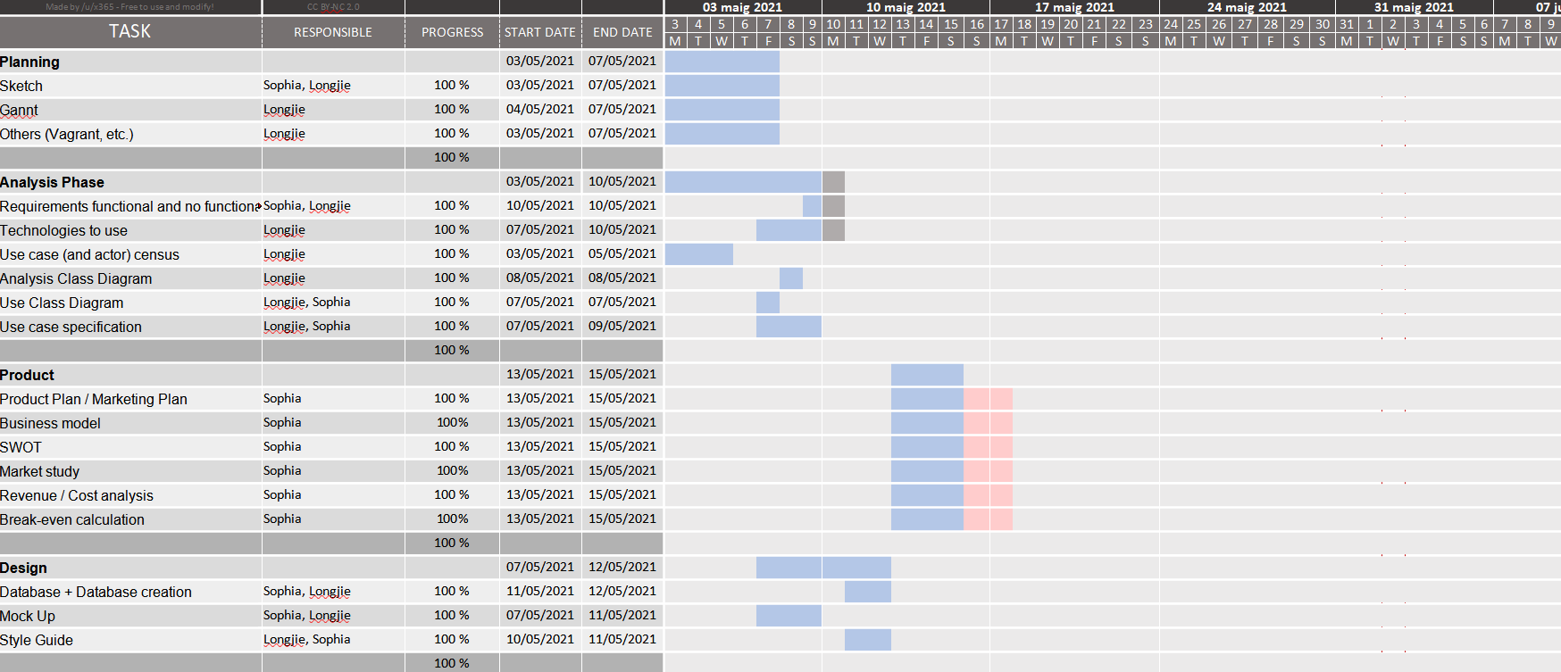Figure 1: Gantt Diagram (1)
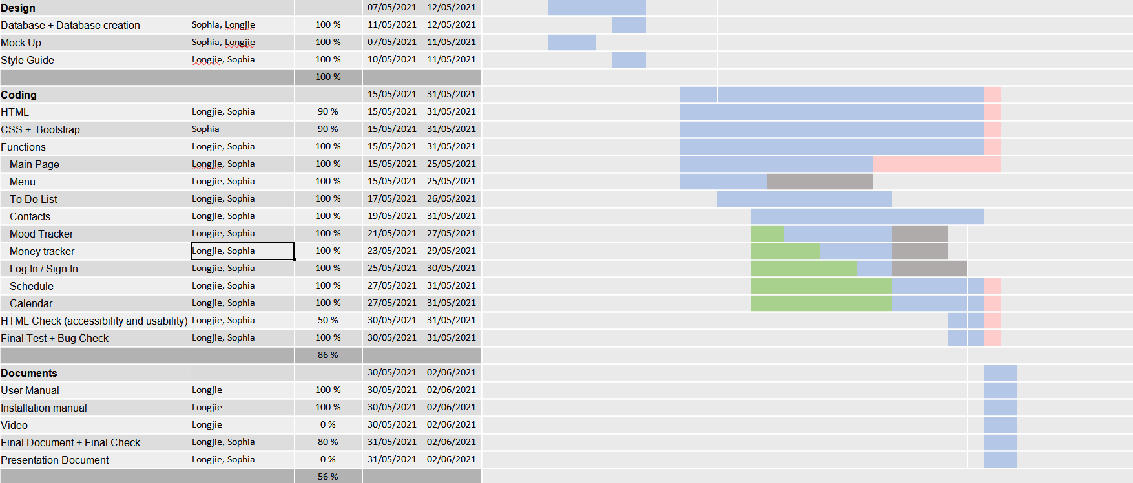Figure 2: Gantt Diagram (2)

Marketing

Executive Summary
We live in a technology world of technology that is both a curse and blessing. Sadly enough, people are connected than ever, but feel less connected at the same time.
Trackr is a unique freemium tracker that provides an effective way on how to manage your time wisely.
Trackr is not your typical tracker where you can only use it as a self-tracking device. It is an extension of one’s life to effectively manage our time to our own rhythm.

Products and services
• Mood tracker with integrated diary
• Financial tracker
• To-do list
• Scheduler

Mission
Trackr’s mission is to provide a rather friendly and useful application that people can use to manage their lives more efficiently and effectively, to not lose time and rather spend it wisely.

Vision
We want the world to be more social. We live in a busy world that loses the personal touch of human connection, so we thrive to create a tool to help people manage their time and spend it wisely with the things and people they love. Life is too short to be too busy.

Competition
• Our biggest competitors are the paper based mood trackers and agendas.
• Single functional applications

Competitive advantage
We live in a technological world where a mobile phone is an essential and an extension of our lives. Comparing to our biggest competitors which are mostly paper based, our application has a lot of potential to integrate in our daily lives. Not only it is easily portable, you can always use it knowing it is on your phone.

SWOT Analysis

Strengths
Trackr is an application which offers a lot of utilities and functionalities that are needed for our daily necessities.

Weaknesses
There are a lot of well known application that only focuses on one thing.

Opportunities
Having the application means that no more managing too many applications.

Threats
A lot of different competitors on different fields of the application are prevalent. While having a lot of functionalities, the application is a jack of all trades, master of none.

Buyer persona
Trackr’s customer can be broken down into two groups, busy professionals and students and your every day consumers. The former are smaller than the latter by the fact that the former can and will utilize the application to its maximum potential while the latter can use the application base on their own needs.
The larger group of everyday consumers consists of:
• Age: 16-60. People tends to be the busiest.
• Marital Status: Single to Widowed
• Area of living: Anywhere in the world
• Women tend to use the application more than men due to their motherly nature.

Marketing objectives
- Develop strong brand awareness: Invite a friend promotion. Local news feature.
- Create brand loyalty: Be a go to application in which people use on their daily lives.
- Increase in sales and decrease in marketing expenses: Holiday promotions, Student / enterprise promotion

Marketing budget
I calculated that the business will need to make at least 50.000€ a month in revenue to reach the break-even point. The first two months will be used to set up the physical location, hire personnel, rent servers and obtain a patented license. Business during the second month will be understandably slow as a steady customer base takes time to build. This is the stage where the majority of our marketing budget will go.

Development Schedule
What: Marketing campaign and Social Media campaign
Who: Longjie
Objectives: Marketing, Socials
Budget: 20.000€

What: Sales research
Who: Sophia
Objectives: Sales
Budget: 10.000€

Marketing Mix
Product: Mood tracker with integrated diary, Financial tracker, To-do list, Scheduler
Price: Free, single purchase: 9.99€, promotional prices: 4.99€
Distribution: App Store, Play Store and Official Website
Promotion: Social media

Social media
Instagram: Purchase of sponsored ads targeting our specified list of interests. Influencer posts. Heavy use of hashtag promotion.
Facebook ads: Purchase of sponsored ads targeting our specified list of interests. Influencer posts. Heavy use of hashtag promotion.
Google ads: Purchase of sponsored ads targeting our specified list of interests.
When it came to collaborations with schools and enterprises, it can be cross-promotional discounts! When looking for influencers we wanted to work with we would hyper-focus on ones with at least 20K followings, and topics that are of interest to us.

Analysis Phase

Non functional requirements
- Compatibility: As a software it needs to be compatible to different Operating System and platforms.
- Conformance: It needs to at least meet the minimum requirements of the product
- Dependability: As a software that saves personal data, it needs to be safe and secured.
- Installation: A software needs to be easy to install.
- Maintainability: A software that is not maintainable is no better than a garbage.
- Performance: Every software must always put performance at the top of the list if not the upmost top.
- Portability: As a modern software, it needs to be atleast compatible to mobile phones.
- Reliability: The software must work at all times
- Usability: A software must be easy to use.
- Security: A software must always have some sort of secure and data encryption at all times.

Technologies
- Web Server Software
  - Apache2: One of the most popular web server software. It allow us to save the files and be able to connect to the server.
- Database Engine
  - MariaDB: Used to create all the database and used to save all the data of the users and their tasks.
- Languages
  - PHP: One of the most popular back-end language for web. It allow us to keep users session, connect to the database, create interaction, encrypt data, etc.
  - HTML: the basic language to create a website.
  - JavaScript: front-end programming language used to make the website more interactive and for example, to make the user create more rows.
  - Bootstrap/CSS: all the visuals of the web site are made with Bootstrap and CSS.

Functional requirements

Use Case Actor Census
Table 1: Use Case Actor Census
Actor | Responsibility | Requirement | Guide
User | A person who wants to use the application and wants to have a better life. | Any user that has email. | The users can see their calendar  The users can modify their schedules, to do list, mood tracker, financial tracker...

Use Case Census
- Sign up / Sign In
- Manage Contact list
  - Add, Modify and Delete Contacts
- Manage To Do List
  - Add and Modify To Do List
    - Set / Change Tag name
      - Manage Tasks
      - Check / Uncheck Important tasks
      - Set Contact
    - Set / Change Description
    - Set type of the To do list
      - Normal
      - Challenge
  - Delete To Do List
- Manage Mood Tracker
  - Select daily mood
  - Show Mood Calendar
  - Set daily mood
- Manage Financial Tracker
  - Enable and Disable function
  - Set Total and Income
  - Set Daily Expenses
    - Set Expenses name and quantity
  - Show Money Stats and Graphic
- Manage Scheduler
  - Add / Change daily entries
  - Delete entries
- Show current schedule
- Show current Schedule
- Show current To do list
- Show Calendar
  - Show Schedule
  - Show To Do List
  - Show Exposes and Income
  - Show mood

Analysis Class Diagram
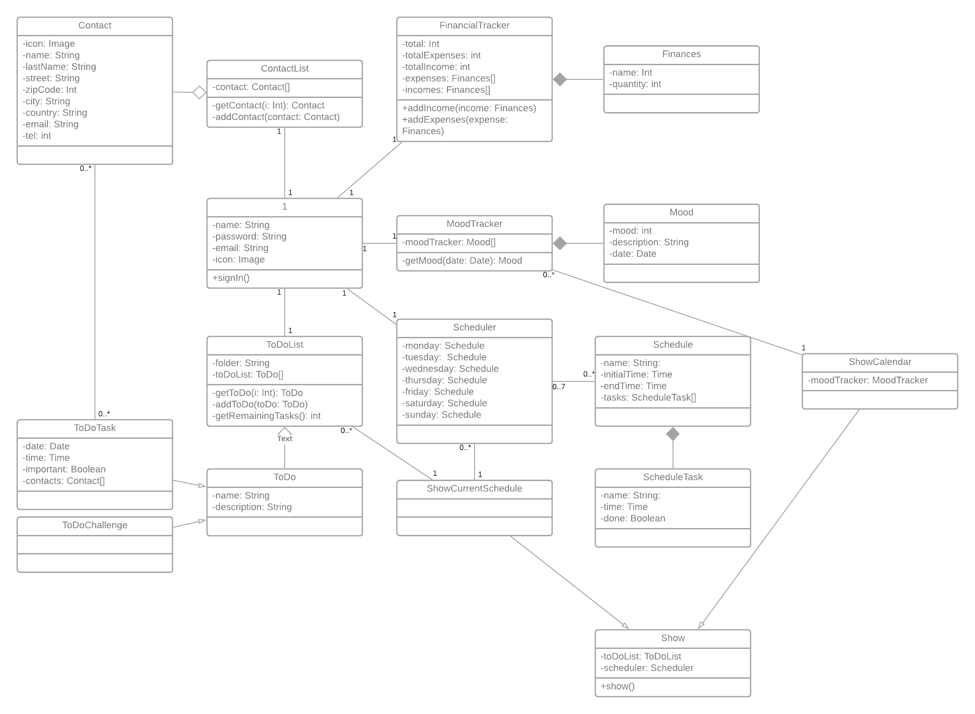Figure 3: Analysis Class Diagram

Use Case Diagram
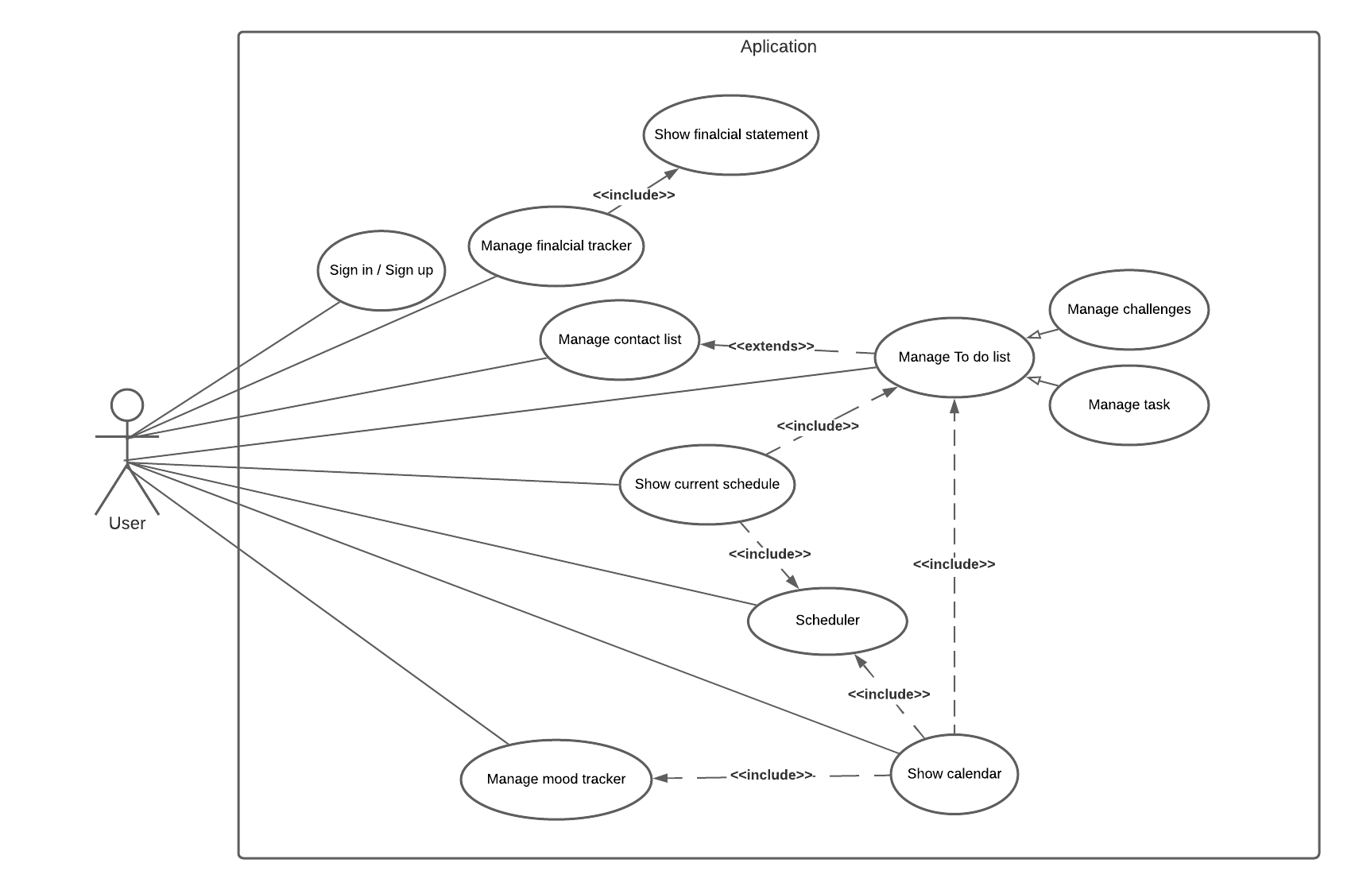Figure 4: Use Case Diagram

Use Case Specification

Table 2: Use Case (Sign Up)
Use Case | Sign up
Pre-condition | - The user doesn’t have an account to access the application.  - The user must have an email to register to the application  - The website must be online
Post-condition | - Account created for the user to access the application
Basic Path | - The user puts its email, password and password confirmation to create an account.  - The system checks if both password coincide.  - The system saves the data to its database
Alternative paths | 2a The passwords don’t coincide.  2b Email already in use  2c Invalid email format
Exception paths | - Cannot create the account  - Cannot create new account  - The application cannot connect to the database

Table 3: Use Case (Sign In)
Use Case | Sign in
Pre-condition | - The user must have an account to access the application  - The website must be online
Post-condition | - The user acceded the application and its functionalities.
Basic Path | - The user enters his email and password.  - The system verifies his email and password, comparing to the database’s.  - The email and password are both correct
Alternative paths | 3a. The email or account doesn’t exist.  3b. The password is incorrect
Exception paths | - Cannot access to the application  - The application cannot connect to the database

Table 4: Use Case (Contact List)
Use Case | Manage contact list
Pre-condition | - The user already signed in  - The website must be online
Post-condition | - The user added a new contact  - The user updated a contact  - The user deleted a contact  - The database was updated  - The user sees the information
Basic Path | - The user go to the Contact List page  - The system gets the information of the users contact  - The user manages the contact list:  - The user wants to add a new contact  - The user clicks the button to add a new contact  - The system shows the user a screen to add a new contact.  - The user enters the new contact informations (Name, Last name, Phone, Email, etc) and confirms  - The system adds the new contact with the information given by the user to the database  - The user wants to update a contact  - The user clicks the edit button of the specified contact  - The system shows the user a screen to edit the specified contact.  - The user changes the information of the contact and confirms  - The system updates the information changed by the user to the database  - The user wants to delete a contact  - The user clicks the delete button of the interested contact  - The system asks if the user wants to delete the contact or not  - The user chooses “yes”  - The system deletes the contact from the database  - The system updates and now shows the contact page without the specified contact
Alternative paths | 2a. The application shows no information of the users contact, because there is none  3.1.3a The user denies on adding a new contact  3.2.3a The user denies on updating the contact  3.3.3a The user chooses “no”  3.3.4b The system doesn’t delete the contact
Exception paths | - The application cannot connect to the database

Table 5: Use Case (To do Folders)
Use Case | Manage To Do list (folders)
Pre-condition | - The website must be online  - The user already signed in
Post-condition | - The user added a new folder  - The user updated a folder  - The user deleted a folder  - The user enters to a folder  - The database was updated  - The user sees the information
Basic Path | - The user go to the To do list page  - The system loads the “folders” and shows the user  - The user manages the folders:  - The user enters to a folder  - The user clicks to the interested folder and enters  - The application shows the tasks within the folder  - The user adds a new folder  - The user clicks on “add new folder” button  - The system gives to the user a form to set a name  - The user puts a names for the new folder and confirms  - The system creates a new folder and inserts into the database  - The user renames a folder  - The user clicks edit on the specified folder  - The system leads the user to another page  - The system loads the old name of the folder  - The user changes the old name of the folder and confirms  - The system updates the folder’s name and updates into the database  - The user deletes a folder  - The user clicks delete on the interested folder  - The system asks the user to delete the folder  - The user accepts  - The system deletes the folder from the database and reloads the page
Alternative paths | 2a There’s no folders  3.2.3a The user denies on adding a new folder  3.2.4a The system doesn’t add a new folder  3.3.4a The user denies on updating the folder  3.3.5a The system doesn’t update the folder  3.4.3a The user denies on deleting the folder  3.4.4a The system doesn’t delete the folder
Exception paths | - The application cannot connect to the database

Table 6: Use Case (Tasks and Challenges)
Use Case | Manage To Do list (tasks and challenges)
Pre-condition | - The website must be online  - The user already signed in  - There must be at least a folder created first  - The user must select a folder first
Post-condition | - The user added a new task/challenge  - The user modified a task/challenge  - The user deleted a task/challenge  - The database was updated  - The user sees the information
Basic Path | - The user chooses the folder  - The system shows the user tasks or challenges created  - The user manages the tasks:  - The user adds a new task  - The user clicks on add new task  - The system gives the user a form about the task  - The users enters all the information (name, important check, date, time and contact).  - The system gets the information and inserts it to the database  - The user modifies a task  - The user clicks on the specific task to update  - The system loads the task information to update  - The user changes the information about the task and confirms  - The System updates the information to the database  - The user deletes a task  - The user clicks on the specific task to delete  - The system asks the user to delete  - The user confirms it.  - The system deletes the task from the database
Alternative paths | 2a There’s no task or challenge  3.1.3a The user changes the type of the task to “challenge” and enters the information (only name)  3.1.4a The system didn’t add a new task  3.2.3a The user changes task to normal or to challenge type, and the system changes the form  3.2.4a The system didn’t update the tasks  3.3.3a The user denies the confirmation  3.3.4a The system didn’t delete the task
Exception paths | - The application cannot connect to the database

Table 7: Use Case (Mood Tracker)
Use Case | Manage mood tracker
Pre-condition | - The website must be online  - The user already signed in
Post-condition | - The user set their mood of the day  - The user set a description of their day  - The database updated the data
Basic Path | - The user goes to the mood tracker page  - The system shows the page to the user  - The user selects his mood and writes a description of the day  - The user clicks on the confirm button  - The system adds a new entry to the database
Alternative paths | 2a The system loads the mood and the description wrote previously  5a The system updates the entry if it already exists
Exception paths | - The application cannot connect to the database

Table 8: Use Case (Financial Tracker)
Use Case | Manage Financial tracker
Pre-condition | - The website must be online  - The user already signed in  - The Financial tracker is enabled
Post-condition | - The user sees his information about the expenses, income and total  - The user sees his information about all the different expenses and incomes
Basic Path | - The user goes to the financial page  - The system shows all of his financial transactions  - The user adds their expenses or income  - The system inserts the entry from the database
Alternative paths | 5. The user click on the old transaction button  6. The system shows the user’s monthly transactions
Exception paths | - The application cannot connect to the database

Table 9: Use Case (Scheduler)
Use Case | Manage Scheduler
Pre-condition | - The website must be online  - The user already signed in
Post-condition | - The user set his schedule  - The database was updated
Basic Path | - The user goes to the scheduler page  - The system shows the scheduler  - The user chooses which day of the week will they update  - The system shows the information about that day  - The user adds, modifies or deletes entries and confirms  - The system makes changes on the database
Alternative paths | 5a The user doesn’t want to make the changes
Exception paths | - The application cannot connect to the database

Table 10: Use Case (Daily Schedule)
Use Case | Show Current schedule (Main page)
Pre-condition | - The website must be online  - The user already signed in
Post-condition | - The user sees his data  - The user sees their daily Schedule and its information (Scheduler and To do)
Basic Path | - The user goes to the main page  - The system loads up the database all information about the scheduler and to do list  - The system uses those information to make a list and shows to the user
Alternative paths
Exception paths | - The application cannot connect to the database

Table 11: Use Case (Calendar)
Use Case | Show Calendar
Pre-condition | - The website must be online  - The user already signed in
Post-condition | - The user sees his data  - The user sees his monthly calendar and its information (To do, mood, financial, etc).
Basic Path | - The user goes to the calendar page  - The system loads from the database the information about the scheduler, to do list, financial tracker and mood tracker  - The system put those information in a calendar and shows the user  - The user click on a certain date  - The system shows to the user a summary of that day
Alternative paths
Exception paths | - The application cannot connect to the database

Design

Database design
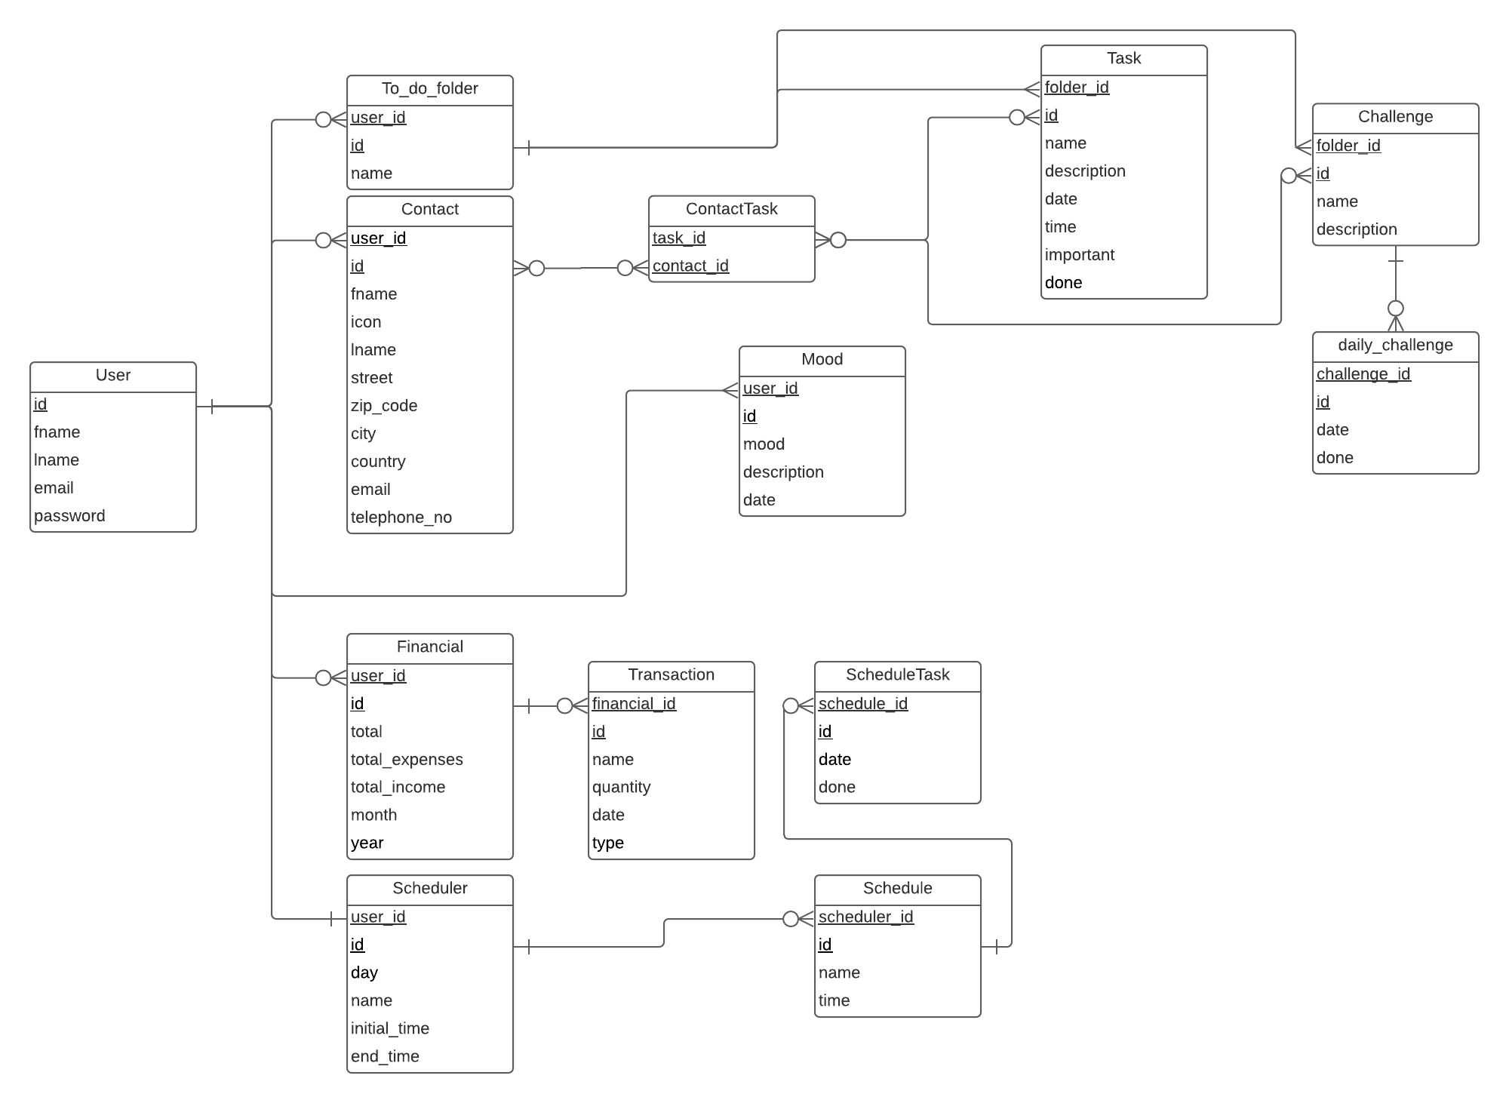Figure 5: Database design

Sketch
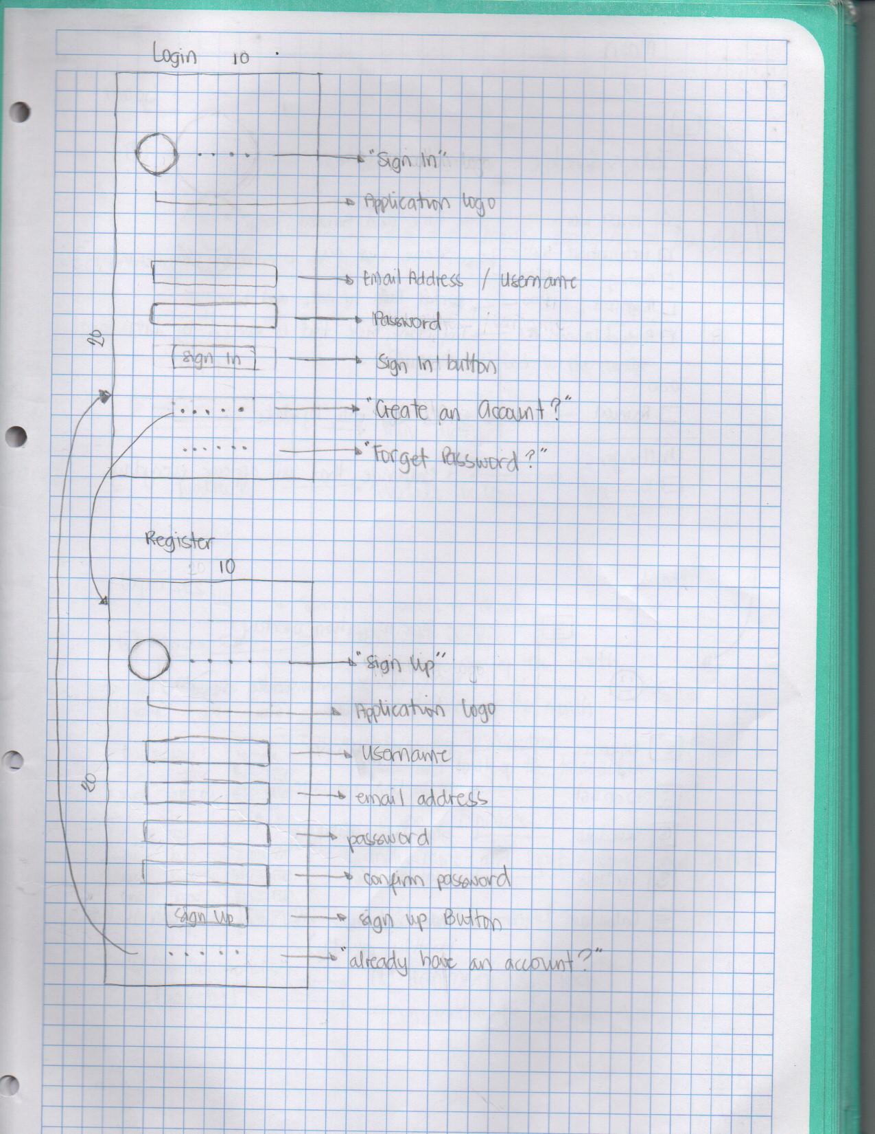Figure 6: Sketch (Login and Registry)

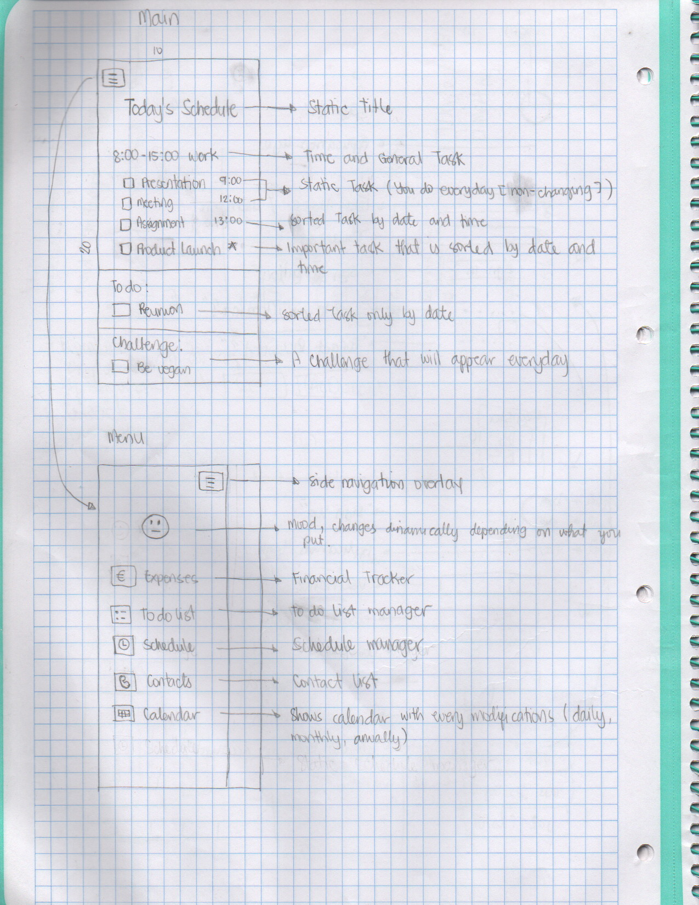Figure 7: Sketch (Main and Menu)
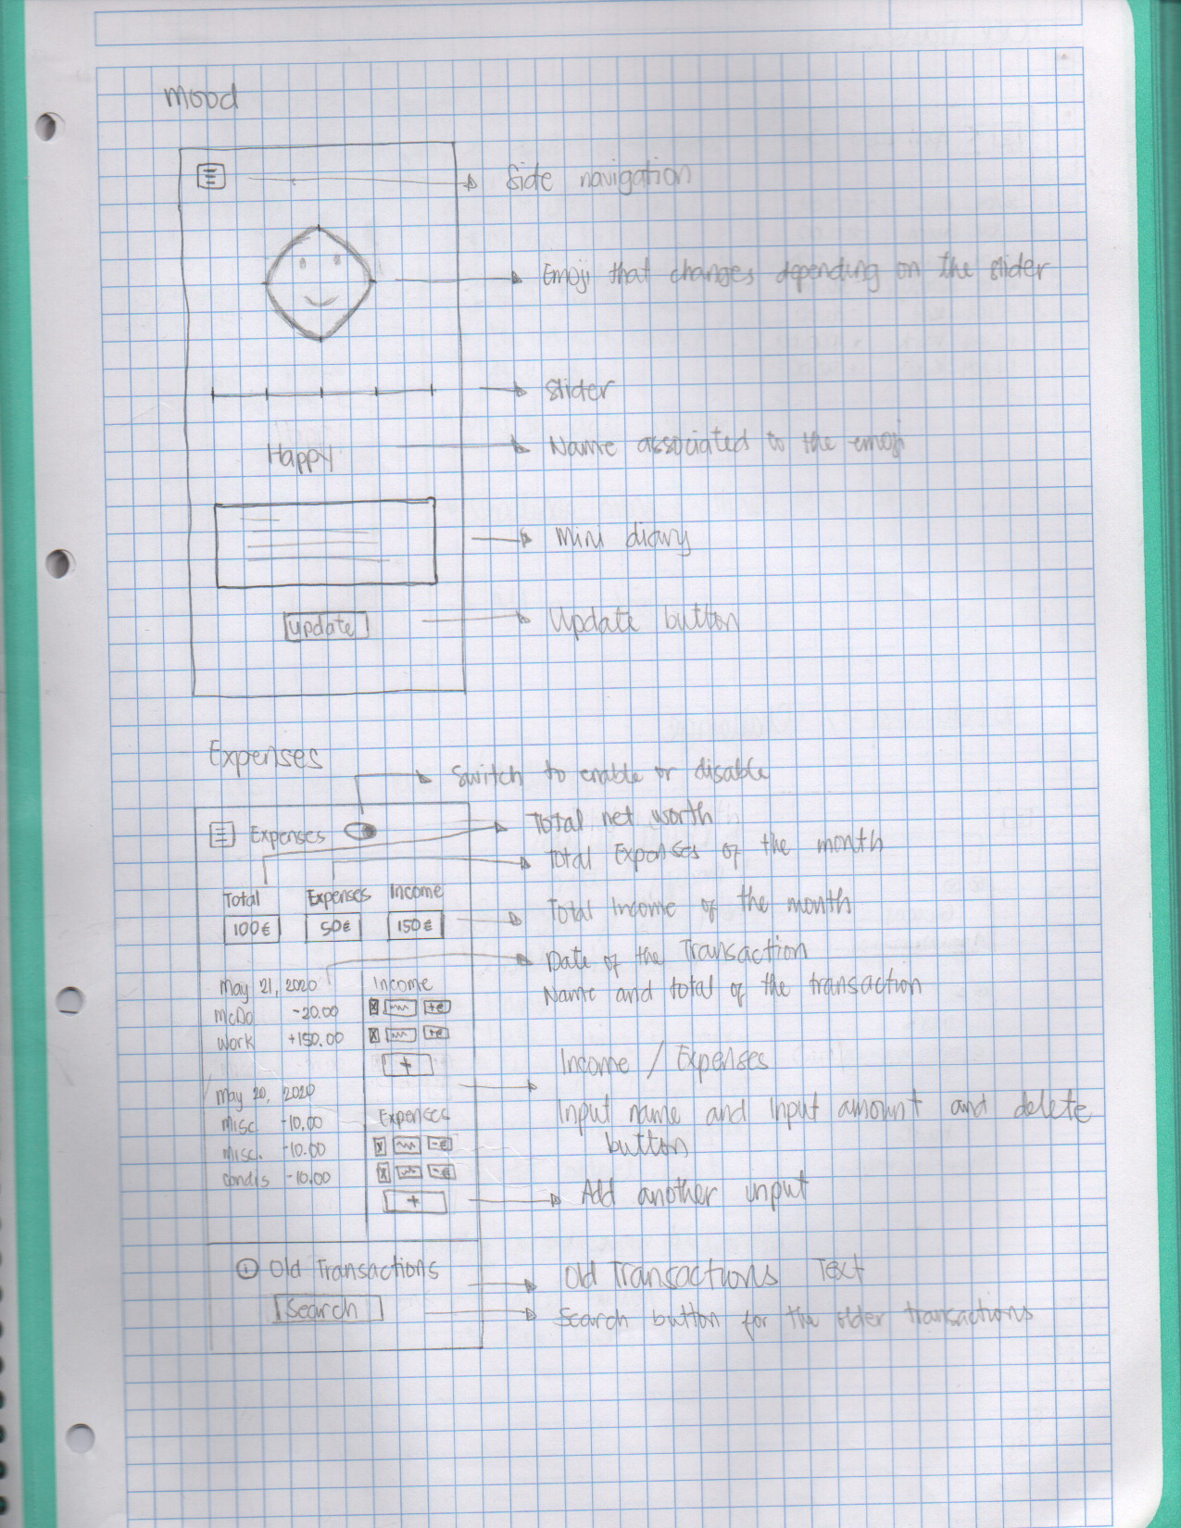Figure 8: Sketch (Mood and Financial Transactions)
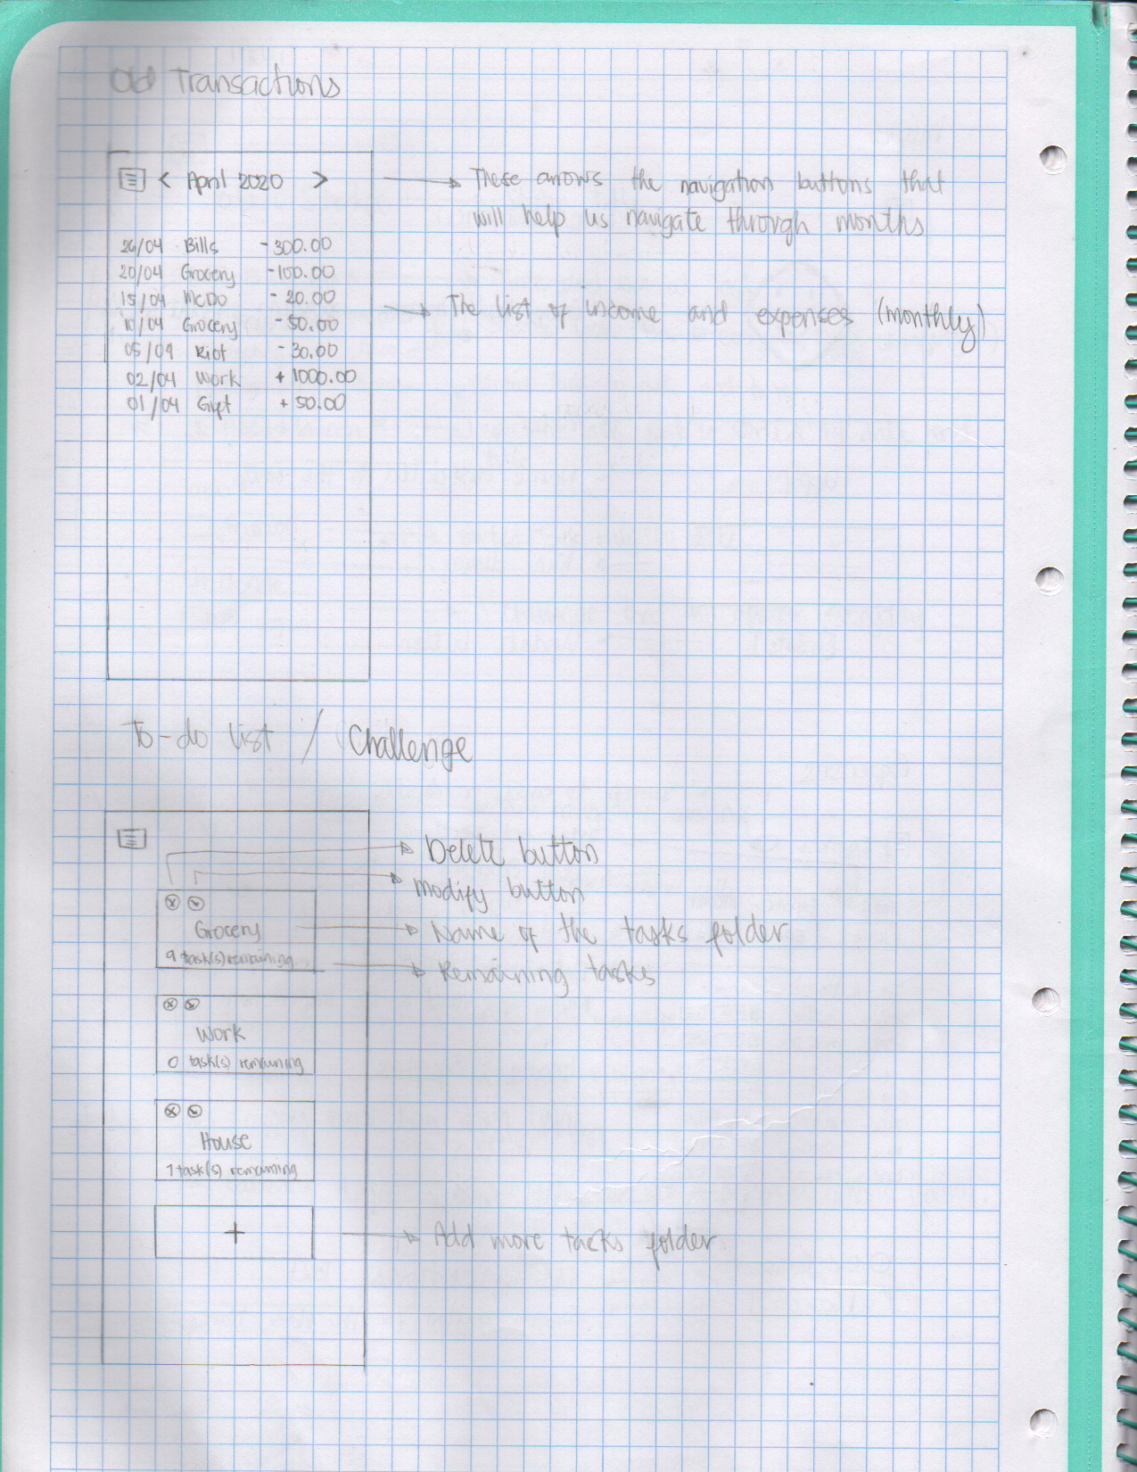Figure 9: Sketch (Old Transactions and To do folder)
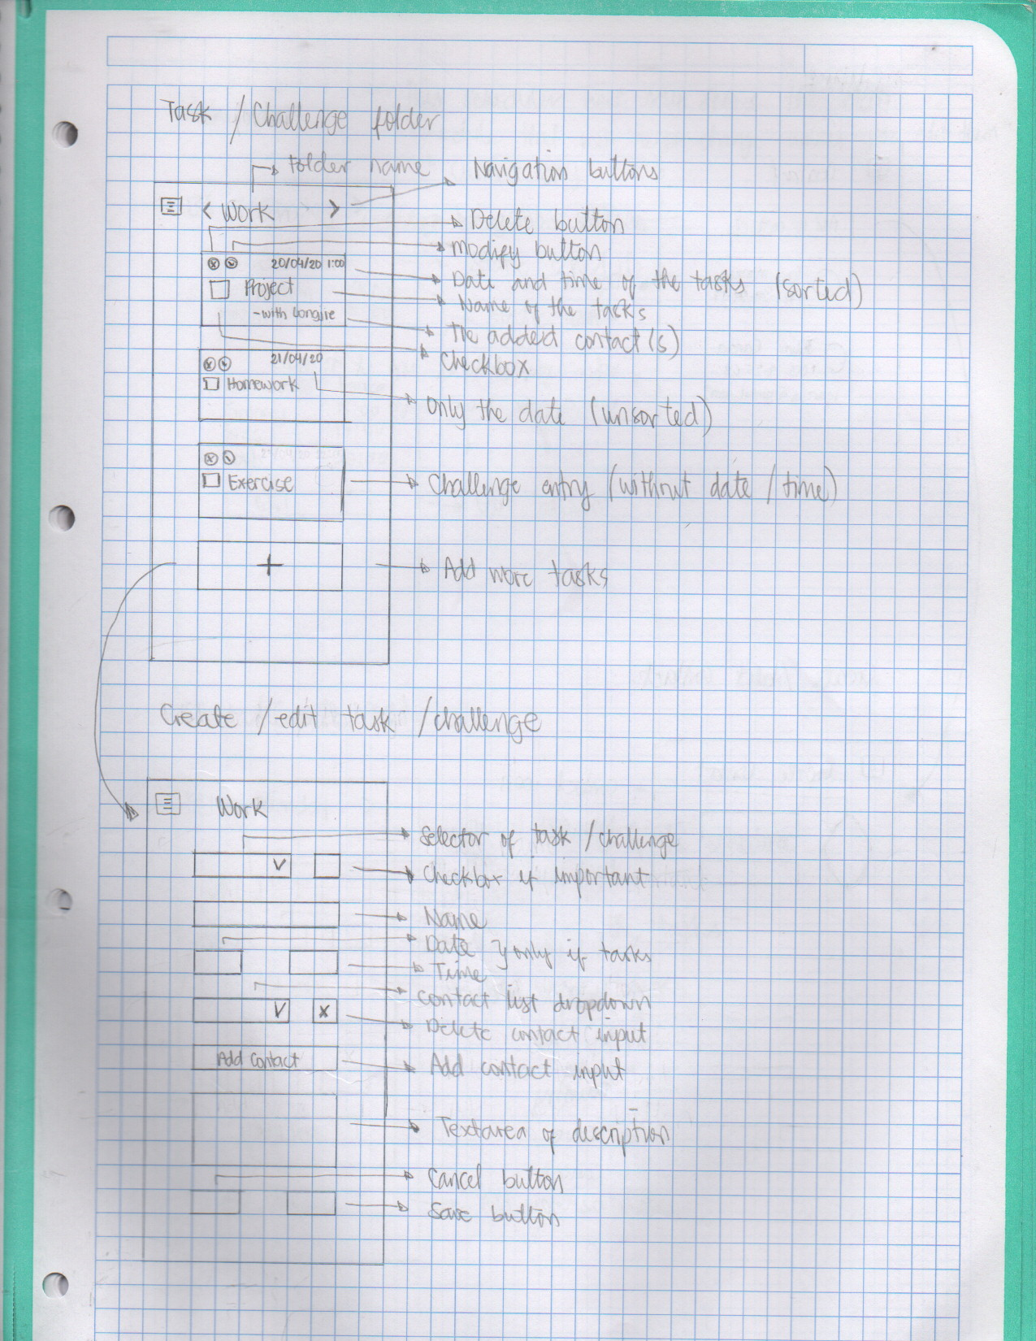Figure 10: Sketch (Task and Challenge, and its CRUD)
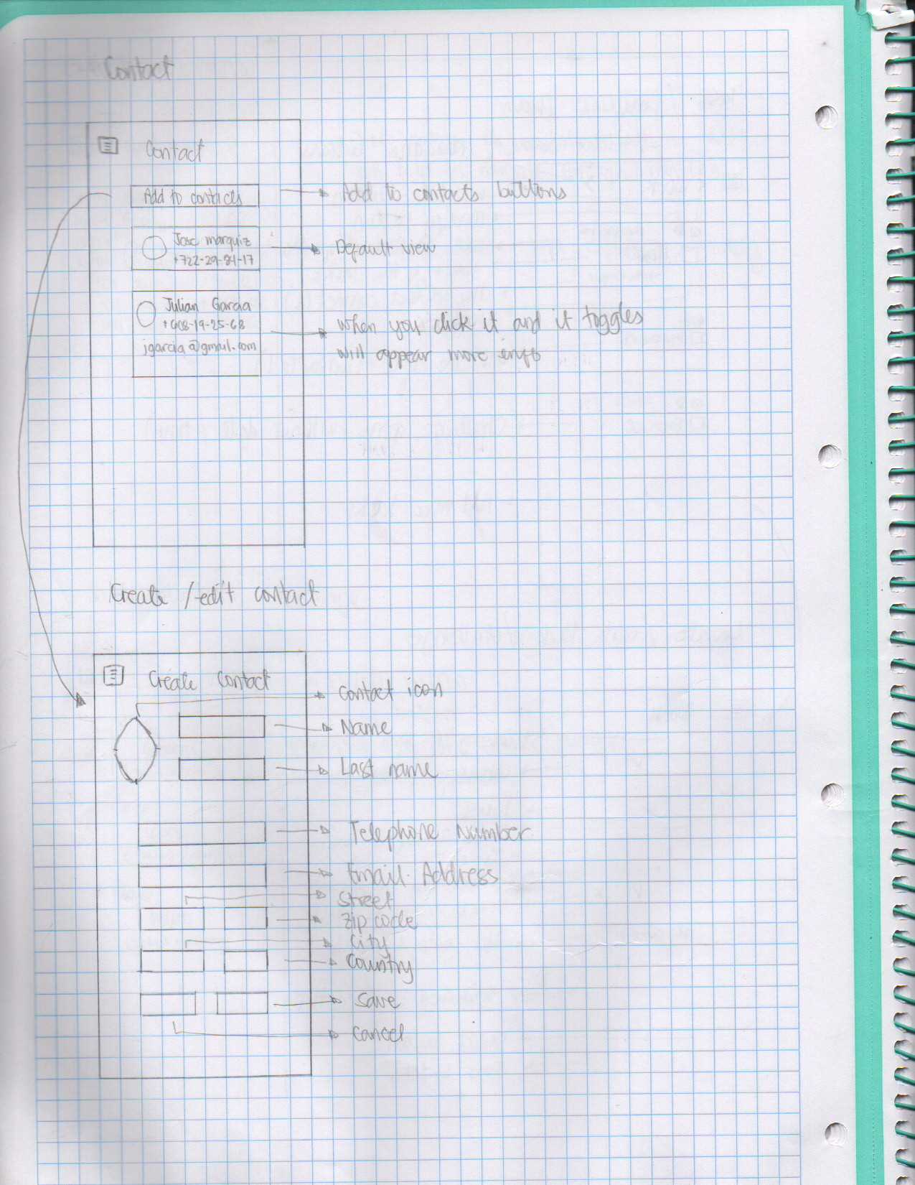Figure 11: Sketch (Contact and its CRUD)
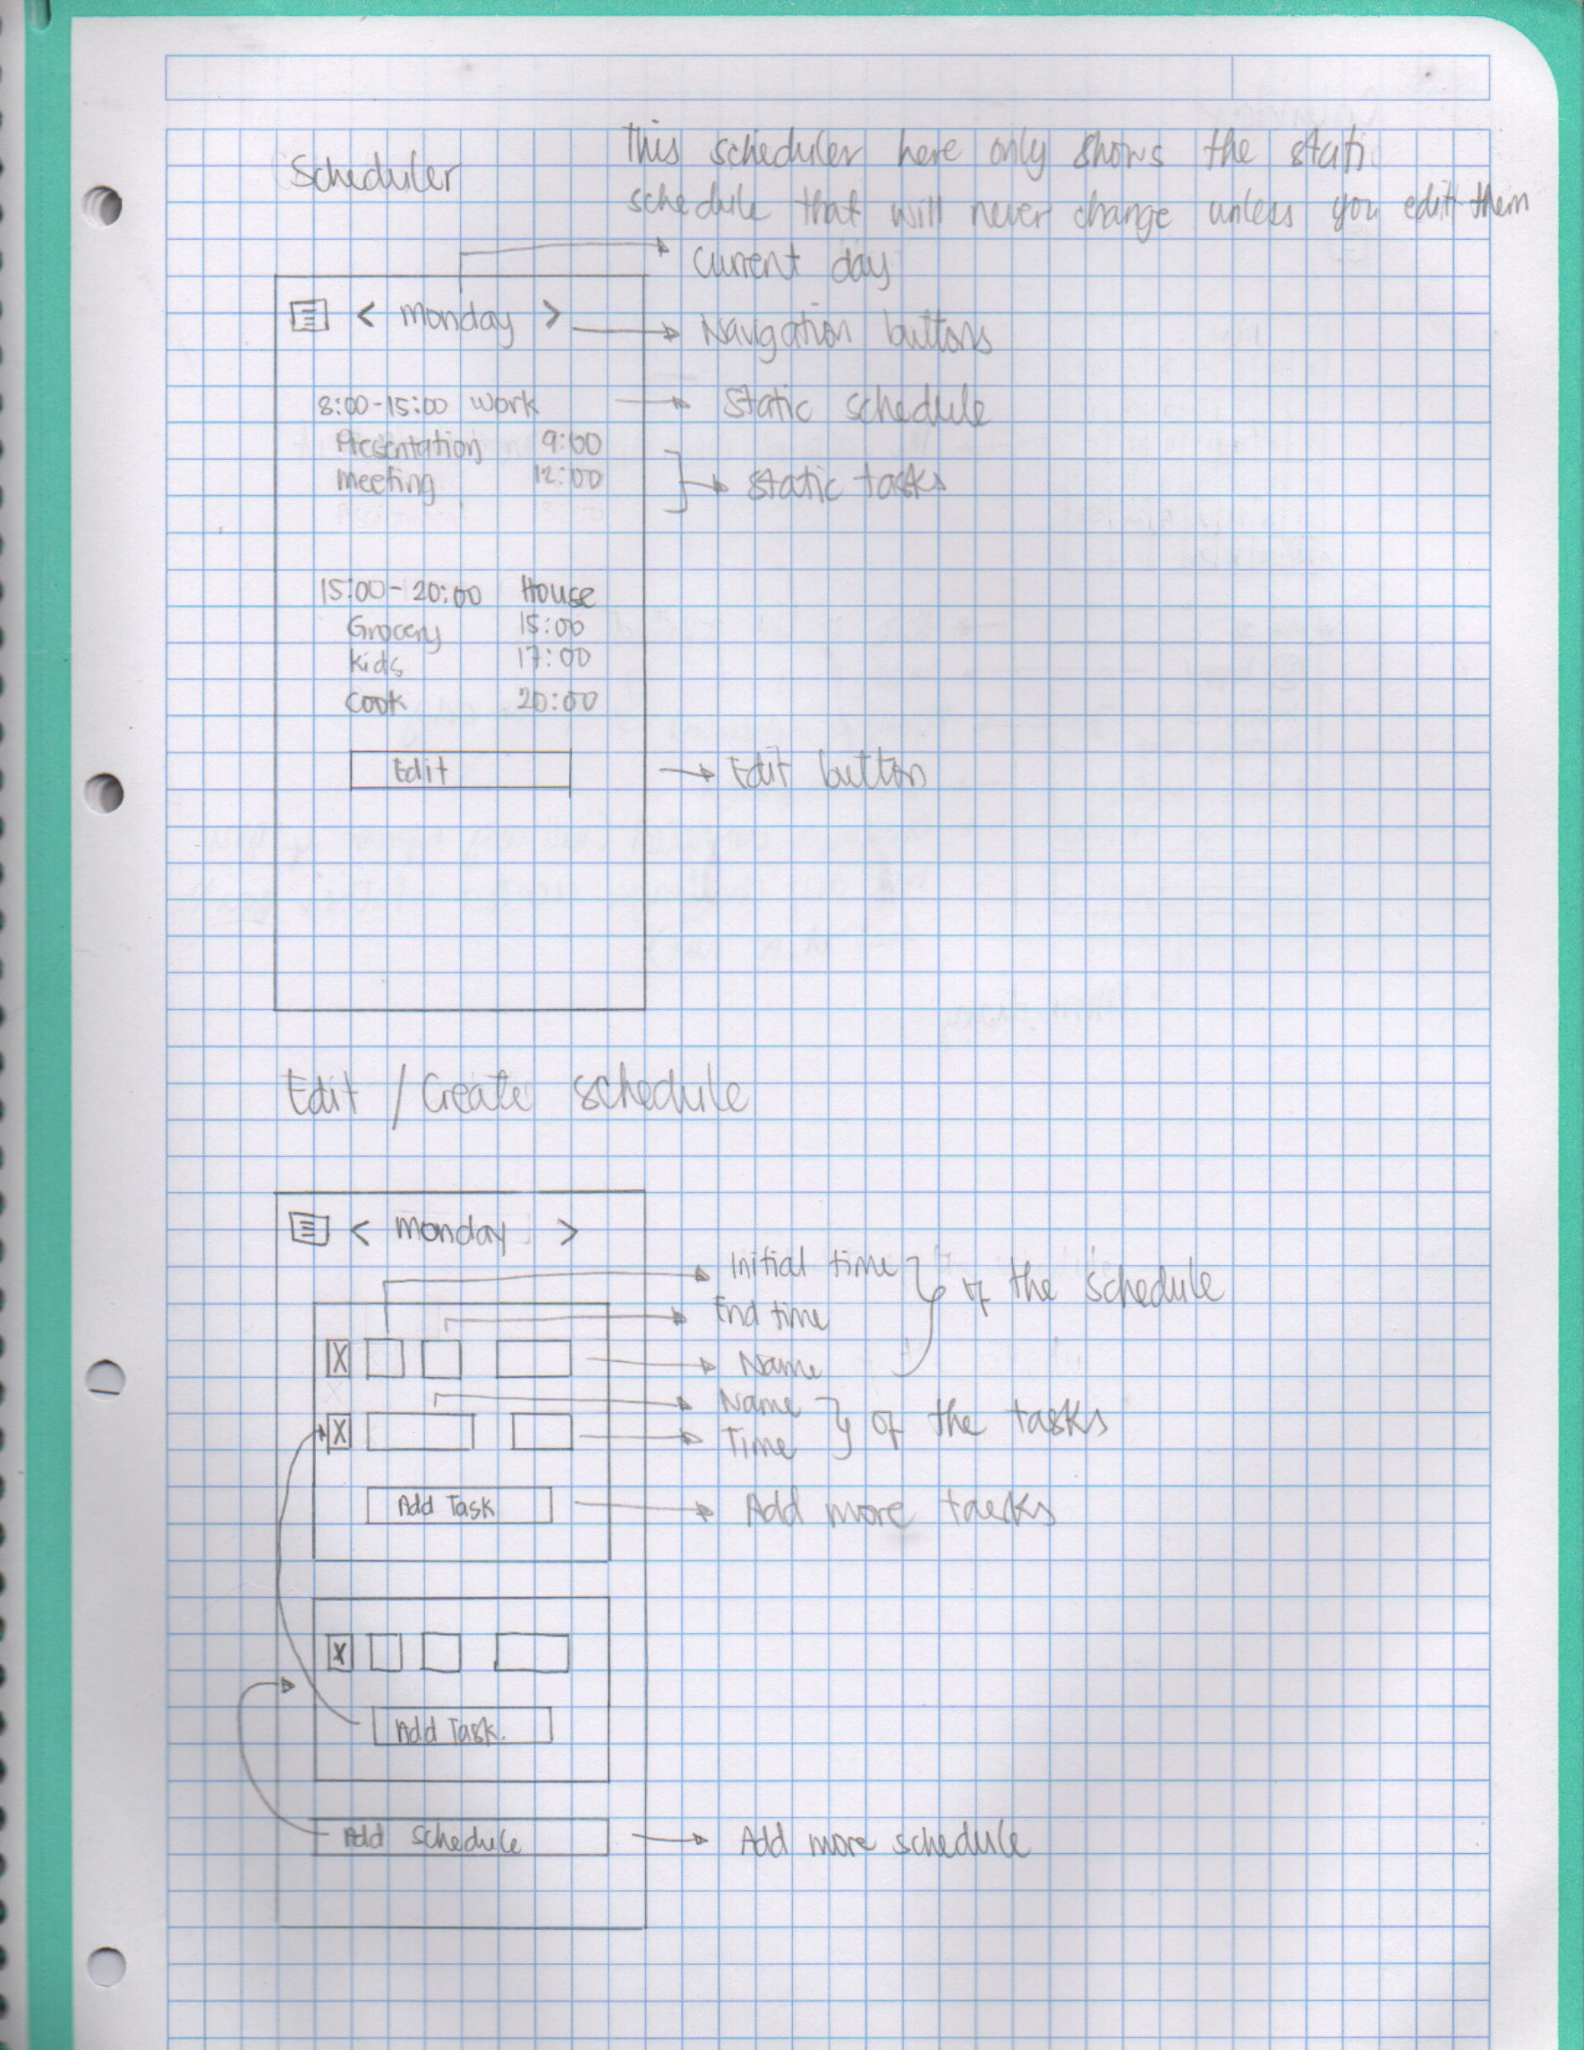Figure 12: Sketch (Scheduler and its CRUD)
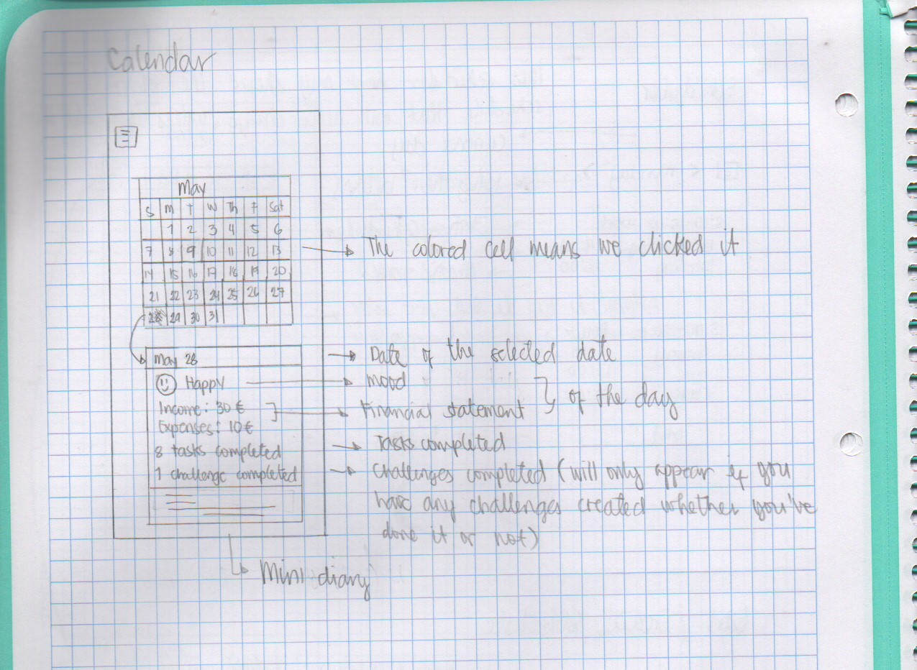Figure 13: Sketch (Calendar)

Mockup

Login
Clicking here will redirect you to another page which is the registry.
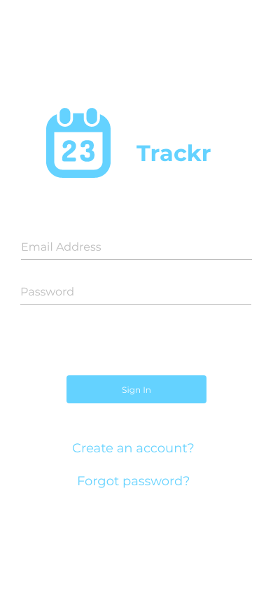Figure 14: Mockup (Login)

Registry
Clicking here will redirect you back to login screen.
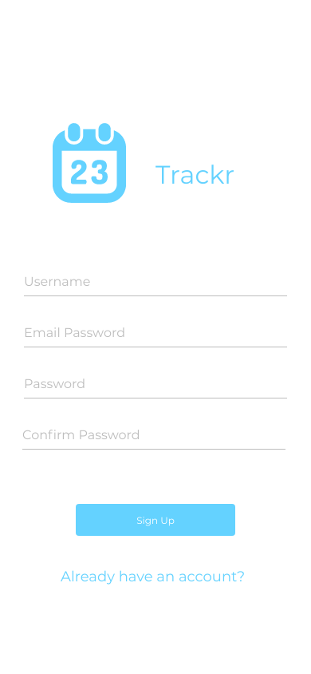Figure 15: Mockup (Registry)

Main page
Sliding navigation menu
Static daily schedule
Static daily task.
Red if important
Tasks you manually created
Daily challenges
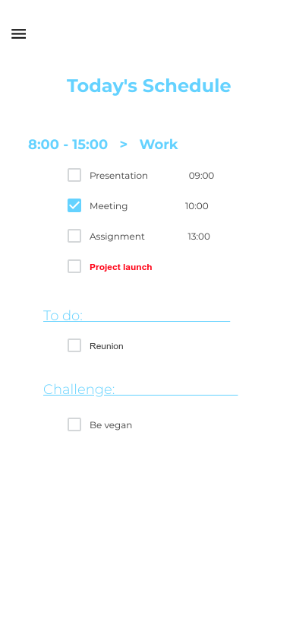Figure 16: Mockup (Main)

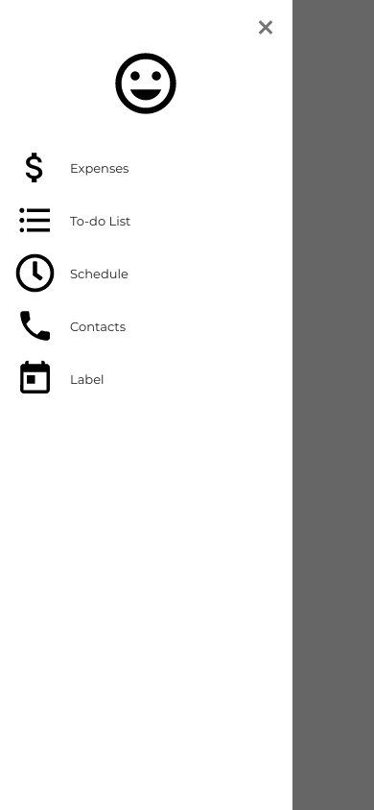
Menu

Mood Tracker
Emoticon that depends on the slider
The slider that changes the information of its dependencies
Name that depends on the emoticon
Mini diary
Updates the tracker
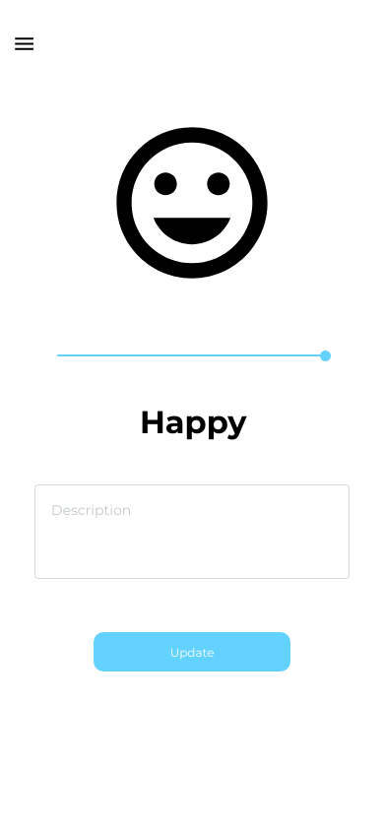Figure 17: Mockup (Mood Tracker)

Financial Tracker
Monthly Total Net Worth, Expenses and Income
Daily Transactions
Red for Expenses
Green for Income
Dropdown for Income / Expenses
Add more Transaction’s input
Save the Transaction’s data above
Delete Transaction’s input
Go to the past Transactions
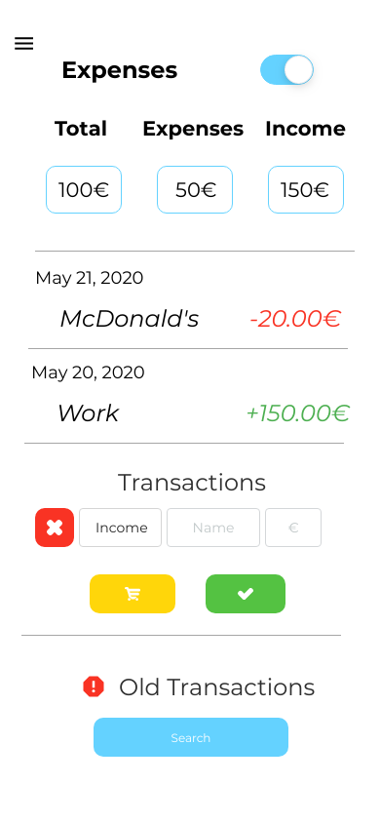Figure 18: Mockup (Financial Tracker)

Old Transactions
Daily Transactions
Red for Expenses
Green for Income
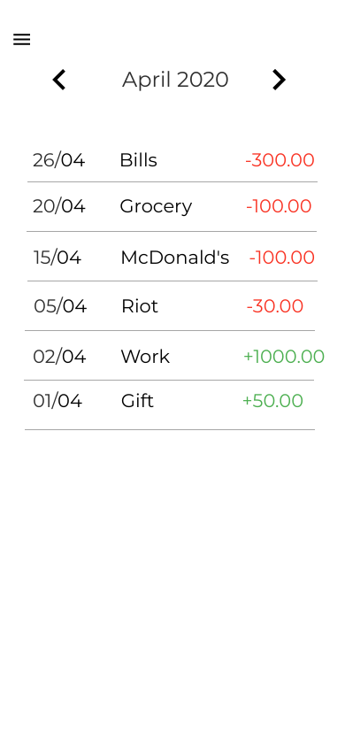Figure 19: Mockup (Old Transactions)

To do folder
Folder’s Name and its remaining tasks
Add more folder
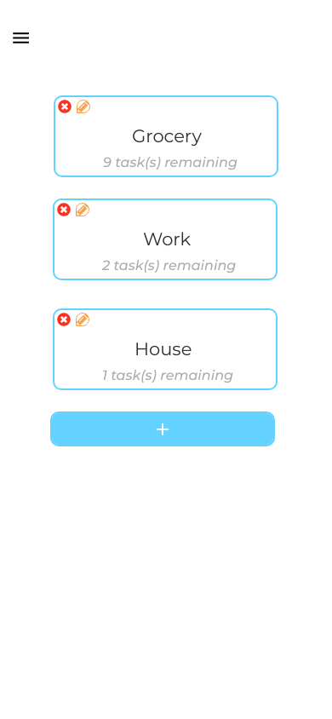Figure 20: Mockup (To do folder)

Task and Challenges
Add more task / challenges
Tasks / Challenges
Button, click if done
Folder’s name
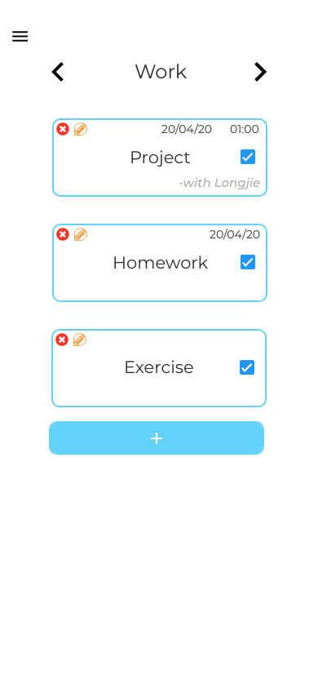Figure 21: Mockup (Task and Challenge)

Task and Challenges’ CRUD
Task / Challenges dropdown
Check if important
Folder’s name
Add contacts input
Delete contacts
Contact’s dropdown
Contacts description
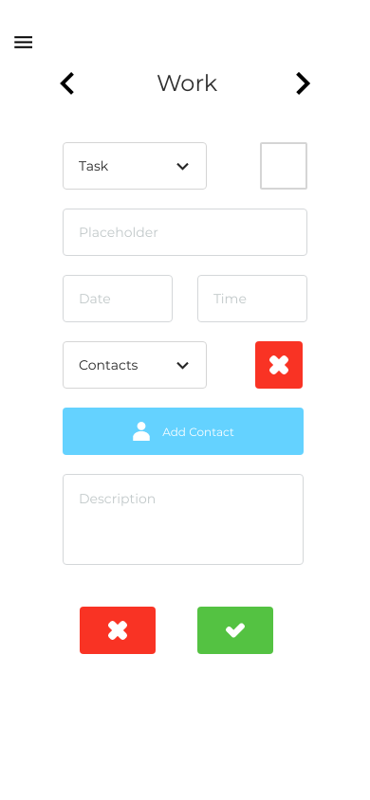Figure 22: Mockup (Tasks and Challenges' CRUD)

Contacts
Add new contacts
Contact’s name and number
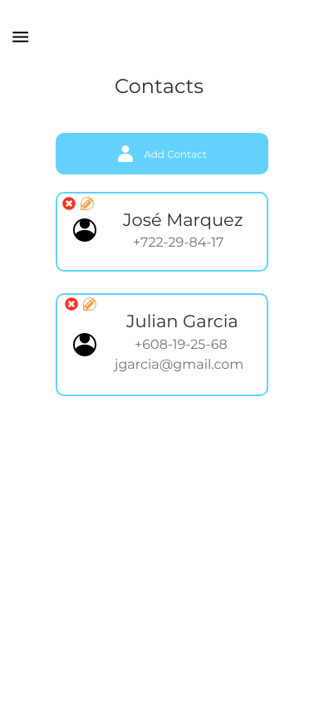Figure 23: Mockup (Contacts)

Contacts’ CRUD
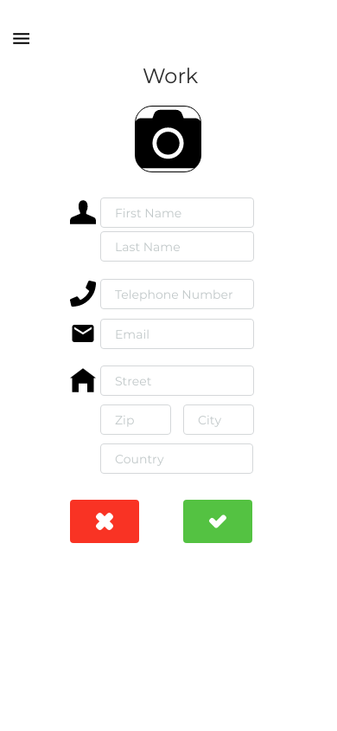Figure 24: Mockup (Contacts' CRUD)

Calendar
Mood Tracker
Financial Tracker
Task and Challenges done
Mini Diary
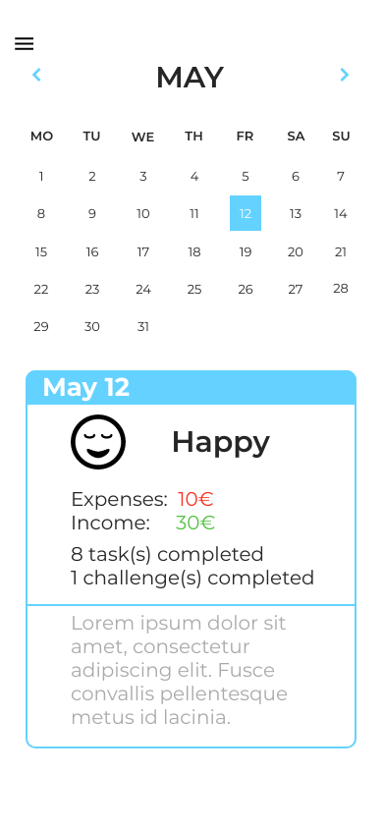Figure 25: Mockup (Calendar)

Scheduler
Static Schedule
Static Tasks
Day
Edit the scheduler
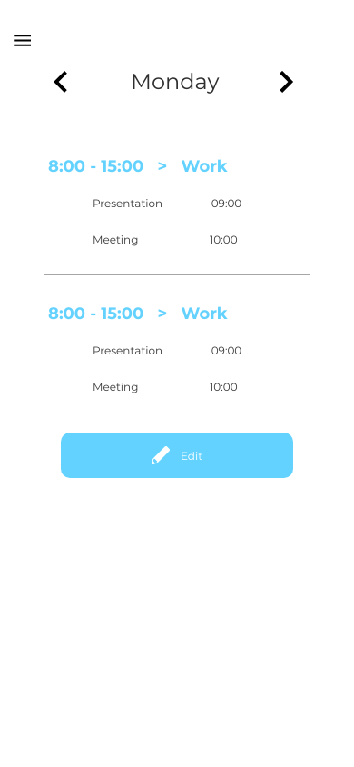Figure 26: Mockup (Scheduler)

Scheduler’s CRUD
Add task input
Add Schedule entries
Schedule entry
Schedule entry with task input
Task input
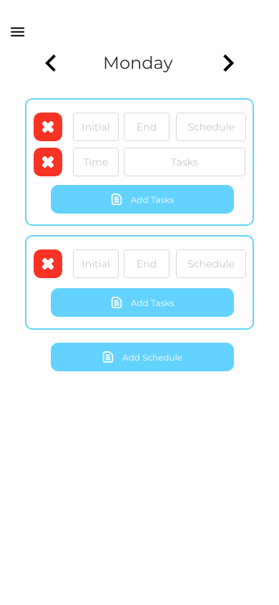Figure 27: Mockup (Scheduler's CRUD)

Style Guide
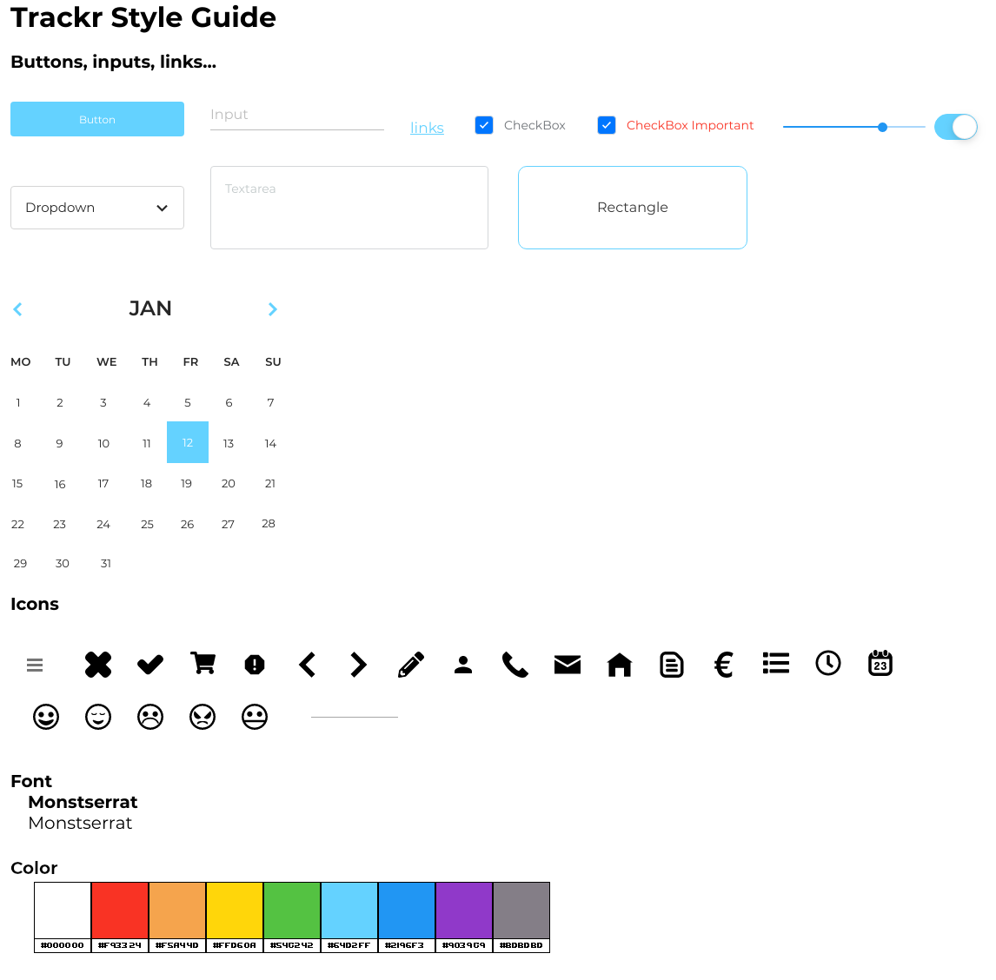Figure 28: Style Guide

User’s Manual

Login
In this page is where the user log in. Apart from logging in we are given the option to register as a new user.
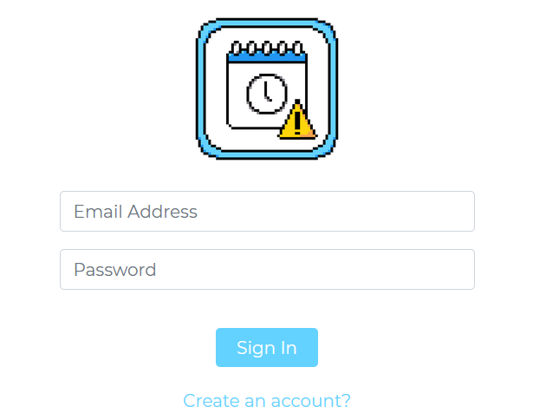Figure 29: User's Manual (Login)

Register
In this page the user can register as a new user by assigning them their first name, last name, email and password.
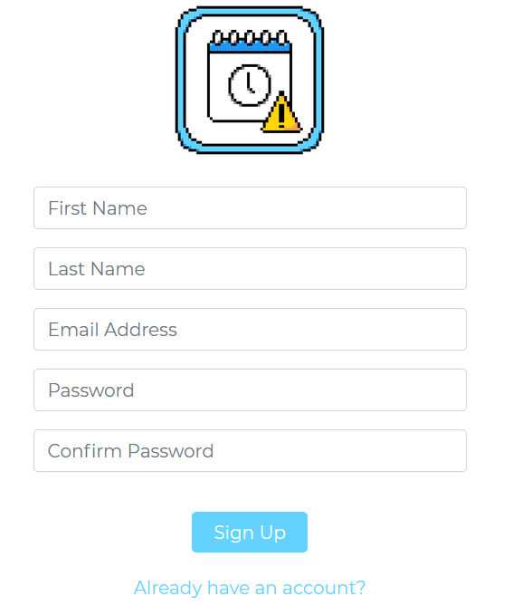Figure 30: User's Manual (Registry)

Menu
Every page has a button, which opens a menu where the users can browse the pages.
Figure 31: User's Manual (Menu Button)
On the menu, it shows the user’s first and last name, an emoticon which shows their emotion, the pages button and a button to log out.
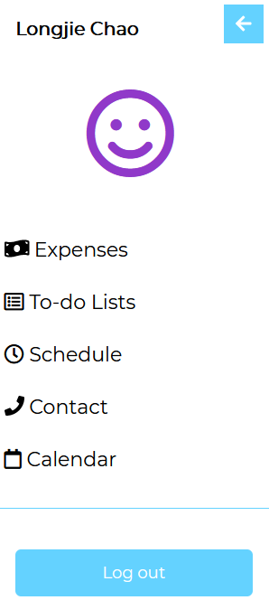Figure 32: User's Manual (Menu)

Mood Tracker
When the user clicks on the emoticon, it will lead them to the mood page. This page has a slider to set their mood and a box where they can express how they feel or write how is the user’s day.
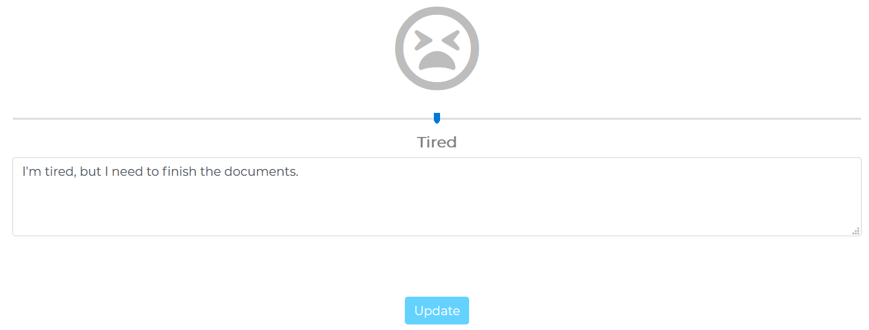Figure 33: User's Manual (Mood Tracker)

Financial Tracker
In this page the user can set their income and expenses by assigning a name and quantity.
To add a new transaction, the user needs to click the add button first and when they finish setting the data, they need to click on submit button.
Figure 34: User's Manual (Financial Tracker's CRUD)

After submitting, the page will refresh and update the data, and show what the user added. Only the data of the current month will be shown. After the month ends the data of the previous month won’t show.
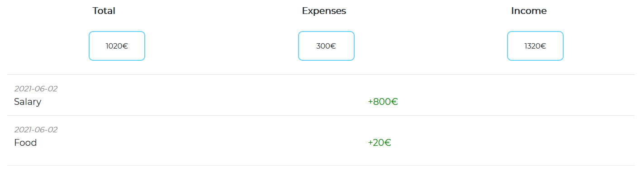Figure 35: User's Manual (Financial Tracker)
If the user wants to see the previous months transaction, they can click the “Old Transaction” button.
Figure 36: User's Manual (Old Transaction's Button)

Old Transactions
In this page the user can see their previous transactions. They can change the month with the arrows.
Figure 37: User's Manual (Old Transaction)
If there’s no data, it will only show a text saying “No data no show”.
Figure 38: User's Manual (Old Transaction's Data)

To do folder
To do list, it’s a folder to organize the tasks that the user will add.
In this page, the user can see the to do lists folder where they can delete, edit or add a new entry. The button “x” is to delete, “pencil” to edit and “+” to add a new to do list.
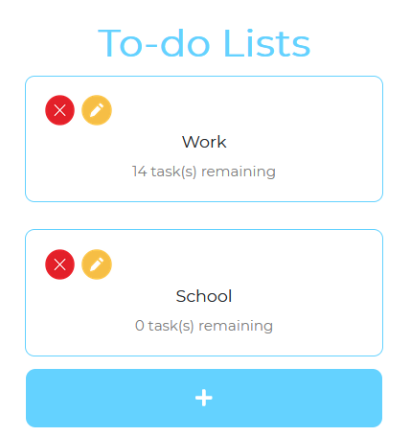Figure 39: User's Manual (To do folder)

To do folder’s CRUD
When the user clicks either the add button or edit button, a modal will appear where the user can add or update the name of the to do list. And click the check button to confirm.
If the user are updating the to do list, the folder’s name will appear.
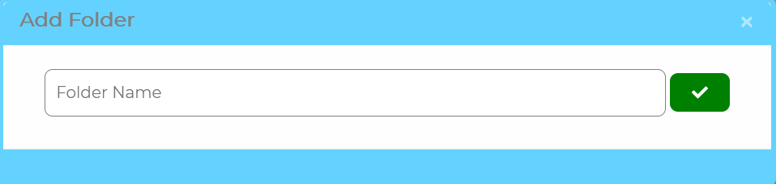Figure 40: User's Manual (To do folder's CRUD)

Tasks and Challenges
In this page, the user can see the to do list’s task or challenge where they can delete, edit or add a new to do list. The button “x” is to delete, “pencil” to edit and “+” to add a new to do list.
Each task will show the name and a button to check as done or not, and if the user will do a task with someone, that someone’s information will appear .
Each challenge will just show its name.
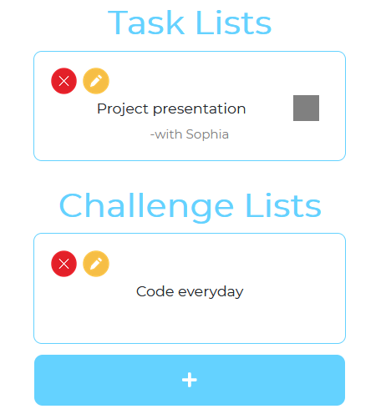Figure 41: User's Manual (Tasks and Challenges)

Task and Challenges CRUD
When updating or adding, the user can choose if they want a task or a challenge.
Task: The user needs to put a name, a date, a time and a description. Also they can add contacts, by clicking “Add Contact” if they’re going to do the task with someone. And if the user checks on the check mark, it will be considered as an important task.
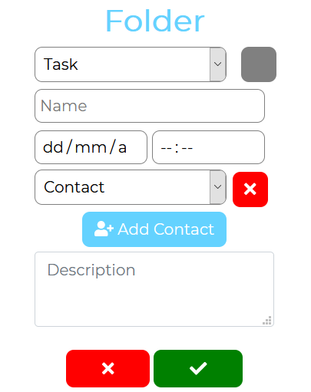Figure 42: User's Manual (Task's CRUD)
Challenge: The user just need to add a name and description. Unlike the task, the challenge doesn’t need to set a date, because everyday the users will do the challenge. It’s a daily challenge.
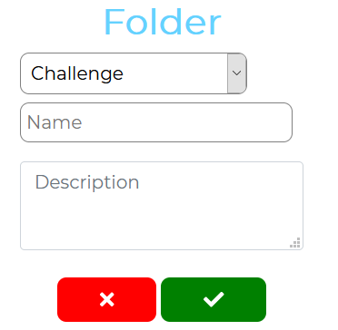Figure 43: User's Manual (Challenges' CRUD)

Scheduler
In this page the user will see what they will be going to do everyday.
The user can change which day of the week they want to see. To edit they just need to click on edit.
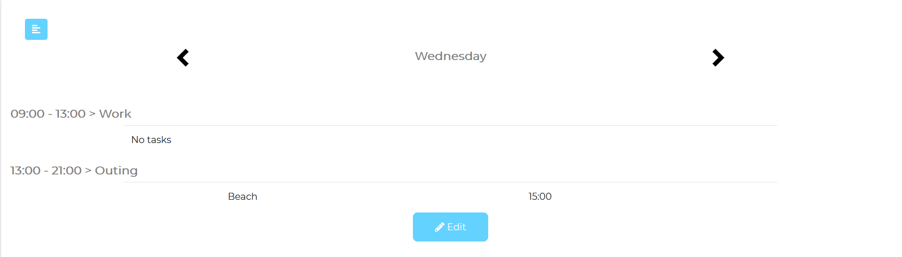Figure 44: User's Manual (Scheduler)

Scheduler’s CRUD
To edit the schedule, the users will see the tags. The first thing they need to do is go on what day of the week they want to make a schedule and by clicking the button “+”, they can add a new schedule by setting a name, initial time and end time.
After that they can edit, by clicking on the pencil button or delete, by clicking on the “X” button.
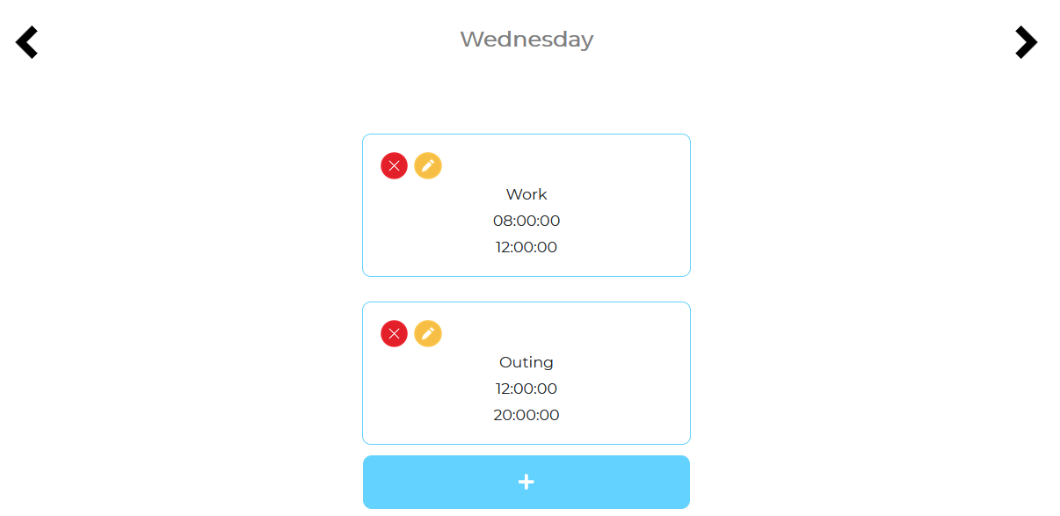Figure 45: User's Manual (Scheduler's CRUD (1))
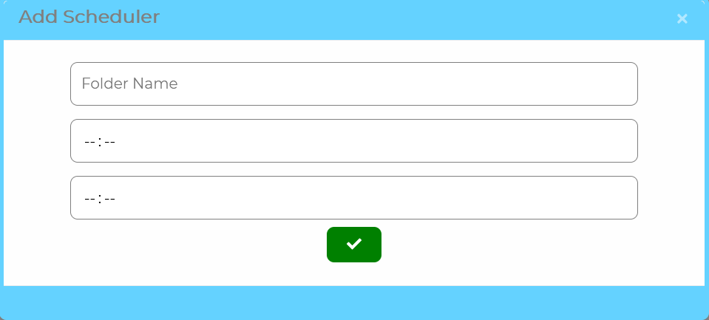Figure 46: User's Manual (Scheduler's CRUD (2))

Schedule task and its CRUD
Now that the user has added a schedule, they can now add a specific task to do between both time.
To do that they first need to click on schedule’s name and then the application will lead them to this page.
Here they can do the same: delete by clicking on “x”, edit and add new task by clicking on pencil by clicking the button “+”. Everything they need to set are the name and the time. The application will show them the name and the time.
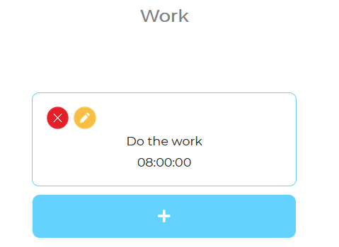Figure 47: User's Manual (Scheduler's Task)
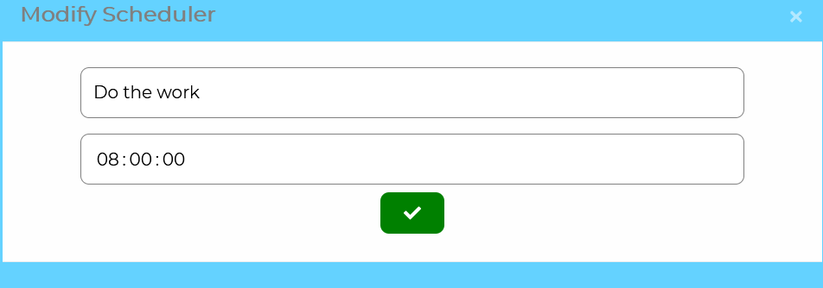Figure 48: User's Manual (Scheduler's Task's CRUD)

Contacts and its CRUD
In this page user can delete, edit and add a contact. The contact is used to add into the to do tasks, to see who are they going to do the tasks with or they can just add a contact to remember them.
To add a contact the user needs to click on the add contact button and it will lead them to the page.
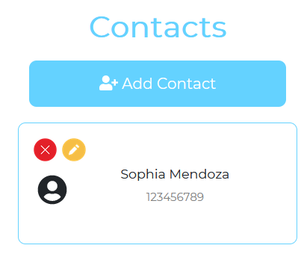Figure 49: User's Manual (Contacts)
Now they need to set the first name, last name, telephone, mail, street, zip, city and country in order to add a new contact. And to update the contact, by clicking on the pencil button, they just need to change those data.
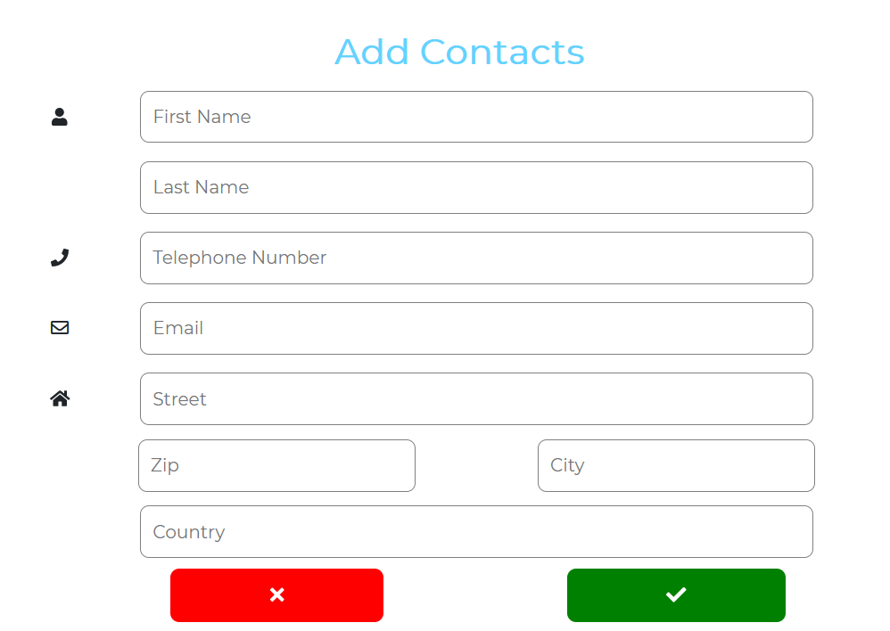Figure 50: User's Manual (Contacts' CRUD)

Calendar
In this page, the user can see what they did everyday for a month. They can choose a specific day and see it, the application will show them their mood and the description of the day, also will show the number of tasks they did.
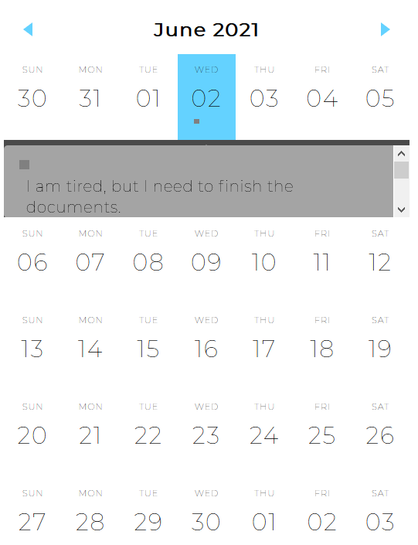Figure 51: User's Manual (Calendar)

Main
This is the main page, where the application shows what tasks they have on the current day. They can check as done by clicking on the button or uncheck.
The first row shows the schedule that the user set on every day of the week.
The to-do row, shows the to do task and shows the time.
The pending, is the same as to-do row, but it shows when the to-do task doesn’t have a specific date on it. Meaning that it will appear everyday until the user marks them as done.
And the last one, the challenge row. The application will give the challenge everyday, until the user deletes them.
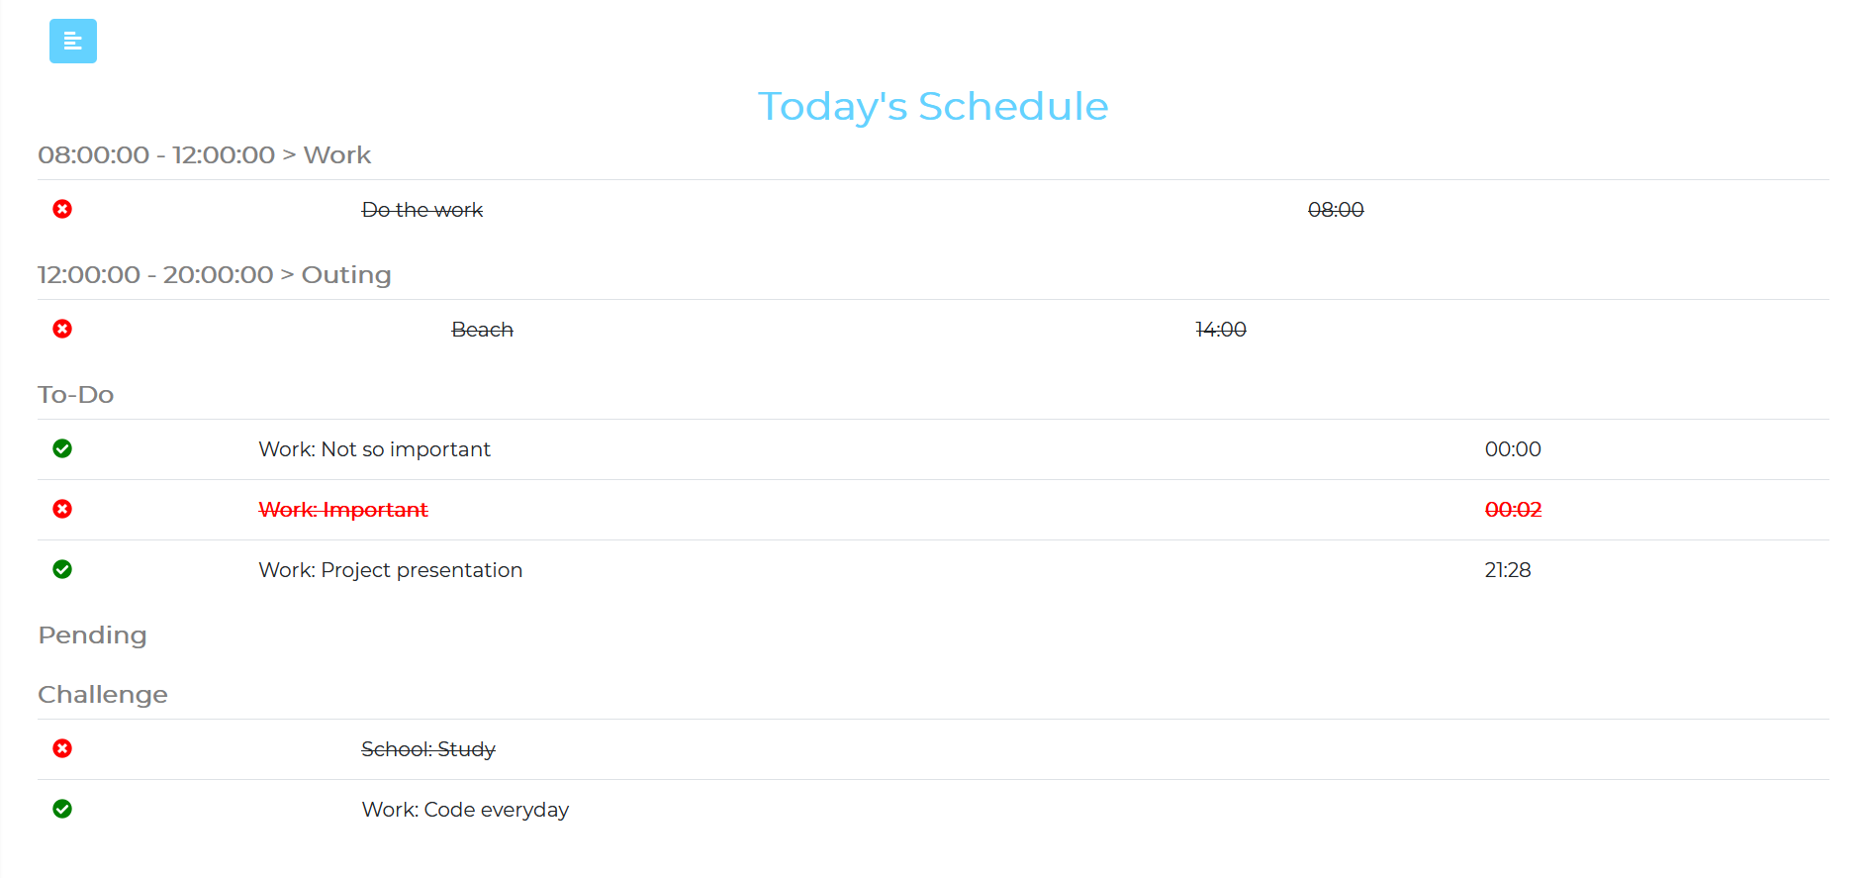Figure 52: User's Manual (Main)

Installation Manual
To install the application, first you will need a server with Apache, PHP and MariaDB. Set up all the server, transfer all the files, set up the database and make the php able to connect to the database.

Or we can register a domain, find a web hosting company, transfer all the files to the web hosting, create and set up the database and connect the files to the database.

After we installed the web application in the hosting or a private server, the users can use a browser and connect to the server and use the application.

Bibliography
Visual Paradigm: “What is Use Case Specification?”, https://www.visual-paradigm.com/guide/use-case/what-is-use-case-specification/
r/x365: “Simple Gantt Template”, https://www.reddit.com/r/excel/comments/axedht/simple_gantt_template/
Stack Exchange Inc.: Stack Overflow, https://stackoverflow.com/
HashiCorp: Vagrant, https://www.vagrantup.com/
The Apache Software Foundation: Apache NetBeans, https://netbeans.apache.org/
Refsnes Data: W3Schools, https://www.w3schools.com/
Fonticons, Inc.: Font Awesome; https://fontawesome.com/
MIT: Bootstrap, https://getbootstrap.com/
The PHP Group: PHP, https://www.php.net/
MariaDB Foundation: MariaDB Server, https://mariadb.org/
The Apache Software Foundation: Apache, https://httpd.apache.org/
Software Freedom Conservancy: Git, https://git-scm.com/
CodePen: CodePen, https://codepen.io/
Lucid Software Inc.: Lucid, https://lucid.app/
Navasard Paul: “Event Calendar Widget”, https://codepen.io/peanav/pen/CfFjl

