
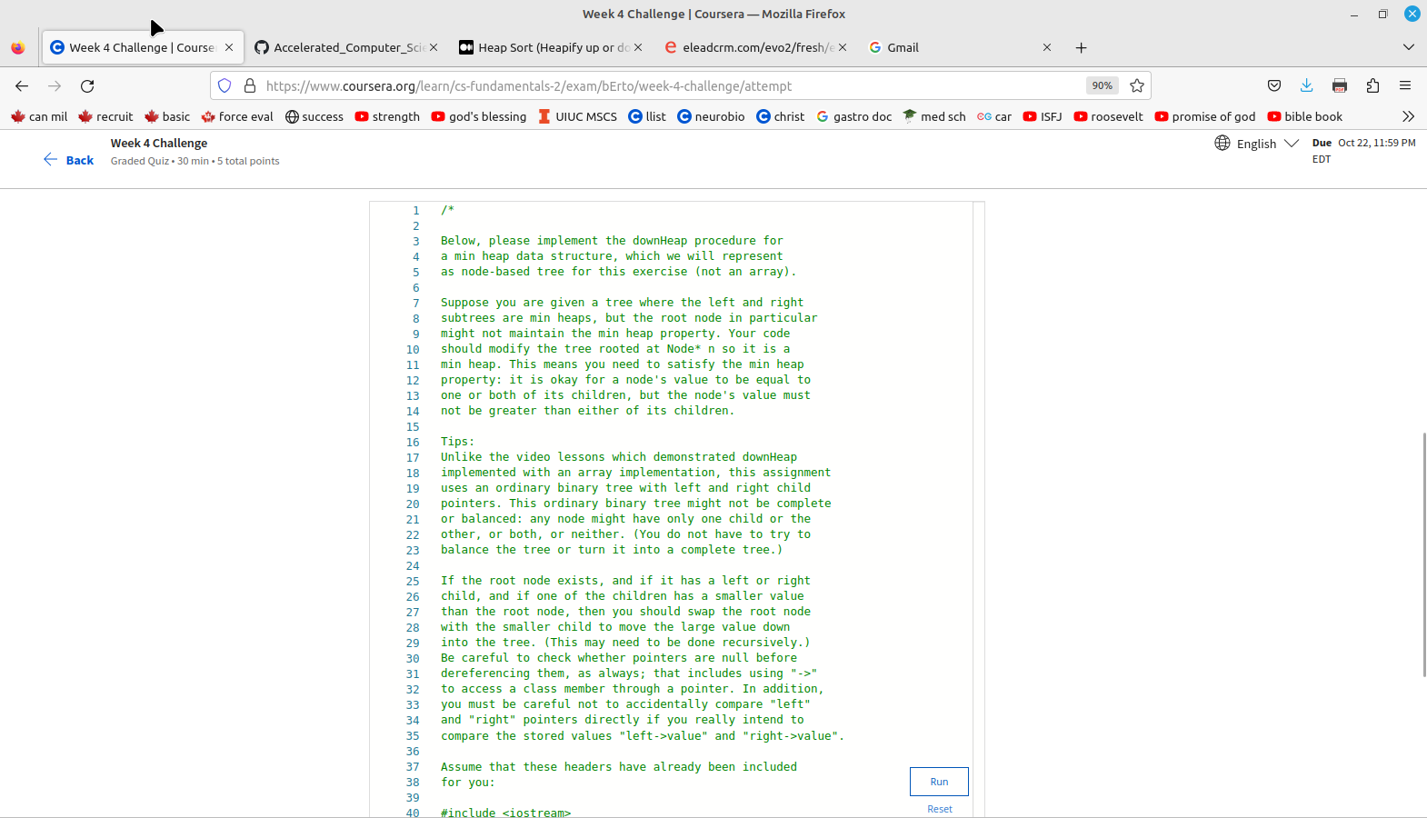

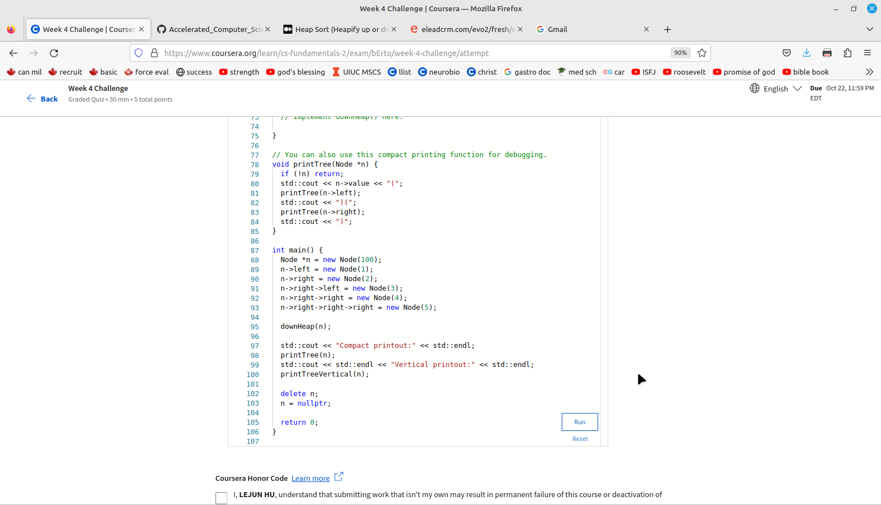
So the data that goes into this tree is:
100 1 2 3 4 5
root is 100
100’s left child is 1
100’s right child is 2
2’s left child is 3
2’s right child is 4
4’s right child is 5

so this looks like the below:
100
1 2
3 4
5
so to make this correct we need to down heapify it:
following the instruction in:
https://devashish-iitg.medium.com/heap-sort-heapify-up-or-down-5fd35adfff39
for downheap, the objective is to put the smallest values at the bottom, and then put the highest value at the top.

The procedure is the following:
start with the first node with a child, this is length(arr)/2-1, which gives 1.

1. starting with element 1 (1), compare with child, there are none, data stays the same,
100 1 2 3 4 5
2. next move to element 0(100), compare with children (1, 2), bigger than both so don’t swap,
100 1 2 3 4 5
3. next we compare element 2 with its children (3 and 4) it’s smaller than both of them, so swap 2 with 4,
100 1 4 3 2 5

top down it looks like:
100
1 4
3 2
5
4. next we compare element (3) with its children, it has none, so don’t bother

5. next we compare element (4) with its children, 5, swap
100
1 4
3 5
2
6.next we compare element (5) with its parent, (4), it’s bigger, so swap
100
1 5
3 4
2

is this even correct? No,

apparently in a downheap the lower keys store a value greater than or equal to its parent’s key.

So let’s try this again:

