
root=pos1
root child=pos2and3
childs 2’s child pos =45
child 3’s child pos=6 and so on


what is a min heap:
A Min Heap Binary Tree is a Binary Tree where the root node has the minimum key in the tree.
The above definition holds true for all sub-trees in the tree. This is called the Min Heap property.
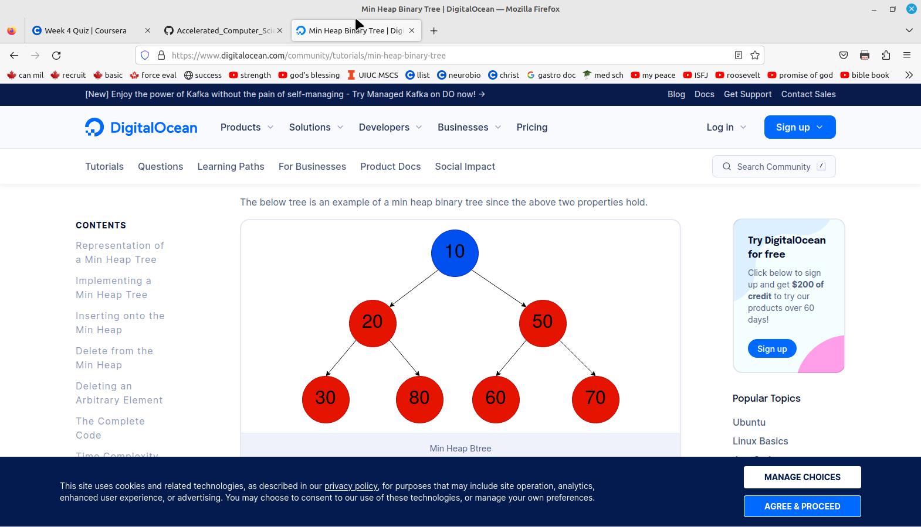
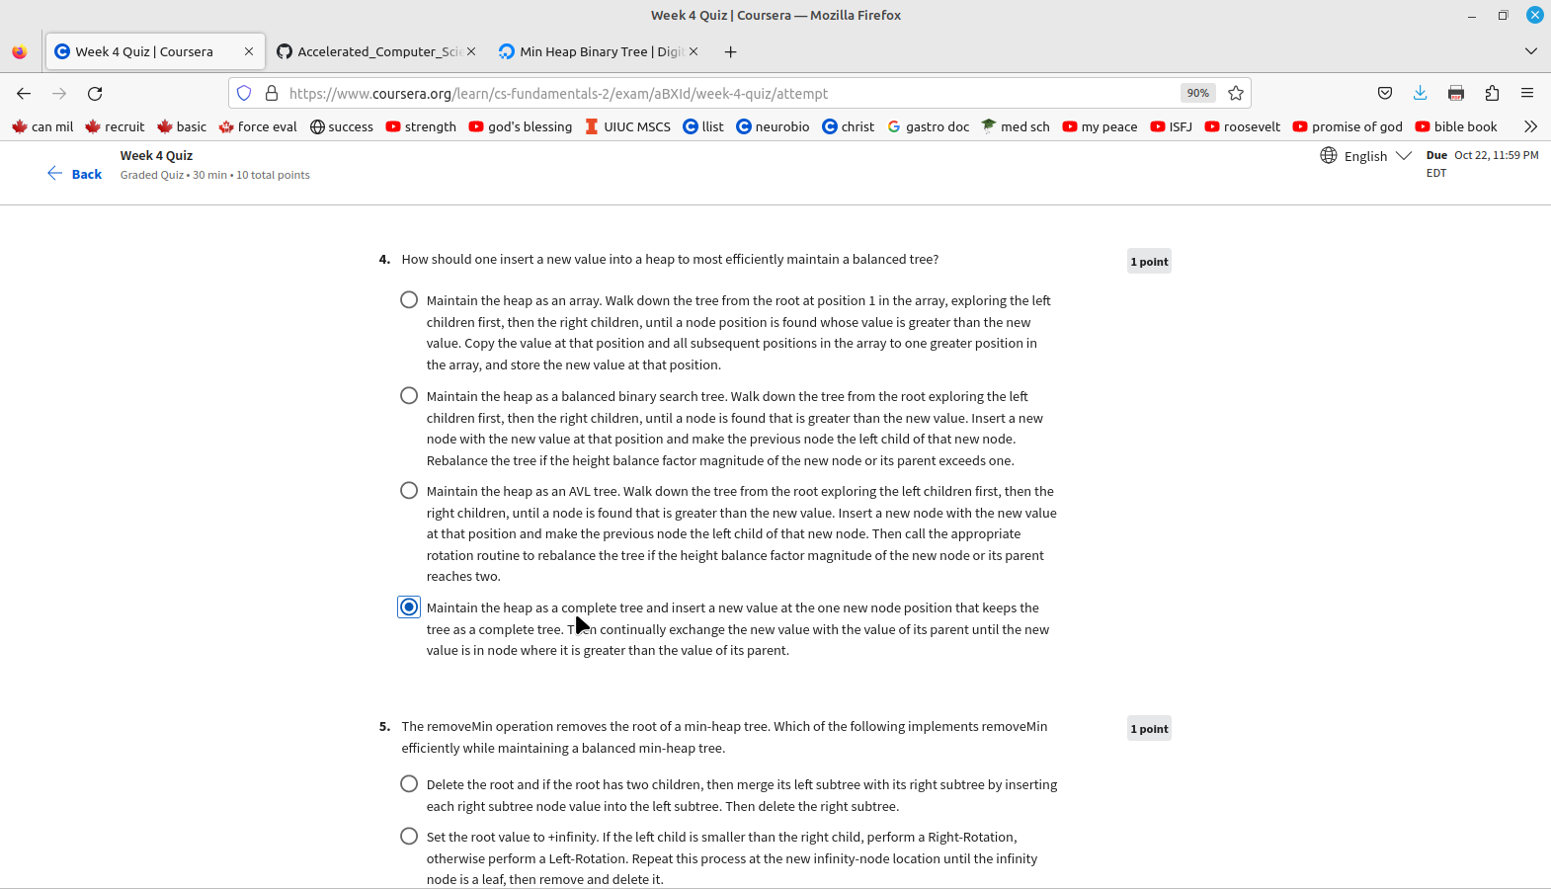

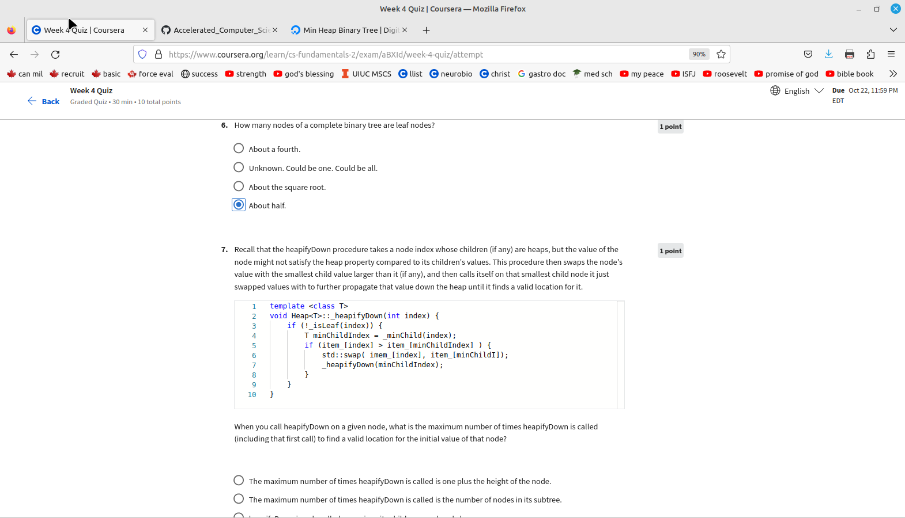
https://devashish-iitg.medium.com/heap-sort-heapify-up-or-down-5fd35adfff39

algos for heapify up or down.

“Thus as we can see that heapify down is much better than heapify up to build the heap in just O(N) time complexity.”

Max-heap: The parent node's value should always be greater than or equal to the child node.
Min-heap: The parent node's value should always be less than or equal to the child node.

