Do monetary aggregates improve inflation forecasting in Switzerland?[1]

October 2023

Jon Tepper, $​^{a}$ Jane Binner, $​^{b}$ and Logan Kelly $​^{c}$

$​^{a}$ Institute, [jtepper@protonmail.com](mailto:jtepper@protonmail.com)

University of Birmingham, [j.m.binner@bham.ac.uk](mailto:j.m.binner@bham.ac.uk)

University of Wisconsin, [logan.kelly@uwrf.edu](mailto:logan.kelly@uwrf.edu)

Abstract

This study examines whether Swiss Divisia aggregates enhance inflation forecasting in Switzerland during economic instabilities using a Multi-recurrent Neural Network. Simply summing monetary stock components can lose dynamic information, potentially explaining why many deem money as having minimal economic relevance. Our findings suggest that combining simple sum, Divisia money measures, and a short-term interest rate optimally predicts Swiss inflation.

**JEL Codes:** C43, C45, C52, C54, E50, E58

**Key Words:** Divisia monetary aggregates, inflation, recurrent neural networks, Swiss monetary policy.

# 1 Introduction

The Swiss National Bank (SNB) is a self-governing central bank that strives to ensure stable prices in different economic circumstances. The SNB characterizes stable prices as an increase in the Swiss Consumer Price Index (CPI) of no more than 2% per year. Sustaining a long-term inflation targeting regime necessitates dependable forecasting; nonetheless, existing discussions cast doubt on the utility of money as a forecasting tool, fueled by empirical research indicating the instability of money demand Hendrickson (2014). The perceived ineffectiveness of monetary aggregates may be attributed to the conventional methodology employed in calculating official monetary aggregate data, utilizing a simple sum index number. A plethora of studies assert that appropriately formulated monetary aggregates do indeed encapsulate pertinent information.[2]

Our research shows that incorporating nonlinear modeling along with the use of both simple sum monetary aggregates (i.e. the portfolio price of the money stock) and Divisia monetary aggregates (i.e. the monetary service provided by the money stock) can significantly enhance the accuracy of long-term inflation forecasts.

# 2 Data Overview

## 2.1 Monetary Aggregates

**M3.** Official monetary aggregets reported by most ceteral bank utilize simple sum index numbers, i.e. they are the portfolio price of a basket of monetary assets. These aggregates have long been criticized as inaccurate measure of both the monetary serves flow (Barnett 2000a, 2000b; Diewert 1976) and the money stock (Kelly 2009). However, the official simple sum aggregates do express the portfolio price of the current stock of monetary aggregates. We utilize the Swiss M3 monetary aggregate in this study.

**Divisia M3.** Divisia M3 measures the flow of monetary services from money holdings by weighting each monetary asset based on expenditure shares, (see Barnett (2000b), Barnett (2000a), Diewert (1976)). Divisia aggregates, rooted in microeconomic aggregation theory, offer an advanced approach considering asset liquidity (see e.g. Kelly, Barnett, and Keating (2011), El-Shaghi and Kelly (2019)).

The data from both M3 and Divisia M3 is composed of component assets of the Swiss National Banks definition of M3 (see Swiss National Bank: Monetary Policy Analysis, Zurich, 1 March 2016) and is sourced monthly from the Swiss National Bank via DataStream. We constructed the Divisia M3 monetary aggregate and its user price dual following methodologies applied to the US economy by the Center for Financial Stability (CFS) in New York, as detailed in Barnett et al. (2013).

## 2.2 Other Macroeconomic DATA

We also utilize the Swiss consumer price index (CPI) as well as the Swiss Franc One-year Deposit Rate. The rationale behind selecting this specific rate was it is one of the only short-term rates consistently availability throughout the entire duration of our sample period, making it a reliable and comprehensive choice for our analysis.

Figure 1 presents the levels of Swiss inflation, the Swiss consumer price index (CPI) and the Swiss monetary aggregates: M3 (Divisia) and M3 (Simple Sum). These data indicate an apparently close link between Divisia M3 and the price level until the mid-1990s and less of any discernible link from the late 1990s, a change that eventually caused the SNB to abandon its use of monetary targeting. The Swiss Franc One-year Deposit Rate is depicted in figure 1 panel D.

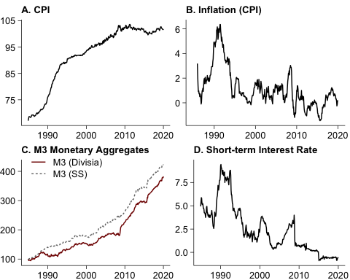

Figure 1: Data used in this study: A. Consumer Price Index (CPI), B. Inflation (Annual Growth Rate of CPI), C. M3 Monetary Aggregates (Divisia and Simple Sum), and D. Swiss Franc One Year Deposit Rate

## 2.3 Unit Root Testing

We test the data for stationarity using the Phillips and Perron unit root tests. We find that all series, i.e. the Swiss consumer price index (CPI) and the Swiss monetary aggregates, and the Swiss Franc One-year Deposit Rate are integrated of order 1.

# 3 Forecasting Framework

This study explores the forecasting relevence of monetary aggregates in the cotext of a nonlinear predictive model, namely a Multi Recurrent Neural Network (MRN), see e.g. (**orojo2021?**) and (**orojo2023?**). We employ various input combinations to assess out-of-sample forecasting and experiment with different variables, evaluating their value as leading indicators of inflation. We also provide results of a Bayesian VAR as a comparison. Table 1 Presents the definitions of each model used.

Table 1: Model Abbreviations and Descriptions

| Mnemonic | Descriptions |
| --- | --- |
| AR | Lags of CPI |
| AR + SFDRTE | Lags of CPI, Short Term Deposit Interest Rate |
| AR + DM3 | Lags of CPI, Divisia M3 Money |
| AR + SSM3 | Lags of CPI, Simple Sum M3 money |
| All Variables | Lags of CPI, Short Term Deposit Interest Rate, Divisia M3 Money, Simple Sum M3 Money |

Building on previous works with MRNs (**ulbricht1994?**; **dorffner1996?**; **elger2006?**; Binner et al. 2010; **tepper2016?**; **orojo2019?**; **orojo2021?**; **orojo2023?**), we utilize an architecture incorporating four levels of feedback and delay, forming a ‘sluggish state space’ and enabling the representation of varying memory rigidity. This architecture, illustrated in Figure 2, has been shown to outperform complex models like LSTMs on volatile time series with fewer parameters (**orojo2019?**); (**orojo2021?**)].

The MRN model can be generalized as:

$$\hat{y}\left(t+τ\right)=g\left(W_{g}\left(t\right)f\left(W_{f}\left(t\right)\left[c\left(t\right),x\left(t\right)\right]\right)\right)$$

where $\hat{y}\left(t+τ\right)$ is the predicted inflation value; $c\left(t\right)$ is the context vector; $x\left(t\right)$ represents input variables; $W_{f}\left(t\right)$ and $W_{g}\left(t\right)$ are the weight matrices; and $f$ and $g$ are activation vectors. The model employs hyperbolic tangent and identity functions for $f$ and $g$ respectively, with the number of hidden units determined by validation set performance.

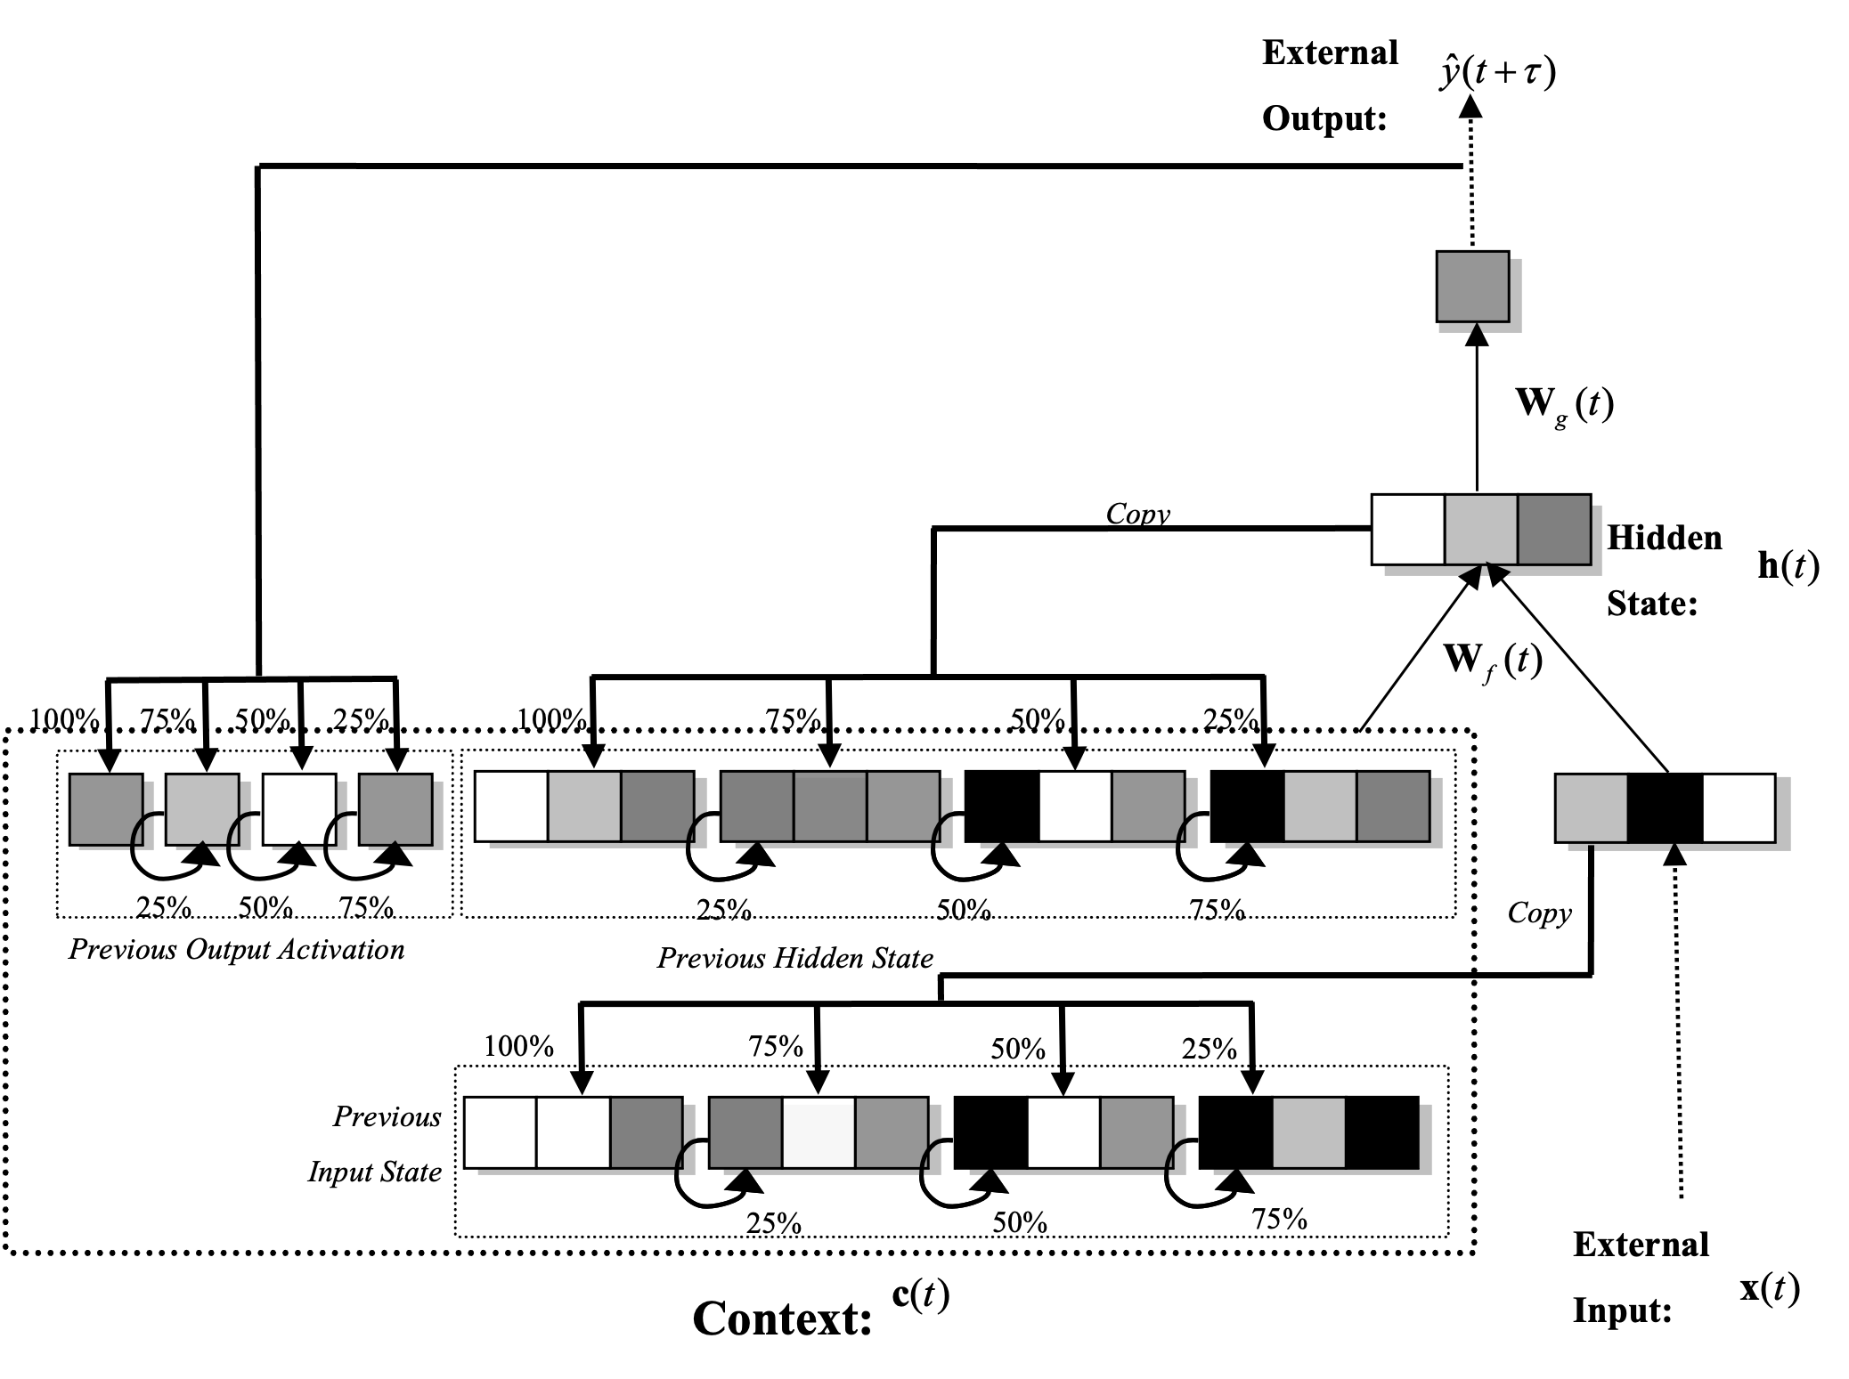

Figure 2: Multi-recurrent Network Architecture

The forecasting power of neural networks is substantiated by several studies (**zhang1998?**; **adya1998?**; Almosova and Andresen 2023). Moreover, (**orojo2023?**) found model we are using in this study to be simpler and superior to current state of the are recurrent nureal networks, such as long short-term memory models for a wide range of forecasting applications.

# 4 Results

The MRN provides superior forecasting performance compared to Bayesian VAR models, especially at longer horizons. The inclusion of both short-term interest rate and both money measures yields the best results. Table 2 presents forecast model comparison using root mean squared error as a metric, and table 3 presents forecast model comparisons using direction of change as a metric.

Table 2: Forecast Model Comparison: Root Mean Squared Error

| h | Method | Autoregressive | Short Term Rate | Divisia Money | Simple Sum | All Variables |
| --- | --- | --- | --- | --- | --- | --- |
| 12 | Bayesian VAR | 1.195 | 1.071 | 1.369 | 1.218 | 1.199 |
|  | Multi Recurrent NN | 0.996 | 1.153 | 0.918 | 1.012 | 0.673 |
| 24 | Bayesian VAR | 1.213 | 1.061 | 1.426 | 1.262 | 1.227 |
|  | Multi Recurrent NN | 0.92 | 0.983 | 1.473 | 0.897 | 0.442 |
| 36 | Bayesian VAR | 1.267 | 1.048 | 1.366 | 1.329 | 1.249 |
|  | Multi Recurrent NN | 1.001 | 2.337 | 1.431 | 0.827 | 0.49 |

Table 3: Forecast Model Comparison: Direction of Change (percent correct)

| h | Method | Autoregressive | Short Term Rate | Divisia Money | Simple Sum | All Variables |
| --- | --- | --- | --- | --- | --- | --- |
| 12 | Bayesian VAR | 53.788 | 49.242 | 46.212 | 56.818 | 56.818 |
|  | Multi Recurrent NN | 55.303 | 64.394 | 61.364 | 56.061 | 79.545 |
| 24 | Bayesian VAR | 36.364 | 37.879 | 37.121 | 36.364 | 36.364 |
|  | Multi Recurrent NN | 39.394 | 54.545 | 46.212 | 36.364 | 85.606 |
| 36 | Bayesian VAR | 43.182 | 42.424 | 55.303 | 42.424 | 46.97 |
|  | Multi Recurrent NN | 57.576 | 40.152 | 38.636 | 40.909 | 81.061 |

MRN outperforms Bayesian VAR across different horizons, with errors over 22 times larger in Bayesian VAR. The addition of Divisia to simple sum always adds value, and MRN predicts the direction of change more accurately.

Both Divisia and simple sum measures are valuable for forecasting inflation due to their divergent correlations in different economic phases. Further research into the interaction of inflation and multiple monetary aggregates is warranted (see (**gogas2013?**) for further evidence). Figures @(h12-fig), @(h24-fig) and @(h36-fig) present actual vs forecasted values of inflation at the 12, 24 and 36 month forecasting horizons.

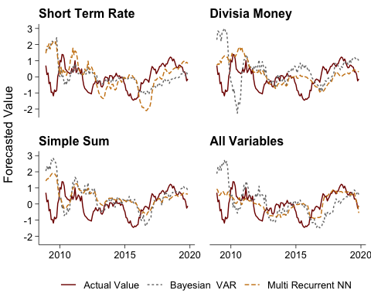

Figure 3: Twelve-Month Ahead Forecast of Inflation by Model and Variable Selection

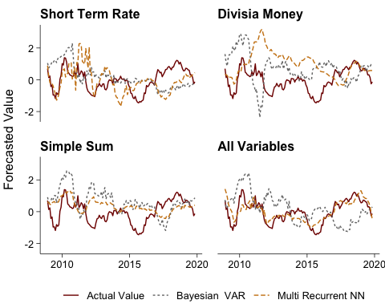

Figure 4: Twenty-Four-Month Ahead Forecast of Inflation by Model and Variable Selection



Figure 5: Thirty-Six-Month Ahead Forecast of Inflation by Model and Variable Selection

# 5 Conclution

In this study, we found that incorporating both simple sum and Divisia monetary aggregates significantly enhances the accuracy of MRN and traditional Bayesian VAR forecasts, particularly in long-run MRN forecasts. The MRN models consistently outperformed Bayesian VAR models due to their non-linear nature and ability to directly use non-stationary series data. The best performing models included CPI, short-term interest rate, and both monetary aggregates, reflecting the divergent correlation of each aggregate with inflation across business cycles, as demonstrated by the behavior of simple sum M3 and Divisia M3.

# References

Almosova, A., and N. Andresen. 2023. “Nonlinear Inflation Forecasting with Recurrent Neural Networks.” *Journal of Forecasting* 42: 240–49.

Barnett, W. A. 2000a. “Economic Monetary Aggregates; an Application of Index Number and Aggregation Theory.” In *The Theory of Monetary Aggregation*, edited by W. A. Barnett and A. Serletis, 11–48. Amsterdam: North Holland.

———. 2000b. “The User Cost of Money.” In *The Theory of Monetary Aggregation*, edited by W. A. Barnett and A. Serletis, 6–10. Amsterdam: North Holland.

Barnett, W. A., J. Liu, R. S. Mattson, and J. van den Noort. 2013. “The New Divisia Aggregates: Design, Construction, and Data Sources.” *Open Economies Review* 24 (1): 101–24.

Belongia, M. T., and P. N. Ireland. 2015. “Interest Rates and Money in the Measurement of Monetary Policy.” *Journal of Business & Economic Statistics* 33 (2): 255–69.

———. 2016. “Money and Output: Friedman and Schwartz Revisited.” *Journal of Money, Credit and Banking* 48 (6): 1223–66.

———. 2022. “Strengthening the Second Pillar: A Greater Role for Money in the ECB’s Strategy.” *Applied Economics* 54: 99–114.

Binner, J. M., S. M. Chaudhry, L. J. Kelly, and J. L. Swofford. 2018. “Risky Monetary Aggregates for the UK and USA.” *Journal of International Money and Finance* 89: 127–38.

Binner, J. M., and L. J. Kelly. 2017. “Modelling Money Shocks in a Small Open Economy: The Case of Taiwan.” *The Manchester School of Economic and Social Studies* 85 (S1): 104–20. <https://doi.org/10.1111/manc.12179>.

Binner, J. M., P. Tino, J. A. Tepper, R. G. Anderson, B. Jones, and G. Kendall. 2010. “Does Money Matter in Inflation Forecasting?” *Physica A, Statistical Mechanics and Its Applications* 389: 4793–4808.

Bissoondeeal, R. K., M. Karaglou, and J. M. Binner. 2019. “Structural Change and the Role of Monetary Aggregates in the u.k.” *Journal of Financial Stability* 42: 100–107.

Diewert, W. E. 1976. “Exact and Superlative Index Numbers.” *Journal of Econometrics* 4 (2): 115–45.

El-Shaghi, M., and L. J. Kelly. 2019. “What Can We Learn from Country Level Liquidity in the EMU?” *Journal of Financial Stability* 42: 75–83.

Hendrickson, J. R. 2014. “Redundancy or Mismeasurement? A Reappraisal of Money.” *Macroeconomic Dynamics* 18 (7): 14371465.

Kelly, L. J. 2009. “The Stock of Money and Why You Should Care?” In *Advances in Econometrics, Measurement Error, Consequences, Applications and Solutions*, edited by J. M. Binner, D. L. Edgerton, and T. Elger, 24:237–50. Emerald Group Publishing Limited.

Kelly, L. J., W. A. Barnett, and J. W. Keating. 2011. “Rethinking the Liquidity Puzzle: Application of a New Measure of the Economic Money Stock.” *Journal of Banking and Finance* 35 (4): 768–74.

Liu, J., and C. J. M. Kool. 2018. “Money and Credit Overhang in the Euro Area.” *Economic Modelling* 68: 622–33.

1. We thank Michael T. Belongia from the University of Mississippi for his invaluable insights and contributions to this research. Dr. Ryan Mattson from the Center for Financial Stability, New York, is acknowledged for constructing the Swiss Divisia Monetary Aggregates Measures. The opinions in this paper are the authors’ and don’t reflect the official stance of the Swiss National Bank. All errors are the authors’ responsibility.
2. see e.g. Binner et al. (2018), Binner and Kelly (2017), Binner et al. (2010), Belongia and Ireland (2022), Belongia and Ireland (2016), Belongia and Ireland (2015), Liu and Kool (2018), and Bissoondeeal, Karaglou, and Binner (2019)