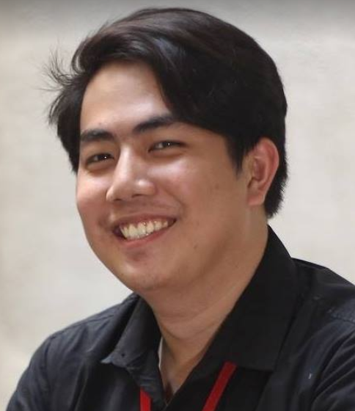
Samuel gabrielle malijan
Aspiring Programmer and filled with determination! Always ready to learn new things!

E-mail: samgabriel_malijan@yahoo.com
Cellphone Number: 09275340900

Objective:

To join an organization that will help me grow as a person, a programmer and possible more, and in turn, give back to the company that nurtured me.

Skills:
Proficient mainly in PHP, MySQL, Java, and developing Android Applications in Android Studio. Has basic knowledge of Python. I have had some experience in integrating applications, such as Google Drive into an application. I mainly do backend for the projects that I am in. Always willing to be trained!

Education

de la salle university
Bachelor of Science degree in Computer Studies, Major in Information Technology, Tentative Date: October 2019.

Don bosco technical institute makati
High School Diploma, March 2014. Awards: Best Photography Member of the Year, 2014;

Co-Curricular Activities:
2018-Current PROGRAMMING HEAD OF ARCHERS NETWORK
Currently managing changes with regards of handling reports and standardizing the process of making reports and planning to make training interns more efficient so they get to learn the things that Programming Department does faster. Managing, Maintaining and Updating the website with a team of skilled individuals that meets the needs of Archers Network.

2017-2018 Research and development DEPARTMENT chair OF THE BATCH GOVERNMENT OF COMPUTER STUDIES
Interviewed several students about the eating area policy in Gokongwei, researched about the psychology of eating isolated and with friends, as well as eating while working and made an entire report with substantiated arguments and properly used evidence to help the Legislative Assembly representative make a case during the handbook revisions.

