**Calling Tree Command**

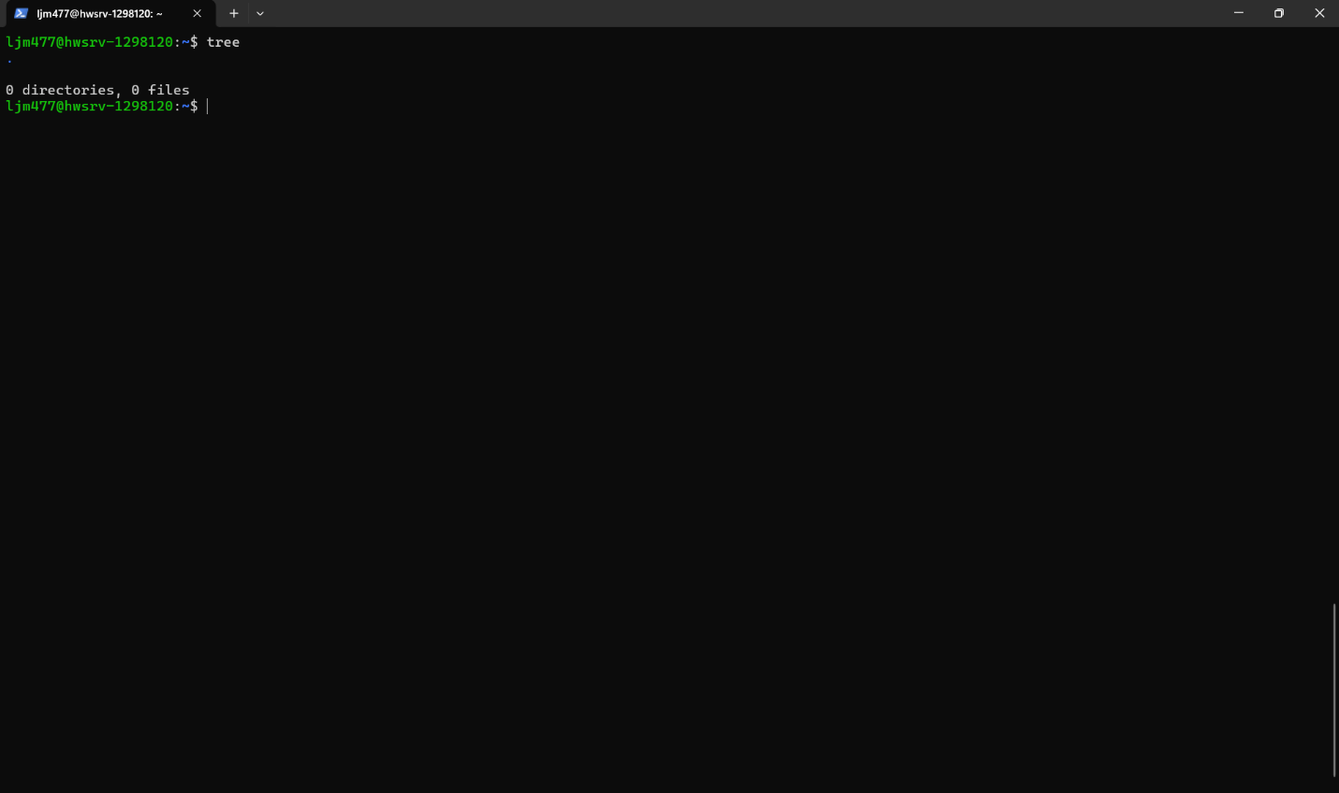

This is a screenshot of me calling the tree command that I previously installed using sudo. After giving myself sudo permissions I was able to install packages from my personal user instead of root.

**Calling id -nG Command**

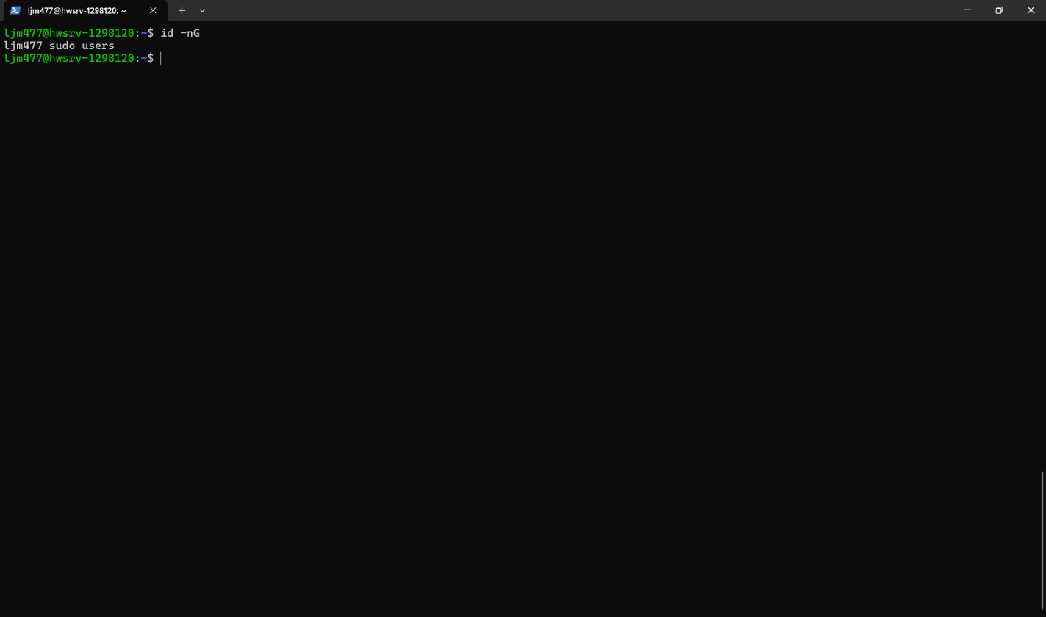

This is a screenshot of me checking what group I’m in and it shows that I’m in the users and sudo group. I added myself to the sudo group from the root user, and I got put into the users group when I created my personal user from the root user.