Abstract: Report documents fuzzy-inference-system (fis) implementations, the first system generated through trial and error approach based on initial assumptions following consultation of medical guidelines, explores various iterations of input/output variables (and their results), membership-function types, parameters, rules connecting them and operators governing them.

The final system is built from an informed stand-point, exploring improved combination of linguistic terms, comprehensive rule-set, range of defuzzification methods, weightings/results in a system capable of producing more comprehensible, useful plateaus of diagnosis in output plots as opposed to excessive curve/blurred diagnosis.

Introduction: Systems of medical diagnosis should be robust, error-free, informative as possible without false diagnosis or alarm. Fuzzy-systems herein place importance on accuracy of input/output based on real-world parameters. Using the Shiny library it is possible to trial effectiveness of membership functions, overlaps, rules connecting input/outputs, clearly visualising evaluation of a system. Personally this appeared to be the most effective approach to modelling the initial system.

Method: Determined by the coursework task, but the particular approach used here is to iterate an initial series of systems based on observations of the system’s behaviour (expectations vs outcomes), to alter the system in the required fashion and repeat evaluative iterations. Finally the knowledge gained from this process is used reflectively to produce the system most suited to the task.

Test 1
Parameters: appendix 10

Code: appendix 1

Expected: Correct diagnosis of the three states identified in rules

Outcome: Three diagnoses were made correctly in the given constraints, however there are obvious flaws with the use of non-overlapping trapezoidal membership functions, particularly given the following profiles as, whilst they do allow one to infer the degree to which a value embodies a particular input variable for instance ‘mid’ is reflected by a true mid-point, on the other hand this makes defuzzification weaker resulting in tentative diagnosis.
Test 2
Aim: To visualise the difference between trap and gauss and gauge appropriateness for temperature variable

Code = appendix 2

Expected: Some degree of grey area between temperature variables, but uncertain as to whether this will provide useful output or not.

Outcome: With the range for optimal human body temperature being narrow approximately 37c, the Gaussian curves pose difficulties in that they are not easily sculpt-able, this is somewhat tantalising as they could plausibly be used to great effect, but the fuzzyR library appears to be somewhat inflexible regarding the parabolic profile. Asymmetry could be useful here, as could nodes along the curve with convex or concave features not unlike the profile of an Indian arch (see illustrated).

Illustration 1: Curve profile

This would allow a median to be embodied as a particular value in the actual curve, and for the accentuation of portions of the curve within the fuzzy inference system.
Test 3
Aim: Revert Temperature variable to trapezoidal (retaining non-overlaps temporarily whilst exploring new linguistic variables in headache severity), with crisp sets as the healthy temperature range is narrow, and this seems to be a categorically ‘clear cut’ measurement (however will consider marginal overlap in later tests to reduce risk of catching unwanted borderline cases). Improve severity verbal rating system with the addition of linguistic variables ‘above average’ and ‘excruciating’ and trial as Gaussian.

Code: appendix 3

Expected: Greater level of detail in absorption of patient verbal responses allowing for imposition of more rules and possible diagnoses.

Outcome: Aesthetically Gaussian membership functions are more pleasing for a spectrum of linguistic variables such as this. There is no reason why this scale has to be anything other than linear as we are measuring increasing severity, so organising it like this makes it more manageable numerically and visually see Fig.2.
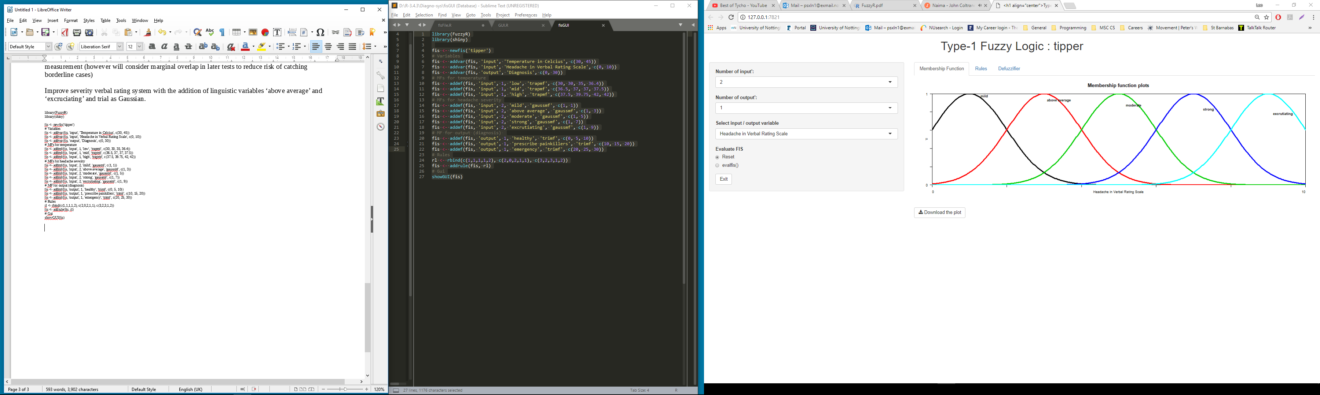Illustration 2

Evaluation: The verbal rating scale appeared to be a valid medical method for headache measurement from the brief research carried out apropos diagnosis. The standard deviation of verbal rating plots appears to be too wide, this could perhaps be reduced in the next test.
The extreme membership functions (mild and excruciating) need to be corrected as they should begin and end at 1-membership respectively. Diagnosis mfs are at risk of being too minimal for the fis to be a useful tool, adding three severity bands to the high mf e.g. some danger, serious risk, critical emergency, seems to be an effective traffic light system (clear/not overly complex).

Test 4
Changes from last test’s findings were implemented, retention of narrow peak for the mid-point of optimal body temperature (manipulation of other trapmf’s with gradings for higher risk categories) were added, this is useful as it provides a ‘tipping point’ for the system, it would be appropriate to shelve steeply into the next membership function, in this case being ‘high temperature(some danger)’, non-overlaps in temperature retained to aid debugging.

Code: appendix 4

Expected: Improvements in the polar extremes of headache severity membership, clearer characterisation of the middle three severity categories.

Result: Improvements to membership functions discussed above apposite. Crispness is questionable with lower temperatures, plural memberships could plausibly aid judgement of borderline cases considering them in conjunction with headache. Optimum body temperature is narrow, but within that range there is scope for erroneous results (even within clinical scenarios), so overlap will be experimented with in next test with rules and diagnosis performance resulting from varied inputs.

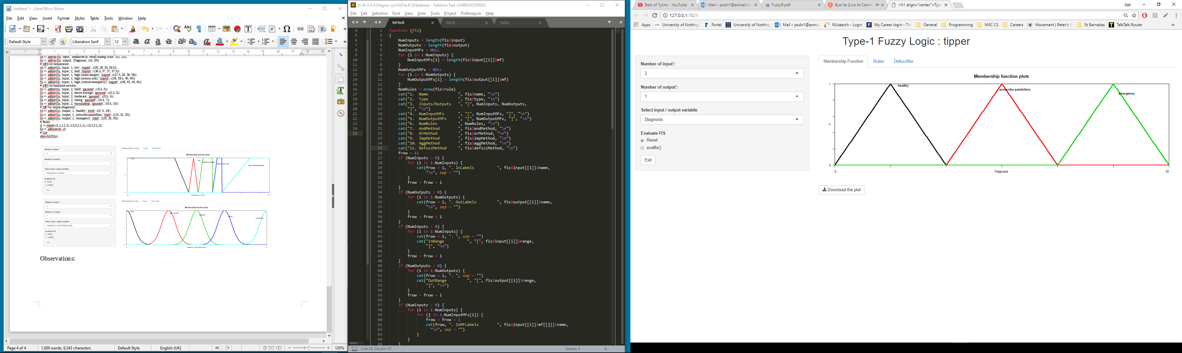

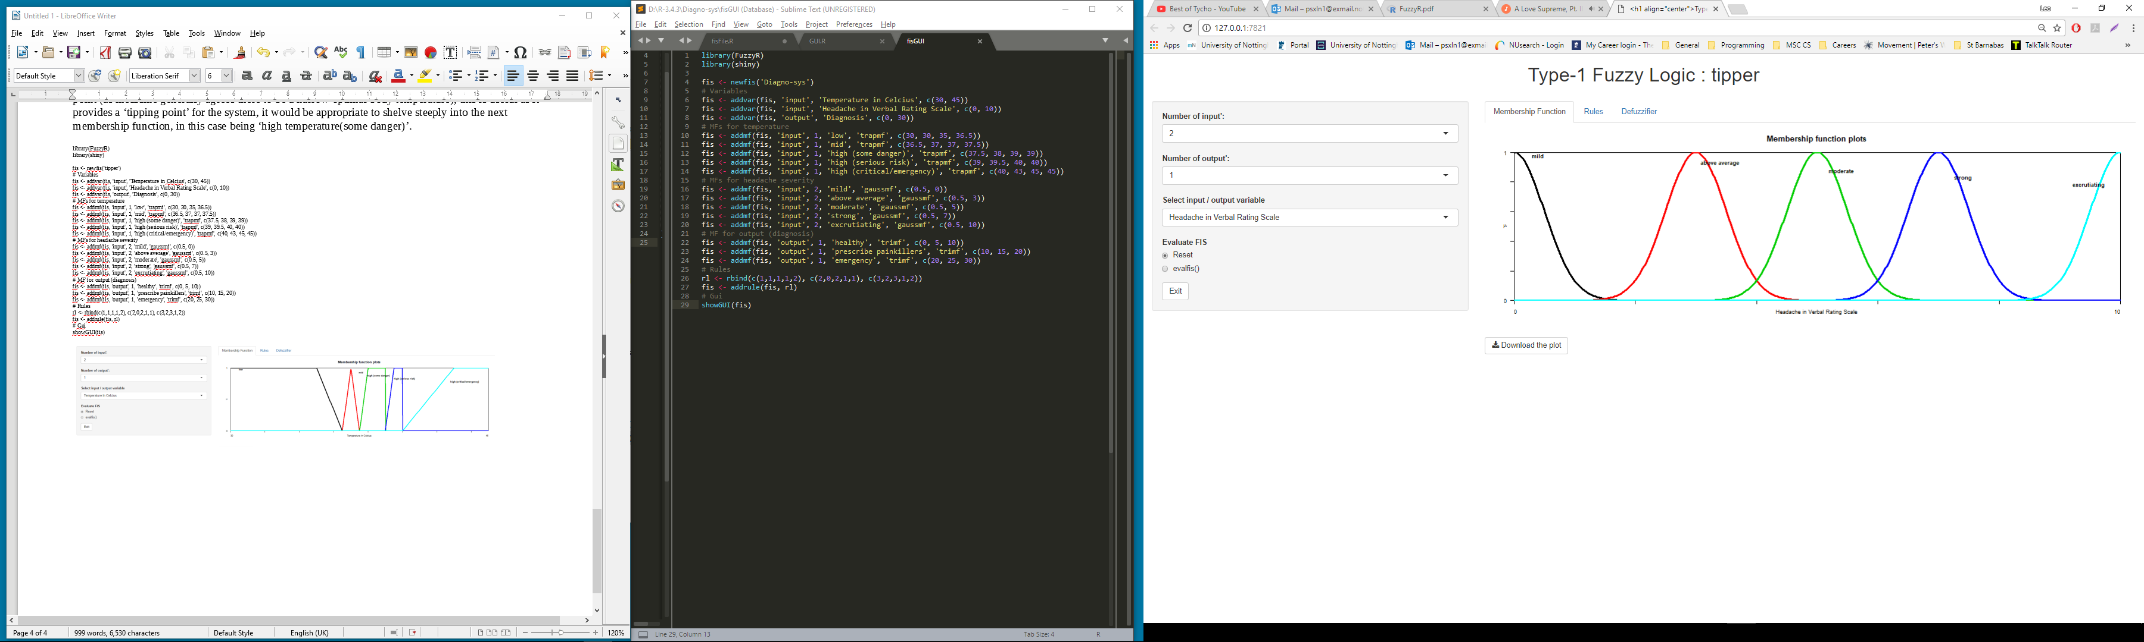

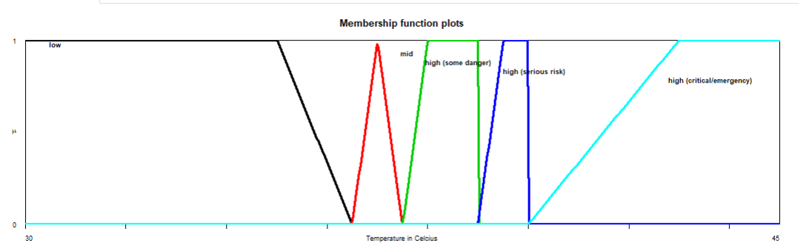Illustration 4

Test 5
Aim: Fully evaluate fis using the following basic rules (to be made more comprehensive of the array of linguistic variables following test findings):

Code: appendix 4

Expected: Correct, albeit limited diagnoses providing opportunity to tune system and develop comprehensive set of rules.

Result: When Celsius or headache variables are changed throughout their range whilst their one of the pair is set to zero the inference system remains unaffected e.g. healthy (unwanted).

When Celsius or headache variables are changed throughout their range whilst one of the pair is set to zero the inference system remains unaffected e.g. healthy (unwanted).

If both variables are set to a mid-point e.g. Celsius approximately 37 (normal healthy range) and headache moderate, fis is currently giving sensible result (prescribe painkillers). As predicted there is a sudden tipping point when healthy temperature range is exceeded e.g. 37.5, resulting in an emergency diagnosis. It is possible that excessive linguistic variables concerning diagnosis in a triage system such as this could create unnecessary convolution, so it is ‘better to be safe than sorry’ concerning the higher temperature ranges: in this particular context the fis appears to be satisfactory.

When body temperature is low but the headache is excruciating we are receiving a healthy reading when a patient is ostensibly not healthy, this necessitates addition of a rule that excruciating headache should always be cause for concern.

Similarly (when headache is within low bounds) the upper Celsius are problematic, when 39 is exceeded the diagnosis reverts back to healthy, hence rule alterations encompassing the ‘serious risk’ and ‘critical emergency categories’ are required.

Test 6

Aim: Further tune system based on previous iteration

Code: appendix 5

Expected: Enhanced performance and accuracy in diagnosis

Result: Observations in support of current fis setup:
Whilst body temperature is within normal parameters the headache verbal rating scale works correctly i.e. prescribes painkillers for a headache and reports an excruciating headache as an emergency.

Observations contrary to current fis setup:
The emergency diagnosis is too aggressive and is diagnosing an emergency for headaches below the moderate bound when temperature is anywhere above ‘mid’.
Test 7

Added the following rule: 6. If (Temperature in Celsius is high (some danger)) and (Headache in Verbal Rating Scale is above average) then (Diagnosis is prescribe painkillers) (1)

Aim: Rectify emergency diagnosis fault.

Expected: Correct diagnosis for painkiller prescription within aforementioned parameters

Result: This alteration provides a favourable transition for borderline cases with a tight-enough tipping point to catch the transition into more dangerous upper bounds, softening the prior propensity of the emergency diagnosis onset.

Third level of high risk categories has been removed as has become redundant.
The system now works in principle excepting some bugs:
-Painkillers not being prescribed throughout headache range when temperature is low.
-Painkillers not being prescribed for mild headaches (considering keeping this as encouragement for people not to damage their vital organs with unnecessary use of painkillers).
-Membership functions for temperature are ineffective in ‘low’-`high(some danger)’ range due to lack of overlap/saturation. This will be rectified and tested whilst keeping the headache rating at a 0 constant.

Test 8

Aims: Refine diagnoses with further rules and revised overlaps of variables in membership functions
Illustration 5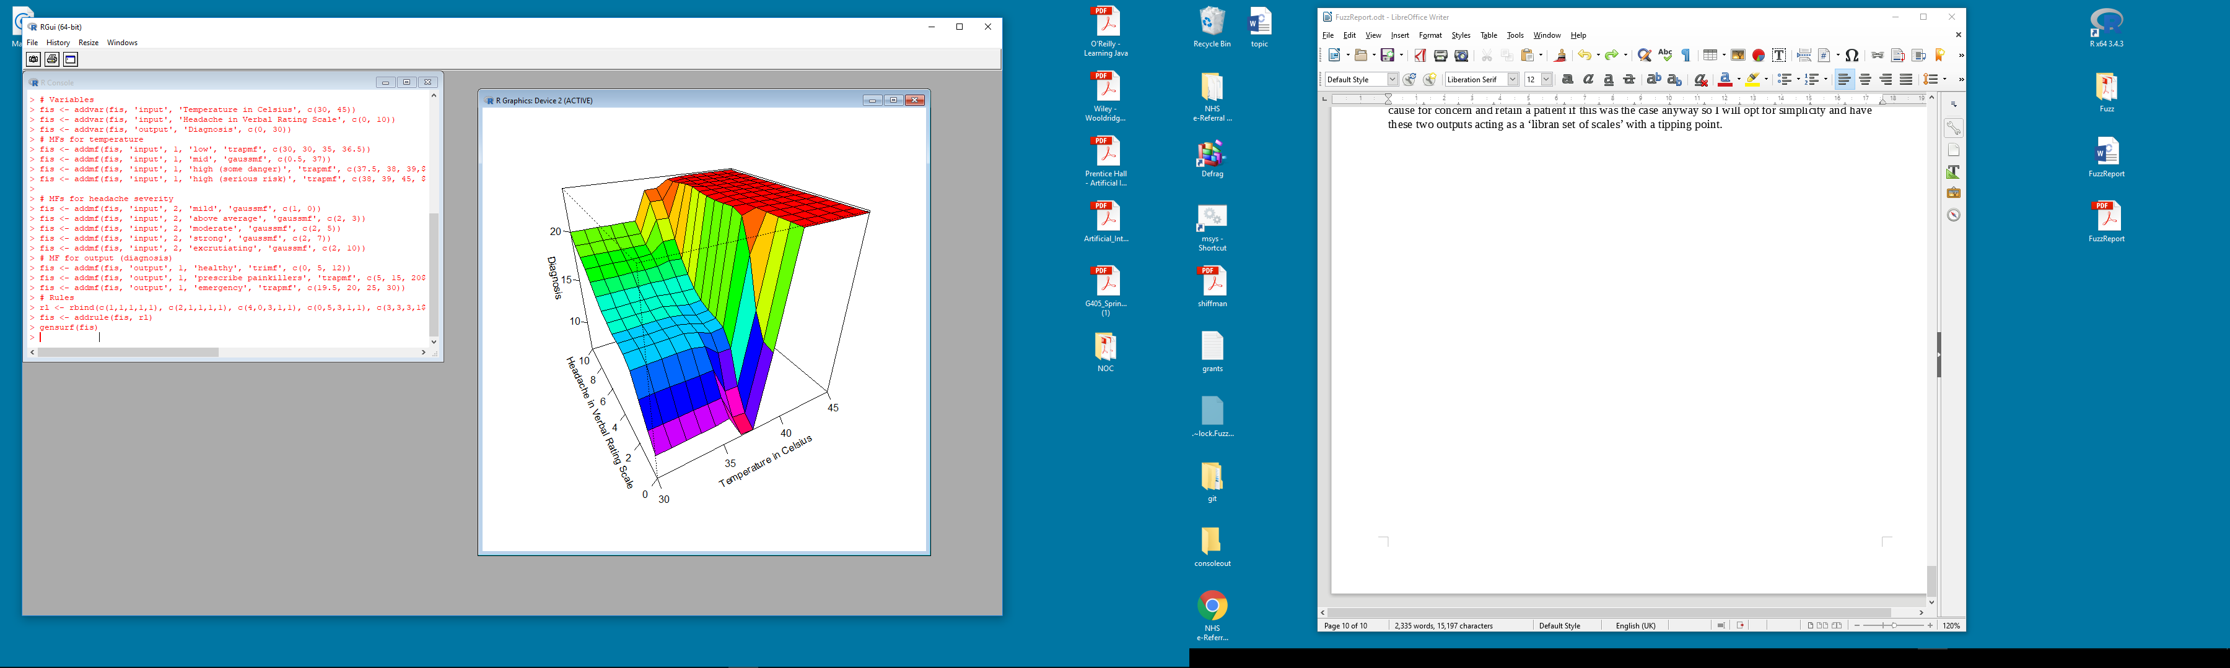

Code: appendix 6

Additional rules: (appendix 9)

Expected: Better visualisation of the grey area between diagnoses and aspects of input variables, fully functional system free from erroneous results.

Evaluation of final test in sequence: Slightly anomalous behaviour when there is no headache e.g. 0 and the temperature begins to encroach into dangerously high territory e.g. over 39, the fis appears to have a foot in either diagnosis i.e. healthy and emergency see below.

Could be mitigated with another output variable e.g. ‘examination’, but it seems that this could be inferred from the fact that the system is intimating tmay be cause for emergency, a medical professional would have to interpret any doubt as a cause for concern and retain a patient.

As can be seen from the 3d plot above, this fis does shelve very sharply into the emergency category. Whilst the above system works, the diagnoses are limited, the headache types are vague and the temperatures leave the important mid-point too narrow.

Test 9
Aim: Completely rebuild diagnosis output variables, rule system and input variables to combat former weaknesses.

Code: appendix 7

Alternative approach: As can be seen in the code, the temperature range incorporates additional upper and lower percentiles of ‘healthy’ temperature, headaches ratings now encompass other identifiable symptoms e.g. meningitis (stiff neck), diagnoses now incorporate extremes of temperature e.g. hypothermic, diagnoses also allow an overlap of healthy and conditional discharge (e.g. requiring follow up/special precautions). The new rules list is completely reworked and has weightings.

Rules used: (see appendix 8)

Defuzzification: To analyse the most appropriate defuzzification technique I tried a selection and compared them using 3d plots (gensurf), mean of maxima was deemed to be the best:

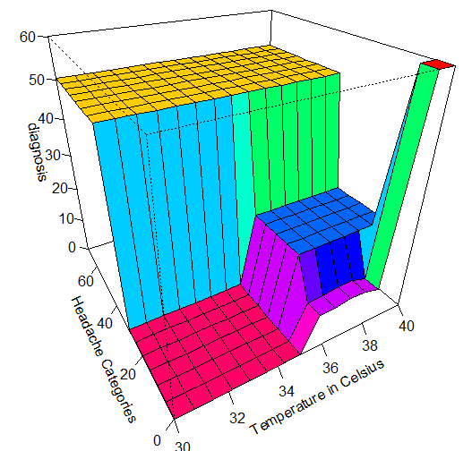
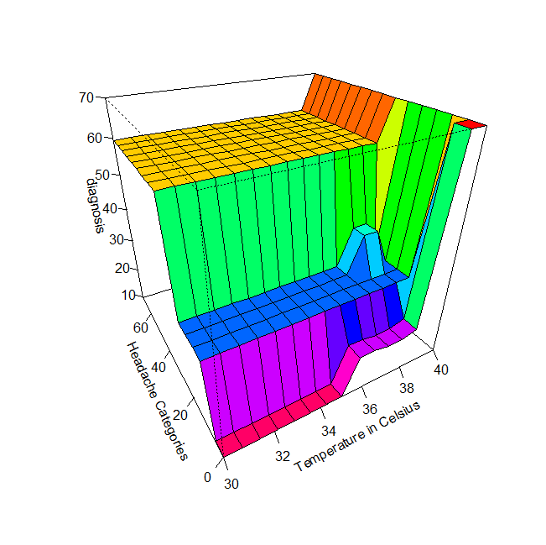

First of maxima (som): Overly saturates diagnoses, removing some of the subtlety from the system.
LOM: An improvement on SOM as we have an extra plateau of diagnosis, and no clipping of upper temperatures.

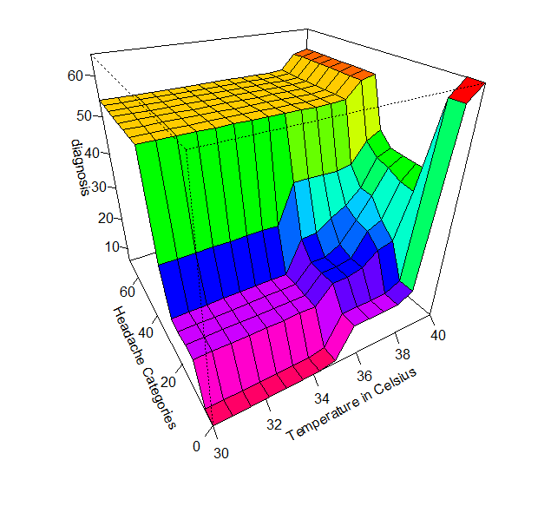
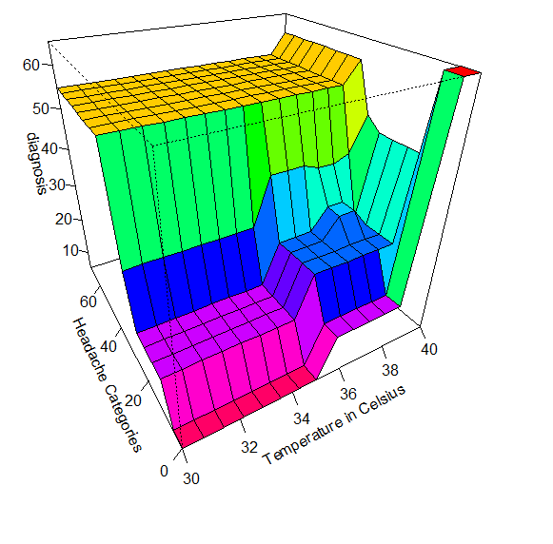

Centroid: Much more blended transition between diagnoses in the crucial ‘tipping point’ area above 37c.
MOM (Selected as optimal for the final fis): Similar behaviour to centroid, with more quantization towards plateaus of diagnosis. We can see the most important tiered plateaus across value ranges and satisfactory diagnoses.

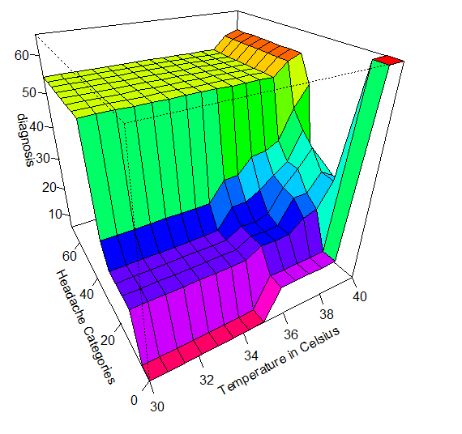

Bisector: Similar behaviour to centroid, less favourable due to loss of upper temperature range.

Evaluation: Performance gains resulted from non-overlapping headache categories, deciding instead to treat the scale non-linearly, favouring more accurate medical terminology useful to diagnoses. This does abuse fuzzyR’s intended use slightly but to me it seems an acceptable adaptation.

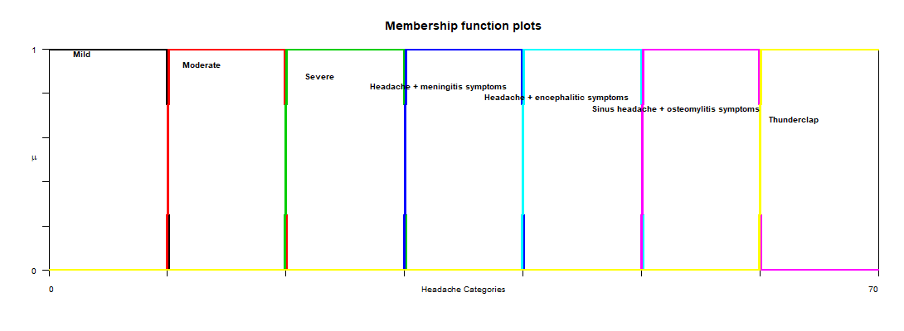
What reason is there for these linguistic variables to overlap? They reflect a diagnosis and are mutually exclusive. The symptoms of the four additional categories are easily identifiable and make this system far more effective.

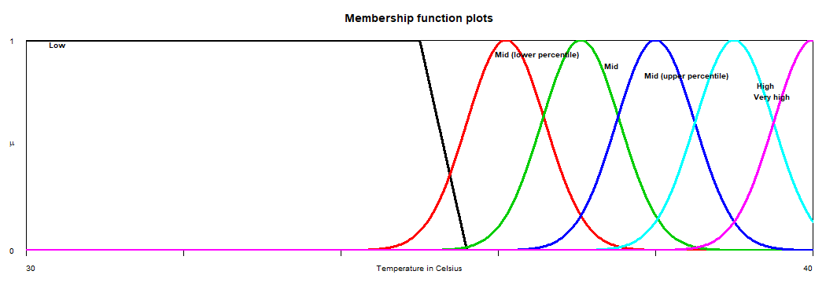

The left plot shows the refined temperature input: expansion of the mid-range with upper and lower percentiles making both comprehension and inference much easier to program.

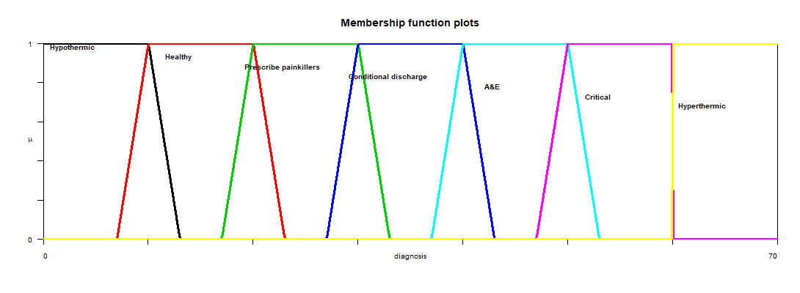
As the output plots illustrate, there is incorporation of ‘fuzziness’ for diagnoses, with the obvious performance gain of a fuller range of situations identifiable. Each range precedes and proceeds its actual domain as a safeguard/buffer, enabling diagnosis to be exact where most likely and possibly inferred if otherwise.

As the fis evaluation below shows, a patient can be identified as both healthy and in need of painkillers when headache is ‘moderate’ and temperature is ‘mid’, with the weighting and diagnosis indicating painkillers can be administered.

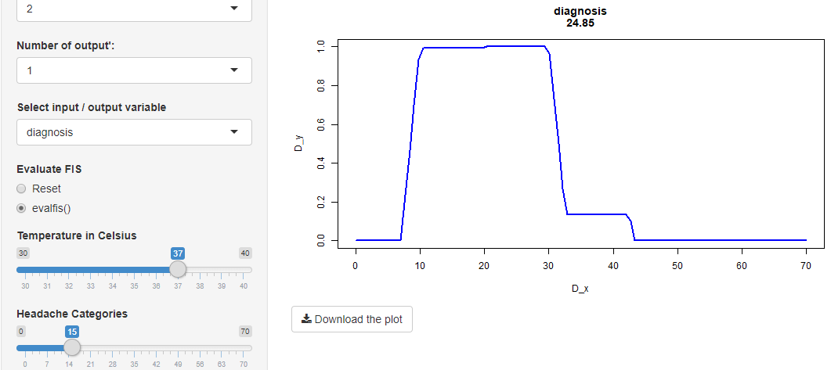

Conclusion: My findings indicate that for concrete variables such as temperature, Gaussian curves work well providing there is enough granularity for accurate reading of target areas within the domain. For more subjective elements that are not necessarily linear e.g. headache symptoms fuzziness is not useful as it is better to correctly pigeon-hole although mild/moderate/severe could conceivably be blended. More outputs have given the final system much wider applicability and arguably make it more useful/intelligent. The greatest difference comes from the accuracy of headaches with accompanying symptoms that can be flagged critical, which to me is the essence of a system like this in terms of usefulness.

There is some slight abuse of the fuzzyR package, obviously my final system (unlike previous iterations) would not evaluate down to one number that could be interpreted, instead the GUI evaluation provides the visual feedback regarding membership, this is because my outputs are non-linear. It is somewhat beyond the scope of the educational material we have been provided to program R to interpret plural memberships in this way, although I’m sure this could be achieved relatively easily so that the diagnosis number is reflective of the most preferable within a non-linear hierarchy so that both hyper/hypo-thermic could overlap with healthy.

I would do this by using higher dimensions of plot visualisation:
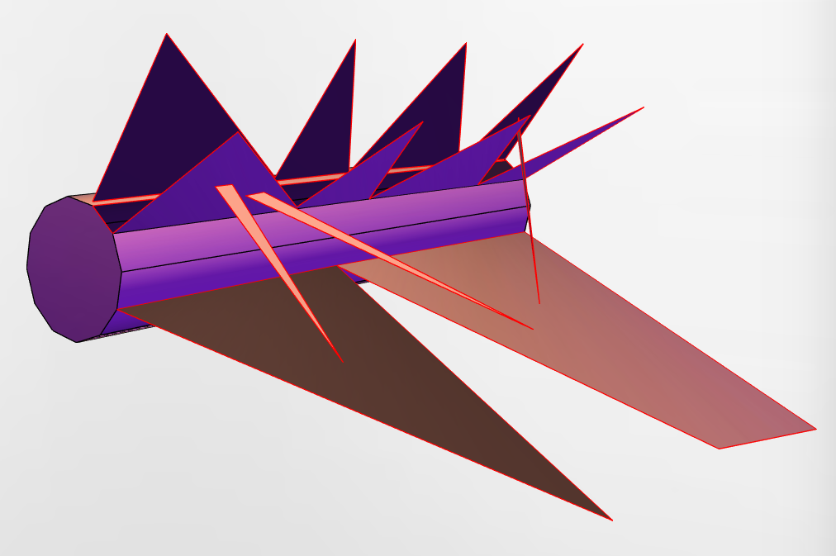

Output plot

Input1 plot

Input 2 plot

Overlap stents

This method would open new dimensions for membership functions and allow separate plots to have overlaps or reference each other, like overlaying graphs without losing the comprehensibility.

Furthermore, if fuzzyR had functionality to do some amount of programming within rbind(), even just operators/comparators, it would significantly reduce the amount of rule writing necessary to make a fis and save a considerable amount of time.

Appendix

1.

library(FuzzyR)
library(shiny)

fis <- newfis('Diagno-sys)
# Variables
fis <- addvar(fis, 'input', 'Temperature in Celcius', c(30, 45))
fis <- addvar(fis, 'input', 'Headache in Verbal Rating Scale', c(0, 10))
fis <- addvar(fis, 'output', 'Diagnosis', c(0, 30))
# MFs for temperature
fis <- addmf(fis, 'input', 1, 'low', 'trapmf', c(30, 30, 35, 36.4))
fis <- addmf(fis, 'input', 1, 'mid', 'trapmf', c(36.5, 37, 37, 37.5))
fis <- addmf(fis, 'input', 1, 'high', 'trapmf', c(37.5, 39.75, 42, 42))
# MFs for headache severity
fis <- addmf(fis, 'input', 2, 'mild', 'trapmf', c(0, 0, 1, 3))
fis <- addmf(fis, 'input', 2, 'moderate', 'trapmf', c(3, 5, 5, 6))
fis <- addmf(fis, 'input', 2, 'strong', 'trapmf', c(7, 9, 10, 10))
# MF for output (diagnosis)
fis <- addmf(fis, 'output', 1, 'healthy', 'trimf', c(0, 5, 10))
fis <- addmf(fis, 'output', 1, 'prescribe painkillers', 'trimf', c(10, 15, 20))
fis <- addmf(fis, 'output', 1, 'emergency', 'trimf', c(20, 25, 30))
# Rules
rl <- rbind(c(1,1,1,1,2), c(2,0,2,1,1), c(3,2,3,1,2))
fis <- addrule(fis, rl)
# Gui
showGUI(fis)

2.

library(FuzzyR)
library(shiny)

fis <- newfis('tipper')
# Variables
fis <- addvar(fis, 'input', 'Temperature in Celcius', c(30, 45))
fis <- addvar(fis, 'input', 'Headache in Verbal Rating Scale', c(0, 10))
fis <- addvar(fis, 'output', 'Diagnosis', c(0, 30))
# MFs for temperature
fis <- addmf(fis, 'input', 1, 'low', 'gaussmf', c(3, 30))
fis <- addmf(fis, 'input', 1, 'mid', 'gaussmf', c(0.5, 37, 1))
fis <- addmf(fis, 'input', 1, 'high', 'gaussmf', c(1, 38))
# MFs for headache severity
fis <- addmf(fis, 'input', 2, 'mild', 'trapmf', c(0, 0, 1, 3))
fis <- addmf(fis, 'input', 2, 'moderate', 'trapmf', c(3, 5, 5, 6))
fis <- addmf(fis, 'input', 2, 'strong', 'trapmf', c(7, 9, 10, 10))
# MF for output (diagnosis)
fis <- addmf(fis, 'output', 1, 'healthy', 'trimf', c(0, 5, 10))
fis <- addmf(fis, 'output', 1, 'prescribe painkillers', 'trimf', c(10, 15, 20))
fis <- addmf(fis, 'output', 1, 'emergency', 'trimf', c(20, 25, 30))
# Rules
rl <- rbind(c(1,1,1,1,2), c(2,0,2,1,1), c(3,2,3,1,2))
fis <- addrule(fis, rl)
# Gui
showGUI(fis)

3.

library(FuzzyR)
library(shiny)

fis <- newfis('tipper')
# Variables
fis <- addvar(fis, 'input', 'Temperature in Celcius', c(30, 45))
fis <- addvar(fis, 'input', 'Headache in Verbal Rating Scale', c(0, 10))
fis <- addvar(fis, 'output', 'Diagnosis', c(0, 30))
# MFs for temperature
fis <- addmf(fis, 'input', 1, 'low', 'trapmf', c(30, 30, 35, 36.4))
fis <- addmf(fis, 'input', 1, 'mid', 'trapmf', c(36.5, 37, 37, 37.5))
fis <- addmf(fis, 'input', 1, 'high', 'trapmf', c(37.5, 39.75, 42, 42))
# MFs for headache severity
fis <- addmf(fis, 'input', 2, 'mild', 'gaussmf', c(1, 1))
fis <- addmf(fis, 'input', 2, 'above average', 'gaussmf', c(1, 3))
fis <- addmf(fis, 'input', 2, 'moderate', 'gaussmf', c(1, 5))
fis <- addmf(fis, 'input', 2, 'strong', 'gaussmf', c(1, 7))
fis <- addmf(fis, 'input', 2, 'excrutiating', 'gaussmf', c(1, 9))
# MF for output (diagnosis)
fis <- addmf(fis, 'output', 1, 'healthy', 'trimf', c(0, 5, 10))
fis <- addmf(fis, 'output', 1, 'prescribe painkillers', 'trimf', c(10, 15, 20))
fis <- addmf(fis, 'output', 1, 'emergency', 'trimf', c(20, 25, 30))
# Rules
rl <- rbind(c(1,1,1,1,2), c(2,0,2,1,1), c(3,2,3,1,2))
fis <- addrule(fis, rl)
# Gui
showGUI(fis)

4.

library(FuzzyR)
library(shiny)

fis <- newfis('tipper')
# Variables
fis <- addvar(fis, 'input', 'Temperature in Celcius', c(30, 45))
fis <- addvar(fis, 'input', 'Headache in Verbal Rating Scale', c(0, 10))
fis <- addvar(fis, 'output', 'Diagnosis', c(0, 30))
# MFs for temperature
fis <- addmf(fis, 'input', 1, 'low', 'trapmf', c(30, 30, 35, 36.5))
fis <- addmf(fis, 'input', 1, 'mid', 'trapmf', c(36.5, 37, 37, 37.5))
fis <- addmf(fis, 'input', 1, 'high (some danger)', 'trapmf', c(37.5, 38, 39, 39))
fis <- addmf(fis, 'input', 1, 'high (serious risk)', 'trapmf', c(39, 39.5, 40, 40))
fis <- addmf(fis, 'input', 1, 'high (critical/emergency)', 'trapmf', c(40, 43, 45, 45))
# MFs for headache severity
fis <- addmf(fis, 'input', 2, 'mild', 'gaussmf', c(0.5, 0))
fis <- addmf(fis, 'input', 2, 'above average', 'gaussmf', c(0.5, 3))
fis <- addmf(fis, 'input', 2, 'moderate', 'gaussmf', c(0.5, 5))
fis <- addmf(fis, 'input', 2, 'strong', 'gaussmf', c(0.5, 7))
fis <- addmf(fis, 'input', 2, 'excrutiating', 'gaussmf', c(0.5, 10))
# MF for output (diagnosis)
fis <- addmf(fis, 'output', 1, 'healthy', 'trimf', c(0, 5, 10))
fis <- addmf(fis, 'output', 1, 'prescribe painkillers', 'trimf', c(10, 15, 20))
fis <- addmf(fis, 'output', 1, 'emergency', 'trimf', c(20, 25, 30))
# Rules
rl <- rbind(c(1,1,1,1,2), c(2,0,2,1,1), c(3,2,3,1,2))
fis <- addrule(fis, rl)
# Gui
showGUI(fis)

5.

library(FuzzyR)
library(shiny)

fis <- newfis('Diagno-sys')
# Variables
fis <- addvar(fis, 'input', 'Temperature in Celsius', c(30, 45))
fis <- addvar(fis, 'input', 'Headache in Verbal Rating Scale', c(0, 10))
fis <- addvar(fis, 'output', 'Diagnosis', c(0, 30))
# MFs for temperature
fis <- addmf(fis, 'input', 1, 'low', 'trapmf', c(30, 30, 35, 36.5))
fis <- addmf(fis, 'input', 1, 'mid', 'trapmf', c(36.5, 37, 37, 37.5))
fis <- addmf(fis, 'input', 1, 'high (some danger)', 'trapmf', c(37.5, 38, 39, 39))
fis <- addmf(fis, 'input', 1, 'high (serious risk)', 'trapmf', c(38, 39, 45, 45))
#fis <- addmf(fis, 'input', 1, 'high (critical/emergency)', 'trapmf', c(39.5, 43, 45, 45))
# MFs for headache severity
fis <- addmf(fis, 'input', 2, 'mild', 'gaussmf', c(0.5, 0))
fis <- addmf(fis, 'input', 2, 'above average', 'gaussmf', c(0.5, 3))
fis <- addmf(fis, 'input', 2, 'moderate', 'gaussmf', c(0.5, 5))
fis <- addmf(fis, 'input', 2, 'strong', 'gaussmf', c(0.5, 7))
fis <- addmf(fis, 'input', 2, 'excrutiating', 'gaussmf', c(0.5, 10))
# MF for output (diagnosis)
fis <- addmf(fis, 'output', 1, 'healthy', 'trimf', c(0, 5, 10))
fis <- addmf(fis, 'output', 1, 'prescribe painkillers', 'trimf', c(10, 15, 20))
fis <- addmf(fis, 'output', 1, 'emergency', 'trimf', c(20, 25, 30))
# Rules
rl <- rbind(c(1,1,1,1,2), c(4,0,3,1,1), c(0,5,3,1,1), c(3,3,3,1,1), c(2,3,2,1,1))
fis <- addrule(fis, rl)
# Gui
showGUI(fis)

6.

library(FuzzyR)
library(shiny)

fis <- newfis('Diagno-sys')
# Variables
fis <- addvar(fis, 'input', 'Temperature in Celsius', c(30, 45))
fis <- addvar(fis, 'input', 'Headache in Verbal Rating Scale', c(0, 10))
fis <- addvar(fis, 'output', 'Diagnosis', c(0, 30))
# MFs for temperature
fis <- addmf(fis, 'input', 1, 'low', 'trapmf', c(30, 30, 35, 36.5))
fis <- addmf(fis, 'input', 1, 'mid', 'gaussmf', c(0.5, 37))
fis <- addmf(fis, 'input', 1, 'high (some danger)', 'trapmf', c(37.5, 38, 39, 39))
fis <- addmf(fis, 'input', 1, 'high (serious risk)', 'trapmf', c(38, 39, 45, 45))

# MFs for headache severity
fis <- addmf(fis, 'input', 2, 'mild', 'gaussmf', c(1, 0))
fis <- addmf(fis, 'input', 2, 'above average', 'gaussmf', c(2, 3))
fis <- addmf(fis, 'input', 2, 'moderate', 'gaussmf', c(2, 5))
fis <- addmf(fis, 'input', 2, 'strong', 'gaussmf', c(2, 7))
fis <- addmf(fis, 'input', 2, 'excrutiating', 'gaussmf', c(2, 10))
# MF for output (diagnosis)
fis <- addmf(fis, 'output', 1, 'healthy', 'trimf', c(0, 5, 12))
fis <- addmf(fis, 'output', 1, 'prescribe painkillers', 'trapmf', c(5, 15, 20, 20.5))
fis <- addmf(fis, 'output', 1, 'emergency', 'trapmf', c(19.5, 20, 25, 30))
# Rules
rl <- rbind(c(1,1,1,1,1), c(2,1,1,1,1), c(4,0,3,1,1), c(0,5,3,1,1), c(3,3,3,1,1), c(2,1,1,1,1), c(2,3,2,1,1), c(3,1,1,1,1), c(1,2,2,1,1), c(1,3,2,1,1), c(1,4,2,1,1))
fis <- addrule(fis, rl)
# Gui
showGUI(fis)

7.

library(FuzzyR)
library(shiny)

fis <- newfis('Diagno-sys', fisType = "mamdani", defuzzMethod = "mom")

# Variables
fis <- addvar(fis, 'input', 'Temperature in Celsius', c(30, 40))
fis <- addvar(fis, 'input', 'Headache Categories', c(0, 70))
fis <- addvar(fis, 'output', 'diagnosis', c(0, 70))

# MFs for temperature
fis <- addmf(fis, 'input', 1, 'Low', 'trapmf', c(30, 30, 35, 35.6))
fis <- addmf(fis, 'input', 1, 'Mid (lower percentile)', 'gaussmf', c(0.5, 36.1))
fis <- addmf(fis, 'input', 1, 'Mid', 'gaussmf', c(0.5, 37.05))
fis <- addmf(fis, 'input', 1, 'Mid (upper percentile)', 'gaussmf', c(0.5, 38))
fis <- addmf(fis, 'input', 1, 'High', 'gaussmf', c(0.5, 39))
fis <- addmf(fis, 'input', 1, 'Very high', 'gaussmf', c(0.5, 40))

# MFs for headache severity
fis <- addmf(fis, 'input', 2, 'Mild', 'trapmf', c(0, 0, 10, 10))
fis <- addmf(fis, 'input', 2, 'Moderate', 'trapmf', c(10, 10, 20, 20))
fis <- addmf(fis, 'input', 2, 'Severe', 'trapmf', c(20, 20, 30, 30))
fis <- addmf(fis, 'input', 2, 'Headache + meningitis symptoms', 'trapmf', c(30, 30, 40, 40))
fis <- addmf(fis, 'input', 2, 'Headache + encephalitic symptoms', 'trapmf', c(40, 40,50, 50))
fis <- addmf(fis, 'input', 2, 'Sinus headache + osteomylitis symptoms', 'trapmf', c(50, 50, 60, 60))
fis <- addmf(fis, 'input', 2, 'Thunderclap', 'trapmf', c(60, 60, 70, 70))

# MF for output (diagnosis)
fis <- addmf(fis, 'output', 1, 'Hypothermic', 'trapmf', c(0, 0, 10, 13))
fis <- addmf(fis, 'output', 1, 'Healthy', 'trapmf', c(7, 10, 20, 23))
fis <- addmf(fis, 'output', 1, 'Prescribe painkillers', 'trapmf', c(17, 20, 30, 33))
fis <- addmf(fis, 'output', 1, 'Conditional discharge', 'trapmf', c(27, 30, 40, 43))
fis <- addmf(fis, 'output', 1, 'A&E', 'trapmf', c(37, 40,50, 53))
fis <- addmf(fis, 'output', 1, 'Critical', 'trapmf', c(47, 50, 60, 60))
fis <- addmf(fis, 'output', 1, 'Hyperthermic', 'trapmf', c(60, 60, 70, 70))

# Rules
rl <- rbind(c(2,1,2,1,1), c(3,1,2,1,1), c(4,1,2,1,1), c(1,1,1,1,1), c(1,2,1,1,1), c(1,3,1,1,1), c(6,0,7,2,1), c(2,2,2,1,1), c(3,2,2,1,1), c(4,2,4,1,1), c(0,2,3,1,1), c(4,3,4,2,1), c(5,2,4,1,1), c(0,3,3,1,1), c(0,4,6,1.5,1), c(0,5,6,1,1), c(0,6,6,1,1), c(0,7,6,1,1), c(5,3,5,1,1))
fis <- addrule(fis, rl)

gensurf(fis)

# Gui
showGUI(fis)

8.

1. If (Temperature in Celsius is Mid (lower percentile)) and (Headache Categories is Mild) then (diagnosis is Healthy) (1)
2. If (Temperature in Celsius is Mid) and (Headache Categories is Mild) then (diagnosis is Healthy) (1)
3. If (Temperature in Celsius is Mid (upper percentile)) and (Headache Categories is Mild) then (diagnosis is Healthy) (1)
4. If (Temperature in Celsius is Low) and (Headache Categories is Mild) then (diagnosis is Hypothermic) (1)
5. If (Temperature in Celsius is Low) and (Headache Categories is Moderate) then (diagnosis is Hypothermic) (1)
6. If (Temperature in Celsius is Low) and (Headache Categories is Severe) then (diagnosis is Hypothermic) (1)
7. If (Temperature in Celsius is Very high) then (diagnosis is Hyperthermic) (10)
8. If (Temperature in Celsius is Mid (lower percentile)) and (Headache Categories is Moderate) then (diagnosis is Healthy) (1)
9. If (Temperature in Celsius is Mid) and (Headache Categories is Moderate) then (diagnosis is Healthy) (1)
10. If (Temperature in Celsius is Mid (upper percentile)) and (Headache Categories is Moderate) then (diagnosis is Conditional discharge) (1)
11. If (Headache Categories is Moderate) then (diagnosis is Prescribe painkillers) (1)
12. If (Temperature in Celsius is Mid (upper percentile)) and (Headache Categories is Severe) then (diagnosis is Conditional discharge) (2)
13. If (Temperature in Celsius is High) and (Headache Categories is Moderate) then (diagnosis is Conditional discharge) (1)
14. If (Headache Categories is Severe) then (diagnosis is Prescribe painkillers) (1)
15. If (Headache Categories is Headache + meningitis symptoms) then (diagnosis is Critical) (1.5)
16. If (Headache Categories is Headache + encephalitic symptoms) then (diagnosis is Critical) (1)
17. If (Headache Categories is Sinus headache + osteomylitis symptoms) then (diagnosis is Critical) (1)
18. If (Headache Categories is Thunderclap) then (diagnosis is Critical) (1)
19. If (Temperature in Celsius is High) and (Headache Categories is Severe) then (diagnosis is A&E) (1)
9.

1. If (Temperature in Celsius is low) and (Headache in Verbal Rating Scale is mild) then (Diagnosis is healthy) (1)
2. If (Temperature in Celsius is mid) and (Headache in Verbal Rating Scale is mild) then (Diagnosis is healthy) (1)
3. If (Temperature in Celsius is high (serious risk)) then (Diagnosis is emergency) (1)
4. If (Headache in Verbal Rating Scale is excruciating) then (Diagnosis is emergency) (1)
5. If (Temperature in Celsius is high (some danger)) and (Headache in Verbal Rating Scale is moderate) then (Diagnosis is emergency) (1)
6. If (Temperature in Celsius is mid) and (Headache in Verbal Rating Scale is mild) then (Diagnosis is healthy) (1)
7. If (Temperature in Celsius is mid) and (Headache in Verbal Rating Scale is moderate) then (Diagnosis is prescribe painkillers) (1)
8. If (Temperature in Celsius is high (some danger)) and (Headache in Verbal Rating Scale is mild) then (Diagnosis is healthy) (1)
9. If (Temperature in Celsius is low) and (Headache in Verbal Rating Scale is above average) then (Diagnosis is prescribe painkillers) (1)
10. If (Temperature in Celsius is low) and (Headache in Verbal Rating Scale is moderate) then (Diagnosis is prescribe painkillers) (1)
11. If (Temperature in Celsius is low) and (Headache in Verbal Rating Scale is strong) then (Diagnosis is prescribe painkillers) (1)
10.
1. Name Diagno-sys
2. Type mamdani
3. Inputs/Outputs [ 2 1 ]
4. NumInputMFs [ 3 3 ]
5. NumOutputMFs [ 3 ]
6. NumRules 3
7. AndMethod min
8. OrMethod max
9. ImpMethod min
10. AggMethod max
11. DefuzzMethod centroid
12. InLabels Temperature in Celcius
13. InLabels Headache in Verbal Rating Scale
14. OutLabels Diagnosis
-Temperature: trap, 3
-Severity: trap, 3
-Diagnosis: tri, 3
-Temperature range = 30-45 Celsius
-Headache employs a verbal rating scale with numerical counterpart from 0-10
-Three diagnosis outputs are used (healthy, prescribe painkillers and emergency)
-Skeleton set of three rules providing a healthy, prescribe painkillers and emergency diagnosis are used corresponding to appropriate combinations e.g. temp ‘low’ and headache ‘mild’ then ‘healthy’

