Sparrowhawk - User Manual

**Contents**

1. Introduction
2. Scope
3. How to use the system
4. **Introduction**

The Sparrowhawk police traffic database system is an intuitively laid out, easy to use system requiring little to no training, offering a user-friendly design akin to commercial/retail websites having smooth navigation features. With its clear, clutter-free, minimalist aesthetic, Sparrowhawk gives just the right number of cues to a user without inundating them with instructions and messages. Rather than create an unnecessarily complicated design, the focus here is on simplicity -a flowing, logical path in terms of data entry and retrieval that sets users and administrators up for success.

1. **Scope**

Sparrowhawk gives four main areas of data interaction: ‘people’, ‘vehicles’, ‘reports’ and ‘fines’. Each of these areas may be searched and added to/edited by the user with the exception of fines (fines may only be allocated by the administrator). Where possible, the system allows users to select details from drop down menus or lists to facilitate ease of use.

The system offers a login and logout feature, and also the ability to add user accounts and fines if logged in as the administrator (these two features are visible in the administrator home screen).

Both the ‘Vehicles’ and ‘Report’ section offer the user the ability to add people to the database in lieu of an existing record. In the report section these additional areas can be viewed as expanding drop downs containing forms. It is important for users to check existing records as a matter of course to prevent duplications of people or vehicles. In all cases the system encourages users to do this first! A check of this kind is always emphasised in the logic of the user interface, options to add additional records are always given secondary status in order to protect data integrity.

1. **How to use the system**
2. Open ‘index.php’ or ‘home.php’ and enter username and password – click ‘sign in’

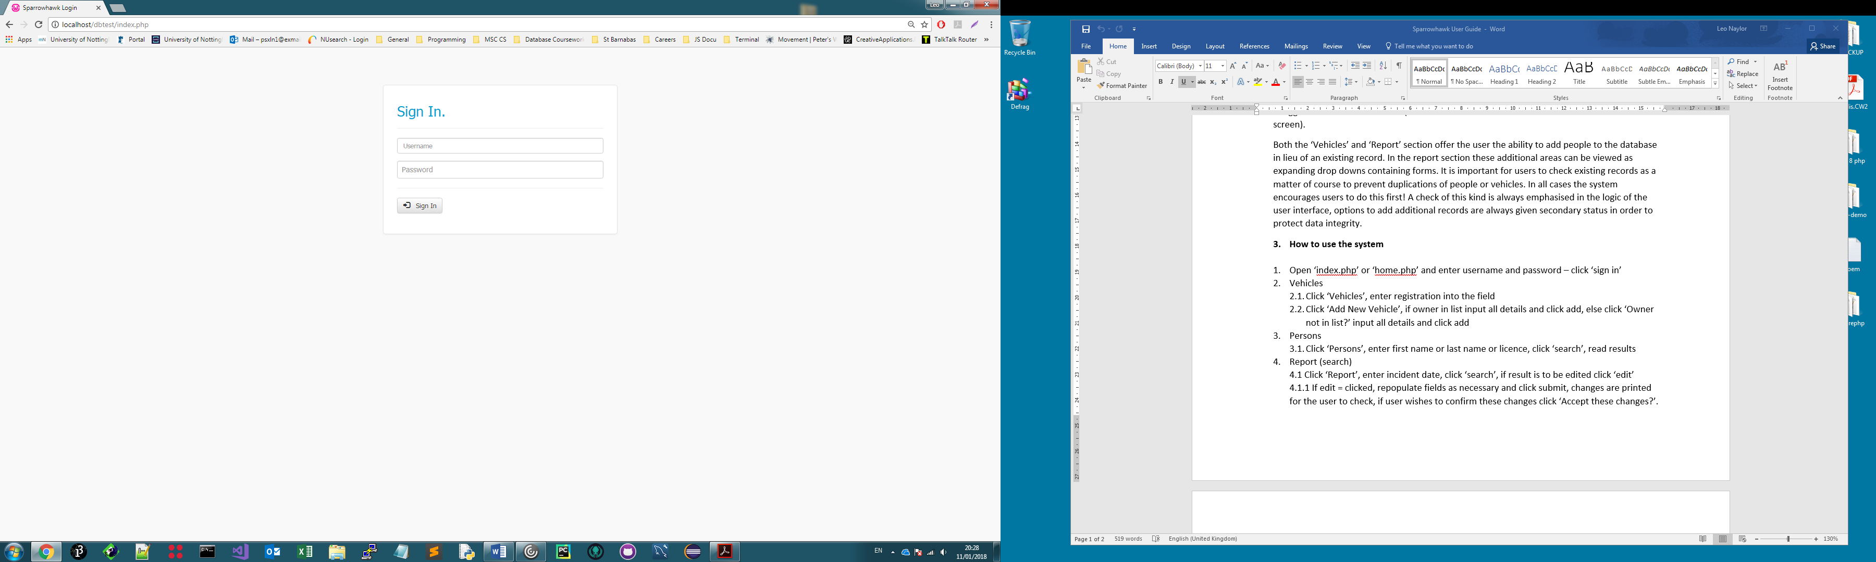

1. Vehicles
   1. Click ‘Vehicles’, enter registration into the field

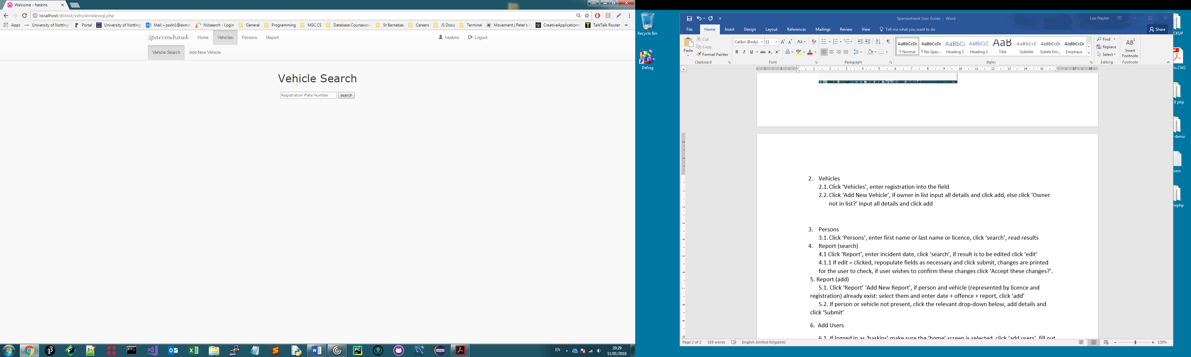

* 1. Click ‘Add New Vehicle’, if owner in list input all details and click add, else click ‘Owner not in list?’ input all details and click add

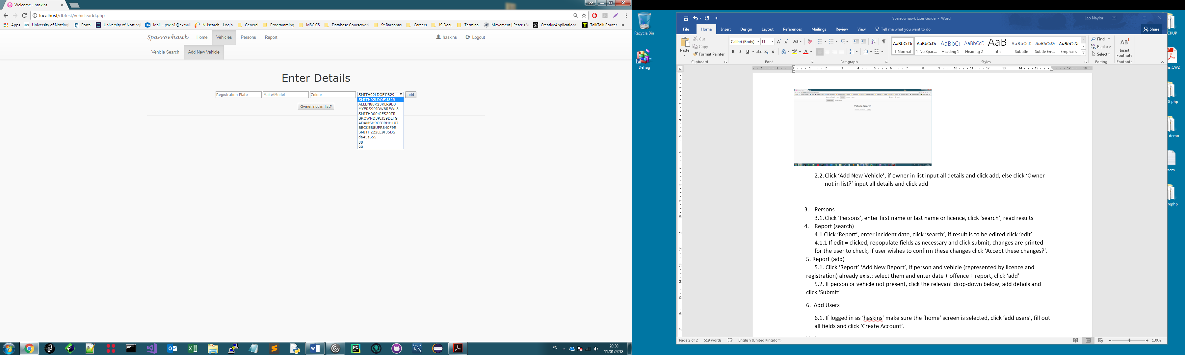

Else

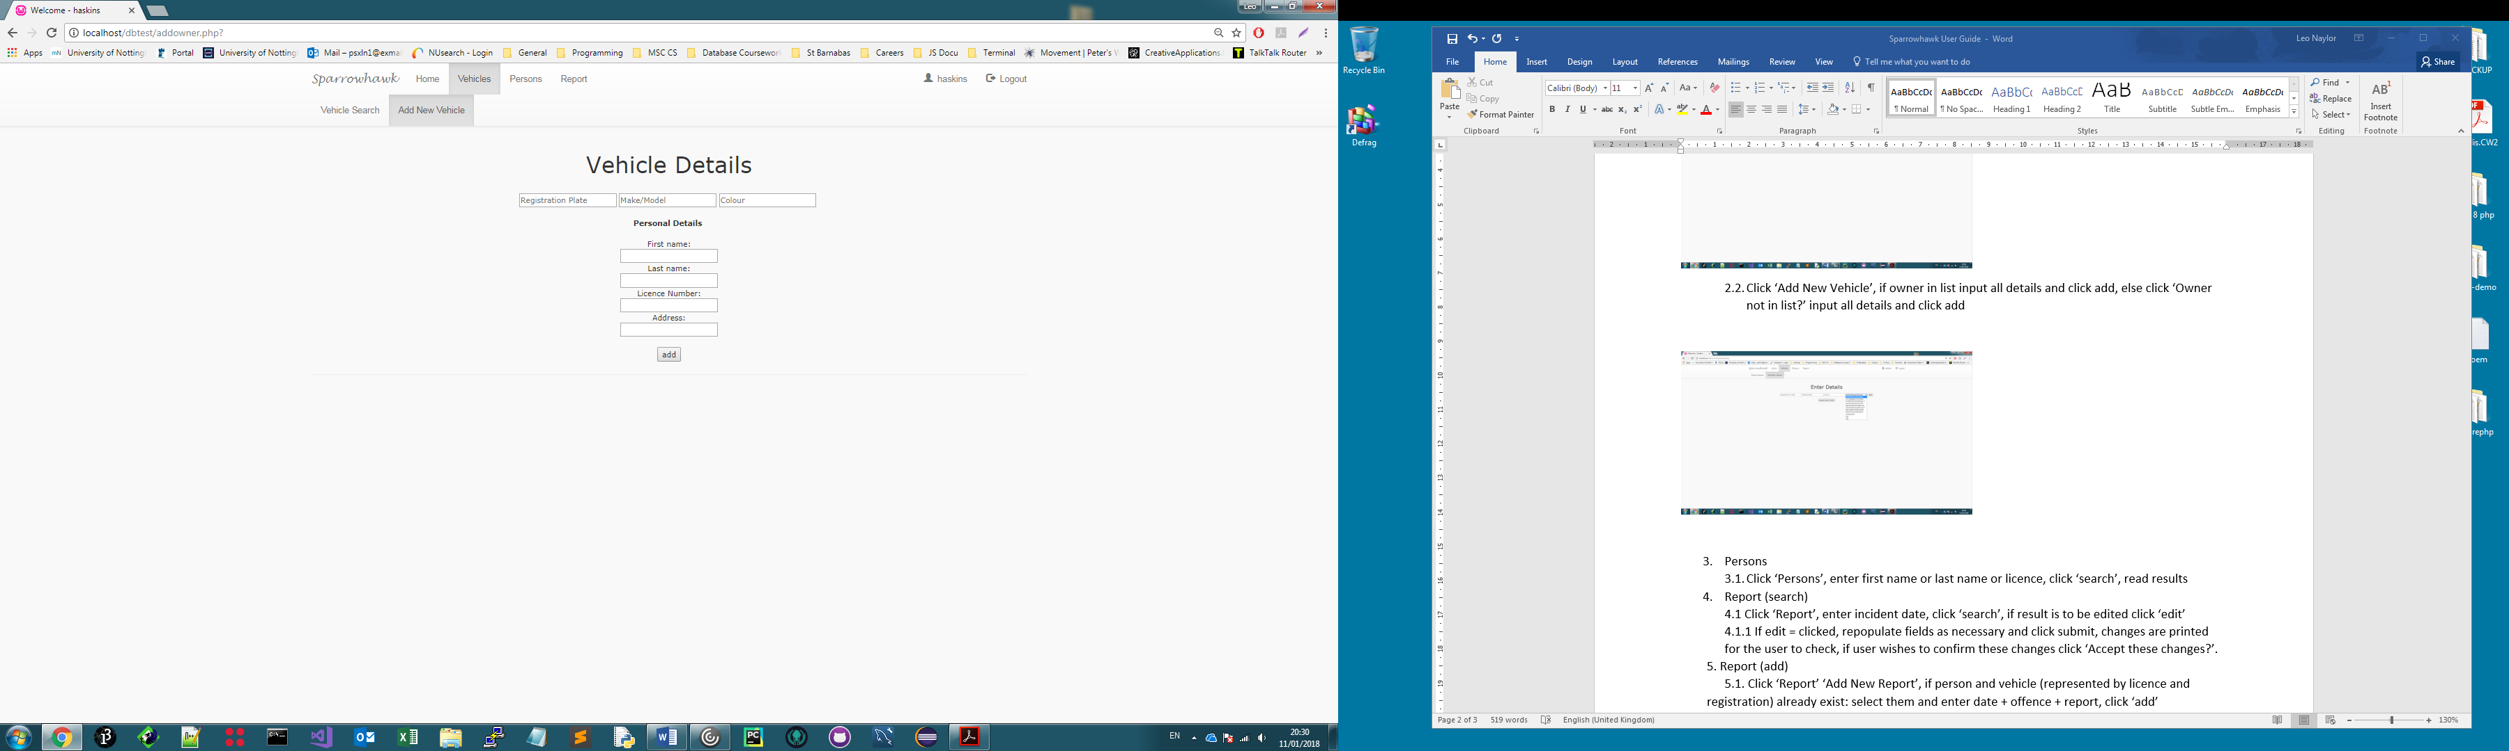

n.b. user can plausibly enter ‘unknown’ into fields, but this will prevent ownership from being assigned to a meaningful result until a genuine set of credentials has been added.

1. Persons
   1. Click ‘Persons’, enter first name or last name or licence, click ‘search’, read results

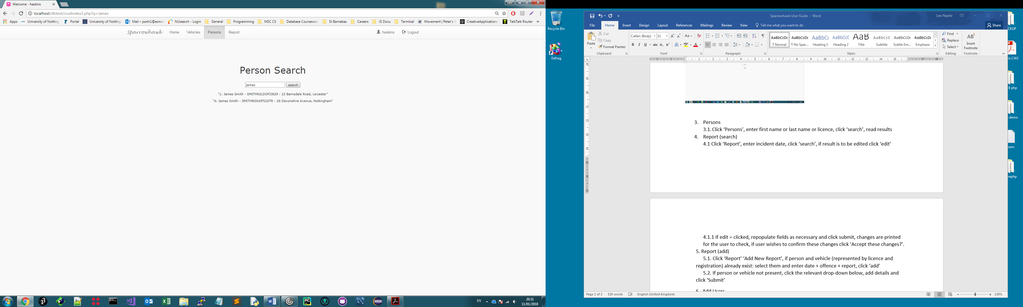

1. Report (search)

4.1 Click ‘Report’, enter incident date, click ‘search’, if result is to be edited click ‘edit’

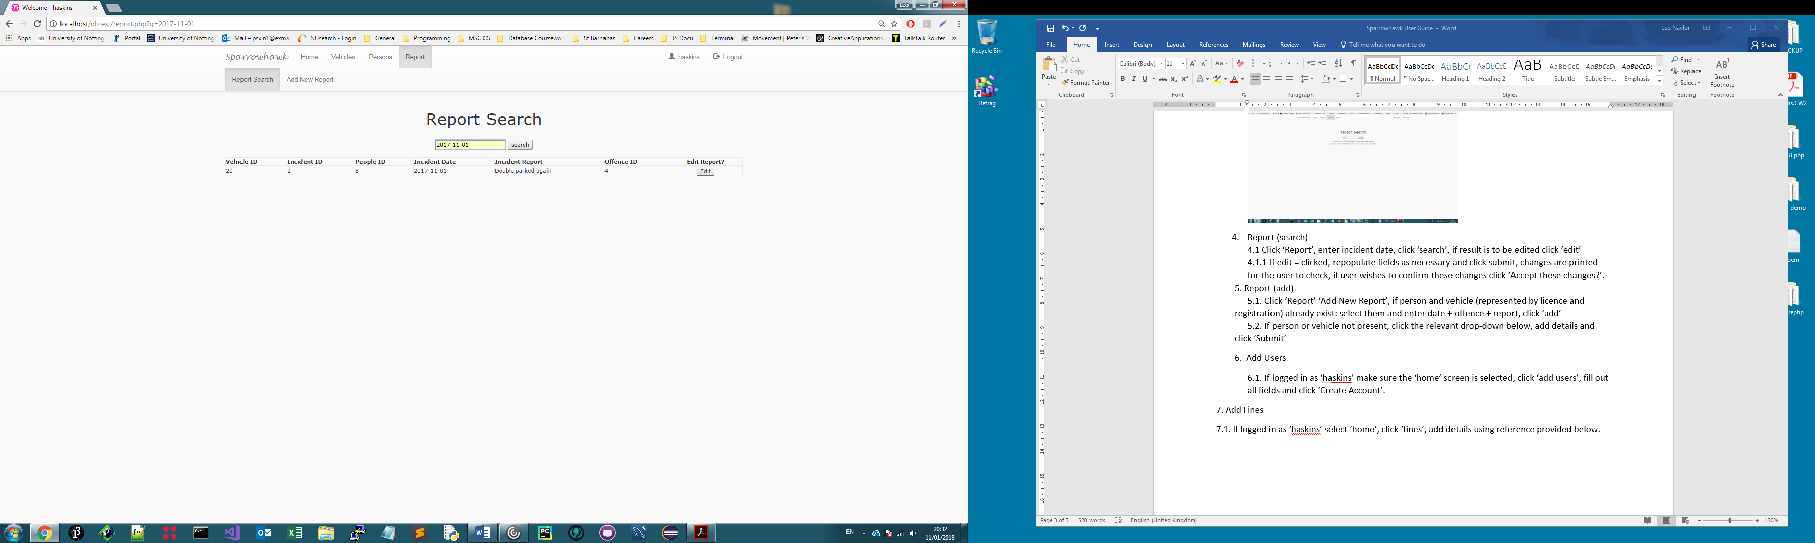

4.1.1 If edit = clicked, repopulate fields as necessary and click submit, changes are printed for the user to check, if user wishes to confirm these changes click ‘Accept these changes?’.

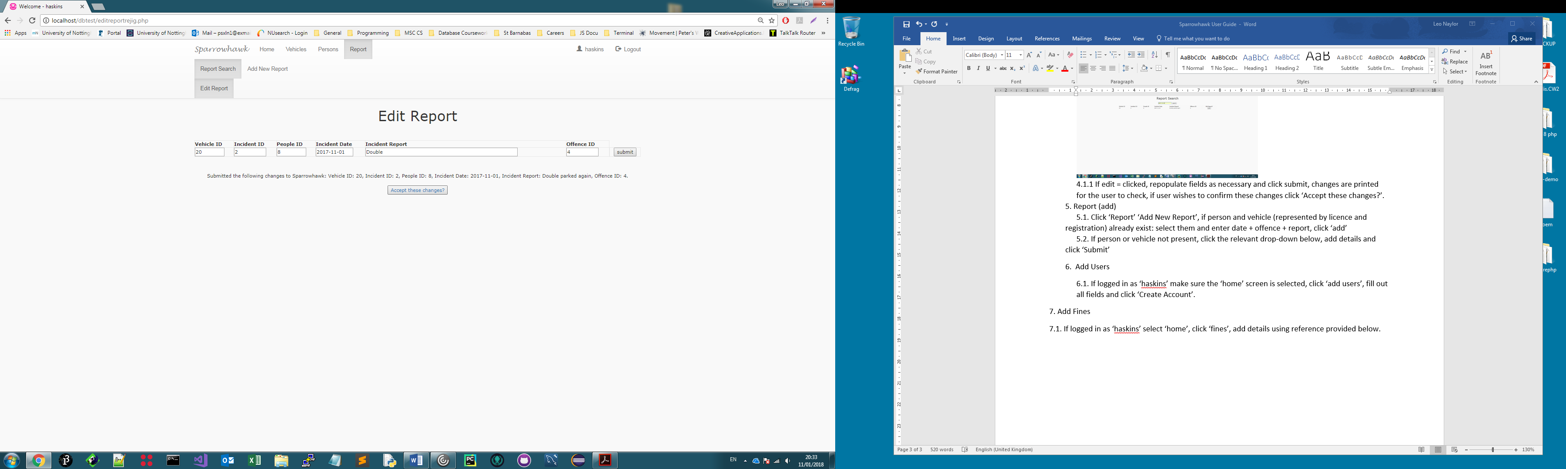

5. Report (add)

5.1. Click ‘Report’ ‘Add New Report’, if person and vehicle (represented by licence and registration) already exist: select them and enter date + offence + report, click ‘add’

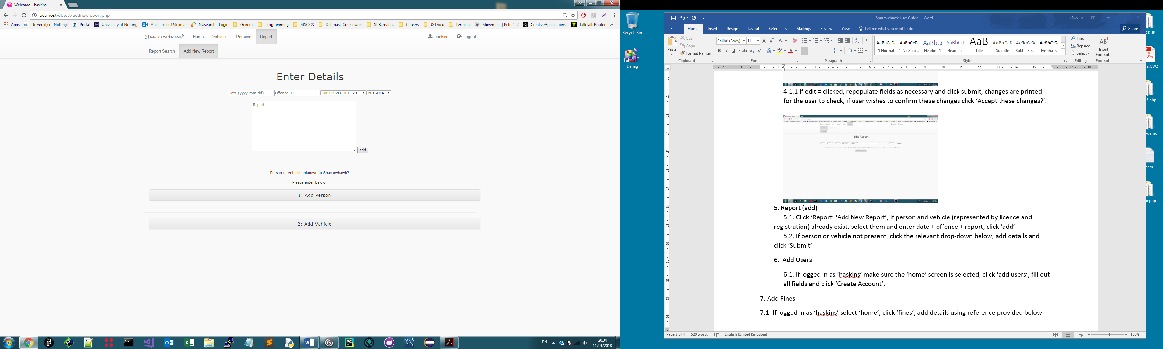

5.2. If person or vehicle not present, click the relevant drop-down below, add details and click ‘Submit’

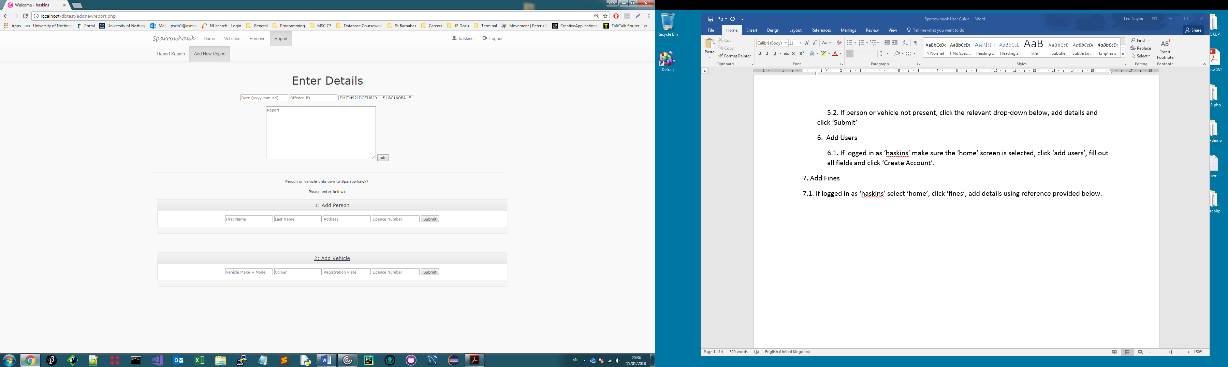

6. Add Users

6.1. If logged in as ‘haskins’ make sure the ‘home’ screen is selected, click ‘add users’, fill out all fields and click ‘Create Account’.

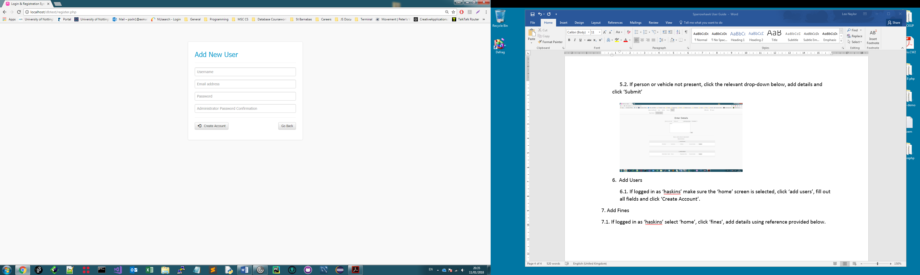

7. Add Fines

7.1. If logged in as ‘haskins’ select ‘home’, click ‘fines’, add details using reference provided below.

