Brain & Development 30 (2008) 295–300

Case report

[www.elsevier.com/locate/braindev](http://www.elsevier.com/locate/braindev)

Alpers syndrome with prominent white matter changes

Xinhua Bao a,*, Ye Wu a, Lee-Jun C. Wong b, Yuehua Zhang a, Hui Xiong a, Ping-Chieh Chou b, Cavatina K. Truong b, Yuwu Jiang a, Jiong Qin a,

Yun Yuan c, Qing Lin a, Xiru Wu a

a *Department of Pediatrics, Peking University First Hospital, Beijing 100034, China*

b *Department of Molecular and Human Genetics, Baylor College of Medicine, Houston, TX, USA*

c *Department of Neurology, Peking University First Hospital, Beijing 100034, China*

Received 19 April 2007; received in revised form 21 June 2007; accepted 19 August 2007

Abstract

Alpers syndrome is a fatal neurogenetic disorder caused by the mutations in *POLG1* gene encoding the mitochondrial DNA polymerase c (polc). Two missense variants, c.248T > C (p.L83P), c.2662G > A (p.G888S) in *POLG1* were detected in a 10-year- old Chinese girl with refractory seizures, acute liver failure after exposure to valproic acid, cortical blindness, and psychomotor regression. The pathology of left occipital lobe showed neuronal loss, spongiform degeneration, astrocytosis, and demyelination. In addition, there were prominent white matter changes in a series of brain magnetic resonance imaging (MRI) and increased immu- nological factors in CSF.

© 2007 Elsevier B.V. All rights reserved.

*Keywords:* Alpers syndrome; *POLG1* mutations; Leukoencephalopathy

1. Introduction

Alpers syndrome is a rare autosomal recessive hepatocerebral syndrome characterized by intractable seizures, early onset progressive liver dysfunction lead- ing to hepatic failure, psychomotor regression (OMIM#203700) [1,2]. The disease manifestation is usu- ally in early childhood and progress to death [1]. Navi- aux et al. ﬁrst demonstrated the deﬁciency of mitochondrial DNA polymerase c activity and mito- chondria DNA (mtDNA) depletion in the muscle and liver tissue of a patient with Alpers syndrome [3]. Muta- tions in *POLG1* gene have also been reported to be responsible for autosomal recessive and autosomal dom- inant forms of progressive external ophthalmoplegia,

* Corresponding author. Tel.: +86 10 66551122x3238; fax: +86 10

66134261.

*E-mail address:* [zwhang@pku.edu.cn](mailto:zwhang@pku.edu.cn) (X. Bao).

juvenile spinocerebellar ataxia-epilepsy syndrome, sen- sory ataxia, neuropathy, dysarthria, and ophthalmopa- resis (SANDO), Parkinsonism, male infertility as well as Alpers syndrome [4–12]. More than 83 point muta- tions, mostly missense mutations have been docu- mented, but cases from Chinese have not been reported (<http://dir-apps.niehs.nih.gov/polg/>).

Alpers syndrome, as a neurodegenerative disease, aﬀects mainly the gray matter. This report describes the ﬁrst conﬁrmed case with Alpers syndrome in China, who had prominent white matter lesion in MRI and high immunological factors in CSF.

1. Case report

The 10-year-old girl is a 4th grade elementary school student. She is the ﬁrst child of healthy, nonconsanguin- eous parents. At 5 years of age, her hearing threshold was found to be a little bit elevated, otherwise she was

0387-7604/$ - see front matter © 2007 Elsevier B.V. All rights reserved. doi:10.1016/j.braindev.2007.08.009

healthy and developed normally until 9 years of age. Her school performance was below average. At 9 years of age, she developed multifocal partial seizures. The sei- zures usually generalized and progressed to status epi- lepticus. Serials EEGs showed slow activity and almost continuous spike wave over the central, parietal, and occipital regions of both hemispheres. She was treated with phenobarbital, carbamazepine, topiramate, vaproic acid (VPA), lamotrigine, and clonazepam. However, the seizures could not be controlled. VPA was used for 2 and half months and then was terminated due to acute liver failure. She developed edema and coagulopathy 52 days after starting VPA treatment. The investigation of the coagulative function at that time revealed decreased ﬁbrinogen (1.56 g/L, normal range: 2.00– 4.00 g/L). Three weeks later she developed jaundice and hepatomegaly. Liver function studies showed abnormalities of alanine transaminase, aspartate trans- aminase, total bilirubin, direct bilirubin, total protein, albumin, and ﬁbrinogen with values of 64 l/L (normal range: 0–40 l/L), 215 l/L (normal range: 0–45 l/L),

145.6 lmol/L (normal range: 1.7–20 lmol/L),

113.1 lmol/L (normal range: 0–6 lmol/L), 44.35 g/L (normal range: 60–82 g/L), 28.8 g/L (normal range: 35–50 g/L), and 0.64 g/L, respectively. VPA treatment was stopped. The liver function improved and was near normal 6 months later.

Seven months after the onset of the disease, the patient developed episodes of visual loss. In the ﬁrst two episodes, the vision recovered several days later. However, the visual loss persisted after the third epi- sode. The simultaneous MRI showed high T2 and DWI signals in the occipital region (Fig. 1C). Visual evoked potentials were absent. The vision problem appeared to be cortical in origin. The patient developed psychomotor regression gradually. She could not walk and sit without support 4 months after the onset of the disease. Nine months after the onset of disease, she lost language and had poor response to commands. She had been in vegetative state since 1 year after the onset of the disease. Her symptoms did not respond to the treatment of intraveously immunoglobulin (2 g/kg), corticosteroids, as well as the above mentioned antiepi- leptic drugs.

Biochemical studies including lactate, pyruvate, and ammonia were normal. Plasma amino acids and urine organic acids were normal. CSF was investigated 8 times from the beginning of the disease to 13 months after the onset. The CSF was acellular but the protein concentra- tion increased every time from 1.99 g/L to 2.28 g/L (nor- mal range: 0.15–0.45 g/L). CSF glucose was normal. The immunological studies of CSF showed that oligo- clone bands were positive from the very beginning to the last investigation. IgG synthesis rate increased from

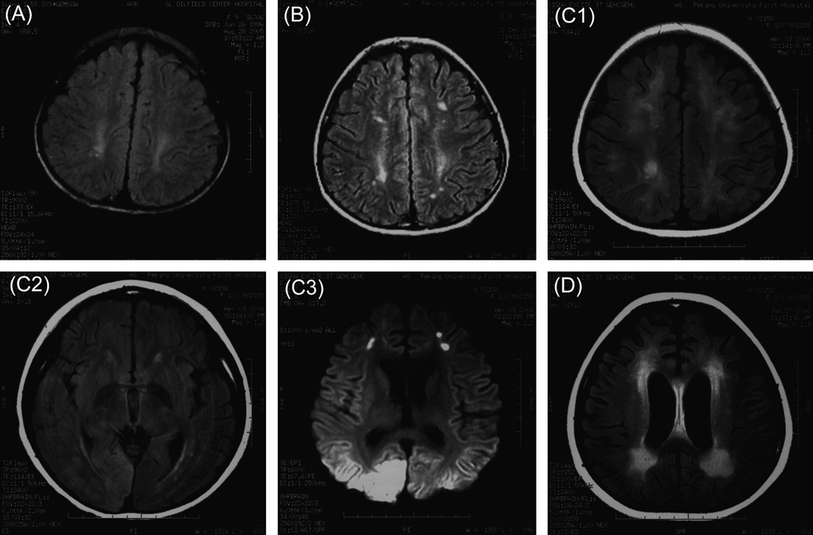

Fig. 1. Magnetic resonance image of the brain. (A and B) Flair image of brain MRIs in 2 days and in 3 months of the onset of the disease showing increased signaling in white matter. (C1) Flair image of brain MRI 7 months later showing the abnormal signal in white matter was more extensive. (C2) Flair image of brain MRI showing increased signaling in right occipital region. (C3) DWI of brain MRI showing increased signaling in both occipital regions. (D) Flair image of brain MRI 10 months later showing diﬀuse brain atrophy, and the abnormal signal in white matter was further extensive.

53.8 mg/24 h to 445 mg/24 h (normal value < 7 mg/ 24 h). IgG index increased from 0.53 to 1.62 (normal value < 0.7).

Brainstem auditory evoked potential showed increased I–III latency. Hearing threshold of left and right ear was 50 dB and 30 dB, respectively. Nerve con- duct velocity studies showed decreased sensory and motor nerve conduct velocity. Sensory nerve conduct velocity of sural nerve and median nerve was 37 m/s and 39.3 m/s, respectively (normal value > 50 m/s). The motor nerve conduct velocity of common peroneal nerve was 40.3 m/s (normal value > 45 m/s).

Several brain MRIs were performed (Fig. 1). The brain MRIs showed increased T2 and ﬂair signals in hemioval central white matter and cerebellar white mat- ter at 2 days and 3 months after the onset of the disease (Fig. 1A and B), and 7 months later, brain MRI showed that the abnormal signal in white matter was more extensive (Fig. 1C1). Increased T2 and ﬂair signals in the right occipital region (Fig. 1C2) and increased DWI signal in both occipital regions were observed (Fig. 1C3). No enhancement was found in the con- trast-enhanced brain MRI at 9 months after disease onset. One month later, MRI revealed diﬀuse brain atro- phy, and the increased T2 signal in the white matter was further extensive (Fig. 1D).

Pathology studies of muscle, peripheral nerve, and brain biopsy were performed. Gastrocnemius muscle biopsy was unremarkable, no ragged-red-ﬁber was found in the Gomori–Trichrome stain. Sural nerve biopsy showed damaged axon and myelin (Fig. 2). Left occipital lobe biopsy showed astrocytosis, neuronal loss and sponginess in the cortex and partial demyelination, gliosis, and vacuolization in white matter (Fig. 3).

Screening of mtDNA common mutations including 3243A > G, 3271T > C, 3460G > A, 8344A > G, 8356T >

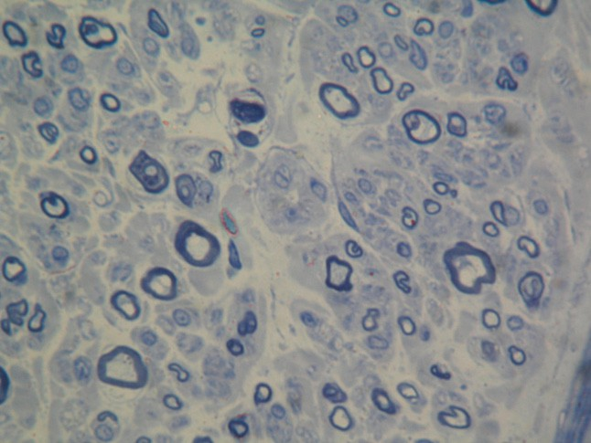

Fig. 2. Microscopic section of the sural nerve showing axon degeneration.

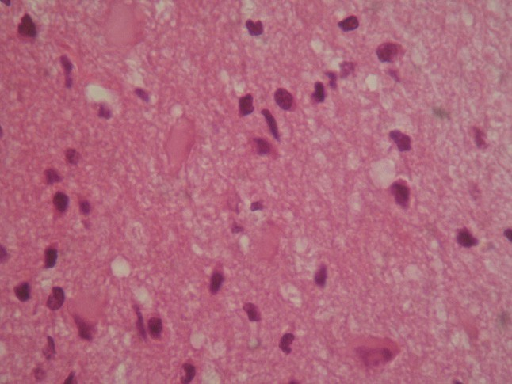

Fig. 3. Microscopic section of the left occipital lobe showing astro- cytosis, neuronal loss and sponginess. Haematoxylin–eosin originally 40·.

C, 8363G > A, 8993T > C, 8993T > G, 11778G > A,

14459G > A, and 14484T > C with the method previ- ously described [13,14] was negative. Large mtDNA deletions and rearrangements were not detected by Southern blot analysis [13,14]. Because of the intractable seizures and liver failure that are consistent with hepato- cerebral mtDNA depletion syndrome, sequencing of coding exons of deoxyguanosine kinase (*DGUOK*) and DNA polymerase c1 (*POLG1*) was performed [15–17]. Deleterious mutations were not detected in *DGUOK*. However, two novel heterozygous missense variants, c.248T > C (p.L83P), c.2662G > A (p.G888S) were

detected in *POLG1* gene. Sequence analysis of parental blood DNA revealed that her father carried L83P and her mother carried G888S (Fig. 4). These two novel mis- sense variants occurred at highly conserved amino acid residues (Fig. 5). The mitochondrial DNA copy number in muscle was examined by real time quantitative PCR [18], and was found to be about 70% of age-matched mean.

1. Discussion

This 10-year-old girl presented with focal, multifocal, and generalized seizures, which were uncontrollable by various antiepileptic medicines. After the administration of VPA, the patient developed acute liver failure. The clinical course was likely to be the Alpers syndrome. The axonopathy in peripheral sensory nerve biopsy and the pathology of brain occipital lobe including the neuronal loss, spongiform degeneration, astrocytosis were similar to those described in Alpers syndrome [6,19,20]. Hearing loss is a common clinical feature reported to be associated with mitochondrial DNA dis- orders, but it is less frequent in patients with Alpers syndrome.

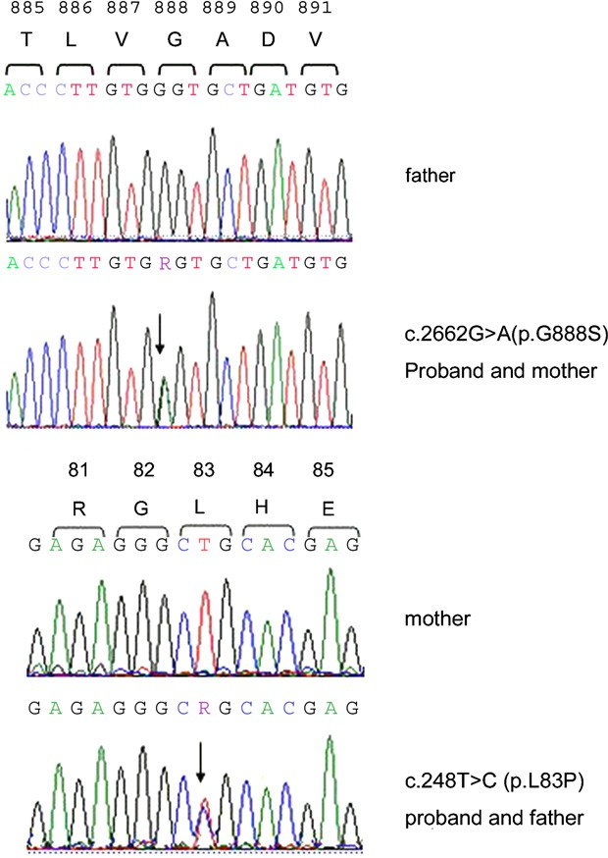

Fig. 4. Two novel heterozygous missense variants. c.248T > C (p.L83P), c.2662G > A (p.G888S) were detected in DNA polymerase gamma1 (*POLG1*). These two missense variants inherited from her father and mother, respectively.

The mitochondrial DNA polymerase c is required for the replication and repair of the 16,569-bp of human mitochondrial genome. It has been reported that the mutant catalytic subunit POLG1 containing the most common mutation, A467T, possesses only 4% of the wild-type DNA polymerase activity due to its failure to interact with the accessory subunit, POLG2, which

stimulates the polymerase activity [21]. MtDNA deple- tion and multiple deletions have been found in muscle or liver tissues from patients with Alpers syndrome [6,11]. In our case, the mitochondrial DNA content in muscle was found to be about 70% of age-matched mean. This is not a dramatic reduction. Unfortunately, liver specimen was not available for analysis. Reduction in mtDNA content causes reduced synthesis of all respi- ratory chain complexes containing mtDNA-encode sub- units leading to generalized deﬁciency in mitochondrial respiratory chain function. Nevertheless, the blood and CSF lactate levels, the pathology and histochemistry of muscle, and the mtDNA copy number in muscle could be normal in some patients, especially in the early stage of the disease [6,7,11,20].

More than 83 *POLG1* mutations have been recorded in the Human DNA Polymerase Gamma Mutation Database (<http://dir-apps.niehs.nih.gov/polg/>). Most of them are missense mutations. The most common A467T mutation accounts for approximately 40% of the *POLG1* mutant alleles described in Alpers syndrome [22–25]. Other recurrent mutations include W748S, G848S, and T914P. Most of the remaining mutations occur only once [6,7,11,22]. Two novel mutations c.248T > C (p.L83P) and c.2662G > A (p.G888S) were

identiﬁed in our patient. The L83 is located in between the polyQ stretch and the beginning of the exonuclease domain, an area of no known function, but appears to be very well conserved from yeast to man ([http://](http://dir-apps.niehs.nih.gov/polg/) [dir-apps.niehs.nih.gov/polg/](http://dir-apps.niehs.nih.gov/polg/)) [21]. The G888 is an abso- lutely conserved amino acid found in motif A of the polymerase domain. It is two residues away from a crit- ical Asp (D890) residue which makes up one of three carboxylic amino acids (triad) to chelate the two magne- sium ions at the active site. Mutation at the neighboring residue, A889T, is found in autosomal dominant pro- gressive external ophthalmoplegia with an early age of presentation. These patients also appear to have ataxia. On the other side, the T885S is associated with Alpers

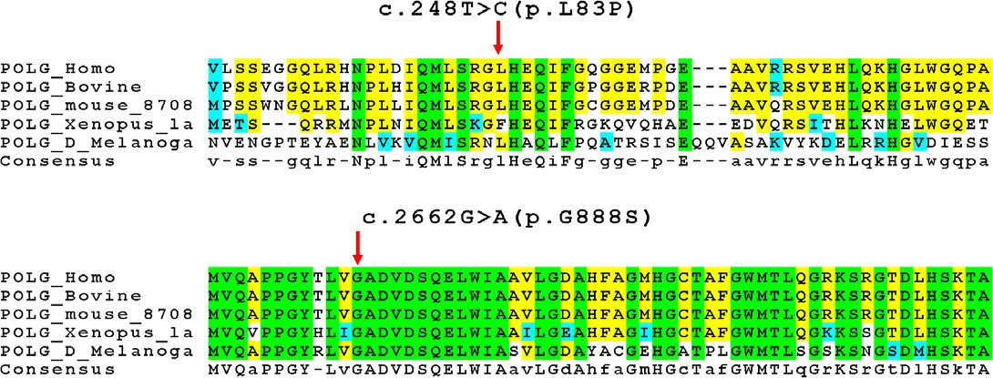

Fig. 5. Alignment showing the Polc regions in which the two novel amino acid substitutions were detected. The two novel amino acid substitutions are highly conserved among diﬀerent species.

syndrome (<http://dir-apps.niehs.nih.gov/polg/>). Thus, although the pathogenicity of these two novel missense variants has not been directly proven, it is most likely that they are responsible for the clinical course of this patient. In addition, the asymptomatic parents were conﬁrmed to be carriers of each of the mutations.

Alpers syndrome is known as a neurodegenerative disease aﬀecting mainly the gray matter. However in this case, MRI showed symmetric abnormal signals in bilat- eral cerebral and cerebellar white matter during the course of the disease. Demyelination and gliosis were also found in the biopsy of white matter. Although MRI and pathological changes in the white matter have been reported in Alpers syndrome [6,20,26], such remarkable white matter changes were unprecedented. Whether this phenotype correlated with the genotype in the Chinese ethnic background is not clear.

Immunological studies in Alpers syndrome have never been reported. In our patient, the CSF showed positive oligo-clone bands, very high IgG synthesis rate, and IgG index throughout the entire course of the dis- ease. These laboratory ﬁndings made the diagnosis of inﬂammatory demyelinative disease initially considered. However, the patient did not respond to the treatment with 2 g/kg IVIG, and 20 mg/kg methylprednisolone daily for 3 days with oral prednisone taper. Thus, the diagnosis of inﬂammatory demyelinative disease was unlikely. The immunological abnormality may be sec- ondary to the brain damage. Whether it plays a role in the disease progression does need further investigation. Mutations in *POLG1* can cause a broad spectrum of clinical disease [12,27]. Even among the patients of Alpers syndrome, the clinical manifestations may be variable. This Chinese case demonstrated that the white matter may also be severely involved in Alpers syn- drome. In addition, the immunological reactions may

play a role in the disease progression.

References

1. Harding BN. Progressive neuronal degeneration of childhood with liver disease (Alpers–Huttenlocher syndrome): a personal review. J Child Neurol 1990;5:273–87.
2. Huttenlocher PR, Solitare GB, Adams G. Infantile diﬀuse cerebral degeneration with hepatic cirrhosis. Arch Neurol 1976;33:186–92.
3. Naviaux RK, Nyhan WL, Barshop BA, Poulton J, Markusic D, Karpinski NC, et al. Mitochondrial DNA polymerase gamma deﬁciency and mtDNA depletion in a child with Alpers’ syndrome. Ann Neurol 1999;45:54–8.
4. Lamantea E, Tiranti V, Bordoni A, Toscano A, Bono F, Servidei S, et al. Mutations of mitochondrial DNA-polymerase gammaA are a frequent cause of autosomal dominant or recessive progressive external ophthalmoplegia. Ann Neurol 2002;52:211–9.
5. Ferrari G, Lamantea E, Donati A, Filosto M, Briem E, Carrara F, et al. Infantile hepatocerebral syndromes associated with mutations in the mitochondrial DNA polymerase-gammaA. Brain 2005;128:723–31.
6. Kollberg G, Moslemi AR, Darin N, Nennesmo I, Bjarnadottir I, Uvebrant P, et al. POLG1 mutations associated with progressive encephalopathy in childhood. J Neuropathol Exp Neurol 2006;65:758–68.
7. Naviaux RK, Nguyen KV. POLG mutations associated with Alpers syndrome and mitochondrial DNA depletion. Ann Neurol 2004;55:706–12.
8. Luoma P, Melberg A, Rinne JO, Kaukonen JA, Nupponen NN, Chalmers RM, et al. Parkinsonism, premature menopause, and mitochondrial DNA polymerase gamma mutations: clinical and molecular genetic study. Lancet 2004;364:875–82.
9. Van Goethem G, Martin JJ, Dermaut B, Lofgren A, Wibail A, Ververken D, et al. Recessive POLG mutations presenting with sensory and ataxia neuropathy in compound heterozygote patients with progressive external ophthalmoplegia. Neuromuscul Disord 2003;13:133–42.
10. Van Goethem G, Luoma P, Rantamaki M, Al Memar A, Kaakkola S, Hackman P, et al. POLG mutations in neurode- generative disorders with ataxia but no muscle involvement. Neurology 2004;63:1251–7.
11. Davidzon G, Mancuso M, Ferraris S, Quinzii C, Hirano M, Peters HL, et al. POLG mutations and Alpers syndrome. Ann Neurol 2005;57:921–4.
12. Longley MJ, Graziewicz MA, Bienstock RJ, Copeland WC. Consequences of mutations in human DNA polymerase gamma. Gene 2005;354:125–31.
13. Wong LJC, Senadheera D. Direct detection of multiple point mutations in mitochondrial DNA. Clin Chem 1997;43:1857–61.
14. Liang MH, Wong LJC. Yield of mtDNA mutation analysis in 2000 patients. Am J Med Genet 1998;77:395–400.
15. Wong LJC, Brunetti-Pierri N, Zhang Q, Yazigi N, Bove KE, Dahms BB, et al. Mutations in the MPV17 gene are responsible for rapidly progressive liver failure in infancy. Hepatology 2007, August 10 [Epub ahead of print].
16. Dimmock DP, Zhang Q, Shieh J, Chou PC, Truong C, Schmitt E, et al. The clinical features and molecular genetics of deoxygua- nosine kinase deﬁciency. ACMG 2007 annual meeting abstract #029.
17. Waters P, Selby K, O’Sullivan M, Hendson G, Truong C, Wong LJC. Multiple mutations in the DNA polymerase gamma 1 (POLG1) gene in a patient with Alpers syndrome. ACMG 2006 annual meeting abstract #276.
18. Bai R, Wong LJC. Simultaneous detection and quantiﬁcation of mitochondrial DNA deletion, depletion, and ampliﬁcation in patients with mitochondrial disease. J Mol Diagn 2005;7:613–22.
19. Simonati A, Filostro M, Tomelleri G, Savio C, Tonin P, Polo A, et al. Central-peripheral sensory axonopathy in a juvenile case of Alpers–Huttenlocher disease. J Neurol 2003;250:702–6.
20. Harding BN, Alsanjari N, Smith SJ, Wiles CM, Thrush D, Miller DH, et al. Progressive neuronal degeneration of childhood with liver disease (Alpers’ disease) presenting in young adults. J Neurol Neurosurg Psychiatry 1995;58:320–5.
21. Chan SS, Longley MJ, Copeland WC. The common A467T mutation in the human mitochondrial DNA polymerase (POLG) compromises catalytic eﬃciency and interaction with the acces- sory subunit. J Biol Chem 2005;280:31341–6.
22. de Vries MC, Rodenburg RJ, Morava E, van Kaauwen EP, Ter Laak H, Mullaart RA, et al. Multiple oxidative phosphorylation deﬁciencies in severe childhood multi-system disorders due to polymerase gamma (*POLG1*) mutations. Eur J Pediatr 2006, September 7 [Epub ahead of print].
23. Nguyen KV, Sharief FS, Chan SSL, Copeland WC, Naviaux RK. Molecular diagnosis of Alpers syndrome. J Hepatol 2006;45:108–16.
24. Horvath R, Hudson G, Ferrari G, Futterer N, Ahola S, Lamantea E, et al. Phenotypic spectrum associated with muta-

tions of the mitochondrial polymerase gamma gene. Brain 2006;129:1674–84.

1. Tzoulis C, Engelsen BA, Telstad W, Aasly J, Zeviani M, Winterthun S, et al. The spectrum of clinical disease caused by the A467T and W748S POLG mutations: a study of 26 cases. Brain 2006;129:1685–92.
2. Kendall BE, Boyd SG, Egger J, Harding BN. Progressive neuronal degeneration of childhood with liver disease. Computed tomographic features. Neuroradiology 1987;29:174–80.
3. DiMauro S, Davidzon G, Hirano M. A polymorphic polymerase. Brain 2006;129:1637–9.