J Neurol (2013) 260:903–905 DOI 10.1007/s00415-012-6776-z

LETTER TO THE EDITORS

*POLG* mutation presenting with late-onset jerky torticollis

Anil M. Tuladhar • F. J. Anton Meijer •

Bart P. van de Warrenburg

Received: 12 October 2012 / Revised: 9 November 2012 / Accepted: 21 November 2012 / Published online: 5 December 2012

© Springer-Verlag Berlin Heidelberg 2012

Dear Sirs,

*POLG* is a nuclear gene and its gene product, polymerase gamma, is involved in the maintenance of mitochondrial DNA (mtDNA) and mutations thus lead to depletion of mtDNA [1]. The corresponding phenotype is markedly variable, and includes (among others) Alpers’ syndrome, mitochondrial spinocerebellar ataxia and epilepsy (MSCAE), chronic progressive external ophthalmoplegia, neuropathy, epilepsy, as well as myoclonus, cerebellar ataxia, and parkinsonism [2]. Herein we report a case of patient with compound heterozygous *POLG* mutation with unusual clinical presentation.

A 43-year-old woman was referred to us for unexplained progressive shaking of the head, which had begun rather abruptly several months earlier. She also mentioned a feeling of imbalance on walking. Family history was negative. On examination, we saw a mild torticollis to the left with a side-to-side, jerky head tremor (see video). Eye movements were normal. Her gait was clearly abnormal,

being broad-based and with deviations from the straight line, but was also rather atypical and effortful, and she could very suddenly lurch to the side. During walking, the head rotation and tremor could be observed. There was no appendicular ataxia. Tendon reflexes were all normal, as was the sensory examination. Our provisional diagnosis was cervical dystonia with either jerky tremor or myo- clonic jerks, and we suspected some aggravation, particu- larly in her gait disturbance, related to psychosocial factors. Mutation analysis for the *SGCE* gene was negative and brain imaging was normal. She was given clonazepam in combination with botulinum toxin injections, which had a moderate effect. Her head tremor and gait difficulty con- tinued to progress and she gradually developed jerks of her left arm and sensory disturbances in both arms. She was admitted at age 45 years because of a generalized tonic– clonic seizure. During admission, several short-lasting— possibly epileptic—myoclonic jerks were observed alter- natingly in the left and right arm. At that time, the neu- rological examination showed incomplete external

ophthalmoplegia; mild torticollis with a severe mainly

Electronic supplementary material The online version of this article (doi:[10.1007/s00415-012-6776-z](http://dx.doi.org/10.1007/s00415-012-6776-z)) contains supplementary material, which is available to authorized users.

side-to-side head tremor; myoclonic jerks of the left arm; ataxic finger chase and heel-shin slide; gait ataxia; and

absent tendon reflexes.

A. M. Tuladhar B. P. van de Warrenburg (&) Department of Neurology, Centre for Neuroscience, Donders Institute for Brain, Cognition, and Behavior, Radboud University Nijmegen Medical Centre,

•

PO Box 9101, 6500 HB Nijmegen, The Netherlands e-mail: [b.vandewarrenburg@neuro.umcn.nl](mailto:b.vandewarrenburg@neuro.umcn.nl)

A. M. Tuladhar

e-mail: [am.tuladhar@neuro.umcn.nl](mailto:am.tuladhar@neuro.umcn.nl)

F. J. A. Meijer

Department of Radiology, Donders Centre for Neuroscience, Radboud University Nijmegen Medical Centre, Nijmegen, The Netherlands

Brain MRI (Fig. 1) now revealed mild cerebellar atro- phy, as well as small symmetric signal changes in the cer- ebellar white matter that were hyperintense on T2, fluid attenuated inversion recovery (FLAIR), and slightly hypo- intense on T1 images. Electroencephalography showed mild diffuse slowing without epileptic activity and elec- tromyography indicated a sensory neuronopathy. As the clinical constellation was now very suggestive of a mito- chondrial disorder, *POLG* mutation analysis was per- formed, which revealed a compound heterozygous mutation (c.1399G ? A and c.2243G ? C). Levetiracetam was

# 1 3

904 J Neurol (2013) 260:903–905

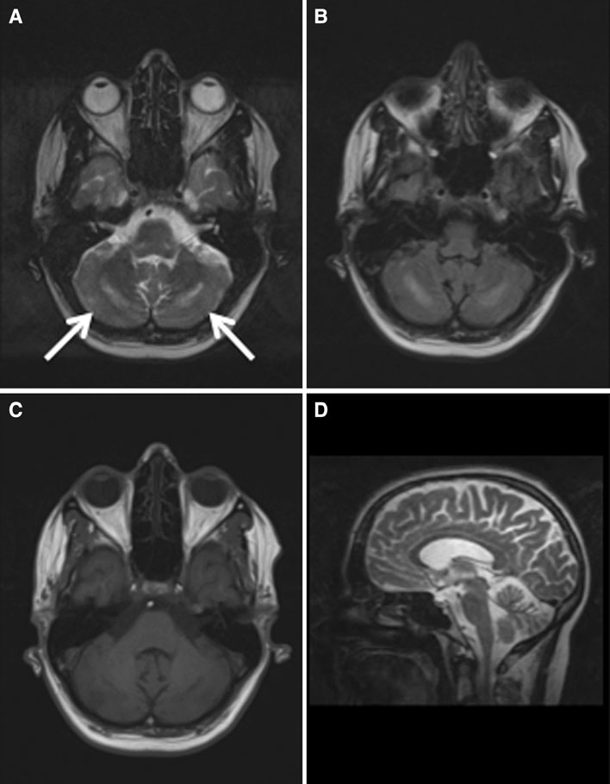Fig. 1 Symmetric hyperintense signal changes in cerebellum, dorsal of dentate nucleus (*arrows*), on axial T2 turbo spin echo image (a) and T2 fluid attenuated inversed recovery (FLAIR) image (b). These changes are slightly hypo- intense on the axial T1 image

(c). The sagittal T2 image shows atrophy of the cerebellum (d)

started because of the myoclonus and possible seizures, and she was referred for rehabilitation and cardiac screening.

This case firstly illustrates that *POLG* can present rela- tively late and can present with hyperkinetic movement disorders, such as jerky torticollis. The mutations we identified (c.1399G ? A and c.2243G ? C) were previ- ously described by Tzoulis and colleagues [6]. The clinical presentation of these mutations usually starts in the second decade and is characterized by epilepsy, headache, ataxia, neuropathy, myoclonus and late-onset ophthalmoplegia. Our case had features suggestive of MSCAE, in which the most common presenting features are gait disorders, epi- lepsy, ataxia, neuropathy and headache. We therefore concur that in otherwise unexplained hyperkinetic move- ment disorders, *POLG* should be in the differential, even if onset is above age 40 years [3]. Secondly, the symmetric

signal changes in the cerebellar white matter as seen in our patient, which have also been observed in other *POLG* mutation patients [4, 5], are an important clue when the clinical presentation is not sufficiently suspicious. *POLG* mutations have been associated with various MRI changes, with a predilection for the occipital lobes, basal ganglia, thalamus, cerebellum, and inferior olives [6]. Such cere- bellar white matter changes have a very limited differential diagnosis, including histiocytosis, peroxisomal disorders, and Alexander disease [7]. When combined with a move- ment disorder, such isolated cerebellar abnormalities should prompt mutation analysis of the *POLG* gene.

Acknowledgments BvdW receives research support from the Prinses Beatrix Fonds, Netherlands Brain Foundation, the Royal Dutch Society for Physical Therapy, and the Gossweiler Foundation.

# 1 3

J Neurol (2013) 260:903–905 905

Conflicts of interest AMT and FM have nothing to disclose.

Ethical standard Informed consent was obtained from the patient prior to her inclusion in the study.

References

1. Van Goethem G, Dermaut B, Lofgren A et al (2001) Mutation of POLG is associated with progressive external ophthalmoplegia characterized by mtDNA deletions. Nat Genet 28:211–212
2. Wong LJC, Naviaux RK, Brunetti-Pierri N et al (2008) Molecular and clinical genetics of mitochondrial diseases due to POLG mutations. Hum Mutat 29:E150–E172
3. Synofzik M, Schule R, Schulte C et al (2010) Complex hyperki- netic movement disorders associated with POLG mutations. Mov Disord 25:2472–2475
4. Winterthun S, Ferrari G, Taylor RW et al (2005) Autosomal recessive mitochondrial ataxic syndrome due to mitochondrial polymerase c mutations. Neurology 64:1204–1208
5. Tzoulis C, Neckelmann G, Mørk SJ et al (2010) Localized cerebral energy failure in DNA polymerase gamma-associated encepha- lopathy syndromes. Brain 133:1428–1437
6. Tzoulis C, Engelsen BA, Telstad W et al (2006) The spectrum of clinical disease caused by the A467T and W748S POLG mutations: a study of 26 cases. Brain 129:1685–1692
7. Van der Knaap MS, Arts WFM, Garbern JY et al (2008) Cerebellar leukoencephalopathy: most likely histiocytosis-related. Neurology 71:1361–1367

1 3