186 *Case Reports / Journal of Clinical Neuroscience 21 (2014) 186–188*

*POLG* mutations associated with remitting/relapsing neurological events 

Bertrand Degos a,b,⇑, Pascal Laforêt c,d, Claude Jardel e, Frédéric Sedel a,b, Murielle Jossay-Winter f,

Norma B. Romero a,g, Olivier Lyon-Caen a,b, Ayman Tourbah h,i

a *Département de Neurologie, Hôpital Pitié-Salpêtrière, AP-HP, 47-83 boulevard de l’Hôpital, 75013 Paris, France*

b *Université Pierre et Marie Curie (Paris VI), Paris, France*

c *Centre de référence de pathologie neuromusculaire Paris-Est, Hôpital Pitié-Salpêtrière, AP-HP, Paris, France*

d *Institut de Myologie, Hôpital Pitié-Salpêtrière, AP-HP, Paris, France*

e *Laboratoire de Biochimie Métabolique, Hôpital Pitié-Salpêtrière, AP-HP, Paris, France*

f *Centre Hospitalier National d’Ophtalmologie des Quinze-Vingts, Paris, France*

g *Institut de Myologie, Unité de Morphologie Neuromusculaire, Inserm UMRS 974, CNRS UMR 7215, Hôpital Pitié-Salpêtrière, AP-HP, Paris, France*

h *Service de Neurologie et Faculté de Médecine, Université Champagne-Ardenne CHU de Reims, Reims, France*

i *Laboratoire de psychopathologie et Neuropsychologie, EA2027 Université Paris, France*

# a r t i c l e i n f o

*Article history:*

Received 16 July 2012

Accepted 18 March 2013

*Keywords:*

Immunology

Magnetic resonance imaging Mitochondrial disorders Multiple sclerosis

Myopathy

# a b s t r a c t

Recent experimental data underline the relationship between mitochondria and immune function. Clin- ical reports of patients presenting with mitochondrial dysfunction associated with dysimmune responses in the central nervous system reinforce this new concept. We describe the ﬁrst case of a woman present- ing with symptoms related to a novel compound heterozygous mutation of the mitochondrial polymer-

ase c (*POLG*) gene, associated with neurological events suggestive of a demyelinating process. Clinical

examination revealed bilateral ptosis, progressive external ophthalmoplegia and axonal sensitive poly- neuropathy suggestive of a mitochondrial disease. In line with this, muscle biopsy showed ragged red ﬁbers, and sequencing of *POLG* revealed two heterozygous mutations. In addition, the patient exhibited relapsing neurological symptoms, and cerebral and spinal MRI mimicking multiple sclerosis. This patient stresses the relationship between mitochondrial dysfunction and inﬂammation. Recent studies suggest that targeting mitochondrial dysfunction could provide beneﬁts in treating some inﬂammatory diseases.

© 2013 Elsevier Ltd. All rights reserved.

1. Introduction

Mutations of the mitochondrial polymerase c (*POLG*) gene are responsible for a broad clinical spectrum of mitochondrial disor- ders with a predominant recessive mode of inheritance.1,2 We re- port a patient presenting with bilateral ptosis, progressive external ophthalmoplegia (EO) and chronic axonal sensory poly- neuropathy associated with episodes of optic neuritis, facial hypo- esthesia and myelitis. Serial cerebral and spinal MRI revealed multiple sclerosis (MS)-like lesions. Sequencing of *POLG* found two recessive pathogenic mutations.

1. Case report

A 59-year-old woman was referred to our unit for neuro-oph- thalmological disorders.

Her medical history began at age 39 with a bilateral progressive ptosis. Blood analyses, including anti-acetylcholine receptor anti- bodies, were negative. Electroneuromyogram (EMG) showed a chronic axonal sensory polyneuropathy with normal neuromuscu- lar transmission. At age 49, diplopia with EO appeared and pro- gressively worsened. At age 59, a mitochondriopathy was suspected because of bilateral ptosis, complete EO, sensory ataxia, proximal muscular deﬁcit, and presence of hyperlactacidemia and axonal sensory polyneuropathy on a second EMG. A deltoid muscle biopsy revealed typical features of mitochondrial myopathy (Fig. 1). Long-range polymerase chain reaction (PCR) of muscle mitochondrial (mt) DNA showed multiple DNA deletions and real-time PCR found a decrease of mtDNA copy number. The genet- ic search for mitochondrial encephalomyopathy, lactic acidosis, and stroke-like episodes (MELAS) and myoclonic epilepsy with rag- ged red ﬁbers was negative. Sequencing of *POLG* found two reces-

⇑ Corresponding author. Tel.: +33 1 4216 1752; fax: +33 1 4216 1719.

*E-mail address:* [bertrand.degos@psl.aphp.fr](mailto:bertrand.degos@psl.aphp.fr) (B. Degos).

sive mutations: one novel (c.1190C>T) and one already known (c.2564T>C)1 which was found in the mother of the patient, but not in her sister; both were asymptomatic. We did not genotype the deceased father.

In addition to symptoms related to *POLG*, the patient experi- enced, at 51 and 56 years of age respectively, acute visual loss (left eye) with central scotoma and acute blurred vision (right eye) with retro-ocular pain, both improving after intravenous methylpred- nisolone. At age 57, a hypoesthesia in the left trigeminal territory resolved spontaneously. Four months later, she presented with hypoesthesia of the left lower limb related to a thoracic myelitis (Fig. 2A). At age 59, optical coherence tomography showed bilat- eral papillary loss of nerve ﬁbers. Blood tests, including neuromy- elitis optica antibodies, were normal. The patient always refused lumbar puncture for cerebrospinal ﬂuid analysis. Brain MRI was suggestive of a condition mimicking MS and showed that lesion load varied with time (Fig. 2B–E).

1. Discussion

We report a patient with symptoms related to a novel com- pound heterozygous mutation of *POLG* associated with remitting/ relapsing neurological events suggestive of an MS-like disease.

Our patient presented clinical, biological, electrophysiological and histological features typical of mitochondriopathy related to *POLG* mutations.1,2 Sequencing of the *POLG* found a mutation al- ready known as deleterious (c.2564T>C)1 and a novel c.1190C>T mutation, now classiﬁed as deleterious according to following cri- teria: association with a known deleterious mutation and co-segre- gation with the disease within the family; signiﬁcant depletion and multiple deletions of muscle mtDNA; pathogenic status of the mutation as evidenced by the great inter-species conservation and by its absence in 250 patients and 100 controls.

In addition to *POLG* mutations, our patient presented with four clinical events mimicking MS on clinical and radiological grounds.3

*Case Reports / Journal of Clinical Neuroscience 21 (2014) 186–188* 187

Fig. 1. Aspects of mitochondriopathy on histological analysis of muscular biopsy. (A) Ragged-red ﬁbers on Gomori trichrome staining, (B) positive periodic acid-Schiff staining showing pathological glycogen accumulation, (C) succinate dehydrogenase staining indicating an unusual accumulation of subsarcolemmal mitochondria, and (D) 10% negative cytochrome *c* oxidase (COX) staining reﬂecting a deﬁcit in mitochondrial COX enzyme. Black arrows indicate abnormal staining. Scale bar in A (100 lm; original magniﬁcation x 20) also applies in B–D. This ﬁgure is available in colour at [www.sciencedirect.com.](http://www.sciencedirect.com/)

Recently, *POLG* variations associated with clinically isolated syn- drome have been reported.4

Primary mitochondrial diseases due to mtDNA or nuclear DNA mutations have been implicated in white matter lesions sugges- tive of a central nervous system inﬂammatory pathology.5 Recent data suggest that mitochondrial dysfunction might favour an inappropriate immune response6 such as in Leber hereditary optic neuropathy and in optic atrophy type 1 gene mutations,7 both disorders having been reported with MS-like disease characteristics.8,9

The polymerase gamma encoded by *POLG* is the only polymer- ase able to replicate and repair mtDNA, therefore any *POLG* muta- tion may induce deleterious effects on mtDNA synthesis and consequently result in a mitochondrial dysfunction. Moreover, mitochondrial gene defects could potentiate mitochondrial dys- function induced by reactive oxygen and nitrogen species in inﬂammatory lesions and therefore increase the vulnerability of energy-demanding demyelinated axons.5,6 This suggests that tar- geting mitochondrial dysfunction could have beneﬁt in treating some inﬂammatory disease.10

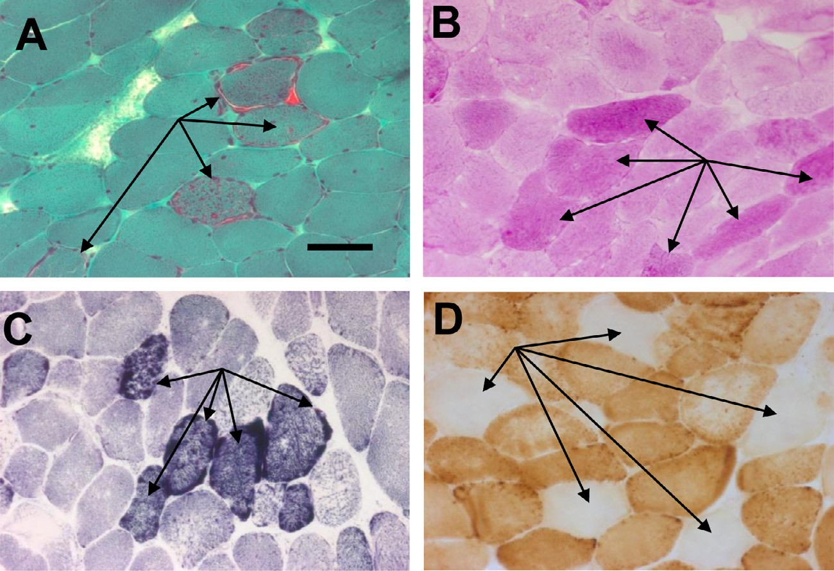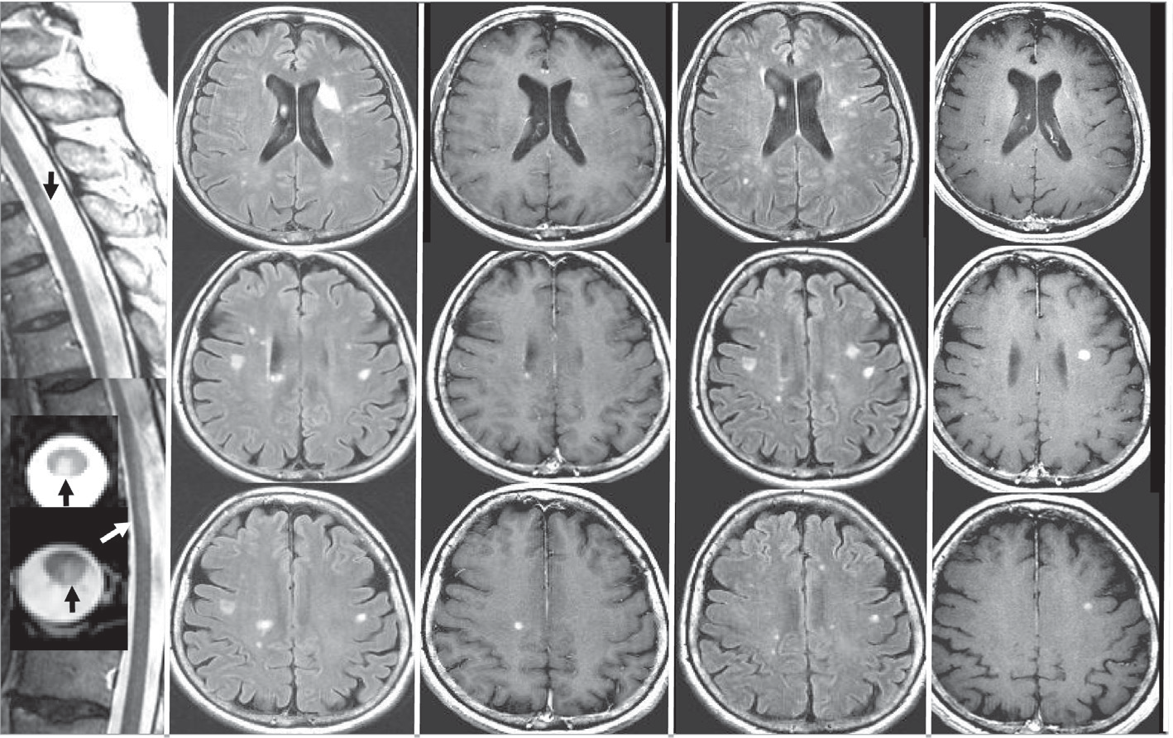

**A**

**B**

**C**

**D**

**E**

Fig. 2. (A) Fluid-attenuated inversion recovery (FLAIR) MRI sagittal sequences (inserts: axial sequences) of the spinal cord showing two thoracic hyperintensities (black and white arrows; taken when the patient was 58 years old). Axial (B) FLAIR MRI showing multiple white matter hyperintensities, with (C) post-gadolinium T1-weighted sequences showing two enhanced lesions (56 years old). Axial (D) T2–FLAIR MRI showing increased lesion load with (E) post-gadolinium T1-weighted sequences showing a new active lesion and disappearance of previous gadolinium enhancement (58 years old).

188 *Case Reports / Journal of Clinical Neuroscience 21 (2014) 186–188*

Conﬂict of interest/disclosure

The authors declare that they have no ﬁnancial or other con- ﬂicts of interest in relation to this research and its publication.

Acknowledgement

The authors thank Rebecca Psutka for editorial suggestions.

References

1. Wong LJ, Naviaux RK, Brunetti-Pierri N, et al. Molecular and clinical genetics of mitochondrial diseases due to POLG mutations. *Hum Mutat* 2008;29:E150–72.
2. Tang S, Wang J, Lee NC, et al. Mitochondrial DNA polymerase gamma mutations: an ever expanding molecular and clinical spectrum. *J Med Genet* 2011;48:669–81.
3. Polman CH, Reingold SC, Banwell B, et al. Diagnostic criteria for multiple sclerosis: 2010 revisions to the McDonald criteria. *Ann Neurol* 2011;69:292–302.
4. Echaniz-Laguna A, Chassagne M, de Sèze J, et al. POLG1 variations presenting as multiple sclerosis. *Arch Neurol* 2010;67:1140–3.
5. Campbell GR, Mahad DJ. Mitochondrial changes associated with demyelination: consequences for axonal integrity. *Mitochondrion* 2012;12:173–9.
6. Campbell GR, Ziabreva I, Reeve AK, et al. Mitochondrial DNA deletions and neurodegeneration in multiple sclerosis. *Ann Neurol* 2011;69:481–92.
7. Carelli V, Bellan M. Myelin, mitochondria, and autoimmunity. What’s the connection? *Neurology* 2008;70:1075–6.
8. Palace J. Multiple sclerosis associated with Leber’s Hereditary Optic Neuropathy. *J Neurol Sci* 2009;286:24–7.
9. Verny C, Loiseau D, Scherer C, et al. Multiple sclerosis like disorder in OPA1- related autosomal dominant optic atrophy. *Neurology* 2008;70:1152–3.
10. Linker RA, Lee DH, Ryan S, et al. Fumaric acid esters exert neuroprotective effects in neuroinﬂammation via activation of the Nrf2 antioxidant pathway. *Brain* 2011;134:678–92.

doi:<http://dx.doi.org/10.1016/j.jocn.2013.03.019>