DOI 10.1007/s00415-014-7428-2

LETTER TO THE EDITORS

Mitochondrial neurogastrointestinal encephalomyopathy (MNGIE)-like phenotype in a patient with a novel heterozygous *POLG* mutation

Pankaj Prasun • Dwight D. Koeberl

Received: 11 June 2014 / Revised: 26 June 2014 / Accepted: 27 June 2014 / Published online: 15 July 2014

© Springer-Verlag Berlin Heidelberg 2014

Dear Sirs,

POLG-related disease can present with varying degree of severity and timing of onset with multiple organ involve- ment [1]. In adulthood, *POLG* mutations usually present with progressive external ophthalmoplegia (PEO). PEO can be due to dominant or recessive mutations in *POLG*. Autosomal dominant PEO is associated with generalized progressive myopathy. Affected individuals may also have sensorineural deafness, ataxia, axonal neuropathy, depres- sion, parkinsonism, cataract, and hypogonadism. Mito- chondrial neurogastrointestinal encephalomyopathy (MNGIE)-like presentations have been reported previously with autosomal recessive *POLG* mutations [2, 3]. Here, we describe a 38-year-old male with a novel heterozygous mutation in *POLG* presenting as MNGIE.

The patient had bilateral cataracts removed in early childhood. He developed chronic diarrhea and weight loss in his 20s, which were associated with a rash that on biopsy showed features of dermatitis herpetiformis. Hence, he was diagnosed with celiac disease. Gluten-restricted diet led to resolution of rash, but diarrhea persisted. At the age of 35 years, the patient presented with weakness of upper extremities and bilateral ptosis. A muscle biopsy revealed ragged-red fibers and cytochrome c oxidase (COX) nega- tive fibers. Mitochondrial genome sequencing from peripheral blood was normal. His weakness continued to progress and involved lower extremities, accompanied by impaired upgaze. He developed cachexia associated with chronic persistent diarrhea. Electromyography and nerve

P. Prasun D. D. Koeberl (&)

Division of Medical Genetics, Department of Pediatrics, Duke University Medical Center 103856, Durham, NC 27710, USA e-mail: [Dwight.Koeberl@duke.edu](mailto:Dwight.Koeberl@duke.edu)

•

1 3

conduction study showed chronic myopathy and severe sensory neuropathy, respectively. MNGIE was suspected due to progressive gastrointestinal dysmotility and cachexia, but sequencing of *TYMP* gene was normal. *POLG* sequencing and deletion/duplication analysis from peripheral blood DNA showed a heterozygous novel vari- ant, c.2669C[A (p.D890A). Mitochondrial genome next- generation sequencing on skeletal muscle revealed multiple deletions confirming pathogenicity of this variant. Mag- netic resonance imaging (MRI) of the brain was normal (Fig. 1). On further evaluation, the patient was found to have hypogonadism, hypothyroidism, and osteopenia. The patient has gained weight after starting testosterone.

MNGIE is characterized by progressive gastrointestinal dysmotility, cachexia, PEO and peripheral neuropathy [4]. It is caused by autosomal recessive mutations in *TYMP* gene. A MNGIE-like phenotype has also been reported in a patient with recessive mutations in *RRM2B* [5]. Autosomal recessive mutations in *POLG* presenting as MNGIE was first reported by Van Goethem et al. [2] in two sisters. Tang et al. [3] reported clinical features consistent with MNGIE in 3 of 92 patients with two pathogenic mutations in *POLG*. We are reporting the first patient with heterozygous *POLG* mutation presenting as MNGIE. This is a novel and likely to be pathogenic mutation due to characteristic clinical presentation, muscle histology, and associated multiple deletions in mitochondrial DNA in muscle biopsy. Aspar- tate at 890 position is evolutionally conserved from yeast to human and resides at the critical site for catalysis. Muta- tions at this position (D890N) in cultured human cells resulted in mitochondrial DNA depletion [6, 7]. Moreover, expression in cultured human cells suggested that this mutation may be pathogenic in heterozygous state [7]. In the absence of affected relatives, this mutation is likely a de novo dominant mutation in our patient. Like the previous

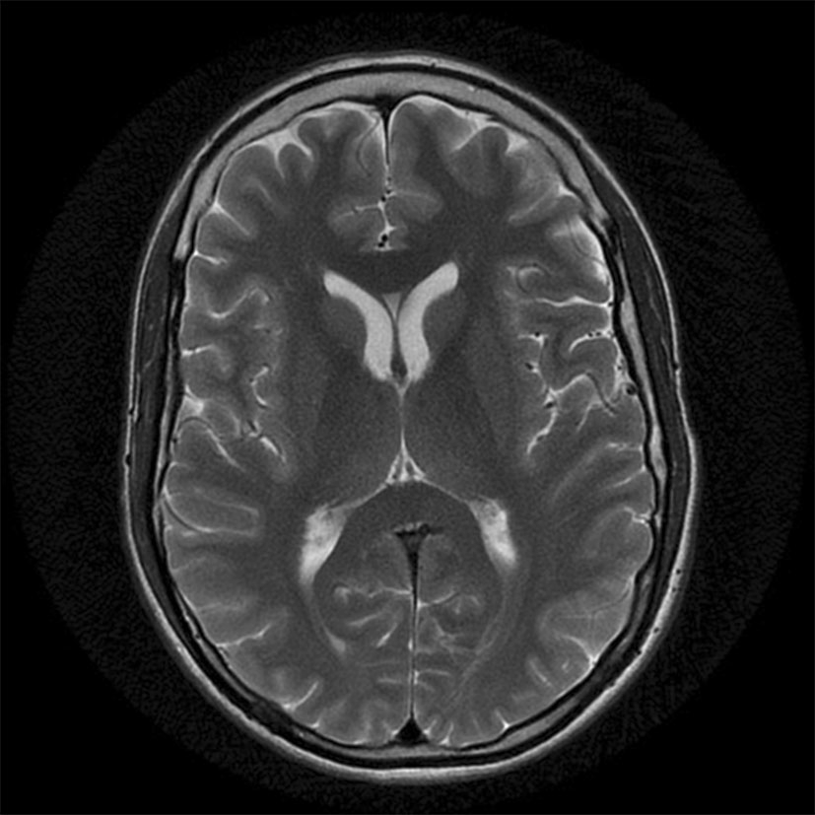

Fig. 1 Brain MRI at diagnosis of POLG-related condition revealed no leukodystrophy

patients with *POLG* mutations and MNGIE phenotype, our patient too had absence of leukodystrophy on brain MRI [2, 3]. Leukodystrophy is hallmark of MNGIE [8]. Although gastrointestinal dysmotility is commonly seen in mito- chondrial disorders [9], the combination of severe dysmo- tility, cachexia, peripheral neuropathy, ophthalmoplegia, and asymptomatic leukodystrophy is suggestive of MNGIE. As many of these features are also seen in POLG- related disorders, clinical presentation may overlap. Brain MRI revealing diffuse leukodystrophy is suggestive of MNGIE. In the absence of asymptomatic diffuse leuko- dystrophy, other possible etiologies, particularly POLG- related conditions should be considered [10]. Thus, this case expands the spectrum of phenotypes linked to AD POLG mutations to include MNGIE-like presentations.

Acknowledgments We wish to acknowledge the contributions of Dr. John Kissel at The Ohio State University to the evaluation of this patient. Dr. Prasun does not have any funding sources to declare related to the study and to the article preparation.

Dr. Koeberl does not have any funding sources to declare related to the study and to the article preparation.

Conflicts of interest Dr. Pankaj Prasun has no potential conflicting or competing interests that could in any way affect the conduct of the study, interpretation of results, or preparation of the manuscript.

Dr. Dwight D. Koeberl has no potential conflicting or competing interests that could in any way affect the conduct of the study, interpretation of results, or preparation of the manuscript.

References

1. Stumpf JD, Saneto RP, Copeland WC (2013) Clinical and molecular features of POLG-related mitochondrial disease. Cold Spring Harb Perspect Biol 5:a011395
2. Van Goethem G, Schwartz M, Lo¨fgren A, Dermaut B, Van Broeckhoven C, Vissing J (2003) Novel POLG mutations in progressive external ophthalmoplegia mimicking mitochondrial neurogastrointestinal encephalomyopathy. Eur J Hum Genet 11:547–549
3. Tang S, Dimberg EL, Milone M, Wong LJ (2012) Mitochondrial neurogastrointestinal encephalomyopathy (MNGIE)-like pheno- type: an expanded clinical spectrum of POLG1 mutations. J Neurol 259:862–868
4. Hirano M, Nishigaki Y, Mart´ı R (2004) Mitochondrial neuro- gastrointestinal encephalomyopathy (MNGIE): a disease of two genomes. Neurologist 10:8–17
5. Shaibani A, Shchelochkov OA, Zhang S, Katsonis P, Lichtarge O, Wong LJ, Shinawi M (2009) Mitochondrial neurogastroin- testinal encephalopathy due to mutations in RRM2B. Arch Neurol 66:1028–1032
6. Spelbrink JN, Toivonen JM, Hakkaart GA, Kurkela JM, Cooper HM, Lehtinen SK, Lecrenier N, Back JW, Speijer D, Foury F, Jacobs HT (2000) In vivo functional analysis of the human mitochondrial DNA polymerase POLG expressed in cultured human cells. J Biol Chem 275:24818–24828
7. Wanrooij S, Goffart S, Pohjoisma¨ki JL, Yasukawa T, Spelbrink JN (2007) Expression of catalytic mutants of the mtDNA helicase Twinkle and polymerase POLG causes distinct replication stall- ing phenotypes. Nucleic Acids Res 35:3238–3251
8. Wong LJ (2012) Mitochondrial syndromes with leukoencephal- opathies. Semin Neurol 32:55–61
9. Di Donato S (2009) Multisystem manifestations of mitochondrial disorders. J Neurol 256:693–710
10. Echaniz-Laguna A, Chassagne M, de Se`ze J, Mohr M, Clerc-

Renaud P, Tranchant C, Mousson de Camaret B (2010) POLG1 variations presenting as multiple sclerosis. Arch Neurol 67:1140–1143

1 3