## RESIDENT & FELLOW SECTION

Section Editor Mitchell S.V. Elkind, MD, MS

# David Arkadir, MD, PhD Vardiella Meiner, MD Arnon Karni, MD Alexander Lossos, MD

Correspondence to Dr. Arkadir:

[arkadir@hadassah.org.il](mailto:arkadir@hadassah.org.il)

Teaching Neuro*Images*:

Hypertrophic olivary degeneration in a young man with *POLG* gene mutation

Figure Abnormal findings on MRI

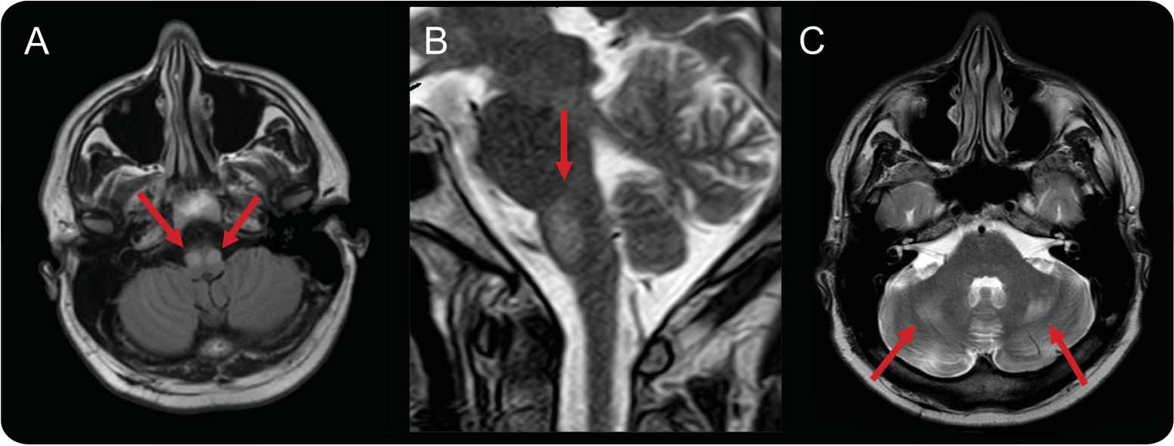

Symmetric hyperintense signal abnormality and enlarged inferior olives on (A) fluid-attenuated inversion recovery and (B) T2 images, characteristic of bilateral hypertrophic olivary degeneration. Additional findings included hyperintense T2 signal changes in the thalami and deep cerebellar nuclei and mild cerebellar vermis atrophy (C).

# A 30-year-old man with sensorineural hearing loss presented with subacute somnolence, slurred speech, and unsteady gait following treatment with peginter- feron a-2b and ribavirin for chronic hepatitis C virus. Examination revealed scanning speech, horizontal nys- tagmus, gait ataxia, and symmetric hyporeflexia with distal sensory loss. There was no palatal myoclonus. Metabolic and serologic workup and blood lactate were unrevealing. Brain MRI demonstrated bilateral hyper- trophic olivary degeneration (HOD, figure). Whole exome sequencing identified a homozygous pathogenic p.W748S *POLG* mutation.1 Differential diagnosis of bilateral HOD includes mutations in the nuclear genes crucial to mitochondrial function, *POLG* and *SURF1*.2

## AUTHOR CONTRIBUTIONS

D.A. had substantial contributions to conception and design of the work, acquisition and interpretation of data, drafting the work, and final approval of the submitted version. V.M. had substantial contributions to conception and design of the work, acquisition and interpretation of

data, drafting the work, and final approval of the submitted version.

A.K. had substantial contributions to conception and design of the work, acquisition and interpretation of data, drafting the work, and final approval of the submitted version. A.L. had substantial contributions to conception and design of the work, acquisition and interpretation of data, drafting the work, and final approval of the submitted version.

## STUDY FUNDING

No targeted funding reported.

## DISCLOSURE

The authors report no disclosures relevant to the manuscript. Go to [Neurology.org](http://neurology.org/) for full disclosures.

## REFERENCES

1. Tzoulis C, Engelsen BA, Telstad W, et al. The spectrum of clinical disease caused by the A467T and W748S POLG mutations: a study of 26 cases. Brain 2006;129:1685–1692.
2. Kinghorn KJ, Kaliakatsos M, Blakely EL, et al. Hypertro- phic olivary degeneration on magnetic resonance imaging in mitochondrial syndromes associated with POLG and SURF1 mutations. J Neurol 2013;260:3–9.



Downloaded from [https://www.neurology.org](http://www.neurology.org/) by 92.40.204.36 on 4 July 2025

Download teaching slides:

[Neurology.org](http://Neurology.org/)

From The Departments of Neurology (D.A., A.L.) and Genetic and Metabolic Diseases (V.M.), Hebrew University–Hadassah Medical Center, Jerusalem; and The Department of Neurology (A.K.), Tel Aviv University–Sourasky Medical Center, Tel Aviv, Israel.

© 2015 American Academy of Neurology e59

ª 2015 American Academy of Neurology. Unauthorized reproduction of this article is prohibited.