Cerebellum (2016) 15:829–831 DOI 10.1007/s12311-015-0749-6



SHORT REPORT

Pure Progressive Ataxia and Palatal Tremor (PAPT) Associated with a New Polymerase Gamma (*POLG*) Mutation

Nicolas Nicastro 1 • Emmanuelle Ranza2 •

Stylianos E. Antonarakis2,3,4 • Judit Horvath1

Published online: 25 November 2015

# Springer Science+Business Media New York 2015

Abstract Progressive ataxia with palatal tremor (PAPT) is a syndrome caused by cerebellar and brainstem lesions involving the dentato-rubro-olivary tract and associated with hypertrophic olivary degeneration. Etiologies include ac- quired posterior fossa lesions (e.g. tumors, superficial siderosis, and inflammatory diseases) and genetic disorders, such as glial fibrillary acidic protein (*GFAP*) and polymerase gamma (*POLG*) mutations. We describe the case of a 52-year- old man who developed pure progressive ataxia and palatal tremor. Genetic analysis has shown that he is compound het- erozygote for a known pathogenic (W748S) and a novel *POLG* variant (I1185N). Patients with *POLG* recessive muta- tions usually manifest a more complex clinical picture, includ- ing polyneuropathy and epilepsy; our case emphasizes the

Nicolas Nicastro and Emmanuelle Ranza contributed equally to this work.

Electronic supplementary material The online version of this article (doi:[10.1007/s12311-015-0749-6](http://dx.doi.org/10.1007/s12311-015-0749-6)) contains supplementary material, which is available to authorized users.

* Judit Horvath [judit.horvath@hcuge.ch](mailto:judit.horvath@hcuge.ch)

1 Division of Neurology, Department of Clinical Neurosciences, Geneva University Hospitals, 4, Rue Gabrielle-Perret-Gentil, 1205 Geneva, Switzerland

2 Division of Genetic Medicine, Geneva University Hospitals, Geneva, Switzerland

3 Department of Genetic Medicine and Development, University of Geneva, Geneva, Switzerland

4 iGE3, Institute of Genetics and Genomics of Geneva, University of Geneva, Geneva, Switzerland

need to consider a genetic origin in a seemingly sporadic and pure PAPT.

Keywords Ataxia . Cerebellar disorders . Mitochondrial disorders . Polymerase gamma

# Introduction

Progressive ataxia with palatal tremor (PAPT) is caused by cerebellar and brainstem lesions involving the dentato- rubro-olivary tract, also referred to as Guillain-Mollaret triangle, resulting in characteristic hypertrophic olivary de- generation. Etiologies include acquired posterior fossa le- sions (such as tumors, superficial siderosis, and inflamma- tory diseases) and genetic disorders [1]. Cases have been described with pathogenic variants in *GFAP* (OMIM 137780, adult-onset Alexander’s disease), in *SURF1* (OMIM 185620), and polymerase gamma (*POLG*) (OMIM 174763). When linked to these latter genes, PAPT is usually part of a wider clinical picture, including extensive neurological symptoms and/or hepatic abnor- malities, which are due to mitochondrial dysfunction [2, 3].

# Case Report

A 52-year-old male patient, treated for hypertension and dia- betes, presented to our neurology division in 2013 because of progressive gait and balance difficulties since two years. One year later, he started complaining of audible ear click and oscillopsia. On neurological examination, he had pendular vertical nystagmus, dysarthria, kinetic and static ataxia with severe postural instability, as well as palatal tremor (as shown

 

830 Cerebellum (2016) 15:829–831

in Video 1). He became wheelchair-bound within 4 years after the first symptoms. He had no visual or hearing loss, neither signs of ophthalmoparesis, peripheral neuropathy, propriocep- tive deficit, myopathy, epileptic activity, or cognitive decline. Family history was unremarkable on the maternal side and unknown on the paternal side. The mother of the patient died at the age of 86 without evidence of neurologic disease. As palatal tremor was not bothering him, no symptomatic treat- ment has been introduced.

Brain MRI was performed in 2012 and showed cerebellar white matter signal abnormalities along with atrophy and bilateral T2 hyperintense enlarged olives (see Fig. 1). Cerebrospinal fluid analysis was normal, including immunoelectrophoresis and PCR for *T. whipplei* . Paraneoplastic antineuronal antibodies were negative, and to- tal body PET-CT did not detect any tumor. Routine EEG and nerve conduction studies (electroneuromyography) were nor- mal. A search for pathogenic mutations in the *GFAP* gene was negative. Mutations in the *POLG* gene were suspected be- cause of progressive ataxia and the above-mentioned MRI findings. Similar MRI abnormalities have already been de- scribed in the literature in patients with POLG mutations [4, 5].

# Results

We performed Sanger sequencing of the coding regions and splice sites of *POLG* (NM_002693.2) and found a compound heterozygous state for mutations c.2243G>C:p.Trp748Ser (W748S) and c.3554T>A:p.Ile1185Asn (I1185N). The

W748S variant is described as one of the most frequent *POLG* pathogenic mutations in the European population with a minimal allele frequency of approximately 0.1 %. The I1185N

variant (not found in ExAC Browser, Exome Aggregation Consortium, <http://exac.broadinstitute.org/>) is predicted to be damaging (Polyphen-2, SIFT, MutationTaster) and lies in a highly conserved position, where another mutation c.3554T>C:p.Ile1185Thr (I1185T) has been recently pub- lished [6]. Familial segregation analysis suggests that the two variants are located *in trans*, as the maternal half brother of the patient carries only the I1185N variant.

# Discussion

*POLG* mutations can lead to a multitude of clinical manifes- tations, constituting the broad phenotypical spectrum of the so-called *POLG*-related disorders [1, 7]: Alpers-Huttenlocher syndrome, childhood myocerebrohepatopathy, autosomal dominant and recessive progressive external ophthalmoplegia (PEO), and ataxia neuropathy syndrome (ANS) further subdivided to sensory ataxia, neuropathy, dysarthria, ophthalmoplegia (SANDO) and mitochondrial recessive atax- ia syndrome (MIRAS).

Our patient is compound heterozygote for one known path- ogenic *POLG* variant, the W748S, and a novel likely pathogen- ic variant, the I1185N. I1185N occurs at the same position as the recently reported I1185T in a case of childhood myocerebrohepatopathy spectrum disorder [6]. Moreover, other pathogenic variants, such as c.3550G>A:p.Asp1184Asn (D1184N), c.3550G>C:p.Asp1184Leu (D1184L), and

c.3559C>T:p.Arg1187Try (R1187W) ([http://tools.niehs.nih.](http://tools.niehs.nih.gov/polg/) [gov/polg/](http://tools.niehs.nih.gov/polg/)), have been found in the same functional region, namely the polymerase domain [2]. The D1184N has been found in a compound heterozygous state in patients with autosomal recessive PEO and tetraparesis. Moreover, the

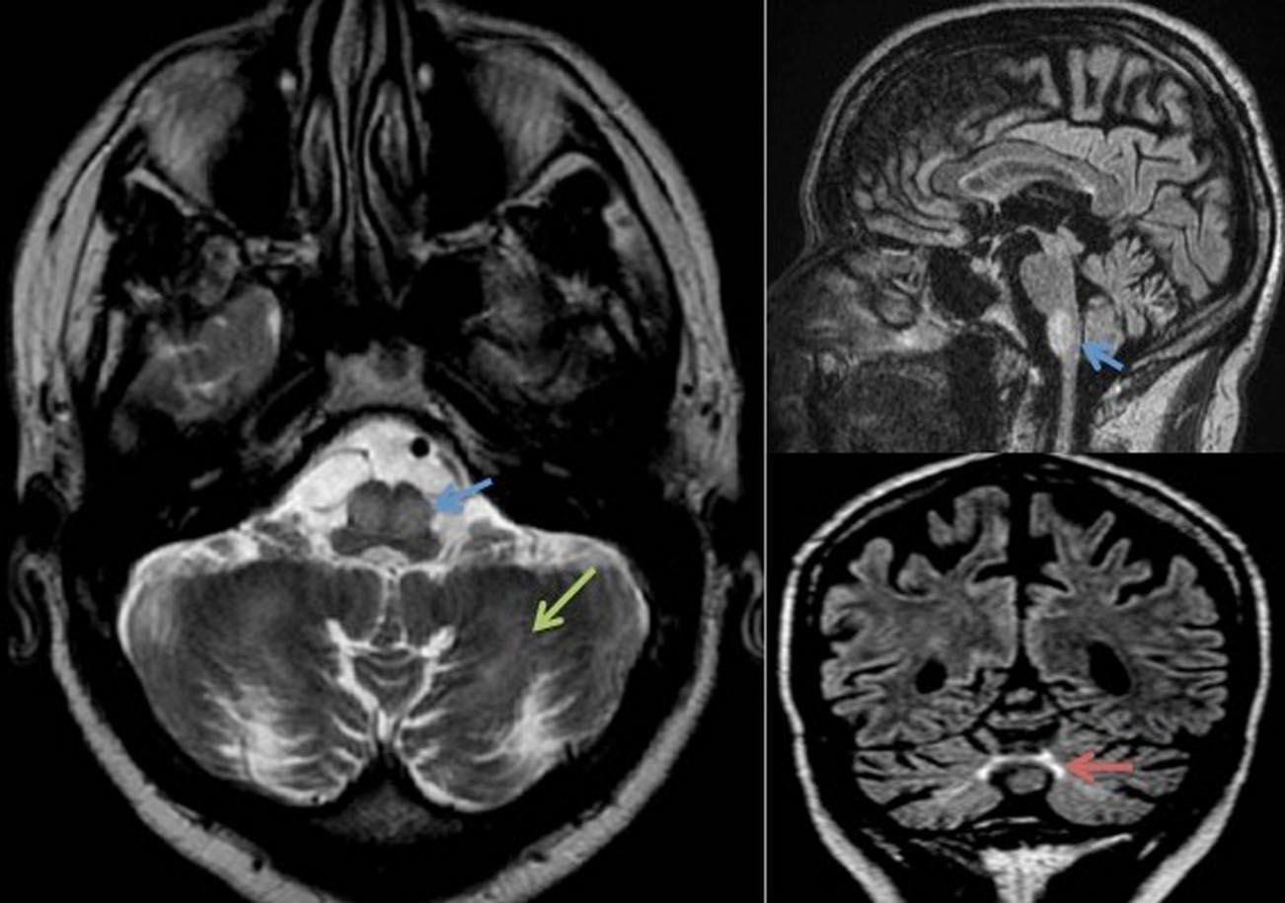Fig. 1 Brain MRI showing bilateral olivary and cerebellar lesions. Hyperintense, hypertrophic inferior olives (*blue arrows*) and symmetrically increased signal intensity of the cerebellar white matter (*green arrow*) at axial T2-weighted images (*on left panel*).

Hyperintense inferior olives at sagittal FLAIR (*right upper panel*) and of the vermis (*red arrow*) at coronal FLAIR sequence (*right lower panel*) with moderate cerebellar and parietal cortical atrophy



Cerebellum (2016) 15:829–831 831

same variant was identified in a heterozygous state in two adult patients suffering from late-onset PEO and parkinsonism, with- out a second mutation, raising the possibility of an incomplete dominant effect [8]. Of note, most of the reported dominant mutations affect the polymerase domain [2]. Family segrega- tion analysis of this type of variants necessitates careful genetic counseling, since they may unveil a late-onset disorder in asymptomatic individuals.

# Conclusion

The patient we report is manifesting a pure PAPT syndrome. Within the *POLG*-related disorders, his clinical picture mostly resembles MIRAS, yet the lack of neuropathy and epilepsy along with the late onset is atypical. Moreover, palatal tremor does not seem to be commonly associated to MIRAS, since it was not described in a series of 27 MIRAS patients [9]. In a small series of hypertrophic olivary degeneration, Kinghorn et al. [3] reported two patients with compound heterozygous *POLG* mutations, both of which had more complex pheno- types than our patient: one had SANDO, the other suffered from ophthalmoplegia, myopathy, and neuropathy. Our case emphasizes the need to consider *POLG* screening in a pure, seemingly sporadic PAPT syndrome.

Acknowledgments We thank Pr Rita Horvath (Institute of Human Genetics, Newcastle University) and Pr Alexandra Durr (Department of Genetics, Hôpital La Pitié-Salpêtrière, Paris) for useful discussion.

Compliance with Ethical Standards

Financial Disclosures Dr N. Nicastro reports no disclosure.

Dr E. Ranza reports no disclosure.

Prof. S.E. Antonarakis reports no disclosure relevant to the manu- script. He received funding from Geberit Foundation and the Synapsy NCCR of the Swiss National Science Foundation

Dr J. Horvath reports no disclosure.

Conflict of Interest The authors declare that they have no competing interests.

# References

1. Samuel M, Torun N, Tuite PJ, Sharpe JA, Lang AE. Progressive ataxia and palatal tremor (PAPT): clinical and MRI assessment with review of palatal tremors. Brain. 2004;127(6):1252–68.
2. Horvath R, Hudson G, Ferrari G, Fütterer N, Ahola S, et al. Phenotypic spectrum associated with mutations of the mito- chondrial polymerase gamma gene. Brain. 2006;129(7): 1674–84.
3. Kinghorn KJ, Kaliakatsos M, Blakely EL, Taylor RW, Rich P, et al. Hypertrophic olivary degeneration on magnetic resonance imaging in mitochondrial syndromes associated with POLG and SURF1 mu- tations. J Neurol. 2013;260(1):3–9.
4. Arkadir D, Meiner V, Karni A, Lossos A. Teaching NeuroImages: hypertrophic olivary degeneration in a young man with POLG gene mutation. Neurology. 2015;84(8), e59.
5. Synofzik M, Srulijes K, Godau J, Berg D, Schöls L. Characterizing POLG ataxia: clinics, electrophysiology and imaging. Cerebellum. 2012;11(4):1002–11.
6. Montassir H, Maegaki Y, Murayama K, Yamazaki T, Kohda M, et al. Myocerebrohepatopathy spectrum disorder due to POLG mutations: a clinicopathological report. Brain Dev 2014; S0387- 7604(14)00261-7
7. Goyal M, Versnick E, Tuite P, Cyr JS, Kucharczyk W, Montanera W, et al. Hypertrophic olivary degeneration: metaanalysis of the temporal evolution of MR findings. Am J Neuroradiol. 2000;21(6):1073–7.
8. Rouzier C, Chaussenot A, Serre V, Fragaki K, Bannwarth S, et al. Quantitative multiplex PCR of short fluorescent frag- ments for the detection of large intragenic POLG rearrange- ments in a large French cohort. Eur J Hum Genet. 2014;22(4): 542–50.
9. Hakonen AH, Heiskanen S, Juvonen V, Lappalainen I, Luoma PT, et al. Mitochondrial DNA polymerase W748S mutation: a common cause of autosomal recessive ataxia with ancient European origin. Am J Hum Genet. 2005;77:430–41.

 