

A

FOR

FINE BRAIDED WIRES

HIGHER RADIAL FORCE

# Self-Expandable LEO+:



EASE OF USE



HIGHER VISIBILITY



FLARED ENDS

Intracranial stent designed for the treatment of wide-neck aneurysm

Braided design allows the ﬁne nitinol wires to slide smoothly onto each other to reach perfect vessel conformability, as well as provide coil support

# The original braided stent

riginal braided

stent

so compatible with a

is al o compatible with a

Mesh size Stent’s lenght



Artery diameter

# coiling microcatheter 1

(VASCO+10, ID: .017”)

## LOW PROFILE to gain access to vessels down to Ø 1,5mm

Avoid microcatheter exchange

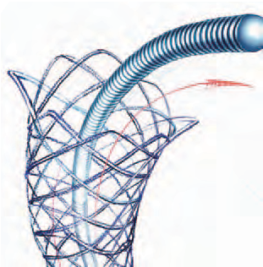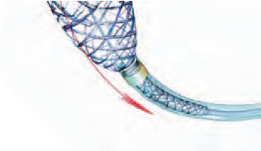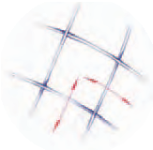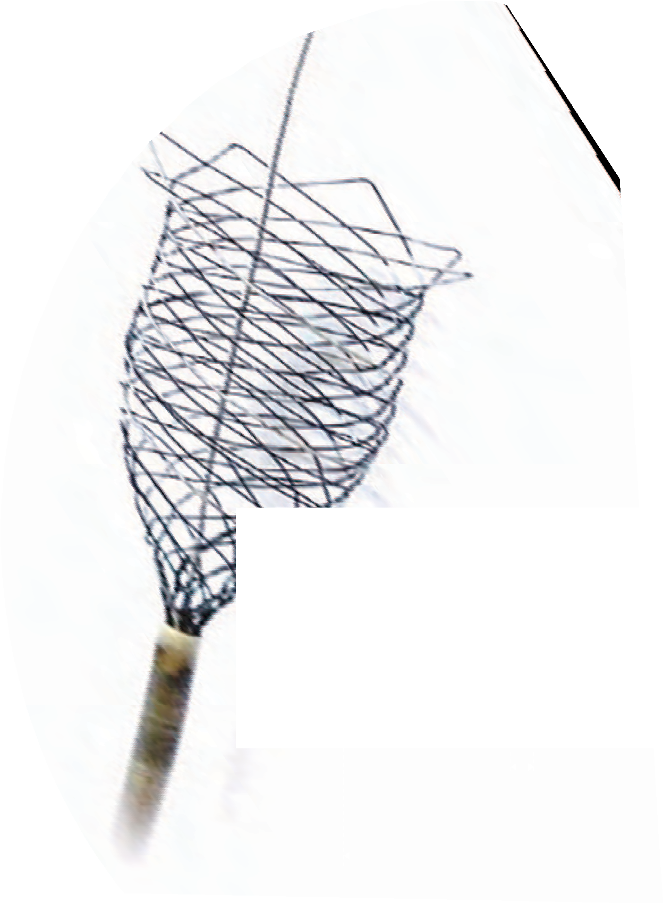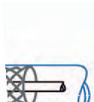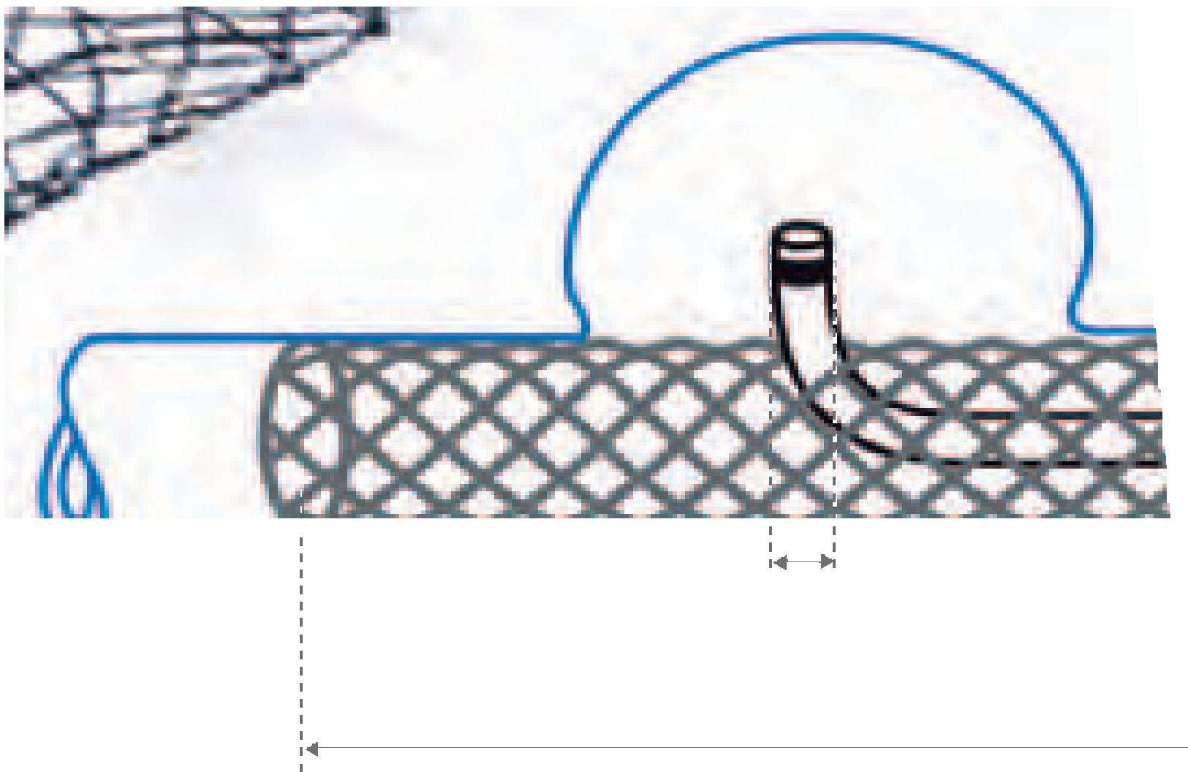

*Case report*

Characteristic brain MRI findings in ataxia-neuropathy spectrum related to POLG mutation

## Adriana I Henao1, Sonia Pira1, Diego A Herrera2,3, Sergio A Vargas2,3, Jorge Montoya4 and Mauricio Castillo5

The Neuroradiology Journal 2016, Vol. 29(1) 46–48

! The Author(s) 2016 Reprints and permissions:

sagepub.co.uk/journalsPermissions.nav DOI: 10.1177/1971400915621324

neu.sagepub.com



Abstract

Patients with mutations in the polymerase gamma gene (POLG) may present with progressive ataxia and in such situations neuroimaging findings may suggest the diagnosis. Herein we report a patient with a POLG gene W748S homozygous mutation and characteristic lesions in the thalamus, cerebellum and inferior olivary nucleus seen on magnetic resonance imaging.

Keywords

Ataxia, MRI, POLG

## Introduction

The nuclear POLG gene in chromosome 15q25.7 codes for polymerase gamma enzyme which is involved in replication and repair of mitochondrial DNA.1 Multiple mutations have been identiﬁed and are associated with diverse clinical syndromes called ‘‘POLG-related disorders’’ including progressive exter- nal ophthalmoparesis, Alpers’ syndrome, epilepsy, Parkinsonism, infertility in men, and ataxia-neuropathy spectrum (previously called SANDO and MIRAS).2–6

The hereditary ataxias are classiﬁed according to their causative genes and inheritance patterns (i.e. auto- somal dominant, autosomal recessive, x-linked, or mitochondrial). A broad range of diagnostic consider- ations may be suggested by the family history, by ﬁndings on physical examination, and by magnetic res- onance imaging (MRI) evidence of atrophy or abnor- mal signal intensity in the cerebellum, brainstem, spinal cord, and other brain structures. However, a deﬁnitive diagnosis relies on molecular genetic testing.7 Occasionally, as in the ataxia-neuropathy spectrum related to POLG mutation, characteristic MRI ﬁndings strongly suggest the diagnosis of ataxia-neuropathy. To illustrate this, here we report a patient with a POLG gene W748S homozygous mutation and a unique combination of lesions in the thalamus, cerebel- lum and inferior olivary nucleus seen on MRI.

## Case report

A 29-year-old woman presented with a 5-year history of ataxia and dysarthria. There were no relevant personal

or familial histories. Physical examination revealed external ophthalmoparesis, generalized areﬂexia, abnormal leg pallesthesia, wide-based gait, positive Romberg test, dysmetria, and a predominantly left dysdiadochokinesia. Laboratory studies were unre- markable. Nerve conduction velocity tests showed a distal symmetric sensorimotor neuropathy and somato- sensory evoked potentials were absent.

Brain MRI showed cerebellar atrophy and T2 bright bilateral lesions in the dorsal thalami, cerebellar white matter and left inferior olivary nucleus (Figure 1). Diﬀusion-weighted images showed no restricted diﬀu- sion in those areas. Contrast-enhanced images were not obtained. Neuroimaging ﬁndings prompted a search for POLG mutation and genetic testing conﬁrmed a POLG W748S homozygous mutation.

1Department of Pediatric Neurology, Universidad de Antioquia, Medell´ın, Colombia

2Department of Radiology, Universidad de Antioquia, Medell´ın, Colombia 3Department of Radiology, CediMed (Centro Avanzado de Diagno´stico Me´dico), Medell´ın, Colombia

4Department of Genetics, Universidad de Antioquia, Medell´ın, Colombia 5Department of Radiology, University of North Carolina, Chapel Hill, NC, USA

Corresponding author:

Diego A Herrera, Universidad de Antioquia, Calle 32D #80B – 34, Medell´ın, 050030, Colombia.

Email: [herrera.diego@gmail.com](mailto:herrera.diego@gmail.com)

*Henao et al.* 47

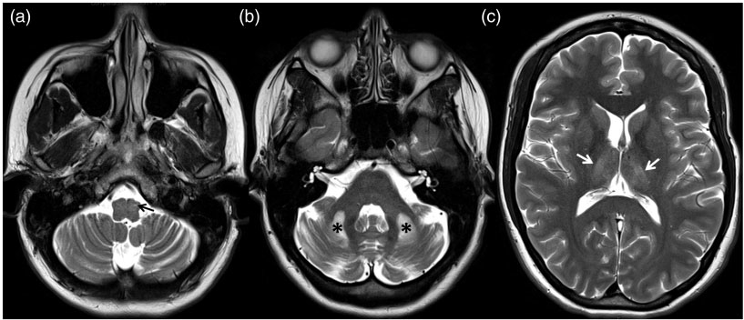

Figure 1. Axial T2-weighted images show cerebellar atrophy with prominent fissures and hyperintense lesions in left inferior olivary nucleus (arrow in A), cerebellar white matter (asterisks in B) and dorso-medial thalami (arrows in C).

## Discussion

There are diﬀerent phenotypes in ataxia related to POLG mutations including: (1) young-onset (<25 years old) with or without ataxia; (2) late-onset ataxia; (3) multiple system atrophy; (4) ataxia with epi- lepsy; (5) ataxia with cognitive impairment; (6) ataxia with elevated liver enzymes; and (7) ataxia with neur- opathy.8 The clinical presentation of the last of these matches the symptoms present in our patient, which were mainly related to cerebellar signs and neuropathy. However, it is to be noted that the genotype–phenotype correlations may be variable and that mixed syndromes are possible.9

In 2001, Rantama¨ki et al. reported a Finnish family with adult-onset progressive ataxia, dysarthria, neur- opathy, epilepsy, ophthalmoparesis and MRI ﬁndings similar to those of our patient with abnormal T2 signal intensity in the thalami and cerebellar white matter.10 Additional neuroimaging ﬁndings have been reported in other series, including cerebellar atrophy and olivary nucleus degeneration, and these ﬁndings can be present in patients with homozygous W748S/ W748S and heterozygous W748S/A467T POLG mutations.1,5,11–13

The latest ACR appropriateness criteria guidelines classify ataxia in four groups as follows.7 Variant 1: Gradually progressive ataxia or ataxia of long duration (mass lesion, demyelinating disorders, congenital dis- orders, hereditary and idiopathic degenerative pro- cesses, superﬁcial siderosis, spinal cord and peripheral nerve-related ataxia, nutritional deﬁciency, toxins and drugs); Variant 2: Acute ataxia as a possible manifest- ation of stroke; Variant 3: Acute or subacute ataxia as a manifestation of suspected infection; and Variant 4: Acute ataxia following head trauma. Occasionally MRI allows diﬀerentiation between these groups, but if a hereditary and idiopathic degenerative ataxia is sus- pected, neuroimaging ﬁndings are nonspeciﬁc in most patients. Nevertheless, awareness of speciﬁc MRI ﬁnd- ings in the ataxia-neuropathy spectrum related to

POLG mutation may be helpful to facilitate the diagnosis and lead to the appropriate genetic tests.

## Conclusion

In the context of neurodegenerative ataxia, MRI ﬁnd- ings of bright T2 lesions in the dorso-medial thalami, cerebellar white matter and the inferior olivary nuclei should prompt a search for POLG mutation and the ataxia-neuropathy spectrum-related disorders.

Funding

This research received no speciﬁc grant from any funding agency in the public, commercial, or not-for-proﬁt sectors.

Conflict of interest

The author(s) declared no potential conﬂicts of interest with respect to the research, authorship, and/or publication of this article.

References

1. Habek M, Barun B, Adamec I, et al. Early-onset ataxia with progressive external ophthalmoplegia associated with POLG mutation: Autosomal recessive mitochondrial ataxic syndrome or SANDO? *Neurologist* 2012; 18: 287–289.
2. Winterthun S, Ferrari G, He L, et al. Autosomal recessive mitochondrial ataxic syndrome due to mitochondrial poly- merase gamma mutations. *Neurology* 2005; 64: 1204–1208.
3. Horvath R, Hudson G, Ferrari G, et al. Phenotypic spec- trum associated with mutations of the mitochondrial poly- merase gamma gene. *Brain* 2006; 129: 1674–1684.
4. Stumpf JD, Saneto RP and Copeland WC. Clinical and molecular features of POLG-related mitochondrial dis- ease. *Cold Spring Harb Perspect Biol* 2013; 5: a011395.
5. Hakonen AH, Heiskanen S, Juvonen V, et al. Mitochondrial DNA polymerase W748S mutation: A common cause of autosomal recessive ataxia with ancient European origin. *Am J Hum Genet* 2005; 77: 430–441.
6. Milone M, Brunetti-Pierri N, Tang LY, et al. Sensory ataxic neuropathy with ophthalmoparesis caused by POLG mutations. *Neuromuscul Disord* 2008; 18: 626–632.

48 *The Neuroradiology Journal 29(1)*

1. Broderick DF, Wippold FJ II, Cornelius RS, et al., Expert Panel on Neurologic Imaging. ACR Appropriateness Criteria® ataxia. [online publication]. Reston (VA): American College of Radiology (ACR), 2012. https://acsearch.acr.org/docs/69477/Narrative/

(2012, accessed 10 August 2015).

1. Synofzik M, Srulijes K, Godau J, et al. Characterizing POLG ataxia: Clinics, electrophysiology and imaging. *Cerebellum* 2012; 11: 1002–1011.
2. Schulte C, Synofzik M, Gasser T, et al. Ataxia with oph- thalmoplegia or sensory neuropathy is frequently caused by POLG mutations. *Neurology* 2009; 73: 898–900.
3. Rantama¨ki M, Krahe R, Paetau A, et al. Adult-onset autosomal recessive ataxia with thalamic lesions in a Finnish family. *Neurology* 2001; 57: 1043–1049.
4. Van Goethem G, Luoma P, Rantamaki M, et al. POLG mutations in neurodegenerative disorders with ataxia but no muscle involvement. *Neurology* 2004; 63: 1251–1257.
5. Arkadir D, Meiner V, Karni A, et al. Teaching NeuroImages: Hypertrophic olivary degeneration in a young man with POLG gene mutation. *Neurology* 2015; 84: e59.
6. Wong LJ, Naviaux RK, Brunetti-Pierri N, et al. Mutations of mitochondrial DNA polymerase gamma A are a frequent cause of autosomal dominant or reces- sive progressive external ophthalmoplegia. *Ann Neurol* 2002; 52: 211–219.