DOI 10.1007/s12311-016-0777-x



SHORT REPORT

POLG-Associated Ataxia Presenting as a Fragile X Tremor/Ataxia Phenocopy Syndrome

Martin Paucar1,2 • Martin Engvall1,3 • Lisa Gordon1 • Emma Tham 4,5 •

Matthis Synofzik6,7 • Per Svenningsson1,2

Published online: 12 April 2016

# Springer Science+Business Media New York 2016

Abstract Hyperintensities in the middle cerebellar pe- duncles (MCP), known as the MCP sign, and progres- sive late-onset ataxia constitute major characteristics of the fragile X tremor/ataxia syndrome (FXTAS). Here, we describe a 60-year-old male affected by ataxia due to biallelic mutations in the mitochondrial polymerase gamma (POLG) gene in which hyperintensities of the middle cerebellar peduncles (MCP) were found. The initial suspicion of FXTAS was however ruled out by a normal CGG expansion size in the *FMR1* gene. We discuss the features of late-onset POLG-A as a pheno- copy of FXTAS.

Keywords FXTAS . POLG . MCP sign

* Martin Paucar

[martin.paucar-arce@karolinska.se](mailto:martin.paucar-arce@karolinska.se)

1 Department of Neurology, Karolinska University Hospital, Stockholm, Sweden

2 Department of Clinical Neuroscience, Karolinska Institutet, Stockholm, Sweden

3 Center for Inherited Metabolic Disorders, Karolinska University Hospital, Stockholm, Sweden

4 Department of Clinical Genetics, Karolinska University Hospital, Stockholm, Sweden

5 Department of Molecular Medicine and Surgery, Karolinska Institutet, Stockholm, Sweden

6 Department of Neurodegenerative Diseases, Hertie Institute for Clinical Brain Research, Tübingen, Germany

7 German Center for Neurodegenerative Diseases (DZNE), Tübingen, Germany

Abbreviations

FXTAS Fragile X tremor/ataxia syndrome POLG-A POLG-associated ataxia

MCP Middle cerebellar peduncles MSA Multiple system atrophy

# Background

Pathological CGG expansions in exon 1 of the *FMR1* cause three different phenotypes: fragile X syndrome, fragile X tremor/ataxia syndrome (FXTAS), and *FMR1*-related primary ovarian insufficiency (POI). Mutations in the catalytic subunit of mitochondrial DNA polymerase gamma (POLG) are the most common cause of mitochondrial disease [1]. Hyperintensities in the middle cerebellar peduncles (MCP) on T2 sequences are called the MCP sign. Late-onset ataxia and the MCP sign constitute major diagnostic criteria for def- inite FXTAS [2]. The MCP sign is present in up to 60 % of FXTAS patients and considered to reflect gliosis [2]. Similar abnormalities occur in other hereditary ataxia disorders and in multiple system atrophy (MSA). Here, we describe the course of disease in a man affected by POLG-associated ataxia (POLG-A) presenting as a FXTAS phenocopy syndrome. The overlapping features of POLG-A and FXTAS are highlighted.

# Case description

Informed consent was obtained from the patient. A 60-year- old Swedish male born to non-consanguineous parents, was evaluated at our center due to progressive balance difficulties, impaired gait and coordination, slurred speech, diplopia, and hypoacusis. Insidious cognitive decline was also reported at

the time of motor onset. The age at onset was 48 years. His past medical history consisted of esophoria. Examination at age 55 with the Scale for the Assessment and Rating of Ataxia (SARA) yielded 10 points; 5 years later, it was 15. Upon exam, signs of both cerebellar and sensory ataxia (positive Romberg’s sign) as well as chorea, myoclonus, areflexia, and complete loss of vibration sense were found. Over time, he has developed bradykinesia and marked postural instabili- ty; he requires the use of walking sticks for most of the time. His latest inventory of non-ataxia symptoms (INAS) count was 5 and his Unified Parkinson’s disease rating scale (UPDRS) part III score was 19 points. Eye examination re- vealed broken up smooth pursuit, nystagmus, mild dysconjugation of lateral eye movements, hypometric sac- cades and partial restriction of vertical gaze. Psychometric evaluation revealed deficits in information processing speed, working memory, attention, and visuospatial skills. A mild sensorineuronal hearing loss was found and the subject was recommended hearing devices. Brain MRI at age 57 displayed the MCP sign, a mega cisterna magna but no evidence of cerebellar atrophy (Fig. 1). FXTAS was suspected; how- ever, a normal CGG expansion size, 21 repeats, was found in the *FMR1* gene. Trinucleotide expansions caus- ing Friedreich ataxia, DRPLA, SCA1, 2, 3, 6, and 7 were also ruled out. A sensory axonal polyneuropathy was found on electroneurography (ENeG). A muscle biopsy re- vealed variation of fiber size and lack of COX activity in some

muscle fibers. In addition, reduced activity was found in com- plex I of the respiratory chain raising then the suspicion of a mitochondrial disorder. The homozygous mutation c.2243G > C (p.W748S) in the *POLG* gene was identified, MLPA analysis of this gene was normal.

A younger sibling was affected by an ataxia syndrome, her age at onset was 19 years and the total disease duration was 30 years. In contrast to our patient, she had epilepsy, her im- aging studies were not possible to retrieve for review. In the course of her disease, she suffered from polyneuropathy, nys- tagmus, vertical ophthalmoparesis, involuntary movements, and cognitive decline. The exact character of her hyperkine- sias was not stated in available chart notes. She became wheel- chair bound and died of pneumonia at age 49.

# Discussion

This patient we describe met the major clinical and radiolog- ical diagnostic criteria for definite FXTAS. However, he was found to be affected by POLG-A. Varying degrees of cerebelllar hyperintensities occur in 38 % of POLG-A patients [3]. As in our case, absence of cerebellar atrophy has been reported in up to 31 % of POLG-A subjects [3]. Ataxia, cog- nitive decline and varying degrees of polyneuropathy occur in both POLG-A and FXTAS. Sensory axonal polyneuropathy is very common in subjects with POLG mutations [1, 3]

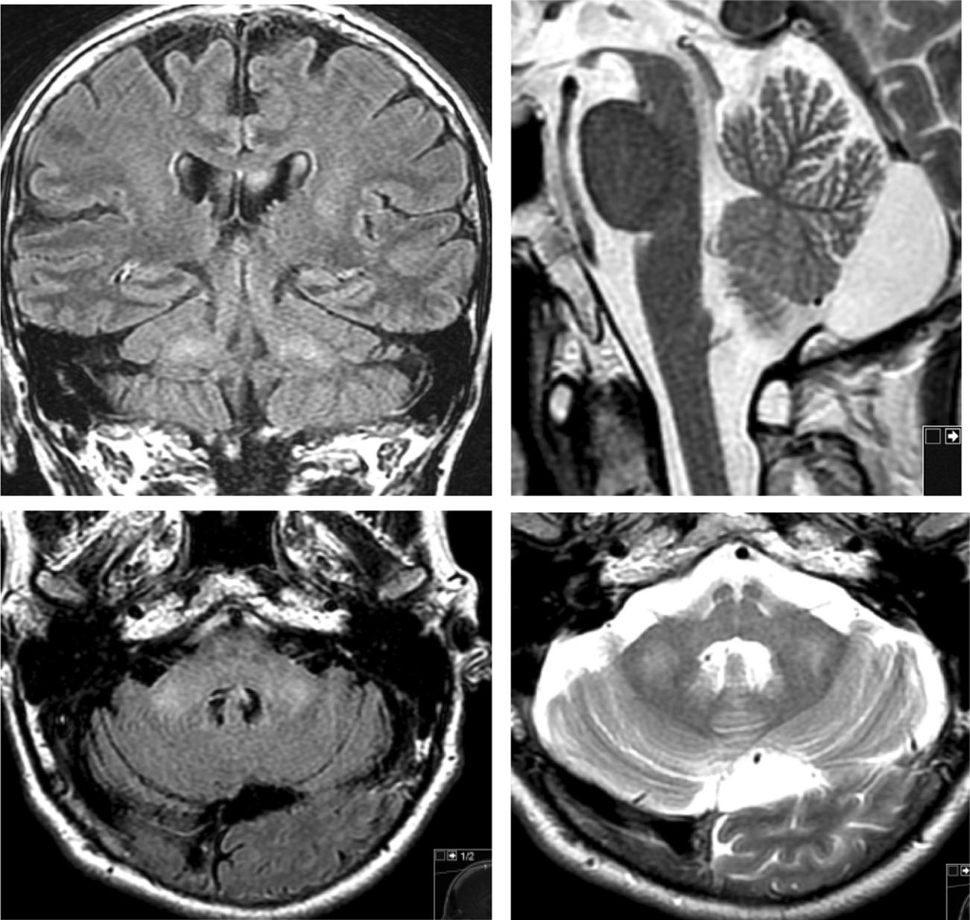Fig. 1 *Upper* and *lower left panel*: coronary and axial FLAIR image sequences displaying symmetric MCP hyperintensities. *Upper* and *lower right panels*: T2-weighted sagittal and axial sequences displaying a mega cisterna magna but normal size cerebellum. *MCP* middle cerebellar peduncles

whereas large-fiber sensory polyneuropathy occurs in FXTAS [4]. Evidence of sensory neuronopathy also exist in FXTAS [5]. An unusual feature in our case is the presence of parkin- sonism, which is rather rare among subjects with POLG mu- tations in the absence of progressive external opthalmoplegia (PEO) [6] but is more common in FXTAS with prevalence ranging between 24 and 67 % [5, 7, 8]. Hearing loss is com- mon in mitochondrial disorders and in FXTAS; it has been reported in 50 % of FXTAS patients [8] and in 31 % of POLG- A patients [3]. Interestingly, premature ovarian failure, com- monly seen in *FMR1* premutation carriers, has also been described in POLG-associated ataxia [9, 10]. Thus, the overlap between POLG mutations and *FMR1*-associated syndromes is striking. There are however differences, for instance the manifestations of POLG mutations are protean and include features unseen in FXTAS (epilepsy, myopathy, liver failure, PEO, and /or encephalopathy), with onsets ranging from early infancy to late adulthood and the presence of hyperkinetic features like chorea and/or myoclo- nus [1, 3]. Dystonia occurs also in POLG mutations [3] but seems to be very rare in FXTAS [8].

There are no specific radiological abnormalities for POLG- associated ataxia; however, white matter abnormalities (WMA) in the cerebellum are common [3]. In the present case, the abnormal muscle biopsy contributed to raise the sus- picion of a mitochondrial disorder. However, muscle biopsies in subjects with POLG mutations are normal in most cases [11]. There are no specific biochemical analyses for POLG- ataxia and analysis of respiratory chain enzymes can also be normal [11, 12]. In summary, the diagnosis of POLG-ataxia requires a high index of suspicion.

The pattern of inheritance of POLG mutations is complex; in most cases, it is autosomal recessive and less often autoso- mal dominant [1, 9]. W748S is one the most common autoso- mal recessive POLG mutations [1]. Of note, there is increas- ing evidence of mitochondrial dysfunction in FXTAS [13].

E. Apartis et al. proposed a revision of the diagnostic criteria for FXTAS [5] based on the fact that hyperintensities of the corpus callosum were more common than the MCP sign (68 %, respectively, 64 %) and for the fairly common presence of polyneuropathy (81 %). Other con- ditions with MCP hyperintensities include MSA [14], adult-onset leukoencephalopathies [15], cerebrotendinous xanthomatosis (CTX), and mitochondrial disorders like PEO and infantile onset spinocerebellar ataxia (IOSCA) [16]. Taking both radiological and clinical features into consider- ation, late-onset POLG-A is the disease that resembles FXTAS in many features, yet external ophthalmoplegia might be a characteristic feature that—if present—clearly distin- guishes POLG-A from FXTAS [17].

Acknowledgments We express our true gratitude to the patient for consenting to this report. Martin Paucar was supported by the

Stockholm County Council (combined clinical residency and PhD train- ing program).

Authors’ Contributions Dr M. Paucar, Dr M. Engvall, Dr L. Gordon and E Tham are responsible for the study concept, data collection, and writing of the manuscript; Dr M. Paucar wrote the first draft; Dr M. Synofzik and Prof. P. Svenningsson are responsible for the study concept and editing of the manuscript.

Compliance with Ethical Standards

Consent Oral and written consent was obtained for this report.

Conflict of Interest The authors declare that they have no conflicts of interest.

Study Funding Stockholm County Council

# References

1. Saneto RP, Naviaux RK. Polymerase gamma disease through the ages. Dev Disabil Res Rev. 2010;16(2):163–74.
2. Adams JS, Adams PE, Nguyen D, Brunberg JA, Tassone F, Zhang W, et al. Volumetric brain changes in females with fragile X- associated tremor/ataxia syndrome (FXTAS). Neurology. 2007;69(9):851–9.
3. Synofzik M, Srulijes K, Godau J, Berg D, Schöls L. Characterizing POLG ataxia: clinics, electrophysiology and imaging. Cerebellum. 2012;11(4):1002–11.
4. Leehey MA. Fragile X-associated tremor/ataxia syndrome: clinical phenotype, diagnosis, and treatment. J Investig Med Off Publ Am Fed Clin Res. 2009;57(8):830–6.
5. Apartis E, Blancher A, Meissner WG, Guyant-Maréchal L, Maltête D, De Broucker T, et al. FXTAS: new insights and the need for revised diagnostic criteria. Neurology. 2012;79(18):1898–907.
6. Davidzon G, Greene P, Mancuso M, Klos KJ, Ahlskog JE, Hirano M, et al. Early-onset familial parkinsonism due to POLG mutations. Ann Neurol. 2006;59(5):859–62.
7. Hall DA, Berry-Kravis E, Jacquemont S, Rice CD, Cogswell J, Zhang L, et al. Initial diagnoses given to persons with the fragile X associated tremor/ataxia syndrome (FXTAS). Neurology. 2005;65(2):299–301.
8. Juncos JL, Lazarus JT, Graves-Allen E, Shubeck L, Rusin M, Novak G, et al. New clinical findings in the fragile X-associated tremor ataxia syndrome (FXTAS). Neurogenetics. 2011;12(2):123–35.
9. Luoma P, Melberg A, Rinne JO, Kaukonen JA, Nupponen NN, Chalmers RM, et al. Parkinsonism, premature menopause, and mi- tochondrial DNA polymerase gamma mutations: clinical and mo- lecular genetic study. Lancet. 2004;364(9437):875–82.
10. Hakonen AH, Heiskanen S, Juvonen V, Lappalainen I, Luoma PT, Rantamaki M, et al. Mitochondrial DNA polymerase W748S mu- tation: a common cause of autosomal recessive ataxia with ancient European origin. Am J Hum Genet. 2005;77(3):430–41.
11. de Vries MC, Rodenburg RJ, Morava E, Lammens M, van den Heuvel LPW, Korenke GC, et al. Normal biochemical analysis of the oxidative phosphorylation (OXPHOS) system in a child with POLG mutations: a cautionary note. J Inherit Metab Dis. 2008;31 Suppl 2:S299–302.
12. Cohen BH, Chinnery PF, Copeland WC. POLG-Related Disorders. In: Pagon RA, Adam MP, Ardinger HH, Wallace SE, Amemiya A, Bean LJ, et al., editors. GeneReviews(®) [Internet]. Seattle (WA): University of Washington, Seattle; 1993 [cited 2016 Jan 8]. Available from: <http://www.ncbi.nlm.nih.gov/books/NBK26471/>.
13. Hagerman R, Hagerman P. Advances in clinical and molecular understanding of the FMR1 premutation and fragile X-associated tremor/ataxia syndrome. Lancet Neurol. 2013;12(8):786–98.
14. Savoiardo M. Differential diagnosis of Parkinson’s disease and atypical Parkinsonian disorders by magnetic resonance imaging. Neurol Sci Off J Ital Neurol Soc Ital Soc Clin Neurophysiol. 2003;24 Suppl 1:S35–7.
15. Ayrignac X, Carra-Dalliere C, Menjot de Champfleur N, Denier C, Aubourg P, Bellesme C, et al. Adult-onset genetic

leukoencephalopathies: a MRI pattern-based approach in a comprehensive study of 154 patients. Brain J Neurol. 2015;138(Pt 2):284–92.

1. Finsterer J, Zarrouk Mahjoub S. Leukoencephalopathies in mito- chondrial disorders: clinical and MRI findings. J Neuroimaging Off J Am Soc Neuroimaging. 2012;22(3):e1–11.
2. Schulte C, Synofzik M, Gasser T, Schöls L. Ataxia with ophthalmoplegia or sensory neuropathy is frequently caused by POLG mutations. Neurology. 2009;73(11):898–900.