Available online at [www.sciencedirect.com](http://www.sciencedirect.com/science/journal/09608966)



**ScienceDirect**

[Neuromuscular Disorders 27 (2017) 500–501](http://dx.doi.org/10.1016/j.nmd.2017.03.001)

Picture of the month



[www.elsevier.com/locate/nmd](http://www.elsevier.com/locate/nmd)

Concentric muscle involvement in *POLG*-related distal myopathy

Giorgio Tasca a,*, Mauro Monforte b, Claudia Nesti c, Filippo Maria Santorelli c,

Gabriella Silvestri b, Enzo Ricci b

a *Institute of Neurology, Policlinico “A. Gemelli” Foundation University Hospital, Rome, Italy*

b *Institute of Neurology, Catholic University of the Sacred Heart, Rome, Italy*

c *Molecular Medicine & Neurogenetics, IRCCS Stella Maris, Pisa, Italy*

Received 12 December 2016; accepted 5 March 2017

*Keywords:* POLG; DNA polymerase gamma; Muscle MRI; Muscle imaging; Distal myopathy; Mitochondrial myopathy

A 58-year-old man was examined because of symptoms suggestive of a mitochondrial disorder. The onset was at age 15 years, with distal weakness in upper limbs, later spread to lower limbs and axial muscles. Physical examination showed bilateral eyelid ptosis, ophthalmoparesis and facial weakness, severe weakness and hypotrophy in proximal and distal upper limbs (biceps, triceps extensor digitorum communis and intrinsic hand muscles; Medical Research Council, MRC, 0–1), and in the distal legs (tibialis anterior and extensor hallucis longus; MRC 0–1). The patient also had dysphagia. He had undergone surgery for bilateral cataracts at age 54, and his family history was negative.

Serum CK level was 1.5 normal, electromyography was myopathic with normal conduction studies, and muscle biopsy disclosed myopathic changes with COX-negative ragged red fibers. Brain MRI was unremarkable besides a lactate peak in cerebrospinal fluid detected on spectroscopy, while muscle imaging revealed an unusual pattern characterized by a non per-muscle distribution of fatty changes, but rather a disto- proximal and “concentric” involvement of the limb muscles. Fat deposition was prominent in superficial muscles and in the subfascial region of each muscle, with relative sparing of deep muscles (Fig. 1). Direct sequencing of the DNA polymerase

gamma gene (*POLG*) revealed the heterozygous c.2840A>G, p.Lys947Arg mutation, already associated with progressive external ophthalmoplegia and bilateral facial weakness [1].

The clinical phenotype we report is similar to that described by Pitceathly et al. [2], and likewise muscle MRI findings are highly consistent with those of one patient reported in that paper. Autosomal dominant *POLG*-related distal myopathy is a rare entity, and we believe that this distinct muscle MRI pattern can be important for addressing molecular testing toward *POLG* in the workup of mitochondrial and distal myopathies [3]. Additional studies are needed to confirm whether this pattern can be found in other diseases of the *POLG* spectrum.

**References**

1. [Baruffini E, Horvath R, Dallabona C, et al. Predicting the contribution of](http://refhub.elsevier.com/S0960-8966(16)31195-6/sr0010) [novel POLG mutations to human disease through analysis in yeast model.](http://refhub.elsevier.com/S0960-8966(16)31195-6/sr0010) [Mitochondrion 2011;11:182–90.](http://refhub.elsevier.com/S0960-8966(16)31195-6/sr0010)
2. [Pitceathly RD, Tomlinson SE, Hargreaves I, et al. Distal myopathy with](http://refhub.elsevier.com/S0960-8966(16)31195-6/sr0015) [cachexia: an unrecognised phenotype caused by dominantly-inherited](http://refhub.elsevier.com/S0960-8966(16)31195-6/sr0015) [mitochondrial polymerase gamma mutations. J Neurol Neurosurg](http://refhub.elsevier.com/S0960-8966(16)31195-6/sr0015) [Psychiatry 2013;84:107–10.](http://refhub.elsevier.com/S0960-8966(16)31195-6/sr0015)
3. [Udd B. 165th ENMC International Workshop: distal myopathies 6-8th](http://refhub.elsevier.com/S0960-8966(16)31195-6/sr0020) [February 2009 Naarden, The Netherlands. Neuromuscul Disord](http://refhub.elsevier.com/S0960-8966(16)31195-6/sr0020) [2009;19:429–38.](http://refhub.elsevier.com/S0960-8966(16)31195-6/sr0020)

* Corresponding author. Institute of Neurology, Policlinico “A. Gemelli” Foundation University Hospital, Largo A. Gemelli, 8, Rome 00168, Italy. Fax:

+39 06 35501909.

*E-mail address:* [giorgiotasca81@gmail.com](mailto:giorgiotasca81@gmail.com) (G. Tasca).

<http://dx.doi.org/10.1016/j.nmd.2017.03.001>

0960-8966/© 2017 Elsevier B.V. All rights reserved.

*G. Tasca et al. / Neuromuscular Disorders 27 (2017) 500–501* 501

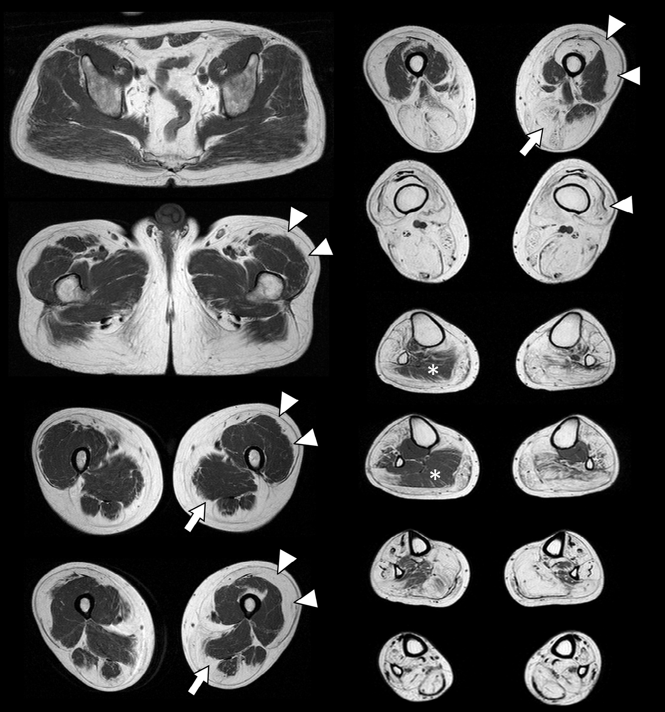

Fig. 1. T1-weighted MRI images of the pelvis and lower limbs show fatty infiltration of the muscles, starting from the outer, subcutaneous layers and progressing to the inner layers moving distally. This gives a peculiar, “concentric” appearance to the T1-hypersignal, which is particularly evident both in the quadriceps (arrowheads) and in the muscles of posterior and medial thigh compartment (arrows). The same phenomenon is evident in the lower leg where tibialis posterior and the proximal part of the right soleus (asterisk) are relatively spared.