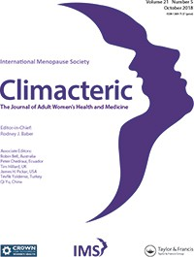**Climacteric**

**ISSN: 1369-7137 (Print) 1473-0804 (Online) Journal homepage:** [**www.tandfonline.com/journals/icmt20**](https://www.tandfonline.com/journals/icmt20?src=pdf)

Identiﬁcation of the ﬁrst homozygous *POLG* mutation causing non-syndromic ovarian dysfunction

**B. Chen, L. Li, J. Wang, Y. Zhou, J. Zhu, T. Li, H. Pan, B. Liu, Y. Cao & B. Wang**

## **To cite this article:** B. Chen, L. Li, J. Wang, Y. Zhou, J. Zhu, T. Li, H. Pan, B. Liu, Y. Cao & B. Wang (2018) Identiﬁcation of the ﬁrst homozygous *POLG* mutation causing non-syndromic ovarian dysfunction, Climacteric, 21:5, 467-471, DOI: [10.1080/13697137.2018.1467891](https://www.tandfonline.com/action/showCitFormats?doi=10.1080/13697137.2018.1467891)

**To link to this article:** <https://doi.org/10.1080/13697137.2018.1467891>

 Published online: 11 Jul 2018.

[](https://www.tandfonline.com/action/authorSubmission?journalCode=icmt20&show=instructions&src=pdf) [Submit your article to this journal [](https://www.tandfonline.com/action/authorSubmission?journalCode=icmt20&show=instructions&src=pdf)](https://www.tandfonline.com/action/authorSubmission?journalCode=icmt20&show=instructions&src=pdf)

 Article views: 290

[](http://crossmark.crossref.org/dialog/?doi=10.1080/13697137.2018.1467891&domain=pdf&date_stamp=11%20Jul%202018)[](https://www.tandfonline.com/doi/mlt/10.1080/13697137.2018.1467891?src=pdf) [View related articles [](https://www.tandfonline.com/doi/mlt/10.1080/13697137.2018.1467891?src=pdf) [](http://crossmark.crossref.org/dialog/?doi=10.1080/13697137.2018.1467891&domain=pdf&date_stamp=11%20Jul%202018) [View Crossmark data](http://crossmark.crossref.org/dialog/?doi=10.1080/13697137.2018.1467891&domain=pdf&date_stamp=11%20Jul%202018)](https://www.tandfonline.com/doi/mlt/10.1080/13697137.2018.1467891?src=pdf)

[](https://www.tandfonline.com/doi/citedby/10.1080/13697137.2018.1467891?src=pdf) [Citing articles: 6 View citing articles [](https://www.tandfonline.com/doi/citedby/10.1080/13697137.2018.1467891?src=pdf)](https://www.tandfonline.com/doi/citedby/10.1080/13697137.2018.1467891?src=pdf)

Full Terms & Conditions of access and use can be found at <https://www.tandfonline.com/action/journalInformation?journalCode=icmt20>

[](http://www.tandfonline.com/)CLIMACTERIC



2018, VOL. 21, NO. 5, 467–471

https://doi.org/10.1080/13697137.2018.1467891

## ORIGINAL ARTICLE

[](http://crossmark.crossref.org/dialog/?doi=10.1080/13697137.2018.1467891&domain=pdf)Identification of the first homozygous *POLG* mutation causing non-syndromic ovarian dysfunction

# B. Chena,b,c*, L. Lid*, J. Wange, Y. Zhoua,b,c, J. Zhua,b,c, T. Lif, H. Panf, B. Liuf, Y. Caoa,b,c and B. Wanga,f,g

aDepartment of Obstetrics and Gynecology, Reproductive Medicine Center, The First Affiliated Hospital of Anhui Medical University, Hefei, China; bInstitute of Reproductive Genetics, Anhui Medical University, Hefei, China; cAnhui Provincial Engineering Technology Research Center for Biopreservation and Artificial Organs, Hefei, China; dCentral Laboratory, Beijing Obstetrics and Gynecology Hospital, Capital Medical University, Beijing, China; eDepartment of Medical Genetics and Developmental Biology, School of Basic Medical Sciences, Capital Medical University, Beijing, China; fCenter for Genetics, National Research Institute for Family Planning, Beijing, China; gKey Laboratory of Family Planning and Reproductive Genetics, National Health and Family Planning Commission, Hebei Research Institute for Family Planning,

Hebei, China

ARTICLE HISTORY

ABSTRACT

Objective: To investigate the genetic cause of non-syndromic ovarian dysfunction in a patient from a consanguineous family.

Methods: This study examined a patient with irregular menstrual cycles and abnormal oocytes. The patient had undergone irregular hormone replacement therapy over 3 years to adjust the menstrual cycle and improve ovarian function. Prior to ovarian stimulation in our hospital, 3 months of androgen and regular hormone therapy were used as an intervention method. No follicular development was detected in the subsequent three cycles using letrozole treatment. The patient then received a con- stantly adjusted dose of menotropins, but produced only one oocyte.

Results: Whole-exome sequencing analysis identified the first homozygous *POLG* mutation (c.2890C > T; p.R964C) associated with ovarian dysfunction. Sanger sequencing was used to validate. *In silico* analysis suggested that the p.R964C mutation was pathogenic. Conservation analysis demon- strated that R964 was an important site for the DNA polymerase function of POLG.

Conclusions: Biallelic mutations in *POLG* may be associated with ovarian dysfunction. This study has improved our understanding of *POLG*-related genetic mutations in ovarian dysfunction, and the mode of inheritance of certain sequence variants. This information will assist genetic counseling and precision medicine in the future.

Received 12 February 2018

Revised 16 April 2018

Accepted 18 April 2018 Published online 11 July 2018

KEYWORDS

Ovarian dysfunction; POLG; whole-exome sequencing; irregular menstrual cycle; abnormal oocyte

# Introduction

Human ovarian dysfunction comprises a variety of different conditions that each result in irregular menstrual cycles, ovar- ian failure, and female infertility. Amenorrhea and irregular menstrual cycles are two main features of ovarian dysfunc- tion. Genetic defects can cause ovarian dysfunction, including chromosomal abnormalities and single gene alterations1–7. Mutations in *STAG3*, *BMP15*, *FSHR*, *GDF9*, *NOBOX*, *MCM8*,

*MCM9*, *NUP107*, *MSH4*, *CSB-PGBD3* and *MSH5* can cause reces- sive primary amenorrhea8–17 or secondary amenorrhea18–20. Sequence variants in *POLG*, *NR5A1*, *KHDRBS1*, and *NOBOX* are reported to be associated with dominant primary21 or sec- ondary amenorrhea22–24. In our clinical practice, some patients exhibit irregular menstrual cycles and poor out- comes of *in vitro* fertilization, but there is a lack of know- ledge of the potential genetic contribution to this ovarian dysfunction.

In this study, we examined a patient from a consanguin-

eous family exhibiting irregular menstrual cycles and abnor- mal oocytes. Using whole-exome sequencing technology, we

identified a novel homozygous *POLG* mutation in this patient. In contrast to previously reported heterozygous *POLG* muta- tions associated with premature ovarian failure (POF), this is the first recessive mode of inheritance of a *POLG* mutation in a patient with ovarian dysfunction.

# Materials and methods

### Patient

A Chinese patient with ovarian dysfunction was recruited from The First Affiliated Hospital of Anhui Medical University, and was from a consanguineous family (Figure 1A). The patient did not show any of the following: karyotypic abnor- malities, autoimmune disorders, history of radiotherapy and chemotherapy, or pelvic surgery. This study was approved by the Ethics Committee of Anhui Medical University. Written informed consent was obtained from the patient and her parents, and 5 ml of peripheral blood was collected from the patient.

CONTACT Y. Cao  [caoyunxia_profr@126.com  Reproductive Medicine Center, The First Affiliated Hospital, Anhui Medical University, Hefei, 230032, China;](mailto:caoyunxia_profr@126.com)

B. Wang  [wbbahu@163.com  Center for Genetics, National Research Institute for Family Planning, 12, Dahuisi Road, Haidian, Beijing, 100081, China](mailto:wbbahu@163.com)

*B. Chen and L. Li contributed equally to this work.

© 2018 International Menopause Society

468 B. CHEN ET AL.

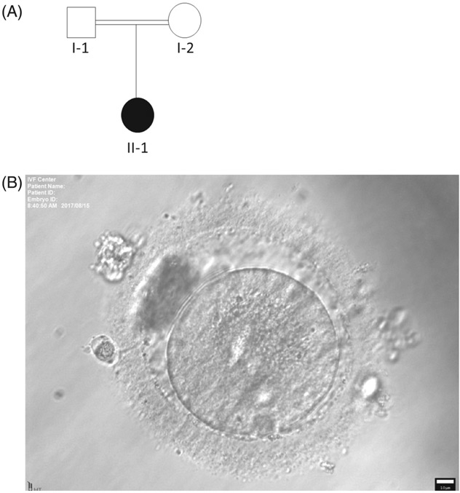

Figure 1. Pedigree analysis of the patient in the family. (A) The patient with ovarian dysfunction in a Chinese consanguineous family. The black circle indi- cates the affected family member. (B) Abnormal oocyte from the patient. The oocyte was abnormal with the presence of two polar bodies and granular cyto- plasm. The white bar ¼10 lm.

### WES and sanger sequencing validation

Exome sequence capture was performed using the SureSelect Human All Exon V5 Kit (Agilent Technologies, Palo Alto, CA, USA) following the manufacturer’s protocol. The captured libraries were sequenced using an Illumina HiSeq 2000 Sequencer. Sequence reads were mapped against a human reference genome (hg19) using the Burrows- Wheeler Aligner algorithm (<http://bio-bwa.sourceforge.net/>). The SNPs and Indels were detected by SAMtools ([http://sam-](http://samtools.sourceforge.net/) [tools.sourceforge.net/](http://samtools.sourceforge.net/)). Sanger sequencing was performed using gene-specific primers.

# Results

### Clinical characterization

The proband (II-1, Figure 1A) was diagnosed with ovarian dysfunction and infertility at 32 years of age in 2017. Her height was 160 cm and weight was 60 kg. She experienced menarche at 15 years of age. Her menstrual cycle was irregu- lar from 24 years of age, when she had a cycle length of approximately 4 months. Both ovaries were not clearly detected by transvaginal color Doppler ultrasound at the first-time consultancy. Circulating hormone levels of the pro- band were: 10.48 IU/l follicle stimulating hormone (FSH);

2.77 IU/l luteinizing hormone (LH); 2.07 nmol/l testosterone; 54 pmol/l estradiol (E2); 10.03 ng/ml prolactin; and 0.05 ng/ml anti-Mu€llerian hormone (AMH). Magnetic resonance imaging showed the pituitary was normal. Examination revealed no progressive external ophthalmoplegia (PEO), sensory ataxic neuropathy dysarthria, ophthalmoparesis, mitochondrial DNA depletion syndrome 4A, Leigh syndrome, or spinocerebellar

ataxia with epilepsy. The proband’s mother (I-2) underwent menopause at the age of 54.

To adjust the menstrual cycle and improve ovarian func- tion, this patient had undergone 3 years of irregular hor- mone replacement therapy. Prior to ovarian stimulation in our hospital, 3 months of androgen supplement (dehydro- epiandrosterone (DHEA) 25 mg three times a day) and regular hormone therapy (oral contraceptive: ethinylestradiol and cyproterone acetate tablets (Diane-35); for 21 days of each month) were used as an intervention method. Hormone lev- els were measured in duplicate: 7.46 IU/l FSH; 1.12 IU/l LH; and 33.43 pmol/l E2. No follicular development was detected in the subsequent three cycles using letrozole tablets (Furui; Jiangsu Hengrui Pharmaceutical Co, Lianyungang, China). The patient then received a constantly adjusted injection dose of menotropins (hMG; Lizhu Pharmaceutical Co, Zhuhai, China) but produced only one oocyte. Details and endpoints of the treatment are shown in Table 1.

The pretreatment with DHEA and hormone replacement lowered the circulating FSH level, improved the ovarian sen- sitivity to FSH and increased the opportunity for oocyte development. The long stimulation lasted for about 1 month; one follicle about 20 x 17 mm could be detected on the left ovary. The only oocyte was retrieved from the left ovary by transvaginal ultrasound-guided puncture, approximately 36 h after induction of ovulation with 5000 IU human chorionic gonadotropin (hCG; Lizhu Pharmaceutical Co.). After denud- ing the oocyte from surrounding granular cells using hyaluro- nidase, the abnormal presence of two polar bodies and granular cytoplasm (Figure 1B) indicated poor oocyte quality. Despite the aberrant morphology, the oocyte underwent intracytoplasmic sperm injection *in vitro,* but displayed com- plete fertilization failure.

### Molecular genetic analysis

Whole-exome sequencing with aligned sequence reads vari- ant identification were performed, as previously described23. Pedigree analysis suggested an autosomal recessive mode of inheritance associated with this family (Figure 1A). We filtered out polymorphisms with allele frequencies >1% in The Short Genetic Variations database (dbSNP), 1000 Genomes (1000G), Exome Aggregation Consortium (ExAC), and Genome Aggregation Database (gnomAD) databases. A list of genes harboring coding/splicing homozygous variants were further filtered by the functional impact of the mutation (e.g. conser- vation and functional prediction by *in silico* prediction mod- ules PolyPhen2, SIFT, and Mutationtaster).

One homozygous *POLG* mutation (NM_002693:exon18: c.2890C > T: p.R964C) passed the filtering steps. This muta- tion was segregated within the family (Figure 2A). The *POLG* gene encodes a DNA polymerase-c involved in the replica- tion of human mitochondrial DNA25. Mutations in *POLG* can cause POF or premature menopause, and all cases to date showed dominant inheritance22,26–28. Our study found the first *POLG* homozygous mutation in a patient with ovarian dysfunction. *In silico* analysis by five online prediction tools suggested that the p.R964C mutation was pathogenic

CLIMACTERIC  469

Table 1. Ovarian stimulation and follicular ultrasound monitoring of patient.

|  |  |  |  |  |  |
| --- | --- | --- | --- | --- | --- |
| *hMG (start from day 1)* | *Date of TVS* | *Right ovary (mm)* | *Left ovary (mm)* | *Mean diameter of uterus (mm)* | *Endometrial thickness (mm)* |
| 150 U*6 day (days 1–6) | Day 1 | Blurred image | 15 x 12 | 32 | Line |
| 225 U*6 days (days 7–12) | Day 7 | Blurred image | 15 x 13 | 35 | 5.4 |
| 300 U*5 days (days 13–17) | Day 13 | Blurred image | 15 x 13 | 35 | 5.5 |
| 225 U*7 days (days 18–24) | Day 18 | Blurred image | F: 4 x 4  21 x 21 | 44 | 8.9 |
| 225 U*3 days (days 25–27) | Day 25 | 20 x 19 | F: 11 x 10  29 x 24 | 38 | 10.9 |
|  |  |  | F: 15 x 16 |  |  |
|  | Day 28 | 17 x 16 | 28 x 27 | 34 | 11 |
|  |  |  | F: 20 x 17 |  |  |

hMG, human menopausal gonadotropin (menotropin); TVS, transvaginal ultrasound; F, follicle.

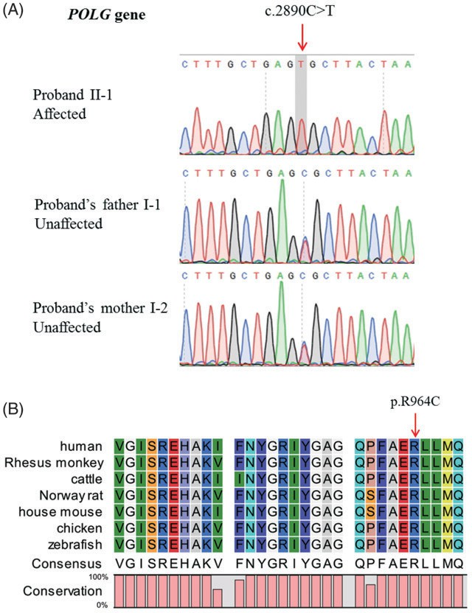

Figure 2. Genetic analysis of the patient. (A) Sanger sequencing validation of the mutation in family members. Red arrow points to the mutation site. (B) Sequence alignment of POLG in different species. Red arrow points to the R964 site in human POLG.

(Table 2). The mutation was also predicted a high risk for pathogenicity using the POLG Pathogenicity Prediction Server (<http://polg.bmb.msu.edu/query.php>). Amino acid R964 is located in the polymerase domain of POLG, and is highly conserved among different species ranging from human to zebrafish (Figure 2B), suggesting the functional importance of the R964 site.

# Discussion

In this study, we report that a novel homozygous *POLG* mutation is associated with ovarian dysfunction in a patient with consanguineous pedigree. The *POLG* gene encodes the catalytic subunit of DNA polymerase-c involved in the repli- cation of mitochondrial DNA25. *Polg* knock-out mice develop an mtDNA mutator phenotype associated with reduced

lifespan, premature onset of aging-related phenotypes and reduced fertility29. Dominant or recessive mutations in human *POLG* can cause a spectrum of disorders associated with mitochondria dysfunction, including PEO, sensory ataxic neuropathy, familial Parkinsonism and progressive sclerosing poliodystrophy30–32. Most women with PEO exhibit early menopause26. The heterozygous p.Y955C, p.R943H, p.Y831C and p.S511N mutations of *POLG* can segregate with POF and PEO22,26,28,33,34. In addition, another heterozygous p.Y951N mutation in *POLG* was found in a patient with cataracts, early-onset distal muscle weakness and atrophy, ovarian dys- genesis (a severe form of POF) and 3-methylglutaconic acidu- ria27. Another study screened *POLG* mutations in 201 patients with spontaneous primary ovarian insufficiency and found one heterozygous p.R953C variant in a patient35. Therefore, *POLG* heterozygous mutations, including p.S511N, p.Y831C, p.R943H, p.Y951N, p.R953C, and p.Y955C, may be associated with syndromic or non-syndromic ovarian failure.

Previous studies have identified dominant *POLG* mutations

in patients with ovarian failure. However, using pedigree and WES analysis, we have found the first homozygous *POLG* mutation in a patient with non-syndromic ovarian dysfunc- tion, suggesting a recessive mode of mutation inheritance. The functional difference between the p.R964C mutation and previously reported heterozygous *POLG* mutations remains to be determined. However, as our reported case manifested as a non-syndromic ovarian dysfunction phenotype (a mild form compared with POF), we speculate that p.R964C produces a milder functional defect in POLG activity than the six above- mentioned mutations. Further experiments are required to directly examine this proposal.

Our study demonstrates, for the first time, that a novel biallelic *POLG* mutation (p.R964C) may cause ovarian dysfunc- tion. This study expands our understanding of *POLG* muta- tions related to ovarian dysfunction, and the mode of inheritance of certain sequence variants. The information pro- vided by this study may also assist in future genetic counsel- ing and precision medicine approaches.

# Authors’ contributions

C.B.L. wrote the paper and contributed reagents, materials, analysis tools and data. L.L. analyzed and interpreted the data and wrote the paper. W.J. performed the experiments and analyzed the data. Z.Y.R. and Z.J. contributed reagents, materials, analysis tools and data. L.T.Y., P.H. and L.B.H.

470 B. CHEN ET AL.

Table 2. *In silico* analysis of the *POLG* [mutation.](http://www.mutationtaster.org/)

*Gene Mutation Amino acid change Zygosity*

*Polyphen-2*a

*SIFT*b

*Mutation taster*c *SNPs & GO*d *FATHMM-MKL*e *ExAC (total)*f *ExAC (East Asian)*g *gnomAD (total)*h

*POLG* c.2890C > T

p.R964C

[Homozygous](http://www.mutationtaster.org/) Probably damaging (1.000) Damaging (0.002) Disease causing (1.000) Disease (0.720) Damaging (0.942) 0.0006708

0.008988

0.0006459

aPolyphen-2 ([http://genetics.bwh.harvard.edu/pph2/](http://www.mutationtaster.org/)). Prediction scores range from 0 to 1, with high scores indicating probably or possibly damaging; bSIFT, i.e. sorting intolerant from tolerant ([http://sift.jcvi.org/).](http://sift.jcvi.org/)) Scores vary between 0 and 1. Variants with scores [close](http://www.mutationtaster.org/) or equal to 0 are predicted to be damaging; cMutation taster ([http://www.mutationtaster.org/).](http://www.mutationtaster.org/)) The probability value is the probability of the prediction, i.e. a value close to 1 indicates a high 'security' of the [prediction;](http://www.mutationtaster.org/) dSNPs & GO ([http://snps.biofold.org/snps-and-go/).](http://snps.biofold.org/snps-and-go/)) Disease probability (if >0.5 mutation is predicted disease); eFATHMM-MKL (<http://fathmm.biocompute.org.uk/> fathmmMKL.htm). Values above 0.5 are [predicted](http://www.mutationtaster.org/) to be deleterious, while those below 0.5 are predicted to be neutral or benign; fFrequency of variations in total of ExAC database; gFrequency of variations in East Asian population of ExAC database; hFrequency of variation in total of gnomAD (genome Aggregation Database).

performed the experiments. C.Y.X. and W.B.B. conceived and designed the experiments.

*Conflict of interest* The authors declare that they have no conflict of interest.

*Source of funding* Research funding was provided by the National Natural Science Foundation of China (81701405), and National Research Institute for Family Planning (2017GJZ05).

# References

1. Qin Y, Jiao X, Simpson JL, *et al.* Genetics of primary ovarian insuffi- ciency: new developments and opportunities. *Hum Reprod Update* 2015;21:787–808
2. Laissue P. The molecular complexity of primary ovarian insuffi- ciency aetiology and the use of massively parallel sequencing. *Mol Cell Endocrinol* 2018;460:170–80
3. Rossi E, Verri AP, Patricelli MG, *et al.* A 12Mb deletion at 7q33-q35 associated with autism spectrum disorders and primary amenor- rhea. *Eur J Med Genet* 2008;51:631–8
4. Sehested LT, Moller RS, Bache I, *et al.* Deletion of 7q34-q36.2 in two siblings with mental retardation, language delay, primary amenorrhea, and dysmorphic features. *Am J Med Genet A* 2010;152A:3115–19
5. Kim MK, Seok HH, Kim YS, *et al.* Molecular genetic and cytogenetic characterization of a partial Xp duplication and Xq deletion in a patient with premature ovarian failure. *Gene* 2014;534:54–9
6. Mohamadhashem F, Rafati M, Hoseininasab F, *et al.* Primary ovar- ian insufficiency with t(5;13): a case report and literature review on disrupted genes. *Climacteric* 2017;20:498–502
7. Ghosh S, Roy S, Pal P, *et al.* Cytogenetic analysis of patients with primary amenorrhea in Eastern India. *J Obstet Gynaecol* 2018;38:270–5
8. Mayer A, Fouquet B, Pugeat M, *et al.* BMP15 "knockout-like" effect in familial premature ovarian insufficiency with persistent ovarian reserve. *Clin Genet* 2017;92:208–12
9. Bramble MS, Goldstein EH, Lipson A, *et al.* A novel follicle-stimulat- ing hormone receptor mutation causing primary ovarian failure: a fertility application of whole exome sequencing. *Hum Reprod* 2016;31:905–14
10. Caburet S, Arboleda VA, Llano E, *et al.* Mutant cohesin in prema- ture ovarian failure. *N Engl J Med* 2014;370:943–9
11. He WB, Banerjee S, Meng LL, *et al.* Whole-exome sequencing iden- tifies a homozygous donor splice site mutation in STAG3 that causes primary ovarian insufficiency. *Clin Genet* 2018;93:340–4
12. Li L, Wang BB, Zhang W, *et al.* A homozygous NOBOX truncating variant causes defective transcriptional activation and leads to pri- mary ovarian insufficiency. *Hum Reprod* 2017; 32:248–55
13. AlAsiri S, Basit S, Wood-Trageser MA, *et al.* Exome sequencing reveals MCM8 mutation underlies ovarian failure and chromosomal instability. *J Clin Invest* 2015;125:258–62
14. Tenenbaum-Rakover Y, Weinberg-Shukron A, Renbaum P, *et al.* Minichromosome maintenance complex component 8 (MCM8) gene mutations result in primary gonadal failure. *J Med Genet* 2015;52:391–9
15. Colombo R, Pontoglio A, Bini M. A STAG3 missense mutation in two sisters with primary ovarian insufficiency. *Eur J Obstet Gynecol Reprod Biol* 2017;216:269–71
16. Weinberg-Shukron A, Renbaum P, Kalifa R, *et al.* A mutation in the nucleoporin-107 gene causes XX gonadal dysgenesis. *J Clin Invest* 2015;125:4295–304
17. Franca MM, Funari MFA, Nishi MY, *et al.* Identification of the first homozygous 1-bp deletion in GDF9 gene leading to primary ovar- ian insufficiency by using targeted massively parallel sequencing. *Clin Genet* 2018;93:408–11

CLIMACTERIC 471

1. Carlosama C, Elzaiat M, Patino LC, *et al.* A homozygous donor splice-site mutation in the meiotic gene MSH4 causes primary ovarian insufficiency. *Hum Mol Genet* 2017;26:3161–6
2. Qin Y, Guo T, Li G, *et al.* CSB-PGBD3 mutations cause premature ovarian failure. *PLoS Genet* 2015;11:e1005419
3. Guo T, Zhao S, Chen M, *et al.* Mutations in MSH5 in primary ovar- ian insufficiency. *Hum Mol Genet* 2017;26:1452–7
4. Lourenco D, Brauner R, Lin L, *et al.* Mutations in NR5A1 associated with ovarian insufficiency. *N Engl J Med* 2009;360:1200–10
5. Pagnamenta AT, Taanman JW, Wilson CJ, *et al.* Dominant inherit- ance of premature ovarian failure associated with mutant mito- chondrial DNA polymerase gamma. *Hum Reprod* 2006;21:2467–73
6. Wang B, Li L, Zhu Y, *et al.* Sequence variants of KHDRBS1 as high penetrance susceptibility risks for primary ovarian insufficiency by mis-regulating mRNA alternative splicing. *Hum Reprod* 2017;32: 2138–46
7. Qin Y, Choi Y, Zhao H, *et al.* NOBOX homeobox mutation causes premature ovarian failure. *Am J Hum Genet* 2007;81:576–81
8. Kaguni LS. DNA polymerase gamma, the mitochondrial replicase.

*Annu Rev Biochem* 2004;73:293–320

1. Luoma P, Melberg A, Rinne JO, *et al.* Parkinsonism, premature menopause, and mitochondrial DNA polymerase gamma muta- tions: clinical and molecular genetic study. *Lancet* 2004;364:875–82
2. Bekheirnia MR, Zhang W, Eble T, *et al.* POLG mutation in a patient with cataracts, early-onset distal muscle weakness and atrophy, ovarian dysgenesis and 3-methylglutaconic aciduria. *Gene* 2012; 499:209–12
3. Blok MJ, van den Bosch BJ, Jongen E, *et al.* The unfolding clinical spectrum of POLG mutations. *J Med Genet* 2009;46: 776–85
4. Trifunovic A, Wredenberg A, Falkenberg M, *et al.* Premature ageing in mice expressing defective mitochondrial DNA polymerase. *Nature* 2004;429:417–23
5. Schulte C, Synofzik M, Gasser T, *et al.* Ataxia with ophthalmoplegia or sensory neuropathy is frequently caused by POLG mutations. *Neurology* 2009;73:898–900
6. Davidzon G, Greene P, Mancuso M, *et al.* Early-onset familial parkinsonism due to POLG mutations. *Ann Neurol* 2006;59: 859–62
7. Lamantea E, Tiranti V, Bordoni A, *et al.* Mutations of mitochondrial DNA polymerase gammaA are a frequent cause of autosomal dominant or recessive progressive external ophthalmoplegia. *Ann Neurol* 2002;52:211–19
8. Hudson G, Schaefer AM, Taylor RW, *et al.* Mutation of the linker region of the polymerase gamma-1 (POLG1) gene associated with progressive external ophthalmoplegia and Parkinsonism. *Arch Neurol* 2007;64:553–7
9. Mancuso M, Filosto M, Oh SJ, *et al.* A novel polymerase gamma mutation in a family with ophthalmoplegia, neuropathy, and Parkinsonism. *Arch Neurol* 2004;61:1777–9
10. Tong ZB, Sullivan SD, Lawless LM, *et al.* Five mutations of mito- chondrial DNA polymerase-gamma (POLG) are not a prevalent eti- ology for spontaneous 46,XX primary ovarian insufficiency. *Fertil Steril* 2010;94:2932–4