Clinical Case Report

Medicine®



OPEN

Lethal neonatal mitochondrial phenotype caused by a novel polymerase subunit gamma mutation

A case report

Mohamed F. AlJabri, MDa, Naglaa M. Kamal, MDb,c,∗, Abdulrahman Halabi, MDd, Haifa Korbi, MBBCHe, Mashhour M.A. Alsayyali, MBBCHe, Yahea A. Alzahrani, MDf

Abstract Rationale: Polymerase subunit gamma (POLG) is a gene that codes for the catalytic subunit of the mitochondrial DNA polymerase, which is involved in the replication of mitochondrial DNA. Mutations in these genes are associated with a range of clinical syndromes characterized by secondary mtDNA defect including mtDNA mutation and mtDNA depletion which may culminate in complete failure of energy production (respiratory changes complex 1 defect) as in this case.

Patient concerns: We herein report a full term Saudi female neonate born to consanguineous parents, who was noticed immediately after birth to have severe hypotonia, poor respiratory effort, and dysmorphic features. She had 3 siblings who died with same clinical scenario in neonatal period.

Diagnoses: Molecular genetic testing revealed a novel compound heterozygous mutation of POLG gene c.680G>A (p.Arg227Gin) and c.3098C>T (p.Ala1033Val).

Interventions: The patient remained in neonatal intensive care unit with multidisciplinary team management and was ventilator dependent until she passed away.

Outcomes: The detected mutation had led to complete failure of energy production (respiratory changes complex 1 defect) until she died at the age of 5 months.

Lessons: Mitochondrial respiratory chain defect should be considered in patients with severe neonatal hypotonia,encephalopathy, and respiratory failure especially in highly consanguineous population.

Abbreviations: MDS = mitochondrial DNA depletion syndromes, MNGIE = mitochondrial neurogastrointestinal encephalopathy disease, mtDNA = mitochondrial DNA, NICU = neonatal intensive care unit, POLG = polymerase subunit gamma.

Keywords: mitochondrial, neonatal, novel, polymerase subunit gamma mutation, Saudi

# 1. Introduction

*Editor: N/A.*

*Funding: This research did not receive any grant from any funding agency.*

*Ethics approval and consent to participate: The study was approved by the research and ethical committee of Alhada Armed Forces Hospital, Taif, Saudi Arabia. Written informed consent was obtained from the patient*’*s parents for contribution of their child in the study.*

*Consent for publication: Written informed consent was obtained from the patient*’*s parents for publication of details of the case report. Personal information was not mentioned in a way, which can lead to identiﬁcation of the patient or his family.*

*Availability of data and material: All data generated or analyzed during this study are included in this published article.*

*Authors declare no conﬂicts of interest.*

*a Pediatric Neurology, b Pediatric Hepatology, Faculty of Medicine, Cairo University, Egypt, c Pediatric Hepatology, d Pediatric Neonatology, e Pediatric, Alhada Armed Forces Hospital, f Neuroradiology, College of Medicine, Taif University, Taif, Saudi Arabia.*

∗ *Correspondence: Naglaa M. Kamal, Pediatrics and Pediatric Hepatology,*

*Faculty of Medicine, Cairo University, Egypt (e-mail:* [*Nagla.kamal@kasralainy.edu.eg).*](mailto:Nagla.kamal@kasralainy.edu.eg)

*Copyright* © *2018 the Author(s). Published by Wolters Kluwer Health, Inc. This is an open access article distributed under the terms of the* [*Creative*](http://creativecommons.org/licenses/by-nc/4.0)[*Commons Attribution-Non Commercial License 4.0*](http://creativecommons.org/licenses/by-nc/4.0) *(CCBY-NC), where it is*

*permissible to download, share, remix, transform, and buildup the work provided it is properly cited. The work cannot be used commercially without permission from the journal.*

*Medicine (2018) 97:40(e12591)*

*Received: 30 May 2018 / Accepted: 3 September 2018* [*http://dx.doi.org/10.1097/MD.0000000000012591*](http://dx.doi.org/10.1097/MD.0000000000012591)

Mitochondrial diseases are chronic, genetically determined disorders caused by dysfunction of mitochondrial DNA (mtDNA) either due to deletion or replication.[1]

9pt?>Isolated complex I deﬁciency is the most commonly identiﬁed biochemical defect in mitochondrial oxidative-phos- phorylation disorders,[2] but it is probably under-diagnosed, since both lactate levels and muscle morphology may be normal[3,4] and the clinical features are extremely variable. The most common clinical phenotype in childhood is probably Leigh syndrome (LS, MIM 25600).[5,6] Other common phenotypes include Alpers syndrome.[2–4,6]

The mitochondrial DNA depletion syndromes (MDS) are autosomal recessive disorders with genetic and clinical problems due to defect in the proteins involved in mtDNA replication resulting in decrease in the amount of mtDNA in the tissues and organs.[7,8]

The nuclear-encoded mtDNA polymerase gamma (POLGI) gene provides instructions for making the active piece, called the alpha subunit, of a protein called polymerase gamma .Polg is the only DNA polymerase that is active in mitochondria and it is very important for replication of mtDNA.[9]*POLGI* is associated with mtDNA depletion syndromes.[10,11]

Nuclear mutations are probably involved in 90% to 95% of children with complex I deﬁciency[12] but it was not until 1998 that the ﬁrst mutations were identiﬁed in the NDUFS4 and NDUFS8 genes by the group in Nijmegen.[13,14] An increasing

number of pathogenic mutations in genes encoding different structural subunits of complex I have since then been identiﬁed. However, the genetic cause remains unclear in about 60% of patients with complex I deﬁciency.[12]

The clinical phenotypes of POLG related disorders include the autosomal recessive and dominant adult onset progressive external ophthalmoplegia,[15,16] myoclonic epilepsy myopathy sensory ataxia syndrome,[17,18] ataxia neuropathy spectrum including mitochondrial recessive ataxia syndrome, and sensory ataxia neuropathy dysarthria ophthalmoplegia syndrome[19,20] and the hepatocerebral MDS (Alpers-Huttenlocher syn- drome).[21,22]

POLG mutations were identiﬁed in individuals with clinical features of mitochondrial neurogastrointestinal encephalopathy disease (MNGIE).[23]

In our report we describe a Saudi female neonate with a lethal mitochondrial depletion syndrome due to a novel POLG compound heterozygous mutation with severe hypotonia, very poor respiratory effort and gross dysmorphism. Her 3 siblings had died at another hospital with the same clinical scenario, hence genetic testing could not be performed.

# Case presentation

A full term Saudi ±37 weeks gestational age female neonate delivered by caesarian section due to previous caesarian section with Apgar score 5 and 6 at 1 and 5 minutes, respectively, was noticed immediately after birth to have severe hypotonia and very poor respiratory effort compromising her ventilation for which prompt intubation in delivery room was done and the baby was immediately shifted to neonatal intensive care unit (NICU) and connected to mechanical ventilation. She had dysmorphic features in the form of low set ears, micrognathia, bilateral clubfeet, and cleft palate.

The baby was born to ﬁrst-degree cousin parents to gravida 5 para 4 mother with 1 living 6 years old boy and 3 early neonatal deaths; 1 male and 2 females; all of them died with severe hypotonia and poor respiratory effort and all had the same dysmorphic features. They died in different hospitals with no speciﬁc ﬁnal diagnosis in all of them. Maternal polyhydramnious and weak fetal movement were consistent features in the pregnancies of our patient and all her siblings who died.

Thorough examination of the patient in NICU revealed, birth weight of 2330 g (<10th percentile), length of 46 cm (25th percentile), and head circumference of 33 cm (25th percentile) with dysmorphic features typical to those found in her dead siblings.

Neurologically, she had severe hypotonia compromising her ventilation and feeding, absent deep tendon reﬂexes in all limbs with intact cranial nerves. Extensive work up was carried out including; complete blood count, renal functions, liver functions, bone proﬁle, blood glucose, congenital infections screen, cerebrospinal ﬂuid analysis for cell count, glucose, protein, lactate, pyruvate and amino acids, tandem mass spectrometry for metabolic diseases, biotinidase level, very long chain fatty acids, abdominal ultrasonography, and karyotyping which all came out to be normal.

Magnetic resonance imaging (MRI) brain showed elements of volume loss that includes prominent Sylvian ﬁssures and extra- axial spaces, marked alteration in the signal intensity affecting bilateral corpus striatum in both T2 and T1 (Fig. 1A and B). Remarkable lactate peak was also noted (Fig. 1C). Furthermore, MRI spectroscopy with Voxel on Basal Ganglia demonstrated

decreased N-acetylaspartate (NAA) peak and increased choline peak (Fig. 1D).

Electroencephalogram conﬁrmed abnormal electrical dis- charge coinciding with partial seizures with secondary generali- zation.

Initial suspicion of Prader Willi was excluded by negative FISH genetic testing of PWS gene and possibility of spinal muscular atrophy was also excluded by normal SMN1 gene.

The patient was revisited and multidisciplinary team discussion including neonatologist, genetic consultant, pediatric neurolo- gist, pediatric gastroenterologist, and ophthalmologist with a ﬁnal agreement about the possibility of mitochondrial disease.

Parents were counseled about the clinical condition of their baby and the expected terminal event due to severe hypotonia and ventilator dependency. They were counseled about the high possibility of a running mitochondrial disorder in their family and they accepted to start genetic work up for them, their baby, and the living apparently normal child. Written informed consent was obtained.

* 1. *Molecular genetic analysis of the POLG gene for the family*

The study was approved by the research and ethical committee of Alhada Armed Forces Hospital, Taif, Saudi Arabia. Written informed consent was obtained from the patient’s parents for contribution of their child in the study.

# Methods

Exons 3 and 19 of the POLG gene (OMIM174763 chromosome 15q26.1) were ampliﬁed from genomic DNA by polymerase chain reaction and sequenced directly. The resulting sequence data were compared with the reference sequence NM_002693.2

# Results

The baby carried the possibly pathogenic heterozygous variant c.680G>A (p.Arg227Gin) in exon 3 on paternal allele as well as the variant c.3098C>T (P.Ala1033Val) which is of unclear pathological signiﬁcance on the maternal allele of the POLG gene (Fig. 2).

The possibly pathogenic POLG variant c.680G>A (p. Arg227Gin) in exon 3 was carried by the father in heterozygous state while the c.3098C>T (p.Ala1033Val) in exon 19 of the POLG gene was not detected (Fig. 3).

The reverse was true for the mother as she carried the c.3098C>T (p.Ala1033Val) variant in exon 19 of the POLG gene in heterozygous state while the c.680G>A (p.Arg227Gin) variant in exon 3 was not detected (Fig. 4).

Genetic counseling of the parents was carried out to avoid recurrence of the condition in their offspring.

The baby died at the age of 5 months after a prolonged stay in NICU on mechanical ventilation and total parenteral nutrition with failure of all attempts of weaning from mechanical ventilation and all trials of feeding.

# Discussion

Mitochondrial diseases form a highly diverse group with variable clinical symptoms and different ages of onset. They are predominantly monogenic disorders and recent advances in sequencing technologies have revolutionized the diagnosis of

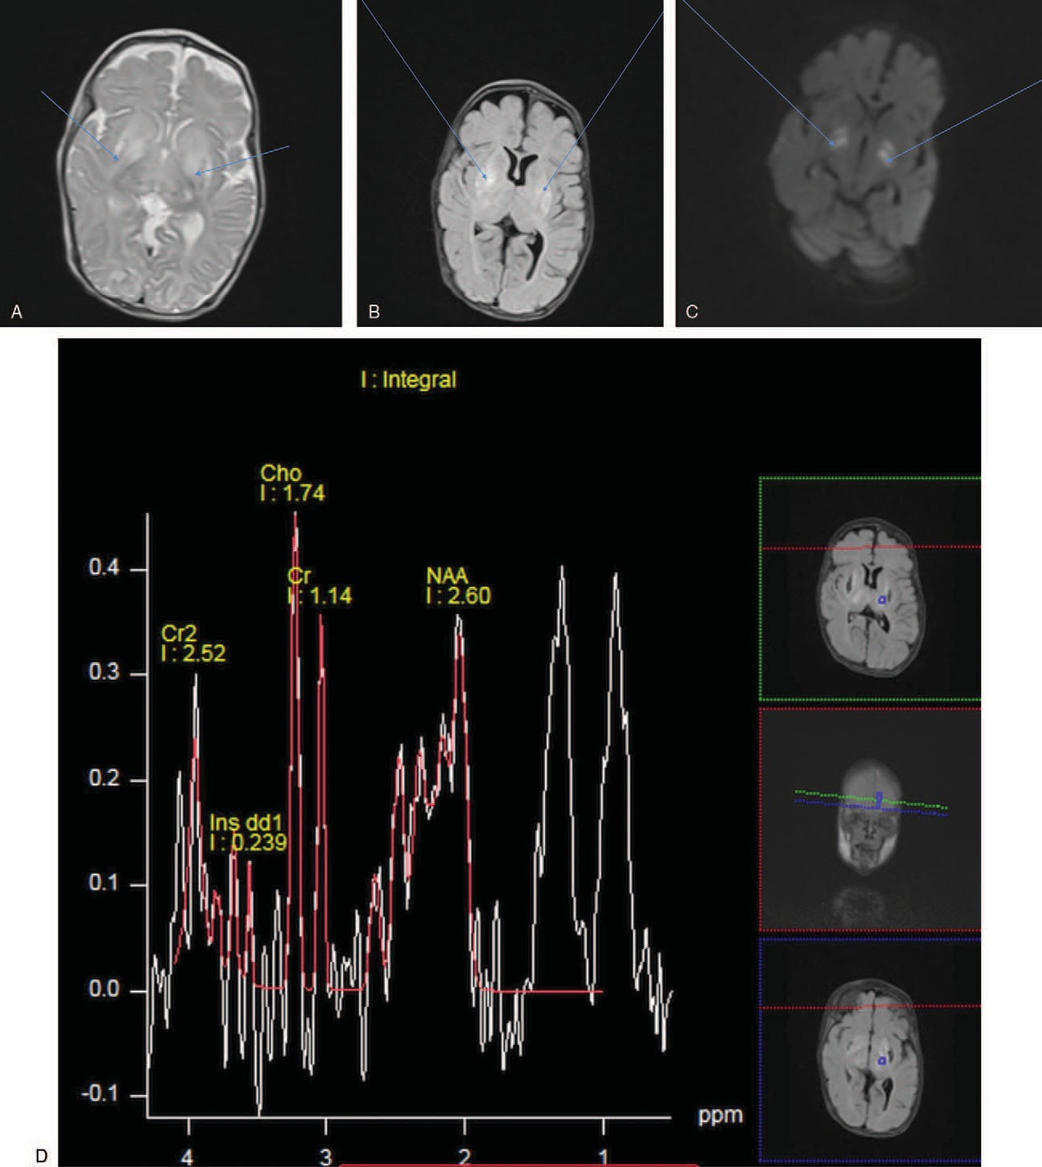

Figure 1. A: Axial T2-weighted MRI images at level of basal ganglia shows hyperintensity within bilateral lentiform nuclei. B: Axial FLAIR MRI images at level of basal ganglia shows hyperintensity within bilateral lentiform nuclei. C: Axial diffusion-weighted image shows areas of diffusion hyperintensity involving bilateral lentiform nuclei. D: Single—voxel MRI spectroscopy from the VOI containing the left affected basal ganglia demonstrated decreased NAA peak and increased choline peak. A discernible doublet is seen at 1.33 ppm suggestive of lactate peak. FLAIR =ﬂuid attenuation inversion recovery, MRI =magnetic resonance imaging, NAA =N- acetylaspartate, VOI =volume of interest.

patients with mitochondrial diseases. Despite these advances, the genotype–phenotype correlations remain difﬁcult to predict. The large heterogeneity of the human genome makes functional validation of novel disease variants essential.[24,25]

Clearly common disease alleles in mitochondrial disease are due to mutation in nuclear genes, which are important to maintain our mitochondrial DNA[26] with an estimated preva- lence of pathogenic nuclear DNA mutations in a northeast

England study on adults with symptomatic mitochondrial disease of 2.9 per 100,000 compared with 20 per 100,000 for the pathogenic mtDNA mutations.[27] A Spanish study found an estimated prevalence of 5.7 per 100,000 for mitochondrial diseases in a population over 14 years of age.[28]

Emmanuele et al[29] studied neonatal cord blood samples for 10 common mtDNA point mutations and a prevalence of 1 in

200 was detected. On the other hand, an Australian study

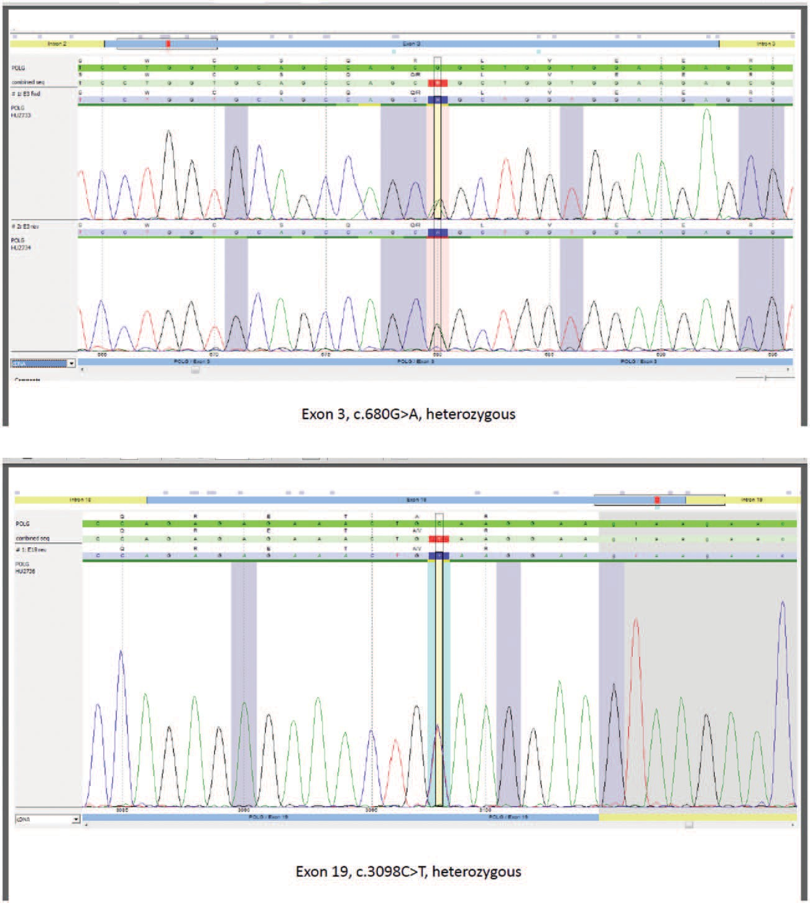

Figure 2. Chromatogram of the patient.

estimated the minimal birth prevalence of primary mitochondrial disorders to be 6.2 per 100,000 births.[30]

To date, there are >230 reported mutations in the human POLG gene alone.[31] The number of individuals harboring a recessive pathogenic mutation in *POLG* has been estimated to approach 2% of the population.[26]

There is one recently diagnosed infant with MNGIE syndrome who had severe hypotonia and generalized muscle weakness requiring ventilator assistance and severe abdominal distention with hypoactive bowel and congenital anomalies in the form of low set ears and bilateral clubfeet, with compound heterozygous

missense mutation in c.679c>t predicting p.R227W and c.2542G>A predicting p.G848s. Sequencing of parental samples conﬁrmed recessive inheritance.[23]

Our patient is similar to this report in having severe hypotonia and poor respiratory effort with low set ears and bilateral clubfeet with a novel compound heterozygous mutation; c.680G>A (p. Arg227Gin) and c.3098C>T (P.Ala1033Val); in POLG gene. Segregation analysis revealed that the baby inherited the POLG variant c.680G>A (p. Arg227Gin) from the father while the POLG variant c.3098C>T (P.Ala10033Val) was inherited maternally.

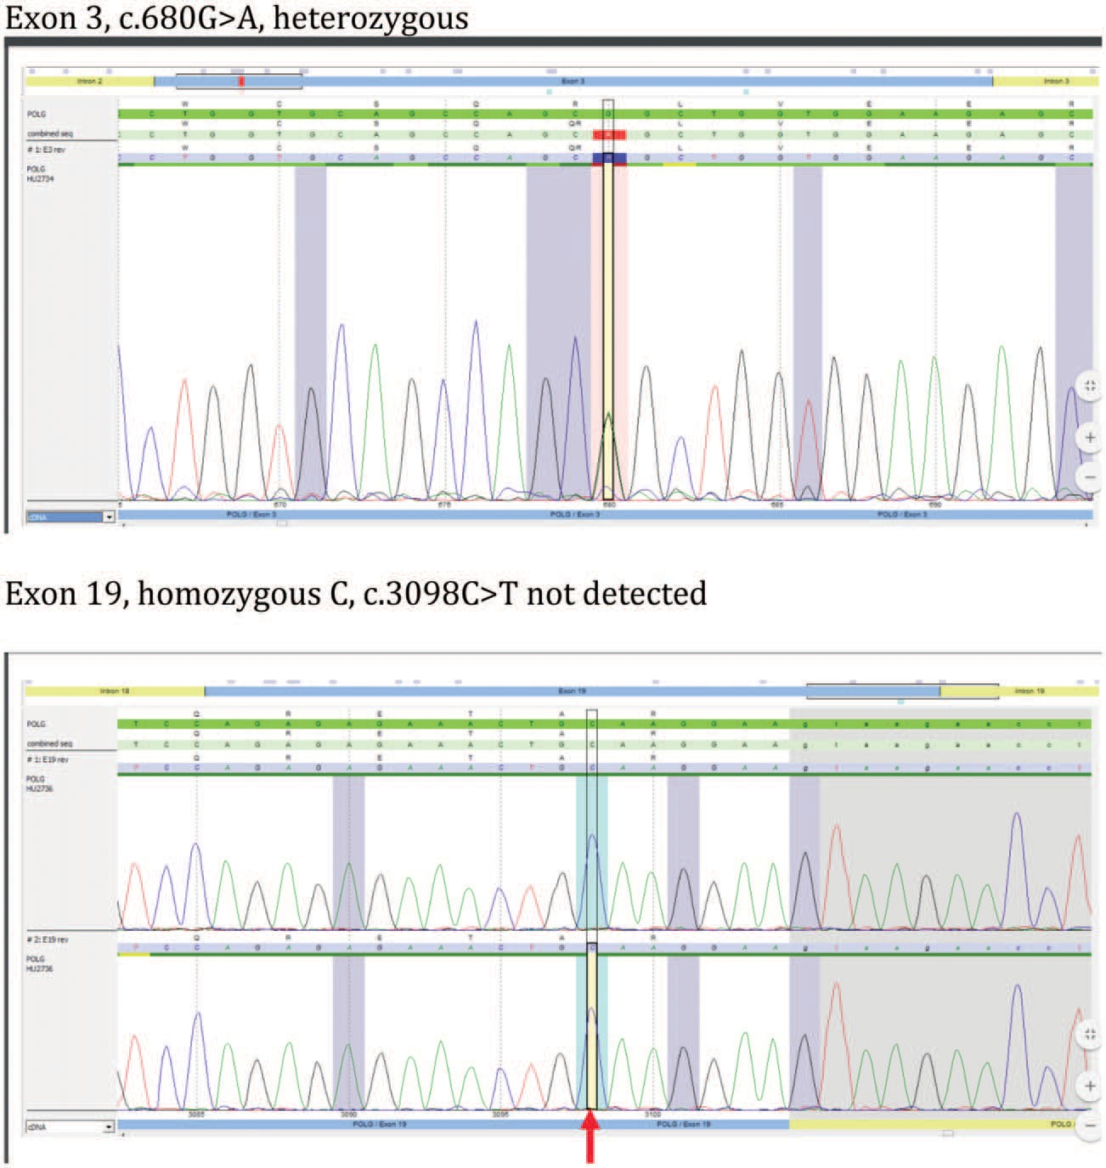

Figure 3. Chromatogram of the father.

To the best of our knowledge the POLG variant c.680G>A (p. Arg227Gin) has not been described in literature or databases so far and there is no information regarding its allele frequency in the general population (ExAC database). Six out of 10 bioinformatic analysis tools used, predicted a signiﬁcant effect on protein function by the variant p.Arg227G conﬁrming its pathogenic effect.

The mutation described by Giordano et al[32] is affecting the same protein position pArg227Trp in compound heterozygosity in his male patient with MNGIE syndrome.

The POLG variant c.3098C>T (P.Ala1033Val) has been annotated as a rare polymorphism (rs551708243) and its allele frequency in the general population is 0.02% (ExAC databases) which would be compatible with a potential pathogenicity. To the best of our knowledge the variant has not been described in

the literature so far. A signiﬁcant effect on protein function was predicted by 2 out of 10 bioinformatic analysis tools used.

Three siblings of our patient died with same clinical scenario. All of them had severe ﬂoppiness, respiratory failure, and were ventilator dependent which started immediately after birth. They all died in the neonatal period.

These similarities in clinical ﬁndings emphasize the hypothesis that all of them carried the same disease and hypothetically the same mutation causing defective respiratory chain energy production like their currently reported sibling especially after genetic conﬁrmation of carrier status of their parents.

Lack of genetic testing of the other 3 siblings who were delivered and died in another hospital might remain a limitation of our report.

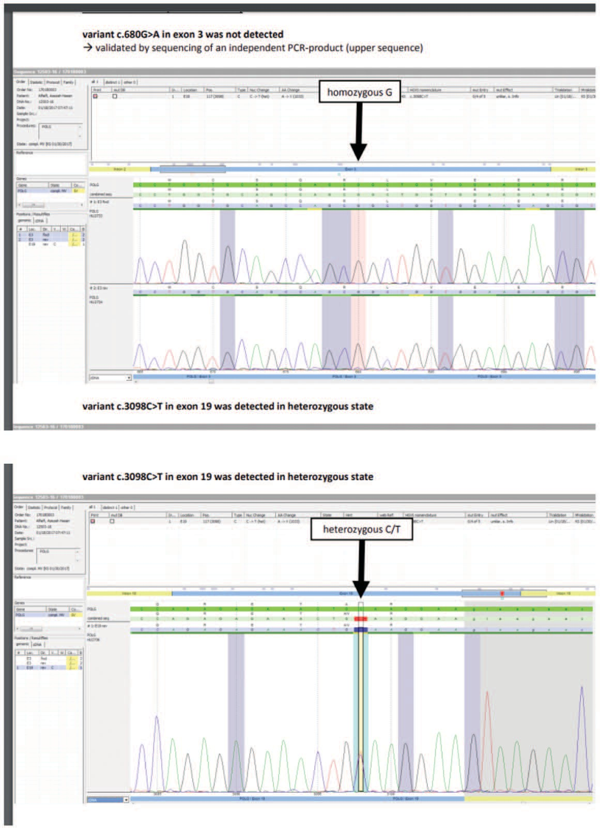

Figure 4. Chromatogram of the mother.

# Conclusion

Mitochondrial respiratory chain defect is not an uncommon cause of severe neonatal hypotonia (paralysis), with absent deep tendon reﬂexes culminating in respiratory failure or intrauterine deaths. The main clue to diagnosis is the

encephalopathy and the characteristics MRI ﬁndings in highly consanguineous population.

# Author contributions

MA and NK: planned, conducted and reported the work.

HK and AH: shared in conducting the work YA: conducted the radiological part of the work

Conceptualization: Mohamed AlJabri, Naglaa M. Kamal.

Data curation: Mohamed AlJabri, Haifa Korbi, Abdulrahman Halabi, Mashour Alsayyali.

Investigation: Mohamed AlJabri, Mashour Alsayyali.

Methodology: Mohamed AlJabri, Abdulrahman Halabi, Yahea Alzahrani.

Project administration: Mohamed AlJabri, Naglaa M. Kamal.

Supervision: Mohamed AlJabri.

Software: Naglaa M. Kamal.

Visualization: Naglaa M. Kamal.

Writing – original draft: Naglaa M. Kamal, Haifa Korbi.

Writing – review & editing: Naglaa M. Kamal. Naglaa M. Kamal orcid: 0000-0002-8535-3838.

# References

1. Mitochondrial structure, function, and genetics. Available at: [https://](https://www.uptodate.com/contents/mitochondrial-structure-function-andgenetics?source=search_result%26search%3Dmitochondrial%2520disease%26selectedTitle%3D3~150) [www.uptodate.com/contents/mitochondrial-structure-function-andge](https://www.uptodate.com/contents/mitochondrial-structure-function-andgenetics?source=search_result%26search%3Dmitochondrial%2520disease%26selectedTitle%3D3~150) [netics?source=search_result&search=mitochondrial%20disease&selec](https://www.uptodate.com/contents/mitochondrial-structure-function-andgenetics?source=search_result%26search%3Dmitochondrial%2520disease%26selectedTitle%3D3~150) [tedTitle=3](https://www.uptodate.com/contents/mitochondrial-structure-function-andgenetics?source=search_result%26search%3Dmitochondrial%2520disease%26selectedTitle%3D3~150)∼[150.](https://www.uptodate.com/contents/mitochondrial-structure-function-andgenetics?source=search_result%26search%3Dmitochondrial%2520disease%26selectedTitle%3D3~150) Accessed November 15, 2017.
2. Darin N, Oldfors A, Moslemi AR, et al. The incidence of mitochondrial encephalomyopathies in childhood: clinical features and morphological, biochemical, and DNA abnormalities. Ann Neurol 2001;49:377–83.
3. Kirby DM, Crawford M, Cleary MA, et al. Respiratory chain complex I deﬁciency: an underdiagnosed energy generation disorder. Neurology 1999;52:1255–64.
4. Loeffen JL, Smeitink JA, Trijbels JM, et al. Isolated complex I deﬁciency in children: clinical, biochemical and genetic aspects. Hum Mutat 2000;15:123–34.
5. Leigh D. Subacute necrotizing encephalomyelopathy in an infant. J Neurochem 1951;14:216–21.
6. Morris AA, Leonard JV, Brown GK, et al. Deﬁciency of respiratory chain complex I is a common cause of Leigh disease. Ann Neurol 1996;40: 25–30.
7. Moraes CT, Shanske S, Tritschler HJ, et al. MtDNA depletion with variable tissue expression: a novel genetic abnormality in mitochondrial diseases. Am J Hum Genet 1991;48:492–501.
8. Spinazzola A, Invernizzi F, Carrara F, et al. Clinical and molecular features of mitochondrial DNA depletion syndromes. J Inherit Metab Dis 2009;32:143–58.
9. Available at: [https://ghr.nlm.nih.gov/gene/POLG.](https://ghr.nlm.nih.gov/gene/POLG) Accessed November 15, 2017.
10. Naviaux RK, Nguyen KV. POLG mutations associated with Alpers’ syndrome and mitochondrial DNA depletion. Ann Neurol 2004;55: 706–12.
11. Kollberg G, Moslemi AR, Darin N, et al. POLG1 mutations associated with progressive encephalopathy in childhood. J Neuropathol Exp Neurol 2006;65:758–68.
12. Loeffen J, Smeitink J, Triepels R, et al. The ﬁrst nuclear-encoded complex I mutation in a patient with Leigh syndrome. Am J Hum Genet 1998;63:1598–608.
13. van den Heuvel L, Smeitink J. The oxidative phosphorylation (OXPHOS) system: nuclear genes and human genetic diseases. Bioessays 2001;23:518–25.
14. Triepels RH, Van Den Heuvel LP, Trijbels JM, et al. Respiratory chain complex I deﬁciency. Am J Med Genet 2001;106:37–45.
15. Van Goethem G, Dermaut B, Lofgren A, et al. Mutation of POLG is associated with progressive external ophthalmoplegia characterized by mtDNA deletions. Nat Genet 2001;28:211–2.
16. Filosto M, Mancuso M, Nishigaki Y, et al. Clinical and genetic heterogeneity in progressive external ophthalmoplegia due to mutations in polymerase gamma. Arch Neurol 2003;60:1279–84.
17. Finsterer J, Zarrouk MS. Epilepsy in mitochondrial disorders. Seizure 2012;21:316–21.
18. Rahman S. Mitochondrial disease and epilepsy. Dev Med Child Neurol 2012;54:397–406.
19. Fadic R, Russell JA, Vedanarayanan VV, et al. Sensory ataxic neuropathy as the presenting feature of a novel mitochondrial disease. Neurology 1997;49:239–45.
20. Tzoulis C, Engelsen BA, Telstad W, et al. The spectrum of clinical disease caused by the A467T and W748S POLG mutations: a study of 26 cases. Brain 2006;129:1685–92.
21. Worle H, Kohler B, Schlote W, et al. Progressive cerebral degeneration of childhood with liver disease (Alpers-Huttenlocher disease) with cyto- chrome oxidase deﬁciency presenting with epilepsia partialis continua as the ﬁrst clinical manifestation. Clin Neuropathol 1998;17:63–8.
22. Cohen BH, Chinnery PF, Copeland WC. POLG-related disorders. In: GeneReviewsTM [online]. Available at: [http://www.ncbi.nlm.nih.gov/](http://www.ncbi.nlm.nih.gov/books/NBK26471/) [books/NBK26471/.](http://www.ncbi.nlm.nih.gov/books/NBK26471/) Updated October 11, 2012. Accessed November 14, 2012.
23. Tang S, Dimberg EL, Milone M, et al. Mitochondrial neurogastrointes- tinal encephalomyopathy (MNGIE)-like phenotype: an expanded clinical spectrum of POLG1 mutations. J Neurol 2012;259:862–8.
24. Zeviani M, Moraes CT, DiMauro S, et al. Deletions of mitochondrial DNA in Kearns-Sayre syndrome. Neurology 1988;38:1339–46.
25. Uusimaa J, Gowda V, McShane A, et al. Prospective study of POLG mutations presenting in children with intractable epilepsy: prevalence and clinical features. Epilepsia 2013;54:1002–11.
26. Cohen BH, Naviaux RK. The clinical diagnosis of POLG disease and other mitochondrial DNA depletion disorders. Methods 2010;51: 364–73.
27. Horváth R, Schoser BG, Müller-Höcker J, et al. Mutations in mtDNA- encoded cytochrome c oxidase subunit genes causing isolated myopathy or severe encephalomyopathy. Neuromuscul Disord 2005;15:851–7.
28. Arpa J, Cruz-Martínez A, Campos Y, et al. Prevalence and progression of mitochondrial diseases: a study of 50 patients. Muscle Nerve 2003;28: 690–5.
29. Emmanuele V, Sotiriou E, Shirazi M, et al. Recurrent myoglobinuria in a sporadic patient with a novel mitochondrial DNA tRNA(Ile) mutation. J Neurol Sci 2011;303:39–42.
30. Skladal D, Halliday J, Thorburn DR. Minimum birth prevalence of mitochondrial respiratory chain disorders in children. Brain 2003;126: 1905–12.
31. Human DNA polymerase gamma mutation database human DNA polymerase gamma mutation database. Available at: [https://tools.niehs.](https://tools.niehs.nih.gov/polg/) [nih.gov/polg/.](https://tools.niehs.nih.gov/polg/) Accessed April 1, 2018.
32. Giordano C, Powell H, Leopizzi M, et al. Fatal congenital myopathy and gastrointestinal pseudo-obstruction due to polg1 mutations. Neurology 2009;72:1103–5.