302 *Case Reports / Journal of Clinical Neuroscience 61 (2019) 302–304*

# Leukoencephalopathy with a case of heterozygous *POLG* mutation mimicking mitochondrial neurogastrointestinal encephalomyopathy (MNGIE)

## Ken Yasuda a,⇑, Nagako Murase b, Kenji Yoshinaga b, Ryo Ohtani b, Yu-ichi Goto c, Ryosuke Takahashi a,

Michikazu Nakamura b

a *Department of Neurology, Kyoto University, Graduate School of Medicine, 54 Shogoin-Kawahara-cho, Sakyo-ku, Kyoto 606-8507, Japan*

b *Department of Neurology, National Hospital Organization Kyoto Medical Center, 1-1 Mukaihata-cho, Fukakusa, Fushimi-ku, Kyoto 612-8555, Japan*

c *Medical Genome Center/National Institute of Neuroscience, National Center of Neurology and Psychiatry, 4-1-1 Ogawahigashi, Kodaira, Tokyo 187-8502, Japan*

### a r t i c l e i n f o

*Article history:*

Received 26 August 2018

Accepted 6 October 2018

*Keywords:*

POLG

Leukoencephalopathy MNGIE

Demyelinating polyneuropathy Pseudo-obstruction

### a b s t r a c t

Diseases due to mutations of polymerase c (*POLG*) usually present with progressive external ophthalmo- plegia. However, a few studies have been reported on *POLG1* mutations with the mitochondrial neurogas- trointestinal encephalomyopathy (MNGIE)-like phenotype. All cases with *POLG1* mutations mimicking MNGIE have never shown leukoencephalopathy on brain magnetic resonance imaging (MRI) or demyeli- nating polyneuropathy.

We present a 26-year-old male with gait disturbance, recurrent bowel obstruction, peripheral neuropathy, ophthalmoplegia or ptosis, which represented MNGIE phenotype. Though he displayed demyelinating peripheral neuropathy or leukoencephalopathy on brain MRI, genetic analysis revealed heterozygous mutation in *POLG1* gene.

We report for the first time two newly characteristics in our patient with heterozygous *POLG1*

mutations with the MNGIE-like phenotype: leukoencephalopathy and demyelinating polyneuropathy.

© 2018 Elsevier Ltd. All rights reserved.

1. Introduction

Mutations in Polymerase c (*POLG*), one of the causative genetic abnormalities of mitochondrial disease, are generally present in patients with familial progressive external ophthalmoplegia. Some patients with this gene abnormality show a phenotype that con- sists of severe gastrointestinal manifestations including recurrent vomiting and intestinal pseudo-obstruction, which is similar to mitochondrial neurogastrointestinal encephalomyopathy (MNGIE) due to mutations in the gene encoding thymidine phosphorylase (TP) [1]. MNGIE usually shows demyelinating peripheral neuropa- thy, leukoencephalopathy, ophthalmoplegia, ptosis, and cachexia. However, all cases with *POLG* mutations that mimic the MNGIE phenotype so far lack leukoencephalopathy on brain magnetic res- onance imaging (MRI) or demyelinating polyneuropathy [2–4]. We report two newly detected characteristics in our patient that have not been reported in patients with *POLG* mutations with the MNGIE-like phenotype: leukoencephalopathy and demyelinating polyneuropathy.

1. Case

The patient was a 26-year-old male who complained of gait disturbance that deteriorated over that started when he was 15 years old. He had no family history of neurological diseases. His past medical history included recurrent bowel obstruction without any mechanical causes. His height was 171 cm, and his body weight was 46 kg. The patient exhibited a lower intelligence level (full IQ = 65). His cranial nerves showed bilateral ptosis, he had mild saccadic eye movement, and his speech was slurred. His muscle strength was slightly weak in the neck and all four limbs. Pinprick, position sense, and vibration sensation were

⇑ Corresponding author.

*E-mail address:* [kenyasud@kuhp.kyoto-u.ac.jp](mailto:ataka_fuji@sis.seirei.or.jp) (K. Yasuda).

markedly decreased in the lower extremities. He displayed areflexia in the lower limbs, and no pathological reflexes or pyramidal tract signs. Muscle tonus was hypotonic. Pes cavus was seen, although no spinal deformities and no skin lesions were observed. The finger-nose-finger test demonstrated dysmetria and decomposition. The Romberg test was positive.

Routine blood tests did not reveal any abnormalities including blood cell count, serum protein, renal or liver function, coagulopa- thy. In addition, tests for anti-SS-A/SS-B, and anti-ganglioside anti- bodies were negative. A cerebrospinal fluid study showed elevated protein (204 mg/dl) and no pleocytosis. Lactate and pyruvic acid were increased in the cerebrospinal fluid, although levels of these were normal in the serum.

Brain MRI revealed diffuse leukoencephalopathy (Fig. 1A) and cerebellar atrophy. Nerve conduction studies showed reduced con- duction velocities and markedly prolonged distal motor latencies with a decreased amplitude of compound muscle action potentials in the bilateral tibial nerves. The F wave minimum latency of these nerves was prolonged (Table 1). Temporal dispersion was detected in the bilateral tibial nerves (Fig. 1B). Sural nerves were not evoked bilaterally. The electrophysiological diagnosis was demyelinating sensorimotor polyneuropathy.

Because needle electromyography revealed early recruitment with short duration and low amplitude in paraspinal muscles, we next performed a muscle biopsy from his biceps brachii. Patholog- ical findings following modified Gomori trichrome staining showed scattered, ragged-red fibers (Fig. 1C).

Based on the above findings, we diagnosed the patient with mitochondrial disease with demyelinating sensorimotor polyneu- ropathy and gastrointestinal manifestations. TP activity was within the reference range. Long-range PCR and Southern hybridization revealed multiple deletions in the patient’s mtDNA, and *POLG* sequencing analysis with the patient and his parents showed com- pound heterozygous mutations in *POLG1*: c.895A > C and c.3626_3629dupGATA (Supplementary Figure).

*Case Reports / Journal of Clinical Neuroscience 61 (2019) 302–304* 303

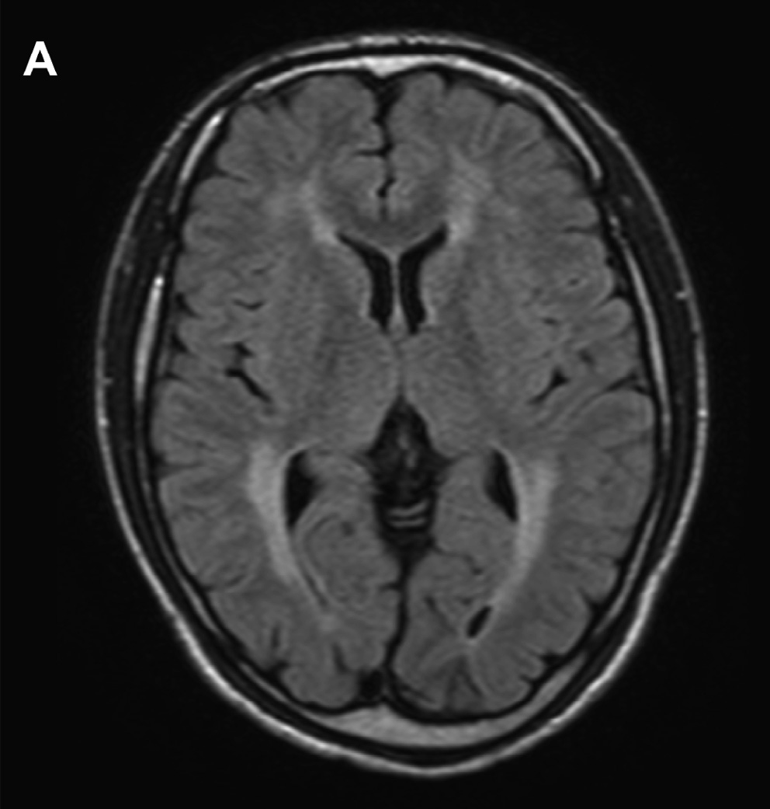

Fig. 1A. Brain MRI at diagnosis of the patient. Axial fluid-attenuated inversion recovery imaging revealed diffuse leukoencephalopathy with preservation of U-fibers.

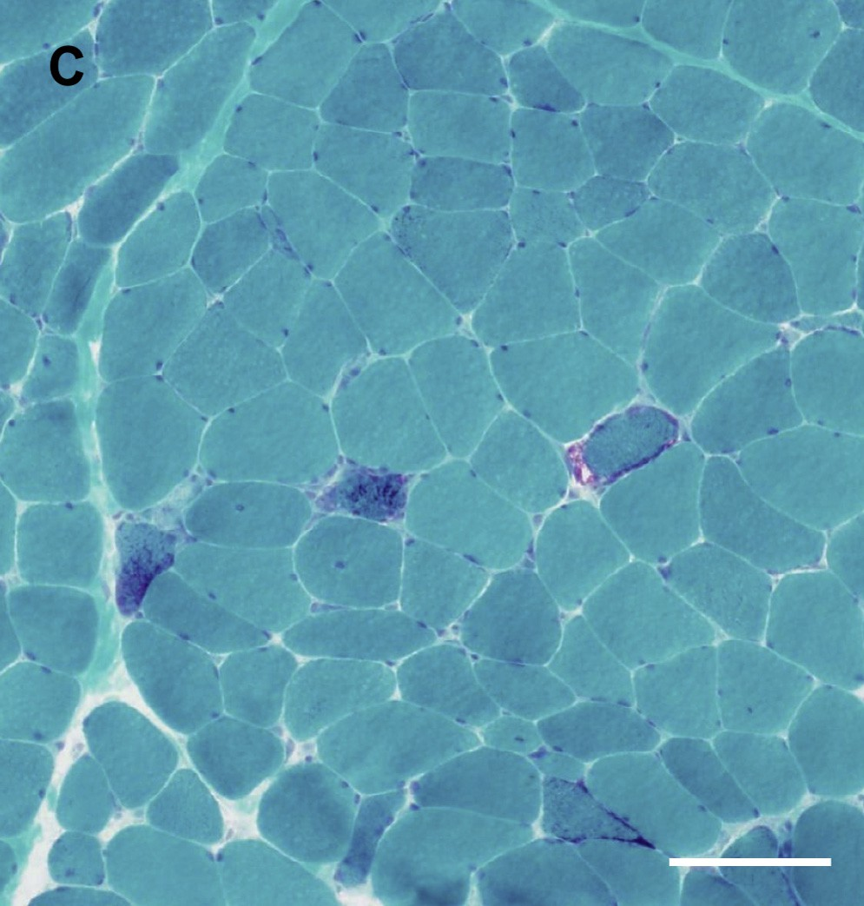

Fig. 1C. Muscle biopsy findings. Modified Gomori trichrome staining showed many ragged-red fibers. Bar indicates 100 mm.

1. Discussion

We report two novel findings in this patient. First, a patient with heterozygous *POLG* mutations presenting with a MNGIE-like phenotype showed leukoencephalopathy on brain MRI, which

was contrary to the previous finding reported for MNGIE-like patients with *POLG* mutations [2–4]. Second, this patient with *POLG* mutations and the MNGIE-like phenotype demonstrated demyeli- nating sensorimotor polyneuropathy, although axonal polyneu- ropathy is the only neuropathy that has been reported in patients with compound heterozygous *POLG* mutations [5]. This

Table 1

Results of nerve conduction study.

|  |  |  |  |  |  |  |  |  |
| --- | --- | --- | --- | --- | --- | --- | --- | --- |
|  | | DL (ms) | MCV (m/s) | CMAP amplitude (distal/proximal) (mV) | Minimum F latency (ms) | F frequency (%) | SCV (m/s) | SNAP amplitude (lV) |
| Median | R | 5.2 | 49.8 | 5.8 (wrist)/5.9 (elbow) | 26.4 | 38 | 45 | 8.4 |
| Ulnar | R | 2.9 | 53.5 | 6.6 (wrist)/4.4 (elbow) | 28.3 | 38 | 45 | 12.5 |
| Tibial | R | 8.9 | 20.4 | 1.0 (ankle)/0.5 (popliteal) | 67.2 | 100 | – | – |
| Sural | R | – | – | – | – | – | NE | NE |

R: right, DL: distal latency, MCV: motor conduction velocity, CMAP: compound muscle action potential, SCV: sensory conduction velocity, SNAP: sensory nerve action potential, NE: not evoked. Because the values were similar on both sides, this table only shows those on the right side.

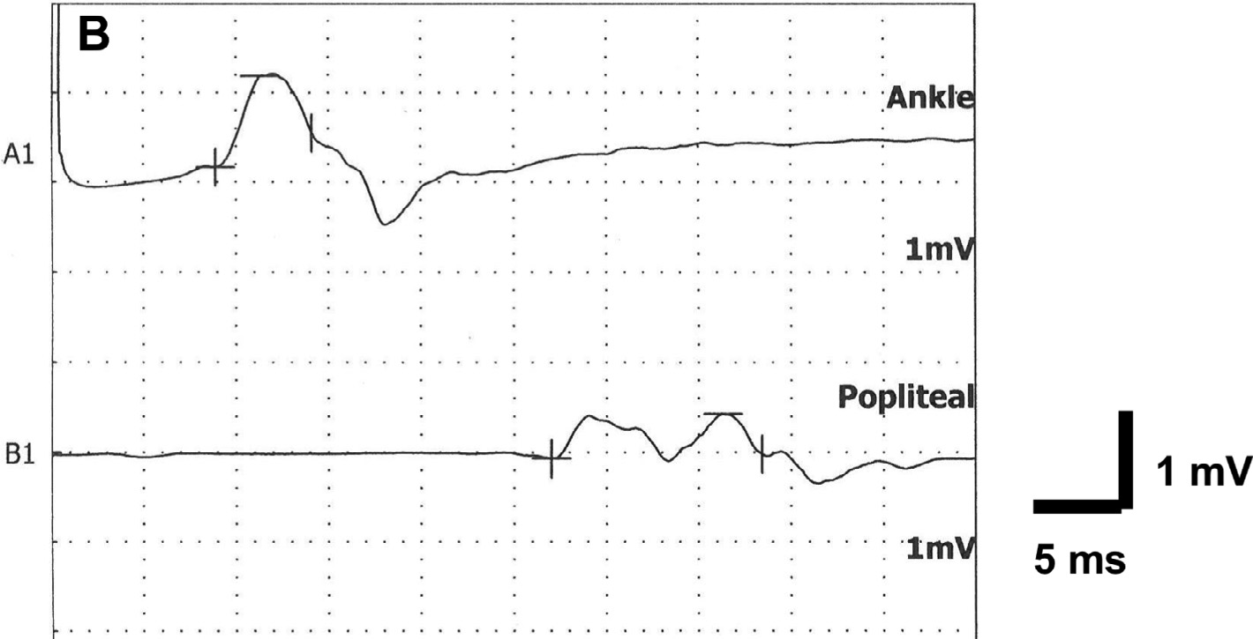

Fig. 1B. Nerve conduction study. Temporal dispersion was observed in the bilateral tibial nerves.

304 *Case Reports / Journal of Clinical Neuroscience 61 (2019) 304–307*

case expands the clinical spectrum of heterozygous *POLG* muta- tions to include MNGIE-like phenotypes.

Conflicts of interest/disclosures

The authors declare no conflicts of interest.

Acknowledgements

We wish to acknowledge the contributions of Prof. Michio Hir- ano at The Colombia University for evaluation of TP activity. We thank Dr. Ichizo Nishino at National Center of Neurology and Psy- chiatry (NCNP) for diagnosis of muscle pathology and Dr. Eri Take- shita at NCNP for genomic analysis. This study was supported in part by the Research Grant for Nervous and Mental Disorders from the NCNP (24-8, 27-6) and Platform Program for Promotion of Gen- ome Medicine from Japan Agency for Medical Research and Devel- opment (18kk0205012s0303).

Appendix A. Supplementary data

Supplementary data to this article can be found online at <https://doi.org/10.1016/j.jocn.2018.10.054>.

References

1. [Nishino I, Spinazzola A, Papadimitriou A, et al. Mitochondrial](http://refhub.elsevier.com/S0967-5868(18)31768-5/h0010) [neurogastrointestinal encephalomyopathy: an autosomal recessive disorder](http://refhub.elsevier.com/S0967-5868(18)31768-5/h0010) [due to thymidine phosphorylase mutations. Ann Neurol 2000;47:792–800](http://refhub.elsevier.com/S0967-5868(18)31768-5/h0010).
2. [Van Goethem G, Schwartz M, Lӧ fgren A, Novel,, et al. POLG mutations in](http://refhub.elsevier.com/S0967-5868(18)31768-5/h0015) [progressive external ophthalmoplegia mimicking mitochondrial](http://refhub.elsevier.com/S0967-5868(18)31768-5/h0015) [neurogastrointestinal encephalomyopathy. Eur J Hum Genet 2003;11:547–9](http://refhub.elsevier.com/S0967-5868(18)31768-5/h0015).
3. [Tang S, Dimberg EL, Milone M, Wong LJ. Mitochondrial neurogastrointestinal](http://refhub.elsevier.com/S0967-5868(18)31768-5/h0020) [encephalomyopathy (MNGIE)-like phenotype: an expanded clinical spectrum of](http://refhub.elsevier.com/S0967-5868(18)31768-5/h0020) [POLG1 mutations. J Neurol 2012;259:862–8](http://refhub.elsevier.com/S0967-5868(18)31768-5/h0020).
4. [Prasun P, Koeberl D. Mitochondrial neurogastrointestinal encephalomyopathy](http://refhub.elsevier.com/S0967-5868(18)31768-5/h0025) [(MNGIE)-like phenotype in a patient with a novel heterozygous POLG mutation.](http://refhub.elsevier.com/S0967-5868(18)31768-5/h0025) [J Neurol 2014;261:1818–9](http://refhub.elsevier.com/S0967-5868(18)31768-5/h0025).
5. [Tchikviladzé M, Gilleron M, Maisonobe T, et al. A diagnostic flow chart for](http://refhub.elsevier.com/S0967-5868(18)31768-5/h0030) [POLG-related diseases based on signs sensitivity and specificity. J Neurol](http://refhub.elsevier.com/S0967-5868(18)31768-5/h0030) [Neurosurg Psychiatry 2015;86:646–54](http://refhub.elsevier.com/S0967-5868(18)31768-5/h0030).

[https://doi.org/10.1016/j.jocn.2018.10.054](https://doi.org/10.1016/j.jocn.2018.10.050)

# Sudden neurological deterioration due to repeated intratumoral hemorrhage in a patient with a vestibular schwannoma

## Mostafa Fatehi Hassanabad ⇑, Ryojo Akagami

*Division of Neurosurgery, Vancouver General Hospital, 899, 12th Avenue West, Vancouver V5Z1M9, Canada*

### a r t i c l e i n f o

*Article history:*

Received 5 August 2018

Accepted 6 October 2018

*:*

### a b s t r a c t

Vestibular schwannomas (VS) are the most common tumors involving the cerebellopontine angle (CPA) and the internal auditory canal (IAC). These tumors are usually slow-growing and commonly present with cranial nerve dysfunction such as hearing loss. Repeated intratumoral hemorrhage (ITH) is extre- mely rare with only four cases previously reported.

We report the case of a 30 year old female with a right sided CP angle tumor who presented with ver- tigo and ataxia due to ITH. Her symptoms initially improved; however, three weeks later, she had acute onset of facial palsy and imaging confirmed rebleeding. Surgical pathology reported typical features of schwannoma.

A literature review performed using the PubMed and EMBASE databases yielded four previous reports. A summary of these cases is presented and the features of ITH are discussed. Patients affected by repeated ITH present with sudden headache and ataxia. Rapid worsening of cranial nerve dysfunction such as hear- ing loss or facial nerve palsy is suggestive of ITH.

© 2018 Elsevier Ltd. All rights reserved.

1. Case presentation

A 30 year old female with a prior history of Hodgkin’s lym- phoma and gradual hearing loss was found to have a right CP angle mass in June 2016. An MRI in June 2016 further characterised the lesion and showed no significant change in size (Fig. 1). After con- sultation with a neurosurgeon, the patient elected to undergo watchful surveillance. In the ensuing months, the patient devel- oped further hearing loss and hemifacial numbness (CN V2 and V3 distribution); however, follow-up MR imaging in January and June 2017 remained largely stable in size (Fig. 2).

The development of headache, tinnitus and ataxia in late June 2017 prompted repeat MR imaging which demonstrated intratu-

⇑ Corresponding author.

*E-mail address:* [m.fatehi@utoronto.ca](mailto:ataka_fuji@sis.seirei.or.jp) (M. Fatehi Hassanabad).

moral hemorrhage and consequent enlargement of the tumor (Fig. 3). While the patient’s symptoms largely improved over the next week, she agreed to undergo neurosurgical treatment in July. However, the day before her scheduled procedure, the patient developed sudden headache and noticed rapidly progressive right facial nerve palsy. Urgent imaging confirmed repeat intratumoral hemorrhage (Fig. 4). The patient had intact level of consciousness throughout and her lower cranial nerves were not affected.

Preoperatively, the patient had right-sided, House-Brackmann (HB) grade IV, facial nerve weakness, no hearing on the right and decreased sensation in the right CN V2 and V3 distribution. Intraoperative neurophysiological monitoring was performed with CN V, CNVII and CN X nerve EMG monitoring. Bilateral brainstem auditory-evoked responses (BAERs) and CNVII motor evoked potentials (MEP) were also monitored. Good subtotal (>85%) resection of the tumor was achieved and a rind of tumor