**International Journal of Neuroscience**

**ISSN: 0020-7454 (Print) 1543-5245 (Online) Journal homepage:** [**www.tandfonline.com/journals/ines20**](https://www.tandfonline.com/journals/ines20?src=pdf)

Novel *POLG* mutation in a patient with early- onset parkinsonism, progressive external ophthalmoplegia and optic atrophy

**Lin Ma, Wei Mao, Erhe Xu, Yanning Cai, Chaodong Wang, Jagadish K. Chhetri & Piu Chan**

**To cite this article:** Lin Ma, Wei Mao, Erhe Xu, Yanning Cai, Chaodong Wang, Jagadish K. Chhetri & Piu Chan (2020) Novel *POLG* mutation in a patient with early-onset parkinsonism, progressive external ophthalmoplegia and optic atrophy, International Journal of Neuroscience, 130:4,

319-321, DOI: [10.1080/00207454.2019.1681422](https://www.tandfonline.com/action/showCitFormats?doi=10.1080/00207454.2019.1681422)

**To link to this article:** <https://doi.org/10.1080/00207454.2019.1681422>

 Published online: 07 Nov 2019.

[](https://www.tandfonline.com/action/authorSubmission?journalCode=ines20&show=instructions&src=pdf) [Submit your article to this journal [](https://www.tandfonline.com/action/authorSubmission?journalCode=ines20&show=instructions&src=pdf)](https://www.tandfonline.com/action/authorSubmission?journalCode=ines20&show=instructions&src=pdf)

 Article views: 316

[](http://crossmark.crossref.org/dialog/?doi=10.1080/00207454.2019.1681422&domain=pdf&date_stamp=07%20Nov%202019)[](https://www.tandfonline.com/doi/mlt/10.1080/00207454.2019.1681422?src=pdf) [View related articles [](https://www.tandfonline.com/doi/mlt/10.1080/00207454.2019.1681422?src=pdf) [](http://crossmark.crossref.org/dialog/?doi=10.1080/00207454.2019.1681422&domain=pdf&date_stamp=07%20Nov%202019) [View Crossmark data](http://crossmark.crossref.org/dialog/?doi=10.1080/00207454.2019.1681422&domain=pdf&date_stamp=07%20Nov%202019)](https://www.tandfonline.com/doi/mlt/10.1080/00207454.2019.1681422?src=pdf)

[](https://www.tandfonline.com/doi/citedby/10.1080/00207454.2019.1681422?src=pdf) [Citing articles: 5 View citing articles [](https://www.tandfonline.com/doi/citedby/10.1080/00207454.2019.1681422?src=pdf)](https://www.tandfonline.com/doi/citedby/10.1080/00207454.2019.1681422?src=pdf)

Full Terms & Conditions of access and use can be found at <https://www.tandfonline.com/action/journalInformation?journalCode=ines20>

[](http://www.tandfonline.com/)INTERNATIONAL JOURNAL OF NEUROSCIENCE 2020, VOL. 130, NO. 4, 319–321



<https://doi.org/10.1080/00207454.2019.1681422>

CASE REPORT

[](http://crossmark.crossref.org/dialog/?doi=10.1080/00207454.2019.1681422&domain=pdf&date_stamp=2020-02-06)Novel *POLG* mutation in a patient with early-onset parkinsonism, progressive external ophthalmoplegia and optic atrophy

Lin Maa [](http://orcid.org/0000-0003-4771-795X), Wei Maoa, Erhe Xua, Yanning Caia, Chaodong Wanga, Jagadish K. Chhetria and Piu Chana,b,c,d

aDepartment of Neurology, Neurobiology and Geriatrics, Xuanwu Hospital of Capital Medical University, Beijing Institute of Brain Disorders, Beijing, China; bClinical Center for Parkinson’s Disease, Capital Medical University, Beijing, China; cKey Laboratory for Neurodegenerative Disease of the Ministry of Education, Beijing, China; dNational Clinical Research Center for Geriatrics,

Beijing, China

ARTICLE HISTORY

ABSTRACT

Introduction: Mitochondrial DNA polymerase gamma (pol c) encoded by *POLG* plays an indis- pensable role in the process of mitochondrial DNA replication and repair. The mutation of *POLG* can result in mitochondrial dysfunction leading to a broad spectrum of disease.

Methods: We report a 29-year-old Chinese female presented with levodopa-responsive parkin- sonism, external ophthalmoplegia and optic atrophy. We conducted clinical, molecular icono- graphic, histological and genetic analyses on this patient.

Results: Sequencing of the *POLG* gene revealed compound heterozygote mutations of a novel c.2693T > C (p.I898T) mutation in exon17 and c.2993C > T (p.S998L) in exon19. The mutation c.2693T > C (p.I898T) has never been reported. Also our patient’s cardinal symptoms are rare and different from other cases which have been reported.

Conclusion: This finding of ours has broadened the spectrum of phenotype caused by the mutation of POLG.

Received 22 September 2018

Revised 2 January 2019

Accepted 12 June 2019

KEYWORDS

POLG; parkinsonism; external ophthalmoplegia; optic atrophy

# Introduction

Polymerase gamma (*POLG*) is a nuclear gene that enc- odes mitochondrial DNA polymerase gamma (pol c). It is the only polymerase for mitochondrial DNA(mtDNA) replication and repair [1]. Dysfunction of pol c results in impaired integrity of mtDNA, including to depletion or deletion, eventually leading to diminution of mitochondrial energy with disorders of oxidative phos- phorylation [2]. The spectrum of phenotypes caused by the mutation of *POLG* is broad, which include Alpers syndrome, progressive external ophthalmople- gia (PEO), limb myopathy, parkinsonism, epilepsy and other multi-systemic features [3]. The first 2 cases of parkinsonism with *POLG* mutation were reported in 2004, by Michelangelo Mancuso [4]. Here, we report another case of a female patient carrying a novel com- pound heterozygotic missense mutation in *POLG*.

# Case presentation

The 29 year-old Chinese female patient developed right upper limb mixed rest and postural tremor at

the age of 16. The tremor gradually progressed to left upper limb, lower extremities and the head. Two years later, she showed signs of parkinsonism includ- ing bradykinesia and shuffling gait. Treatment with benserazide/levodopa 25/100 mg bid and benzhexol hydrochloride 2 mg tid significantly improved tremor and bradykinesia, however, soon accompanied with severe peak-dose dyskinesia. With time the patient showed end-of-dose deterioration effect, and self- adjusted benserazide/levodopa’s dose to 12.5/50 mg q2h (about 150/600 mg per day) which helped to relieve the fluctuation. At 23 years of age, the patient developed signs of slowly progressive bilateral ptosis, and a year later, her symptoms significantly aggra- vated, with frequent falls because of dyskinesia and postural instability, along with development of diplo- pia, dysarthria and dysphagia. The patient also reported presence of mild muscles weakness and exercise intolerance conditions.

Her family history was unremarkable. No familial history of consanguineous marriage was found.

CONTACT Piu Chan  [pbchan90@gmail.com  45 Changchun Street, Xicheng District, Beijing, 100053, China Color versions of one or more of the figures in the article can be found online at [www.tandfonline.com/ines](http://www.tandfonline.com/ines). Lin Ma and Wei Mao are co-first authors.](mailto:pbchan90@gmail.com)

Paper previously presented, in part, at XXII World Congress of Parkinson’s disease and related disorders, and the abstract can be found at [https://www.](https://www.sciencedirect.com/science/article/pii/S1353802017305187?via%3Dihub) [sciencedirect.com/science/article/pii/S1353802017305187?via%3Dihub](https://www.sciencedirect.com/science/article/pii/S1353802017305187?via%3Dihub).

© 2019 Informa UK Limited, trading as Taylor & Francis Group

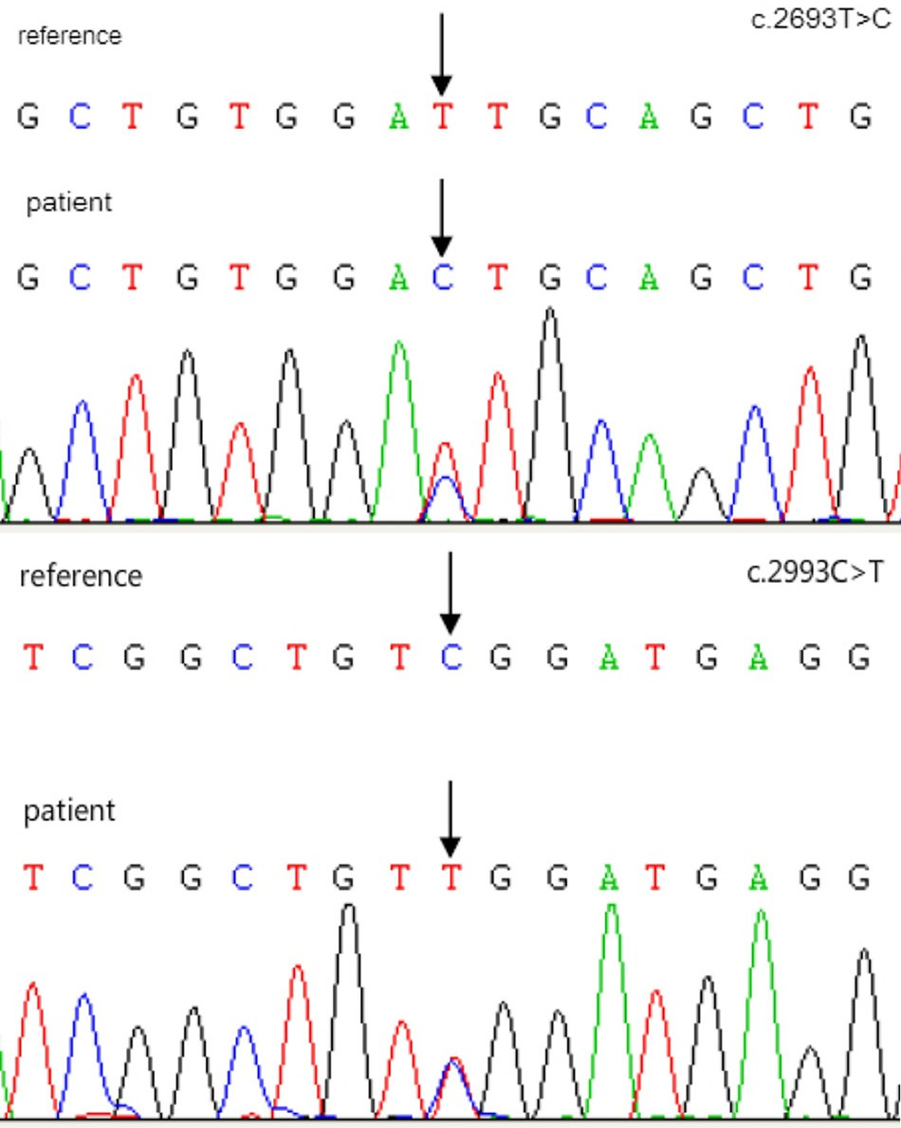320  L. MA ET AL.

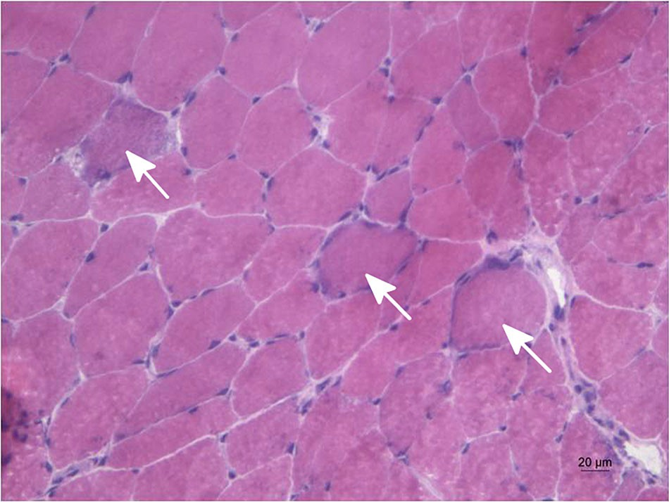

Figure 1. Arrows show ragged red fibers.

Neurological examination revealed cognitive defi- cits, with Montreal Cognitive Assessment (MoCA) score of 16/30 (decline in calculation and delayed recall). Hypophonia, hypomimia, bilateral blepharoptosis and external ophthalmoplegia with diplopia were found. Presence of hypopsia (Vision acuity: right 0.05, left counting fingers/2 centimeters), mild symmetrical proximal muscle weakness (Medical Research Council grade 4/5), with diminished deep tendon reflexes was found. Presence of rest tremor in all limbs, slowing and amplitude decrements during finger tapping and hand pronation-supination movements, and postural instability were found. Reduced bilateral arm swing during walking could be seen. The patient had a posi- tive response to levodopa accompanied by peak-dose dyskinesia in limbs and trunk.

Fundoscopy revealed bilateral optic atrophy. Optical coherence tomography (OCT) showed retinal nerve fiber layer thickness loss. Brain MRI displayed diffuse cortical atrophy. Reduced striatal 11 C-b-CFT uptake was seen in the bilateral putamen and caudate on DaT scan. FDG-PET scan showed hypometabolism in parietal and occipital lobe. Muscle biopsy specimen obtained from the biceps brachii muscle revealed spe- cific changes with ragged red fibers (Figure 1).

Total DNA was extracted by using DNA extraction kit (made by Qiagen, DNeasy Blood &Tissue Kit) from blood. Specific DNA probes were customized accord- ing to NCBI. Whole exons (including nuclear genomes and mitochondrial DNA) were sequenced by Southern blot and PCR. No mutations were found in any of the recessive genes associated with early-onset Parkinson’s disease, such as pakin, PINK1, DJ-1. While a novel het- erozygous c.2693T > C (p.I898T) (Figure 2) mutation was found in exon17 of POLG. The patient’s mother also carried the same heterozygous mutation but her father was wild type. Another heterozygous point

Figure 2. c.2693T > C (p.I898T) and c.2993C > T (p.S998L).

mutation found was c.2993C > T (p.S998L) in exon19 of *POLG* which has been reported previously [5] (Figure 2). Also, the same mutation was verified in her father.

# Discussion

Parkinsonism features have been reported as a late complication of POLG-associated dominant PEO [4, 6–9]. While our patient developed parkinsonism symptoms about 5 years prior to PEO. In addition, this patient suf- fered from severely decreased visual acuity, loss in ret- inal nerve fiber layer thickness and optic atrophy, which is extremely rare in cases with *POLG* mutation. Only one case reported by Margherita Milone [10] pre- sented with optic atrophy carried a splice-site mutation in intron 18 of *POLG* (c.3104 þ 3A > T), accompanied with ptosis, ophthalmoparesis and dysphagia. However, the major difference from our case was the lack of parkinsonism.

The mutation c.2993C > T (p.S998L) has been described previously, besides, in that case the patient was reported to have two heterozygous nucleotide substitutions: c.2993C > T (p.998S > L) and c.3550G > C (p.1184D > H). The dominant features of that patient were bilateral ptosis, external ophthalmoplegia and pro- gressive encephalopathy. Our patient on the other hand carried another novel mutation c.2693T > C (p.I898T)

INTERNATIONAL JOURNAL OF NEUROSCIENCE 321

and her dominant symptoms were parkinsonism, exter- nal ophthalmoplegia, optic atrophy, which are obviously different from the patient reported before.

# Conclusion

We reported a patient carrying a novel compound heterozygotic missense mutation in POLG(c.2993C > T (p.998S > L) and c.2693T > C (p.I898T)). And

c.2693T > C (p.I898T) to our knowledge has never been reported before. This finding of ours has broad- ened the spectrum of phenotype caused by the muta- tion of POLG1.

# Disclosure statement

The authors report no conflicts of interest relevant to this work.

# Funding

This research was supported by Beijing Municipal Administration of Hospitals’ Mission Plan (Code: SML20150803), Beijing Municipal Science & Technology Commission (Nos. Z161100000216140, Z171100000117013)

and Beijing Municipal commission of Health and Family Planning (No. PXM2018_026283_000002).

# ORCID

Lin Ma  <http://orcid.org/0000-0003-4771-795X>

# References

1. Batabyal D, Mckenzie JL, Johnson KA. Role of histidine 932 of the human mitochondrial DNA polymerase in

nucleotide discrimination and inherited disease. J Biol Chem. 2010;285(44):34191–34201.

1. Van Goethem G, Dermaut B, Lofgren A, et al. Mutation of POLG is associated with progressive external ophthalmoplegia characterized by mtDNA deletions. Nat Genet. 2001;28(3):211–212.
2. Milone M, Massie R. Polymerase gamma 1 mutations: clinical correlations. Neurologist. 2010;16(2):84–91.
3. Mancuso M, Filosto M, Oh SJ, et al. A novel polymer- ase gamma mutation in a family with ophthalmople- gia, neuropathy, and parkinsonism. Arch Neurol. 2004; 61(11):1777–1779.
4. Martikainen MH, Hinttala R, Majamaa K. Novel POLG1 mutations in a patient with adult-onset progressive external ophthalmoplegia and encephalopathy. BMJ Case Rep. 2010;2010. Available from: [https://casere-](https://casereports.bmj.com/content/2010/bcr.01.2010.2604.info) [ports.bmj.com/content/2010/bcr.01.2010.2604.info](https://casereports.bmj.com/content/2010/bcr.01.2010.2604.info)
5. Delgado-Alvarado M, de la Riva P, Jimenez-Urbieta H, et al. Parkinsonism, cognitive deficit and behavioural disturbance caused by a novel mutation in the poly- merase gamma gene. J Neurol Sci. 2015;350(1-2): 93–97.
6. Dolhun R, Presant EM, Hedera P. Novel polymerase gamma (POLG1) gene mutation in the linker domain associated with parkinsonism. BMC Neurol. 2013;13(1): 92.
7. Bandettini DPM, Nesti C, Bruno C, et al. Dopamine- agonist responsive parkinsonism in a patient with the SANDO syndrome caused by POLG mutation. BMC Med Genet. 2013;14:105.
8. Brandon BR, Diederich NJ, Soni M, et al. Autosomal dominant mutations in POLG and C10orf2: association with late onset chronic progressive external ophthal- moplegia and Parkinsonism in two patients. J Neurol. 2013;260(7):1931–1933.
9. Milone M, Wang J, Liewluck T, et al. Novel POLG splice site mutation and optic atrophy. Arch Neurol. 2011;68(6):806–811.