[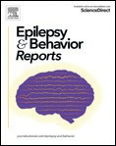](Journal%20logo)[](Unlabelled%20image)[Epilepsy & Behavior Reports 12 (2019) 100342](https://doi.org/10.1016/j.ebr.2019.100342)

Contents lists available at [ScienceDirect](http://www.sciencedirect.com/science/journal/25899864)

Epilepsy & Behavior Reports

journal homepage: [www.elsevier.com/locate/ebcr](http://www.elsevier.com/locate/ebcr)

Case Report

[](http://crossmark.crossref.org/dialog/?doi=10.1016/j.ebr.2019.100342&domain=pdf)Acute liver failure in a military recruit treated with valproic acid and harboring a previously unrecognized POLG-1 mutation

John T. Bassett a,⁎, Benjamin Rodriguez b, Lisa Mulligan c, Robert J. Fontana d

a *Sanford Health, Fargo, ND, United States of America*

b *Naval Hospital Jacksonville, FL, United States of America*

c *Naval Medical Center Portsmouth, Portsmouth, VA, United States of America*

d *University of Michigan, Ann Arbor, MI, United States of America*

# a r t i c l e i n f o

*Article history:*

Received 1 September 2019

Received in revised form 13 October 2019

Accepted 18 October 2019

Available online 25 October 2019

*Keywords:*

Liver transplantation Drug hepatotoxicity Anti-convulsants

# a b s t r a c t

Patients with mutations in the POLG-1 gene often are afﬂicted with drug-resistant seizures at an early age and have an increased risk of valproic acid-induced acute liver failure. Severe valproate hepatotoxicity most com- monly arises in children within the ﬁrst 3 months of treatment with an overall estimated incidence of 1 in 40,000 treated patients. Due to high mortality rates among transplanted children, many experts consider valproic acid-induced acute liver failure in patients with mitochondrial disorders to be a contraindication to liver transplant. We report the successful use of liver transplantation in a young man with valproic acid-associated acute liver failure harboring a previously unrecognized POLG-1 mutation.

© 2019 The Authors. Published by Elsevier Inc. This is an open access article under the CC BY-NC-ND license

(<http://creativecommons.org/licenses/by-nc-nd/4.0/>).

1. Introduction

Valproic acid (VPA) is a widely used branched, medium chain fatty acid that was approved as a treatment for patients with epilepsy in 1978. Due to its other beneﬁts, VPA has also received United States Food and Drug Administration approval for use in patients with bipolar disorders and recurrent migraine headaches [1]. The use of VPA in epilepsy patients is guided by the clinical response, blood levels, and dose-dependent side effects. VPA can cause several distinctive

forms of acute and chronic hepatic injury in treated patients [2–5].

The most common form of injury to the liver is mild elevation in serum AST and ALT levels that occur in up to 5 to 10% of treated patients within 12 months. The frequency and severity of these self-limited ami- notransferase elevations do not appear to be related to subject age, gen- der, or race nor the dose of VPA administered or peak serum VPA level. VPA can also interfere with intracellular ammonia metabolism and lead to a systemic hyperammonemia syndrome with associated mental sta- tus changes despite normal hepatic enzymes and bilirubin levels. Hyperammonemia is most commonly seen during the ﬁrst 6 months of therapy but can occur later in treatment with dose escalations and usually resolves with either holding or reducing the dose of VPA or by giving L-carnitine supplementation [6]. The third and least common phenotype of VPA-mediated injury to the liver is acute hepatocellular

*Abbreviations:* ALF, acute liver failure; DILI, drug-induced liver injury; ULN, upper limit of normal; VPA, valproic acid.

⁎ Corresponding author.

*E-mail address:* [john.bassett@sanfordhealth.org](mailto:john.bassett@sanfordhealth.org) (J.T. Bassett).

injury with jaundice and/or coagulopathy. The liver biopsy in these cases typically shows microvesicular steatosis and varying degrees of centrolobular inﬂammation and necrosis. Studies demonstrate that chil- dren under the age of two, patients on multiple antiseizure drugs, and those with inherited mitochondrial disorders are particularly suscepti- ble to this potentially severe form of liver injury with over 100 fatalities

reported in the literature [2–5]. Patients with mutations in the mito-

chondrial DNA (mtDNA) polymerase Ɣ (POLG-1) gene appear to be par- ticularly susceptible to severe hepatic injury [7]. As a result, the prescribing information for VPA contains a BLACK-BOX warning stating that the medication is contraindicated in patients with known mito- chondrial disorders caused by POLG mutations and children under two years of age who are clinically suspected of having a mitochondrial disorder. When the drug is used in children less than 2 years of age it should be given with extreme caution and as a sole agent [3].

1. Case

A 20-year-old previously healthy caucasian male experienced multi- ple focal aware-motor seizures involving the left upper and lower ex- tremity in July 2017 after initiating boot camp exercises as a military recruit. He subsequently developed generalized motor seizures. His past medical history and family history were negative for epilepsy and he was receiving no antiseizure medication. The patient underwent an extensive medical evaluation including an MRI of the brain that showed bilateral multifocal areas of gyriform-restricted diffusion with associ- ated cortical thickening and T2/FLAIR hyperintensity most pronounced in the posterior right frontal lobe. He had an EEG performed that

<https://doi.org/10.1016/j.ebr.2019.100342>

2589-9864/© 2019 The Authors. Published by Elsevier Inc. This is an open access article under the CC BY-NC-ND license (<http://creativecommons.org/licenses/by-nc-nd/4.0/>).

2 *J.T. Bassett et al. / Epilepsy & Behavior Reports 12 (2019) 100342*

showed focal motor status epilepticus emanating from the right frontal region associated wtih myoclonic jerks. The patient underwent a lum- bar puncture that showed elevated protein and B2 microglobulin. For the diagnosis of focal motor status epilepticus, the patient was treated with a series of antiseizure medications including levetiracetam, phe- nytoin, and lacosamide. However, due to progressive neurological symptoms including persistent left upper and lower extremity focal sei- zures, mental status ﬂuctuations and weakness, he required hospitaliza- tion and was diagnosed with presumed autoimmune encephalopathy based on results of the above studies and after a PET scan showed large areas of hypermetabolic activity in the right parietal lobe, thala- mus and left cerebellum. A cerebral angiogram was unremarkable with- out evidence of vasculitis. He was given immunoglobulin, plasma exchange, cyclophosphamide, mycophenolate mofetil and rituximab infusions as well as high dose corticosteroids. CSF testing for the pres- ence of anti-NMDA antibodies was negative. The patient's seizures eventually were controlled with the addition of valproic acid that was initiated in October 2017 at a dose of 1000 mg/day. Of note, his pretreat- ment liver biochemical analyses were normal. Follow-up lab work in December 2017 demonstrated a serum AST of 28 IU/L and ALT of 73 IU/L with total bilirubin of 0.6 mg/dl and his valproate dose was in- creased to 1500 mg per day due to a low serum concentration (Fig. 1). In January 2018 the patient developed extreme fatigue, lethargy, and nausea with vomiting and subsequent jaundice, mental status changes and coagulopathy. At the time of hospitalization he had a serum AST 161 IU/L, ALT 283 IU/L bilirubin 4.5 mg/dl and INR of 3.1 with no eosin- ophilia. His initial NH3 level was elevated at 70 μg/dl in Nov 2017 and remained elevated at 60 μg/dl in January 2018. Evaluation for hepatitis A, B, C and CMV/EBV infection was negative as was liver imaging. A liver biopsy showed marked microvascular steatosis and associated ne- crosis consistent with drug-induced hepatotoxicity. Despite discontinu- ation of VPA and use of *N*-acetylcysteine, his liver function continued to decline and he underwent emergency orthotopic liver transplantation

in February 2018. His explanted liver weighed 1332 g and demonstrated regenerative nodules with extensive necrosis and early cirrhosis on trichrome stain (Fig. 2). Post-operative genetic testing demonstrated a homozygous pathogenic variant in the POLG-1 gene (A467T).

Early in the course following transplantation the patient experi- enced several focal aware-motor seizures that involved the left upper and lower extremity and were successfully managed with a combina- tion of levetiracetam, lacosamide, pregabalin and topiramate. As of Oc- tober 2019, he continues to have preserved allograft function with normal liver enzyme tests while receiving tacrolimus, prednisone, L- carnitine and Co-enzyme Q-10.

1. Discussion

Patients with mutations in the POLG-1 gene encoding mitochondrial DNA polymerase often are afﬂicted with drug-resistant seizures and progressive neurological dysfunction at a young age [8,9]. Both hetero- zygotes and homozygotes with point mutations in the POLG-1 gene are at increased risk of developing injury to the liver when given VPA espe- cially in patients given the drug that tends to develop within the ﬁrst 3 months of treatment and in those receiving multiple antiseizure drugs [2]. VPA may inhibit mitochondrial beta-oxidation through the microsomal production of toxic metabolites or via direct effects on mi- tochondrial function [10,11]. The estimated prevalence of nuclear and mitochondrial disorders in the adult general population is 7 per 100,000. Prior case series report a 1-year survival rate as low as 18% in children transplanted for VPA-induced ALF who have a known mi- tochondrial disorder [12]. As a result, many experts advise against pro- ceeding with liver transplantation in children with VPA-related ALF who have known POLG1 mutations [13,14]. Our patient's POLG-1 muta- tion, A467T is the most common mutation for POLG-1-related disorders and the A467T and W748S mutations account for nearly 2/3 of patients with autosomal recessive POLG-related disorders [8]. These POLG-1

[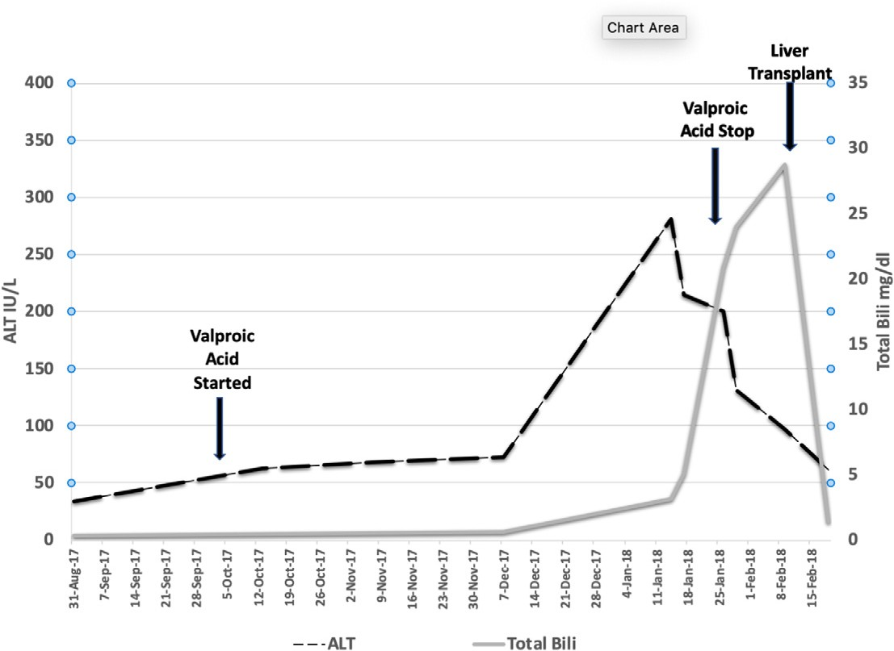](Image%20of%20Fig.%201)

Fig. 1. Serial serum ALT and bilirubin levels in a 20-year-old caucasian man with new onset seizures who started VPA in October 2017.

*J.T. Bassett et al. / Epilepsy & Behavior Reports 12 (2019) 100342* 3

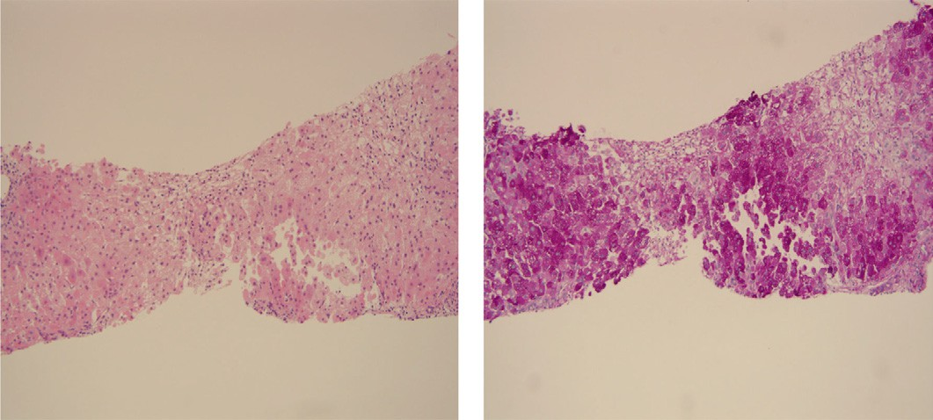

[Areas of necrosis](Image%20of%20Fig.%202)

[PAS stain highlights areas of necrosis](Image%20of%20Fig.%202)

[Hepatocytes with diﬀuse microvesicular change](Image%20of%20Fig.%202)

[Image 1: Liver biopsy with Hematoxylin and Eosin stain demonstrating areas](Image%20of%20Fig.%202)

[of necrosis and hepatocytes with diffuse microvesicular change](Image%20of%20Fig.%202)

[Image 2: Liver biopsy with Periodic Acid-Schiff stain highlighting areas of](Image%20of%20Fig.%202)

[necrosis (identified by arrows)](Image%20of%20Fig.%202)

Fig. 2. Liver biopsy with Hematoxylin and Eosin stain (image 1) as well as Periodic Acid-Schiff stain (image 2).

mutations are associated with ataxia–neuropathy syndrome and Alpers–Huttenlocher syndrome that manifests with seizures, liver dis- ease and impaired cognitive ability at a young age. Prior studies in ani- mals and human studies with historical controls have demonstrated

that prompt administration of L-carnitine which is frequently depleted in patients on chronic VPA therapy may rescue some patients with se- vere acute VPA-induced liver injury [15,16]. Unfortunately, L-carnitine was not instituted prior to transplant in our patient due to the difﬁculty in establishing a diagnosis of idiosyncratic drug-induced hepatic injury due to VPA.

Due to its side-effect proﬁle, VPA is often used as a second line anti- seizure drug for adults and children with focal epilepsies. Nonetheless, it is reported by [ClinCalc.com](http://ClinCalc.com/) that in 2016 there were 5,484,270 total pre- scriptions of divalproex sodium identiﬁed in the United States. The incidence of mitochondrial diseases in the United Kingdom population is 1 in 4000 to 1 in 5000 [17]. Some authors have advocated for testing for POLG mutations in all children under the age of 2 prior to initiating VPA therapy although this is not routinely done in most medical centers in the United States [18]. Furthermore, the overall incidence of severe idiosyncratic drug-induced hepatic injury from VPA decreases with age and among adults the overall incidence is estimated at 1 in 40,000 [3,4]. However, a notable exception would be an adult patient presenting with focal status epilepticus without other explanation since this could be the ﬁrst clinical manifestation of a subclinical con- genital mitochondrial disorder as was seen in this case [18]. In those in- stances, whole exome sequencing to identify the entire POLG gene would be helpful in patients independent of their ethnicity. Epilepsy pa- tients that harbor an unrecognized POLG-1 mutation may be at in- creased risk for severe VPA hepatotoxicity [19,20].

In the past, acute liver failure attributed to VPA therapy in patients with known POLG1 mutations has been considered a contraindication to liver transplantation among children [12–14]. However, the current case illustrates that liver transplantation can result in favorable clinical outcomes among adult patients with presumably milder forms of mito- chondrial disorders. It is possible that our patient's older age at presen- tation and lack of features suggestive of Alpers–Huttenlocher syndrome may have contributed to his more favorable outcome [9].

Disclaimer statement

Some of the authors of this manuscript are active duty U.S. Navy ser- vice members. This work was prepared as part of their ofﬁcial duties. Title 17 U.S.C. 105 provides that copyright protection under this title is

not available for any work of the United States Government. Title 17

U.S.C. 101 deﬁnes United States Government work as a work prepared by a military service member or employee of the United States Govern- ment as part of that person's ofﬁcial duties.

Ethics statement

Our manuscript “Acute Liver failure in a military recruit treated with valproic acid and harboring a previously unrecognized POLG-1 mutation” does adhere to ethics in publishing and ethical guidelines for journal publication.

Declaration of competing interest

The authors John T. Bassett, Sanford Health, Fargo, ND; Benjamin Rodriguez, Naval Hospital Jacksonville, FL; and Lisa Mulligan, Naval Medical Center Portsmouth, Portsmouth, VA declare that they have no conﬂicts of interest/disclosures.

The author Robert J. Fontana, University of Michigan, Ann Arbor, MI has received research grants from Abbvie, Gilead and Bristol-Myers Squibb. He also consults for Sanoﬁ.

References

1. Accessdata.fda.gov. [https://www.accessdata.fda.gov/drugsatfda_docs/label/2011/](https://www.accessdata.fda.gov/drugsatfda_docs/label/2011/018081s046_18082s031lbl.pdf)

[018081s046_18082s031lbl.pdf](https://www.accessdata.fda.gov/drugsatfda_docs/label/2011/018081s046_18082s031lbl.pdf). Published 2019. Accessed July 5, 2019.

1. Bryant A, Dreifuss F. Valproic acid hepatic fatalities. III. U.S. experience since 1986. Neurology 1996;46(2):465–9. <https://doi.org/10.1212/wnl.46.2.465>.
2. Dreifuss F, Langer D. Hepatic considerations in the use of antiepileptic drugs. Epilepsia 1987;28(s2):S23–9. [https://doi.org/10.1111/j.1528-1157.1987.tb05768.x](mailto:john.bassett@sanfordhealth.org).
3. Dreifuss F, Santilli N, Langer D, Sweeney K, Moline K, Menander K. Valproic acid he- patic fatalities: a retrospective review. Neurology 1987;37(3):379. [https://doi.org/](https://doi.org/10.1212/wnl.37.3.379) [10.1212/wnl.37.3.379](https://doi.org/10.1212/wnl.37.3.379).
4. [Mindikoglu AL, Magder LS, Regev A. Outcome of liver transplantation for drug-](http://refhub.elsevier.com/S2589-9864(19)30136-4/rf0020) [induced acute liver failure in the United States: analysis of the United Network for](http://refhub.elsevier.com/S2589-9864(19)30136-4/rf0020) [Organ Sharing database. Liver Transpl 2009;15:719–29 [PubMed: 19562705].](http://refhub.elsevier.com/S2589-9864(19)30136-4/rf0020)
5. Nanau R, Neuman M. Adverse drug reactions induced by valproic acid. Clin Biochem 2013;46(15):1323–38. <https://doi.org/10.1016/j.clinbiochem.2013.06.012>.
6. McFarland R, Hudson G, Taylor R, et al. Reversible valproate hepatotoxicity due to mutations in mitochondrial DNA polymerase (POLG1). Case Reports 2009. [https://](https://doi.org/10.1136/bcr.12.2008.1303) [doi.org/10.1136/bcr.12.2008.1303](https://doi.org/10.1136/bcr.12.2008.1303) 2009(may10 1):bcr1220081303-bcr1220081303.
7. Hynynen J, Komulainen T, Tukiainen E, Nordin A, Arola J, Kälviäinen R, et al. Acute liver failure after valproate exposure in patients with POLG1mutations and the prog- nosis after liver transplantation. Liver Transpl 2014;20(11):1402–12. [https://doi.](https://doi.org/10.1002/lt.23965) [org/10.1002/lt.23965](https://doi.org/10.1002/lt.23965).
8. McKiernan P. Acute liver failure after valproate exposure: liver transplantation may be indicated beyond childhood. Liver Transpl 2014;20(11):1287–9. [https://doi.org/](https://doi.org/10.1002/lt.23988) [10.1002/lt.23988](https://doi.org/10.1002/lt.23988).

4 *J.T. Bassett et al. / Epilepsy & Behavior Reports 12 (2019) 100342*

1. Ishikura H, Matsuo N, Matsubara M, Ishihara T, Takeyama N, Tanaka T. Valproic acid overdose and L-carnitine therapy. J Anal Toxicol 1996;20(1):55–8. [https://doi.org/](https://doi.org/10.1093/jat/20.1.55) [10.1093/jat/20.1.55](https://doi.org/10.1093/jat/20.1.55).
2. Aires C, Ruiter J, Luis P, et al. Studies on the extra-mitochondrial CoA-ester formation of valproic and Δ4-valproic acids. Biochimica et Biophysica Acta (BBA) - Molecular and Cell Biology of Lipids 2007;1771(4):533–43. [https://doi.org/10.1016/j.bbalip.](https://doi.org/10.1016/j.bbalip.2007.01.010) [2007.01.010](https://doi.org/10.1016/j.bbalip.2007.01.010).
3. Mindikoglu A, King D, Magder L, Ozolek J, Mazariegos G, Shneider B. Valproic acid- associated acute liver failure in children: case report and analysis of liver transplan- tation outcomes in the United States. J Pediatr 2011;158(5):802–7. [https://doi.org/](https://doi.org/10.1016/j.jpeds.2010.10.033) [10.1016/j.jpeds.2010.10.033](https://doi.org/10.1016/j.jpeds.2010.10.033).
4. Lee W, Sokol R. Mitochondrial hepatopathies: advances in genetics, therapeutic ap- proaches, and outcomes. J Pediatr 2013;163(4):942–8. [https://doi.org/10.1016/j.](https://doi.org/10.1016/j.jpeds.2013.05.036) [jpeds.2013.05.036](https://doi.org/10.1016/j.jpeds.2013.05.036).
5. McKiernan P. Liver transplantation and cell therapies for inborn errors of metabo- lism. J Inherit Metab Dis 2013;36(4):675–80. [https://doi.org/10.1007/s10545-012-](https://doi.org/10.1007/s10545-012-9581-z) [9581-z](https://doi.org/10.1007/s10545-012-9581-z).
6. Mock C, Schwetschenau K. Levocarnitine for valproic-acid-induced hyperammonemic encephalopathy. Am J Health Syst Pharm 2012;69(1):35–9. [https://doi.org/10.2146/](https://doi.org/10.2146/ajhp110049) [ajhp110049](https://doi.org/10.2146/ajhp110049).
7. Perrott J, Murphy N, Zed P. L-Carnitine for acute valproic acid overdose: a systematic review of published cases. Annals of Pharmacotherapy 2010;44(7–8):1287–93. <https://doi.org/10.1345/aph.1p135>.
8. Gorman G, Schaefer A, Ng Y, Gomez N, Blakely E, Alston C, et al. Prevalence of nuclear and mitochondrial DNA mutations related to adult mitochondrial disease. Ann Neurol 2015;77(5):753–9. <https://doi.org/10.1002/ana.24362>.
9. Saneto R, Lee I, Koenig M, et al. POLG DNA testing as an emerging standard of care before instituting valproic acid therapy for pediatric seizure disorders. Seizure 2010;19(3):140–6. <https://doi.org/10.1016/j.seizure.2010.01.002>.
10. Debray F, Lambert M, Mitchell G. Disorders of mitochondrial function. Curr Opin Pediatr 2008;20(4):471–82. <https://doi.org/10.1097/mop.0b013e328306ebb6>.
11. Stewart J, Horvath R, Barufﬁni E, et al. Polymerase γ gene POLG determines the risk of sodium valproate-induced liver toxicity. Hepatology 2010;52(5):1791–6. [https://](https://doi.org/10.1002/hep.23891) [doi.org/10.1002/hep.23891](https://doi.org/10.1002/hep.23891).