OPEN ACCESS

ARTICLE

Deep sequencing of mitochondrial DNA and characterization of a novel *POLG* mutation in a patient with arPEO

Carola Hedberg-Oldfors, PhD,* Bertil Macao, PhD,* Swaraj Basu, PhD, Christopher Lindberg, MD, PhD, Bradley Peter, PhD, Direnis Erdinc, MSc, Jay P. Uhler, PhD, Erik Larsson, PhD, Maria Falkenberg, PhD, and Anders Oldfors, MD, PhD

*Neurol Genet* 2020;6:e391. doi:[10.1212/NXG.0000000000000391](http://dx.doi.org/10.1212/NXG.0000000000000391)

# Abstract

Objective

To determine the pathogenicity of a novel *POLG* mutation in a man with late-onset autosomal recessive progressive external ophthalmoplegia using clinical, molecular, and biochemical analyses.

Methods

A multipronged approach with detailed neurologic examinations, muscle biopsy analyses, molecular genetic studies, and in vitro biochemical characterization.

Results

The patient had slowly progressive bilateral ptosis and severely reduced horizontal and vertical gaze. Muscle biopsy showed slight variability in muscle ﬁber size, scattered ragged red ﬁbers, and partial cytochrome c oxidase deﬁciency. Biallelic mutations were identiﬁed in the *POLG* gene encoding the catalytic A subunit of POL*γ*. One allele carried a novel mutation in the exonuclease domain (c.590T>C; p.F197S), and the other had a previously characterized null mutation in the polymerase domain (c.2740A>C; p.T914P). Biochemical characterization revealed that the novel F197S mutant protein had reduced exonuclease and DNA polymerase activities and conﬁrmed that T914P was inactive. By deep sequencing of mitochondrial DNA (mtDNA) extracted from muscle, multiple large-scale rearrangements were mapped and quantiﬁed.

Conclusions

The patient’s phenotype was caused by biallelic *POLG* mutations, resulting in one inactive POL*γ*A protein (T914P) and one with decreased polymerase and exonuclease activity (F197S). The reduction in polymerase activity explains the presence of multiple pathogenic large-scale deletions in the patient’s mtDNA.

Correspondence

Dr. Falkenberg [maria.falkenberg@medkem.gu.se](mailto:maria.falkenberg@medkem.gu.se) or Dr. Oldfors [anders.oldfors@pathology.gu.se](mailto:anders.oldfors@pathology.gu.se)

*These authors contributed equally to this work.

From the Department of Pathology and Genetics (C.H.-O., A.O.) and Medical Biochemistry and Cell Biology (B.M., S.B., B.P., D.E., J.P.U., E.L., M.F.), University of Gothenburg; and Neuromuscular Centre (C.L.), Department of Neurology, Sahlgrenska University Hospital, Gothenburg, Sweden.

Go to [Neurology.org/NG](https://ng.neurology.org/content/6/1/e391/tab-article-info) for full disclosures. Funding information is provided at the end of the article. The Article Processing Charge was funded by the Swedish Research Council.

This is an open access article distributed under the terms of the [Creative Commons Attribution License 4.0 (CC BY),](http://creativecommons.org/licenses/by/4.0/) which permits unrestricted use, distribution, and reproduction in any medium, provided the original work is properly cited.

# Glossary

dsDNA = double-stranded DNA; ES = exome sequencing; mtDNA = mitochondrial DNA; mtSSB = mitochondrial single- stranded DNA binding protein; PEO = progressive external ophthalmoplegia; ssDNA = single-stranded DNA; WT = wild type.

Cells contain thousands of mitochondrial DNA (mtDNA) molecules that are maintained by a dedicated mitochondrial replication machinery encoded by nuclear genes.1,2 mtDNA is replicated by POL*γ*, a trimeric protein comprising one POL*γ*A catalytic subunit and a dimer of the processivity factor POL*γ*B.1

Mutations in POL*γ*A are one of the most frequent causes of mitochondrial disease, which is characterized by insuﬃciency in oxidative phosphorylation. Pathogenic POL*γ*A mutations are associated with the accumulation of secondary mtDNA muta- tions and/or progressive mtDNA depletion due to errors in DNA replication.3–6 A common clinical manifestation of POL*γ*A-related diseases is progressive external ophthalmoplegia (PEO), a disorder involving progressive weakening of the extraocular muscles that is frequently combined with symptoms from other parts of the neuromuscular and nervous system.

Here, we report a patient with PEO carrying biallelic POL*γ*A mutations. One allele carries the previously characterized T914P null mutation in the polymerase domain,7 and the other allele carries the F197S mutation in the 39-59 exo- nuclease domain, which is described here for the ﬁrst time. To gain a molecular understanding of the patient’s phenotype, we performed clinical and laboratory investigations and charac- terized the biochemical properties of the mutant proteins.

# Methods

Case report

The patient investigated is a man aged 69 years. His father had kidney failure of unknown reason, and his mother died at age 92 years. Neither of them had ptosis, hearing impairment, or muscle complaints. He has a healthy 68-year-old brother and 2 healthy sons aged 33 years and 37 years. The patient had normal motor milestones as a child, did his military service at age 20 years, and has always been physically active. He has no history of migraines, visual or hearing impairment, and cardiac or cognitive complaints or symptoms. At age 55 years, he noted slowly progressive bilateral ptosis and also a limitation in both horizontal and vertical gaze. Since age 65 years, he has complete horizontal ophthalmoplegia, no upward gaze whatsoever, but has limited downward gaze. He has been bilaterally operated for ptosis. A complete clinical neurologic examination was otherwise normal except a slight bilateral sensory-neuronal hearing impairment thought to be a cochlear aﬄiction due to his mitochondrial disorder. Cardiac examination, including ECG and 24-hour Holter ECG, was normal. Brain MRI showed slight atrophy of the mesencephalon, pedunculus cerebelli superior, and frontotemporal parts of the brain. Clinically, he has no cognitive impairment, although no formal

cognitive investigation has been performed. Serum creatine kinase, troponin T, Nt-pro-BNP, creatinine, cystatin C, and thyroid function tests were normal as was CSF examination.

Morphologic analysis

Open skeletal muscle biopsy from the deltoid muscle was performed at age 66 years. Specimens were snap frozen for cryostat sectioning and histochemistry. Standard techniques were applied for enzyme histochemistry.8

Molecular genetic analysis

Exome sequencing (ES) was performed on blood DNA using the SureSelectXT Human All Exon kit v6 (Agilent Technol- ogies, Santa Clara, CA) and sequenced on the HiSeq2500 platform (Illumina, Inc., San Diego, CA). The paired-end reads were aligned to the reference genome (hg19) using the CLC Biomedical Genomics workbench (QIAGEN GmbH, Hilden, Germany). Data were analyzed with Ingenuity Vari- ant Analysis (QIAGEN). Candidate genes associated with myopathy were analyzed for biologically relevant variants that were predicted to be damaging using SIFT algorithm and PolyPhen2 and were not common in the human population (minor allele frequency below 1%).

Analysis of mtDNA deletions using deep sequencing

DNA was isolated from muscle biopsies from the patient and 2 age-matched control individuals using standard protocols. DNA was subjected to whole-genome sequencing using the TruSeq PCR free library preparation kit (Illumina), and the Illumina HiSeq X platform was used for sequencing (Illumina). A previously described pipeline was used to align reads to nuclear chromosomes (hg19 assembly) and the mitochondrial genome (revised Cambridge Reference Sequence assembly, NC_012920.1) to identify deletions and duplications.9 We observed a chrM coverage depth of 106,170 for the patient (11,777,135 reads), whereas the controls were 54,426 and 101,942, respectively (6,092,978 and 11,263,816 reads). Gap- ped alignments, indicative of deletions/duplications, were clustered and visualized.9 Heteroplasmy levels for individual deletions/duplications were estimated by comparing the number of reads supporting the corresponding breakpoints to the total number of reads overlapping the breakpoints (in- cluding wild type) after removal of PCR duplicates.

Mutagenesis and protein purification

The mutant POL*γ*A variants were generated with the Quik- Change Lightning Site-Directed Mutagenesis Kit (Agilent Technologies) and conﬁrmed by sequencing (Euroﬁns MWG Operon, Ebersberg, Germany). Recombinant 6× His-tagged TWINKLE, POL*γ*B, and the POL*γ*A versions were expressed

in baculovirus-infected Sf9 cells,10 puriﬁed over His-Select Nickel Aﬃnity Gel (Sigma-Aldrich AB, Stockholm, Sweden) and HiTrap Heparin HP, followed by HiTrap SP HP, HiTrap Q HP, or both columns. *E. coli* BL21(DE3)-expressed mito- chondrial single-stranded DNA binding protein (mtSSB) was puriﬁed over DEAE Sepharose Fast Flow, HiTrap Heparin HP, HiTrap SP HP, and HiLoad Superdex 200 (GE Healthcare, Uppsala, Sweden).

Electrophoretic mobility shift assay

A primed template, consisting of a 32P 59-labeled 21-nt oli- gonucleotide (59- GCGGTCGAGTCTAGAGGAGCC-39)

hybridized to a 36-nt oligonucleotide (59GACTACGTC- TATCCGGGCTCCTCTAGACTCGACCGC-39) (ﬁgure 2A,

lower panel), was used to examine POL*γ*-DNA binding aﬃnity. Fifteen-microliter reactions contained 10 fmol DNA template, 25 mM Tris-HCl (pH 7.8), 1 mM dithiothreitol, 0.1 mg/mL bovine serum albumin, 10% glycerol, 0.3 mM dideoxyguanosine triphosphate, 3 mM deoxycytidine triphosphate, and the holoenzyme (POL*γ*A/POL*γ*B complex). Reactions were incubated for 10 minutes at ambient temperature, separated on 6% native polyacrylamide gels in 0.5 × TBE for 30 minutes at 180 V, and visualized by autoradiography.

39-59 exonuclease activity assay

A 32P-labeled 32-nt oligonucleotide (59-CTATCTCAGC- GATCTGTCTATTTCGTTCATCG39) was annealed to single-stranded pBluescript SK+ plasmid, creating a 31-bp double-stranded DNA (dsDNA) region with a 39-end one-nucleotide mismatch (ﬁgure 2D, lower panel). Reactions (20 *μ*L) were performed using the same buﬀer conditions as above (but with 10 mM MgCl2) using 10 fmol DNA, but without any deoxynucleotide triphosphates to promote exo- nuclease activity. POL*γ*A (150 fmol) and POL*γ*B (300 fmol, dimeric) were added. Products were run in 7 M urea/20% polyacrylamide gels and visualized by autoradiography.

DNA synthesis on a single-stranded DNA template

A 32P-labeled 32-nt oligonucleotide (59-CTATCTCAGC- GATCTGTCTATTTCGTTCATCC- 39) was hybridized to single-stranded pBluescript SK(+) plasmid. Reactions (20 *μ*L) contained 10 fmol DNA template, 10 *μ*M deoxynucleotide triphosphates, 25 mM Tris-HCl (pH 7.8), 1 mM dithiothreitol, 10 mM MgCl2, 0.1 mg/mL bovine serum albumin, 150 fmol POL*γ*A, 300 fmol POL*γ*B (dimeric), and 2.4 pmol mtSSB (tetrameric). Reactions were incubated at 37°C and stopped with 6 *μ*L stop buﬀer (90 mM EDTA, 6% sodium dodecyl sulfate, 30% glycerol, 0.025% bromophenol blue, and 0.025% xylene cyanol). Products were analyzed on 0.8% agarose gels in 1 × TBE buﬀer and visualized by autoradiography.

DNA synthesis on a dsDNA template

A 70-nt oligonucleotide (59-T42ATCTCAGCGATCTGTC- TATTTCGTTCAT-39) was annealed to single-stranded pBluescript SK(+) followed by one cycle of polymerization using KOD polymerase (Merck Chemicals and Life Science

AB, Stockholm, Sweden) to produce a ;3-kb double- stranded template with a preformed replication fork. Reac- tions (20 *μ*L) contained 10 fmol DNA, 10 *μ*M deoxy- nucleotide triphosphates, 4 mM adenosine triphosphate, 2 *μ*Ci *α*-32P-deoxycytidine triphosphate, 4 pmol mtSSB (tetrameric), 100 fmol of TWINKLE (hexameric), and 250 fmol POL*γ*A in complex with POL*γ*B (dimeric) in the same buﬀer conditions as above. Reactions were incubated at 37°C and stopped with 6 *μ*L alkaline stop buﬀer (18% [wt/vol] Ficoll, 300 mM NaOH, 60 mM EDTA [pH8], 0.15% [wt/vol] Bromocresol green, and 0.35% [wt/vol] xylene cyanol). Products were run in 0.8% alkaline agarose gels and visualized by autoradiography.10

Standard protocol approvals, registrations, and patient consents

This study was approved by the local ethics committee. The study complied with the Declaration of Helsinki, and in- formed consent was obtained from the patient.

Data availability

Data are available from the corresponding authors on rea- sonable request.

# Results

Morphologic analyses demonstrate mitochondrial myopathy

A muscle biopsy from the deltoid muscle at age 66 years showed slight variability in muscle ﬁber size, scattered ragged red ﬁbers, and 10%–20% ﬁbers with cytochrome c oxidase deﬁciency (ﬁgure 1, A and B).

Molecular genetic analysis identifies

*POLG* variants

ES revealed that the patient had 2 potentially pathogenic het- erozygous missense mutations in the gene coding for the catalytic subunit of DNA polymerase gamma (*POLG*), the novel c.590T>C p.(F197S), and the previously described c.2740A>C; p.(T914P) (NM_002693.2) (ﬁgure 1, C and D).

The variants were not common in the human population and aﬀected conserved amino acids among species (ﬁgure 1E). Genetic analysis of the sons revealed that both were heterozy- gous carriers for the c.2740A>C; p.(T914P) variant (ﬁgure 1C), demonstrating that the mutations are located on diﬀerent alleles.

The F197S mutant has reduced 39-59 exonuclease activity

To further understand the molecular consequences of the mutations, we expressed and puriﬁed WT, F197S, and T914P POL*γ*A for biochemical analysis. We previously showed that T914P had no DNA binding aﬃnity.7 Given the patient’s relatively mild condition, we predicted the F197S mutation to have no impact on DNA binding aﬃnity, which we conﬁrmed using electrophoretic mobility shift assay (ﬁgure 2A).

We next considered whether the Phe-197-Ser substitution aﬀected 39-59 exonuclease activity. F197 is strongly

Figure 1 Morphologic analysis, pedigree, and molecular genetics

1. 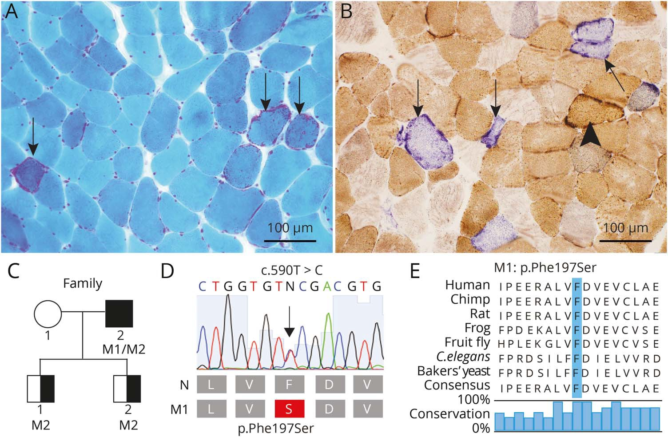The muscle biopsy from the patient showed slight variability in muscle fiber size and scattered ragged red fibers (arrows) (Gomori trichrome staining).
2. Several fibers show cytochrome c oxidase (COX) deficiency with normal succinate dehydrogenase (SDH) activ- ity (blue fibers, arrows), whereas a few fibers with mitochondrial proliferation show no COX deficiency (arrowhead) (combined enzyme histochemical staining of COX and SDH). (C) Pedigree of the family: filled symbol indicates affected individual with biallelic var- iants in *POLG*, and half-filled symbols indicate healthy heterozygous carriers. M1 indicates the novel variant c.590T>C; p.(F197S) and M2 c.2740A>C; p.(T914P) in *POLG* (NM_002693.2). (D)

Illustration of the novel c.590T>C. p.(F197S) variant in *POLG*, with chro- matogram. (E) Illustration showing the evolutionary conservation of amino acids. Blue bar indicates the mutated residue (p.Phe197Ser).

conserved in the DNA polymerase A family across verte- brates and invertebrates (ﬁgure 2B, lower panel). In the 39- 59 exonuclease domain, the F197 residue is located within a large hydrophobic pocket where it forms numerous van der Waals interactions with the surrounding residues (ﬁgure 2B, upper panel). Substitution of the bulky and hydrophobic phenylalanine with the smaller and polar serine would likely cause partial collapse of this pocket and local structural distortions. This may induce a misalignment of the neigh- boring D198 residue and subsequent reduction in its ability to bind a catalytically essential Mg2+ ion. Of interest, the closely related T7 DNA polymerase carries a serine at this position (ﬁgure 2C, lower panel) arguing that this amino acid change might not provoke structural or functional changes. Structural analysis, however, revealed that the exonuclease pocket is substantially smaller and that the presence of a phenylalanine would induce severe steric clashes and likely destabilize the exonuclease domain in T7 DNA polymerase (ﬁgure 2C, upper panel).

Despite being tolerated in T7 DNA polymerase, we decided to test whether the serine aﬀects the 39-59 exonuclease activity of POL*γ*A in vitro. A double-stranded template with a one-nt 39-ﬂap (ﬁgure 2D, lower panel) was incubated with the WT or mutant POL*γ* variants including a previously characterized exonuclease-deﬁcient mutant D274A (herein EXO-) for comparison.11 As expected, WT POL*γ* was able to hydrolyze the primer (ﬁgure 2D, lanes 1–5), whereas EXO- was unable to degrade the primer (ﬁgure 2D, lanes 6–10). F197S was able to degrade the primer, however, to a much lower extent than WT. This demonstrates that in POL*γ*A, unlike the related T7 DNA polymerases, a serine at this position is not well

tolerated (ﬁgure 2D, lanes 16-20). No 39-59 exonuclease ac- tivity from T914P was observed (ﬁgure 2D, lanes 11–15), likely due to the lack of DNA binding rather than an enzy- matic eﬀect of the mutation.7

The exonuclease-deﬁcient POL*γ* (EXO-) in mice causes a 5-fold increase in mtDNA point mutations,12 prompting us to investigate the mutation load of the patient’s mtDNA. We isolated total muscle DNA from the patient and performed deep DNA sequencing. We identiﬁed a slight, but signiﬁcant, increase in mtDNA point mutations in the patient compared with age-matched controls (table), consistent with our in vitro ﬁndings. However, the level of heteroplasmy is likely too low to by itself explain the disease phenotype in the patient.

The F197S mutation affects DNA polymerase activity

We next tested the polymerase activities of the mutants. First, we performed a DNA synthesis assay using a circular single- stranded DNA (ssDNA) template (ﬁgure 3A, lower panel). Because the F197S mutation is located in the 39-59 exo- nuclease domain, we also included EXO- for comparison. We found that F197S was active as a polymerase, albeit with strongly diminished activity compared with WT and EXO- (ﬁgure 3A, lanes 16–20 vs 1–5 and 6–10, respectively). The speed of replication was slower, generating less full-length product due to increased stalling. T914P was unable to sup- port DNA synthesis (ﬁgure 3A, lanes 11–15).7

We also examined DNA synthesis in the context of the repli- some (i.e., in the presence of the TWINKLE helicase and

Figure 2 The F197S point mutation reduces 39-59 exonuclease activity

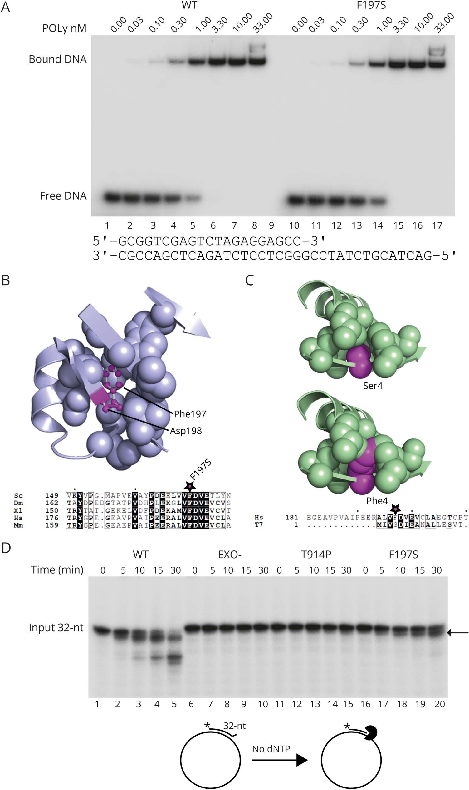(A) The F197S mutant has WT-like DNA binding affinity. DNA affinity of POLγ to a primer template (lowerpanel) was examined by electrophoretic mobility shift assay. Each reaction contained 10 fmol of DNA template and increasing (indicated) amounts of POLγ holoen- zyme in a final volume of 15 μL. The reactions were run on 6% native polyacrylamide gels in 0.5 × TBE for 30 minutes at 180 V and visualized by autoradiography. No major differ- ences in binding affinity between WT and F197S were observed. (B) The F197S point mutation disrupts the ar- chitecture of the exonuclease pocket. F197 is located in a large hydrophobic pocket directly adjacent to the cata- lytically essential D198 (upper panel; PDB ID: 3IKM). This residue is strongly conserved among members of the DNA polymerase A family (lower panel; Sc = *Saccharomyces cerevisiae*; Dm = *Drosophila melanogaster*; Xl = *Xenopus laevis*; Hs = *Homo sapiens*; Mm

= *Mus musculus*). (C) The T7 exo- nuclease pocket is substantially smaller to accommodate a serine residue at the position equivalent to F197. Mutation of this residue to phe- nylalanine results in steric clashes, which would likely destabilize the pocket (PDB ID: 1T7P; Hs = *Homo sa- piens*; T7 = bacteriophage T7). (D) A 59-labeled (32P) primer with a 39-mis- match was annealed to a circular sin- gle-stranded plasmid (lower panel to the left). POLγA with 39-59 exonuclease activity will, in the absence of dNTP, hydrolyze DNA into shorter frag- ments. As expected, WT degraded the primer (lanes 1–5), whereas EXO- could not due to lack of exonuclease activity (lanes 6–10). T914P showed no activity. The F197S mutant had weak exonuclease activity, only able to hy- drolyze a few nucleotides under these conditions. The arrow indicates the partially hydrolyzed primer.

mtSSB) using a circular dsDNA template containing a pre- formed replication fork (ﬁgure 3B, lower panel). Here, F197S was able to synthesize long stretches of DNA, although it was

not as eﬃcient as WT (ﬁgure 3B, compare lanes 11–15 and 1–5). T914P was not able to support DNA synthesis (ﬁgure 3A, lanes 11–15 and 3B lanes 6–10).7 To mimic the in vivo situation

Table Somatic point mutations detected in mtDNA in the range between 1% and 5% heteroplasmy levels

Heteroplasmy levels (%)

|  |  |  |  |  |  |  |
| --- | --- | --- | --- | --- | --- | --- |
| Position mtDNA | Ref allele | Sample allele | Gene symbol | Protein variant | Patient | Ten age-matched controls |
| 593 | T | C | MT-TF |  | 1.42 | — |
| 948 | T | C | MT-RNR1 |  | 1.44 | — |
| 968 | T | C | MT-RNR1 |  | 1.44 | — |
| 972 |  | AACC | MT-RNR1 |  | 1.02 | — |
| 3396 | T | C | MT-ND1 | p.Y30Y | 2.01 | — |
| 3760 | T | C | MT-ND1 | p.S152P | 1.12 | — |
| 4553 | T | C | MT-ND2 | p.F28F | — | 1.06a |
| 5522 | G | A | MT-TW |  | — | 1.31a |
| 11032 | A |  | MT-ND4 | p.K93fs*7 | 1.45 | — |
| 15167 | T | C | MT-CYB | p.W141R | 1.33 | — |

Abbreviation: mtDNA = mitochondrial DNA.

a Found in 1 of 10 controls.

(of the patient), a reaction was included where both disease- associated mutants were mixed at a 1:1 ratio, but keeping the same total amount of protein. This decreased the eﬃciency of replication further due to only half the amount of POL*γ*A (F197S) being functional (ﬁgure 3B, lanes 16–20 vs 11–15).

The F197S mutant causes multiple deletions and duplications in vivo

Disease-causing mutations in POL*γ* are known to cause mtDNA depletion and/or multiple mtDNA rearrangements. Based on the deep sequencing of isolated total muscle DNA, we found that mtDNA copy number in the patient was comparable to two controls, demonstrating that the patient does not exhibit mtDNA depletion (ﬁgure 4, A and C). However, the patient did have multiple deletions in both the major and minor arc (ﬁgure 4B). The sum heteroplasmy for the deletions and duplications amounted to 50.7%, which likely explains the patient’s phenotype (ﬁgure 4D). Of in- terest, we also found a strong hotspot region for duplications spanning over the promoter region (position 300 nt–1,000 nt) where the top 3 candidate duplications were closely spaced (positions: 310–962, 310–960, and 315–965) (ﬁgure

4E) accounting for 21% heteroplasmy (14.7, 2.5, and 3.4% individually) of all deletions/duplications detected.

# Discussion

We describe a patient with myopathy, PEO, and ptosis asso- ciated with biallelic *POLG* mutations. By identiﬁcation of mi- tochondrial myopathy caused by multiple large-scale mtDNA rearrangements and in vitro functional analysis of the identiﬁed *POLG* variants, we can explain several of the diﬀerent molec- ular events leading to the disease and thus functionally link the primary genetic defect to the clinical phenotype.

*POLG* mutations are the most common cause of mitochon- drial disease and are associated with a large variety of clinical phenotypes ranging from severe infantile neurodegenerative disorder with liver disease to late onset PEO with minor or no other symptoms.13 Our patient had a mild phenotype with ptosis and ophthalmoplegia as his main symptoms, requiring surgery for ptosis several years before his genetic diagnosis. His hearing deﬁcit was probably due to the *POLG*-associated mitochondrial disease because hearing loss is a characteristic ﬁnding in patients with PEO, especially autosomal dominant PEO. Whether the brain atrophy was part of the syndrome has not been deﬁnitely established, but brain atrophy has been found in 28% of patients with *POLG*-associated epilepsy.14

Why some patients with mitochondrial disease develop PEO is not completely clear, partly because extraocular muscles are relatively inaccessible. However, MRI studies have demon- strated that extraocular muscles are atrophic in patients with PEO.15,16 The reason for this vulnerability has been specu- lated to depend on the distinct physiologic characteristics of extraocular muscles.17 They are very rich in mitochondria and are highly dependent on oxidative phosphorylation for en- durance despite their composition of mainly fast-twitch ﬁbers, and they develop age-related mitochondrial changes with multiple deletions at a considerably higher rate than limb muscles. It is therefore likely that they accumulate multiple deletions secondary to POL*γ*A dysfunction at a higher rate than limb muscles, which then leads to atrophy and muscle ﬁber loss.

Our biochemical analysis of the mutant proteins showed that T914P had no activities, consistent with its previous charac- terization as an aggregation-prone inactive protein.7 The only potentially functional polymerase in the patient is thus

Figure 3 The F197S mutation affects DNA polymerase activity

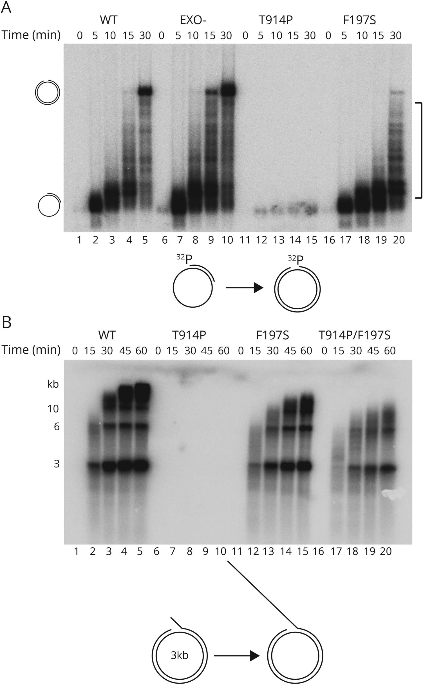(A) DNA synthesis reaction on single- stranded DNA, where POLγA has the possibility to synthesize ≈3,000 nt. WT (lanes 1–5) and EXO- (lanes 6–10) POLγA displayed efficient DNA syn- thesis. F197S (lanes 16–20) was con- siderably slower, and T914P (lanes 11–15) was enzymatically dead. The squared bracket shows the positions of disrupted polymerization products. Below: A cartoon showing the tem- plate to the left and the fully synthe- sized product to the right. (B) DNA synthesis reaction on double- stranded DNA, where the replisome has the possibility to produce very long DNA products (>20 kb). The replisome, in the presence of F197S, was considerably slower than in the presence of WT. The T914P mutant was not able to support DNA synthe- sis. Mixing T914P and F197S (1:1 ratio) together to mimic the patient situation caused an apparent decrease in rep- lication efficiency because only half of the total amount of polymerase (F197S) is active (lanes 16–20).

derived from the other allele containing the novel F197S substitution. We found that F197S has reduced exonuclease and polymerase activities compared with WT POL*γ*A, which can explain the patient phenotype.

Of the over 30 disease-associated mutations located in the exonuclease domain (Human DNA Polymerase Gamma Mutation Database, [tools.niehs.nih.gov/polg/),](https://tools.niehs.nih.gov/polg/) only a few have been shown to be associated with increased mtDNA

Figure 4 General statistics and distribution of breakpoints in the patient and control samples

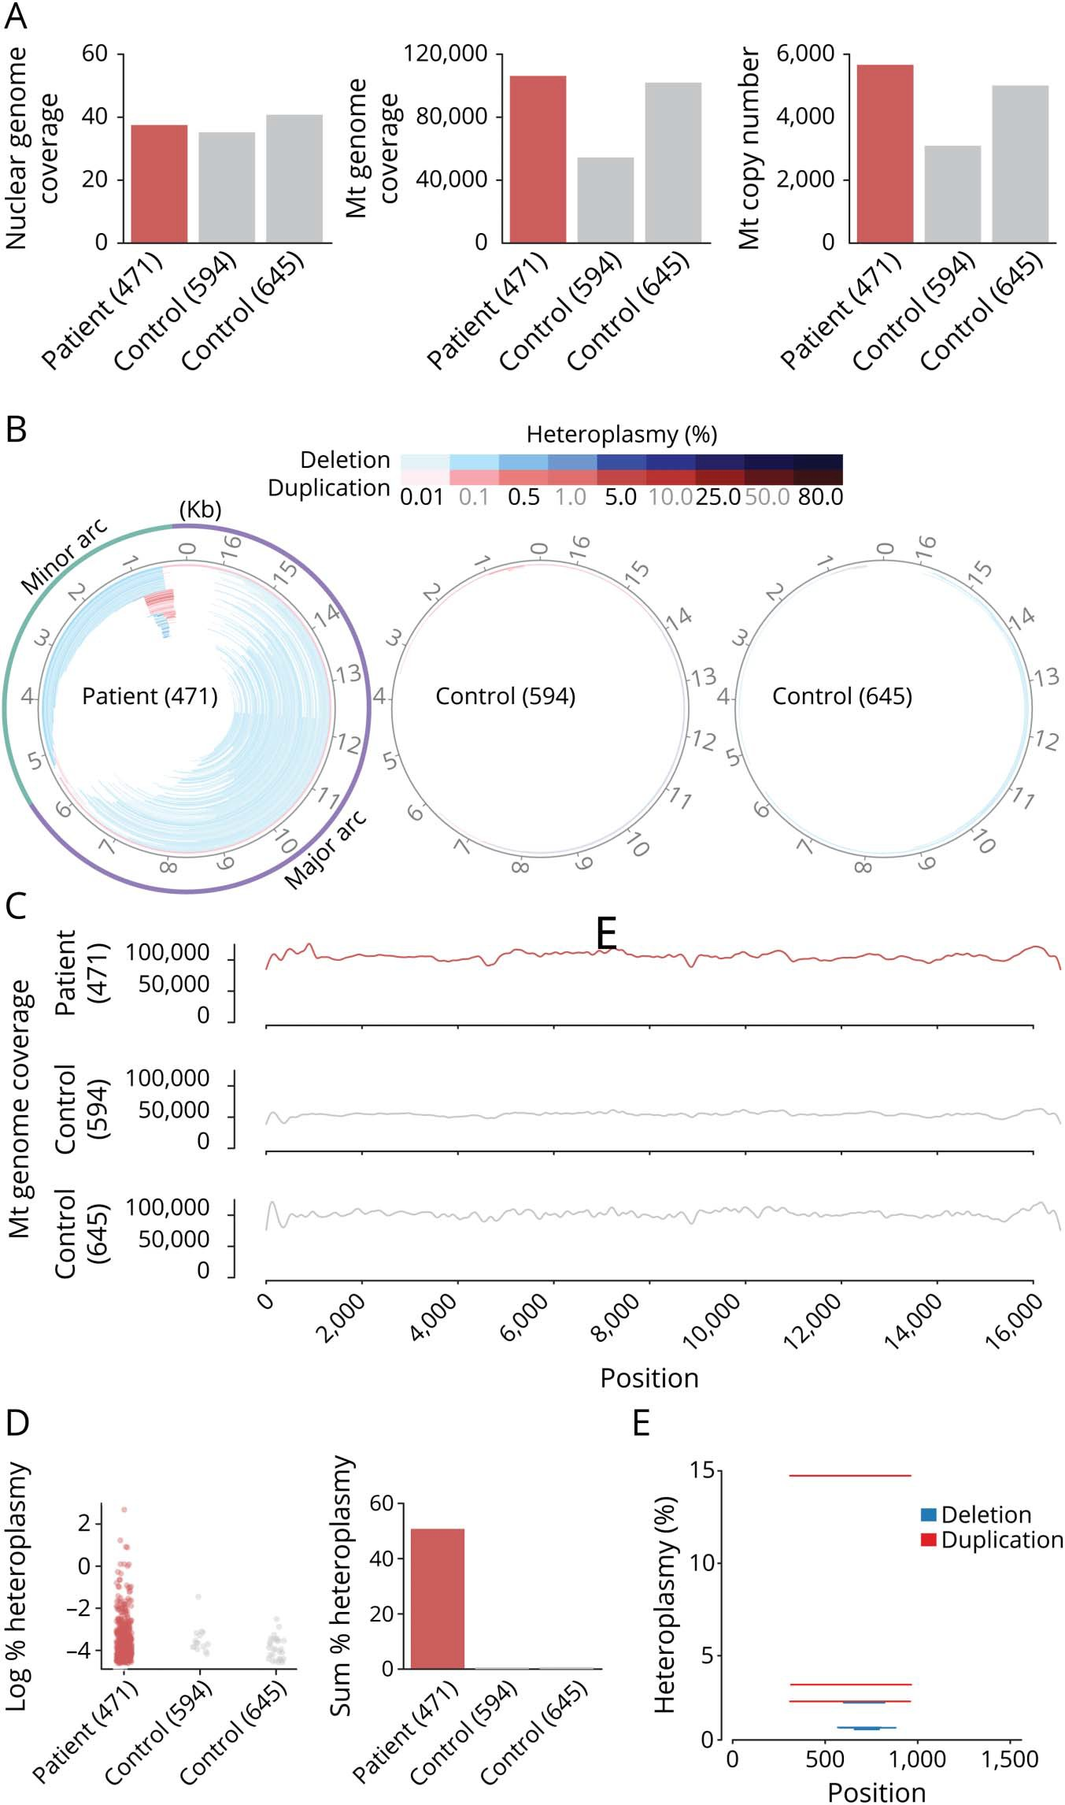(A) Total coverage depth in the nuclear and mito- chondrial genome of the samples along with es- timated mitochondrial copy number. (B) Mitochondrial DNA (mtDNA) deletions (blue) and duplications (red) predicted from the sequencing data in the patient and control samples where the color intensity reflects the heteroplasmy level. Here, deleted regions are those showing gapped alignment of reads on the circular genome. Duplications are a gapped alignment indicating deletion of a genome fragment with an origin of replication, which is not plausible for a functioning mtDNA molecule. Thus, for duplications, the remaining fragment on the circular genome is considered as duplicated. (C) Coverage depth of sequencing reads along the mitochondrial ge- nome in the patient and control samples. (D) Dis- tribution of heteroplasmy for the detected deletions and duplications and the sum of the heteroplasmy levels for all deletions and duplica- tions in the given samples. (E) Position and heter- oplasmy levels of the deletions/duplications detected above 1% threshold heteroplasmy in the patient sample (none detected in the controls).

point mutations.18 F197S is uniquely located in motif I, ad- jacent to the D198 residue that is essential for 39-59 exo- nuclease activity.19 As expected from the location and strong conservation, F197S showed severely reduced 39-59 exo- nuclease activity. Nonetheless, this appears to be suﬃcient to deal with nucleotide misincorporation because only a very

modest increase in mtDNA point mutations was observed in the patient.

We instead propose that the pathogenic molecular defect lies in reduced polymerase activity. That a mutation in the exo- nuclease domain can aﬀect polymerase activity is unexpected

but not unprecedented20,21 and may be due to an imbalance between the polymerase and exonuclease activities. The in- eﬃcient polymerase activity explains the patient’s disease phenotype and presence of mtDNA rearrangements. Re- cently, we were able to reconstitute mtDNA deletion forma- tion in vitro and could demonstrate that replication stalling during L-strand synthesis causes copy-choice recombination and deletion formation.9 Most reported deletions in patients are found in the major arc of mtDNA, a ;11-kb region that becomes single-stranded during H-strand replication and acts as an ssDNA template during L-strand synthesis. The strong replication stalling by F197S on ssDNA can explain the mtDNA deletions identiﬁed in the patient.

We also found mtDNA breakpoints consistent with duplica- tions over the promoter region (mtDNA position 300–1,000 nt). Whether duplications themselves are pathogenic is not clear because no genetic material is lost. Exactly how these duplications arise is not known, but it would be interesting to investigate whether the G-rich conserved sequence block re- gion causes extra problems for polymerases to bypass. It is intriguing to speculate that replication stalling, in combination with the high transcription activity in this area (both light and heavy strand promoters are located here), causes the dupli- cations. In future, we will try to identify speciﬁc sequences that are hotspots for polymerase stalling to elucidate the formation of duplications/deletions further.

More than 300 pathogenic *POLG* mutations have been reported, but the pathogenicity can be diﬃcult to establish. Here, we applied in vitro assays to investigate the functional properties of speciﬁc POL*γ* mutants, which in combination with clinical investigation and detailed analysis of mtDNA rearrangements by means of genome sequencing demon- strated not only pathogenicity but also deepens our un- derstanding of the pathobiology. This approach will be essential in the future to evaluate novel *POLG* variants and already described variants that are not fully characterized with regard to pathogenicity.

Acknowledgment

The authors acknowledge the Clinical Genomics Stockholm facility at Science for Life Laboratory and the Genome Core Facility at the University of Gothenburg for providing assistance in next-generation sequencing.

Study funding

Supported by the Swedish Research Council (M.F., E.L., and A.O.); the Swedish Cancer Foundation (M.F. and E.L.); the European Research Council (M.F.); the IngaBritt and Arne Lundberg Foundation (M.F.); the Knut and Alice Wallen- berg Foundation (M.F. and E.L.); and Va¨stra Go¨talands Regionen to M.F. (ALFGBG-727491) and A.O. (ALFGBG- 716821).

Disclosure

Disclosures available: [Neurology.org/NG.](https://ng.neurology.org/content/6/1/e391/tab-article-info)

Publication history

Received by *Neurology: Genetics* July 3, 2019. Accepted in ﬁnal form November 13, 2019.

Appendix Authors

Name Location Role Contribution

|  |  |  |  |
| --- | --- | --- | --- |
| Carola Hedberg- Oldfors, PhD | University of Gothenburg | Author | Analyzed the genetic data and drafted and revised the manuscript |
| Swaraj | University of | Author | Analyzed the deep |
| Basu, PhD | Gothenburg |  | sequencing data and |
|  |  |  | drafted and revised the |
|  |  |  | manuscript |
| Bertil | University of | Author | Acquisition of the |
| Macao, PhD | Gothenburg |  | biochemical data and |
|  |  |  | drafted and revised the |
|  |  |  | manuscript |
| Christopher | Sahlgrenska | Author | Acquisition of the clinical |
| Lindberg, | University |  | data and drafted and |
| MD, PhD | Hospital, |  | revised the manuscript |
|  | Gothenburg |  |  |
| Bradley | University of | Author | Structural analysis and |
| Peter, PhD | Gothenburg |  | drafted and revised the |
|  |  |  | manuscript |
| Direnis | University of | Author | Acquisition of the |
| Erdinc, MSc | Gothenburg |  | biochemical data |
| Jay P. Uhler, | University of | Author | Drafted and revised the |
| PhD | Gothenburg |  | manuscript |
| Erik | University of | Author | Analyzed the deep |
| Larsson, | Gothenburg |  | sequencing data and |
| PhD |  |  | revised the manuscript |
| Maria | University of | Author | Designed the study, |
| Falkenberg, | Gothenburg |  | analyzed the data, and |
| PhD |  |  | drafted and revised the |
|  |  |  | manuscript |
| Anders | University of | Author | Designed the study, |
| Oldfors, MD, | Gothenburg |  | analyzed the data, and |
| PhD |  |  | drafted and revised the |
|  |  |  | manuscript |

References

1. Gustafsson CM, Falkenberg M, Larsson NG. Maintenance and expression of mam- malian mitochondrial DNA. Annu Rev Biochem 2016;85:133–160.
2. Viscomi C, Zeviani M. MtDNA-maintenance defects: syndromes and genes. J Inherit

Metab Dis 2017;40:587–599.

1. Agostino A, Valletta L, Chinnery PF, et al. Mutations of ANT1, Twinkle, and POLG1 in sporadic progressive external ophthalmoplegia (PEO). Neurology 2003;60: 1354–1356.
2. Spelbrink JN, Li FY, Tiranti V, et al. Human mitochondrial DNA deletions associated with mutations in the gene encoding Twinkle, a phage T7 gene 4-like protein localized in mitochondria. Nat Genet 2001;28:223–231.
3. Van Goethem G, Dermaut B, Lofgren A, Martin JJ, Van Broeckhoven C. Mutation of POLG is associated with progressive external ophthalmoplegia characterized by mtDNA deletions. Nat Genet 2001;28:211–212.
4. Kollberg G, Jansson M, Perez-Bercoﬀ A, et al. Low frequency of mtDNA point mutations in patients with PEO associated with POLG1 mutations. Eur J Hum Genet 2005;13:463–469.
5. Roos S, Macao B, Fuste JM, et al. Subnormal levels of POLgammaA cause ineﬃcient initiation of light-strand DNA synthesis and lead to mitochondrial DNA deletions and progressive external ophthalmoplegia [corrected]. Hum Mol Genet 2013;22:2411–2422.
6. Dubowitz V, Sewry C, Oldfors A. Muscle Biopsy. A Practical Approach, 4th ed. Philadelphia: Elsevier; 2013.
7. Persson O, Muthukumar Y, Basu S, et al. Copy-choice recombination during mito- chondrial L-strand synthesis causes DNA deletions. Nat Commun 2019;10:759.
8. Korhonen JA, Pham XH, Pellegrini M, Falkenberg M. Reconstitution of a minimal mtDNA replisome in vitro. EMBO J 2004;23:2423–2429.
9. Macao B, Uhler JP, Siibak T, et al. The exonuclease activity of DNA polymerase gamma is required for ligation during mitochondrial DNA replication. Nat Commun 2015;6:7303.
10. Trifunovic A, Wredenberg A, Falkenberg M, et al. Premature ageing in mice expressing defective mitochondrial DNA polymerase. Nature 2004;429: 417–423.
11. Rahman S, Copeland WC. POLG-related disorders and their neurological manifes- tations. Nat Rev Neurol 2019;15:40–52.
12. Anagnostou ME, Ng YS, Taylor RW, McFarland R. Epilepsy due to mutations in the mitochondrial polymerase gamma (POLG) gene: a clinical and molecular genetic review. Epilepsia 2016;57:1531–1545.
13. Pitceathly RD, Morrow JM, Sinclair CD, et al. Extra-ocular muscle MRI in genetically- deﬁned mitochondrial disease. Eur Radiol 2016;26:130–137.
14. Yu-Wai-Man C, Smith FE, Firbank MJ, et al. Extraocular muscle atrophy and central nervous system involvement in chronic progressive external ophthalmoplegia. PLoS One 2013;8:e75048.
15. Yu Wai Man CY, Chinnery PF, Griﬃths PG. Extraocular muscles have fundamentally distinct properties that make them selectively vulnerable to certain disorders. Neu- romuscul Disord 2005;15:17–23.
16. Del Bo R, Bordoni A, Sciacco M, et al. Remarkable inﬁdelity of polymerase gammaA associated with mutations in POLG1 exonuclease domain. Neurology 2003;61: 903–908.
17. Longley MJ, Ropp PA, Lim SE, Copeland WC. Characterization of the native and recombinant catalytic subunit of human DNA polymerase gamma: identiﬁcation of residues critical for exonuclease activity and dideoxynucleotide sensitivity. Bio- chemistry 1998;37:10529–10539.
18. Bratic A, Kauppila TE, Macao B, et al. Complementation between polymerase- and exonuclease-deﬁcient mitochondrial DNA polymerase mutants in genomically engi- neered ﬂies. Nat Commun 2015;6:8808.
19. DeBalsi KL, Longley MJ, Hoﬀ KE, Copeland WC. Synergistic eﬀects of the in cis T251I and P587L mitochondrial DNA polymerase gamma disease mutations. J Biol Chem 2017;292:4198–4209.