Available online at [www.sciencedirect.com](http://www.sciencedirect.com/)

Journal logo

[Neuromuscular Disorders 30 (2020) 590–592](https://doi.org/10.1016/j.nmd.2020.04.008)

Case report



[www.elsevier.com/locate/nmd](http://www.elsevier.com/locate/nmd)

MRI findings in SANDO variety of the ataxia-neuropathy spectrum with a novel mutation in POLG (c.3287G*>T*): A case report

Juan Didier Parada-Garzaa,∗, German López-Valencia a, Luis Adrián Miranda-Garcia´ a,

Guillermo Pérez-Garcia´ b, José Luis Ruiz-Sandovala

a *Department of Neurology, Hospital Civil de Guadalajara “Fray Antonio Alcalde”, Hospital 278. Guadalajara, Jalisco 44280, Mexico*

b *Department of Neurosciences (Dr. Ruiz-Sandoval), Centro Universitario de Ciencias de la Salud (CUCS), Universidad de Guadalajara, Mexico*

Received 3 December 2019; received in revised form 26 April 2020; accepted 27 April 2020

**Abstract**

Sensory ataxic neuropathy with dysarthria and ophthalmoparesis (SANDO) is an adult onset sensory ataxic neuropathy, dysarthria and chronic progressive external ophthalmoplegia associated with mutations in POLG1. We report a 38-year-old woman with a history of progressive gait instability and bilateral ptosis. Neurological examination found ataxia, ophthalmoplegia, and dysarthria. MRI showed bilateral thalamic and cerebellar lesions. A POLG related disorder was suspected and after DNA sequencing a SANDO with a novel mutation in POLG was confirmed.

© 2020 Elsevier B.V. All rights reserved.

*Keywords:* Ataxia-neuropathy spectrum; CPEO; Mitochondrial disease; POLG gene; POLG mutation; Ophthalmoparesis; SANDO.

# Introduction

In patients with mitochondrial diseases, the most frequent clinical symptom is chronic progressive external ophthalmoplegia (CPEO), the latter is often associated with multisystem presentations, so the term CPEO-plus has been employed to include all patients within the spectrum. Sensory ataxic neuropathy with dysarthria and ophthalmoparesis (SANDO) is one of the most common chronic progressive external ophthalmoplegia-plus (CPEO-plus) syndromes [1](#_bookmark11),[2]. The POLG gene, which is located in chromosome 15q25.7 encodes the polymerase gamma enzyme that participates in the replication and repair of mitochondrial DNA. Certain mutations in this gene give rise to the so-called "POLG- related disorders", which include CPEO itself, epilepsy, parkinsonism, infertility in men, Alpers syndrome and ataxia- neuropathy spectrum (SANO, SANDO and MIRAS)[1](#_bookmark11)–[3].

∗ Dr. Juan Didier Parada Garza, Neuromuscular Disorders Clinic. Hospital Civil de Guadalajara “Fray Antonio Alcalde”. Hospital 278. Guadalajara, Jalisco México. Postal Code 44280.

*E-mail address:* [j_didiergarza@hotmail.com](mailto:j_didiergarza@hotmail.com) (J.D. Parada-Garza).

<https://doi.org/10.1016/j.nmd.2020.04.008>

0960-8966/© 2020 Elsevier B.V. All rights reserved.

Here we describe a patient with SANDO diagnosis, who present characteristic findings in MRI and a novel POLG gene c.3287G*> T* heterozygous mutation.

# Case report

We present a 38-year-old woman, with no relevant prior clinical history or consanguinity in family members. Her condition began at age 27, with progressive gait instability that slowly worsened and after 5 years of onset progressive bilateral ptosis was developed. She began the evaluation in our hospital 11 years after the onset of symptoms, at first evaluation we noted an ataxic gait and the presence of bilateral ptosis.

Neurological examination revealed, normal mental state, pupils without abnormalities, bilateral complete ophthalmoplegia, dysarthria, normal strength with global areflexia, normal sensitive examination, wide-based gait and positive Romberg test.

General laboratory studies were unremarkable. Targeted studies including rheumatoid factor, C-reactive protein levels, serologies for HIV and syphilis, vitamin B12 levels and

*J.D. Parada-Garza, G. López-Valencia and L.A. Miranda-Garcia´ et al. / Neuromuscular Disorders 30 (2020) 590–592* 591

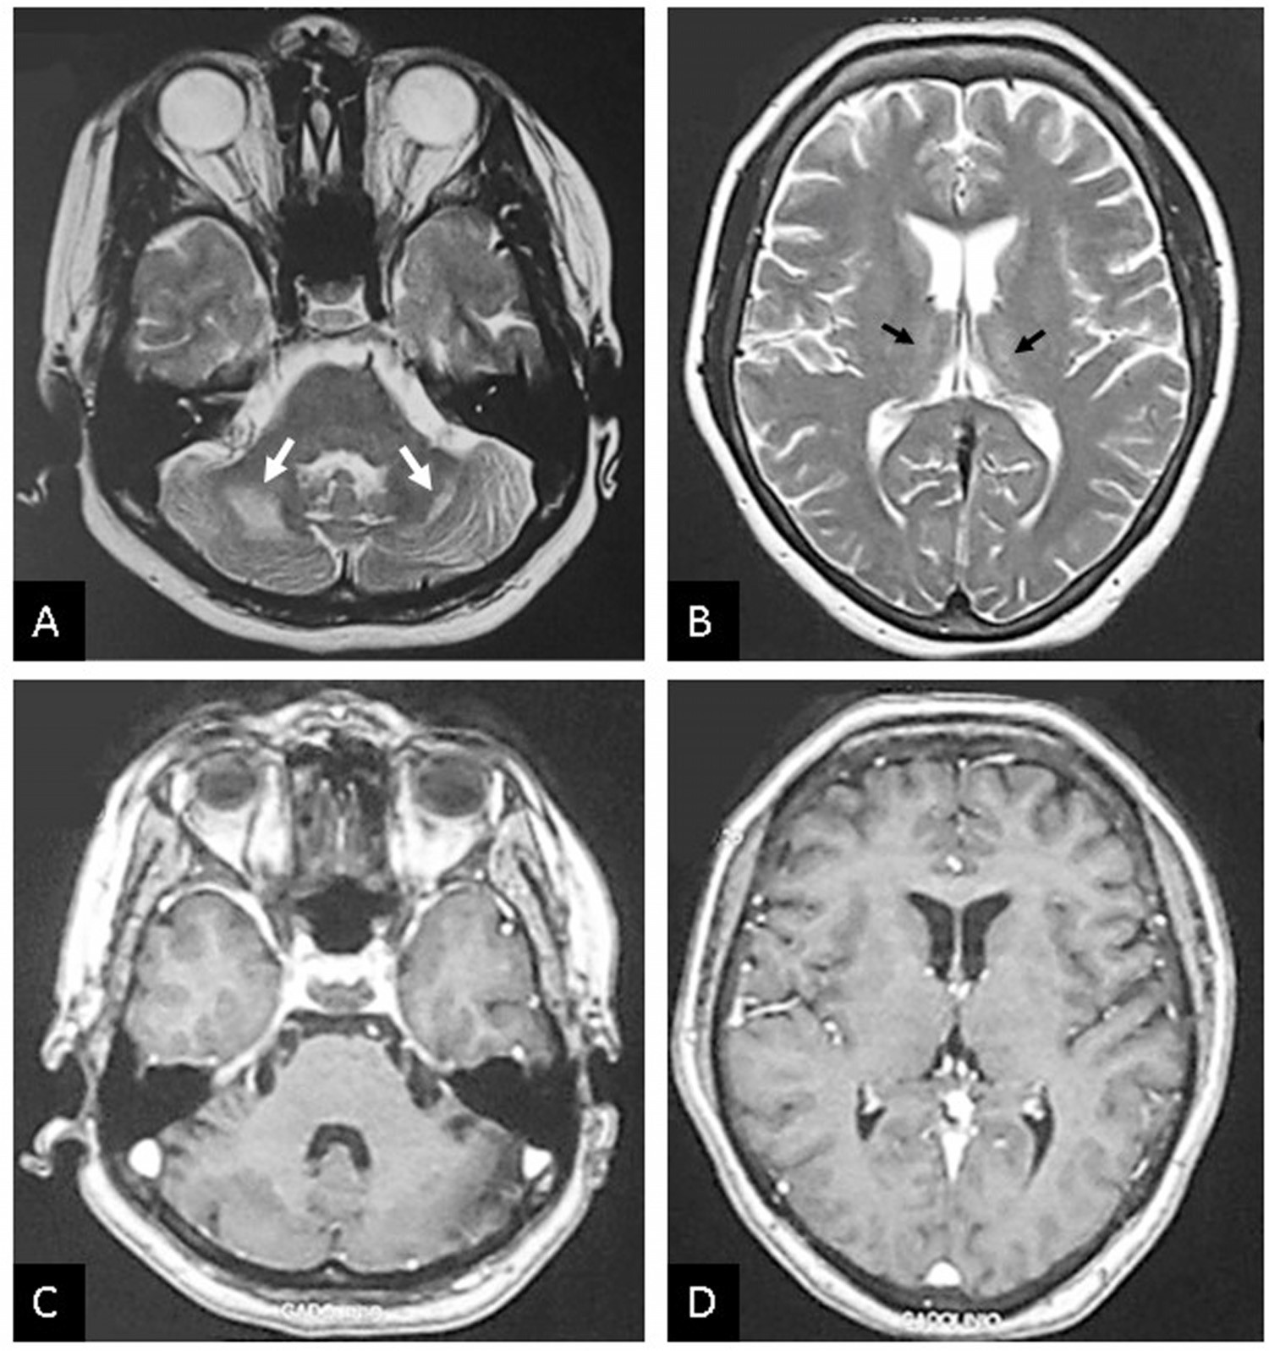

Fig. 1. Axial T2-weighted images (A, B) show hyperintense lesions in cerebellar white matter (white arrows) and dorso-medial thalami (black arrows). Post-contrast T1- weighted MRI (C, D) does not show contrast enhancement.

antibodies against the acetylcholine receptor were reported normal. Positive antinuclear antibodies in 1:1280 dilution with a centromeric fluorescence pattern were reported. The electrodiagnostic studies showed sensory axonal neuropathy and negative repetitive stimulation test.

Brain MRI revealed T2 and FLAIR hyperintense bilateral lesions in the dorso- medial thalami and cerebellar white matter. Diffusion-weighted and contrast-enhanced MRI were normal (Fig. 1A-D). Based on these results the suspicion of a "POLG related disorder" increased. Molecular genetic investigation with DNA sequencing of the POLG1 gene discovered two heterozygote mutations c.264C*> G* and c.3287G*> T*, thus a SANDO variety of the ataxia-neuropathy spectrum was diagnosed.

# Discussion

The clinical evolution with initial predominant ataxia and late CPEO (which invariably develops during the first decade

of the disease) of our case is consistent with previous reports in SANDO case series [1].

According to prior reports, in cases of ataxia-neuropathy spectrum, the MRI findings such as the hyperintense lesions in cerebellar white matter, inferior olivary nucleus and dorso- medial thalami have been the pivot signs for the initial diagnosis and an indication to proceed with a sequencing of POLG gene, just as happened in this case [2]. The most common MRI findings in these patients are the with matter lesions in 26%, cerebellar lesions in 19% and thalamic lesions in 15% of cases [1]. Therefore, knowledge of this signs in the ataxia-neuropathy spectrum related to POLG mutation is useful to facilitate the diagnosis.

The sequence variant c.264C*>G* p.Phe88Leu replaces phenylalanine with leucine at codon 88 of the POLG protein. The phenylalanine residue is highly conserved and there is a small physicochemical difference between phenylalanine and leucine. This variant has been observed in individuals with POLG related disease and is classified as a variant of uncertain significance [4](#_bookmark5),[5]. c.3287G*>T* is the second

592 *J.D. Parada-Garza, G. López-Valencia and L.A. Miranda-Garcia´ et al. / Neuromuscular Disorders 30 (2020) 590–592*

sequence variant presented by our patient, it is predicted that it will result in amino acids substitution p.Arg1096Leu in the exon 21 of the POLG gene. The R1096L mutation is a non-conservative amino acid substitution, which is likely to impact secondary protein structure as these residues differ in polarity, charge, size and/or other properties. Previously, a different amino acid change was reported in this position (p.Arg1096Cys by 3286C*>T*) as pathogenic in a patient with a "POLG-related disorder" diagnosis with CPEO [4]. Therefore, the clinical significance of p.Arg1096Leu interprets as likely pathogenic[6,7,8].

The most frequent POLG mutations that are reports to cause of SANDO include A467T, T748S, R627W, H932Y and G1051R [9]. However, the same mutation can give rise to different clinical pictures and vice versa, so this are genetically heterogenous diseases.

# Conclusion

In this case report, the MRI findings were essential for the diagnostic approach, and a further sequencing of the POLG gene. The ever-expanding molecular and clinical spectrum of mitochondrial DNA polymerase gamma mutations, now enriches with the c.3287G*>T* mutation with a clinical spectrum consisting with ophthalmoplegia, ataxia and sensory neuronopathy.

# References

1. Hanisch F, Kornhuber M, Alston C, Taylor R, Deschauer M, Zierz S. SANDO syndrome in a cohort of 107 patients with CPEO and mitochondrial DNA deletions. J Neurol Neurosurg Psychiatry 2014;86(6):630–4. doi:[10.1136/jnnp-2013-306748](https://doi.org/10.1136/jnnp-2013-306748).
2. Gago MF, Rosas MJ, Guimarães J, Ferreira M, Vilarinho L, Castro L, Carpenter S. SANDO: two novel mutations in POLG1 gene. Neuromuscul Disord 2006;16(8):507–9. doi:[10.1016/j.nmd.2006.05.016](https://doi.org/10.1016/j.nmd.2006.05.016).
3. Henao AI, Pira S, Herrera DA, Vargas SA, Montoya J, Castillo M. Characteristic brain MRI findings in ataxia-neuropathy spectrum related [to POLG mutation. Neuroradiol J 2016;29(1):46–8. doi:10.1177/ 197140091562132.](https://doi.org/10.1177/197140091562132)
4. Tang S, Wang J, Lee N, Milone M, Halberg M, Schmitt E, et al. Mitochondrial DNA polymerase mutations: an ever expanding molecular [and clinical spectrum. J Med Genet 2011;48(10):669–81. doi:10.1136/ jmedgenet-2011-100222.](https://doi.org/10.1136/jmedgenet-2011-100222)
5. [Richards S](http://refhub.elsevier.com/S0960-8966(20)30100-0/sbref0005), [Aziz N](http://refhub.elsevier.com/S0960-8966(20)30100-0/sbref0005), [Bale S](http://refhub.elsevier.com/S0960-8966(20)30100-0/sbref0005), [Bick D](http://refhub.elsevier.com/S0960-8966(20)30100-0/sbref0005), [Das S](http://refhub.elsevier.com/S0960-8966(20)30100-0/sbref0005), [Gastier-Foster J](http://refhub.elsevier.com/S0960-8966(20)30100-0/sbref0005), [et al. Standards and guidelines for the interpretation of sequence variants: a joint consensus recommendation of the American College of Medical Genetics and Genomics and the Association for Molecular Pathology. Genet Med 2015;17(5):405–24.](http://refhub.elsevier.com/S0960-8966(20)30100-0/sbref0005)
6. Agostino A, Valletta L, Chinnery P, Ferrari G, Carrara F, Taylor R, et al. Mutations of ANT1, Twinkle, and POLG1 in sporadic progressive [external ophthalmoplegia (PEO). Neurology 2003;60(8):1354–6. doi:10. 1212/01.WNL.0000056088.09408.3C.](https://doi.org/10.1212/01.WNL.0000056088.09408.3C)
7. Submissions for variant NM_002693.2(POLG):c.3287G>T (p.Arg1096Leu) (rs368435864) - ClinVar Miner [Internet]. Clinvarminer.genetics.utah.edu. 2019 [cited 3 December 2019]. Available from: <https://clinvarminer.genetics.utah.edu/submissions-by-> variant/NM_002693.2%28POLG%29%3Ac.3287G%3ET%20%28p.Arg 1096Leu% 29
8. [Horvath R, Hudson G, Ferrari G, Fütterer N, Ahola S, Lamantea E. Phenotypic spectrum associated with mutations of the mitochondrial polymerase g gene. Brain 2006;129:1674–84.](http://refhub.elsevier.com/S0960-8966(20)30100-0/sbref0007)
9. Habek M, Barun B, Adamec I, Mitrovic´ Z, Ozretic´ D, Brinar V. Early-onset ataxia with progressive external ophthalmoplegia associated [with POLG mutation. Neurologist 2012;18(5):287–9. doi:10.1097/NRL. 0b013e318266f5a6.](https://doi.org/10.1097/NRL.0b013e318266f5a6)