Received: 30 April 2019 Revised: 30 August 2020 Accepted: 1 September 2020

DOI: 10.1002/jmd2.12169

CA SE REPO RT



Ketogenic diet in a patient with refractory status epilepticus due to *POLG* mutation

## Miriam Koessler1 | Edda Haberlandt2 | Daniela Karall3 | Matthias Baumann1 | Alexander Höller3 | Sabine Scholl-Bürgi3

1Department of Pediatrics I, Neuropediatrics, Medical University of Innsbruck, Innsbruck, Austria

Abstract

We present a 16-year-old female patient with *POLG* syndrome, treated with ketogenic diet after she presented with refractory status epilepticus. Initially, benefit of the ketogenic diet could be seen, but the outcome was fatal, with death 3 months after presenting symptoms. Additionally, we give a literature review of the utility of ketogenic diet in patients with *POLG* disease.

KEYWOR DS

ketogenic diet, *POLG* mutation, refractory status epilepticus

2Department of Pediatrics, Hospital Dornbirn, Dornbirn, Austria

3Department of Pediatrics I, Inherited Metabolic Disorders, Medical University of Innsbruck, Innsbruck, Austria

Correspondence

Miriam Koessler, Department of Pediatrics, Medical University of Innsbruck, Anichstraße 35, 6020 Innsbruck, Austria.

Email: [miriam.koessler@tirol-kliniken.at](mailto:miriam.koessler@tirol-kliniken.at)

Communicating Editor: Avihu Boneh

# | INTRODUCTION

Polymerase gamma (*POLG, 174763)* mutation leads to mitochondrial DNA depletion syndrome, resulting in epi- lepsy, movement disorders, cognitive impairment and liver dysfunction.1 Usually, clinical symptoms commence in early childhood, but later manifestation is also possi- ble. Treatment options are limited and consist in symp- tomatic treatment. Beneficial effects of ketogenic diet were previously reported in six patients with *POLG* muta- tion.2-6 Ketogenic diet is based on high-fat and low carbo- hydrate intake. This induces a shift in cellular energy supply from glucose to ketones. In inborn disorders of

Abbreviations: cMRI, cerebral magnetic resonance imaging; EEG, electroencephalography; Lab, laboratory; LEV, levetiracetam; LZP, lorazepam; MDZ, midazolam; Mg, magnesium; MPL, methylprednisolon; PB, phenobarbital; PHT, phenytoin; POLG, polymerase gamma; TPM, topiramate; VPA, valproic acid.

metabolism, it is used in two different ways, firstly, targeting mainly the underlying metabolic disorder or secondly, targeting mainly the clinical symptoms (eg, seizures/epilepsy).7 However, long-term outcome is poor. Here we present a case of POLG syndrome treated with anticonvulsants and ketogenic diet with initial good response, but nevertheless poor long-term outcome.

# | CASE REPORT

A previously healthy 16-year-old female juvenile pres- ented with migraine type headache. Within the out- patient visit, a secondary generalized seizure occurred. Cerebral MRI (cMRI) showed decreased dif- fusion on right occipital lobe; electroencephalography (EEG) presented focal slowing (Figure 1). On the same day, the patient fell into an intractable focal

This is an open access article under the terms of the [Creative Commons Attribution](http://creativecommons.org/licenses/by/4.0/) License, which permits use, distribution and reproduction in any medium, provided the original work is properly cited.

© 2020 The Authors. Journal of Inherited Metabolic Disease published by John Wiley & Sons Ltd on behalf of SSIEM.

*JIMD Reports.* 2021;57:3–8.

[wileyonlinelibrary.com/journal/jmd2](http://wileyonlinelibrary.com/journal/jmd2)

3

status epilepticus, requiring intensive care treatment. Therapy with lorazepam, levetiracetam, phenytoin, cortisone, valproate and lacosamid could not inter- rupt focal status epilepticus.

Diagnostic work-up included lumbar puncture, which showed an isolated blood-cerebrospinal fluid barrier

dysfunction (leukocytes 3/μL [0-4/μL], protein 659 mg/L [150-450 mg/L] and albumin quotient 9.2 [<8]). In view of the clinical neurological symptoms, such as ascending tetraparesis, the suspicion of Guillain-Barre-syndrome raised and immunoglobulins IV were administered over 4 days without improvement.

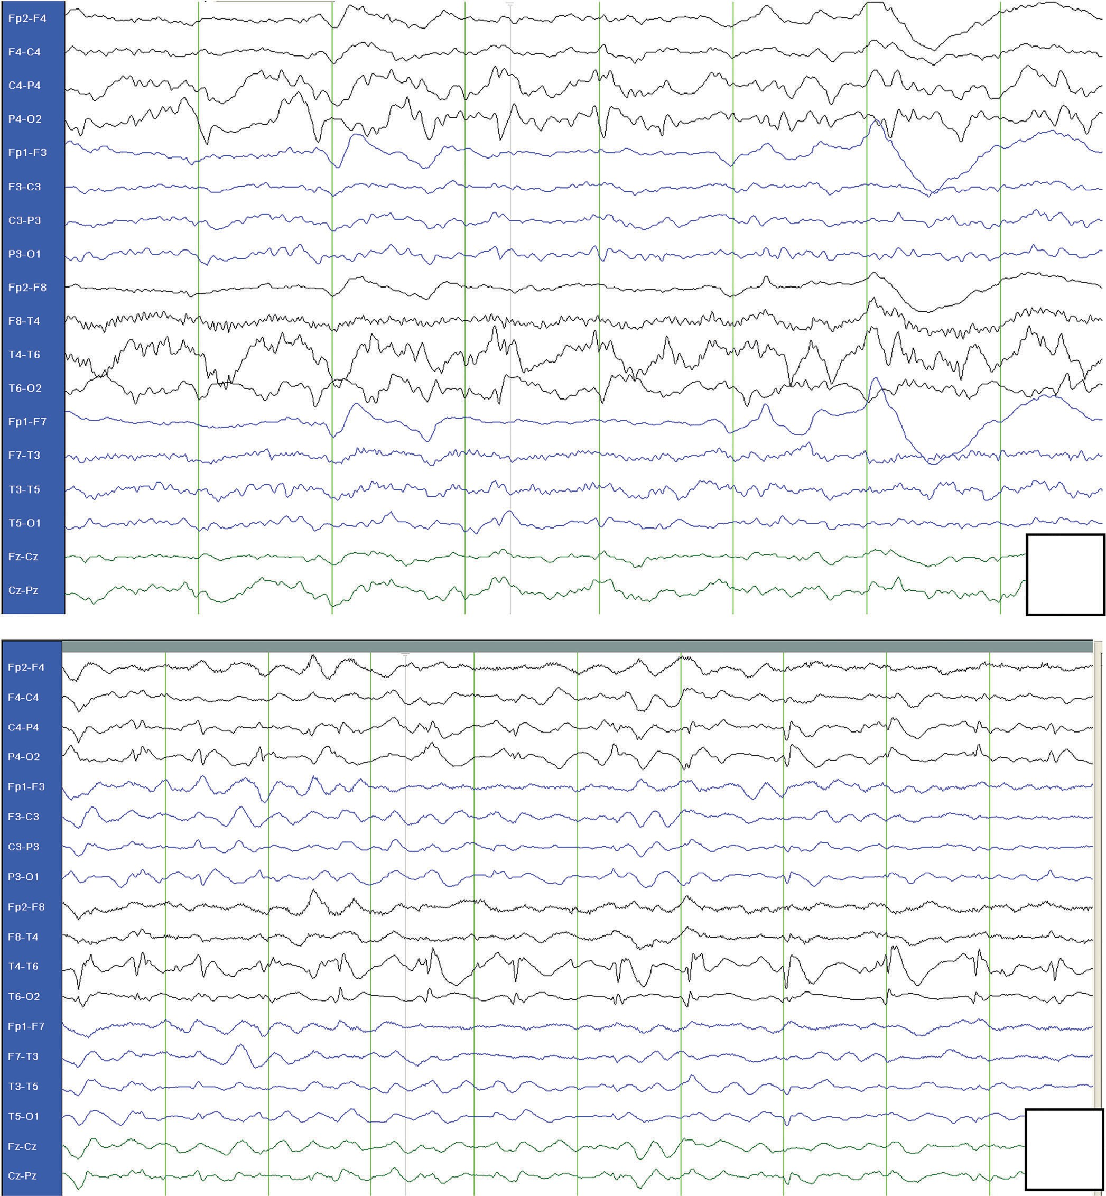(A)

(B)

FIGU RE 1 A, Initial EEG with focal slowing at admission. B, Control EEG 21 days after admission: diffuse generalized slowing, with continuous spike–wave activity temporo-occipital and polyspikes-compatible or pathognomic for *POLG* mutation

Six days after admission and because of typical pat- tern of epilepsia, presenting as epilepsia partialis con- tinua, POLG molecular genetic testing was performed (Dr. J.A. Mayr, Salzburg) and revealed homozygous *POLG* mutation. A missense mutation in the encoding

region and the adjoining introns leading to c.1399G>A (p.Ala467Thr) exchange was identified. Parents, both het- erozygous carriers of this mutation, are healthy.

This mutation has been previously described in patients with Alpers disease8,9 (# 203700). Though our

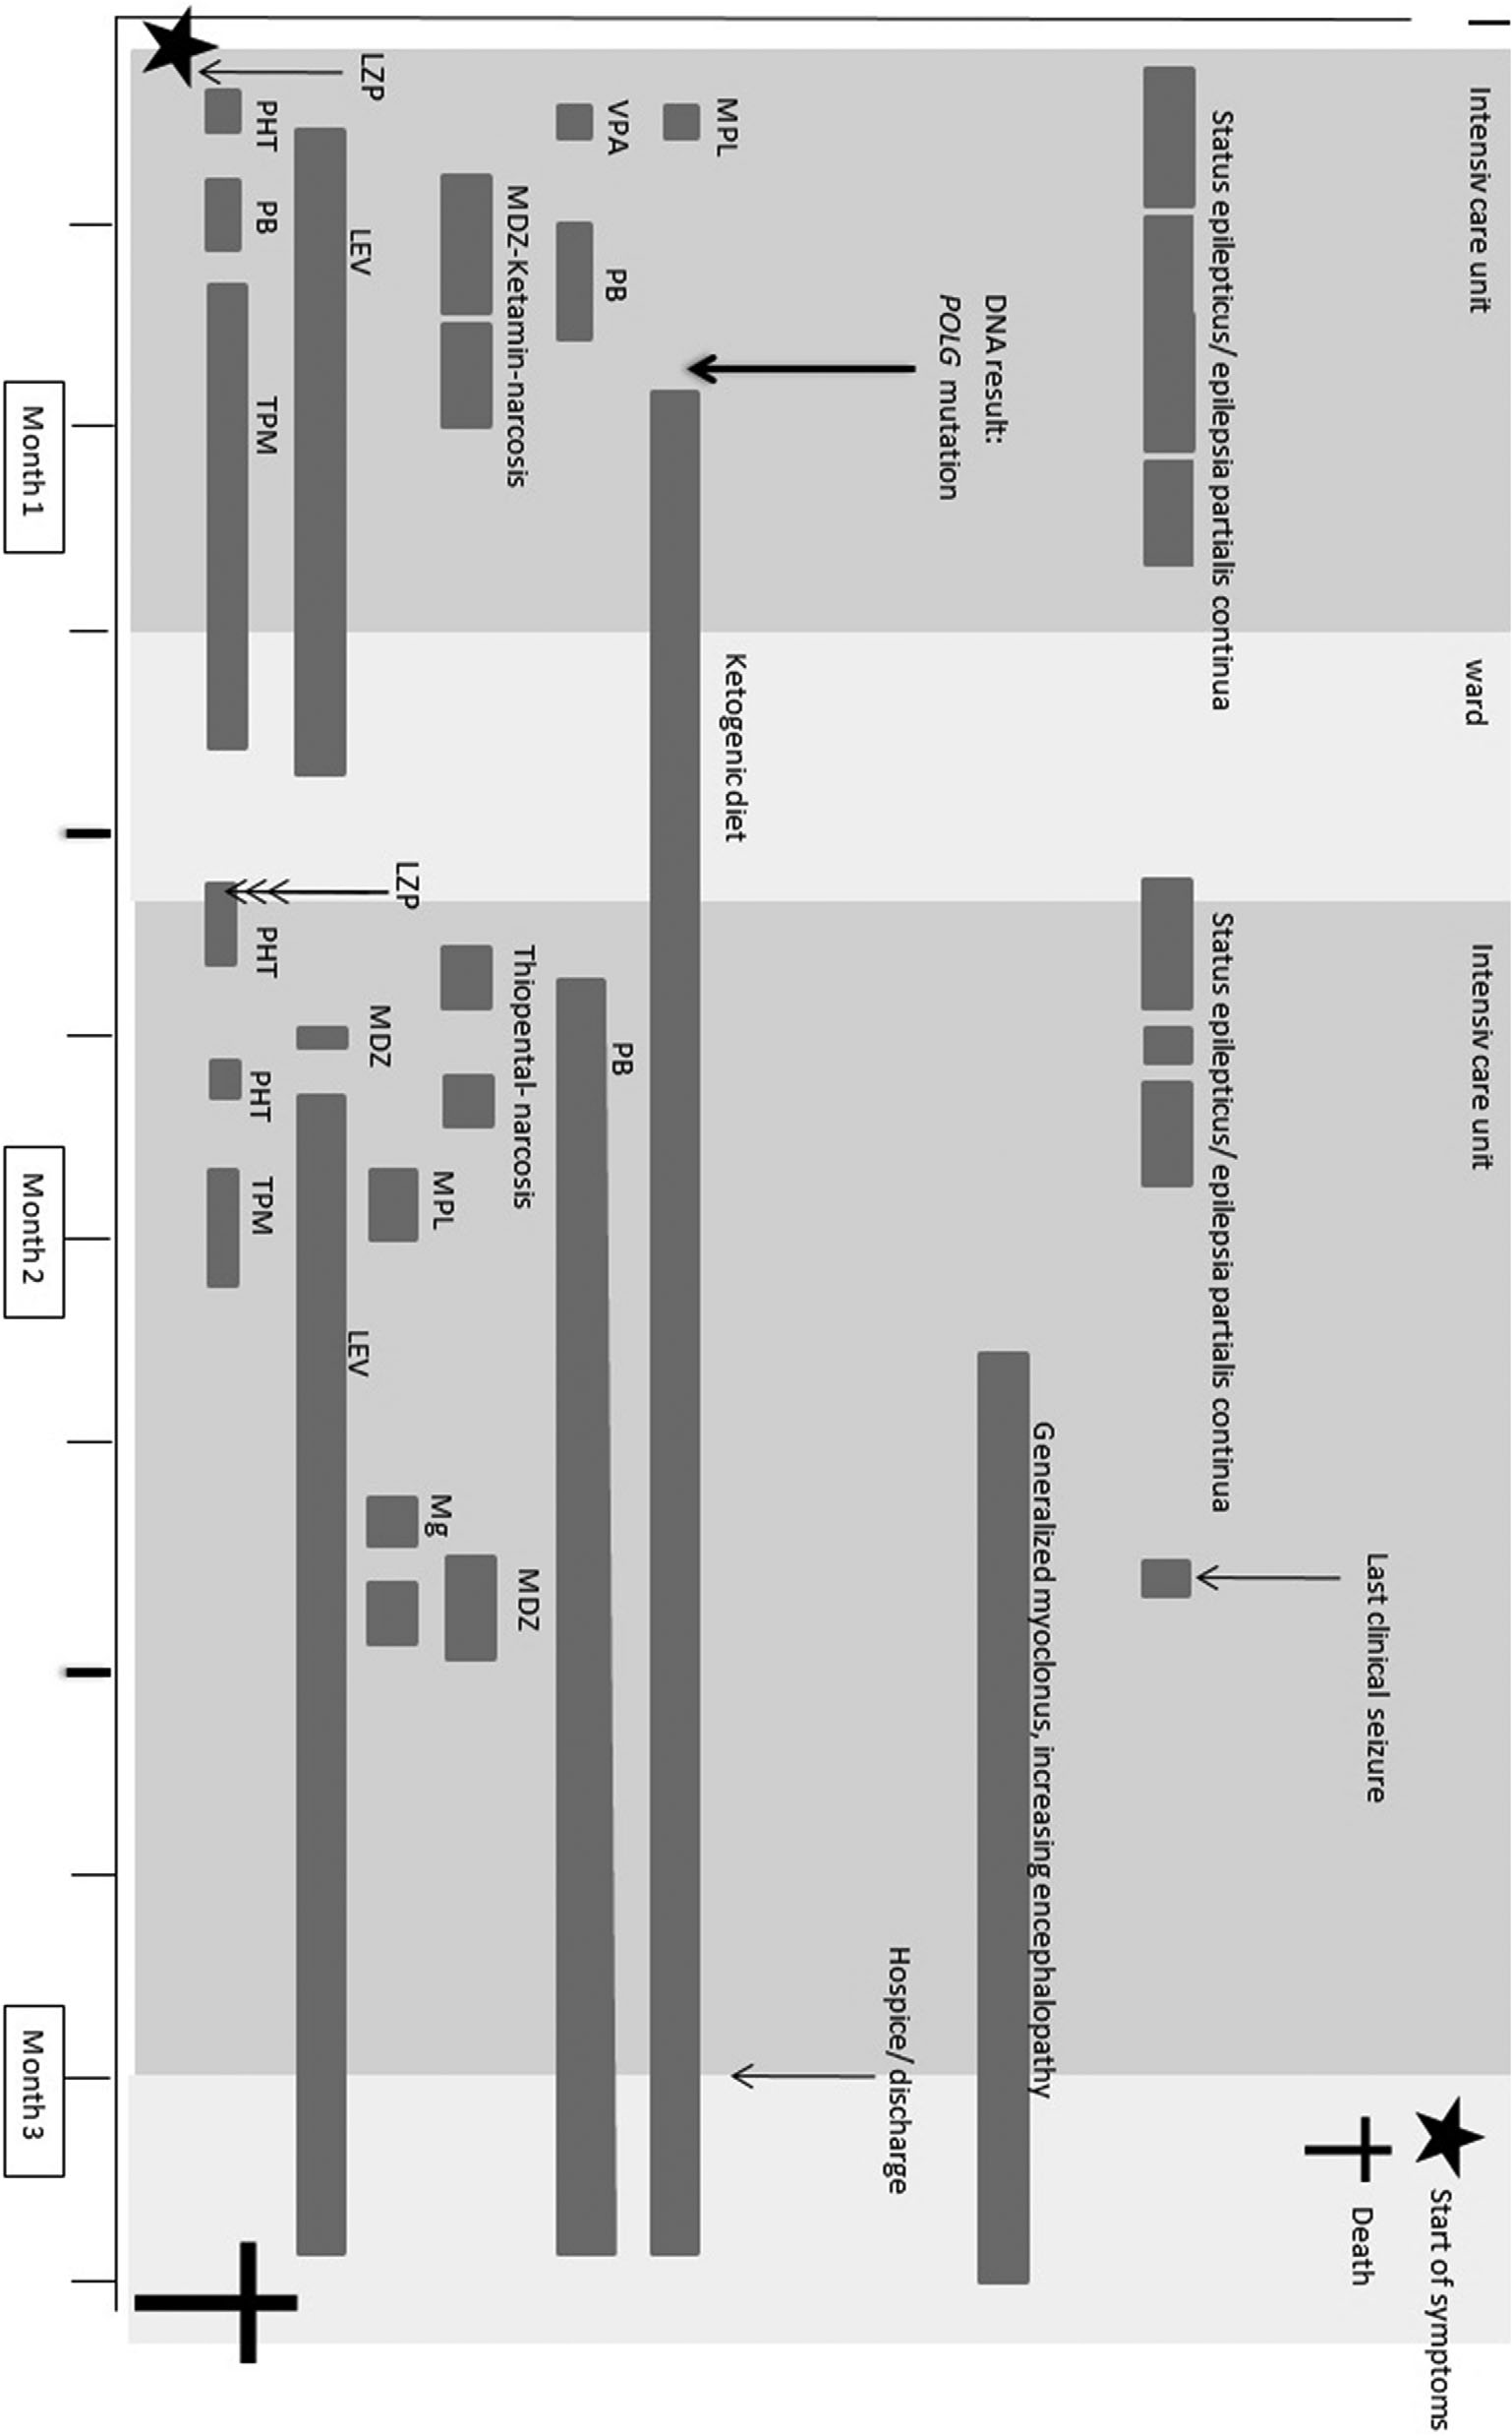FIGU RE 2 Timetable of our case report, with symptoms and treatments. LEV, levetiracetam; LZP, lorazepam; MDZ, midazolam; Mg, magnesium; MPL, methylprednisolon; PB, phenobarbital; PHT, phenytoin; TPM, topiramate; VPA, valproic acid. Maximum drug doses: levetiracetam, 60 mg/kg/d;

lorazepam, 0.05 to 0.1 mg/kg per dose; ketamin, 3.5 mg/kg/h; midazolam, 0.08 to 0.2 mg/kg per dose, 0.3 mg/kg/h; phenobarbital, 10 mg/kg per dose, up to 50 mg/kg/d; phenytoin, 12 mg/kg/d; thiopental, 5 mg/kg/h; valproic acid, 40 mg/kg/d

patient received valproic acid (for 2 days) before diagno- sis, no reparable liver dysfunction was noted.

Koessler et al 2020

Female c.1399G>A

16 y

16 y

After diagnosis

LEV, PHT, LCM

Initially

Abbreviations: CLB, Clobazam; CBZ, Carbamazepin; DD, developmental delay; ESM, Ethosuximid; KD, Ketogenic diet; LCM, Lacosamide; LEV, Levetiracetam; LGIT, low glycaemic index therapy; NA, not available; OXC, oxcarbazepine; PB, phenobarbital; PHT, phenytoin; SE, status epilepticus; TPM, topiramate; VPA, valproic acid.

Immediately after diagnosis (day 9 after admission), in addition to antiseizure drugs, classical ketogenic diet (4:1) (KD) was started. Full ketosis (beta-hydroxybutyrate in plasma >2 mmoL/L) could be achieved after 5 days. Lab- oratory tests showed high levels of liver transaminases in blood with a normalization within 4 days (maximum aspartate transaminase 704 U/L, alanine transaminase 782 U/L, gamma glutamyltransferase 1700 U/L), blood glucose levels and pH were within normal range (glucose 74-110 mg/dL, pH 7.40-7.45). Repeated abdominal ultra- sounds were normal.

Martikainen et al5

Female c.2243G>C

Khan et al6

Male c.1399G>A;

c.3562T>C

—

16 y

9 mo

14 mo

13 mo

PHT, OXC, LEV

Yes

Yes

First control cMRI performed 2 days after onset of symptoms showed alternating areas of decreased diffusion (altogether eight MRIs were done). EEG abnormalities were persistent with focal slowing and superimposed epi- leptic spikes as typical for patients with *POLG* mutations (see Figure 1). Only treatment with midazolam and keta- mine narcosis in combination with phenobarbital could stop the status epilepticus after 25 hours, though reduction of narcosis was only feasible after initiation of ketogenic diet (on fifth day of narcosis, see Figure 2). Her condition stabilized and she could be transferred to regular ward.

Female

c.844T>G, c.1399G>A

18 mo (DD)

43 mo (SE)

45 mo

46 mo NA

22 y

26 y

—

LGIT

TPM, LCM (VPA over a short period)

Yes

Again 3 weeks later, she developed focal status epilepticus, despite ongoing therapy with levetiracetam, topiramate and phenytoin as well as ketogenic diet (4:1). Under treatment with thiopental narcosis for 5 days, seizures improved only short-term. When seda- tion was tempered, she showed focal seizures despite intensive antiepileptic therapy (levetiracetam, pheno- barbital, midazolam, phenytoin, topiramate and corti- sone), magnesium infusion, ketogenic diet and riboflavin, coenzyme Q10 and thiamine.

TA BLE 1 Review of patients with *POLG* mutation in literature, treated with ketogenic diet

Cardenas and Amato3

Female

c.911T>G, c.1174C>g,

pR1081dup

14 mo

Spiegler et al4

Male c.911T>G,

c.3434insGAGG

15 mo (DD)

27 mo (SE)

33 mo

35 mo

33 mo, stopped 2 weeks later

NA (VPA over a short period)

No

Her condition worsened as she was severely enceph- alopathic and hardly able to communicate. She devel- oped generalized myoclonus that did not correspond with an electroencephalographic change, and she had severe muscle pain.

14 mo

19 mo

14 mo

Multidrug

Yes

Ten weeks after admission, she was transferred to a hospice, and finally going home with mobile home- nursing. The patient died 3 months after presenting with initial symptoms (Figure 2) from apnea.

Joshi et al2

Female c.2243G>C; c.2480

+1g>A

31 mo

LEV, ESM,

Nitrazepam

Yes

# | LITERATURE REVIEW

55 mo

66 mo

55 mo

Only few reports exist on patients with *POLG* mutation and ketogenic diet (see Table 1).

Gender

*POLG* mutation

Age at initial presentation

Age at diagnosis Age at death

Start of KD

Co-medication

Clinical improvement

In 2009, Joshi et al described a 4.5-year-old girl with Alpers-Huttenlocher syndrome and a heterozygous muta- tion in *POLG1* gene (c.2243G>C; c.2480+1g>A).2 The girl presented with epilepsia partialis continua, after initiation

of ketogenic diet (4:1) she remained seizure-free for 7 months. Triggered by an intercurrent infection under diet, she showed a subclinical status epilepticus, which could be successfully treated with midazolam infusion. After restart of the diet nei- ther seizure control nor her baseline clinical state could be sustained anymore. At the age of 5.5 years, and 11 months after diagnosis, she died due to respiratory failure.2

One year later (2010), Cardenas and Amato described a 14-month-old girl with compound heterozygous muta- tion in *POLG1* gene (c.911T>G, c.1174C>g, pR1081dup) presenting with epilepsia partialis continua evolving into generalized status epilepticus. Treatment with a multidrug therapy, including ketogenic diet terminated her seizures, but she was severely encephalopathic. Sev- eral weeks after discharge seizures returned and she died at the age of 19 months, 5 months after diagnosis.3

In 2011, Spiegler et al reported two patients diagnosed with Alpers-Huttenlocher syndrome due to *POLG1* muta- tion (patient 1 c.911T>G, c.3434insGAGG; patient 2 c.844T>G, c.1399G>A) at ages 33 and 45 months. Both were treated with ketogenic diet. The first patient did not respond and treatment was stopped 2 weeks after initia- tion, the boy died 3 months after diagnosis, at 35 months of age. The second patient became more alert and seizure activity ceased for a few weeks, but developed epilepsia partialis continua under treatment with antiepileptic drugs and KD, therapy was continued until death at 46 months.4 A 26-year-old woman with homozygous mutation in *POLG1* gene (c.2243G>C) and non-convulsive status epilepticus was presented by Martikainen et al.5 Under low glycemic index treatment (LGIT), a variant of keto- genic diet, in addition to phenytoin, oxcarbazepine and levetiracetam, her symptoms resolved. Phenytoin and oxcarbazepine were gradually discontinued and she had no further seizures under levetiracetam monotherapy

and LGIT.5

Another group described a boy diagnosed with Alpers syndrome and heterozygous *POLG1* mutation (c.1399G>A; c.3562T>C) at the age of 9 months.6 After starting ketogenic diet at 13 months of age, seizures sub- stantially decreased without clinical improvement. One month later and 5 months after diagnosis, he died due to congestive heart failure and respiratory difficulties.6

# | DISCUSSION

## | Patients

In our literature research, we found six patients with *POLG* mutation and intractable seizures receiving ketogenic diet2-5 (see Table 1). In five of these six patients, the diet led to substantial reduction of seizure activity, whereas

general condition often did not improve.2-6 Four of these five died shortly after initiation of therapy2-4,6 (see Table 1). One reported patient did not respond, hence therapy was stopped after 2 weeks4 (see Table 1).

In our patient, ketogenic diet only showed initial improvement of symptoms, with an improvement of EEG, finally leading to a reduction of antiseizure therapy and a stabilization of her general condition over a short time. However, she showed an outstanding rapid deterioration leading to death 3 months after initial presentation.

## | Ketogenic diet

Ketogenic diet is used in inborn disorders of metabo- lism10,11 and is the treatment of choice in some of them; for example, glucose transporter type 1 deficiency syn- drome.12-14 Further, ketogenic diet was found to be effec- tive for therapy of intractable seizures.11,15,16 However, the precise mechanism of action of the diet is not fully understood. As some inborn disorders of metabolism deteriorate with catabolism, ketosis should be reached and maintained without catabolism.

According to data,1 most patients with *POLG* muta- tion presented with first symptoms in their early child- hood. Our patient showed a juvenile and rapid progressive form of *POLG* mutation. The group of Mar- tikainen presented a woman at the age of 26 years.5 Beside the adult patient, all patients died within 1 year after diagnosis. Thus, one might conclude that despite an initial improvement with ketogenic diet outcome is poor once symptoms have started.

ACKNOWLEDGMENTS

The authors would like to acknowledge the rapid and professional work of laboratory J. A. Mayr, Salzburg, where the mutation was confirmed. All authors disclaim any financial or commercial involvement or other con- flicts of interest.

AUTHOR CONTRIBUTIONS

Miriam Koessler designed and implemented the article, and wrote the manuscript. Edda Haberlandt, Daniela Karall, Matthias Baumann have made substantial contri- bution to conception, design and interpretation of data. Sabine Scholl-Bürgi has made substantial contributions to conception and design, acquisition and interpretation of data. Alexander Höller A contributed to the concep- tion. All authors read, revised the manuscript critically and approved the version of the manuscript.

ORCID

*Miriam Koessler [](https://orcid.org/0000-0001-8249-6107)* <https://orcid.org/0000-0001-8249-6107>

REFERENCES

* + 1. Horvath R, Hudson G, Ferrari G, et al. Phenotypic spectrum associated with mutations of the mitochondrial polymerase gamma gene. *Brain*. 2006;129:1674-1684.
    2. Joshi CN, Greenberg CR, Mhanni AA, Salman MS. Ketogenic diet in Alpers-Huttenlocher syndrome. *Pediatr Neurol*. 2009;40: 316-316.
    3. Cardenas JF, Amato RS. Compound heterozygous polymerase gamma gene mutation in a patient with Alpers disease. *Semin Pediatr Neurol*. 2010;17:62-64.
    4. Spiegler J, Stefanova I, Hellenbroich Y, Sperner J. Bowel obstruction in patients with Alpers-Huttenlocher syndrome. *Neuropediatrics*. 2011;42:194-196.
    5. Martikainen MH, Päivärinta M, Jääskeläinen S, Majamaa K. Successful treatment of POLG-related mitochondrial epilepsy with antiepileptic drugs and low glycaemic index diet. *Epileptic Disord*. 2012;14:438-441.
    6. Khan A, Trevenen C, Wei XC, Sarnat HB, Payne E, Kirton A. Alpers syndrome: the natural history of a case highlighting neuroimaging, neuropathology, and fat metabolism. *J Child Neurol*. 2012;27:636-640.
    7. Scholl-Bürgi S, Höller A, Pichler K, Michel M, Haberlandt E, Karall D. Ketogenic diets in patients with inherited metabolic disorders. *J Inherit Metab Dis*. 2015;38: 765-773.
    8. Tzoulis C, Engelsen BA, Telstad W, et al. The spectrum of clini- cal disease caused by the A467T and W748S POLG mutations: a study of 26 cases. *Brain*. 2006;129:1685-1692.
    9. Polymerase Gamma gene mutation database. [http://tools.](http://tools.niehs.nih.gov/polg/) [niehs.nih.gov/polg/.](http://tools.niehs.nih.gov/polg/) Accessed September 20, 2016.
    10. Leen WG, Mewasingh L, Verbeek MM, Kamsteeg EJ, van de Warrenburg BP, Willemsen MA. Movement disorders in GLUT1 deficiency syndrome respond to the modified Atkins diet. *Mov Disord*. 2013;28:1439-1442.
    11. Kossoff EH, Nabbout R. Use of dietary therapy for status epilepticus. *J Child Neurol*. 2013;28:1049-1051.
    12. Ito Y, Oguni H, Ito S, Oguni M, Osawa M. A modified Atkins diet is promising as a treatment for glucose transporter type 1 deficiency syndrome. *Dev Med Child Neurol*. 2011;53:658-663.
    13. Haberlandt E, Karall D, Jud V, et al. Glucose transporter type 1 deficiency syndrome effectively treated with modified Atkins diet. *Neuropediatrics*. 2014;45:117-119.
    14. De Giorgis V, Veggiotti P. GLUT1 deficiency syndrome 2013: current state of the art. *Seizure*. 2013;22:803-811.
    15. O'Connor SE, Richardson C, Trescher WH, et al. The Ketogenic diet for the treatment of pediatric status epilepticus. *Pediatr Neurol*. 2014;50:101-103.
    16. Wibisono C, Rowe N, Beavis E, et al. Ten-year single-center experience of the ketogenic diet: factors influencing efficacy, tolerability, and compliance. *J Pediatr*. 2015;166:1030-1036.

How to cite this article: Koessler M, Haberlandt E, Karall D, Baumann M, Höller A,

Scholl-Bürgi S. Ketogenic diet in a patient with refractory status epilepticus due to *POLG* mutation. *JIMD Reports*. 2021;57:3–8. [https://doi.org/10.1002/](https://doi.org/10.1002/jmd2.12169) [jmd2.12169](https://doi.org/10.1002/jmd2.12169)