Seizure 18 (2009) 232–234

Contents lists available at [ScienceDirect](http://www.sciencedirect.com/science/journal/10591311)

Seizure

journal homepage: www. elsevier.com/locate/yseiz

Case report

Proof of progression over time: Finally fulminant brain, muscle, and liver affection in Alpers syndrome associated with the A467T *POLG1* mutation

M. Boes a,*, J. Bauer a, H. Urbach b, C.E. Elger a, S. Frank c, M. Baron a, G. Zsurka a,

W.S. Kunz a, C. Kornblum d

a *Department of Epileptology, University Hospital of Bonn, Germany*

b *Department of Radiology, University Hospital of Bonn, Germany*

c *Department of Neuropathology, University Hospital of Bonn, Germany*

d *Department of Neurology, University Hospital of Bonn, Germany*

A R T I C L E I N F O

*Article history:*

Received 14 April 2008

Received in revised form 18 July 2008 Accepted 8 August 2008

*Keywords:*

Alpers syndrome POLG mutation Epileptic seizure Brain MRI

A B S T R A C T

This case concerns a 17-year-old boy, who was given the diagnosis of Alpers syndrome only postmortem when a homozygous 1399G!A (A467T) mutation was found in the linker-region of *POLG1*. Serial muscle and liver biopsies as well as brain MRI scans in our patient ranging from early childhood to postmortem analyses showed that (i) routine diagnostic procedures can be normal in the early stage of the disorder and that (ii) central nervous system and further organ affection may only develop in the time course of the disease. Consecutive diagnostic examinations clearly reﬂected the devastating clinical course and cerebral deterioration evolving over time in Alpers syndrome.

© 2008 British Epilepsy Association. Published by Elsevier Ltd. All rights reserved.

1. 1 Introduction

Infantile Alpers syndrome (OMIM 203700) is a severe neurodegenerative disorder frequently associated with mitochon- drial DNA polymerase g gene (*POLG1*) mutations.1–3 The syndrome is clinically characterized by the triad of (a) refractory epilepsy, (b) developmental delay, and (c) liver failure.

1. 2 Case report

A 17-year-old boy was referred to our Department of Epileptology with refractory epilepsy and died three months later in cerebral coma. He had developed normal until the age of ﬁve years, when he was ﬁrst admitted to hospital for status epilepticus. Weeks later, he presented with cerebellar ataxia and myoclonus of the left arm, evolving into epilepsia partialis continua. Skeletal muscle biopsy at that time was non-contributory [no *ragged red* or cytochrome *c* oxidase (COX)-negative ﬁbbers]. However, retro- spective moleculargenetic work-up of the muscle sample showed a low amount of multiple mitochondrial (mt) DNA deletions (<5%)

* Corresponding author at: University Hospital of Bonn, Department of Epileptology, Sigmund Freud Strasse 25, 53105 Bonn, Germany.

Tel.: +49 228 287 15712; fax: +49 228 287 14486.

*E-mail address:* [monika.boes@ukb.uni-bonn.de](mailto:monika.boes@ukb.uni-bonn.de) (M. Boes).

and considerable mtDNA depletion (the mean mtDNA content was reduced to 55% of 9 healthy controls aged 20.1 ± 10.3 years) using long-range and real-time PCR as previously described.4 The patient’s condition gradually deteriorated over the years with progressive cerebellar signs, cognitive decline from the age of 12, and worsening of the myoclonus from the age of 15 years. Transient liver dysfunction occurred under intermittent antiepileptic treatment with sodium valproate. However, standard liver biopsy and magnetic resonance imaging (MRI) of the brain at the age of 15 years were normal. At the age of 17 years, the patient developed refractory focal motor status in association with pneumonia ﬁnally requiring ventilatory assistance and admission to our hospital. General anaesthesia, high dose benzodiazepines, and phenobarbiturate did not interrupt the intractable focal motor status. For successful seizure control, treatment with sodium valproate was indispensable. Over the following weeks, blood chemistries showed persistent mild (twofold) elevated liver transaminase levels but no jaundice, hyperammonae- mia, abnormalities of blood coagulation, or other signs of hepatic failure. After three months of intubation, the patient remained in a vegetative state after reduction of all anaesthetics maintaining sodium valproate. A 1.5T brain MRI at that time showed symmetric hyperintensities and swelling of deep grey matter nuclei as well as cortical grey and subcortical white matter with relative sparing of the frontal cortex (Fig. 1). In the further clinical course, the patient developed brainstem symptoms and died in coma one week after the ﬁnal brain MRI examination. Autopsy showed a multiorgan failure

1059-1311/$ – see front matter © 2008 British Epilepsy Association. Published by Elsevier Ltd. All rights reserved. doi:[10.1016/j.seizure.2008.08.003](http://dx.doi.org/10.1016/j.seizure.2008.08.003)

*M. Boes et al. / Seizure 18 (2009) 232–234* 233

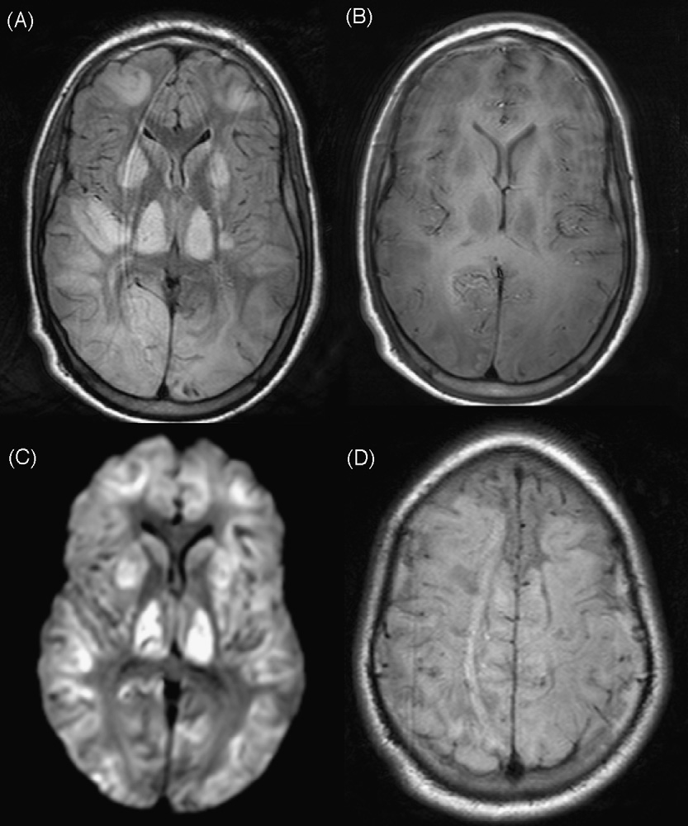

Fig. 1. Axial 5 mm thick FLAIR fast spin echo (A), T1-weighted spin echo (B), and diffusion-weighted spin echo EPI (C) at the level of the basal ganglia show hyperintense and swollen deep grey matter nuclei as well as hyperintensity and swelling of the cortical grey and subcortical white matter. Note the nearly symmetric distribution and the fact that the frontal cortex is rather spared (B, D).

but no signs of liver ﬁbrosis or cirrhosis and no hepatic microvesicular steatosis. Neuropathological examinations revealed spongiform changes in the cerebrum, white matter spongiosis of the cerebellum, a brainstem bleeding, and multiple lacunar ischaemic cortical infarcts. Postmortem analyses of skeletal muscle and liver tissue revealed massive mtDNA depletion. The mean mtDNA content in muscle was reduced to 16% of controls, in liver to 10% of 5 normal controls aged 53.5 ± 1 years. Histology of postmortem liver tissue showed abundant COX-negative areas with only isolated ﬁelds of preserved COX-activity.5 The diagnosis of Alpers syndrome was given postmortem, when a homozygous 1399G!A (A467T) mutation was found in the linker-region of *POLG1*.

1. 3 Discussion

The phenotypic spectrum associated with *POLG1* mutations is wide and comprises progressive external ophthalmoplegia,6 ataxic syndromes,7 progressive neurological disorders,8,9 and infantile Alpers syndrome with mitochondrial DNA depletion.1,4 According to recent data, the A467T mutation can be detected in the majority of childhood-onset cases associated with *POLG1* mutations.3 A467T was recently found in 0.19% of German control alleles, providing a reservoir for recessive disease.3 Previous reports on cerebral MRI in Alpers syndrome taken months to years before death revealed hyperintensities frequently located in occipital lobes, deep cerebellar nuclei, thalamus, and basal ganglia.2,9,10 In contrast,

MRI in our patient taken one week before death showed more pronounced cortical and subcortical hyperintensities and swelling similarly including deep grey matter nuclei. These ﬁndings were more pronounced and only partly in line compared with previously reported MRI patterns in Alpers syndrome. However, this is the ﬁrst report on terminal brain MRI ﬁndings in a fatal disease course. It may be speculative if the more generalized and severe signal abnormalities in our patient are consequences of the natural history of the disorder itself or due to the characteristic complications of the disease like refractory status epilepticus. Involvement of the deep grey internal nuclei, however, is not consistent with prolonged status epilepticus. Therefore, these ﬁndings can be interpreted as an expression of the terminal phase of encephalopathy in this distinct mitochondrial disorder. Differ- ential diagnostically, pronounced thalamic signal changes in MRI can be present in general cerebral hypoxia, the variant of Creutzfeld-Jakob disease, deep cerebral vein thrombosis, and various mitochondrial disorders like infantile Leigh syndrome or Kearns-Sayre syndrome. However, cerebral MRI pathology is usually not restricted to deep grey internal or thalamic nuclei in these disorders, which are usually easily to distinguish from Alpers syndrome by clinical signs and symptoms.

Examination results of serial muscle samples taken at the age of

5 years and postmortem, liver biopsies taken at the age of 15 years and postmortem, and brain MRI scans performed at 15 and 17 years of age prove the continuous and serious progress of cerebral

234 *M. Boes et al. / Seizure 18 (2009) 232–234*

and multiorgan affection in Alpers syndrome over time. In detail, our case demonstrates that brain MRI abnormalities in Alpers syndrome may rapidly develop over a comparably short time period and that muscle and liver biopsies following standard histological procedures can be normal particularly in the early course of the disease. Our experience underlines the impact of serial MRI scans and the need for speciﬁc biopsy work-up in clinically suspect patients including qualitative and quantitative mtDNA examinations comprising analyses for multiple deletions and/or depletion usually present in syndromes associated with *POLG1* mutations. As *POLG1* mutations were only recently reported as frequent causes of infantile Alpers syndrome, deﬁnite numbers of affected children are not known, and the diagnosis may easily be overseen as many patients die at young age.

The severe ﬁndings in our patient clearly reﬂect the devastating clinical course and cerebral deterioration that may evolve in Alpers syndrome. Our data indicate that not only liver failure but also severe brain damage may contribute to death in Alpers syndrome. In patients with POLG1 mutations, prolonged convulsive status epilepticus is a common and fatal complication and represents a major cause of death in these disease entities (Engelsen et al.).10 Focal epileptic seizures that often result in generalized status epilepticus are characteristic symptoms of brain affection in Alpers syndrome; however, they result in further cerebral damage themselves thus creating a vicious cycle of central nervous system pathology. In our patient, brainstem affection may have further contributed to death potentially leading to central respiratory and autonomic failure. Intriguingly, histochemical and molecularge- netic postmortem analyses gave evidence of serious liver dysfunction without conclusive clinical or morphological evidence for fatal liver failure like ﬁbrosis, cirrhosis, or hepatic micro-

vesicular steatosis as usually seen in hepatic failure due to valproate treatment. We postulate that severe mtDNA depletion in liver tissue resulted in respiratory chain dysfunction which was reﬂected by severe COX-negativity of the liver tissue. Biochemical liver dysfunction in our patient obviously did not yet lead to relevant clinical signs or severe morphological tissue changes.

References

1. Davidzon G, Mancuso M, Ferraris S, Quinzii C, Hirano M, Peters HL, et al. POLG mutations and Alpers’syndrome. *Ann Neurol* 2005;57:921–4.
2. Ferrari G, Lamantea E, Donati A, Filosto M, Carrara F, Parini R, et al. Infantile hepatocerebral syndromes associated with mutations in the mitochondrial DNA polymerase-g A. *Brain* 2005;128:723–31.
3. Horvath R, Hudson G, Ferrari G, Fu¨ tterer N, Ahola S, Lamantea E, et al. Pheno- typic spectrum associated with mutations of the mitochondrial polymerase g gene. *Brain* 2006;129:1674–84.
4. Baron M, Kudin AP, Kunz WS. Mitochondrial dysfunction in neurodegenerative disorders. *Biochem Soc Trans* 2007;35:1228–31.
5. Kornblum C, Baron M, Boes M, Zsurka G, Kunz WS. Phenotypic variations in patients with linker-region mutations in the mitochondrial DNA polymerase gamma gene. *Neuromuscul Disord* 2007;17(9–10):747.
6. Van Goethem G, Dermaut B, Lofgren A, Martin JJ, Van Broeckhoven C. Mutation of *POLG* is associated with progressive external ophthalmoplegia characterized by mtDNA deletions. *Nat Genet* 2001;28:211–2.
7. Van Goethem G, Luoma P, Rantamaki M, Al Memar A, Kaakola S, Hackman P, et al. POLG mutations in neurodenegerative disorders with ataxia but no muscle involvement. *Neurology* 2004;63:1251–7.
8. Luoma P, Melberg A, Rinne JO, Kaukonen JA, Nupponen NN, Chalmers RM, et al. Parkinsonism, premature menopause, and mitochondrial DNA polymerase gamma mutations: clinical and molecular genetic study. *Lancet* 2004;364: 875–82.
9. Tzoulis C, Engelsen BA, Telstad W, Aasly J, Zeviani M, Winterthun S, et al. The spectrum of clinical disease caused by the A467T and W748S POLG mutation: a study of 26 cases. *Brain* 2006;129:1685–92.
10. Engelsen BA, Tzoulis C, Karlsen B, Lillebø A, Laegreid LM, Aasly J, et al. POLG1 mutations cause a syndromic epilepsy with occipital lobe predilection. *Brain* 2008;131:818–28.