*Neuropathology and Applied Neurobiology* (2009), **35**, 120–124 doi: 10.1111/j.1365-2990.2008.00981.x

Scientific correspondence

Published online *Article Accepted* on 19th August 2008

# Alpha-synuclein pathology and Parkinsonism associated with *POLG1* mutations and multiple mitochondrial DNA deletions

Mutations in the mitochondrial genome (mtDNA) accu- mulate in a variety of tissues with age [1]. It has been proposed that these somatic mtDNA mutations play a role in ageing and age-related diseases, such as Parkinson’s disease (PD) [2,3]. Recently, it was shown that high levels of deleted mtDNA are present in substantia nigra (SN) neurones from both aged controls and individuals with PD, strengthening the suggestion that somatic mtDNA deletions are involved in the selective neuronal loss ob- served in brain ageing and in PD [2,4]. To further investi- gate a possible association between multiple mtDNA deletions and ageing, we performed *post mortem* examina- tion of the brain from a patient with multiple mtDNA deletions. Multiple mtDNA deletions usually develop secondary to a mutation in one of the enzymes involved in mtDNA maintenance, e.g. polymerase gamma, encoded by the nuclear gene *POLG1* [5]. Patients with multiple mtDNA deletions show clinical heterogeneity [6], although in our patient chronic progressive external ophthalmoplegia (PEO) and Parkinsonism were both prominent features.

The patient first presented at the age of 22 years with

left-sided ptosis, which slowly progressed over the next 20 years to an almost complete ophthalmoplegia. He devel- oped proximal muscle weakness at age 50 and his first Parkinsonian features at age 51. The features, including rigidity, tremor, bradykinesia and difficulty performing fine motor tasks, were initially unilateral and responded well to dopamine agonists. Aged 54 years, he showed signs of cognitive impairment and increasing dysphagia, dysar- thria and dysphonia. His proximal myopathy also became more prominent and there was evidence of sensorimotor neuropathy at age 57. Dopamine agonists became less effective, but he responded well to apomorphine. His dys- phagia deteriorated and a PEG tube was inserted because of recurrent aspiration. The patient died aged 59 years because of pneumonia. There was no family history of either mitochondrial disease or PD.

Examination of a *post mortem* skeletal muscle sample revealed features of mitochondrial myopathy with fre- quent muscle fibres deficient in the mtDNA-encoded cyto- chrome *c* oxidase (COX), some of which were hyperactive for nuclear DNA (nDNA) encoded succinate dehydroge- nase (SDH) (Figure 1**A**). Multiple mtDNA deletions were detected, bothon Southernblot andlong-range PCR assays of total muscle homogenate DNA (Figure 1**B**). Genetic analysis revealed that the patient was compound heterozy- gous for mutations in the nDNA-encoded *POLG1* gene, coding for thecatalytic subunitof themtDNA-specific poly- merase *g* [7]. These compound heterozygous mutations were c.3311CG (p.S1104C) and c.2542GA (p.G848S).

Macroscopic examination of the brain did not reveal any external abnormalities; however, the SN was almost devoid of pigment throughout. Microscopic examination of the midbrain revealed the extent of SN neuronal loss, which was severe in the lateral group, moderately severe in the middle group and moderately severe in the medial group of the lower midbrain and also uniformly moderate to moderately severe in the upper midbrain. With haema- toxylin and eosin stain Lewy bodies (LBs) were seen in the surviving SN neurones (Figure 2**A**). The red, oculomotor, Edinger-Westphal and dorsal raphe nuclei appeared unaf- fected. Within the pons there was mild loss of neurones in the locus coeruleus and normal neuronal population density (n.p.d.) within the superior raphe. Within the medulla the n.p.d. of the dorsal nucleus of vagus and of the olivary nuclei were relatively intact. The cerebellum was affected with moderate focal loss of Purkinje cells and focal mild neurone loss in the dentate nucleus. In the basal forebrain the n.p.d. of the nucleus of Meynert appeared intact. Immunohistochemistry using antibodies to alpha- synuclein revealed a high proportion of neurones with cytoplasmic immunoreactivity, neurites and immunore- activity in the neuropil of the SN (Figure 2**B**) and the nucleus of Meynert. The dorsal nucleus of vagus and the other brainstem and subcortical nuclei showed only mild LB pathology. Fewer than five alpha-synuclein- immunoreactive LBs were present in the anterior cin- gulate and the frontal cortex but none in the transentorhinal, lateral temporal or parietal cortex. This

120 © 2009 Blackwell Publishing Ltd

*Scientific correspondence* 121

**A**

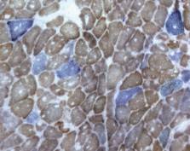

**B 1 kb**

**Control**

**Patient**

**kb**

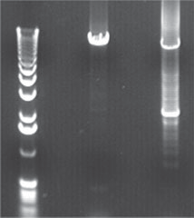

- **9**

**multiple mtDNA deletions**

Dual COX/SDH histochemistry revealed that 21.2% of the remaining SN neurones were COX-deficient (Figure 2**D**). This level of COX deficiency is higher than the levels recently observed in the SN of ageing controls (1%) and PD patients (3%) [2]. Immu- nohistochemistry for the mtDNA-encoded COX subunit I revealed deficiency in individual nigral neurones (Figure 2**E**), while all nigral neurones showed normal activity for porin, a transmembrane mitochondrial protein used as a reference marker for mitochondrial mass (Figure 2**F**). From the remaining SN neurones, five pooled, single neurones were laser-microdissected and mtDNA deletion load was assessed using a previously multiplex real-time PCR [9]. The results confirmed high levels of mtDNA deletions in the SN neurones (*~*65%, *n =* 5).

Parkinsonism has been previously described in PEO patients with mtDNA deletions [5], as has severe neuronal loss from the SN in patients with multiple mtDNA deletion disorders [10,11]. However, we believe this to be the first report of LB pathology in a patient with Parkinsonism, PEO and multiple mtDNA deletions, secondary to a *POLG1*

**Figure 1.** Histochemical and mtDNA analyses. (**A**) Dual histochemistry for the mtDNA-encoded cytochrome *c* oxidase (COX) and the nDNA-encoded succinate dehydrogenase (SDH) on the patient’s muscle biopsy demonstrates COX-deficient ragged-red fibres (blue) and muscle fibres expressing both COX and SDH (brown). Some freezing artefact is apparent in this muscle sample, but the mitochondrial abnormality is clearly apparent;

bar *=* 40 *m*m. (**B**) Long-range PCR (10 kb amplimer) amplification of skeletal muscle DNA extracted from a tissue homogenate. Lane 1, 1-kb ladder; lane 2, age-matched control muscle; lane 3, patient muscle clearly revealing multiple mtDNA deletions in addition to the full-length, wild-type molecule.

pattern is similar, but not identical, to that seen in idio- pathic PD with cognitive impairment, as those patients usually show more neurone loss and *a*-synuclein pathol- ogy in the locus coeruleus, the medullary dorsal nucleus of vagus and reticular formation, the nucleus of Meynert, the limbic system and the neocortex [8]. Unlike PD patients but similar to patients with mitochondrial disease, the gracile fascicle in the cervical spinal cord showed myelin loss (Figure 2**C**) and the gracile nucleus in the lower medulla showed neurone loss and degeneration with microvacuolation of the neuropil. The Alzheimer- type pathology was minimal – scattered neurofibrillary tangles restricted to the parahippocampal gyrus (Braak stage 0) and no neuritic or amyloid plaques.

mutation. Here, additional single-cell studies are required to examine whether the LB pathology is specifically asso- ciated with high levels of mtDNA deletions within indi- vidual nigral neurones, or whether these represent a coincidental pathology in a patient with mitochondrial disease. Alpha-synuclein-defined Lewy pathology may occur in neurologically impaired individuals and normal aged individuals [12,13]. However, as our patient was younger (59 years old) than the individuals previously described, we do not believe that the observed LB pathol- ogy is merely age-related. In addition, our patient demon- strated Parkinsonism and signs of cognitive decline. Interestingly, in a separate study of two patients with autosomal dominant PEO and Parkinsonism, neurofibril- lary tangles and plaques suggestive of the early stages of Alzheimer’s disease were identified in one of the individu- als who died at the age of 60 years [3]. The authors specu- lated that high levels of mtDNA deletions present in that patient may have caused premature ageing and the earlier onset of AD, which usually occurs at a more advanced age. Similarly, we believe that our finding of alpha- synuclein immunoreactive LB-PD pathology associated with mtDNA deletions strengthens the suggestion that somatic mtDNA mutations contribute to the selective neuronal involvement observed in brain ageing and in ageing-related diseases [2,14].

© 2009 Blackwell Publishing Ltd, *Neuropathology and Applied Neurobiology,* **35**, 120–124

13652990, 2009, 1, Downloaded from https://onlinelibrary.wiley.com/doi/10.1111/j.1365-2990.2008.00981.x by The University Of Manchester, Wiley Online Library on [22/05/2025]. See the Terms and Conditions (https://onlinelibrary.wiley.com/terms-and-conditions) on Wiley Online Library for rules of use; OA articles are governed by the applicable Creative Commons License

13652990, 2009, 1, Downloaded from https://onlinelibrary.wiley.com/doi/10.1111/j.1365-2990.2008.00981.x by The University Of Manchester, Wiley Online Library on [22/05/2025]. See the Terms and Conditions (https://onlinelibrary.wiley.com/terms-and-conditions) on Wiley Online Library for rules of use; OA articles are governed by the applicable Creative Commons License

122

*Scientific correspondence*

© 2009 Blackwell Publishing Ltd, *Neuropathology and Applied Neurobiology,* **35**, 120–124

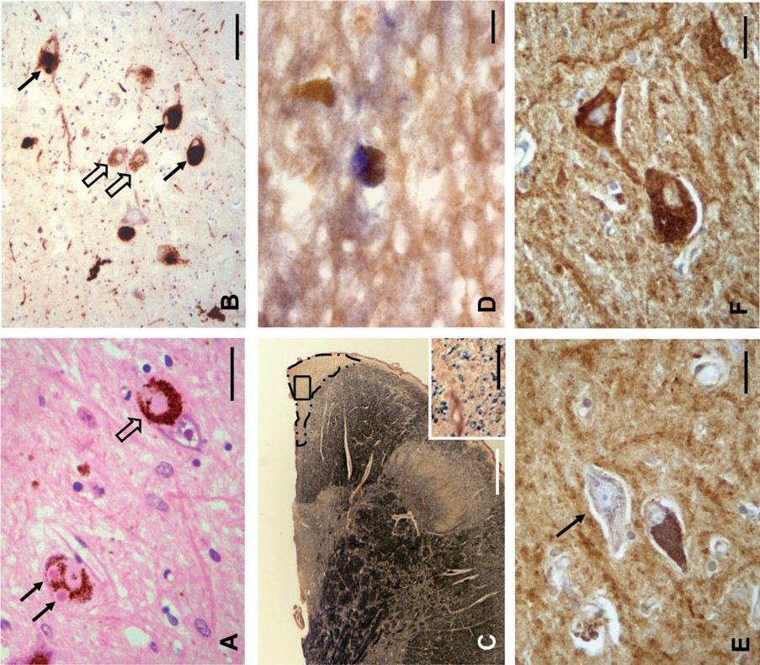

*Scientific correspondence* 123

**Figure 2.** Neurohistology and immunohistochemistry (IHC). (**A**) Lewy bodies (filled-in arrow) and pale body (empty arrow) in surviving substantia nigra neurones; haematoxylin and eosin; bar *=* 30 *m*m. (**B**) Neuronal perikaryal inclusions – solid (arrows) or finely granular (empty arrows) in surviving substantia nigra neurones and neurites in neuropil; alpha-synuclein IHC (Table 1); bar *=* 80 *m*m. (**C**) Myelin loss in the gracile fasciculus of the cervical spinal cord (outlined by dashed/dotted line); bar *=* 850 *m*m; insert, higher magnification of area boxed in main picture; Loyez myelin stain; bar *=* 80 *m*m. (**D**) Dual cytochrome *c* oxidase (COX)/succinate dehydrogenase (SDH) histochemistry on substantia nigra demonstrating neurones that are COX-deficient (blue) or expressing both COX and succinate dehydrogenase (brown); bar *=* 20 *m*m. (**E**) Substantia nigra shows neurones deficient in the mtDNA-encoded subunit I of COX (arrow); COX I IHC (Table 1); bar *=* 80 *m*m. (**F**) All nigral neurones show normal activity for porin, the transmembrane mitochondrial protein used as a reference marker for mitochondrial mass; porin IHC (Table 1); bar *=* 80 *m*m.

**Table 1.** Immunohistochemistry, antibodies, antigen retrieval and detection system

|  |  |  |  |  |
| --- | --- | --- | --- | --- |
| *Antibody* | *Manufacturer (clone)* | *Dilution* | *Antigen retrieval* | *Detection system* |
| *a*-Synuclein | Novocastra (KM51) | 1:30 | 100% FA 15 min & H-T-P (1) EDTA | Vectastain Elite |
|  |  |  |  | ABC-peroxidase |
| Complex IV – subunit I (*=* COX I) | Molecular probes (1D6-E1-A8) | 1:200 | H-T-P (5) EDTA | kit & DAB & H |
| Porin | Molecular probes (31HL) | 1:400 | H-T-P (5) EDTA |  |

COX, cytochrome *c* oxidase; DAB, diaminobenzidine; EDTA, 0.1 M ethylene diamine tetra-acetic acid pH 8.0; FA, formic acid; H, haematoxylin counterstain; H-T-P, high temperature and pressure (1 or 5 min at 15 ppi in pressure cooker).

# Acknowledgements

This work was supported by the Wellcome Trust.

**J. Betts-Henderson\***

**E. Jaros†‡**

**K. J. Krishnan\***

**R. H. Perry†‡**

**A. K. Reeve\***

**A. M. Schaefer\***

**R. W. Taylor\***

**D. M. Turnbull\***

*\*Mitochondrial Research Group and †Institute for Ageing and Health, Newcastle University, and ‡Division of Neuropathology, Cellular Pathology, Newcastle upon Tyne Hospitals NHS Trust,*

*Newcastle upon Tyne, UK*

# References

1. Corral-Debrinski M, Horton T, Lott MT, Shoffner JM, McKee AC, Beal MR, Graham BH, Wallace DC. Mitochon- drial DNA deletions in human brain: regional variability and increase with advanced age. *Nat Genet* 1992; **4**: 324–9
2. Bender A, Krishnan KJ, Morris CM, Taylor GA, Reeve AK, Perry RH, Jaros E, Hersheson JS, Betts J, Klopstock T, Taylor RW, Turnbull DM. High levels of mitochondrial DNA deletions in substantia nigra neurons in aging and Parkinson disease. *Nat Genet* 2006; **38**: 515–17
3. Melberg A, Nennesmo I, Moslemi AR, Kollberg G, Luoma P, Suomalainen A, Holme E, Oldfors A. Alzheimer pathol- ogy associated with POLG1 mutation, multiple mtDNA

deletions, and APOE4/4: premature ageing or just coin- cidence? *Acta Neuropathol (Berl)* 2005; **110**: 315–16

1. Kraytsberg Y, Kudryavtseva E, McKee AC, Geula C, Kowall NW, Khrapko K. Mitochondrial DNA deletions are abundant and cause functional impairment in aged human substantia nigra neurons. *Nat Genet* 2006; **38**: 518–20
2. Hudson G, Chinnery PF. Mitochondrial DNA polymerase- *g* and human disease. *Human Mol Genet* 2006; **15**: R244–52
3. Horvath R, Hudson G, Ferrari G, Futterer N, Ahola S, Lamantea E, Prokisch H, Lochmuller H, McFarland R, Ramesh V, Klopstock T, Freisinger P, Salvi F, Mayr JA, Santer R, Tesarova M, Zeman J, Udd B, Taylor RW, Turn- bull DM, Hanna M, Fialho D, Zeviani M, Chinnery PF. Phenotypic spectrum associated with mutations of the mitochondrial polymerase gamma gene. *Brain* 2006; **129**: 1674–84
4. Agostino A, Valletta L, Chinnery PF, Ferrari G, Carrara F, Taylor RW, Schaefer AM, Turnbull DM, Tiranti V, Zeviani

M. Mutations of ANT1, Twinkle, and POLG1 in sporadic progressive external ophthalmoplegia (PEO). *Neurology* 2003; **60**: 1354–6

1. Braak H, Ghebremedhin E, Rub U, Bratzke H, Del Tredici

K. Stages in the development of Parkinson’s disease- related pathology. *Cell Tissue Res* 2004; **318**: 121–34

1. Krishnan KJ, Bender A, Taylor RW, Turnbull DM. A mul- tiplex real-time PCR method to detect and quantify mito- chondrial DNA deletions in individual cells. *Anal Biochem* 2007; **370**: 127–9
2. Luoma P, Melberg A, Rinne JO, Kaukonen JA, Nupponen NN, Chalmers RM, Oldfors A, Rautakorpi I, Peltonen L, Majamaa K, Somer H, Suomalainen A. Parkinsonism, premature menopause, and mitochondrial DNA

© 2009 Blackwell Publishing Ltd, *Neuropathology and Applied Neurobiology,* **35**, 120–124

13652990, 2009, 1, Downloaded from https://onlinelibrary.wiley.com/doi/10.1111/j.1365-2990.2008.00981.x by The University Of Manchester, Wiley Online Library on [22/05/2025]. See the Terms and Conditions (https://onlinelibrary.wiley.com/terms-and-conditions) on Wiley Online Library for rules of use; OA articles are governed by the applicable Creative Commons License

124 *Scientific correspondence*

polymerase gamma mutations: clinical and molecular genetic study. *Lancet* 2004; **364**: 875–82

1. Cottrell DA, Ince PG, Blakely EL, Johnson MA, Chinnery PF, Hanna M, Turnbull DM. Neuropathological and his- tochemical changes in a multiple mitochondrial DNA deletion disorder. *J Neuropathol Exp Neurol* 2000; **59**: 621–7
2. Neuropathology Group, Medical Research Council Cogni- tive Function and Ageing Study. Pathological correlates of late-onset dementia in a multicentre, community- based population in England and Wales. *Lancet* 2001; **357**: 169–75
3. Parkkinen L, Kauppinen T, Pirttila T, Autere JM, Alafuzoff I. Alpha-synuclein pathology does not predict extrapyramidal symptoms or dementia. *Ann Neurol* 2005; **57**: 82–91
4. Trifunovic A, Wredenberg A, Falkenberg M, Spelbrink JN, Rovio AT, Bruder CE, Bohlooly YM, Gidlöf S, Oldfors A, Wibom R, Tornell J, Jacobs HT, Larsson NG. Premature ageing in mice expressing defective mitochondrial DNA polymerase. *Nature* 2004; **429**: 417–23

*Received 28 February 2008*

*Accepted after revision 23 July 2008*

13652990, 2009, 1, Downloaded from https://onlinelibrary.wiley.com/doi/10.1111/j.1365-2990.2008.00981.x by The University Of Manchester, Wiley Online Library on [22/05/2025]. See the Terms and Conditions (https://onlinelibrary.wiley.com/terms-and-conditions) on Wiley Online Library for rules of use; OA articles are governed by the applicable Creative Commons License

© 2009 Blackwell Publishing Ltd, *Neuropathology and Applied Neurobiology,* **35**, 120–124