Available online at [www.sciencedirect.com](http://www.sciencedirect.com/)

Digestive and Liver Disease 41 (2009) 494–499

Liver, Pancreas and Biliary Tract

Two novel POLG mutations causing hepatic mitochondrial DNA depletion with recurrent hypoketotic hypoglycaemia and fatal liver dysfunction

B. Bortot a*,*c, E. Barbi b, S. Biffi a*,*d, G. Lunazzi a, R. Bussani e, A. Burlina f,

S. Norbedo b, A. Ventura b, M. Carrozzi a, G.M. Severini a*,*c*,*∗

a *Children’s Neurology and Psychiatry Unit, Institute of Child Health IRCCS, Burlo Garofolo, Via dell’Istria, Trieste, Italy*

b *Department of Pediatrics, University of Trieste, Institute of Child Health IRCCS, Burlo Garofolo, Via dell’Istria, Trieste, Italy*

c *Medical Genetics Unit, Institute of Child Health IRCCS, Burlo Garofolo, Via dell’Istria, Trieste, Italy*

d *Optical Imaging Laboratory, CBM S.c.r.l. AREA SCIENCE PARK, Basovizza - SS 14, km 163.5, Trieste, Italy*

e *Department of Pathologic Anatomy, Ospedale di Cattinara, Strada di Fiume, Trieste, Italy*

f *Division of Metabolic Disorders, Department of Pediatrics, University Hospital, Via Giustiniani, Padua, Italy*

Received 1 August 2008; accepted 13 November 2008

Available online 4 February 2009

**Abstract**

**Background.** Inherited mtDNA depletion syndromes (MDS) are a group of severe mitochondrial disorders resulting from defects in nucleus-encoded factors and often associated with severe or fatal liver failure.

**Patient.** In this article, we describe the case of an 18-month-old patient with recurrent hypoketotic hypoglycaemia and fatal hepatic dysfunction with liver mtDNA depletion.

**Methods.** The assessment of mtDNA copy number was performed on leucocytes, liver and muscle biopsy by Quantitative Real Time PCR and total RNA from liver biopsy was used as a template to amplify the cDNA of the POLG1 gene.

**Results.** Sequence analysis identified two previously undescribed mutations (1868T>G and 2263A>G) located in the gene coding the catalytic subunit of mitochondrial DNA polymerase 'Y (POLG), predicting an L623W and K755E amino acid change, respectively. Both mutations were located in the highly conserved linker region of the protein and were absent in more than 200 healthy unrelated control subjects. The identification of these two mutations allowed us to perform genetic counselling and prenatal diagnosis.

**Conclusion.** Our data further expand the spectrum of POLG1 gene mutations and the unique phenotype reported (late onset isolated liver disease without lactic acidosis) increase the variability of clinical presentations associated with mutations in this gene.

© 2008 Editrice Gastroenterologica Italiana S.r.l. Published by Elsevier Ltd. All rights reserved.

*Keywords:* DNA polymerase gamma; Late onset; Liver failure; mtDNA depletion syndrome

# Introduction

mtDNA depletion syndromes (MDS) are a group of severe mitochondrial disorders usually presenting in infancy or childhood, due to tissue-specific reduction of the mtDNA

∗ Corresponding author at: Neuromuscular Disorders Laboratory, Child Neurology and Psychiatry Unit, Institute of Child Health IRCCS, Burlo Garofolo, Via dell’Istria, Trieste, Italy. Tel.: +39 040 3785423;

fax: +39 040 3785210.

*E-mail address:* [severini@burlo.trieste.it](mailto:severini@burlo.trieste.it) (G.M. Severini).

copy number. MDS is phenotypically heterogeneous, man- ifesting either as a hepatocerebral, encephalomyopathic or myopathic form [1]. All these syndromes result from defects in nucleus-encoded factors and are mostly inherited as autosomal recessive traits [2]. The hepatocerebral form is probably the most common variant of MDS, characterized by an infantile onset of acute liver failure and associated with lethargy, hypotonia, vomiting, seizures and hypoglycaemia [3,4].

Three genes have been identified as major cause of this MDS form: DGUOK [5,6], which encodes the deoxyguano-

1590-8658/$30 © 2008 Editrice Gastroenterologica Italiana S.r.l. Published by Elsevier Ltd. All rights reserved. doi:[10.1016/j.dld.2008.11.013](http://dx.doi.org/10.1016/j.dld.2008.11.013)

sine kinase (dGK) that, together with TK2, maintains the supply of dNTPs for mtDNA synthesis [2]; MPV17 encod- ing a mitochondrial inner membrane protein of unknown function that seems to be involved in the mtDNA mainte- nance and regulation of protein OXPHOS [7,8]; and POLG1, the gene encoding the catalytic subunit of mitochondrial DNA polymerase [9,10]. POLG1 is a major disease gene in mitochondrial disorders [11]. Mutations in this gene can be associated with depletion but also with multiple dele- tions or point mutations of mitochondrial DNA [12]. This genetic complexity is associated with an extremely heteroge- neous clinical presentation, with an overlapping phenotypic spectrum ranging from severe and fatal childhood hepatoen- cephalopathy to late-onset external ophthalmoplegia, ataxia, myopathy and epilepsy [4,13,14].

Here, we describe the case of an 18-month-old patient with recurrent hypoketotic hypoglycaemia and fatal liver dysfunc- tion with tissue-specific mtDNA depletion due to mutations in the POLG1 gene.

# Case report

An 18-month-old boy – the second child to healthy unre- lated parents – was referred for a history of hypoketotic hypoglycaemia. He was born at term and his history was unremarkable until 18 months of age, when he was admitted for the first time to the local hospital due to an episode of lethargy which happened late in the morning. The child had not had any breakfast. Glycaemia was 19 mg/dl with a mild ketonuria (1 + at a Combur test urine stix).

Laboratory tests showed raised levels of transaminase, alterations of coagulation and metabolic acidosis (see Table 1). Serological testing for parvovirus, hepatitis B, C, A, cytomegalovirus and Ebstein-Barr virus was negative. He recovered in a few days, clinical conditions were appar- ently normal so he was discharged with a program of further tests and follow-up. Fundamental developmental milestones appeared normally acquired, even though a Brunette-Lezine test showed a psychomotor delay (QS 79).

After one month, he was admitted again for hypogly- caemia (28 mg/dl) associated with lethargy and hypotonia. He was treated with intravenous glucose and was referred to our clinic. Again on that occasion, ketones levels were low in urine (1 + at Combur stix) and within normal range in blood (2.5 mg/dl).

On admission, physical examination showed a lethargic and hypotonic child; all the standard haematological analy- ses were performed (see Table 1). His weight was 8.5 kg (<3rd centile), height was 75 cm (<3rd centile). An ultrasound scan of the abdomen showed an unhomogeneous and hypereco- genic liver with normal intra- and extrahepatic biliary ducts, normal gall-bladder and spleen.

ECG and echocardiogram were normal. Repeat surface EEG recordings were performed according to the Interna- tional 10–20 System during wakefulness, drowsiness and

Table 1

Hematochemical examinations.

|  |  |  |  |
| --- | --- | --- | --- |
|  | 1st admission | 2nd admission | Normal range |
| *Liver function tests*  AST | 751 U/i | 561 U/I | 10–34 U/i |
| ALT | 239 U/i | 330 U/i | 10–44 U/i |
| LDH | 1011 U/i | 927 U/i | 155–280 U/i |
| Total bilirubin | 0.88 mg/dl | 0.77 mg/dl | 0.2–1.0 mg/dl |
| Direct bilirubin | 0.48 mg/dl | 0.39 mg/dl | 0.0–0.2 mg/dl |
| *Coagulation tests*  INR | 1.3 | 1.45 | 0.81–1.20 |
| APTT | 2.96 | 1.41 | 0.77–1.22 |
| Fib | 213 mg/dl | 124 mg/dl | 202–502 mg/dl |
| AT III | 59% | 62% | 87–127% |
| *Haemogasanalysis*  PH | 7.32 | 7.28 | 7.35 |
| pCO2 | 25.7 mmHg | 33.0 mmHg | 35–45 mmHg |
| HCO3 | 13.1 mEq/l | 15.2 mEq/l | 22–26 mEq/l |

*Analysis with normal results (1st and 2nd admission)*

Erythrocyte sedimentation rate, C reactive protein, Electrolytes, Albumin, Creatin phosphokinase, Immunoglobulins, Ammonia, Lactic acid, Insulin, Cortisolemia, Cholinesterase, Ceruloplasmin, Autoantibodies (LKM, LC1, SMA), Acylcarnitine, Amino acid, Organic acid.

LKM, anti-liver kidney microsomal antibodies; LC1, anti-liver cytosolic antigen type 1 antibodies; SMA, anti-smooth muscle antibodies.

sleep which demonstrated slowing and high amplitude of background activity (3–4 Hz) more evident on the right hemi- sphere, lacking clear epileptiform abnormalities. A liver biopsy was performed (see Section 4) and genetic testing for mitochondrial disease was started at the Neuromuscular Disorders Laboratory of our Institute.

He was treated with intravenous glucose, fresh plasma and enteral feeding with progressive improvement up to a normal standard of behaviour and muscular tone without neurological abnormalities. An apparent slow trend towards normalization of liver function tests was present and he was therefore discharged on nocturnal enteral feeding while wait- ing for the missing laboratory tests. After a few days he was readmitted for hypoglycaemia during acute diarrhoea with fever. Laboratory tests showed a rotavirus infection with liver failure. His conditions progressively worsened and the patient died.

# Materials and methods

Respiratory chain enzymes were studied by spectropho- tometric assays performed on supernatants obtained from muscle and liver homogenates, as previously described [15]. Total DNA was isolated from peripheral blood lympho- cytes, liver and muscle biopsy by proteinase K digestion followed by standard phenol-chloroform extraction and

ethanol precipitation [16].

The presence of large-scale mtDNA rearrangements was investigated through an amplification of the complete mito- chondrial genome (16.6 kb) using the GeneAmp XL PCR kit (Applied Biosystems, Foster City, CA, USA) with primers

located in essential regions of the mitochondrial genome itself [17]. Screening for mtDNA point mutations was performed by amplifying the entire mtDNA in 10 partially overlapping PCR fragments, which were then analysed with 96 sequences using the sequencing kit ABI PRISM dye terminator cycle and the automatic sequencing system Applied Biosystems 3100 (Applied Biosystems, Foster City, CA, USA) following standard procedures.

The measure of mtDNA copy number was performed on leucocytes, liver and muscle biopsy by Quantitative Real Time PCR (qRT-PCR) based on SYBR-Green I fluorescence. In this analysis, the amount of mtDNA was compared with the amount of the nuclear gene encoding the �-globin gene, contained in the same sample. The fluorescent signal inten- sities were recorded and analysed during PCR in an ABI Prism 7700 sequence detector system (Applied Biosystems), equipped with the 7700 Sequence Detection System Soft- ware, Ver. 1.7 [18]. The mtDNA/�-globin gene DNA ratio obtained in the patient’s samples was expressed as a percent- age of the mean value obtained in control samples, which represent the 100% value.

Total RNA from liver biopsy was used as a template to amplify the cDNA of the POLG1 gene. DNA obtained from lymphocytes was used to confirm mutations identified in the cDNA. For prenatal diagnosis, total DNA was extracted from amniotic cells.

All PCR fragments were analysed using the sequencing kit ABI PRISM dye terminator cycle and the automatic sequenc- ing system Applied Biosystems 3100 (Applied Biosystems, Foster City, CA, USA).

# Results

Histopathological examination of liver biopsy showed macro (10%) and microvesicular (10%) steatoses and some hepatocytes with intracytoplasmic microvesicles, hyper- plasia of Kupffer cells, portal and periportal fibrosis (Fig. 1).

Biochemical studies of liver homogenate showed low activities (30% of the control values) of the mitochondrial- coded complexes I+II (NADH-cytochrome *c* reductase rotenone-sensitive) and I+III (succinate-cytochrome *c* reduc- tase). Cytochrome *c* oxidase activity was not detectable, while the nuclear-coded subunits, namely complex I (NADH dehydrogenase), II (succinate dehydrogenase) and citrate synthase, showed activity within the normal range. The studies performed on muscle homogenate showed only a reduction of the mitochondrial-coded I+III complex (70% of the control values), while the other enzymatic activities were within the normal range. This biochemical pattern suggested a mitochondrial DNA depletion.

XL-PCR amplification of mtDNA did not reveal any deletions in liver or muscle and sequencing of the entire mitochondrial genome in the liver DNA did not reveal any pathogenic mutations. The results of qRT-PCR showed a

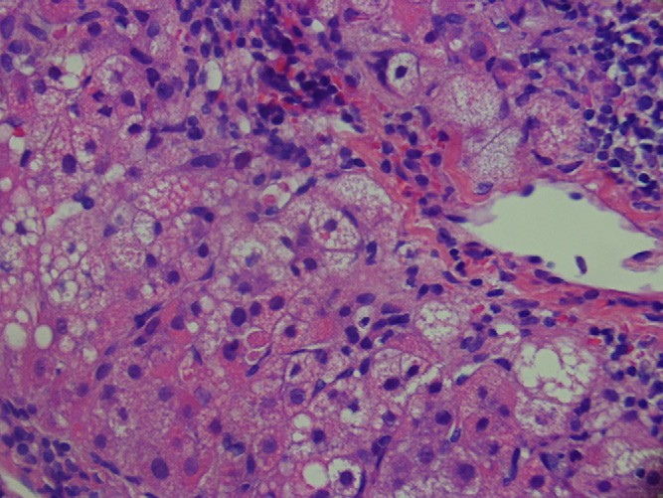

Fig. 1. Diffuse steatosis of hepatocytes and Kupffer cells. Moderate cellular infiltrate composed of mononuclear cells and plasma cells. Liver cells have foamy cytoplasm (H&E, 40×).

reduction of the mtDNA/�-globin gene DNA ratio of 63% in different determinations of the patient’s postmortem frozen liver sample, compared with similar specimens from three age-matched control individuals, as suggested by Morten et al. [19]. mtDNA copy number in blood and muscle biopsy were within the normal range but closed to the lower value. Mutations in the dGK, TK2, and MPV17 genes, which are known to be responsible for a number of cases of mtDNA depletion syndromes (MDS) [5,7,20,9,4], were first excluded. After that – as several authors identified POLG1 mutations causing Alpers’ hepatopathic poliodys- trophy (Alpers-Huttenlocher syndrome) [2,4,12,21] – we decide to investigate the POLG1 gene also in our patient.

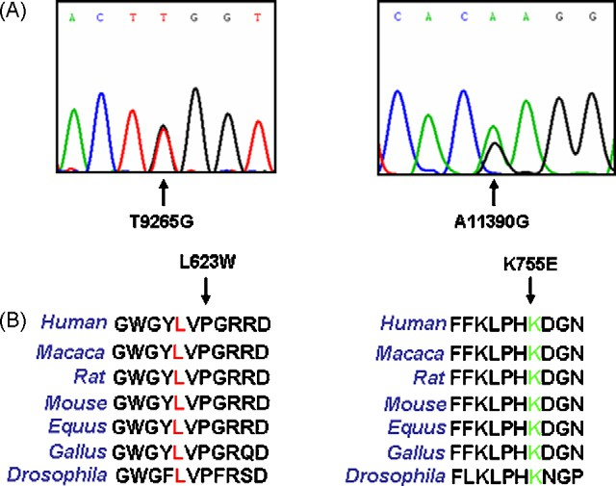

Fig. 2. (A) Sequence analysis showing the presence of the T9256G and the A11390G mutations in POLG gene. (B) Aminoacidic sequence comparison of both mutations in different species, demonstrating that amino acids 623 and 755 are highly conserved in mammals and drosophila.

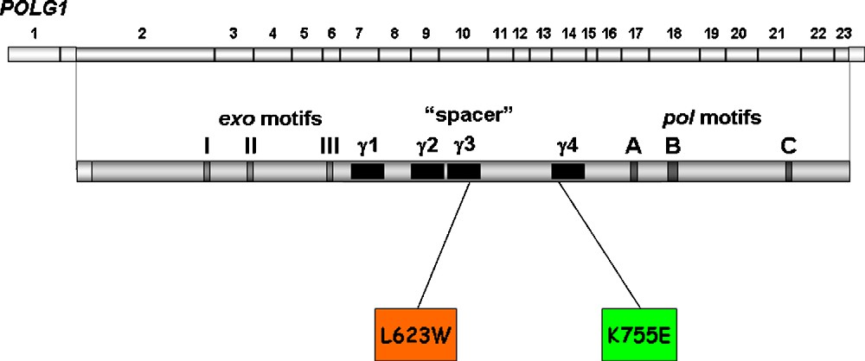

Fig. 3. A Human POLG1 cDNA showing the 22 coding exons (2–23) (A) and the corresponding POLG-a primary sequence of 1239 amino acids (B). Vertical grey bars represent highly conserved exonuclease and polymerase motifs in the family-A polymerases. The black boxes indicate the location of the four conserved spacer-region blocks 'Y1–'Y4 (within amino acid boundaries 441–829). The substitutions identified in this report are indicated with the orange and the green boxes and located in the 'Y3 and 'Y4 spacer region blocks.

The analysis performed on cDNA (4465 bp) – and confirmed on genomic DNA – demonstrated that the patient was a compound heterozygote for a (maternal) 1868T>G mutation (exon 10 of the POLG1 gene) predicting an L623W amino acid change, and a (paternal) 2263A>G mutation (exon 13 of the POLG1 gene) predicting a K755E amino acid change (Fig. 2A). Both mutations had never been previously reported and were absent in more than 200 healthy unrelated control subjects. L623W and K755E amino acid changes are located in the ‘linker’ region (spacer) between the N-terminal proof- reading domain and the C-terminal polymerase domain of the protein (Fig. 3).

Moreover, interspecies comparison demonstrates that L623 and K755 residues are highly conserved in vertebrates and in *Drosophila Melanogaster* (Fig. 2B).

After one year, the mother reported being pregnant of another baby and a prenatal diagnostic procedure, starting from nuclear DNA isolated from amniotic fluid cells, was car- ried out. The new foetus tested heterozygote for the maternal mutation while the paternal allele was normal. He was deliv- ered uneventfully and is now a healthy baby of 16 months of age (Fig. 4).

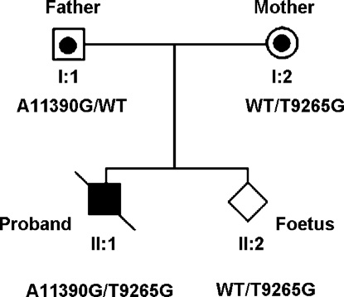

Fig. 4. Pedigree of family harbouring the newly identified mutations.

# Discussion

Mitochondrial disorders are often associated with liver dysfunction because of the high mitochondrial density in hepatocyte and the need for high levels of ATP for its biosyn- thetic and detoxifying functions. In this article, we describe a patient affected by liver mitochondrial DNA depletion with recurrent hypoketotic hypoglycaemia and fatal liver failure. The level of depletion is consistent with that observed in some patients showing a severe neonatal-onset liver involve- ment (liver insufficiency or hepatocellular dysfunction), as described by other authors [22].

While it is well known that hypoketotic hypoglycaemia is a common symptom of beta oxidation deficit, few cases have been reported of mithocondrial DNA depletion with isolated liver disease—i.e. without evident muscle or CNS involve- ment, with a relatively late onset and without lactic acidosis [23–25,10]. As a matter of fact, some cases of Alper’s syn- drome with POLG mutations have already been published, but only few of them emphasize the possibility of a late onset (after one year of age) isolated liver disease. Moreover, to the best of our knowledge, none of these cases presented normal lactic acid levels, as in our patient.

The molecular genetic analysis identified two previously undescribed mutations located in the gene encoding the catalytic subunit (a subunit) of the mitochondrial DNA polymerase 'Y (POLG). These mutations are assumed to be pathogenic because they are not reported as polymor- phic changes, are absent from more than 400 control alleles and can change highly conserved amino acids. The leucine residue at codon 623 is located in a highly conserved region in vertebrates (Fig. 2B) and includes another pathogenic POLG1 mutation, namely R627W [26]. The region con- taining the lysine residue at codon 755 is also conserved in drosophila (Fig. 2B) and includes the pathogenic F749S POLG1 mutation [27].

DNA polymerase 'Y is composed of 2 subunits (a and �) and is necessary for replication and repair of the mtDNA, pre- senting both DNA polymerase and 3∗–5∗ exonuclease activity [28]. The region of POLG-a located between the exonucle- ase and polymerase (“spacer”) has four POLG-a specific sequences ('Y1–'Y4) (Fig. 3) [29] which are highly conserved in species from drosophila to human. The two mutations iden- tified in our patient lead to the amino acids substitutions in the 'Y3 (L623W) and 'Y4 (K755E) region of the POLG-a spacer (Fig. 3).

Up to date – although the almost 30 disease mutations located in the spacer region of the POLG gene [30] have been associated with the most severe clinical manifestations – most of them have not been biochemically characterized yet or linked to a specific phenotype [29]. However, mutagenesis in these conserved blocks ('Y3 and 'Y4) in drosophila protein seems to induce low DNA polymerase activity ('Y3 and 'Y4) and decrease of interaction with POLG-� subunit ('Y4) [31]. The strongest hypothesis during the initial diagnostic work up was that of a possible medium chain Acyl-CoA deficiency (MCAD). The clinical and laboratory picture of MCAD can initially resemble a mitochondrial DNA depletion and MCAD is by far more frequent than mitochondrial DNA depletion. Furthermore, normal lactate levels made unlikely the hypothesis of a mitochondrial DNA depletion. While waiting for the results of the Acyl-CoA tests, the child was put on continuous enteral feeding to avoid hypoglycaemia and further crises. Despite this, he developed severe episodes of hypoglycaemia and liver abnormalities. We believe that in this setting the recurrence of hypoglycaemia without fasting should have strongly induced the suspicion of a mitochondrial DNA depletion. This case is a further warning of the fact that even if this is a rare event it should be taken into account in differential diagnoses. A strong clinical suspicion could have accelerated diagnostic testing, particularly in the per- spective of a possible emergency liver transplant. The issue of liver transplant in mitochondrial DNA depletion has been debated without a definite consensus [24,25,10]. The possi- bility of a multivisceral involvement (muscle, brain, heart) in the forthcoming years is an argument against transplant. In our case, the protracted lethargy accompanying the criti- cal episodes could suggest possible future brain involvement

[4].

Moreover, we retain that this case is relevant also because it adds to the knowledge of two new mutations never reported before in literature, allowing us to perform genetic coun- selling and prenatal diagnosis.

To our knowledge, only two authors have reported prenatal findings that were later confirmed as MDS [22,29]. In the first case, prenatal diagnosis was based on immunocytochemical staining of an mtDNA encoded protein from cultured amnio- cytes and confirmed by the measurement of mtDNA in liver and muscle after birth [32]. However, as measuring mtDNA levels from amniocytes or from chorionic villus is currently not a standard procedure, this approach cannot be considered a valid option for prenatal diagnosis. More recently prenatal

diagnosis starting from nuclear DNA isolated from amniotic fluid has been reported in a family at risk for MDS due to DGK gene mutations [13]. In our case, the identification of defined genetic mutations in the POLG gene allowed us to perform accurate prenatal testing by analyzing amniocytes’ nuclear DNA by PCR and direct sequencing.

As a conclusion, our data further expand the spectrum of POLG1 gene mutations and the unique phenotype reported increase the variability of clinical presentations associated with mutations in this gene. Since an accurate molecular diagnosis is essential for proper genetic counselling and pre- natal diagnostics, we suggest performing POLG1 mutation analysis in children with a variety of clinical aspects of mitochondrial disorders, including those showing late onset isolated liver disease without lactic acidosis.

# Conﬂict of interest statement

We certify that there is no conflict of interest with any finan- cial organization regarding the material discussed in the manuscript.

# Acknowledgment

We would like to thank Mrs. B. Bernato for her linguistic support to the manuscript.

# References

1. Elpeleg O. Inherited mitochondrial DNA depletion. Pediatr Res 2003;54:153–9.
2. Alberio S, Mineri R, Tiranti V, Zeviani M. Depletion of mtDNA: syn- dromes and genes. Mitochondrion 2007;7:6–12.
3. Ferrari G, Lamantea E, Donati A, Filosto M, Briem E, Carrara F, et al. Infantile hepatocerebral syndromes associated with mutations in the mitochondrial DNA polymerase-gamma A. Brain 2005;128: 723–31.
4. Horvath R, Hudson G, Ferrari G, Futterer N, Ahola S, Lamantea E, et al. Phenotypic spectrum associated with mutations of the mitochondrial polymerase gamma gene. Brain 2006;129:1674–84.
5. Mandel H, Szargel R, Labay V, Elpeleg O, Saada A, Shalata A, et al. The deoxyguanosine kinase gene is mutated in individuals with depleted hepatocerebral mitochondrial DNA. Nat Genet 2001;29: 337–41.
6. Freisinger P, Fütterer N, Lankes E, Gempel K, Berger TM, Spalinger J, et al. Hepatocerebral mitochondrial DNA depletion syndrome caused by deoxyguanosine kinase (DGUOK) mutations. Arch Neurol 2006;63:1129–34.
7. Spinazzola A, Viscomi C, Fernandez-Vizarra E, Carrara F, D’Adamo P, Calvo S, et al. MPV17 encodes an inner mitochondrial membrane pro- tein and is mutated in infantile hepatic mitochondrial DNA depletion. Nat Genet 2006;38:576–82.
8. de Vries MC, Rodenburg RJ, Morava E, van Kaauwen EP, ter Laak H, Mullaart RA, et al. Multiple oxidative phosphorylation deficiencies in severe childhood multi-system disorders due to polymerase gamma (POLG1) mutations. Eur J Pediatr 2007;166:229–34.
9. Naviaux RK, Nguyen KV. POLG mutations associated with Alpers syndrome and mitochondrial DNA depletion. Ann Neurol 2004;55:706–12.
10. Lee WS, Sokol RJ. Liver disease in mitochondrial disorders. Semin Liver Dis 2007;27:259–73.
11. Longley MJ, Graziewicz MA, Bienstock RJ, Copeland WC. Con- sequences of mutations in human DNA polymerase gamma. Gene 2005;354:125–31.
12. Nguyen KV, Ostergaard E, Ravn SH, Balslev T, Danielsen ER, Vardag A, et al. POLG mutations in Alpers syndrome. Neurology 2005;65:1493–5.
13. Hudson G, Chinnery PF. Mitochondrial DNA polymerase-gamma and human disease. Hum Mol Genet 2006;15:R244–52.
14. Chinnery PF, Zeviani M. 155th ENMC workshop: polymerase gamma and disorders of mitochondrial DNA synthesis, 21–23 September 2007, Naarden, The Netherlands. Neuromuscul Disord 2008;18:259–67.
15. Rustin P, Chretien D, Bourgeron T, Gerard B, Rotig A, Saudubray JM, et al. Biochemical and molecular investigations in respiratory chain deficiencies. Clin Chim Acta 1994;228:35–51.
16. Remes AM, Majamaa-Voltti K, Kärppä M, Moilanen JS, Uimonen S, Helander H, et al. Prevalence of large-scale mitochondrial DNA deletions in an adult Finnish population. Neurology 2005;64:976–81.
17. Sambrook J, Fritsch EF, Maniatis T. Molecular cloning: A labora- tory manual. 2nd ed. Cold Spring Harbor, NY: Cold Spring Harbor Laboratory Press; 1989.
18. Bai RK, Wong LJ. Detection and quantification of heteroplasmic mutant mitochondrial DNA by real-time amplification refractory mutation sys- tem quantitative PCR analysis: a single-step approach. Clin Chem 2004;50:996–1001.
19. Morten KJ, Ashley N, Wijburg F, Hadzic N, Parr J, Jayawant S, et al. Liver mtDNA content increases during development: a comparison of methods and the importance of age- and tissue-specific controls for the diagnosis of mtDNA depletion. Mitochondrion 2007;7:386–95.
20. Saada A, Shaag A, Mandel H, Nevo Y, Eriksson S, Elpeleg O. Mutant mitochondrial thymidine kinase in mitochondrial DNA deple- tion myopathy. Nat Genet 2001;29:342–4.
21. Davidzon G, Mancuso M, Ferraris S, Quinzii C, Hirano M, Peters HL, et al. POLG mutations and Alpers syndrome. Ann Neurol 2005;57:921–3.
22. Sarzi E, Bourdon A, Chrétien D, Zarhrate M, Corcos J, Slama A, et al. Mitochondrial DNA depletion is a prevalent cause of multi- ple respiratory chain deficiency in childhood. J Pediatr 2007;150: 531–4.
23. Cormier-Daire V, Chretien D, Rustin P, Rötig A, Dubuisson C, Jacquemin E, et al. Neonatal and delayed-onset liver involve- ment in disorders of oxidative phosphorylation. J Pediatr 1997;130: 817–22.
24. Dubern B, Broue P, Dubuisson C, Cormier-Daire V, Habes D, Chardot C, et al. Orthotopic liver transplantation for mitochondrial respiratory chain disorders: a study of 5 children. Transplantation 2001;71:633–7.
25. Rabinowitz SS, Gelfond D, Chen CK, Gloster ES, Whitington PF, Sac- coni S, et al. Hepatocerebral mitochondrial DNA depletion syndrome: clinical and morphologic features of a nuclear gene mutation. J Pediatr Gastroenterol Nutr 2004;38:216–20.
26. Van Goethem G, Mercelis R, Löfgren A, Seneca S, Ceuterick C, Martin JJ, et al. Patient homozygous for a recessive POLG mutation presents with features of MERRF. Neurology 2003;61:1811–3.
27. Nguyen KV, Sharief FS, Chan SS, Copeland WC, Naviaux RK. Molec- ular diagnosis of Alpers syndrome. J Hepatol 2006;45:108–16.
28. Kaguni LS. DNA polymerase gamma, the mitochondrial replicase. Annu Rev Biochem 2004;73:293–320.
29. Luoma PT, Luo N, Löscher WN, Farr CL, Horvath R, Wanschitz J, et al. Functional defects due to spacer-region mutations of human mitochon- drial DNA polymerase in a family with an ataxia-myopathy syndrome. Hum Mol Genet 2005;14:1907–20.
30. NIEHS, Human DNA Polymerase Gamma Mutation Database – Mitochondrial DNA Replication Group, 2008. Available from: <http://dir-apps.niehs.nih.gov/polg/>.
31. Luo N, Kaguni LS. Mutations in the spacer region of Drosophila mito- chondrial DNA polymerase affect DNA binding, processivity, and the balance between Pol and Exo function. J Biol Chem 2005;280:2491–7.
32. Blake JC, Taanman JW, Morris AMM, Gray RG, Cooper JM, McKier- nan PJ, et al. Mitochondrial DNA depletion syndrome is expressed in amniotic fluid cell cultures. Am J Pathol 1999;155:67–70.