Aamir Badruddin, MD Ravi S. Menon, MD Anthony T. Reder, MD

**4-AMINOPYRIDINE TOXICITY MIMICS AUTOIMMUNE-MEDIATED LIMBIC ENCEPHALITIS**

4-Aminopyridine (4-AP) is a potassium channel

blocker which increases motor performance and walking speed in multiple sclerosis (MS) and spinal cord injury.1 It enhances action potentials by block- ing open potassium channels. 4-AP toxicity can cause dizziness, nausea, weakness, psychosis, and seizures.2 In limbic encephalitis, antibodies bind voltage- gated potassium channels (VGKC) and damage pe- ripheral and central neurons.3 VGKC subtypes exist in brain, peripheral nerves, vascular endothelium, and all muscle types.4 We document that severe 4-AP overdose causes significant abulia, cognitive impair- ment, and prominent myopathic changes in heart and skeletal muscle. The temporal lobe MRI signal and clinical presentation have parallels to the seem-

ingly distinct disease, limbic encephalitis.

**Case report.** A 22-year-old man with MS ingested 30 10-mg tablets of 4-AP. He had agitated behavior but was oriented, conversant, and without focal neu- rologic deficits or muscle fibrillations. He had cool, flushed, diaphoretic skin with temperature of 38.9°C. Blood pressure was 209/108 mm Hg, with runs of supraventricular tachycardia to 170 beats per minute. Intubation for airway protection led to in- tensive care unit admission.

EEG exhibited frequent diffuse polyspike and spike-wave discharges that normalized over time. There were no electrographic or clinical seizures. Transthoracic echocardiogram revealed diffuse hypo- kinesis, and an ejection fraction of 24%. CSF fluid on admission and 4 days after overdose had normal cell count, protein, and glucose, but contained CSF oligoclonal bands. Bilateral medial temporal lobe MRI hyperintensity (figure) on T2 and fluid- attenuated inversion recovery did not enhance with gadolinium. His MRI before overdose did not show these signal abnormalities.

Five days after overdose, he was awake with spon- taneous eye opening, but had minimal awareness of the examiner and did not speak. He displayed mini- mal bradykinetic movement to noxious stimuli, and had symmetric 1/5 strength on Ashworth scale. By the ninth day, serum CPK peaked at 494 IU/L. He

produced rare, hypophonic, lucid speech and fol- lowed simple commands. Neuropsychiatric evalua- tion revealed profound memory loss.

A right ventricular endomyocardial biopsy ex- cluded inflammation, fibrosis, or toxic inclusions on day 12. The ejection fraction normalized (57%). Nerve conduction velocities were normal. EMG demonstrated myopathy in multiple myotomes. Muscle biopsy showed mild focal endomysial inflam- mation, with normal blood vessels and muscle architecture.

At 27 days the patient’s affect was brighter, with rare, hypophonic speech; he had 3/5 antigravity limb movement. Over the next 8 weeks, his speech and language returned to normal and he walked indepen- dently. Despite 3 months of cognitive rehabilitation, he had significant anterograde and retrograde mem- ory dysfunction and inefficient cognitive processing, suggesting medial temporal lobe dysfunction. MRI signal abnormalities were no longer present at 4 months.

One year after 4-AP overdose, spontaneous speech, motor and verbal responses, strength, bal- ance, and gait had improved to baseline status. He had difficulty with short-term memory and learning new tasks.

**Discussion.** The cognitive deficits, abulia, and tem- poral lobe lesions on MRI are strikingly similar to findings in patients with HSV or paraneoplastic lim- bic encephalitis.5 Clinical and radiographic findings likely resulted from direct high-dose 4-AP toxicity to CNS neurons and cardiac and skeletal muscle.

An infectious etiology is unlikely. Two CSF stud- ies showed no lymphocytosis; CSF PCR for HSV and viral cultures were negative. Paraneoplastic dis- ease is unlikely because of the acute onset and lack of progression. Morvan disease is unlikely in the ab- sence of neuromyotonia and insidious clinical course, vs the acute onset in this patient.6

VGKC are present in brain and peripheral nerves.6 There are antibodies to VGKC in neuro- myotonia, a PNS disease, as well as in Morvan syn- drome, which involves CNS, peripheral nervous system, and autonomic nerves. VGKC blockage re- duces glucose metabolism in the hippocampus and

Clinical/Scientific Notes

1100 Neurology 72 March 24, 2009

channels could also reverse deficits in autoimmune limbic encephalitis. The similarity between antibody- mediated limbic encephalitis and pharmacologically induced encephalitis suggests that an animal model for reversible limbic encephalitis could be developed using pharmacologic blockade of VGKC.

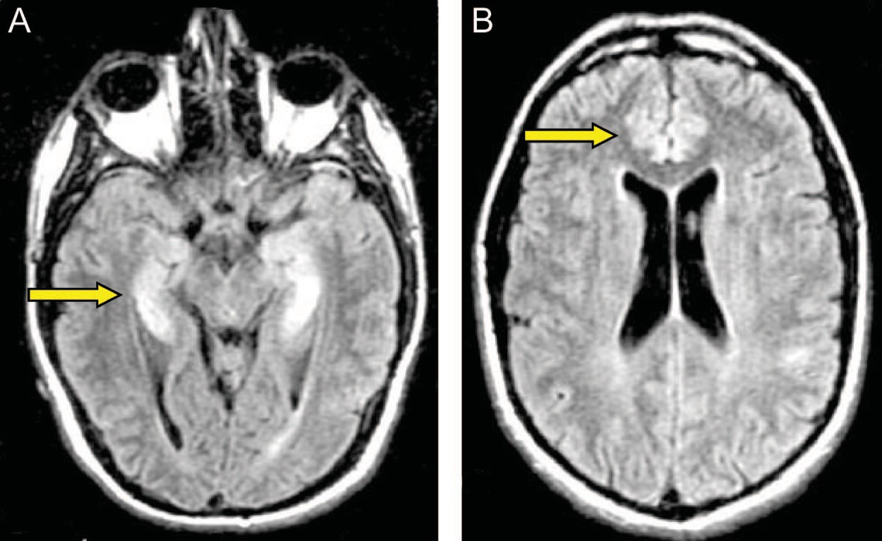

**Figure Sagittal fluid-attenuated inversion recovery MRI demonstrating increased signal intensity in (A) both medial temporal lobes and (B) anterior cingulum**

*From the Department of Neurology, University of Chicago Medical Center, IL.*

*Disclosure: The authors report no disclosures.*

*Presented in part at the 57th annual meeting of the American Acad- emy of Neurology, Miami Beach, FL, April 9 –16, 2005.*

*Received May 20, 2008. Accepted in final form November 20, 2008.*

*Address correspondence and reprint requests to Dr. Anthony Reder, The University of Chicago, Department of Neurology MC-2030, 5841*

*S. Maryland Ave, Chicago, IL 60637;* [*areder@neurology.bsd.*](mailto:areder@neurology.bsd) *uchicago.edu*

Copyright © 2009 by AAN Enterprises, Inc.

Papez circuit, affecting memory and learning.7 In Morvan syndrome and limbic encephalitis, antibod- ies to Kv 1.1, 1.2, and 1.6 in the molecular layer of the dentate gyrus are associated with memory disrup- tion and agitation.5 Blockade of Kv1.1 and other Kv1 subtypes, concentrated in the hippocampus and limbic circuit, is likely in 4-AP-induced limbic en- cephalitis, and it could explain amnesia, bradykine- sia, and impaired visual learning.

Kv1.5 VGKC are present in skeletal muscles and the heart. 4-AP toxicity causes supraventricular tachycardias and atrial fibrillation.2 Here, supraven- tricular tachycardia and severe contractile dysfunc- tion resolved with time. The cardiac dysfunction, clinical weakness, EMG abnormalities, and skeletal muscle findings reflect a reversible toxic myopathy from direct 4-AP toxicity, as there was no history of prolonged muscle disuse or exertion.

Clinical improvement as 4-AP was metabolized suggests that early removal of antibodies to K+

1. Davis FA, Stefoski D, Rush J. Orally administered 4-aminopyridine improves clinical signs in multiple sclero- sis. Ann Neurol 1990;27:186–192.
2. Johnson NC, Morgan MW. An unusual case of 4-aminopyridine toxicity. J Emerg Med 2006;30: 175–177.
3. Vincent A, Buckley C, Schott JM, et al. Potassium channel antibody-associated encephalopathy: a poten- tially immunotherapy-responsive form of limbic en- cephalitis. Brain 2004;127:701–712.
4. Judge SI, Bever CT Jr. Potassium channel blockers in multiple sclerosis: neuronal Kv channels and effects of symptomatic treatment. Pharmacol Ther 2006;111: 224–259.
5. Buckley C, Oger J, Clover L, et al. Potassium channel an- tibodies in two patients with reversible limbic encephalitis. Ann Neurol 2001;50:73–78.
6. Liguori R, Vincent A, Clover L, et al. Morvan’s syndrome: peripheral and central nervous system and cardiac involve- ment with antibodies to voltage-gated potassium channels. Brain 2001;124:2417–2426.
7. Cochran SM, Harvey AL, Pratt JA. Regionally selective alterations in local cerebral glucose utilization evoked by charybdotoxin, a blocker of central voltage-activated K+- channels. Eur J Neurosci 2001;14:1455–1463.

E.C. Klawiter, MD

E. Alvarez III, MD, PhD

J. Xu, PhD

A.R. Paciorkowski, MD

L. Zhu, MD, PhD

B.J. Parks, MD

A.H. Cross, MD

R.T. Naismith, MD

**NMO-IgG DETECTED IN CSF IN SERONEGATIVE NEUROMYELITIS OPTICA**

Neuromyelitis optica (NMO) is an inflammatory

and demyelinating disease characterized by recurrent at- tacks of optic neuritis (ON) and longitudinally exten- sive transverse myelitis (LETM).1 NMO is associated with antibodies against the aquaporin-4 (AQP4) water channel.2 NMO–immunoglobulin G (IgG) predicts a relapsing course and is a supportive criterion for NMO.3-5 The high risk of relapse, sometimes with dev- astating effects, makes early diagnosis important. Early identification permits counseling and consideration for immunosuppressive therapy. The serum NMO-IgG as- say, using indirect immunofluorescence, is 73% sensi-

tive and 91% specific for clinically defined NMO.6 While helpful when positive, the sensitivity is insuffi- cient to exclude the diagnosis. We describe 3 of 26 pa- tients with NMO at our institution with NMO-IgG positivity restricted to CSF.

**Case reports. *Case 1.*** A 25-year-old African Amer- ican woman presented with leg numbness and mild tetraparesis that resolved over 1 month. Two months later, she developed a midthoracic sensory level, again with recovery. The next month, bilat- eral leg weakness impaired her ability to ambulate. MRI (figure, A–C) demonstrated T2 hyperintensi-

Neurology 72 March 24, 2009 1101

Treatment included IV glucocorticoids and ritux- imab with no further exacerbations. After 8 months of disease, Expanded Disability Status Scale (EDSS) was 6.0.

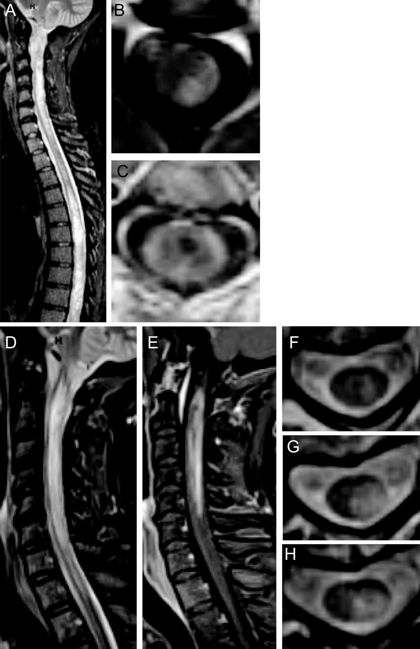

**Figure Neuroimaging of CSF antibody-positive neuromyelitis optica**

***Case 2.*** A 43 year-old African American woman presented with right-sided weakness and numbness. MRI demonstrated longitudinally extensive T2H with enhancement from the lower medulla through C6. Brain MRI was nondiagnostic. Serum NMO- IgG was negative. She recovered after IV glucocorti- coids. Four months later, she developed right-sided weakness, left-sided numbness, and difficulty ambu- lating. Cervical spine MRI (figure, D and E) showed increased T2H with enhancement. VEPs were nor- mal. Repeat serum NMO-IgG was negative. CSF NMO-IgG was positive with 1:8 titer. CSF IgG in- dex was 0.76, IgG synthesis rate was 6.5, with 6 leu- kocytes/µL. OCBs and albumin index were normal. Serum ANA was negative. Treatment has included monthly IV glucocorticoids with no exacerbations. EDSS after 5 months of disease was 2.0.

***Case 3.*** A 49-year-old white woman presented with left upper extremity paresthesias and clumsi- ness. This improved, but was followed 2 months later by ascending bilateral numbness and weakness requiring a walker. MRI (figure, F–H) demonstrated enhancing expansile T2 hyperintensity spanning C2–C5. Brain MRI and VEPs were normal. She im- proved with IV glucocorticoids. NMO-IgG was neg- ative in serum, but positive in CSF. Other CSF parameters were normal. Serum ANA was 1:320. Azathioprine was started, with no further exacerba- tions. After 2 years of disease, EDSS was 2.0.

Case 1: Sagittal T2-weighted STIR MRI (A) shows hyperintensity throughout the cervi- cal and thoracic spinal cord. Axial T1-weighted postgadolinium MRI at the level C2 (B) shows dorsal enhancement and at level C2–3 (C) shows peripheral enhancement and a central T1-weighted hypointensity. Case 2: Sagittal T2-weighted STIR MRI (D) shows hyperintensity from the lower medulla caudally with enhancement on T1-weighted post- gadolinium MRI (E). Case 3: Axial T2-weighted MRI at successive levels C2 (F), C3 (G), and C4 (H) show central gray matter involvement.

ties (T2H) and patchy enhancement spanning the medulla through C7 and T2–T11. Brain MRI re- vealed a single nonspecific T2H. Visual evoked potentials (VEPs) were normal. Serum NMO-IgG was negative but CSF NMO-IgG was positive. IgG index was elevated to 0.79, CSF leukocytes were 24/µL, but albumin index, IgG synthesis, and oligoclonal bands (OCBs) were normal. Se- rum antinuclear antibodies (ANA) were negative.

**Discussion.** We report three cases of NMO spec- trum disorder with restriction of NMO-IgG posi- tivity to the CSF. The cases presented with rapidly relapsing LETM, and a normal or nondiagnostic brain MRI. While none showed evidence for ON, these individuals have been followed less than 2 years. In each case, the second relapse was severe and disabling, occurring within months of onset. In each patient, serum NMO-IgG testing was neg- ative at a 1:120 dilution and simultaneous CSF NMO-IgG was positive during an exacerbation, before administration of corticosteroids. Antibody testing was performed by the same laboratory (Mayo Medical Laboratories). The cause of NMO-IgG seronegativity in these three CSF- positive patients is unknown. The presence of a coexisting, interfering antibody may hinder sero- logic interpretation. However, only case 3 was noted to have coexisting ANA. The CSF albumin indices indicated intact blood– brain barriers.

1102 Neurology 72 March 24, 2009

Serum testing for NMO-IgG remains the stan- dard test for confirming a diagnosis of relapsing NMO spectrum disorder. In our three seronega- tive cases of relapsing LETM, detection of NMO- IgG in the CSF confirmed the diagnosis of an NMO spectrum disorder, and mandated initiation of immunosuppressive therapies. The potential value of early treatment emphasizes the impor- tance of making the correct diagnosis.7 If NMO is strongly suspected and serum NMO-IgG is nega- tive, measurement of CSF NMO-IgG is recom- mended and may add to the overall sensitivity of laboratory testing. Clinical scenarios that may warrant supplementary testing of CSF include the following: 1) LETM, 2) relapsing TM, 3) severe and bilateral ON, 4) ON with poor recovery, and

5) rapidly relapsing ON.

CSF studies should not be a substitute for se- rum testing. Larger systematic studies are required to determine the sensitivity and specificity of com- bined serum and CSF testing. Whether distinct clinical characteristics exist for cases with CSF re- stricted NMO-IgG positivity remains to be determined.

*From Washington University, St. Louis, MO.*

*Supported by grant UL1 RR024992 from the National Center for Research Resources (NCRR), a component of the NIH and NIH Roadmap for Medical Research. NIH funding included UL1RR024992 (E.C.K.), K23NS052430-01A1 (R.T.N.), K12RR02324902 (R.T.N.), K24 RR017100 (A.H.C.),*

*CA1012 (A.H.C.); American Academy of Neurology Founda- tion Clinical Research Training Fellowship (E.C.K.); and Na- tional MS Society FG1782A1 (J.X.). Dr. Cross was supported in part by the Manny and Rosalyn Rosenthal–Dr. John L. Trotter Chair in Neuroimmunology.*

*Disclosure: Drs. Klawiter, Alvarez, Xu, Paciorkowski, and Zhu have no disclosures to report. Dr. Parks is a participant in clinical trials for BioMS and Teva Neurosciences. She has received consult- ing fees or speaking honoraria from Biogen Idec, Bayer Healthcare, Teva Neurosciences, and Pfizer/Serono. Dr. Cross has received re- search funding, clinical trial funding, honoraria, or consulting fees from the NIH, National MS Society USA, Consortium of Multiple*

*Sclerosis Centers, Genentech, Inc., Berlex (now Bayer Healthcare), Biogen-Idec, Teva Neuroscience, Acorda Therapeutics, Serono, Pfizer, and BioMS. Dr. Naismith is a participant in clinical trials for Fampridine SR by Acorda Therapeutics. He has received consult- ing fees and speaking honoraria from Bayer Healthcare, Biogen Idec, and Teva Neurosciences. Research funding is through the NIH and National MS Society.*

*The corresponding author takes full responsibility for the data, the anal- yses and interpretation, and the conduct of the research. The cor- responding author has full access to all the data and has the right to publish any and all data, separate and apart from the attitudes of the sponsor. The contents are solely the responsibility of the authors and do not necessarily represent the official view of NCRR or NIH.*

*Received September 29, 2008. Accepted in final form November 25, 2008.*

*Address correspondence and reprint requests to Dr. Eric Klawiter, Neurology, Box 8111, 660 S. Euclid Ave., Washington University, St. Louis, MO 63110;* [*klawitere@neuro.wustl.edu*](mailto:klawitere@neuro.wustl.edu)

Copyright © 2009 by AAN Enterprises, Inc.

1. Wingerchuk DM, Lennon VA, Lucchinetti CF, Pittock SJ, Weinshenker BG. The spectrum of neuromyelitis op- tica. Lancet Neurol 2007;6:805–815.
2. Lennon VA, Kryzer TJ, Pittock SJ, Verkman AS, Hinson SR. IgG marker of optic-spinal multiple sclero- sis binds to the aquaporin-4 water channel. J Exp Med 2005;202:473–477.
3. Weinshenker BG, Wingerchuk DM, Vukusic S, et al. Neuromyelitis optica IgG predicts relapse after longitu- dinally extensive transverse myelitis. Ann Neurol 2006; 59:566–569.
4. Matiello M, Lennon VA, Jacob A, et al. NMO-IgG pre- dicts the outcome of recurrent optic neuritis. Neurology 2008;70:2197–2200.
5. Wingerchuk DM, Lennon VA, Pittock SJ, Lucchinetti CF, Weinshenker BG. Revised diagnostic criteria for neu- romyelitis optica. Neurology 2006;66:1485–1489.
6. Lennon VA, Wingerchuk DM, Kryzer TJ, et al. A se- rum autoantibody marker of neuromyelitis optica: dis- tinction from multiple sclerosis. Lancet 2004;364: 2106–2112.
7. Cree BA, Lamb S, Morgan K, Chen A, Waubant E, Genain C. An open label study of the effects of ritux- imab in neuromyelitis optica. Neurology 2005;64: 1270–1272.

C. Giordano, MD, PhD

H. Powell, BSc

M. Leopizzi, BSc

M. de Curtis, MD

C. Travaglini, BSc

M. Sebastiani, PhD

P. Gallo, MD

R.W. Taylor, PhD

G. d’Amati, MD, PhD

**FATAL CONGENITAL MYOPATHY AND GASTROINTESTINAL PSEUDO-OBSTRUCTION DUE TO *POLG1* MUTATIONS**

Mutations in the gene coding for the catalytic sub- unit of the mitochondrial DNA (mtDNA) polymer- ase 'Y (*POLG1*) are associated with a range of clinical syndromes characterized by secondary mtDNA de- fects, including mtDNA depletion and multiple mtDNA deletions.1 The phenotypic spectrum of *POLG1*-associated disease ranges from fatal childhood encephalopathy with intractable epilepsy and liver fail- ure (Alpers-Huttenlocher syndrome)2 to late-onset clin- ical disease affecting a single organ (for a review, see reference 3). We describe a fatal skeletal and visceral myop-

athy in the neonatal period associated with recessive

*POLG1* mutations.

**Case report.** A newborn boy of healthy nonconsan- guineous parents was delivered at 37 weeks’ gestation by cesarean section. His mother (primipara, 32 years old) had been admitted to our hospital 2 weeks pre- viously because of reduced fetal intrauterine move- ments and polyhydramnios. The child’s birthweight was 2,330 g (<10th percentile), length 47 cm, and head circumference 33.2 cm (25th percentile). He had low-set ears and bilateral clubfoot. Apgar scores were 2, 6, and 7 at 1, 5, and 10 minutes. The child presented with severe hypotonia and generalized

Neurology 72 March 24, 2009 1103

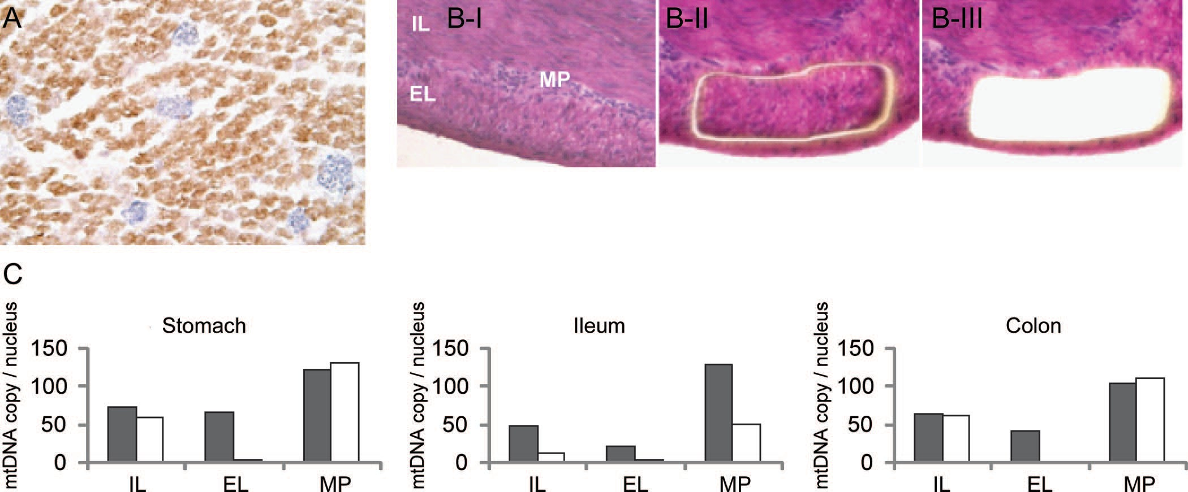

**Figure Morpho-molecular features of skeletal muscle and gastrointestinal tract**

(A) Combined COX/SDH histochemistry on skeletal muscle biopsy showing numerous hypertrophic COX-deficient muscle fibers (blue). (B) Small intestine wall of *POLG1* patient, before (I), during (II), and after (III) laser microdissection of cells from the external layer of muscularis propria. Histologic features are unremarkable. Hematoxylin-eosin, x20. (C) Real-time PCR evaluation of mtDNA amount on microdissected tissue from gastrointestinal wall of patient (white) and one age-matched autopsy control (gray). Data are expressed as the mean value of three repeated measurements. MP = myenteric plexus; IL = internal layer; EL = external layer of muscularis propria.

**Supplemental data at** [**www.neurology.org**](http://www.neurology.org/)

muscle weakness, requiring ventilatory assistance and total parenteral nutrition. Weaning failed because of inadequate pulmonary ventilation and respiratory ac- idosis. Hearing loss was detected by auditory evoked potentials, while cranial MRI showed mildly en- larged ventricles and liquor spaces. Two days after birth, the infant presented with severe abdominal distension with a hypoactive bowel. MRI revealed marked intestinal dilation without mechanical ob- struction. Laboratory investigations showed hypogly- cemia (27 mg/dL), hypomagnesemia (0.58 mmol/L), and hypokalemia (2.4 mmol/L). Blood lactate was normal (1.3 mmol/L, normal range 0.5–2.2 mmol/L) and liver enzymes were unremarkable. A skeletal muscle biopsy was performed and showed scattered, hypertrophic cytochrome *c* oxidase (COX)-deficient and succinate dehydrogenase–positive muscle fibers (figure), suggesting a mitochondrial disorder. Molecular genetic studies revealed marked mtDNA depletion in muscle (93% decrease as compared to age-matched controls), while a screen for mtDNA rearrangements within individual COX-positive and COX-deficient fi- bers4 was negative. We sequenced the entire coding re- gion and intron-exon boundaries of the *POLG1* gene, identifying two reported heterozygous missense muta- tions in compound c.679C>T predicting p.R227W and c.2542G>A predicting p.G848S. Sequencing of parental samples confirmed recessive inheritance.

The infant died at 20 days of respiratory failure. At

autopsy, the brain did not show remarkable changes on gross examination. Histology was not informative due

to poor preservation of tissue; there was no evidence of neuronal damage in the spinal cord. The liver showed diffuse cholestasis, consistent with total parenteral nu- trition; hepatocyte steatosis, necrosis, or liver fibrosis were not observed. The testicles were undescended, while remaining visceral organs were normal except for a marked dilation and thinning of the bowel wall. De- spite normal histology, analysis of stomach, ileum, and colon homogenates revealed severe mtDNA depletion (up to 94% decrease; table e-1 on the *Neurology®* Web site at [www.neurology.org).](http://www.neurology.org/) Laser capture micro- dissection analysis5 revealed that the mtDNA de- pletion was confined to the muscularis propria, being most prominent in its external layer (figure). Ganglion cells from the myenteric plexus showed milder mtDNA depletion, restricted to the small intestine (figure). There was no mtDNA depletion in liver (not shown).

**Discussion.** We describe an infant with a multisystem disorder whose main clinical features were severe skele- tal myopathy and visceral dysmotility. Sequencing of the *POLG1* gene identified compound heterozygous mutations. Both mutations have been reported previ- ously as recessive, although not together; the p.G848S mutation in patients presenting with PEO, Alpers- Huttenlocher syndrome, and a case with encephalopa- thy and stroke-like episodes; the p.R227W mutation in Alpers-Huttenlocher syndrome and sporadic PEO [(http://tools.niehs.nih.gov/polg).](http://tools.niehs.nih.gov/polg))

1104 Neurology 72 March 24, 2009

Children with mutations in *POLG1* typically mani- fest in the first years of life with Alpers-Huttenlocher syndrome2 or a progressive multisystem disorder with- out liver failure. Combined respiratory chain deficiency due to mtDNA depletion in affected tissues is often ob- served.3,6 Our patient showed mild cerebral atrophy, yet typical symptoms of Alpers-Huttenlocher syndrome such as intractable seizures and signs of liver dysfunction were not observed. The prominent feature was a severe muscle weakness, with marked mtDNA depletion and COX-deficient muscle fibers, leading to death from re- spiratory insufficiency. In addition, mtDNA depletion was the likely cause of a visceral myopathy causing hy- poperistalsis and intestinal pseudo-obstruction. The molecular features observed in the gastrointestinal tract parallel those recently reported in another autosomal recessive syndrome, mitochondrial neurogastrointesti- nal encephalomyopathy.5 Based on these findings, the external layer of muscularis propria is confirmed as the most susceptible point of the gastrointestinal tract to develop mtDNA depletion, possibly because of the con- stitutive low abundance of mtDNA within smooth muscle cells at this site.

*From the Dipartimento di Medicina Sperimentale (C.G., M.L., C.T., M.S., P.G., G.d.) and Dipartimento di Ginecologia, Perina- tologia e Puericultura (M.d.C.), Sapienza, Universita` di Roma, Rome, Italy; Northern Regional Genetics Service (H.P.), Institute of Human Genetics, Newcastle upon Tyne; and Mitochondrial Re- search Group (R.W.T.), Newcastle University, Newcastle upon Tyne, UK.*

*Supported by Telethon Grant GGP06233A, Associazione Serena Talarico per i giovani nel mondo, and the Wellcome Trust (UK).*

*Disclosure: The authors report no disclosures. Received August 19, 2008. Accepted in final form December 1, 2008.*

*Address correspondence and reprint requests to Dr. Giulia d’Amati, Department of Experimental Pathology, Sect. of Pathology, Sapienza University, Policlinico Umberto I, Viale Regina Elena 324, 00161 Rome, Italy;* [*giulia.damati@uniroma1.it*](mailto:giulia.damati@uniroma1.it)

Copyright © 2009 by AAN Enterprises, Inc.

**ACKNOWLEDGMENT**

The authors thank Flaminia Calzolari and Paola Repole for assistance with manuscript preparation.

1. Hudson G, Chinnery PF. Mitochondrial DNA polymerase- gamma and human disease. Hum Mol Genet 2006;15: R244–R252.
2. Ferrari G, Lamantea E, Donati A, et al. Infantile hepa- tocerebral syndromes associated with mutations in the mitochondrial DNA polymerase-gamma A. Brain 2005; 128:723–731.
3. Horvath R, Hudson G, Ferrari G, et al. Phenotypic spectrum associated with mutations of the mitochon- drial polymerase gamma gene. Brain 2006;129:1674– 1684.
4. He L, Chinnery PF, Durham SE, et al. Detection and quantification of mitochondrial DNA deletions in indi- vidual cells by real-time PCR. Nucleic Acids Res 2002; 30:e68.
5. Giordano C, Sebastiani M, De Giorgio R, et al. Gastrointes- tinal dysmotility in mitochondrial neuro-gastrointestinal encephalomyopathy is caused by mitochondrial DNA deple- tion. Am J Pathol 2008;173:1120–1129.
6. de Vries MC, Rodenburg RJ, Morava E, et al. Multiple oxidative phosphorylation deficiencies in severe child- hood multi-system disorders due to polymerase gamma (*POLG1*) mutations. Eur J Pediatr 2007;166:229–234.

Neurology 72 March 24, 2009 1105