**OBSERVATION**

**Is It ADEM, *POLG*, or Both?**

*Mandy O. Harris, MD; Laurence E. Walsh, MD; Eyas M. Hattab, MD; Meredith R. Golomb, MD, MSc*

**Objective:** To describe a child with apparent brain bio- psy–confirmed acute disseminated encephalomyelitis (ADEM) but genetic confirmation of compound hetero- zygosity for DNA mutations of the polymerase 'Y *(POLG)* gene.

**Design:** Case report.

**Setting:** Tertiary referral center.

**Patient:** A 4-year-old boy presented with ataxia and en- cephalopathy.

**Results:** Magnetic resonance imaging demonstrated mul- tiple focal areas of T2 prolongation. The patient’s family refused steroid treatment. His symptoms improved then progressed. Magnetic resonance imaging findings also pro- gressed. A cerebrospinal fluid specimen revealed my- elin basic protein and oligoclonal bands. A brain biopsy

specimen demonstrated demyelination, suggesting pro- gression of ADEM. However, polymerase chain reaction amplification and sequencing revealed 2 heterozygous mu- tations of the *POLG* gene, suggesting mitochondrial dis- ease. The patient died 9 months after his initial presen- tation.

**Conclusions:** This case raises interesting questions about whether ADEM triggered severe neurologic degenera- tion in a patient with mitochondrial disease, whether mi- tochondrial disease predisposed to a pathologic im- mune response, or whether mitochondrial disease can mimic an autoimmune disease. Mitochondrial disease– causing mutations may help explain the poor outcome in some cases of apparent autoimmune central nervous system disease.

*Arch Neurol . 2010;67(4):493-496*

**Author Affiliations:** Department of Neurology, Division of Pediatric Neurology (Drs Harris, Walsh, and Golomb), and Department of Pathology and Laboratory Medicine (Dr Hattab), Indiana University School of Medicine, Indianapolis.

MPROVED GENETIC AND RADIO-

graphic testing techniques have blurred the borders between au- toimmune and neurogenetic dis- ease. Several patients who clini-

**I**

cally appeared to have multiple sclerosis or variations of autoimmune demyelin- ation but carried variants of the proteo- lipid protein 1 (*PLP1*) gene have been de- scribed in the literature. The *PLP1* gene usually causes Pelizaeus-Merzbacher dis- ease or hereditary spastic paraparesis type

2. It was unclear whether the cases were unusual presentations of a neurogenetic disease or whether the mutation induced an abnormal autoimmune response.1,2 Mouse studies of juvenile Batten disease, another neurogenetic disease, have re- vealed an autoimmune attack against glu- tamic acid decarboxylase 65; the authors speculated that the causative gene might affect glutamic acid decarboxylase 65 in a way that induces the abnormal autoim- mune response.3 In Duchenne muscular dystrophy, dystrophinopathy appears to induce a secondary autoimmune re- sponse4; prednisone has become a stan-

dard part of therapy in these cases.5 We describe a patient with apparent brain bi- opsy–proved progressive acute dissemi- nated encephalomyelitis (ADEM) in whom genetic testing supported mitochondrial disease due to compound heterozygous mutations in the polymerase 'Y (*POLG*) gene.

**REPORT OF A CASE**

A 4-year-old boy presented with 1 week of ataxia after an otitis media infection. His birth and developmental and medical his- tories were unremarkable. His family his- tory revealed only 1 relative with cere- bral palsy due to hypoxia (further details not available). Initial brain magnetic reso- nance imaging in this case revealed mul- tiple focal areas of T2 prolongation with gadolinium enhancement. The affected re- gions included the left parietal lobe, the internal capsule and head of the caudate, and the right middle cerebellar peduncle (**Figure 1**A). The findings were thought to be most compatible with ADEM. The

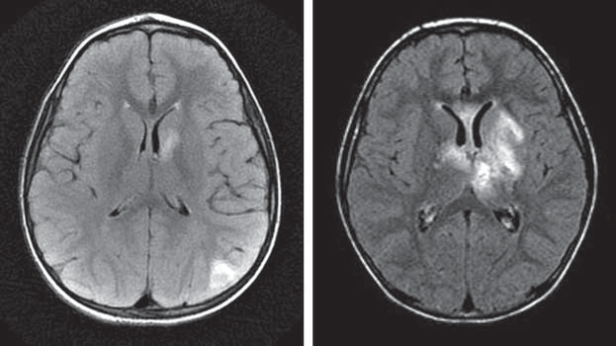

A

B

C

Signa 1.5T SYS#MR01ow0 Ex: 12765

Se: 10

Im: 1

35TE FOR LT BASAL

Mach. # Ratio

NA 33 0.67

Cr 50 - Ref -

Ch 52 1.03

28 0.56

probe-p TR:1500 TE:35

GANGLIA 2 FOR SERIES 10 H20

mI

191054 3822.03

1

2

RMS Noise = 2.65

Cr SNR = 18.87

Voxel Location

R/L A/P S/I Ctr L20.4 A02.8 S18.2 Dim 18.2 18.2 20.0

3

**Figure 1.** The findings of magnetic resonance imaging are consistent with acute disseminated encephalomyelitis (A and B) and then suggestive of aggressive tumor (C). A, Initial fluid-attenuated inversion recovery magnetic resonance imaging demonstrates involvement of the left internal capsule and caudate. B, Subsequent fluid-attenuated inversion recovery magnetic resonance imaging 3 months later demonstrates increased involvement. C, Magnetic resonance spectroscopy on the second admission demonstrates an elevated level of choline (arrow 1), a depressed level of *N*-acetylaspartate (arrow 2), and an elevated lactate doublet (arrow 3) in the left basal ganglia.

family declined treatment with steroids, and the patient improved during hospitalization. After discharge, the fam- ily failed to appear for routine follow-up appointments but brought the child to the emergency department sev- eral times for worsening ataxia. Each time, they refused admission. With the help of social services, the patient was readmitted 3 months after his initial presentation.

At readmission, he was somnolent and responded only to tactile stimuli, with loss of extraocular movement on the right and right arm and leg spasticity and hyperre- flexia. Magnetic resonance imaging revealed enlarge- ment of previously identified lesions and new foci of T2 prolongation in the left frontoparietal subcortical white matter, genu of the corpus callosum, genu of the right internal capsule, anterior thalamus, and bilateral cer- ebellar hemispheres, with extension into the bilateral cer- ebellar peduncles. Subacute hemorrhage was present in the left thalamus and putamen (Figure 1B). Magnetic reso- nance spectroscopy showed an elevated lactate level, a markedly depressed *N*-acetylaspartate level, and a mark- edly elevated choline level in the left basal ganglia, find- ings most compatible with an aggressive tumor such as glioblastoma multiforme (Figure 1C). However, mag- netic resonance perfusion studies showed no evidence of increased perfusion in the lesions, findings more con- sistent with a fulminant inflammatory process such as tumefactive demyelination than with neoplasm. Biopsy of the deep left frontal lesion revealed multiple frag- ments of heavily gliotic white matter diffusely infil- trated by abundant foamy histiocytes, scattered lympho- cytes, and occasional plasma cells (**Figure 2**A). A myelin stain showed remarkable loss of myelin with macro- phages containing myelin particles (Figure 2B). As ex- pected, the reactive astrocytes were intensely high- lighted by glial fibrillary acidic protein (Figure 2C), and the macrophages stained for the macrophage marker CD68 (Figure 2D). No microorganisms were identified, and there was no evidence of a neoplasm. These find- ings were most consistent with an active demyelinating process.

**RESULTS**

The patient was treated with 30 mg/kg of methylpred- nisolone sodium succinate (Solu-Medrol) for 5 daily doses followed by an oral prednisolone taper, with only mini- mal clinical improvement. His hospitalization was com- plicated by steroid-induced hyperglycemia and wit- nessed physical abuse by his mother. He was subsequently placed in state custody. He eventually required percuta- neous gastrostomy tube placement for feeding and was discharged to a long-term care facility. He died 9 months after his initial presentation.

After his discharge but before his death, several of his laboratory test results returned and were reviewed. Urinary organic acids demonstrated a mild increase in vanillate levels, presumably from diet. Levels of serum amino acids, very long-chain fatty acids, and plasma carnitine were normal, as were the results of an acyl carnitine profile. The cerebrospinal fluid specimen demonstrated normal levels of protein, but the myelin basic protein level was higher than 1000 ng/mL and oli- goclonal bands were present. No atypical cells were present on cytologic examination. Epstein-Barr virus, cytomegalovirus, and human herpesvirus 6 were not detected by polymerase chain reaction. The serum lac- tate level was slightly high at 23.4 mg/dL (reference range, 4.5-19.8 mg/dL) (to convert to millimoles per liter, multiply by 0.111); however, the cerebrospinal fluid lactate level was normal. DNA *POLG* sequencing revealed compound heterozygous mutations C752T (T251I) and C1760T (P587L).

**COMMENT**

DNA POLG is the nuclear-encoded polymerase that is responsible for replication of the mitochondrial ge- nome. It consists of 2 subunits, a catalytic subunit en- coded by *POLG1* (now known as *POLG*) and an acces- sory subunit encoded by *POLG2*. *POLG* is located on

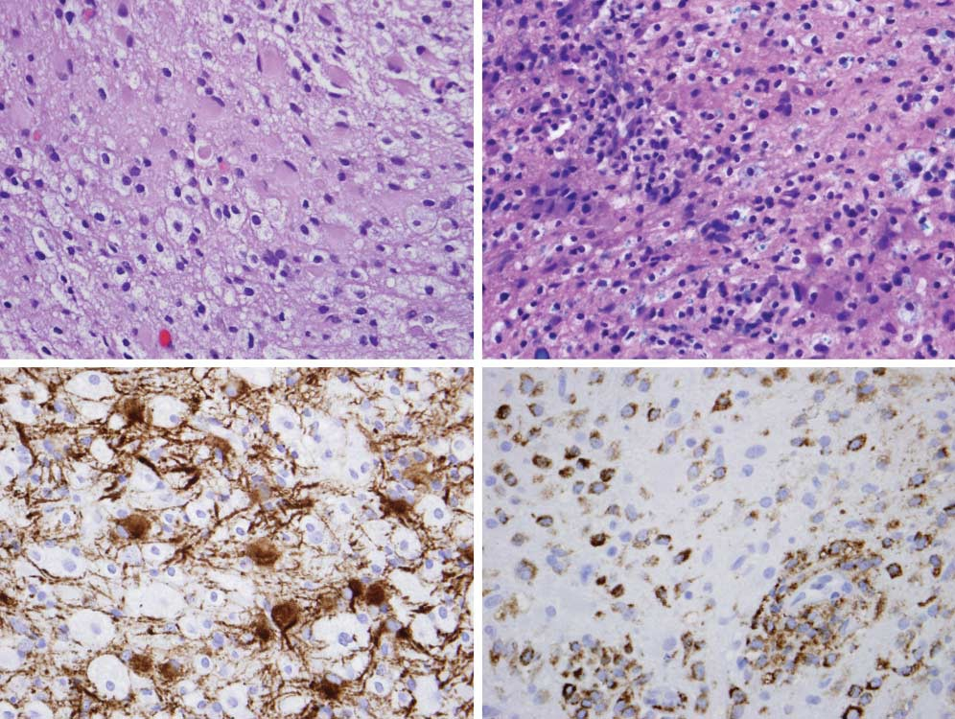

A

B

C

D

**Figure 2.** Pathologic findings of a brain biopsy are consistent with acute disseminated encephalomyelitis. A, A stereotactic biopsy specimen from the left frontal lobe shows diffuse infiltration by reactive astrocytes (arrows) and foamy macrophages (arrowheads) (hematoxylin-eosin, original magnification x500). B, A myelin stain shows severe pallor of white matter (loss of blue-staining myelin). Note the myelin particles engulfed by macrophages (arrows) (Luxol fast blue; original magnification x500). C, An immunostain for polyclonal glial fibrillary acidic protein (Dako, Carpinteria, California) intensely highlights reactive astrocytes (arrows), while leaving macrophages unstained (original magnification x500). D, Conversely, the macrophage marker CD68 (Dako) positively stains macrophages (arrows). Note the perivascular aggregates of macrophages (arrowheads). Reactive astrocytes are nonreactive (original magnification x500).

chromosome 15q25.6 Homozygosity for the A467T mu- tation and compound heterozygosity for A467T in *POLG* are most commonly associated with autosomal reces- sive progressive external ophthalmoplegia, sensory ataxic neuropathy, and Alpers syndrome, which is character- ized by a clinical triad of psychomotor retardation, in- tractable epilepsy, and liver failure in infants and young children.7 Our patient’s *POLG* sequencing revealed com- pound heterozygosity at T251I and P587L. Horvath et al8 described 8 patients with this combination of muta- tions; all were adults, and 7 of the 8 had progressive ex- ternal ophthalmoplegia. Six patients also had myopa- thy; 1 had ataxia; and 1 had neuropathy. One patient had only isolated myopathy. This combination of mutations was also described in 2 sisters with mitochondrial neu- rogastrointestinal syndrome but no leukoencephalopa- thy.9,10 Also, 3 families with autosomal recessive progres- sive external ophthalmoplegia were compound heterozygous for the T251I and the P587L gene muta- tions.11 Our patient had progressive ataxia, asymmetrical right ophthalmoplegia, seizures, and brain biopsy find- ings that were consistent with rapidly progressive demy-

elination, suggesting a wider phenotypic spectrum asso- ciated with *POLG* mutations.

Demyelinating disease—or what appears to be demy- elinating disease—has been reported previously in pa- tients carrying other mutations associated with mito- chondrial disease. There is a “Leber plus” phenotype that has a radiographic appearance suggestive of multiple scle- rosis12; however, most patients with multiple sclerosis do not carry Leber mitochondrial DNA mutations.13 An adult man with a multiple sclerosis–like clinical presentation, compatible radiographic imaging results, and oligo- clonal bands in a cerebrospinal fluid specimen had a het- erozygous S646L mutation in the optic atrophy 1 (*OPA1*) gene, which codes for a mitochondrial protein and is as- sociated with autosomal dominant optic atrophy.14 Carelli and Bellan15 suggested that mitochondrial dysfunction in Leber and *OPA1* mutations may induce an autoim- mune response. Conversely, mitochondrial dysfunction has been proposed as a contributor to axonal degenera- tion in multiple sclerosis, although the initial trigger of this dysfunction remains unclear.16 Our patient’s presen- tation, antecedent infectious prodrome, and radio-

graphic, laboratory, and pathologic evidence were all con- sistent with acute autoimmune demyelinating disease, but the subsequent degenerative course was unusual for ADEM and triggered the search for mitochondrial causes. We wonder whether the underlying *POLG* mutation trig- gered an autoimmune reaction, as suggested by Carelli and Bellan15 for other mitochondrial mutations, or whether the stress of ADEM triggered severe mitochondrial dys- function, leading to our patient’s decline and death.

Which came first? Mitochondrial dysfunction or the autoimmune response? Did both occur, or can mito- chondrial disease mimic autoimmune disease? Could the *POLG* mutation have been an incidental finding in a child with severe ADEM? Further work is needed to clarify the time line and pathogenesis in cases like these and to clarify how mitochondrial dysfunction contributes to poor out- comes in other patients who appear to have autoim- mune disease.

**Accepted for Publication:** September 22, 2009. **Correspondence:** Meredith R. Golomb, MD, MSc, De- partment of Neurology, Indiana University School of Medicine, Bldg XE, Room 040, 575 West Dr, Indianapo- lis, IN 46202 [(mgolomb@iupui.edu).](mailto:(mgolomb@iupui.edu)

**Author Contributions:** Drs Harris and Golomb had full access to all the data in the study and take responsibility for the integrity of the data and the accuracy of the data analysis. *Study concept and design:* Harris, Walsh, and Golomb. *Acquisition of data:* Harris, Hattab, and Golomb. *Analysis and interpretation of data:* Harris, Walsh, Hat- tab, and Golomb. *Drafting of the manuscript:* Harris, Walsh, Hattab, and Golomb. *Critical revision of the manuscript for important intellectual content:* Harris, Walsh, Hattab, and Golomb. *Obtained funding:* Golomb. *Administrative, technical, and material support:* Harris, Walsh, and Golomb. *Study supervision:* Walsh and Golomb. *Pathologic inter- pretation:* Hattab.

**Financial Disclosure:** None reported. **Funding/Support:** Dr Golomb is supported by the Na- tional Institutes of Health National Institute of Neuro- logical Disorders and Stroke grant K23 NS048024 and an Indiana University Research Support Funds Grant. **Additional Contributions:** Mary Edwards-Brown, MD, provided discussion of radiographic findings, and Monica Barkat-Masih, MD, MBBS, provided technical support.

**REFERENCES**

1. Warshawsky I, Rudick RA, Staugaitis SM, Natowicz MR. Primary progressive multiple sclerosis as a phenotype of a PLP1 gene mutation. *Ann Neurol*. 2005; 58(3):470-473.
2. Gorman MP, Golomb MR, Walsh LE, et al. Steroid-responsive neurologic re- lapses in a child with a proteolipid protein-1 mutation. *Neurology*. 2007;68 (16):1305-1307.
3. Chattopadhyay S, Ito M, Cooper JD, et al. An autoantibody inhibitory to glutamic acid decarboxylase in the neurodegenerative disorder Batten disease. *Hum Mol Genet*. 2002;11(12):1421-1431.
4. La´szlo´ A, Huda´k J, Szabo´ E, Varga L. Antinuclear factor, smooth and striated muscle antibodies in Duchenne-type muscular dystrophy. *Acta Paediatr Hung*. 1983; 24(4):331-336.
5. Moxley RT III, Ashwal S, Pandya S, et al; Quality Standards Subcommittee of the American Academy of Neurology; Practice Committee of the Child Neurol- ogy Society. Practice parameter: corticosteroid treatment of Duchenne dystro- phy: report of the Quality Standards Subcommittee of the American Academy of Neurology and the Practice Committee of the Child Neurology Society. *Neurology*. 2005;64(1):13-20.
6. Kaguni LS. DNA polymerase gamma, the mitochondrial replicase. *Annu Rev Biochem*. 2004;73:293-320.
7. Harding BN, Alsanjari N, Smith SJ, et al. Progressive neuronal degeneration of childhood with liver disease (Alpers’ disease) presenting in young adults. *J Neu- rol Neurosurg Psychiatry*. 1995;58(3):320-325.
8. Horvath R, Hudson G, Ferrari G, et al. Phenotypic spectrum associated with mu- tations of the mitochondrial polymerase gamma gene. *Brain*. 2006;129(pt 7): 1674-1684.
9. Vissing J, Ravn K, Danielsen ER, et al. Multiple mtDNA deletions with features of MNGIE. *Neurology*. 2002;59(6):926-929.
10. Van Goethem G, Schwartz M, Lofgren A, Dermaut B, Van Broeckhoven C, Vis- sing J. Novel POLG mutations in progressive external ophthalmoplegia mimick- ing mitochondrial neurogastrointestinal encephalomyopathy. *Eur J Hum Genet*. 2003;11(7):547-549.
11. Lamantea E, Zeviani M. Sequence analysis of familial PEO shows additional mu- tations associated with the 752CT and 3527CT changes in the POLG1 gene. *Ann Neurol*. 2004;56(3):454-455.
12. Harding AE, Sweeney MG, Miller DH, et al. Occurrence of a multiple sclerosis– like illness in women who have a Leber’s hereditary optic neuropathy mitochon- drial DNA mutation. *Brain*. 1992;115(pt 4):979-989.
13. Kellar-Wood H, Robertson N, Govan GG, Compston DA, Harding AE. Leber’s he- reditary optic neuropathy mitochondrial DNA mutations in multiple sclerosis. *Ann Neurol*. 1994;36(1):109-112.
14. Verny C, Loiseau D, Scherer C, et al. Multiple sclerosis–like disorder in OPA1- related autosomal dominant optic atrophy. *Neurology*. 2008;70(13, pt 2):1152- 1153.
15. Carelli V, Bellan M. Myelin, mitochondria, and autoimmunity: what’s the connection?

*Neurology*. 2008;70(13, pt 2):1075-1076.

1. Dutta R, McDonough J, Yin X, et al. Mitochondrial dysfunction as a cause of axo- nal degeneration in multiple sclerosis patients. *Ann Neurol*. 2006;59(3):478- 489.