Compound Heterozygous Polymerase Gamma Gene Mutation in a Patient With Alpers Disease



## Javier F. Cardenas, MD, and R. Stephen Amato, MD

Alpers disease is a mitochondrial depletion syndrome characterized by psychomotor retardation, intractable epilepsy, and liver failure. Polymerase gamma (POLG) gene muta- tions are a known cause of the disease. We describe a case in which a 14-month-old female presented with epilepsia partialis continua evolving into generalized status epilepticus. Treatment with multiple antiepileptic medications and the ketogenic diet eliminated her seizures, but she remained severely encephalopathic. Magnetic resonance imaging showed diffuse atrophy of gray-matter structures. She ultimately developed liver failure and died. Mitochondrial analysis revealed compound heterozygosity for 3 POLG gene muta- tions, 2 of which were previously unreported.

Semin Pediatr Neurol 17:62-64 © 2010 Elsevier Inc. All rights reserved.

14-month-old female with a history of poor weight gain and persistently loose stools presented with new-onset epilepsia partialis continua. Her parents reported irritability several days before admission but denied symptoms of ill- ness. She was initially noted to have intermittent, rhythmic jerking of her left arm with a clenched left hand. She was alert and afebrile but was taken to an urgent care center where she was described as having myoclonic jerking of her bilateral upper extremities. Upon arrival to the intensive care unit, she had generalized, tonic-clonic jerking; she was treated with antiepileptic drugs and intubated. The initial evaluation re- vealed a weight greater than 2 standard deviations below the mean, with height and head circumference measurements in the 40th and 25th percentiles, respectively. The initial labo- ratory and neuroimaging studies were unrevealing for infec- tious, inflammatory, or metabolic causes. Cerebrospinal fluid

A

revealed an elevated lactate of 4.0 mEq/L.

A trend electroencephalogram showed persistent general- ized epileptiform discharges, and antiepileptic therapy was escalated to the point of pentobarbital suppression. Valproate was deliberately avoided because of a concern for a possible mitochondrial etiology of disease. The patient ultimately re- sponded to multidrug therapy that included the ketogenic diet. After extubation, the patient was severely encephalo- pathic and unable to communicate, feed, or dress herself. She had persistent episodes of asymmetric myoclonic activity of the upper extremities that did not correspond with an elec-

From the Division of Child Neurology, Barrow Neurological Institute and St.

Joseph’s Hospital and Medical Center, Phoenix, AZ. Address reprint requests to Javier F. Cardenas, MD, 500 West Thomas Road,

Suite 400, Phoenix, AZ 85013. E-mail: [javier.cardenas@chw.edu](mailto:javier.cardenas@chw.edu)

troencephalographic change. Repeated neuroimaging re- vealed global cerebral atrophy involving both the cortex and basal ganglia (Fig 1).

The diagnosis of Alpers disease was finalized based on muscle biopsy and genetic testing. Electron microscopy showed reduced mitochondria with abnormal cristae and vacuolization (Fig 2). Mitochondrial analysis revealed a DNA polymerase gamma1 (POLG) heterozygous mutation. A pre- viously reported c911T > G (p. L30 4R) mutation was ac- companied by an unknown mutation c.1174C > G (PL39 2V) and a 3240-3242 duplication (pR1081dup). Parental testing revealed paternal presence of the known mutation and the existence of both unknown POLG mutations in the mother.

The patient was discharged after prolonged hospitaliza- tion. She remained at home for several weeks with continu- ous care but was readmitted with coagulopathy and elevated liver enzymes. Her seizures returned, and she was found to be unable to make ketones in her urine. She died approxi- mately 5 months after her initial presentation.

# Alpers Disease

Alpers’ disease, also known as Alpers Huttenlocher syn- drome and progressive neuronal degeneration of childhood with liver disease, was initially described by Bernard Alpers in 1931.1-3 He detailed the neuropathological degeneration of cerebral gray matter in a 4-month-old female with intractable epilepsy.1 Huttenlocher et al3 reported similar pathologic findings in 2 children who also developed liver failure and death by 3 years of age in 1976.3 Harding2 detailed the cere-

**62** 1071-9091/10/$-see front matter © 2010 Elsevier Inc. All rights reserved. doi:10.1016/j.spen.2010.02.012

**Compound heterozygous POLG gene mutation** **63**

# POLG

Mitochondrial DNA POLG is the only DNA polymerase present in the mitochondria.9 Composed of 2 subunits, POLG functions to replicate and repair mitochondrial DNA.POLG is susceptible to oxidative damage by free oxy- gen species.10 Defects and dysfunction in POLG result in mitochondrial depletion and cellular failure.

Clinical mitochondrial depletion syndromes in which POLG has been implicated include progressive external oph- thalmoplegia (PEO), male infertility, myoclonic epilepsy with ragged red fibers, sensory ataxia with neuropathy dys- arthria and ophthalmopresis, and Alpers disease.11-15 Patients suffering from PEO typically display ocular myopathies, pto- sis, and muscle weakness.10,16 Genotypic differences in POLG mutations have been shown to influence a spectrum of disease ranging from PEO to Alpers disease.8

Evidence of a POLG mutation resulting in an Alpers dis- ease phenotype was first reported in 1999 by Naviaux, et al.17 Homozygous and compound heterozygous mutations have been reported, including E873X, A467Y, G848S, and W748S.12,18 Tzoulis et al8 described the clinical heterogeneity of Alpers disease because of A467Y and G848S mutations. The known POLG mutation in our patient was first described in a patient with PEO and later in a patient with sensory ataxia with neuropathy dysarthria and ophthalmopresis.14,19

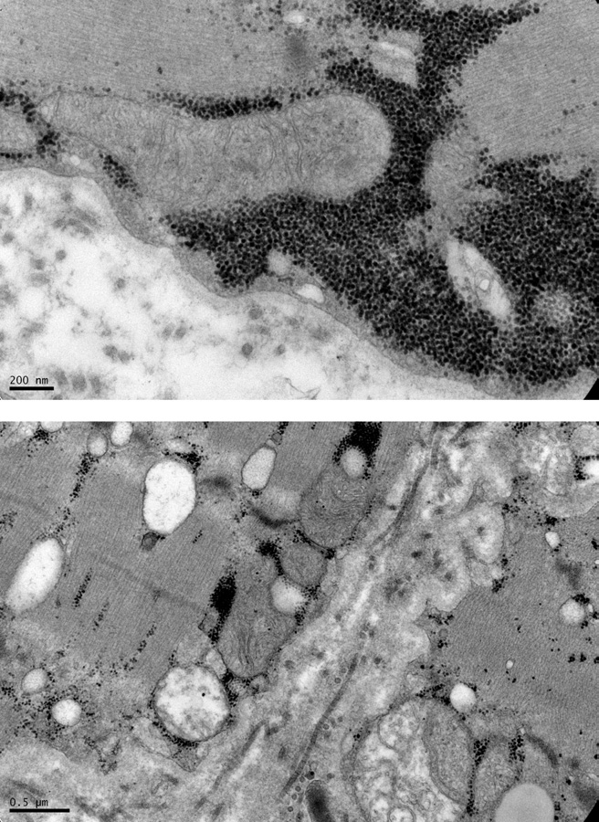**Figure 1** Axial (top) and coronal (bottom) magnetic resonance im- aging showing atrophic changes of the cortical gray matter and basal ganglia.

bral pathology, liver pathology, and electrophysiological changes in 30 patients. The diagnosis of Alpers disease is based on the clinical triad of psychomotor retardation, in- tractable seizures, and liver failure.

The typical presentation of Alpers disease is of an infant or young child with new-onset seizures in the setting of fever including myoclonic seizures, generalized seizures, or epi- lepsia partialis continua.2 Rare juvenile cases have been re- ported as late as 18 years of age.4-6

Electroencephalography in most patients shows low-am- plitude polyspikes superimposed over a slow (<1 Hz), high- amplitude (0.2-1 mV) background.2 Epilepsy resistant to anticonvulsant medication is most common although a clinical response to the ketogenic diet, as in our pat- ient, has been previously reported.7 A neurodegenerative course ensues, which is characterized by progressive men- tal retardation and intractable epilepsy. Neuropathologi- cal changes almost exclusively involve the gray matter. Frequently affected areas include the calcarine cortex, and basal ganglia, but diffuse involvement is common.1,2,8 Pro- gressive degeneration of the gray matter results in diffuse atrophy and secondary white-matter degeneration. Liver failure is equally common and presents frequently in the setting of valproate administration. Death by 3 years of age most often occurs because of intractable status epilepticus or liver failure.

**Figure 2** Electron microscopic images from a muscle biopsy showing abnormal mitochondrial cristae (top) and vacuolization (bottom).

**64 J.F. Cardenas and R.S. Amato**

As with our patient, presentations with the highest mortality included status epilepticus and liver failure.8

# Conclusions

Alpers disease is a mitochondrial depletion syndrome pre- senting with intractable seizures, psychomotor retardation, and liver failure. Rapidly progressive gray-matter degenera- tion results in characteristic changes on magnetic resonance imaging and an electroencephalogram. Valproate administra- tion should be avoided in children who present with this clinical triad because of its known impact on mitochondria and potential for fatal hepatopathy in these patients. Com- pound heterozygous mutations of the POLG gene, such as in our patient, are a known cause of Alpers disease and should be included in the diagnostic evaluation of patients who fall in the clinical spectrum.

## References

1. Alpers BJ: Diffuse progressive degeneration of gray matter of cerebrum.

Arch Neurol 25:469-505, 1931

1. Harding B: Progressive neuronal degeneration of childhood with liver disease (Alpers-Huttenlocher syndrome): A personal review. J Child Neurol 5:273-287, 1990
2. Huttenlocher P, Solitare G, Adams G: Infantile diffuse cerebral degen- eration with hepatic cirrhosis. Arch Neurol 33:186-192, 1976
3. Harding BN, Alsanjari N, Smith SJ, et al: Progressive neuronal degen- eration of childhood with liver disease (Alpers’ disease) presenting in young adults. J Neurol Neurosurg Psychiatry 58:320-325, 1995
4. Uusimaa J, Hinttala R, Rantala H, et al: Homozygous W74 8S mutation in the POLG1 gene in patients with juvenile-onset Alpers’ syndrome and status epilepticus. Epilepsia 49:1038-1045, 2008
5. Wiltshire E, Davidzon G, DiMauro S, et al: Juvenile Alpers’ disease. Arch Neurol 65:121-124, 2008
6. Joshi CN, Greenberg CR, Mhanni AA, et al: Ketogenic diet in Alpers- Huttenlocher syndrome. Pediatr Neurol 40:314-316, 2009
7. Tzoulis C, Engelsen BA, Telstad W, et al: The spectrum of clinical disease caused by the A467T and W74 8S POLG mutations: A study of 26 cases. Brain 129:1685-1692, 2006
8. Chan SS, Copeland WC: DNA polymerase gamma and mitochondrial disease: Understanding the consequence of POLG mutations. Biochim Biophys Acta 1787:312-319, 2009
9. Copeland WC, Ponamarev MV, Nguyen D, et al: Mutations in DNA polymerase gamma cause error prone DNA synthesis in human mito- chondrial disorders. Acta Biochim Pol 50:155-167, 2003
10. McHugh JC, Lonergan R, Howley R, et al: Sensory ataxic neuropathy dysarthria and ophthalmoparesis (SAND) in a sibling pair with a ho- mozygous p.A467T POLG mutation. Muscle Nerve 41:265-269, 2010
11. Naviaux RK, Nguyen KV: POLG mutations associated with Alpers’ syndrome and mitochondrial DNA depletion. Ann Neurol 55:706-712, 2004
12. Rovio AT, Marchington DR, Donat S, et al: Mutations at the mitochon- drial DNA polymerase (POLG) locus associated with male infertility. Nat Genet 29:261-262, 2001
13. Van Goethem G, Dermaut B, Lofgren A, et al: Mutation of POLG is associated with progressive external ophthalmoplegia characterized by mtDNA deletions. Nat Genet 28:211-212, 2001
14. Van Goethem G, Mercelis R, Lofgren A, et al: Patient homozygous for a recessive POLG mutation presents with features of MERRF. Neurology 61:1811-1813, 2003
15. Van Goethem G, Schwartz M, Lofgren A, et al: Novel POLG mutations in progressive external ophthalmoplegia mimicking mitochondrial neurogastrointestinal encephalomyopathy. Eur J Hum Genet 11:547- 549, 2003
16. Naviaux RK, Nyhan WL, Barshop BA, et al: Mitochondrial DNA poly- merase gamma deficiency and mtDNA depletion in a child with Alpers’ syndrome. Ann Neurol 45:54-58, 1999
17. Davidzon G, Mancuso M, Ferraris S, et al: POLG mutations and Alpers

syndrome. Ann Neurol 57:921-923, 2005

1. Naimi M, Bannwarth S, Procaccio V, et al: Molecular analysis of ANT1, TWINKLE and POLG in patients with multiple deletions or depletion of mitochondrial DNA by a dHPLC-based assay. Eur J Hum Genet 14:917-922, 2006