diagnosis. It is common for a patient with myopathy to show liver enzyme abnormalities. Therefore, it is important to check muscle enzymes in patients when the diagnosis and cause of abnormal liver enzymes is uncertain.

In conclusion, we have demonstrated the ab- sence of LAMP-2 expression in skeletal muscles from a female patient with early-onset overt proxi- mal weakness, many vacuolated ﬁbers, and a de novo novel mutation in the *LAMP2* gene. We strongly suggest that the pathogenesis of proximal weakness is more related to autophagic vacuoles than primary LAMP-2 expression. We also believe that there may be other factors that cause cardio- myopathy in Danon disease.

This study was supported by a grant from the Korea Healthcare Technology R&D project, Ministry for Health, Welfare and Family Affairs, Republic of Korea (Grant No. A080588). The authors thank MiSun Park for her English correction of the manuscript.

REFERENCES

1. Nishino I, Fu J, Tanki K, Yamada T, Shimojo S, Koorl T, et al. Pri- mary LAMP-2 deﬁciency causes X-linked vacuolar cardiomyopathy and myopathy (Danon disease). Nature 2000;406:906–910.
2. Nishino I. Autophagic vacuolar myopathy. Semin Pediatr Neurol 2006;13:90–95.
3. Sugie K, Noguchi S, Kozuka Y, Arikawa-Hirasawa E, Tanaka M, Yan C, et al. Autophagic vacuoles with sarcolemmal features delineate Danon disease and related myopathies. J Neuropathol Exp Neurol 2005;64:513–522.
4. Malicdan MC, Noguchi S, Nonaka I, Saftig P, Nishino I. Lysosomal myopathies: An excessive build-up in autophagosomes is too much to handle. Neuromusc Disord 2008;18:521–529.
5. Sugie K, Yamamoto A, Murayama BS, Oh SJ, Takahashi M, Mora M, et al. Clinicopathological features of genetically conﬁrmed Danon disease. Neurology 2002;58:1773–1778.
6. Fanin M, Nascimbeni AC, Fulizio L, Spinazzi M, Melacini P, Angelini

C. Generalized lysosome-associated membrane protein-2 defect explains multisystem clinical involvement and allows leukocyte diag- nostic screening in Danon disease. Am J Pathol 2006;168:1309–1320.

1. Sugie K, Koori T, Yamamoto A, Ogawa M, Hirano M, Inoue K, et al. Characterization of Danon disease in a male patient and his affected mother. Neuromuscul Disord 2003;13:708–711.
2. Byrne E, Dennett X, Crotty B, Trounce I, Sands JM, Hawkins R, et al. Dominantly inherited cardioskeletal myopathy with lysosomal glycogen storage and normal acid maltase levels. Brain 1986;109: 523–536.
3. Dworzak F, Casazza F, Mora M, De Maria R, Gronda E, Baroldi G, et al. Lysosomal glycogen storage with normal acid maltase: a fami- lial study with successful heart transplant. Neuromuscul Disord 1994; 4:243–247.
4. Tunˇon T, Guerrero D, Urchaga A, Nishino I, Ayuso T, Matsuda Y, et al. Danon disease: A novel LAMP-2 gene mutation in a family with four affected members. Neuromusc Disord 2008;18:167–174.
5. Tanaka Y, Guhde G, Suter A, Eskelinen EL, Hartmann D, Lu¨ llmann- Rauch R, et al. Accumulation of autophagic vacuoles and cardiomy- opathy in LAMP-2-deﬁcient mice. Nature 2000;406:902–906.

SENSORY ATAXIC NEUROPATHY WITH DYSARTHRIA AND OPHTHALMOPARESIS (SANDO) IN LATE LIFE DUE TO COMPOUND HETEROZYGOUS *POLG* MUTATIONS

MICHAEL D. WEISS, MD,1 and RUSSELL P. SANETO, DO, PhD2

1 Department of Neurology, University of Washington Medical Center, Box 356115, 1959 NE Paciﬁc Street, Seattle, Washington 98195, USA

2 Division of Pediatric Neurology, Seattle Children’s Hospital, Seattle, Washington, USA

*Accepted 24 November 2009*

ABSTRACT: Missense mutations in the gene for polymerase c 1 (*POLG1*) cause a number of phenotypically heterogeneous mito- chondrial diseases, most commonly progressive external ophthal- moplegia, and are characterized by the accumulation of multiple, large-scale deletions of mitochondrial DNA. The triad of sensory ataxic neuropathy, dysarthria, and ophthalmoparesis (SANDO) has been demonstrated in a small subset of patients with *POLG1* muta- tions. We report a sporadic case of an 80-year-old compound het- erozygote man who presented with SANDO and was found to have three known pathogenic mutations in the *POLG1* gene (p.T251I/ p.P587L/p.G848S). To our knowledge, none of these mutations have been demonstrated previously in SANDO. This patient’s late presentation illustrates that a mitochondrial disorder should be con- sidered regardless of age if the clinical symptoms warrant.

*Muscle Nerve* 41: 882–885, 2010

Abbreviations: ANA, antinuclear antibodies; *ANT1*, adenine nucleotide translocator 1; COX, cytochrome *c* oxidase; EMG, electromyography; PEO, progressive external ophthalmoplegia; MIRAS, mitochondrial ataxic syndrome without ophthalmoplegia; mtDNA, mitochondrial DNA; *POLG1*, acetylcholine receptor; SANDO, sensory ataxic neuropathy, dysarthria, and ophthalmoparesis; SNAP, sensory nerve action potential

Key words: dysarthria; polymerase c; mitochondrial myopathy; progressive external ophthalmoplegia; sensory ataxic neuropathy

Correspondence to: M.D. Weiss; e-mail: [mdweiss@u.washington.edu](mailto:mdweiss@u.washington.edu)

VC 2010 Wiley Periodicals, Inc.

Published online 15 May 2010 in Wiley InterScience (www.interscience. wiley.com). DOI 10.1002/mus.21636

Mutations in polymerase c 1 (*POLG1*) lead to a number of mitochondrial disease phenotypes asso- ciated with multiple mitochondrial DNA deletions. Such mutations present clinically in a heterogene- ous manner and include both autosomal dominant and recessive forms of progressive external oph- thalmoplegia (PEO); mitochondrial ataxic syn- drome without opthalmoplegia (MIRAS); and the clinical triad of sensory ataxic neuropathy, dysarth- ria, and ophthalmoparesis (SANDO).1,2 There is no speciﬁc treatment for diseases related to *POLG1* mutations, although valproic acid is contraindi- cated, as it may precipate fulminant liver disease. Only a few cases of SANDO associated with *POLG1* mutations have been reported.3–8 We report a case of SANDO associated with known pathogenic *POLG1* mutations that presented in late life in a compound heterozygote male.

CASE REPORT

An 80-year-old-man presented with a 7-year history of progressively droopy eyelids, a 4-year history of double vision, and 3 years of an increasingly nasal

882 SANDO from *POLG* Mutations MUSCLE & NERVE June 2010

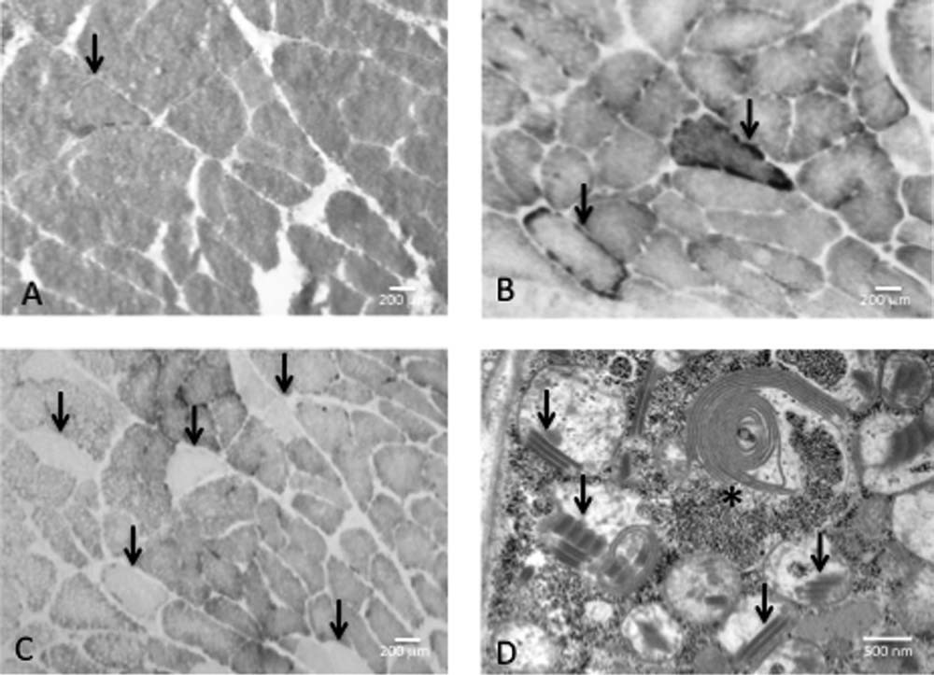

FIGURE 1. Left deltoid muscle biopsy. (A) Modified Gomori trichrome staining reveals a single ragged red fiber (arrow). (B) Two ragged blue fibers are noted with succinate dehydrogenase staining (arrows). (C) A number of cytochrome *c* oxidase–negative fibers are shown (arrows). (D) On ultrastructural analysis, paracrystalline (‘parking lot’) inclusions are noted within mitochondria (arrows), as are membranous whirls (asterisk), and debris.

voice, as well as more recent gait instability with near falls and proximal arm weakness. He denied any family history of a similar disorder. A previous workup earlier in the year by another physician had included negative serologic and electrophysio- logic testing for myasthenia gravis along with nor- mal, but limited needle electromyography. A bi- opsy of the left deltoid muscle demonstrated non- speciﬁc changes, including ﬁber size variability and central nuclei. There were also ragged red and ragged blue (succinate dehydrogenase–positive) ﬁbers in about 3% and 6% of all muscle ﬁbers, respectively, both signifying increased mitochon- drial numbers, and cytochrome *c* oxidase (COX)- negative ﬁbers in about 6% of all ﬁbers. There were also ultrastructural changes of abnormally swollen mitochondria and paracrystalline inclu- sions (Fig. 1). Respiratory chain complex activity showed an increase in citrate synthase levels, con- sistent with increased mitochondrial content, but it was otherwise normal.

On neurologic examination at presentation, the patient had moderate to severe bilateral ptosis and lateral rectus palsies with associated horizontal diplopia. His also had a moderately severe nasal, ﬂaccid dysarthria, moderate facial weakness, and mild tongue weakness without any atrophy. His power was reduced in both deltoid muscles 4þ/5 (Medical Research Council scale), but was other-

wise 5/5. His sensory examination showed mild stocking loss to light touch and pin prick, absent vibratory sensation and impaired joint position sense at the toes, and decreased vibratory sensation at the ankles. He had a positive Romberg sign. His deep tendon reﬂexes were absent at the ankles. His gait was mildly wide-based.

Repeat nerve conduction studies of the right arm and leg demonstrated absent right sural and peroneal sensory nerve action potentials (SNAP) and a moderately reduced superﬁcial radial SNAP amplitude of 7 lV (normal >12 lV) with a normal conduction velocity of 63 m/s, consistent with a sensory axonopathy. Right peroneal motor nerve conduction and minimum F-wave latencies were normal. Needle electromyographic (EMG) study of the right arm and leg demonstrated an excess of low-amplitude, short-duration, occasionally poly- phasic motor unit action potentials, without ﬁbril- lation potentials or positive sharp waves, and early recruitment in the right iliacus and biceps brachii muscles, consistent with a non-irritative myopathy involving the proximal limbs. Quantitative motor unit analysis was performed on the right orbicula- ris oris muscle, employing the technique described by Farrugia and Kennett.9 It showed a mean motor unit action potential duration of 3.5 ms (normal range 7.2–11.0 ms), which was indicative of myopa- thy involving the facial muscles.

SANDO from *POLG* Mutations MUSCLE & NERVE June 2010 883

10974598, 2010, 6, Downloaded from https://onlinelibrary.wiley.com/doi/10.1002/mus.21636 by The University Of Manchester, Wiley Online Library on [22/05/2025]. See the Terms and Conditions (https://onlinelibrary.wiley.com/terms-and-conditions) on Wiley Online Library for rules of use; OA articles are governed by the applicable Creative Commons License

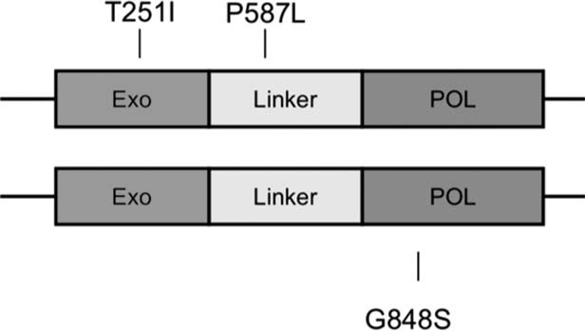

FIGURE 2. Location of missense mutations in the polymerase c gene in SANDO. p.T25I1 and p.P587L mutations were identified in *cis*, in the exonuclease motif and linker regions of the gene, respectively. In addition, the p.G848S mutation was found in the polymerase motif. These mutations have been seen in other mi- tochondrial phenotypes, such as Alpers syndrome and progres- sive external ophthalmoplegia, both individually and in combination, but not with SANDO (courtesy of Dr. Robert Naviaux).

The patient had a normal metabolic panel, liver function proﬁle, sedimentation rate, thyroid function, vitamin B12, methylmalonic acid, serum protein and immunoﬁxation electrophoresis, se- rum amino acid, urine organic proﬁle, lactic acid, ammonia, and creatine phosphokinase, and nega- tive antibodies to extractable nuclear antigen and to Ro and La. He had a mildly elevated glycosyla- ted hemoglobin level of 6.2% and positive antinu- clear antibodies (ANA) of 1:160, showing a speck- led pattern. His free carnitine level was mildly elevated at 67.2 lmol/L (normal 16–65 lmol/L), short-chain acyl carnitine level moderately increased at 46.1 lmol/L (normal 1–24 lmol/L), and acyl/free ratio modestly increased at 0.73 lmol/L (normal <0.7 lmol/L). Testing of the genes for polyadenylate binding protein nuclear 1 (for oculopharyngeal muscular dystrophy), *ANT1*, and *TWINKLE* (*PEO1*) demonstrated normal cod- ing sequences. Direct sequencing of the coding exons of the *POLG1* gene showed that the patient had three known deleterious heterozygous mis- sense mutations, c.752C>T (p.T251I), c.1760C>T (p.P587L), and c.2542G>A (p.G848S), located in exons 2, 9, and 15, respectively. All have previously been associated with disease (Fig. 2).

DISCUSSION

Our patient fulﬁlled the clinical triad for SANDO but developed symptoms of the disease very late in life. This presented a diagnostic challenge in deﬁn- ing his phenotype, in that some of the objective evidence for his disease could have been age- related, including his abnormal sensory nerve con- duction and the alterations on muscle biopsy. For instance, sural SNAPs are thought to be commonly absent in the lower extremities of normal elderly

patients. However, a recent study of normal older volunteers documented the presence of a sural SNAP in the majority of subjects up to 89 years of age.10 Our patient also had a presenting history of imbalance and near falls and absent su- perﬁcial peroneal and moderately reduced radial SNAP amplitudes, in addition to the absent sural SNAP, supporting the diagnosis of sensory ataxic polyneuropathy. The patient also met deﬁned cri- teria for mitochondrial disease in adults >50 years of age in that his muscle biopsy demonstrated ragged red ﬁbers in excess of 2% and COX-nega- tive ﬁbers in excess of 5%.11 Although these crite- ria do not speciﬁcally comment on presentations of mitochondrial disease in the elderly, a previous study by Rifai and colleagues demonstrated a fre- quency of no more than 0.33% ragged red ﬁbers in their evaluation of the muscle biopsies of nor- mal older patients.12

Interestingly, studies of patients with SANDO and *POLG1* mutations have demonstrated substan- tial variability in muscle pathology, ranging from severe to normal, often with normal respiratory chain enzyme levels.4 An explanation for such vari- ability is uncertain, but it may relate to the degree of *POLG1* activity within a tissue, as the mtDNA subunits within the ﬁve respiratory chain com- plexes are differentially affected compared with the nuclear transcribed subunits. Mitochondrial DNA (mtDNA) depletion syndromes may either affect a speciﬁc tissue (most commonly muscle, liver, or brain) or a combination of tissues (includ- ing muscle, liver, brain, or kidney). In *POLG1* dis- ease, mtDNA depletion is usually only found in liver and muscle. During the early part of the dis- ease, respiratory chain enzyme abnormalities are usually found only as the disease advances and are more likely to be evident in more severely affected tissue (such as the extraocular muscles in our patient).

*POLG1* encodes for polc, a polymerase respon- sible for maintaining the integrity of all mtDNA replication and repair transactions. It is the only DNA polymerase in animal mitochondria.1,13 Polc is composed of a 140-kDa catalytic subunit and a 55-kDa accessory subunit. Mutations in the coding region of *POLG1* for the catalytic subunit, and less commonly the linker region,14 have been shown to be a frequent cause of mitochondrial disorders. Pathogenic *POLG1* mutations are commonly associ- ated with the phenotype of PEO.15–19 Autosomal dominant *POLG1* mutations associated with PEO have all been found in the polymerase domain of polc, likely causing this disorder by producing a mutant protein that has a dominant negative effect on wild-type polc.20 However, most *POLG1* muta- tions that cause PEO are autosomal recessive,

884 SANDO from *POLG* Mutations MUSCLE & NERVE June 2010

10974598, 2010, 6, Downloaded from https://onlinelibrary.wiley.com/doi/10.1002/mus.21636 by The University Of Manchester, Wiley Online Library on [22/05/2025]. See the Terms and Conditions (https://onlinelibrary.wiley.com/terms-and-conditions) on Wiley Online Library for rules of use; OA articles are governed by the applicable Creative Commons License

including the three mutations identiﬁed in our patient, and are frequently found in compound heterozygosity.20 Therefore, an autosomal domi- nant inheritance pattern for the patient cannot be excluded, as the patient’s extended family was not available for genetic testing, but an autosomal re- cessive presentation seems more likely.

SANDO as a manifestation of mitochondrial disease is uncommon. In 1997, Fadic and col- leagues demonstrated this phenotype in four patients in association with multiple mtDNA dele- tions in muscle and peripheral nerve.21 Since the initial report in which a *POLG1* mutation was iden- tiﬁed,7 only a small number of SANDO patients with *POLG1* mutations have been documented, all either presenting in an autosomal recessive or sporadic fashion. Previous *POLG1* mutations ass- ociated with the SANDO phenotype include p.R1138C, p.E1143G, p.G737R, p.R627W, p.W748S,

p.Q947H, p.R807C, p.P648R, and, most commonly, p.A467T, which has generally been found in com- pound heterozygosity or homozygosity.3–8

The late onset of presentation of our patient as a consequence of his *POLG1* mutations is of great interest. As is true of patients with the other phe- notypes seen with *POLG1* mutations, such as MIRAS, Alpers syndrome, and PEO, previously documented patients with SANDO have all gener- ally presented before the ﬁfth decade of life. The reason for the delay in presentation in our patient remains uncertain. Both the p.T251I and p.P587L mutations are commonly seen in PEO; they usually present in *cis*, making it difﬁcult to conclude which is the pathogenic mutation. A pathogenic synergy likely exists between the two changes, resulting in the mutated protein being dominant to the wild- type protein. These same compound *trans* muta- tions, p.T2511/p.P587L, together with G848S, have been described in the severe form of *POLG1* dis- ease, Alpers–Huttenlocher syndrome.2 The two mutations in *cis*, p.T251I/p.P587L, have also been demonstrated as homozygous mutations in a patient with encephalopathy and myopathy and in another patient with the p.T251I/p.P587L and p.L304R mutations that express encephalopathy and neuropathy.20 Currently, the reason for the di- versity in phenotype expression remains unclear. Our patient represents a unique genotype for the SANDO presentation. His age of onset is highly unusual for mitochondrial disorders, suggesting that some other factor or factors, possibly environ- mental and/or genetic, account for the delay in presentation. However, his case demonstrates that, regardless of age, the prospect of a mitochondrial

disease should be considered if the constellation of symptoms warrants.

The authors thank Dr. Greg Carter and Dr. Thomas Bird for their critical review of the manuscript, and Dr. Donald Born for his help with Figure 1.

REFERENCES

1. Longley MJ, Graziewicz MA, Bienstock RJ, Copeland MC. Conse- quences of mutations in human DNA polymerase c. Gene 2005;354: 125–131.
2. Wong LJ, Naviaux RK, Brunetti-Pierri N, Zhang Q, Schmitt ES, Truong C, et al. Molecular and clinical genetics of mitochondrial diseases due to POLG mutations. Hum Mutat 2008;29:E150–E172.
3. Gago MF, Rosas MJ, Guimaraes J, Ferreira M, Vilarinho L, Castro L, et al. SANDO: two novel mutations in POLG1 gene. Neuromuscul Disord 2006;16:507–509.
4. Milone M, Brunetti-Pierri N, Tang L-Y, Kumar N, Mezei MM, Josephs K, et al. Sensory ataxic neuropathy with ophthalmoparesis caused by POLG mutations. Neuromuscul Disord 2008;18:626–632
5. Na¨ımi M, Bannwarth S, Procaccio V, Pouget J, Desnuelle C, Pellissier JF, et al. Molecular analysis of ANT1, TWINKLE and POLG in patients with multiple deletions or depletion of mitochondrial DNA by a dHPLC-based assay. Eur J Hum Genet 2006;14:917–922.
6. Van Goethem G, Luoma P, Rantama¨ki M, Al Memar A, Kaakkola S, Hackman P, et al. POLG mutations in neurodegenerative disorders with ataxia but no muscle involvement. Neurology 2004;63:1251–1257.
7. Van Goethem G, Martin JJ, Dermaut B, Lo¨fgren A, Wibail A, Ververken D, et al. Recessive POLG mutations presenting with sensory and ataxic neuropathy in compound heterozygote patients with progressive external ophthalmoplegia. Neuromuscul Disord 2003;13:133–142.
8. Winterthun S, Ferrari G, He L, Taylor RW, Zeviani M, Turnbull DM, et al. Autosomal recessive mitochondrial ataxic syndrome due to mi- tochondrial polymerase c mutations. Neurology 2005;64:1204–1208.
9. Farrugia ME, Kennett RP. Turns amplitude analysis of the orbicularis oculi and oris muscles. Clin Neurophysiol 2005;116:2550–2559.
10. Rivner MH, Swift TR, Malik K. Inﬂuence of age and height on nerve conduction. Muscle Nerve 2001;24:1134–1141.
11. Bernier FP, Boneh A, Dennett X, Chow CW, Cleary MA, Thorburn DR. Diagnostic criteria for respiratory chain disorders in adults and children. Neurology 2002;59:1406–1411.
12. Rifai Z, Welle S, Kamp C, Thornton CA. Ragged red ﬁbers in normal aging and inﬂammatory myopathy. Ann Neurol 1995;37:24–29.
13. Kollberg G, Jansson M, Perez-Bercoff A, Melberg A, Lindberg C, Holme E, et al. Low frequency of mtDNA point mutations in patients with PEO associated with POLG1 mutations. Eur J Hum Genet 2005;13:463–466.
14. Hudson G, Schaefer AM, Taylor RW, Tiangyou W, Gibson A, Ven- ables G, et al. Mutation of the linker region of the polymerase c-1 (POLG1) gene associated with progressive external ophthalmoplegia and parkinsonism. Arch Neurol 2007;64:553–557.
15. Agostino A, Valletta L, Chinnery PF, Ferrari G, Carrara F, Taylor RW, et al. Mutations of ANT1, Twinkle, and POLG1 in sporadic pro- gressive external ophthalmoplegia (PEO). Neurology 2003;60: 1354–1356.
16. Filosto M, Mancuso M, Nishigaki Y, et al. Clinical and genetic hetero- geneity in progressive external ophthalmoplegia due to mutations in polymerase c. Arch Neurol 2003;60:1279–1284.
17. Gonzalez-Vioque E, Blazquez A, Fernandez-Moreira D, Ferna´ndez- Moreira D, Bornstein B, Bautista J, et al. Association of novel POLG mutations and multiple mitochondrial DNA deletions with variable clinical phenotypes in a Spanish population. Arch Neurol 2006;63: 107–111.
18. Tzoulis C, Engelsen BA, Telstad W, Aasly J, Zeviani M, Winterthun S, et al. The spectrum of clinical disease caused by the A467T and W748S POLG mutations: a study of 26 cases. Brain 2006;129: 1685–1692.
19. Van Goethem G, Dermaut B, Lo¨fgren A, Martin JJ, Van Broeckhoven

C. Mutation of POLG is associated with progressive external ophthal- moplegia characterized by mtDNA deletions. Nat Genet 2001;28: 211–212.

1. Horvath R, Hudson G, Ferrari G, Futterer N, Ahola S, Lamantea E, et al. Phenotypic spectrum associated with mutations of the mito- chondrial polymerase c gene. Brain 2006;129:1674–1684.
2. Fadic R, Russell JA, Vedanarayanan VV, Lehar M, Kuncl RW, Johns DR. Sensory ataxic neuropathy as the presenting feature of a novel mitochondrial disease. Neurology 1997;49:239–245.

10974598, 2010, 6, Downloaded from https://onlinelibrary.wiley.com/doi/10.1002/mus.21636 by The University Of Manchester, Wiley Online Library on [22/05/2025]. See the Terms and Conditions (https://onlinelibrary.wiley.com/terms-and-conditions) on Wiley Online Library for rules of use; OA articles are governed by the applicable Creative Commons License

SANDO from *POLG* Mutations MUSCLE & NERVE June 2010 885