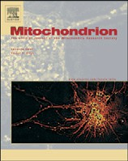[Mitochondrion 11 (2011) 104–107](http://dx.doi.org/10.1016/j.mito.2010.07.012)

Contents lists available at [ScienceDirect](http://www.sciencedirect.com/science/journal/15677249)

Mitochondrion

journal homepage: [www.el sevier.com/locate/mito](http://www.elsevier.com/locate/mito)

Application of oligonucleotide array CGH in the detection of a large intragenic deletion in *POLG* associated with Alpers Syndrome

Alison G. Compton a, Christopher Troedson b, Meredith Wilson c, Peter G. Procopis b, Fang-Yuan Li d,

Ellen K. Brundage d, Taro Yamazaki a,e, David R. Thorburn a,f,⁎, Lee-Jun C. Wong d

a *Murdoch Childrens Research Institute and Genetic Health Services Victoria, Royal Children's Hospital, Melbourne, Australia*

b *TY Nelson Department of Neurology, The Children's Hospital at Westmead, Sydney, Australia*

c *Western Sydney Genetics Program, The Children's Hospital at Westmead and Disciplines of Paediatrics and Child Health & Genetic Medicine, University of Sydney, Sydney, Australia*

d *Department of Molecular and Human Genetics, Baylor College of Medicine, Houston, USA*

e *Department of Pediatrics, School of Medicine, Saitama Medical University, Saitama, Japan*

f *Department of Paediatrics, University of Melbourne, Melbourne, Australia*

# a r t i c l e i n f o

*Article history:*

Received 18 June 2010

Received in revised form 23 July 2010 Accepted 23 July 2010

Available online 12 August 2010

*Keywords:*

POLG

Array CGH Intragenic deletion Alpers syndrome

# a b s t r a c t

Mutations in the polymerase γ (*POLG*) gene are among the most common causes of mitochondrial disease and more than 160 *POLG* mutations have been reported. However, a large proportion of patients suspected of having *POLG* mutations only have one (heterozygous) deﬁnitive pathogenic mutation identiﬁed. Using oligonucleotide array CGH, we identiﬁed a compound heterozygous large intragenic deletion encompassing

exons 15–21 of this gene in a child with Alpers syndrome due to mtDNA depletion. This is the ﬁrst large *POLG*

deletion reported and the ﬁndings show the clinical utility of using array CGH in cases where a single heterozygous mutation has been identiﬁed in *POLG*.

© 2010 Elsevier B.V. and Mitochondria Research Society. All rights reserved.

1. Introduction

DNA polymerase γ (POLG) encoded by the nuclear *POLG* gene (MIM# 174763) is the only known DNA polymerase in human mitochondria. It possesses both polymerase and 3′–5′ exonuclease activities and is essential for mitochondrial DNA (mtDNA) replication and repair. More than 160 coding variations in this gene have been identiﬁed since its identiﬁcation as a disease gene in 2001 ([http://](http://www.tools.niehs.nih.gov/polg/) [www.tools.niehs.nih.gov/polg/](http://www.tools.niehs.nih.gov/polg/)). Mutations in this gene cause sec-

ondary defects in mtDNA maintenance leading to respiratory chain dysfunction. The current diagnostic sequencing techniques only allow the detection of point mutations, small deletions or duplications, and several reports have commented on identifying only a single heterozygous autosomal recessive *POLG* mutation in multiple sus- pected *POLG* patients (Agostino et al., 2003; Blok et al., 2009; Filosto et al., 2003; Wong et al., 2008b).

Here we describe a patient with a common POLG disease presentation, Alpers syndrome (MIM# 203700), characterized by early age of onset, fatal intractable seizures, hepatic failure and global neurological deterioration (Naviaux and Nguyen, 2004). She was

⁎ Corresponding author. The Murdoch Childrens Research Institute, Royal Children's Hospital, Flemington Rd, Parkville 3052, Melbourne, Australia. Tel.: +61 3 8341 6235;

fax: +61 3 8341 6212.

*E-mail address:* [david.thorburn@mcri.edu.au](mailto:david.thorburn@mcri.edu.au) (D.R. Thorburn).

compound heterozygous for the common p.A467T *POLG* mutation and a novel large intragenic deletion of ~ 4.7 kb length. To our knowledge this is the ﬁrst reported case of a large deletion in *POLG*, illustrating the necessity of testing for intragenic deletions in all patients with a single heterozygous mutation identiﬁed.

1. Methods
   1. *Respiratory chain enzyme and mtDNA analysis*

Respiratory chain enzyme activities and relative abundance of mtDNA were assayed as described previously (Kirby et al., 1999; Pagnamenta et al., 2006). All enzyme and molecular investigations were performed as part of the diagnostic investigations for this patient with informed consent from the parents and in compliance with ethics approval by the Human Research Ethics Committee of the Royal Children's Hospital, Melbourne.

* 1. *Mutation analysis*

Mutation analysis was performed on genomic DNA using primers designed to amplify the coding exons and the exon–intron boundaries of *POLG* (NM_002693.2), *DGUOK* (NM_080916.1 and NM_080918.1), *MPV17* (NM_002437.4) and *C10orf2* (*PEO1*/*TWINKLE*) (NM_021830).

1567-7249/$ – see front matter © 2010 Elsevier B.V. and Mitochondria Research Society. All rights reserved. doi:[10.1016/j.mito.2010.07.012](http://dx.doi.org/10.1016/j.mito.2010.07.012)

*A.G. Compton et al. / Mitochondrion 11 (2011) 104*–*107* 105

Fragments were analysed by direct sequencing using ABI 3130XL (Applied Biosystems, Melbourne, VIC Australia).

* 1. *RNA analysis*

Primary ﬁbroblasts were cultured in media with or without 100 ng/μL cycloheximide (CHX) for 24 h prior to preparation of RNA in order to minimize nonsense mediated decay (Lamande et al., 1998) before total RNA was extracted using Illustra RNAspin Mini kit (GE Healthcare, Rydalmere, NSW Australia). PCR primers were designed to amplify the entire cDNA in one or two fragments.

* 1. *Analysis of deletion and breakpoints*

A custom designed clinical oligonucleotide Comparative Genomic Hybridization (CGH) array with complete coverage of the mitochon- drial genome and about 160 nuclear genes related to mitochondrial functions and metabolic diseases, including the *POLG* gene (Chinault et al., 2009; Wong et al., 2008a) was manufactured using the Agilent microarray platform (Agilent Technologies, Santa Clara, CA). Analysis of the deletion breakpoints was performed by PCR of the deletion junction detected by array CGH.

1. Results
   1. *Case report*

This patient was the ﬁrst child of non-consanguineous Caucasian parents. Her birth and perinatal history were unremarkable. She presented at 12 months of age with acute partial motor status epilepticus. Initial tests demonstrated mildly abnormal liver function tests and normal blood lactate. An MRI performed 10 h after the event demonstrated a focal area of restricted diffusion with overlying subtle gyral swelling in the right occipital lobe. Acutely the EEG demonstrated almost continuous paroxysmal lateralizing epileptiform discharges over the right hemisphere. She remained encephalopathic for 24 h. On day 3 she had a further episode of focal status, despite a therapeutic level of phenytoin. Seizures continued after phenobarbitone loading and she was commenced on a midazolam infusion. Her seizures settled and she was discharged home on phenobarbitone after a 2½week admission.

The patient had further admissions between 18 and 36 months, with repeated MRI showing progressively more extensive right sided diffusion changes involving the right occipital and parietal lobes plus the right posterior thalamus. At 2 years, the patient was admitted with left sided epilepsia partialis continua, which was resistant to multiple

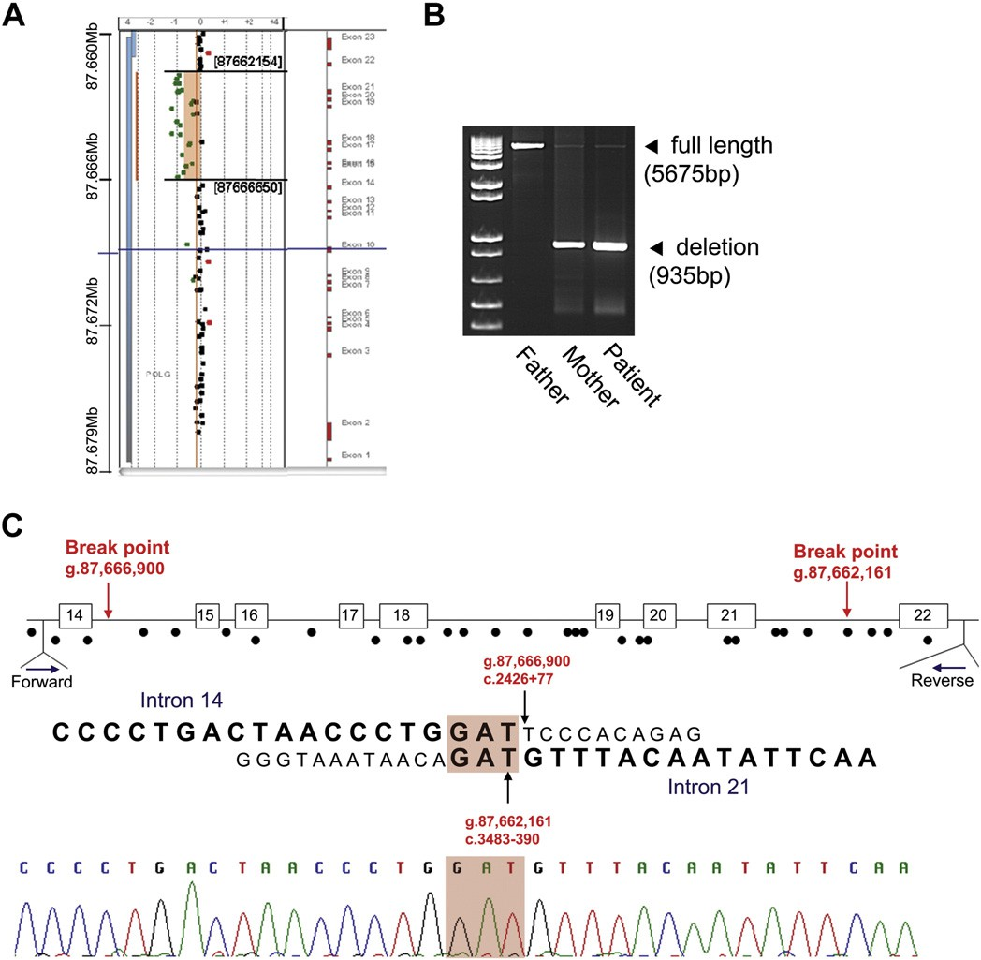

Fig. 1. Genomic DNA deletion analyses. A. Oligonucleotide array CGH analysis identiﬁed a heterozygous loss of ~ 4.5 kb (nucleotide position 87,662,154 to 87,666,650) in the long arm of chromosome 15, spanning from intron 14 to intron 21 of the *POLG* gene in the patient. Each dot indicates an oligonucleotide probe. Green dots represent copy number loss. The deletion region is boxed and the numbers are the coordinates of the estimated break points according to the reference sequence in the Ensembl database (ENSG00000140521 in version 54). Black dots represent no copy number changes and the red dots represent gain of copy number. The corresponding genomic structure of the *POLG* gene is on the right. B: Long-range PCR analysis of the *POLG* gene using primers located in introns 13 and 22 showed that a full-length product (5675 bp) could be detected in the father (F), mother (M)

and patient (P), however a deletion product of 935 bp was also detected in a heterozygous state in both the patient and her mother (primers: forward 5′-gcaggtactcacgttggttc-3′ and

reverse 5′-ctgttctccaagacccactt-3′). C: Sequencing of the genomic PCR deletion product identiﬁed the deletion breakpoints.

106 *A.G. Compton et al. / Mitochondrion 11 (2011) 104*–*107*

medications including topiramate, levetiracetam and clobazam, a ketogenic diet, zonisamide and a mitochondrial cocktail and no new developmental milestones were gained over the next 12 months. Liver function tests indicated a progressive hepatopathy from age 2 year 10 months. At 36 months, she had a catastrophic deterioration and was

found unresponsive with right arm tonic–clonic jerking and right leg

stiffness. MRI brain and EEG demonstrated new extensive left hemispheric involvement. Further neurological deterioration contin- ued; her seizures were intractable, she required tube feeding, and was cortically blind. She died at age 3 years 6 months.

* 1. *Mitochondrial enzyme and molecular studies*

Liver respiratory chain enzymes showed Complex I deﬁciency (16% of normal control mean relative to Complex II) with an overall proﬁle suggestive of mtDNA depletion, which was conﬁrmed by qPCR (8% of the mean normal control amount of mtDNA relative to nuclear DNA). Residual enzyme activities relative to protein were 53% Complex I, 330% Complex II, 117% Complex III, 110% Complex IV and 221% citrate synthase.

Sequence analysis of genomic DNA for the three most common pathogenic *POLG* mutations in the Australian population (Hakonen et al., 2007) identiﬁed a heterozygous p.A467T (c.1399GNA) mutation. Full *POLG* sequencing did not reveal any other mutations. Other genes associated with hepatic mtDNA depletion, *MPV17*, *C10orf2* and *DGUOK* were also sequenced. No potentially pathogenic mutations were found in *MPV17* or *C10orf2*. However, a heterozygous c.509ANG (p.Q170R) sequence variant was identiﬁed in *DGUOK*. This variant had been reported previously in a patient with hepatic mtDNA depletion (Freisinger et al., 2006) but is now regarded as a polymorphism. Sequence analysis of parental DNA demonstrated that her father carried both the *POLG* p.A467T mutation and the *DGUOK* sequence variant, making digenic inheritance unlikely. cDNA sequencing of exons 5 to 8 of *POLG* (from ﬁbroblasts grown±CHX) showed the presence of the heterozygous c.1399GNA *POLG* mutation, indicating that both alleles are expressed and that nonsense mediated mRNA decay was not occurring. Array CGH analysis on patient lymphocyte DNA revealed a heterozygous loss of approximately 4.5 kb (nucleotide positions

87,662,154 to 87,666,650) in the long arm of chromosome 15, spanning intron 14 to intron 21 of the *POLG* gene (Fig. 1A). Long-range PCR of this region conﬁrmed the large intragenic deletion was inherited from the mother (Fig. 1B). Sequence analysis of the PCR products revealed a 4740 bp deletion (87,662,161 to 87,666,900 or c.2426 + 77 to c.3483 − 390, inclusive) with a direct repeat of 3 nucleotides of GAT (c.2426 + 74_76 and c.3483 − 390_392) ﬂanking the break points (Fig. 1C). Ampliﬁcation of the patient's cDNA (using primers anchored in exons 12 and 23) showed that this large deletion resulted in skipping of exons 15 to 21 (inclusive) without nonsense mediated mRNA decay (Fig. 2A). Sequence analysis showed that this deletion leads to an in-frame skipping of all three of the highly conserved C-terminal polymerase motifs in a truncated POLG protein, c.2427_3482del1056; p.S809_T1160del352 (Fig. 2B).

1. Discussion

Hepatocerebral mtDNA depletion syndrome has been associated with mutations in four nuclear genes (*POLG*, *DGUOK*, *MPV17*, and *C10orf2*). Identiﬁcation of the speciﬁc disease gene carries important prognostic information; however, there is often a lack of clear phenotype:genotype correlation. Between these four genes there are almost 200 reported mutations. All previous *POLG* mutations and virtually all those in other genes have either been point mutations or small insertions or deletions. In this paper, we report a novel intragenic ~ 4.7 kb deletion in *POLG*, which was not detectable by conventional genomic sequence analysis.

Recently, two large studies of *POLG* patients reported that 40.5% (15/ 37) and 46% (28/61) of patients, respectively had only one deﬁnitive (heterozygous) pathogenic mutation identiﬁed (Blok et al., 2009; Wong et al., 2008b). As such, the molecular diagnosis for these 43 patients is still unclear and suggests either locus heterogeneity or undetected mutations outside of the *POLG* coding region (such as the intronic or promoter regions). Locus heterogeneity or digenic inheritance has been suggested previously for a PEO patient with recessive mutations in both *POLG* and *C10orf2* (Van Goethem et al., 2003). In light of our current patient the importance of testing all patients with a single heterozygous

[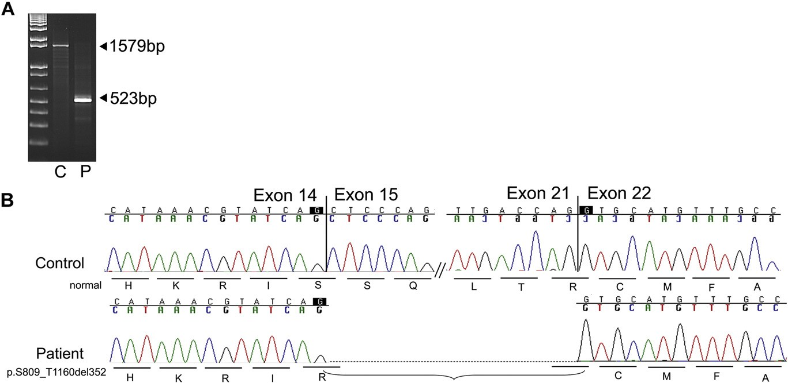](image%20of%20Fig. 2)

Fig. 2. Analysis of patient's cDNA. A: PCR products of exons 12–23 from control and patient's ﬁbroblast cDNA. A PCR product of 1579 bp was detected in control (C) while a smaller band (523 bp) was detected in patient's (P) cDNA indicating a deletion of ~ 1 kb in size. B: Sequencing of the cDNA deletion product revealed skipping of exons 15–21 (inclusive) leaving the protein in frame but lacking the polymerase catalytic domain.

*A.G. Compton et al. / Mitochondrion 11 (2011) 104*–*107* 107

mutation in *POLG* for intragenic deletions becomes more important and supports the value in targeted CGH array analyses.

In conclusion, this report demonstrates that *POLG* deﬁciency can result from large intragenic deletions, and that custom oligonucleotide array CGH should be considered to screen the large number of patients previously identiﬁed as having a single heterozygous mutation in this gene.

1. Conﬂict of interest

The authors declare no conﬂict of interest.

Acknowledgement

This work was supported by grants and a Principal Research Fellowship (DRT) from the Australian National Health and Medical Research Council.

References

Agostino, A., Valletta, L., Chinnery, P.F., Ferrari, G., Carrara, F., Taylor, R.W., Schaefer, A.M., Turnbull, D.M., Tiranti, V., Zeviani, M., 2003. Mutations of ANT1, Twinkle, and POLG1 in sporadic progressive external ophthalmoplegia (PEO). Neurology 60, 1354–1356. Blok, M.J., van den Bosch, B.J., Jongen, E., Hendrickx, A., de Die-Smulders, C.E., Hoogendijk, J.E.,

Brusse, E., de Visser, M., Poll-The, B.T., Bierau, J., de Coo, I.F., Smeets, H.J., 2009. The unfolding clinical spectrum of POLG mutations. J. Med. Genet. 46, 776–785.

Chinault, A.C., Shaw, C.A., Brundage, E.K., Tang, L.Y., Wong, L.J., 2009. Application of dual-genome oligonucleotide array-based comparative genomic hybridization to the molecular diagnosis of mitochondrial DNA deletion and depletion syndromes. Genet. Med. 11, 518–526.

Filosto, M., Mancuso, M., Nishigaki, Y., Pancrudo, J., Harati, Y., Gooch, C., Mankodi, A., Bayne, L., Bonilla, E., Shanske, S., Hirano, M., DiMauro, S., 2003. Clinical and genetic

heterogeneity in progressive external ophthalmoplegia due to mutations in polymerase gamma. Arch. Neurol. 60, 1279–1284.

Freisinger, P., Futterer, N., Lankes, E., Gempel, K., Berger, T.M., Spalinger, J., Hoerbe, A., Schwantes, C., Lindner, M., Santer, R., Burdelski, M., Schaefer, H., Setzer, B., Walker, U.A., Horvath, R., 2006. Hepatocerebral mitochondrial DNA depletion syndrome

caused by deoxyguanosine kinase (DGUOK) mutations. Arch. Neurol. 63, 1129–1134.

Hakonen, A.H., Davidzon, G., Salemi, R., Bindoff, L.A., Van Goethem, G., DiMauro, S., Thorburn, D.R., Suomalainen, A., 2007. Abundance of the POLG disease mutations in Europe, Australia, New Zealand, and the United States explained by single ancient European founders. Eur. J. Hum. Genet. 15, 779–783.

Kirby, D.M., Crawford, M., Cleary, M.A., Dahl, H.H., Dennett, X., Thorburn, D.R., 1999. Respiratory chain complex I deﬁciency: an underdiagnosed energy generation disorder. Neurology 52, 1255–1264.

Lamande, S.R., Bateman, J.F., Hutchison, W., McKinlay Gardner, R.J., Bower, S.P., Byrne, E., Dahl, H.H., 1998. Reduced collagen VI causes Bethlem myopathy: a heterozygous COL6A1 nonsense mutation results in mRNA decay and functional haploinsufﬁ- ciency. Hum. Mol. Genet. 7, 981–989.

Naviaux, R.K., Nguyen, K.V., 2004. POLG mutations associated with Alpers' syndrome and mitochondrial DNA depletion. Ann. Neurol. 55, 706–712.

Pagnamenta, A.T., Taanman, J.W., Wilson, C.J., Anderson, N.E., Marotta, R., Duncan, A.J., Bitner-Glindzicz, M., Taylor, R.W., Laskowski, A., Thorburn, D.R., Rahman, S., 2006. Dominant inheritance of premature ovarian failure associated with mutant mitochondrial DNA polymerase gamma. Hum. Reprod. 21, 2467–2473.

Van Goethem, G., Lofgren, A., Dermaut, B., Ceuterick, C., Martin, J.J., Van Broeckhoven, C., 2003. Digenic progressive external ophthalmoplegia in a sporadic patient: recessive mutations in POLG and C10orf2/Twinkle. Hum. Mutat. 22, 175–176.

Wong, L.J., Dimmock, D., Geraghty, M.T., Quan, R., Lichter-Konecki, U., Wang, J., Brundage, E.K., Scaglia, F., Chinault, A.C., 2008a. Utility of oligonucleotide array- based comparative genomic hybridization for detection of target gene deletions. Clin. Chem. 54, 1141–1148.

Wong, L.J., Naviaux, R.K., Brunetti-Pierri, N., Zhang, Q., Schmitt, E.S., Truong, C., Milone, M., Cohen, B.H., Wical, B., Ganesh, J., Basinger, A.A., Burton, B.K., Swoboda, K., Gilbert, D.L., Vanderver, A., Saneto, R.P., Maranda, B., Arnold, G., Abdenur, J.E., Waters, P.J., Copeland, W.C., 2008b. Molecular and clinical genetics of mitochondrial diseases due to POLG mutations. Hum. Mutat. 29,

E150–E172.