*Movement Disorders*

Vol. 25, No. 14, 2010, pp. 2461–2477

© 2010 Movement Disorder Society

Letters to the Editor Related to New Topics

# Retina Thickness in Parkinson’s Disease and Essential Tremor

Visual symptoms, particularly impaired foveal vision, are common among the nonmotor phenomena in Parkinson’s dis- ease (PD). Experimental evidence from humans and monkeys shows that there are dopaminergic cells in the retina, includ- ing the amacrine subtype A18 with D1 and D2 receptors, and interplexiform cells.

Postmortem studies have shown that PD eyes have lower dopamine content,1 compared with healthy controls. Like- wise, a loss in the sensitivity to contrast and color vision, altered visual evoked potential, and electroretinographic measurements have been observed, indicating foveal retinal ganglion cells damage in PD.2

Quantitative morphology of gross retinal histology in humans can be measured in vivo using time domain *Optical Coherence Tomography* (*OCT*). In PD a thinning of the peri- papillary retinal nerve ﬁber layer, which represents axons of the ganglion cells, and macula have been shown, supporting the hypothesis that dopaminergic deﬁcit in the retina can cause structural changes.2–5 However, the usefulness of meas- uring foveal thickness by *OCT* as a diagnostic tool to differ- entiate PD from other tremor disease, such as essential tremor (ET) remains unknown. Therefore, the main purpose of this pilot study was to measure foveal thickness in patients with PD, and to compare it against a normal population and patients with ET.

We designed a cross-sectional pilot study that included a consecutive sample of outpatients diagnosed with idiopathic PD in accordance with the UK Parkinson’s Disease Society brain bank, and ET based on clinical criteria. Patients with any coexisting ocular disease were excluded. This study was approved by the Ethics Committee of the General Yagu¨e Hospital, Burgos (Spain), and all patients signed the informed consent before being enrolled. Control subjects were matched for age (6 5 years) and gender to PD patients. Demographic and PD/ET laterality data were collected. *OCT* was acquired through a dilated pupil by an experienced operator using the *OCT3* (Carl Zeiss Meditec, Dublin, Calif), with axial resolu- tion of < 10 lm. The macular thickness map analysis and the center foveal thickness was automatically determined by the *OCT3* software.6 Images were considered to be of good quality if the signal-to-noise ratio was greater than 30dB or had more than 95% sweeps accepted.

Data analysis was performed from an exploratory point of view using the statistical package *SPSS program* (*SPSS 17*; SPSS, Chicago). Only descriptive analysis was used, owing to the small sample size. Data were summarized as mean 6

Potential conﬂict of interest: Nothing to report.

Published online 28 July 2010 in Wiley Online Library (wileyonlinelibrary.com). DOI: 10.1002/mds.23215

standard deviation, and median (range). To maintain inde- pendence of all observations, right eye [RE] versus left eye [LE] were analyzed for each patient.

Fifty-two eyes from 9 patients with PD (5 men and 4 women) with a mean age of 64.1 + 12 years and disease du- ration of 8.4 6 1.9 years, 8 patients with ET (4 men and 4 women) with a mean age of 67.8 6 4.8 years and disease du- ration of 23.7 6 18.3 years, and 9 controls were included. The mean foveal thickness was thinner in the PD group com- pared with the ET group and controls (Table 1). For the PD and ET groups, the mean foveal thickness was also thinner in the contra lateral eye of the most affected side (Table 1).

In this pilot study, based on the *OCT* imaging, the fovea was thinner in the PD group compared with the ET group and controls. Interestingly, whereas interocular macular sym- metry has been found in the normal population,7 we found that the foveal thickness was asymmetric and thinner in the eye contralateral to the side more affected by tremor and par- kinsonism in the ET and PD groups, respectively. Hajee et al, also found the correlation between thinning in the left and the right eye of the same was not perfect.7 Hence, this interocular foveal asymmetry should be considered in inter- pretation. Except that for ET, although mild tremor asymme- try has been documented as a fundamental characteristic of ET, there is no published information regarding foveal thick- ness in patients with ET. The similar asymmetry ﬁnding in ET is difﬁcult to understand, and we cannot obviously explain it based on our preliminary data. However, abnormal OCT measures have also been found in other neurodegenera- tive diseases, such as Alzheimer’s disease, multiple sclerosis, and spinocerebellar ataxias, most likely related to the loss of retinal ganglion cells and axons.8 Therefore, further studies are required to establish whether OCT measures contribute for a sensitive and speciﬁc diagnosis of PD and to differenti- ate it from other conditions. We recognize our results cannot be compared with prior *OCT* reports in PD because of the different imaging map protocol and equipment. We are also aware that because of the small sample size used, these results need to be repeated in larger cohorts to ensure repro- ducibility.

With regards to technical feasibility, the OCT compared with other expensive ones, such as the single photon emission computed tomography (SPECT) studies using 123I-FP-CIT (DAT scan), is widely available, fast, as it only takes a few minutes to perform, and relatively inexpensive. Based on our preliminary data, and in accordance with other authors,2–5 we believe that foveal thickness measured by the OCT could be a promising, feasible biomarker of PD, by quantifying the mor- phological changes of retinal dopaminergic neurons.

Acknowledgment: This study was supported by a grant from Caja Burgos 2009.

Financial Disclosures: Cubo E—Honoraria: Boehringer Ingelheim, Glaxo Smith Kline, Lundbeck; Grant: Michael J

### 2461

|  |  |  |
| --- | --- | --- |
| *2462* | *LETTERS TO THE EDITOR* |  |
|  | TABLE 1. *Clinical characteristics and Retina thickness* |
|  | Total retina thickness | Right eye/left eye retina thickness |
|  | (lm) mean (SD) [Range] | (lm) median range) |
| Controls (n 5 9) | 218.9 (15.3) [189-238] | 221 (194–235)/221 (182–252) |
| Parkinson’s disease | 202.2 (27.8) [154-227.5] | 207 (117–248)/214 (148–257) |
| Right PD (n 5 5) | 203.4 (28.7) [154-227] | 214 (154–248)/207 (148–257) |
| Left PD (n 5 4) | 200.7 (30.7) [155-229] | 202 (117–222)/219 193–232) |
| Essential tremor | 207.3 (27.3) [174-5-242.5] | 220 (177–228)/196 (152–257) |
| Right ET (n 5 3) | 198.6 (13.8) [186-213.5] | 220 (220–224)/169 (152–207) |
| Left ET (n 5 5) | 212.6 (28.2) [174.5-242-5] | 220 (177–228)/226 (172–257) |

Fox, FIS, Sacyl. Prieto Tedejo R—None. Rodriguez Mendez V—None. Lo´pez Pueyo MJ—None. Trejo Gabriel y Gala´n JM—Honoraria: Pﬁzer, Grants: Servier, Sanoﬁ, Esteve, Sacyl, Michael J Fox.

Author Roles: Cubo E—Research project: conception and organization; Statistical Analysis: design and execution; writ- ing of the ﬁrst draft of the manuscript. Prieto Tedejo R— research project: organization and execution. Rodriguez Men- dez V—research project: organization; Lo´pez Pueyo MJ— review and critique of statistical analysis and manuscript. Trejo Gabriel y Gala´n JM—review and critique of statistical analysis and manuscript.

Esther Cubo, MD, PhD* Rosa Prieto Tedejo *Neurology Department Hospital General Yagu¨e*

*Burgos, Spain*

*\*E-mail:* [*esthercubo@gmail.com*](mailto:esthercubo@gmail.com)

Vero´nica Rodriguez Mendez, MD Mar´ıa Jesu´s Lo´pez Pen˜a, MD, PhD *Ophthalmology Department Hospital General Yagu¨e*

*Burgos, Spain*

Jose´ Mar´ıa Trejo Gabriel y Gala´n, MD, PhD

*Neurology Department Hospital General Yagu¨e*

*Burgos, Spain*

## References

1. Harnois C, DiPaolo T. Decreased dopamine in the retina of patients with Parkinson’s disease. Invest Ophthalmol 1990;31: 2473–2475.
2. Bodis-Wollner I. Retinopathy in Parkinson’s disease. J Neural Transm 2009;116:1493–1501.
3. Hajee ME, March WF, Lazzaro DR, Wolintz AH, Shrier EM, Glaz- man S, Bodis-Wollner IG. Inner retinal layer thinning in Parkinson disease. Arch Ophthalmol 2009;127:737–741.
4. Altintas¸ O, Is¸eri P, Ozkan B, Cag˘lar Y. Correlation between retinal morphological and functional ﬁndings and clinical severity in Par- kinson’s disease. Doc Ophthalmol 2008;116:137–146.
5. Inzelberg R, Ramirez JA, Nisipeanu P, Ophir A. Retinal nerve ﬁber
6. Berisha F, Feke GT, Trempe CL, McMeel JW, Schepens CL. Reti- nal abnormalities in early Alzheimer’s disease. Invest Ophthalmol Vis Sci 2007;48:2285–2289.
7. Lamirel C, Newman N, Biousse V. The use of optical coherence to- mography in neurology. Rev Neurol Dis 2009;6:105–120.

# Acute Renal Failure in Patients with Bilateral Deep Brain Stimulation

The management of Parkinson’s disease is mainly pharma- cological with levodopa but in recent years, surgery [deep brain stimulation of the subthalamic nucleus (STN-DBS)] has been revitalized for the treatment of patients with uncontrol- lable motor complications.1

A large proportion of patients suffering from Parkinson’s disease presents with urinary dysfunction described as urgency, increased frequency or incontinence as predominant symptoms2,3 and also STN-DBS has proven to improve uri- nary function.4 Data from experimental urodynamic measures in men and animal models have demonstrated a signiﬁcant inﬂuence of STN-DBS on urinary bladder function.5,6 In these studies, the main effect of STN-DBS appeared to be a normalization of urodynamic parameters but there is no data reported about kidney function in these patients.7 Despite its clinical efﬁcacy, the manifold physiological consequences of STN-DBS are to date poorly understood.

Acute renal failure (ARF) deﬁned as an abrupt or rapid decline in renal ﬁltration function and creatinine clearance (CC) is used to estimate the glomerular ﬁltration rate (GFR). The CC test compares the level of creatinine in urine with the creatinine level in the blood, usually based on measure- ments of a 24-hour urine sample. GFR has never been stud- ied in Parkinson patients with normal preoperative renal function immediately after STN-DBS. Here, we report a decline in renal ﬁltration function after STN-DBS.

Nineteen patients (15 men and four women) with a mean (6SD) age of 63 6 7 years at the time of surgery and a mean duration of disease of 16 6 9 years were selected for implantation of electrodes in the STN. The selection criteria were clinically diagnosed Parkinson’s disease, severe levo- dopa-related motor complications despite optimal adjustment of antiparkinsonian medication, an age under 70 years, no

layer thinning in Parkinson disease. Vision Res 2004;44: 2793–

2797.

1. El-Ashry M, Hegde V, James P, Pagliarini S. Analysis of macular thickness in British population using optical coherence tomography (OCT): an emphasis on interocular symmetry. Curr Eye Res 2008;33:693–699.

Potential conﬂict of interest: There is no potential conﬂicts of interest from each author that relate to the research covered in the article submitted.

Published online 28 July 2010 in Wiley Online Library (wileyonlinelibrary.com). DOI: 10.1002/mds.23228

15318257, 2010, 14, Downloaded from https://movementdisorders.onlinelibrary.wiley.com/doi/10.1002/mds.23307 by The University Of Manchester, Wiley Online Library on [22/05/2025]. See the Terms and Conditions (https://onlinelibrary.wiley.com/terms-and-conditions) on Wiley Online Library for rules of use; OA articles are governed by the applicable Creative Commons License

*Movement Disorders, Vol. 25, No. 14, 2010*

### LETTERS TO THE EDITOR 2463

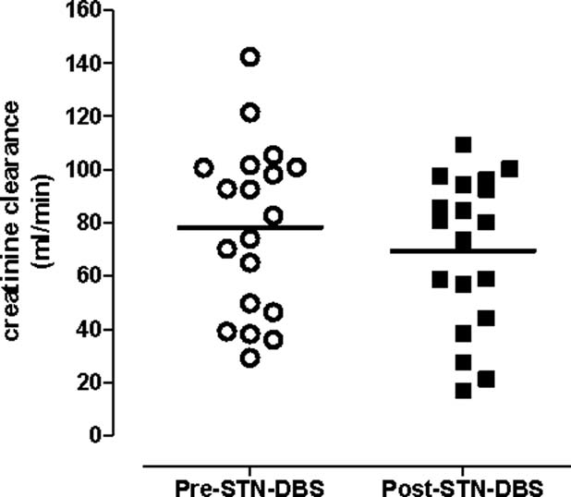

FIG. 1. Creatinine clearance before and after STN-DBS.

surgical contraindications, and no dementia or major ongoing psychiatric illness. Electrodes were implanted bilaterally under local anesthesia as described previously.8

Patients were evaluated preoperatively (1 week after sur- gery) and postoperatively (1 week after surgery). Evaluations included (1) the Uniﬁed Parkinson’s Disease Rating Scale (UPDRS) parts III (motor); (2) mean dose of levodopa; (3) all medical manifestations; (4) 24 hours urine; (5) urine iono- gram and biochemistry (6) blood ionogram; and (7) CC.

CC and fractional excretion of sodium, potassium, and phosphate were calculated as previously reported (5). Urea was measured by an enzymatic test and creatinine by the Jaffe´ method. Ion-selective electrodes performed the quan- tiﬁcations of sodium and potassium in urine samples. Phosphate was determined by a direct photometric method. All assays were performed by Cobas Mira Plus analyser (ABX Diagnostics, Geneva, Switzerland). Urine and plasma osmolality were determined by means of an os-

changes were observed in urine and blood ionogram before and after surgery (Table 1).

STN-DBS has been shown to ameliorate bladder dysfunc- tion (increases bladder capacity) in patients with Parkinson’s disease, by modulation of sensory processing.9 It appears to be a normalization of urodynamic parameters, but there is no data reported about kidney function in these patients.

In our patients kidney function was altered immediately after surgery. A decline in ﬁltration function developed after STN-DBS and some patients without preoperative RI devel- oped acute RI postoperatively. In these patients no urinary retention occurred, urinary volume was similar before and after surgery. No preoperative hemodynamic complications, as dehydration occurred; like other series, neurostimulator implantation anesthetic technique is not associated with major hemodynamic adverse effects.10

A recent study of experimentally induced ARF showed that there is a close interaction between the kidney and the central nervous system.11 Sympathetic inﬂuence in kidney functions is under control of brainstem biogenic amine cell groups and hypo- thalamic nuclei.12,13 It cannot be excluded that there may be regional effects of DBS-STN on hypothalamic centers, depending on the exact location of the contacts in the STN area.

Effect of DBS-STN in hypothalamic centers remains a valid hypothesis which could explain an altered kidney func- tion immediately after surgery, but further investigations are required to explore this possible mechanism. With these pre- liminary results the authors suggest that it is necessary to evaluate CC before and after surgery for early orientation of patients with RI.

Acknowledgments: We thank the Clinical Investigation Center of Hospital de Sa˜o Joa˜o.

Financial Disclosures: The authors have no ﬁnancial dis- closures or nothing to disclose. Financial disclosures of all authors for the past year: none of the authors have received

TABLE 1. *Urine and blood ionogram before and after surgery*

mometer (model 3 MO, Advanced Instruments). Wilcoxon signed rank test and Spearman test were used for statistical

Parkinson patient experimental conditions

STN-DBS

before

STN-DBS

after

analysis.

24 hours urine volume (mL) 1,601 6 562 1,521 6 583

After surgery, DBS-STN produced a statistically and clini-

cally signiﬁcant reduction in mean Uniﬁed Parkison’s Disease Rating Scale (UPDRS) motor scores. UPRSS-III was signiﬁ-

Glomerular ﬁltration rate (mL/min)

Blood ionogram

78.2 6 31.1* 69.3 6 27.9*

cantly improved after DBS-STN (*P* < 0.005): 52 6 8.3 before

surgery and 16.5 6 8.4, 1 week after surgery. As well as a ma

red 49

Sodium (mEq/L) 139 6 2.2 136 6 2.1

Potassium (mEq/L) 4.1 6 0.1 4.0 6 0.1

Mean estimated GFR, calculated by CC (mL/min) declined signiﬁcantly (*P* < 0.005) after STN-DBS, from 78.2 6 31.1

15318257, 2010, 14, Downloaded from https://movementdisorders.onlinelibrary.wiley.com/doi/10.1002/mds.23307 by The University Of Manchester, Wiley Online Library on [22/05/2025]. See the Terms and Conditions (https://onlinelibrary.wiley.com/terms-and-conditions) on Wiley Online Library for rules of use; OA articles are governed by the applicable Creative Commons License

to 69.3 6 27.9 (Fig. 1). Moreover, three patients without pre- operative renal insufﬁciency (RI) (CC < 90 mL/min) devel- oped acute RI postoperatively: stage 2 RI in two patients; and stage 3 RI in one patient. Three patients with preopera- tive RI exacerbated: stage 2 into stage 3 in one patient; and stage 3 into stage 4 in two patients.

Mean urinary volume in mL/day were similar preopera- tively (1,601 6 562) and postoperatively (1,521 6 583). No

Urine ionogram

Sodium (mmmol/L) 109 6 40 123 6 67

|  |  |  |
| --- | --- | --- |
| jor amelioration in therapy-related complications, with a Chloride (mEq/L)  uction in mean levodopa dosage (mg/day): from 1,118 6 Blood biochemistry  6 before surgery to 653 6 447 after surgery. Urea (g/L) | 105 6 4.6  0.43 6 0.1 | 108 6 4.9  0.44 6 0.1 |
| Creatinine (mg/L) | 10.3 6 1.9 | 10.3 6 1.8 |

Potassium (mmmol/L) 33.7 6 11.3 33.7 6 10.4

Calcium (mg/dL) 8.2 6 4.2 7.7 6 4.3

Phosporum (mg/dL) 59.8 6 26.1 55.1 6 27.9

Uric acid (mg/dL) 6.4 6 5.3 10.3 6 7.6

Urine biochemistry

|  |  |  |
| --- | --- | --- |
| Urea (mg/dL) | 1,821 6 691.6 | 1,669 6 631.2 |
| Creatinine (mg/dL) | 76.39 6 36 | 72.0 6 35 |
| \**P* < 0.0001. |  |  |

*Movement Disorders, Vol. 25, No. 14, 2010*

### 2464 LETTERS TO THE EDITOR

ﬁnancial support and funding for the preceding 12 months of the listed sources, regardless of relationship to current manuscript.

Author Roles: Joana Guimara˜es: Research project (Con- ception, Organization, Execution); Statistical Analysis (Design); Manuscript (Writing of the ﬁrst draft, Review and Critique); Augusta Vieira-Coelho: Research project (Concep- tion); Manuscript (Writing of the ﬁrst draft, Review and Cri- tique); Maria Jose´ Rosas: Research project (Conception, Or- ganization, Execution); Manuscript (Writing of the ﬁrst draft, Review and Critique); Eduardo Moura: Research project (Execution); Statistical Analysis (Design, Execution, Review and Critique); Manuscript (Writing of the ﬁrst draft); Rui Vaz: Research project (Conception, Organization); Manu- script (Review and Critique); Carolina Garrett: Research pro- ject (Conception, Organization).

Joana Guimara˜es, MD* *Neurology Department, Faculty of Medicine University of Porto, Hospital de Sa˜o Joa˜o*

*Alameda Professor Hernaˆni Monteiro, Porto 4200, Portugal*

*\*E-mail:* [*jguimraes9@hotmail.com*](mailto:jguimraes9@hotmail.com)

Augusta Vieira-Coelho, MD, PhD *Institute of Pharmacology and Therapeutics Faculty of Medicine, University of Porto Hospital de Sa˜o Joa˜o, Hospital de Sa˜o Joa˜o*

*Alameda Professor Hernaˆni Monteiro, Porto 4200, Portugal*

Maria Jose´ Rosas, MD *Neurology Department, Hospital de Sa˜o Joa˜o, Alameda Professor Hernaˆni Monteiro, Porto 4200, Portugal*

Eduardo Moura, MD, PhD *Institute of Pharmacology and Therapeutics Faculty of Medicine, University of Porto Hospital de Sa˜o Joa˜o, Hospital de Sa˜o Joa˜o*

*Alameda Professor Hernaˆni Monteiro, Porto 4200, Portugal*

Rui Vaz, MD, PhD Carolina Garrett, MD, PhD

*Neurosurgery Department, Faculty of Medicine University of Porto, Hospital de Sa˜o Joa˜o*

*Hospital de Sa˜o Joa˜o Alameda Professor Hernaˆni Monteiro, Porto 4200, Portugal*

## References

1. Krack P, Batir A, Van Blercom N, et al. Five-year follow-up of bilateral stimulation of the subthalamic nucleus in advanced Par- kinson’s disease. N Engl J Med 2003;349:1925–1934.
2. Lemack GE, Dewey RB Jr, Roehrborn CG, O’Suilleabhain PE, Zimmern PE. Questionnaire-based assessment of bladder dysfunc- tion in patients with mild to moderate Parkinson’s disease. Urol- ogy 2000;56:250–254.
3. Winge K, Fowler CJ. Bladder dysfunction in Parkinsonism: mechanisms, prevalence, symptoms, and management. Mov Dis- ord 2006;21:737–745.
4. Herzog J, Weiss PH, Assmus A, et al. Improved sensory gating of urinary bladder afferents in Parkinson’s disease following sub- thalamic stimulation. Brain 2008;131 (Pt 1):132–145.
5. Krack P, Batir A, Van Blercom N, et al. Five-year follow-up of bilateral stimulation of the subthalamic nucleus in advanced Par- kinson’s disease. N Engl J Med 2003;349:1925–1934.
6. Seif C, Herzog J, van der Horst C, et al. Effect of subthalamic deep brain stimulation on the function of the urinary bladder. Ann Neurol 2004;55:118–120.
7. Herzog J, Weiss PH, Assmus A, et al. Subthalamic stimulation modulates cortical control of urinary bladder in Parkinson’s dis- ease. Brain 2006;129:3366–3375.
8. Lemaire JJ, Coste J, Ouchchane L, et al. Brain mapping in ste- reotactic surgery: a brief overview from the probabilistic target- ing to the patient-based anatomic mapping. Neuroimage 2007;37 (Suppl. 1):S109–S115.
9. Karimi M, Golchin N, Tabbal SD, et al. Subthalamic nucleus stimula- tion-induced regional blood ﬂow responses correlate with improvement of motor signs in Parkinson disease. Brain 2008;131:2710–2719.
10. Poon CC, Irwin MG. Anaesthesia for deep brain stimulation and in patients with implanted neurostimulator devices. Br J Anaesth 2009;103:152–165.
11. Palkovits M, Sebekova K, Gallatz K, et al. Neuronal activation in the CNS during different forms of acute renal failure in rats. Neuroscience 2009;159:862–882.
12. Turner MS, Gray TS, Mickiewicz AL, Napier TC. Fos expression following activation of the ventral pallidum in normal rats and in a model of Parkinson’s Disease: implications for limbic system and basal ganglia interactions. Brain Struct Funct 2008;213:197– 213.
13. Kitta T, Matsumoto M, Tanaka H, Mitsui T, Yoshioka M, Non- omura K. GABAergic mechanism mediated via D receptors in the rat periaqueductal gray participates in the micturition reﬂex: an in vivo microdialysis study. Eur J Neurosci 2008;27:3216– 3225.

# ADEM Presenting as a Movement Disorder

Video 

Acute disseminated encephalomyelitis (ADEM) is a demyelinating disease of the central nervous system charac- terized by multifocal neurological deﬁcits and encephalop- athy.1 We report a patient with ADEM who presented with a movement disorder.

A 44-year-old woman was admitted with choreiform movements. Her medications included sodium valproate 400 mg thrice daily for migraine and phenelzine 30 mg twice daily for schizoaffective disorder. The patient had developed involuntary movements in her left leg 3 days following an upper respiratory tract infection. The movements progressed to involve both upper and lower limbs. Phenelzine was ceased with no improvement. Examination revealed chorei- form movements affecting the upper limb and lower limb, particularly on the left. The movements were continuous, with intermittent brief jerks (See Video 1).

CT brain was unremarkable. Blood glucose was normal. The creatine kinase (CK) was elevated at 9882 lmol/L, decreasing to 835 lmol/L by day 5. Sodium valproate level was 106 lmol/L (therapeutic range 350–700 lmol/L). The ASOT was elevated at 473 IU/mL, and increased to 837 IU/ mL after 2 weeks. Anti-DNAse B titre remained negative.

Additional Supporting Information may be found in the online ver- sion of this article.

Potential conﬂict of interest: Nothing to report.

Published online 24 August 2010 in Wiley Online Library (wileyonlinelibrary.com). DOI: 10.1002/mds.23229

15318257, 2010, 14, Downloaded from https://movementdisorders.onlinelibrary.wiley.com/doi/10.1002/mds.23307 by The University Of Manchester, Wiley Online Library on [22/05/2025]. See the Terms and Conditions (https://onlinelibrary.wiley.com/terms-and-conditions) on Wiley Online Library for rules of use; OA articles are governed by the applicable Creative Commons License

*Movement Disorders, Vol. 25, No. 14, 2010*

### LETTERS TO THE EDITOR 2465

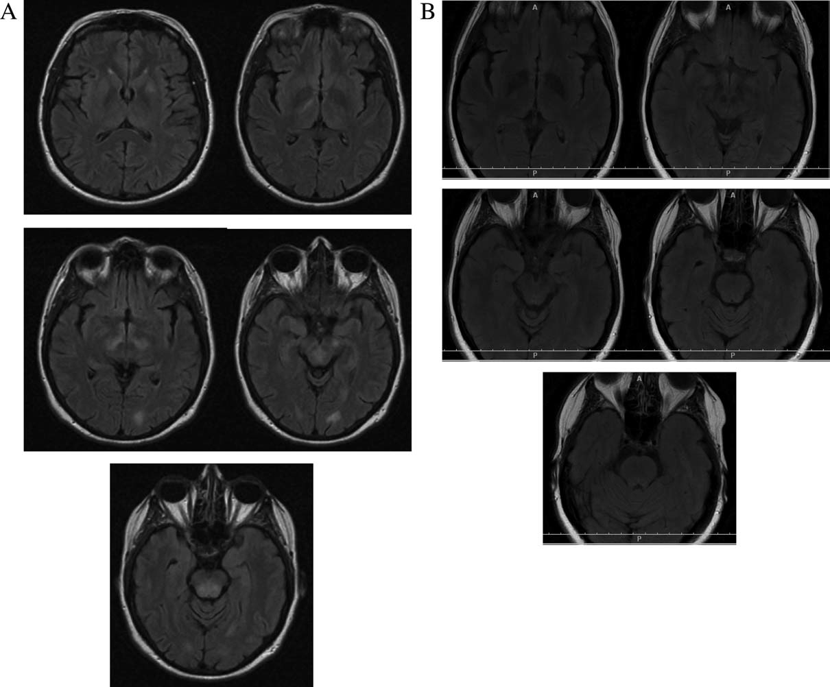

FIG. 1 (A) Axial ﬂuid-attenuated inversion recovery (FLAIR) MRI brain. Multiple foci of hyperintenstiy in the subthalamic regions, brainstem, cerebellum (not shown), left occipital white matter, and left lentiform nucleus. (B) Repeat axial ﬂuid-attenuated inversion recovery (FLAIR) MRI brain three months after onset, showing resolution of lesions.

The patient was commenced on benzylpenicillin and clo- nazepam. Phenelzine was recommenced. Her movement dis- order improved within a few days and resolved over the fol- lowing several days. On the 5th day, the patient developed a fever and left-sided 6th nerve palsy. The cerebrospinal ﬂuid (CSF) showed normal protein and glucose and one mononu- clear cell. Oligoclonal bands were not present. MRI brain revealed multiple nonenhancing foci of hyperintensity in the subthalamic regions bilaterally, brainstem, cerebellum, left lentiform nucleus, and left occipital white matter (Fig. 1A).

The patient then deteriorated with delirium, ataxia, nystag- mus, a left Horner’s syndrome and bilateral sixth nerve palsies. Repeat cerebral MRI showed progression of the previous ﬁnd- ings, with patchy areas of enhancement. Methylprednisone was commenced. Repeat CSF examination 2 days later showed 12 mononuclear cells, but remained otherwise normal.

Tests for HIV, *Borrelia burgdorferi*, *B. henselae*, *B. per- tussis*, EBV, CMV, Mycoplasma, Toxoplasmosis, Cryptococ- cal antigen, Q fever, Barmah Forest, HSV 1 and 2, Inﬂuenza A and B, Flavivirus, Ross River, HHV 6, VZ, measles, and

Rickettsia serology were negative. Testing for metabolic dis- eases, as well as autoimmune markers including anti-GQ1b IgG antibodies were negative.

By day 17, the patient gradually improved, and was dis- charged to rehabilitation.

At 3-month follow-up, the patient had experienced complete resolution of her symptoms and MRI changes (Fig. 1B).

The clinical and radiological ﬁndings in our patient were consistent with ADEM. Although lesions in ADEM typi- cally enhance with gadolinium, Schwarz et al. reported patchy enhancement in 24% of cases, with no enhancement in 4%.1 Similarly, although CSF oligoclonal bands were nega- tive, the reported percentage in ADEM varies from 0 to 58% in contrast to multiple sclerosis where oligoclonal bands are detected in 90–95% of cases.2 This lower percentage may be explained by polyclonal, rather than oligoclonal activation in ADEM in response to an antigenic challenge.

It is likely that the bilateral subthalamic lesions and possi- bly also the left lentiform nucleus lesion resulted in the de- velopment of chorea in our patient.

15318257, 2010, 14, Downloaded from https://movementdisorders.onlinelibrary.wiley.com/doi/10.1002/mds.23307 by The University Of Manchester, Wiley Online Library on [22/05/2025]. See the Terms and Conditions (https://onlinelibrary.wiley.com/terms-and-conditions) on Wiley Online Library for rules of use; OA articles are governed by the applicable Creative Commons License

*Movement Disorders, Vol. 25, No. 14, 2010*

### 2466 LETTERS TO THE EDITOR

The ﬁnding of an elevated ASOT raises the possibility of Sydenham’s chorea, but in the setting of a persistently nega- tive anti-DNAse B is insufﬁcient evidence to support a recent streptococcal infection. A normal value for anti-streptococcal antibody is difﬁcult to deﬁne, owing to disparities due to age, geography, and seasonal variation.3

Reports of choreiform movements associated with sodium valproate have been described.4 However our patient improved despite continuation of this medication. We have found one report of chorea associated with monoamine oxidase inhibi- tors.5 However, the patient also improved despite recom- mencement and maintenance of her monoamine oxidase inhibi- tor. An adverse reaction to this medication, such as serotonin syndrome, is therefore also unlikely. The elevation in CK is presumably related to muscle damage in the setting of intense and prolonged involuntary movements.

Intravenous immunoglobulin has been used for treatment of steroid-resistant ADEM with success in a few cases, however it is unclear whether the improvement was co-inci- dental with the self-limiting nature of the disease.6 Reports regarding the effectiveness of plasmapheresis have been inconsistent.7

In conclusion, we describe an adult patient who presented with an involuntary movement disorder and subsequently went on to develop a typical clinical course and radiological ﬁndings consistent with ADEM.

## Legend to the Video

Video clip of initial examination showing choreiform movements affecting upper limbs and lower limbs, particu- larly on the left.

Financial Disclosures: Nothing to disclose.

Author Roles: Ainhi Ha: Writing of the ﬁrst draft, Review and Critique of Manuscript. Carolyn Sue: Conception, Orga- nization, Execution of Research project; Design, Execution, Review and Critique of Statistical Analysis; and Writing of the ﬁrst draft, Review and Critique of Manuscript.

Ainhi D. Ha, MBBS *Department of Neurology Royal North Shore Hospital*

*Sydney*

Carolyn Sue, MBBS, PhD, FRACP* *Medicine, Northern Clinical School Kolling Institute of Medical Research Royal North Shore Hospital*

*The University of Sydney New South Wales 2006*

*Australia*

*\*E-mail:* [*csue@med.usyd.edu.au*](mailto:csue@med.usyd.edu.au)

## References

1. Schwarz S, Mohr A, Knauth M, Wildemann B, Storch-Hagen- locher B. Acute disseminated encephalomyelitis: a follow-up study of 40 adult patients. Neurology 2001;56:1313–1318.

cian or primary care physician. Pediatr Infect Dis J 2002;21:420– 456; quiz 427–430.

1. Gunal DI, Guleryuz M, Bingol CA. Reversible valproate-induced choreiform movements. Seizure 2002;11:205–206.
2. Macleod DM. Chorea induced by Tranquillisers. Lancet 1964;1: 388–389.
3. Ravaglia S, Piccolo G, Ceroni M, et al. Severe steroid-resistant post-infectious encephalomyelitis: general features and effects of IVIg. J Neurol 2007;254:1518–1523.
4. Kaynar L, Altuntas F, Aydogdu I, et al. Therapeutic plasma exchange in patients with neurologic diseases: retrospective mul- ticenter study. Transfus Apher Sci 2008;38:109–115.

# Pet Findings in Reversible Improvement of Olfactory Dysfunction After STN Stimulation in a Parkinson’s Disease Patient

Olfactory dysfunction (OD) is one of the earliest nonmotor symptoms of Idiopathic Parkinson’s disease (PD).1 Hyposmia in PD is generally bilateral and remains unaffected by parkin- sonian medication.1 Despite of its high occurrence, little is really known about the mechanisms of olfactory loss.2 Most hypotheses raised to explain this phenomenon involve neuro- degenerative processes of olfactory structures.3 The authors report a case and the ﬂuorodeoxyglucose (FDG)-PET ﬁndings of a patient who underwent bilateral deep brain stimulation of the subthalamic nucleus (STN-DBS) and subsequently developed a great improvement in motor symptoms paral- leled by an impressive recovery of olfaction after surgery.

A 51-year-old man with advanced PD, severe motor ﬂuc- tuations, and incapacitating levodopa-induced dyskinesias underwent bilateral STN-DBS. He presented early onset of PD symptoms (35 years-old). Eight years ago, he started complaining of severe loss of olfaction discrimination (he seldom perceived very intense and unpleasant fragrances) and loss of libido. His motor scores on the UPDRS part III in ON medication were 35 and 74 in OFF medication condi- tion. Chronic monopolar stimulation was applied on the con- tacts corresponding to the STN (two distal contacts on each side as the cathodes—1.7 V (right), 2.0 V (left), pulse width 210 ls, and frequency of 130 Hz). At ﬁve months on postop- erative follow-up, the patient had experienced improvement in the UPDRS part III score (16 ONmed/ONstim vs. 39 OFFmed/ONstim). During a routine visit, the patient sponta- neously reported marked improvement in his olfactory func- tion. Olfaction was assessed using the brief smell identiﬁca- tion test (12-items, B-SIT).4 He recognized the odor of eight of twelve substances, score considered normal olfaction for someone his age, according to the Doty’s values.1

Six months after surgery, under informed consent, the patient underwent FDG-PET scan study, in the ONstim/ ONmed vs. the OFFstim/ONmed conditions. The ﬁrst study was performed with the stimulator ON and under routine medication (best functional condition). The radiotracer was injected at rest, in a dark and quiet room during odor exposi-

1. Franciotta D, Columba-Cabezas S, Andreoni L, et al. Oligoclonal

IgG band patterns in inﬂammatory demyelinating human and mouse diseases. J Neuroimmunol 2008;200:125–128.

1. Shet A, Kaplan EL. Clinical use and interpretation of group A streptococcal antibody tests: a practical approach for the pediatri-

Potential conﬂict of interest: The authors report no conﬂicts of interest.

Published online 4 August 2010 in Wiley Online Library (wileyonlinelibrary.com). DOI: 10.1002/mds.23253

15318257, 2010, 14, Downloaded from https://movementdisorders.onlinelibrary.wiley.com/doi/10.1002/mds.23307 by The University Of Manchester, Wiley Online Library on [22/05/2025]. See the Terms and Conditions (https://onlinelibrary.wiley.com/terms-and-conditions) on Wiley Online Library for rules of use; OA articles are governed by the applicable Creative Commons License

*Movement Disorders, Vol. 25, No. 14, 2010*

### LETTERS TO THE EDITOR 2467

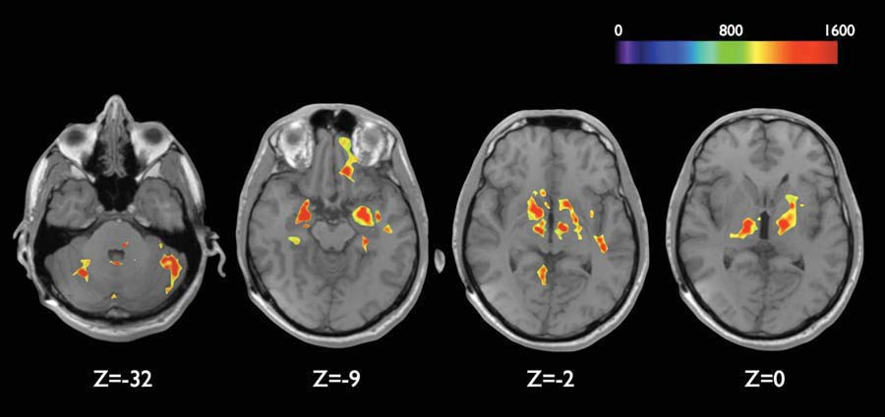

FIG. 1. Results of regional brain activation related to the olfactory paradigm during bilateral STN stimulation. Images corresponding to ‘‘on’’ and ‘‘off’’ conditions were compared through computerized voxel-based image subtraction (Matlab1/ImageJ1), fused onto the MRI (Osirix1) and plotted into the Tailarach atlas (Brainsight1). The image shows in red and yellow the greater activation areas (thalamus, striatum, nucleus accumbens and amygdaloid complex bilaterally, and the left gyrus rectus). At the bottom ‘‘Z’’ shows the brain slice distance from the AC–PC line (coordinates of Talairach Atlas). [Color ﬁgure can be viewed in the online issue, which is available at wileyonlinelibrary.com.]

tion to one of the substances (B-SIT). The second PET study was performed under the same conditions, but the stimulator had been turned off for seven days. At this time, the patient experienced return of hyposmia, as he observed and reported spontaneously. The OD at this point corresponded to the identiﬁcation of 2/12 fragrances in B-SIT. The results of PET images revealed signiﬁcant metabolic activation of thalamus, striatum, nucleus accumbens, and amygdaloid complex bilat- erally as well as the left gyrus rectus. The tissue around the electrode also revealed metabolic activation, from deep STN extending to ventral thalamus (Fig. 1).

Previous reports have stated that odor discrimination improves after STN-DBS in PD patients, while olfactory detection threshold does not. These results suggest that STN- DBS might modulate cognitive processing of olfactory infor- mation.5 The return to hyposmia after the stimulation was turned off, favors the hypothesis that functional changes in striatum-thalamus-cortical networks, rather than irreversible degeneration of olfactory structures only, are responsible for OD observed in PD patients. The progressive neuronal loss throughout the brain generates dysfunction in the chronome- try of circuits of the basal ganglia affecting different systems interpreted clinically as various symptoms of PD. Once the hyper activation of STN is reversed by the onset of local electrical stimulation, its inﬂuence spreads out to other neural circuits correcting dysfunctions of modulatory neurotrans- mitters, which in turn is related to the temporary improve- ment of motor and nonmotor symptoms. Although data in previous studies6 suggest that the motor effect obtained by dopaminergic medication and by STN stimulation shares the same activated brain areas, this is not likely to happen with olfactory function because dopaminergic reposition has no effect on hyposmia.1

In line with previous reports, PET signs of motor improvement, attenuation of the Parkinson disease related pattern (PDRP)6 was expressed, except for a residual hyper- metabolism in left striatum observed in the present study. Although a remarkable motor improvement was observed in this patient, the expected abolition of PDRP was not fully

expressed. This apparent inconsistency may be related to individual variability in a single subject analysis or it may suggest the participation of left striatum in the olfactory in- formation-processing network in this patient. Also, a substan- tial increase in metabolism in the vicinity of the subthalamic target site extending rostrally into the ventral thalamus was observed. Since the FDG hypermetabolism was highly coin- cident with the location of electrodes, this component is probably related to the direct effects of electrical stimulation of STN, inhibiting depolarization on the cell membrane.6 The electrode trajectory performed in this patient includes the motor anterior ventralis oralis nucleus of thalamus/poste- rior ventralis oralis nucleus of thalamus (VoA/VoP), as observed in the postoperative MRI, the upper contact is located within the ventral portion of thalamus. Besides the activation of amygdaloid complex, hippocampus, orbitofron- tal cortex, striatum, thalamus, midbrain, and cerebellum related to olfactory stimulation in PD patients, as shown by Westermann et al.,7 also observed in this case, there was additional activation of bilateral nucleus accumbens and left gyrus rectus. Although further studies are required for more robust conclusions, the present ﬁndings suggest that the acti- vated areas may mediate the odor discrimination improvement after bilateral STN-DBS. The stimulation of thalamic region in this case might also have activated thalamic nuclei related to olfactory function [e.g., nucleus parataenialis of thalamus (Pt)]. The connections of the Pt nucleus arise from the secondary olfactory centers through stria medullaris of thalamus.8 The activation of this nucleus could inﬂuence the olfactory circuitry at distant sites once reports of olfactory sensation were observed by direct electrical stimulation of this region.9

These preliminary observations suggest that OD in PD may rather be a circuitry dysfunction and not only a neuro- degenerative process in olfactory structures; a dysfunction of cognitive processing involved in odor discrimination might explain this phenomenon. There are multiple levels of integration of olfactory information and the STN-DBS seems to inﬂuence the circuit involving the primary olfac- tory areas, limbic areas as the ventral striatum and basal frontal cortex.

15318257, 2010, 14, Downloaded from https://movementdisorders.onlinelibrary.wiley.com/doi/10.1002/mds.23307 by The University Of Manchester, Wiley Online Library on [22/05/2025]. See the Terms and Conditions (https://onlinelibrary.wiley.com/terms-and-conditions) on Wiley Online Library for rules of use; OA articles are governed by the applicable Creative Commons License

*Movement Disorders, Vol. 25, No. 14, 2010*

### 2468 LETTERS TO THE EDITOR

Acknowledgments: This study was supported by FAPESP 03/11794-6 and Division of Functional Neurosurgery of Hos- pital das Cl´ınicas.

Author Roles: Dr. Fonoff was involved in conception and design, acquisition of data, analysis and interpretation of data; drafting the article; critically revising the article, review of ﬁnal version of the manuscript and approval for submission; and administrative/technical/material support. Dr. Teixeira was involved in conception and design; critically revising the article; review of ﬁnal version of the manuscript and approval for sub- mission; and administrative/technical/material support. Dr. Almeida was involved in acquisition, analysis, and interpretation of data; drafting the article, and review of ﬁnal version of the manuscript and approval for submission. Dr. Garrido was involved in analysis and interpretation of data. Dr. Sallem was involved in drafting and critically revising the article. Dr. Andrade was involved in critically revising the article; review of ﬁnal version of the manuscript and approval for submission. Dr. Barbosa was involved in critically revising the article; review of ﬁnal version of the manuscript and approval for submission.

Erich Talamoni Fonoff, MD, PhD* Ywzhe Sifuentes Almeida de Oliveira, MD

Santiago Driollet, MD

*Division of Functional Neurosurgery*

*Department of Neurology School of Medicine, University of Sa˜o Paulo*

*Sa˜o Paulo, Brazil*

*\*E-mail:* [*fonoffet@usp.br*](mailto:fonoffet@usp.br)

Griselda Jarra Garrido, PhD

*Informatics Division Heart Institute, School of Medicine*

*University of Sao Paulo Sao Paulo, Brazil*

Daniel Ciampi de Andrade, MD

Fla´vio Sallem, MD

*Division of Functional Neurosurgery*

*Department of Neurology School of Medicine, University of Sa˜o Paulo*

*Sa˜o Paulo, Brazil*

Egberto Reis Barbosa, MD, PhD

*Department of Neurology School of Medicine, University of Sa˜o Paulo*

*Sa˜o Paulo, Brazil*

Manoel Jacobsen Teixeira, MD, PhD

*Division of Functional Neurosurgery*

*Department of Neurology School of Medicine, University of Sa˜o Paulo*

*Sa˜o Paulo, Brazil*

## References

1. Doty RL, Deems D, Steller S. Olfactory dysfunction in Parkin- son’s disease: a general deﬁcit unrelated to neurologic signs, dis-
2. Braak H, DelTredici K, Rub U, de Vos RAI, Jansen Steur ENH, Braak E. Staging of brain pathology related to sporadic Parkin- son’s disease. Neurobiol Aging 2003;24:197–210.
3. Double KL, Rowe DB, Hayes M, Chan DKY, Blackie J. Identify- ing the pattern of olfactory deﬁcits in Parkinson disease using the brief smell identiﬁcation test. Arch Neurol 2003;60:545–549.
4. Hummel T, Jahnke U, Sommer U, Reichmann H, Mu¨ller A. Olfactory function in patients with idiopathic Parkinson’s disease: effects of deep brain stimulation in the subthalamic nucleus. J Neural Transm 2005;112:669–676.
5. Asanuma K, Tang C, Ma Y, Dhawan V, Mattis P, Edwards C, Kaplitt MG, Feigin A, Eidelberg D. Network modulation in the treatment of Parkinson’s disease. Brain 2006;129:2667–2678.
6. Westermann B, Wattendorf E, Schwerdtfeger U, Husner A, Fuhr P, Gratzl O, Hummel T, Bilecen D, Welge-Lu¨ssen A. Functional imaging of the cerebral olfactory system in patients with Parkinson’s disease. J Neurol Neurosurg Psychiatr 2008;79:19–24.
7. Schaltenbrand G, Walker E, Hassler R, Narabayashi H, Riechert T, editors. Stereotaxy of the human brain, Second ed. New York: Thieme-Stratton Inc.; 1982.153p.
8. Nashold BS, Wilson WP. Olfactory hallucinations evoked from stimulation of human thalamus. Conﬁn Neurol 1970;32:298–306.

# Familial Nonkinesigenic Paroxysmal Dyskinesia and Intracranial Calciﬁcations: A New Syndrome?

Paroxysmal nonkinesigenic dyskinesia (PNKD) refers to a clinical syndrome characterized by attacks of involuntary movements, including dystonia, chorea, athetosis, or ballism, occurring at rest.1,2 PNKD is associated to a wide range of aetiologies, for example, autoimmune, vascular, traumatic, in- fective, and endocrine disorders.1 However, most cases of PNKD are idiopathic and neuroimaging is usually unremark- able.1,2 We report a PNKD family whose computed tomogra- phy (CT) scan revealed intracranial calciﬁcations.

This four-generation family includes 5 (one deceased) patients (Table 1; Fig. 1). The proband (*individual IV:2*) is 7- year-old girl who experienced at age of 9 months a ﬁrst attack of dystonic posture of the head with concomitant bal- listic and choreic movements of upper and lower extremities. This event lasted 30 minutes, without alteration of conscious- ness, and was followed by prompt recovery. One month later, the girl experienced a similar episode precipitated by fever and resolving spontaneously. Neurological examination between attacks was normal. Laboratory investigations (serum and urine copper, calcium, phosphorus, vitamin D, ceruloplasmin, ferritin, transferrin, serum iron, thyroid, para- thyroid, and adrenocorticotropic hormones, anti-transglutami- nase antibodies, serum lipoproteins and lipid proﬁle, lactate, pyruvate, amino acids, and urine organic acids) were normal. Brain magnetic resonance imaging (MRI) was unremarkable. Mutations in *MR-1* (myoﬁbrillogenesis regulator 1)3 and *SLC2A1* (Glut-1)4 genes were excluded, as well as and fam- ily linkage to chromosome 14q5 (lod score < 22;Y 5 0). In the following years, the girl continued to experience similar episodes at the frequency of about one per year. In one occa-

ease stage, or disease duration. Neurology 1988;38:1237–1244.

1. Takeda A, Kikuchi A, Matsuzaki-Kobayashi M, Sugeno N, Itoyama Y. Olfactory dysfunction in Parkinson’s disease. J Neu- rol 2007;254:IV/2–IV/7.

Potential conﬂict of interest: Nothing to report.

Published online 27 August 2010 in Wiley Online Library (wileyonlinelibrary.com). DOI: 10.1002/mds.23267

15318257, 2010, 14, Downloaded from https://movementdisorders.onlinelibrary.wiley.com/doi/10.1002/mds.23307 by The University Of Manchester, Wiley Online Library on [22/05/2025]. See the Terms and Conditions (https://onlinelibrary.wiley.com/terms-and-conditions) on Wiley Online Library for rules of use; OA articles are governed by the applicable Creative Commons License

*Movement Disorders, Vol. 25, No. 14, 2010*

### LETTERS TO THE EDITOR 2469

TABLE 1. *Clinical features of the PNKD patients*

trunk (20–300)

|  |  |  |  |  |  |  |
| --- | --- | --- | --- | --- | --- | --- |
| Pt ID/age/sex | Age of onset | Precipitating factors | Body regions involved (duration) | Neurological examination | Intracranial calciﬁcations distribution | Frequency of the attacks/Outcome |
| I:2/82/M | 70 years | Fever | Head (150) | Normal | NDa | Single episode |
| II:3/70/F | 4 years | Fasting, | Head, limbs (15–200) | Postural, kinetic | Basal ganglia, | Yearly/Spontaneous |
|  |  | emotional |  | tremor | cerebellum | remission at 30 years |
|  |  | stress |  |  |  |  |
| III:2/39/M | 4 years | Emotional stress | Head, limbs, and | Normal | Basal ganglia, | Yearly/Spontaneous |

cerebral white matter

remission at 33 years

III:3/37/M 6 years Fever, emotional

stress

Head, limbs (20–300) Normal Basal ganglia Yearly/Persist

IV:2/7/F 9 months Fever Head, limbs (5–300) Normal Absent Sporadic/Persist

aND: Not done.

sion, ictal electroencephalography (EEG) recording excluded the epileptic nature of the event. At the age of 7 years, a new CT scan was unremarkable.

*Individual III:2* is a 39-year-old man suffering from recur- rent attacks of choreic-dystonic postures involving the head, limbs, and trunk from 4 years of life, precipitated by emo- tional stress. At age 33 years, brain CT and MRI revealed ba- sal ganglia and cerebral white matter calciﬁcations. Extensive laboratory screening and neurological examination were un- remarkable. No further attacks were reported during the last 6 years.

*Individual III:3* is a 37-year-old man experiencing yearly attacks of sudden-onset dystonia and choreic movements of the head and limbs from age 6 to 30 years, related to physical or emotional stress. Neurological examination was unremarkable. Laboratory investigations and EEG were normal. Brain CT at age 30 years showed basal ganglia calciﬁcations.

*Individual II:3* is a 70-year-old woman presenting her ﬁrst attack choreic-dystonic postures involving the head and the four limbs at the age of 4 years. Subsequently, these manifes- tations occurred regularly at the frequency of one per year in association with fasting or stress. Laboratory investigations and neurological examination were normal. At the age of 65 years, brain CT revealed basal ganglia and cerebellar calciﬁ- cations. The patient still experiences yearly episodes and, in the last few years, developed postural and kinetic tremor, responding to alcohol intake.

*Individual I:2* experienced a single episode of choreic-dys- tonic postures of the head at the age of 75 years, precipitated by fever and lasting about 20 minutes.

This family shows typical clinical features of PNKD.1,2 All patients showed a typical pattern and duration of the epi- sodes, not activated by movement, and showed normal neuro- logical status between attacks except for the oldest living individual (II:3) who developed late-onset postural and ki- netic tremor, responding to alcohol intake. Individual I:1 who experienced a single attack at age 75 years related to febrile illness, was considered as probably affected, considering the transitory nature of his manifestation and the fact that fever was a precipitating factor also in other affected members, as reported in PNKD.6 The course of the disease was relatively benign and affected individuals achieved spontaneous remis- sion or continued to have about yearly episodes without treat- ment. Mutations in *MR-1*, the only gene associated with familial PNKD,3,7 were excluded.

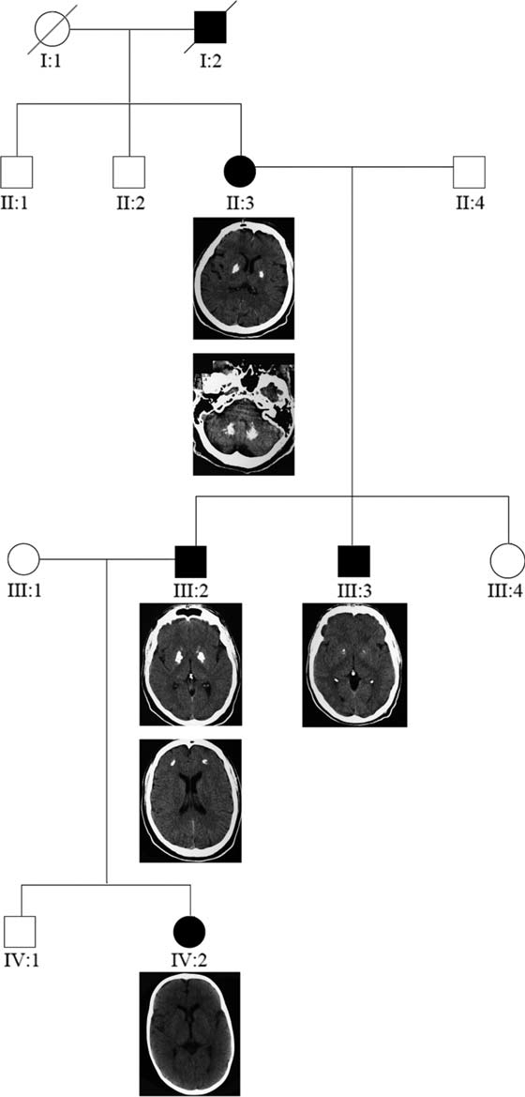

FIG. 1. Pedigree and CT scans of affected family members. See the text for details.

15318257, 2010, 14, Downloaded from https://movementdisorders.onlinelibrary.wiley.com/doi/10.1002/mds.23307 by The University Of Manchester, Wiley Online Library on [22/05/2025]. See the Terms and Conditions (https://onlinelibrary.wiley.com/terms-and-conditions) on Wiley Online Library for rules of use; OA articles are governed by the applicable Creative Commons License

*Movement Disorders, Vol. 25, No. 14, 2010*

### 2470 LETTERS TO THE EDITOR

Indeed, the most distinctive feature in our family was the ﬁnding of symmetrical intracranial calciﬁcations, primarily affecting the basal ganglia, which has been previously reported in few isolated cases.8–11 Hereditary brain calcinosis may be found in several different conditions,12 for example, disorders of parathyroid hormone or calcium regulation, mi- tochondrial diseases, and defects of organic or amino acid metabolism. However, all these aetiologies were ruled out in our family. Linkage to 14q, described in families with Fahr disease and neurological symptoms,5 was excluded, conﬁrm- ing that this condition is genetically heterogeneous.13,14 Moreover, the pathogenetic role of calciﬁcations remains unclear as the youngest patient showed unremarkable neuroi- maging despite full phenotypical presentation. Identiﬁcation of further families could shed light on the pathogenesis of PNKD.

Author Roles: Conception and design: Nune S. Yeghia- zaryan and P. Striano. Data acquisition and analysis: P. Striano, Patrizia Accorsi, Lorenzo Pinelli, Francesca Faravelli, and Lucio Giordano. Drafting, editing, and revising of the text: Nune S. Yeghiazaryan, P. Striano, Federico Zara, and Carlo Minetti.

Nune S. Yeghiazaryan, MD*

*Muscular and Neurodegenerative Disease Unit*

*Institute G. Gaslini Genova, Italy*

*Armenian Republican Epilepsy Center Erebouni*

*Yerevan State Medical University*

*Yerevan, Armenia*

*\*E-mail:* [*ynune@yahoo.com;*](mailto:ynune@yahoo.com)[*nunepilepsy@gmail.com*](mailto:nunepilepsy@gmail.com)

Pasquale Striano, MD, PhD

*Muscular and Neurodegenerative Disease Unit*

*Institute G. Gaslini Genova, Italy*

Patrizia Accorsi, MD

*Pediatric Neuropsychiatric Division*

*Spedali Riuniti Brescia, Italy*

Lorenzo Pinelli, MD

*Neuroradiology Department*

*Spedali Riuniti Brescia, Italy*

Francesca Faravelli, MD

*Laboratory of Human Genetics*

*Galliera Hospital Genova, Italy*

Federico Zara, PhD

*Muscular and Neurodegenerative Disease Unit*

*Institute G. Gaslini Genova, Italy*

Carlo Minetti, MD

*Muscular and Neurodegenerative Disease Unit*

*Institute G. Gaslini Genova, Italy*

Lucio Giordano, MD

*Pediatric Neuropsychiatric Division*

*Spedali Riuniti Brescia, Italy*

## References

1. Demirkiran M, Jankovic J. Paroxysmal dyskinesias: clinical fea- tures and classiﬁcation. Ann Neurol 1995;38:571–579.
2. Bhatia KP. The paroxysmal dyskinesias. J Neurol 1999;246:149–155.
3. Lee HY, Xu Y, Huang Y, et al. The gene for paroxysmal nonki- nesigenic dyskinesia encodes an enzyme in a stress response pathway. Hum Mol Genet 2004;13:3161–3170.
4. Suls A, Dedeken P, Gofﬁn K, et al. Paroxysmal exercise- induced dyskinesia and epilepsy is due to mutations in SLC2A1, encoding the glucose transporter GLUT1. Brain 2008; 131:1831–1844.
5. Geschwind DH, Loginov M, Stern JM. Identiﬁcation of a locus on chromosome 14q for idiopathic basal ganglia calciﬁcation (Fahr disease). Am J Hum Genet 1999;65:764–777.
6. Harbord MG, Kobayashi JS. Fever producing ballismus in patients with choreoathetosis. J Child Neurol 1991;6:49–52.
7. Stefanova E, Djarmati A, Momcilovic D, et al. Clinical charac- teristics of paroxysmal nonkinesigenic dyskinesia in Serbian family with Myoﬁbrillogenesis regulator 1 gene mutation. Mov Disord 2006;21:2010–2015.
8. Micheli F, Fernandez Pardal MM, Casas Parera I, Giannaula R. Sporadic paroxysmal dystonic choreoathetosis associated with basal ganglia calciﬁcations. Ann Neurol 1986;20:750.
9. Yamamoto K, Kawazawa S. Basal ganglion calciﬁcation in par- oxysmal dystonic choreoathetosis. Ann Neurol 1987;22:556.
10. Klein C, Vieregge P, Ko¨mpf D. Paroxysmal choreoathetosis in a patient with idiopathic basal ganglia calciﬁcation, chorea, and dystonia. Mov Disord 1997;12:254–255.
11. Alemdar M, Selek A, Is¸eri P, Efendi H, Komsuoglu SS. Fahr’s disease presenting with paroxysmal nonkinesigenic dyskinesia: a case report. Parkinsonism Relat Disord 2008;14:69–71.
12. Baba Y, Broderick DF, Uitti RJ, Hutton ML, Wszolek ZK. Heredofa- milial brain calcinosis syndrome. Mayo Clin Proc 2005;80: 641–651.
13. Spacey SD, Adams PJ, Lam PC, Materek LA, Stoessl AJ, Snutch TP, Hsiung GY. Genetic heterogeneity in paroxysmal nonkinesi- genic dyskinesia. Neurology 2006;66:1588–1590.
14. Bruno MK, Lee HY, Auburger GW, et al. Genotype-phenotype correlation of paroxysmal nonkinesigenic dyskinesia. Neurology 2007;68:1782–1789.

# Dramatic Response of Facial Stereotype/Tic to Tetrabenazine in the First Reported Cases of Neuroferritinopathy in the United States

Video 

Neuroferritinopathy is a rare neurodegenerative disease associated with brain iron deposition caused by mutations in gene encoding the ferritin light polypeptide (FTL). A 460dupA FTL was ﬁrst identiﬁed in patients in northern Eng- land.1 Since then several different mutations of FLT were identiﬁed in Japanese and French, and French–Canadian/

Additional Supporting Information may be found in the online version of this article.

Potential conﬂict of interest: Nothing to report.

Published online 3 September 2010 in Wiley Online Library (wileyonlinelibrary.com). DOI: 10.1002/mds.23299

15318257, 2010, 14, Downloaded from https://movementdisorders.onlinelibrary.wiley.com/doi/10.1002/mds.23307 by The University Of Manchester, Wiley Online Library on [22/05/2025]. See the Terms and Conditions (https://onlinelibrary.wiley.com/terms-and-conditions) on Wiley Online Library for rules of use; OA articles are governed by the applicable Creative Commons License

*Movement Disorders, Vol. 25, No. 14, 2010*

### LETTERS TO THE EDITOR 2471

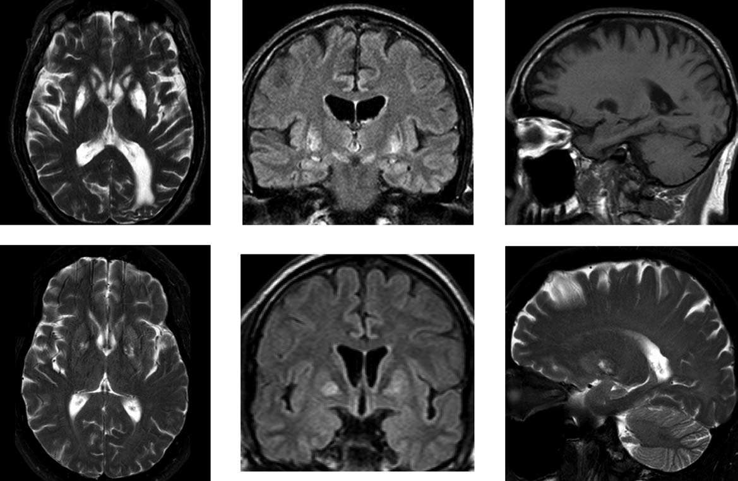

FIG. 1. Top row of MRIs (various sequences) of the father, age 74, and bottom role shows MRIs of son, age 49.

Dutch,2–6 but the original mutation, which accounts for the majority of documented cases, has not been reported outside the United Kingdom. We report the ﬁrst cases of neuroferri- tinopathy in North America, and the ﬁrst cases showing the 460dupA FTL mutation originating from outside the United Kingdom, in an American family of German ancestry. One patient presented with oral tics/stereotypies most phenotypi- cally similar to those seen in frontotemporal dementia or Tourette’s. These completely resolved with low-dose tetrabe- nazine (TBZ). His father who demonstrated facial and appen- dicular chorea, marked bulbar dysfunction, ataxia, and de- mentia, also improved with TBZ.

A 49-year-old right-handed man presented with a 2-year

history of varied involuntary facial movements including asymmetric facial grimacing, symmetric lip pursing, tongue biting and teeth clicking, paranasal contractions, touching his mouth with his hand, and vocalizations including throat clear- ing, coughing, and a ‘‘TZ’’ sound. These were partially sup- pressible but there was no clear urge to move. These move- ments worsened while on escitalopram, despite improvement of mood. No other exacerbating or alleviating factors were noted. His other subjective complaints were of mild worsening of balance, mild decreased dexterity manifest only while typ- ing, and general fatigue. Past medical and social histories were unrevealing. The patient’s father is affected and is pre- sented below. His paternal grandfather was diagnosed with Huntington’s disease and ‘‘bulbar palsy’’ and had chorea. Two of the grandfather’s brothers were diagnosed with Parkinson’s disease but we have no actual clinical descriptions.

Formal neurological examination was largely normal. MMSE was 29/30. Cranial nerves were intact. Motor testing

showed normal strength, bulk and tone, and a trace action tremor. Sensory, cerebellar, and gait examinations were nor- mal. Reﬂexes were modestly depressed throughout. The patient had frequent mouth touching, right facial grimacing, and ﬁnger rubbing, which was partially suppressible (Sup- porting Information Video Segment 1). Patients provided informed consent for the videos.

Ferritin was 22 lg/mL and iron binding percentage was 28%, a lower than typical ferritin: iron binding ratio. Thyroid test and electrolytes were normal. Acanthocyte smear, Hun- tington’s testing, ceruloplasmin, and chorein (*VPS13A*) test- ing were normal. EMG/NCV was normal. Brain MRI showed T2 and FLAIR lesions in the globus pallidus and to a lesser extent in the cerebelli (Fig. 1).

The patient was placed on TBZ, which was eventually maintained on 37.5 mg/day (25 mg in A.M. and 12.5 mg in P.M.) resulting in complete cessation of the movements. After 6 months, he reported some subjective worsening in balance without falls. TBZ withdrawal did not alter the balance com- plaint but did result in recrudescence of the same movements within 24 hours. The TBZ was reinstituted at the same dose without any other adverse events.

The father of Case 1 ﬁrst appreciated involuntary move- ments of the hand around age 50. Upon presentation to us at age 69, he had oral and appendicular movements, a 4-year history of progressive dysarthria and dysphagia, marked sia- lorrhea, a 2-year history of gait and balance difﬁculty with several falls, and recent mild cognitive slowing. Examination showed a MMSE of 29/30. Cranial nerves showed guttural, more than lingual or labial dysarthria, and hypomimia, but were otherwise normal. Strength was normal but there were

15318257, 2010, 14, Downloaded from https://movementdisorders.onlinelibrary.wiley.com/doi/10.1002/mds.23307 by The University Of Manchester, Wiley Online Library on [22/05/2025]. See the Terms and Conditions (https://onlinelibrary.wiley.com/terms-and-conditions) on Wiley Online Library for rules of use; OA articles are governed by the applicable Creative Commons License

*Movement Disorders, Vol. 25, No. 14, 2010*

### 2472 LETTERS TO THE EDITOR

some fasciculations and distal atrophy. Sensory examination showed decreased distal vibration and proprioception. Gait was modestly wide based and unsteady but not parkinsonian. Reﬂexes were normal with downgoing toes and positive ‘‘frontal release signs.’’ The involuntary movements were complex and best described as a mix of stereotype (mouth and hands) and chorea, with oral movements most prominent (Supporting Information Video Segment 2, age 74).

Over the next 6 years, the dysphagia/dysarthria, gait, and cognition gradually progressed. At age 75, he was anarthric, unable to volitionally move the tongue despite lack of periph- eral involvement per EMG, and wheelchair bound. Unreveal- ing evaluations were similar to Case 1 but also showed nor- mal CSF studies, including a normal 14-3-3 protein, and a normal ataxia panel including dentatorubral-pallidoluysian at- rophy. MRI showed T2 lesions throughout the striatum and globus pallidus (Fig. 1). TBZ did help the chorea and stereo- type but was poorly tolerated at higher doses due to sedation and parkinsonism. TBZ withdrawal on several occasions resulted in increased movements. He remains on 25 mg/day with continued beneﬁt.

We report the ﬁrst cases of neuroferritinopathy in the United States. The mutation was identical to the original one, which until now was isolated only in cases originating in the United Kingdom. The family denies any known ancestry from that area. On examination, the father appears to have a ‘‘classic’’ phenotype of chorea, prominently in the lower face, with later onset of gait disorder and dementia. However, we feel that the phenomenology of the son is best described as tics, or possibly stereotype, potentially expanding the phenotype of neuroferritinopathy. He had a complete resolution of symptoms on TBZ, whereas his father had fair control of the chorea move- ments, but was limited by side effects.

## Legends to the Video

Segment 1. Patient showing facial stereotype/tics.

Segment 2. Patient showing constant facial stereotype, dif- fuse slow chorea, and mild ataxia.

Acknowledgments: We would like to acknowledge the as- sistance of Joseph M. Ferrara, MD, for assistance with the MRI ﬁgure.

Financial Disclosures: Dr. Ondo has received speaker fees from Lundbeck, Allergan, Ipsen, TEVA, and GSK; has received consulting fees from TEVA, Merz, and Lundbeck; and has received grant support from TEVA, Ipsen, Allergan, and Bayer. Dr. Jankovic has received consutlting fees from Lundbeck; research support from Allergan, Inc., Boehringer-Ingeheim, Inc., Ceregene, Inc., Chelsea Therapeutics, Helis Foundation, Hun- tington’s Disease Society of America, Huntington Study Group, Impax Pharmaceuticals, Ipsen, Ltd., Lundbeck, Inc., Medtronic, Merz Pharmceuticals, NIH, National Parkinson Foundation, Neurogen, St. Jude Medical, TEVA, University of Rochester, and the Parkinson Study Group; has been consultant and/or advisory committee memeber for Allergan, Inc., Biovail, the Michael J. Fox Foundation for Parkinson Research, Merz

William G. Ondo, MD* *Department of Neurology Baylor College of Medicine, Houston, Texas, USA*

*\*E-mail:* [*wondo@bcm.tmc.edu*](mailto:wondo@bcm.tmc.edu)

Octavian R. Adam, MD *Department of Neurology University of Texas Medical Branch*

*Galveston, Texas, USA*

Joseph Jankovic, MD *Department of Neurology Baylor College of Medicine Houston, Texas, USA*

Patrick F. Chinnery, MBBS, PhD, FRCP

*Institute of Human Genetics Newcastle University Newcastle, UK*

## References

1. Curtis AR, Fey C, Morris CM, et al. Mutation in the gene encoding ferritin light polypeptide causes dominant adult-onset basal ganglia disease. Nat Genet 2001;28:350–354.
2. Devos D, Tchofo PJ, Vuillaume I, et al. Clinical features and natural history of neuroferritinopathy caused by the 458dupA FTL mutation. Brain 2009;132:1-3,e109.
3. Ohta E, Nagasaka T, Shindo K, et al. Neuroferritinopathy in a Japanese family with a duplication in the ferritin light chain gene. Neurology 2008;70 (Part 2):1493–1494.
4. Maciel P, Cruz VT, Constante M, et al. Neuroferritinopathy:

missense mutation in FTL causing early-onset bilateral pallidal involvement. Neurology 2005;65:603–605.

1. Levi S, Cozzi A, Arosio P. Neuroferritinopathy: a neurodege-

nerative disorder associated with L-ferritin mutation. Best Pract Res Clin Haematol 2005;18:265–276.

1. Mancuso M, Davidzon G, Kurlan RM, et al. Hereditary

ferritinopathy: a novel mutation, its cellular pathology, and patho- genetic insights. J Neuropathol Exp Neurol 2005;64: 280–294.

# Complex Hyperkinetic Movement Disorders Associated with *POLG* Mutations

Video 

Patients presenting with complex hyperkinetic movement disorders remain a major diagnostic challenge due to difﬁcul- ties in clinical classiﬁcation and an increasing number of associated monogenetic diseases.1

Mutations in the mitochondrial DNA polymerase gamma (*POLG*) have been described to cause a broad variety of phe- notypes,2 but chorea, dystonia, and myoclonus have only

Pharmaceuticals, Lundbeck, Inc., and TEVA.

Additional Supporting Information may be found in the online

Author Roles: Dr. Ondo: inception, data collection, draft-

ing, and reviewing of the article. Dr. Adam: critical review. Dr. Jankovic: critical review. Dr. Chinnery: data collection/ analysis and critical review.

version of this article.

Potential conﬂict of interest: Nothing to report.

Published online 3 September 2010 in Wiley Online Library (wileyonlinelibrary.com). DOI: 10.1002/mds.23307

15318257, 2010, 14, Downloaded from https://movementdisorders.onlinelibrary.wiley.com/doi/10.1002/mds.23307 by The University Of Manchester, Wiley Online Library on [22/05/2025]. See the Terms and Conditions (https://onlinelibrary.wiley.com/terms-and-conditions) on Wiley Online Library for rules of use; OA articles are governed by the applicable Creative Commons License

*Movement Disorders, Vol. 25, No. 14, 2010*

### LETTERS TO THE EDITOR 2473

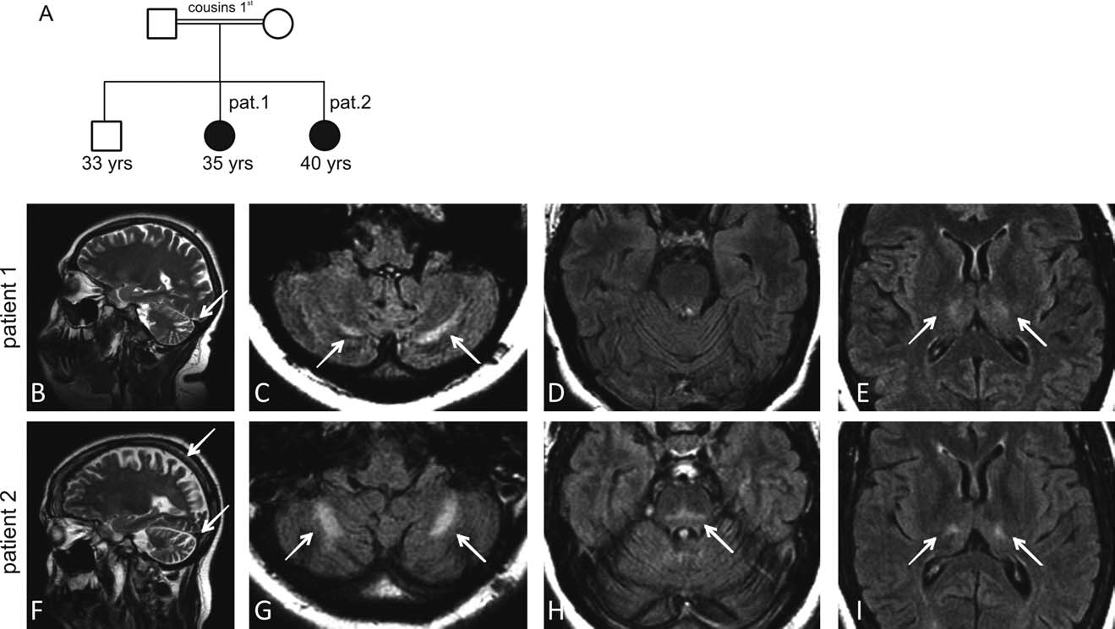

FIG. 1. Pedigree and characteristic MRI ﬁndings in two patients with a homozygous W748S *POLG* mutation. Two affected Sicilian siblings of consanguineous parents (A) were investigated by magnetic resonance imaging. MR T2 weighted images in Patient 1 (B–E) reveal an enlarged cer- ebellar primary ﬁssure (B), beginning bilateral hyperintense lesions in the cerebellar white matter (C), and the thalamus (E). The brain stem and pons appeared normal in Patient 1 (D). T2 weighted images in Patient 2 (F–I) show cerebellar and parieto-occipital atrophy (F) and, like in Patient 1 and similar to other POLG patients,5 symmetric hyperintense lesions in the cerebellar white matter (G) and the thalamus (I) and, addi- tionally, in the pons (H). Magnetic resonance spectroscopy of the cerebellar white matter lesions revealed normal levels of choline and creatine, but reduced levels of *N*-acetyl aspartate, indicating chronic neuronal loss (not shown).

been mentioned as parts of a plethora of *POLG*-associated symptoms,2,3 not as the only presenting symptom. Here we report on two siblings from a consanguineous Sicilian family with a homozygous *POLG* mutation. The index patient pre- sented with a complex hyperkinetic movement disorder as initial symptom, whereas other common *POLG*-associated symptoms did not evolve until three years later.

The index patient (Patient 1) underwent uncomplicated surgery of a right-sided carpal tunnel syndrome at 32 years of age. Two weeks later, she developed complex regional pain syndrome of the operated limb with severe pain and allodynia. Another two weeks later, dystonic posturing of the right hand with rapid jerky wrist and ﬁnger movements mani- fested. These jerks consisted of a complex mixture of phasic dystonic wrist ﬂexions and small amplitude ﬁnger movements (polymini-myoclonus). In addition, continuous jerky move- ments of her feet at rest were observed (Supporting Informa- tion Video, Segment 1), which were presumably preexisting but unrecognized by the patient herself. These movements were unpatterned and similar to limb movements seen in patients with benign hereditary chorea.1,4 EEG and SEP recordings showed no cortical correlates of the limb jerks but temporo-parietal focal slowing and intermittent temporal sharp-slow waves. As the forceful wrist and ﬁnger move- ments triggered pain attacks, injections to wrist and ﬁnger extensors and ﬂexors were given with a total dose of 800 U botulinum neurotoxin A (BoNTA); (Dysport, Ipsen Pharma).

Injections dramatically reduced movement-induced pain attacks and were repeated every 3-month since then (Sup- porting Information Video, Segment 2). Severe depression with recurrent anxiety attacks necessitated admission to the local psychiatric hospital. Secondary generalized seizures and premature amenorrhoea started at the age of 33 years. Com- prehensive neuropsychological testing revealed below-aver- age cognitive capacities. At the age of 35 years, she started to develop sensory neuropathy, mild external ophthalmople- gia, and subtle gait ataxia, yet without leading to incapacita- tions in daily life (Supporting Information Video, Segment 3) (for MRI images, see Fig. 1).

Patient 2, the index patient’s sister, manifested with slowly progressive cognitive deﬁcits during primary school, leading to severe cognitive deﬁcits at the age of 40. At age 13 years, epileptic seizures, recurrent headaches, and mild personality changes started. The movement disorder was similar to her sis- ter’s: action-triggered myoclonus started at the left arm at age 14 years and generalized afterwards, whereas dystonic ulnar deviation of the right hand with ﬂexion of the ﬁngers III–V was ﬁrst noticed at age 20 years. Since then, she also developed progressive cerebellar ataxia and became wheel-chair bound at the age of 31. At the last examination (age 40 years) incom- plete chronic progressive external ophthalmoplegia (PEO); (Supporting Information Video, Segment 5) and severe axonal sensorimotor neuropathy were detected. As her phenotype sug- gested mitochondrial recessive ataxia syndrome (MIRAS),6

15318257, 2010, 14, Downloaded from https://movementdisorders.onlinelibrary.wiley.com/doi/10.1002/mds.23307 by The University Of Manchester, Wiley Online Library on [22/05/2025]. See the Terms and Conditions (https://onlinelibrary.wiley.com/terms-and-conditions) on Wiley Online Library for rules of use; OA articles are governed by the applicable Creative Commons License

*Movement Disorders, Vol. 25, No. 14, 2010*

### 2474 LETTERS TO THE EDITOR

genetic analysis of the *POLG* gene was initiated, revealing a homozygous W748S mutation in both patients. Genotyping of intragenic single nucleotide polymorphism (SNPs) rs2072267, rs2307433, rs2246900, rs2302084, and rs2307438 showed a homozygous ‘‘C-Insertion-G-C-G’’ haplotype, which is identi- cal to the haplotype common in North European W748S muta- tion carriers6 and thus suggests a relation between an ancient founder from North Europe and these Sicilian patients.

Our ﬁndings demonstrate that *POLG* mutations should be considered in the workup of progressive complex hyperkinetic movement disorders. As of yet, hyperkinetic movements like myoclonus and chorea have been mentioned in *POLG* patients mainly as part of a plethora of *POLG*-associated symptoms.2,3 As shown in Patient 1, complex hyperkinetic movements pre- senting with myoclonus, dystonia, and possibly also choreic elements may be the only feature seen for several years. This ﬁnding moreover demonstrates that not only apraxia of eye lid opening7 and dystonic toe curling,8 but also upper limb dysto- nia is part of the spectrum of *POLG*-associated dystonia.

Interestingly, the disease course in Patient 1 shows that cere- bellar ataxia, sensory neuropathy, and/or PEO are not necessar- ily presenting or early features of autosomal-recessive-*POLG* (AR-*POLG)* mutations. A family history with consanguineous marriage and/or recessive inheritance (like in our pedigree) or *POLG*-characteristic features in the disease course (like in Patient 1) may support the decision for *POLG* sequencing in undiagnosed patients with hyperkinetic movement disorders.

## Legends to the Video Patient 1

Segment 1. At the age of 33 years, Patient 1 showed dys- tonia of both arms, with predominant dystonic ulnar devia- tion of the right upper limb with jerky wrist and ﬁnger move- ments, which had started four weeks after carpal tunnel sur- gery induced CRPS. Distal ﬁnger movements have smaller amplitudes characteristic of polymini-myoclonus. Also her feet show unpatterend jerky movements, which may be clas- siﬁed as myoclonus but are also similar to limb movements in benign hereditary chorea.1,4

Segment 2. Botulinum toxin treatment of extensor and ﬂexor muscles of the right forearm markedly reduced hyper- kinetic movements. The main therapeutic goal remained pain reduction. Apart from the botulinum toxin effect, also inter- mittent mirror movements can be observed in this segment.

Segment 3. At the age of 35 years, external ophthalmople- gia, slowing of voluntary saccades and gait ataxia started. Also, a reduced arm swing on the right side was ﬁrst noticed.

## Patient 2

Segment 4. At the age of 40 years, Patient 2 displayed dystonic ulnar deviation of the left upper limb with distal predominance. She showed intermittent facial and jaw open- ing dystonia. At rest, she had marked postural instability caused by trunk ataxia, which is aggravated by motor actions like e.g. lifting the upper limbs.

Segment 5. In Patient 2 severe dysarthria, incomplete hor- izontal and vertical external ophthalmoplegia and ataxia were observed as clinical features of MIRAS. Patient 2 was only able to stand assisted for a few seconds.

Author Roles: Synofzik was involved in the Research project: Conception, Organization, Execution; Manuscript: Writing of the ﬁrst draft. Schu¨le was involved in the Research project: Execution; Manuscript: Review and Cri- tique. Schulte was involved in the Research project: Execu- tion; Manuscript: Review and Critique. Lindig was involved in the Research project: Execution; Manuscript: Review and Critique. Kru¨ger was involved in the Research project: Execution; Manuscript: Review and Critique. Scho¨ls was involved in the Research project: Organization; Manuscript: Review and Critique. Asmus was involved in the Research project: Conception, Organization, Execution; Manuscript: Writing of the ﬁrst draft.

Financial Disclosures: Dr. Synofzik received a research grant by the Volkswagen Foundation (European platform pro- ject) and a travel grant by Actelion Pharmaceuticals. Dr. Kru¨ger received research grants of the German Research Council (DFG; KR2119/3-1) and the Federal Ministry for Education and Research [BMBF, NGFNplus; 01GS08134], as well as speakers honoraria and travel grants from UCB Pharma, Solvay Pharma and Medtronic. Dr. Lindig has received travel grants from Ipsen Pharma, Allergan and Merz Pharmaceuticals. Dr. Scho¨ls served as an editorial board member of Movement Disorders and was a member of the scientiﬁc advisory board for Takeda Pharma. As participant of the MICONOS trial Dr. Scho¨ls received fees from San- thera Pharmaceuticals. Dr. Scho¨ls received research grants of the Deutsche Forschungsgemeinschaft (SCHO754/3-1 and SCHO754/4-1), grants of the German Research Council (BMBF) to Leukonet (01GM0644) GeNeMove (01GM0603) and mitoNET (01GM0864), funding from the EU for EUROSCA (LSHM-CT-2004-503304) and E-RARE grants to EUROSPA (01GM0807) and RISCA (01GM0820) as well as a

grant of the Volkswagen Foundation (I/80711). He further received funding from the HSP-Selbsthilfegruppe Deutschland eV. Dr. Asmus has received speakers honoraria and travel grants from Ipsen Pharma, Allergan and Merz Pharmaceuticals.

Acknowledgments: LS was supported by a grant from the German Ministry for Education and Research (BMBF) to mitoNET (01GM0864). FA and MS were supported by grants of the German center for neurodenerative diseases (DZNE).

Matthis Synofzik, MD Rebecca Schu¨le, MD Claudia Schulte, PhD Rejko Kru¨ger, MD Tobias Lindig, MD Ludger Scho¨ls, MD

*Department of Neurodegenerative Diseases Hertie-Institute for Clinical Brain Research*

*German Research Center for Neurodegenerative Diseases*

*University of Tuebingen Tuebingen, Germany*

Friedrich Asmus, MD*

*Department of General Neurology Hertie-Institute for Clinical Brain Research*

*German Research Center for Neurodegenerative Diseases*

*University of Tuebingen Tuebingen, Germany*

*\*E-mail:* [*friedrich.asmus@dystonia-genetics.com*](mailto:friedrich.asmus@dystonia-genetics.com)

15318257, 2010, 14, Downloaded from https://movementdisorders.onlinelibrary.wiley.com/doi/10.1002/mds.23307 by The University Of Manchester, Wiley Online Library on [22/05/2025]. See the Terms and Conditions (https://onlinelibrary.wiley.com/terms-and-conditions) on Wiley Online Library for rules of use; OA articles are governed by the applicable Creative Commons License

*Movement Disorders, Vol. 25, No. 14, 2010*

*LETTERS TO THE EDITOR* *2475*

## References

1. Asmus F, Langseth A, Doherty E, et al. ‘‘Jerky’’ dystonia in chil- dren: spectrum of phenotypes and genetic testing. Mov Disord 2009;24:702–709.
2. Blok MJ, Van den Bosch BJ, Jongen E, et al. The unfolding clini- cal spectrum of POLG mutations. J Med Genet 2009;46:776–785.
3. Tzoulis C, Engelsen BA, Telstad W, et al. The spectrum of clini- cal disease caused by the A467T and W748S POLG mutations: a study of 26 cases. Brain 2006;129 (Part 7):1685–1692.
4. Schrag A, Quinn NP, Bhatia KP, Marsden CD. Benign hereditary chorea—entity or syndrome? Mov Disord 2000;15:280–288.
5. Engelsen BA, Tzoulis C, Karlsen B, et al. POLG1 mutations cause a syndromic epilepsy with occipital lobe predilection. Brain 2008;131 (Part 3):818–828.
6. Hakonen AH, Davidzon G, Salemi R, et al. Abundance of the POLG disease mutations in Europe, Australia, New Zealand, and the United States explained by single ancient European founders. Eur J Hum Genet 2007;15:779–783.
7. Paus S, Zsurka G, Baron M, et al. Apraxia of lid opening mim- icking ptosis in compound heterozygosity for A467T and W748S POLG1 mutations. Mov Disord 2008;23:1286–1288.
8. Davidzon G, Greene P, Mancuso M, et al. Early-onset familial par- kinsonism due to POLG mutations. Ann Neurol 2006;59:859–862.

# Neuroleptic Malignant Syndrome with Aripiprazole in Huntington’s Disease

The atypical antipsychotic drug aripiprazole is a partial dopamine D2 and serotonin 5-HT1A receptor agonist and an antagonist at serotonin 5-HT2A receptors. It is a promising agent for patients with schizophrenia but also for those with Huntington’s disease (HD), who may suffer from psychosis, aggression, cognitive decline, and movement disorder. Recent reports1,2 and clinical observations suggest that aripiprazole improves chorea and functional disability with an effect com- parable with tetrabenazine but with less sedation and better tolerability. Thus, aripiprazole may be an attractive treatment option in HD, in particular for patients with psychosis and chorea or those not responding to other chorea treatments. In schizophrenia, however, aripiprazole was associated with neuroleptic malignant syndrome (NMS).3,4 Patients with HD may have an increased risk for developing NMS although the occurrence of NMS in HD is rarely reported.5 Here, we pres- ent a case of MNS in a HD patient treated with aripiprazole.

The patient, a 55-year-old retired engineering technician, presented with increasingly severe behavioral disorders including irritability and violent behavior. Unequivocal motor signs of HD (chorea) had been observed for the ﬁrst time 10 years before. The father and brother of the patients had died of HD. The clinical diagnosis of HD was conﬁrmed with mo- lecular genetic testing (CAG repeat expansion with 43 trip- lets). An MRI scan of the brain at the time of diagnosis showed normal cerebral morphology. Recent MRI scans revealed HD typical morphological alterations (symmetric at- rophy of the striatum and widening of the lateral ventricles). Subsequently, the patient developed severe chorea of arms and legs, head and trunk together with moderate cognitive

Potential conﬂict of interest: Nothing to report.

Published online 28 July 2010 in Wiley Online Library (wileyonlinelibrary.com). DOI: 10.1002/mds.23332

impairment. He lost 25 kg of weight because of chorea- induced difﬁculties with eating. On admission, he presented with severe dysarthria, generalized chorea, slowing of sacca- dic eye movements, severely unsteady gait and postural insta- bility. Cognitive deﬁcits comprised several domains including attention, memory, and executive functions.

Initially, the patient had been treated for chorea with per- phenazine and tiapride; because of increasingly aggressive behavior, risperidone was initiated and considered effective over 4 years. Sertraline was added to treat depressive symp- toms. Upon admission, the patient was treated with risperi- done (3 mg/d), sertraline (50 mg/d), and tiapride (700 mg/d). Trimipramine (50 mg) and melperone (50 mg) had been tried unsuccessfully to ameliorate insomnia. We considered a con- nection between risperidone and aggravated agitation and restlessness in terms of an extrapyramidal side effect. With- drawing risperidone, we added aripiprazole (10 mg) to tiapr- ide and melperone to treat the patient’s aggressive behavior because aripiprazole is known to reduce aggressive symptoms in other psychiatric disorders.6 Within 2 days, the patient attracted attention because of apathy, muscular rigidity, and fever together with tachycardia and tachypnea. Peak creatine kinase levels were 33980 U/L, leucocytosis reached levels of

19.5 G/L. Upon immediate withdrawal of all dopamine antagonists (tiapride, melperone, aripiprazole), parenteral hydration and treatment with diuretics, clinical symptoms, and laboratory abnormalities resolved within 2 weeks. Because of recurrent symptoms of chorea, irritability, and disturbed sleep, we initiated tetrabenazine (up to 112.5 mg) and quetiapine (50 mg) together with sertraline (150 mg) and mirtazapine (45 mg), resulting in adequate symptom control without recurrence of NMS.

To the best of our knowledge, this is the ﬁrst report of NMS in HD with aripiprazole treatment. The application of conventional clinical doses of aripiprazole, such as in our case, leads to a nearly complete saturation of D2-like dopa- mine receptors.7 High dopamine D2 receptor afﬁnity has been suggested as one of the bases of NMS, particularly of note when adding aripiprazole to other dopamine-receptor antagonists3 as in our case. Blocking striatal and hypothala- mic dopamine transmission may have contributed to muscu- lar rigidity and dysfunctional thermoregulation.7 Although a polypharmacologic cause of NMS has to be considered in our patient, the proportionally low afﬁnity of tiapride and melperone to D2-like dopamine receptors suggests that aripi- prazole may have been the main culprit. In conclusion, when using aripiprazole in HD one needs to be aware of the risk for NMS, in particular, if patients take other dopamine-recep- tor antagonists.

Author Roles: B. Abler was involved in clinical manage- ment of the patient, including diagnostics and treatment, and review and critique of the manuscript. M. Gahr was involved in writing of the ﬁrst draft of the manuscript. M. Orth was involved in review and critique of the manuscript.

Maximilian Gahr, PhD*

*Department of Psychiatry*

*University of Ulm Leimgrubenweg 12-14*

*Ulm 89075, Germany*

*\*E-mail:* [*maximilian.gahr@uni-ulm.de*](mailto:maximilian.gahr@uni-ulm.de)

15318257, 2010, 14, Downloaded from https://movementdisorders.onlinelibrary.wiley.com/doi/10.1002/mds.23307 by The University Of Manchester, Wiley Online Library on [22/05/2025]. See the Terms and Conditions (https://onlinelibrary.wiley.com/terms-and-conditions) on Wiley Online Library for rules of use; OA articles are governed by the applicable Creative Commons License

*Movement Disorders, Vol. 25, No. 14, 2010*

### 2476 LETTERS TO THE EDITOR

Michael Orth, PhD *Department of Neurology University of Ulm Leimgrubenweg 12-14*

*Ulm 89075, Germany*

Birgit Abler, PhD

*Department of Psychiatry*

*University of Ulm Leimgrubenweg 12-14*

*Ulm 89075, Germany*

## References

1. Brusa L, Orlacchio A, Moschella V, Iani C, Bernardi G, Mercuri NB. Treatment of the symptoms of Huntington’s disease: prelimi- nary results comparing aripiprazole and tetrabenazine. Mov Dis- ord 2009;24:126–129.
2. Lin WC, Chou YH. Aripiprazole effects on psychosis and chorea in a patient with Huntington’s Disease. Am J Psychiatr 2008;165:1207–1208.
3. Marshall PB, Mellman TA, Nguyen SX. Neuroleptic malignant syndrome with the addition of aripiprazole to olanzapine. Am J Psychiatr 2008;165:1488–1489.
4. Molina D, Tingle LE, Lu X. Aripiprazole as the causative agent of neuroleptic malignant syndrome: a case report. Prim Care Companion J Clin Psychiatr 2007;9:148–150.
5. Gaasbeek D, Naarding P, Stor T, Kremer HP. Drug-induced hyperthermia in Huntington’s disease. J Neurol 2004;251: 454–457.
6. Greenaway M, Elbe D. Focus on aripiprazole: a review on its use in child and adolescent psychiatry. J Can Acad Child Adolesc Psychiatr 2009;18:250–260.
7. Liebermann JA. Aripiprazole. In: Schatzberg AF, Nemeroff CB, editors. The American Psychiatric Publishing textbook of Psycho- pharmacology, Third ed. Washington, DC and London, UK: American Psychiatric Publishing; 2004. p 407–497.

# Electrophysiological Evaluation of Thalamic DBS for Orthostatic Tremor

Orthostatic tremor (OT) is characterized by high-frequency muscle discharges of the leg when standing.1 Pharmacologi- cal treatment offers a limited improvement but a beneﬁt with thalamic stimulation was recently published.2,3 We report new electrophysiological evidence in a case of OT with DBS in the ventral intermediate nucleus of the thalamus (Vim). A 68-year-old woman had both legs shaking during standing and was unable to maintain balance during bipedestation. Surface EMG showed a 12 to 18 Hz tremor in the lower limbs when standing. Treatment with propranolol, gabapen- tin, clonazepam, primidone, or ropirinole was unsuccessful and DBS was offered. The patient signed a written consent. The surgical procedure was similar to that done in Parkinson patients.4 The lateral aspect of the Vim was determined by MRI/CT imaging and neuronal recordings and bilateral elec- trodes were implanted (DBS model 3389, Medtronic, Minne- apolis, MN). All drugs were withdrawn after surgery. One

Potential conﬂict of interest: Nothing to report.

Published online 3 September 2010 in Wiley Online Library (wileyonlinelibrary.com). DOI: 10.1002/mds.23333

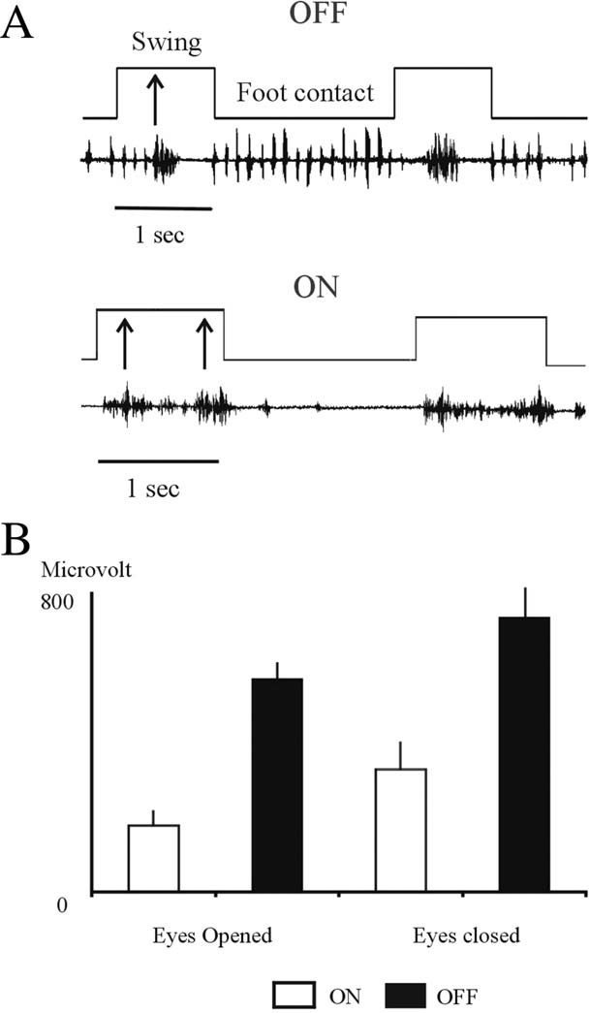

FIG. 1. A: Right foot step cycle during OFF (above) and ON stimu- lation (below). During OFF stimulation, the anterior tibialis is acti- vated just once along the swing phase (arrow). The contraction of the muscle is vigorous in amplitude and occurred in the middle of the phase. During foot contact, the muscle shows several bursts with a frequency similar to OT. However, during ON stimulation, the same muscle is activated twice along the swing phase and is almost silence during foot contact. B: EMG tremor amplitude of the right anterior tibialis during OFF and ON stimulation and with the eyes opened and closed (the patient was standing). With the eyes closed, the amplitude of the tremor was higher (*P* < 0.01) than with the eyes opened during OFF and ON stimulation (1 second calculated).

year after DBS implantation (bipolar, 185 Hz, 90 ls) the patient could stand up normally without any help or leg trem- bling. Nevertheless, when the patient walked still remained a degree of postural instability although not appreciable by her. For gait analysis (STEP 32; Demitalia, Torino, Italy), the patient walked along a corridor several times. We studied the tibialis anterior, gastronimius, rectus femoris, biceps femoris, and paraspinal of both sides. The analysis was with the stim- ulator OFF and ON and with the eyes opened and closed. Tremor amplitude diminished signiﬁcantly in all muscles studied (*P* < 0.01) with ON stimulation but the frequency remained the same. Tremor started before the patient reached

15318257, 2010, 14, Downloaded from https://movementdisorders.onlinelibrary.wiley.com/doi/10.1002/mds.23307 by The University Of Manchester, Wiley Online Library on [22/05/2025]. See the Terms and Conditions (https://onlinelibrary.wiley.com/terms-and-conditions) on Wiley Online Library for rules of use; OA articles are governed by the applicable Creative Commons License

*Movement Disorders, Vol. 25, No. 14, 2010*

### LETTERS TO THE EDITOR 2477

15318257, 2010, 14, Downloaded from https://movementdisorders.onlinelibrary.wiley.com/doi/10.1002/mds.23307 by The University Of Manchester, Wiley Online Library on [22/05/2025]. See the Terms and Conditions (https://onlinelibrary.wiley.com/terms-and-conditions) on Wiley Online Library for rules of use; OA articles are governed by the applicable Creative Commons License

orthostatism during OFF but had a delay of 500 to 1,000 ms during ON stimulation. The parameters of the step cycle were normal with OFF and ON stimulation. However, during OFF stimulation, the tibialis anterior contracted in the middle of the swing phase and showed a 12-Hz tremor activity dur- ing foot contact. On the contrary, during ON stimulation, the muscle produced two sets of contractions for each swing phase and was silent during foot contact both activities con- sidered normal (Fig. 1A). A signiﬁcant difference of tremor amplitude was found with the eyes closed compared with the eyes opened in OFF and ON stimulation (Fig. 1B).

Our results conﬁrm the validity of Vim DBS for drug re- fractory OT.2,3 The reduction in the amplitude of tremor indi- cates a role of the Vim in the genesis of OT but the lack of effect in the frequency suggests other generators. The greater amplitude of the patient tremor with the eyes closed com- pared with the eyes opened in OFF and ON stimulation points to the involvement of somatosensory inputs and may explain the degree of postural instability. At this respect, Wu et al.5 discarded the possible effect of vestibular afferents and suggested the posterior fossa as the origin of tremor. Another factor inﬂuencing the stability when walking during OFF stimulation may be the tremor frequency found during the phase of contact and the irregular activation of the tibialis anterior during the phase of swing.

Acknowledgments: We thank Amparo Martin Bautista for her help in technical matters and P.R. Williams for revision of the English language.

Financial Disclosures: None.

Author Roles: Carlos Magarin˜os-Ascone: collection of data, execution of the gait analysis, analysis of data, writing of the ﬁrst draft. Fidel Mart´ınez-Ruiz: data collection of the gait analysis, critical appraisal of the manuscript, statistics analysis. Arantza San Milla´n: data collection of the gait analysis, criti- cal appraisal of the manuscript. Elena Montes: design and exe- cution of the gait analysis. Ignacio Regidor: organization and design of the work; review and critical appraisal of the manu- script. Marta del Alamo de Pedro: conception; execution. Rob- erto Figueiras-Me´ndez: organization, conception, execution.

Carlos Magarin˜os-Ascone*

*Dpto. Investigacio´n, Servicio de Neurologı´a Experimental*

*Unidad de Neurocirugı´a Funcional Hospital Ramo´n y Cajal, Madrid, Spain*

*E-mail:* [*carlos.ascone@hrc.es*](mailto:carlos.ascone@hrc.es) *or* [*carlosmasko@hotmail.com*](mailto:carlosmasko@hotmail.com)

Fidel Mart´ınez Ruiz *Unidad de Biomateriales Hospital Ramo´n y Cajal*

*Madrid, Spain*

Arantza San Milla´n *Servicio de Rehabilitacio´n Hospital Ramo´n y Cajal*

*Madrid, Spain*

Elena Montes *Servicio de Neuroﬁsiologı´a Hospital Ramo´n y Cajal*

*Madrid, Spain*

Ignacio Regidor *Unidad de Neurocirugı´a Funcional Servicio de Neuroﬁsiologı´a Hospital Ramo´n y Cajal*

*Madrid, Spain*

Marta del Alamo de Pedro

*Unidad de Neurocirugı´a Funcional*

*Hospital Ramo´n y Cajal*

*Madrid, Spain*

Roberto Figueiras-Me´ndez *Unidad de Cirugı´a Funcional Hospital Ramo´n y Cajal*

*Madrid, Spain*

## References

1. Heilman KM. Ortohstatic tremor. Arch Neurol 1984;41: 880–881.
2. Espay AJ, Duker AP, Chen R, et al. Deep brain stimulation of the ventral intermediate nucleus of the thalamus in medically refractory orthostatic tremor: preliminary observations. Mov Disord 2008;16:2357–2362.
3. Guridi J, Rodriguez-Oroz MC, Arbizu J, et al. Successful tha- lamic deep brain stimulation for orthostatic tremor. Mov Dis- ord 2008; 23:1808–1811.
4. Figueiras-Me´ndez R, Magarin˜os-Ascone C, Regidor I, et al. Estimulacio´n cerebral profunda: 12 an˜os de experiencia y 250 pacientes intervenidos con un seguimiento de ma´s de un an˜o. Rev Neurol 2009;49:511–516.
5. Wu YR, Ashby P, Lang AE. Orthostatic tremor arises from an oscillator in the posterior fossa. Mov Disord 2001;16: 272–279.

*Movement Disorders, Vol. 25, No. 14, 2010*